## 3.1-6

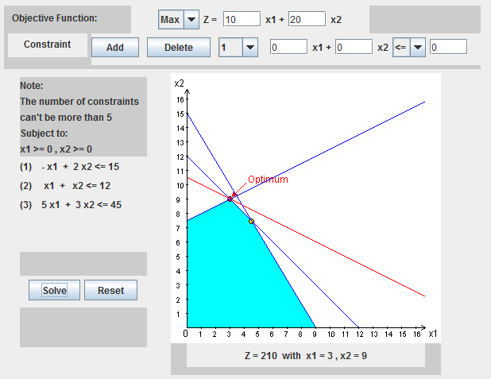

## 3.1-9

### (a)

Objective:

Max $Z=5x_{1}+2x_{2}$

Constraints:

$$3x_{1}+2x_{2}≤2400$$

$$0x_{1}+1x_{2}≤800$$

$$2x_{1}+0x_{2}≤1200$$

### (b)

To maximize profit, Primo Insurance Co. should sell 600 units of special risk and 300 units of mortgage for a profit of $3600

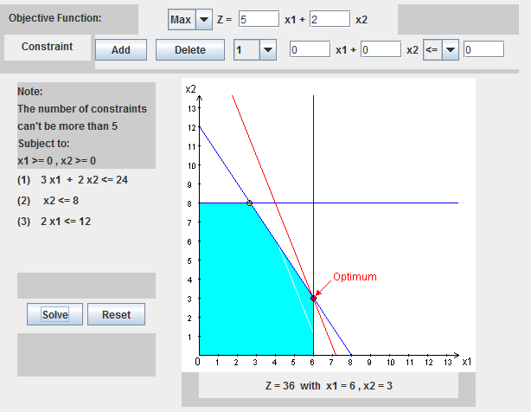

## 3.1-10

### (a)

Objective:

Max $Z=0.88x_{1}+0.33x_{2}$

Constraints:

$$x_{1}≤3,200$$

$$x_{2}≤2,000$$

$$3x_{1}+2x_{2}≤12,000$$

### (b)

To maximize profit, the Weenies and Buns should make 3,200 hot dogs and 1,200 hot dog buns for a total profit of $3,210 per week.

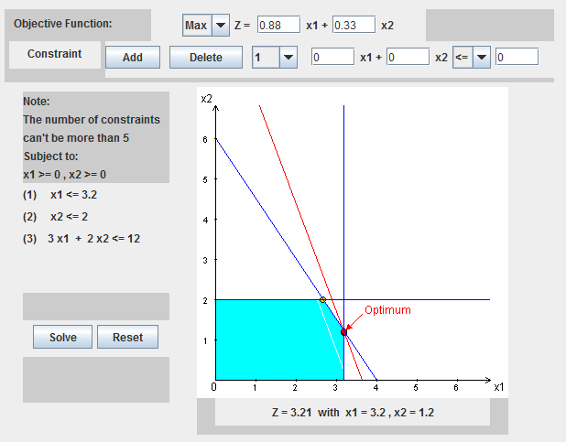

## 3.2-2

### (a)

False. The (6,0) could also be a solution.

Example: $Z=1,000x_{1}+x_{2}$

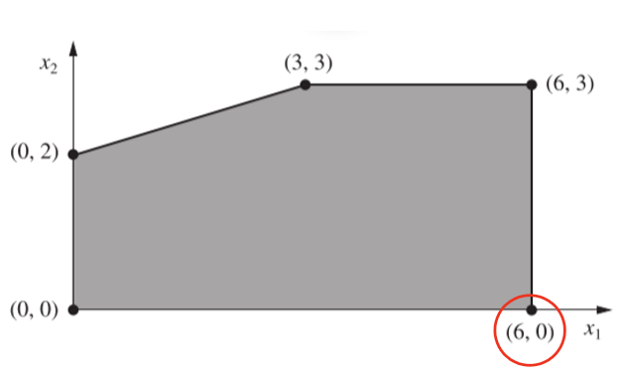

### (b)

True. In the case of multiple optimal solutions, there exists a line with an infinite number of solutions.

Example: (blue line) $Z= -\frac{1}{6}x_{1}+\frac{1}{2}x_{2}$

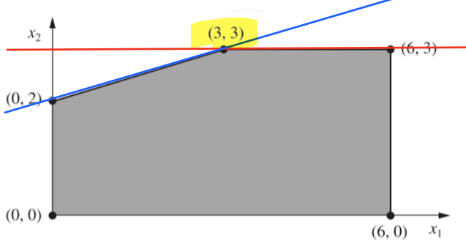

## (c)

True. In some cases, the origin could be the optimal solution if there is no nonnegative constraint.

Example: $Z=-1,000x_{1}+ -2,000x_{2}$

## 3.2-3

### (a)

|  |  |  |  |
| --- | --- | --- | --- |
| Resource | Friend 1 | Friend 2 | Constraint |
| Dollars | $10,000 | $8,000 | $12,000 |
| Hours | 400 | 500 | 600 |
| Total Profit | $9000 | $9000 |  |

### (b)

Objective:

Max $Z=\$9,000x_{1}+\$9,000x_{2}$

Constraints:

$${\$10,000x}_{1}+{\$8,000x}_{2}≤\$12,000$$

$${400x_{1}+500 x}_{2}≤600$$

### (c)

The total estimated profit is $12,000.

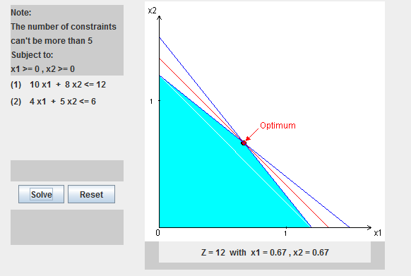

## 3.2-4

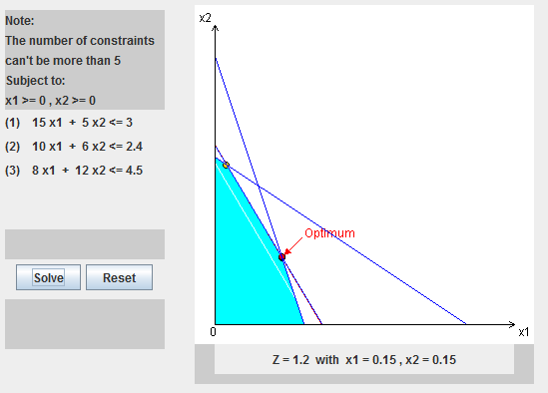

## 3.2-6

(a)

With these constraints, there is nothing bound on the right edge.

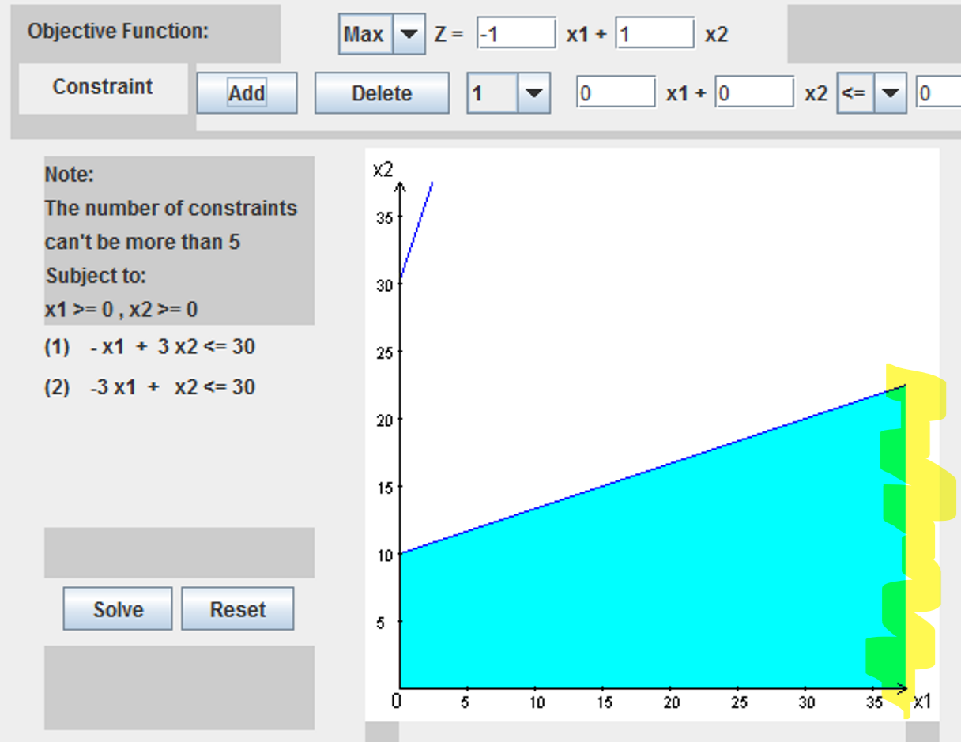

### (b)

Yes. there is an optimal solution (see below).

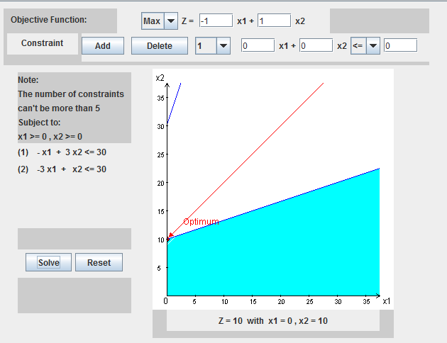

### (c)

No. There is no optimal solution for this problem.

### (d)

We can compute a formula that works. Good would be subjective at this point but we could come up with a formula that is within the given constraints.

Most likely, an additional constraint was accidentally left out of the problem.

## 3.3-2

Proportionality – This is satisfied. Each level of each activity is proportional to the other level within that activity.

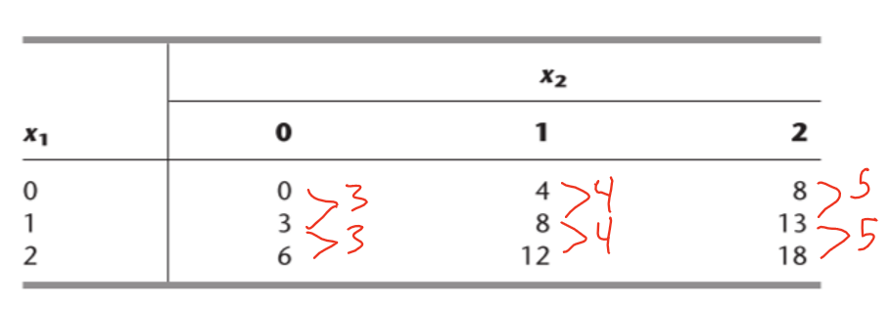

Additivity – This is NOT satisfied. The value at (0,1) = 4. The value at (1,0) = 3. However, the value at (1,1) = 8. If additivity were true, the presence both activities should match the combination of the separate activities (3 + 4 = 7)

Divisibility – Unknown. As all the values in the problem are integers, we do not know if fractions are allowed.

Certainty – N/A. This constraint is not often applicable in real-world problems as we are using the model to predict unknown values.