# 4.7-3

## (a)

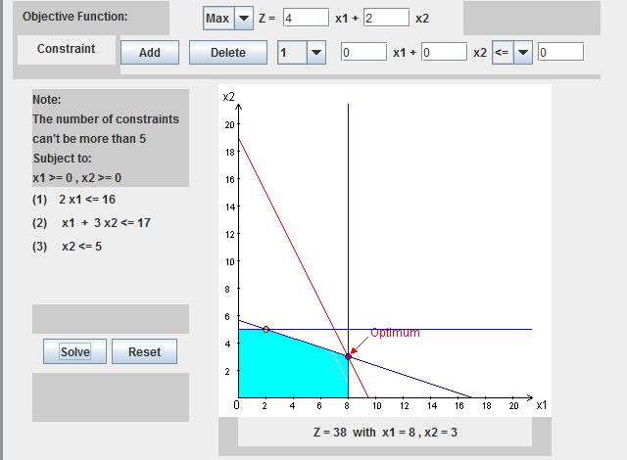

## (b)

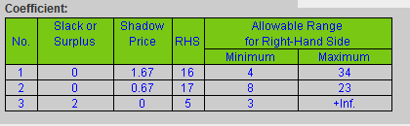

## (c)

We would need to increase $x_{1}$ by $9$ to increase Z by $15$.

# 4.7-6

## (c)

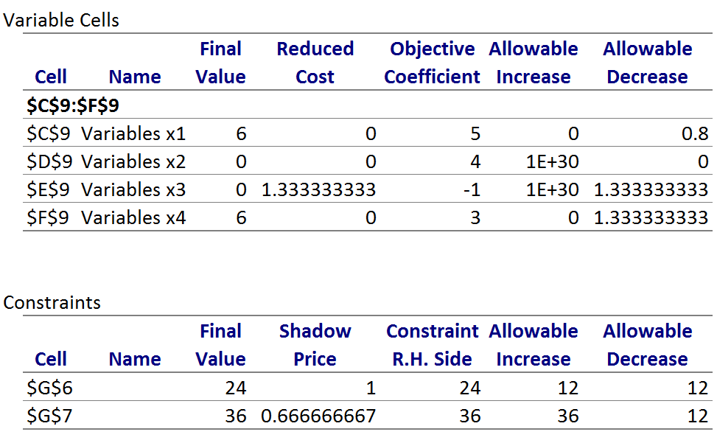

*See Excel.*

7.3-4

## (a)

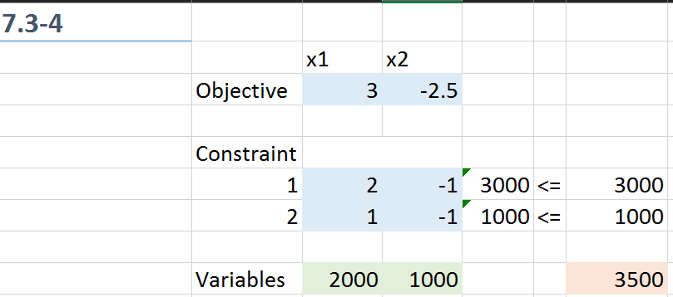

*See Excel.*

## (f)

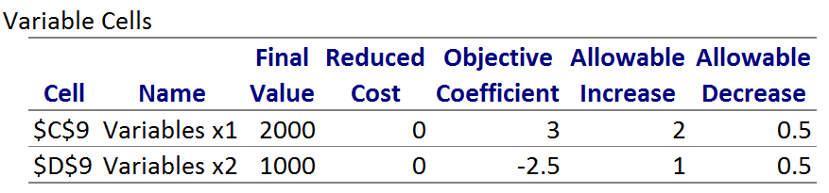

*See Excel.*

## (g)

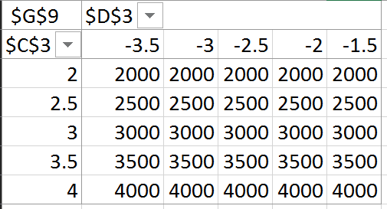

*See Excel.*

## (h)

Based on the Sensitivity Report from Solver the profit of each toy needs to be at least $2.00 and the cost of producing the set of subassemblies needs to be no more than $3.00.

# 7.3-5

## (a)

*See Excel.*

## (b)

The company should pay no more than a $0.50 per unit premium for subassembly A.

## (c)

The company should pay no more than a $2.00 per unit premium for subassembly B.

## (d)

*See Excel.*

## (e)

*See Excel.*

## (f)

# 7.3-7

## (a)

We can increase the minimum agents we require for the 3rd, 4th, 5th, 6th, and 9th time periods without increasing the total cost.

For the 3rd time period, we could increase by 14 hours.

For the 4th time period, we could increase by 31 hours.

For the 5th time period, we could increase by 6 hours.

For the 6th time period, we could increase by 9 hours.

For the 9th time period, we could increase by 6 hours.

# 7.4-4

## (a)

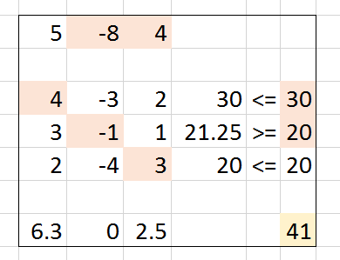

*See Excel.*

## (b)

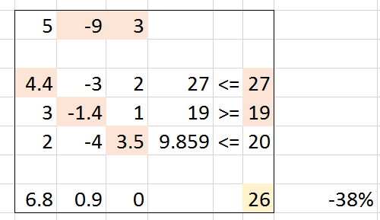

*See Excel.*

# 7.5-1

## (a)

4 - 2.33(0.1) = 3.77

12 – 2.33(0.25) = 11.42

18 – 2.33(0.5) = 16.84

## (b)

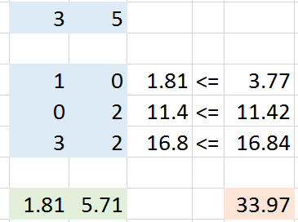

*See Excel.*

The company was able to increase profit by $848 per week using careful measurement!