Top of Form

Question 1: **Correct**

Create a Project using a Template of your choosing and name it "{LastName}-CICDCert".

**Explanation**

**Create a GitLab Repository**

**1.** Click on "New Project".

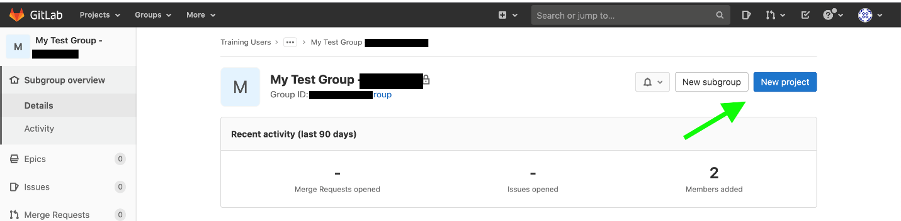

**2.** Select "Create blank project".

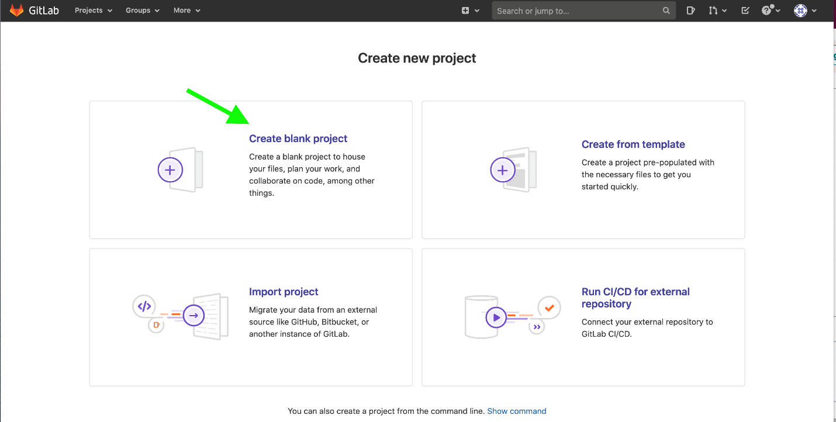

**3.**  Name your GitLab Repository as per instruction from GitLab and click on "Create project". e.g {LastName}-CICDCert

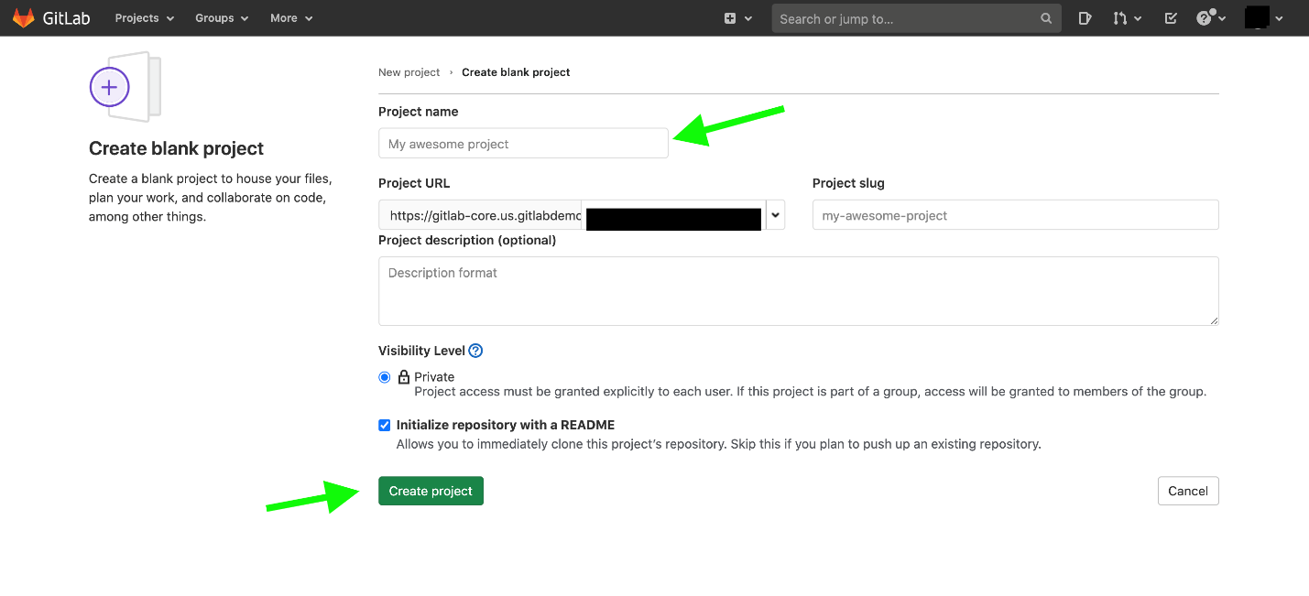

**4.**  Click on "+" as pointed by the green arrow in the screenshot and upload the file below given files from **QuizExperts** GitHub Repository to the new Repository in GitLab.

          *   [.gitlab-ci.yml](https://github.com/quiz-experts/GitLab-CI-CD-Specialist/blob/main/Solution%20of%20GitLab%20Certified%20CICD%20Specialist%20Hands%20On%20Assessment/.gitlab-ci.yml)

          *   [Dockerfile](https://github.com/quiz-experts/GitLab-CI-CD-Specialist/blob/main/Solution%20of%20GitLab%20Certified%20CICD%20Specialist%20Hands%20On%20Assessment/Dockerfile)

          *   [main.go](https://github.com/quiz-experts/GitLab-CI-CD-Specialist/blob/main/Solution%20of%20GitLab%20Certified%20CICD%20Specialist%20Hands%20On%20Assessment/main.go)

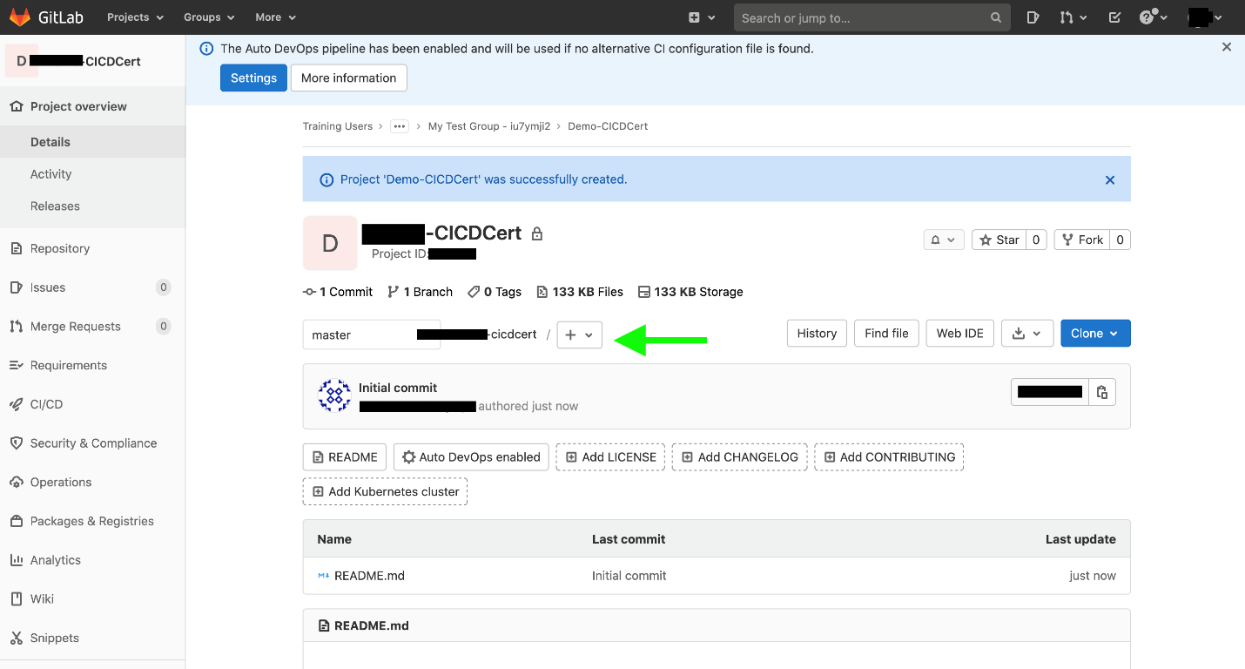

**Register a Runner**

**1.** Click on "Settings" -> "CI/CD" as highlighted below with the green arrows.

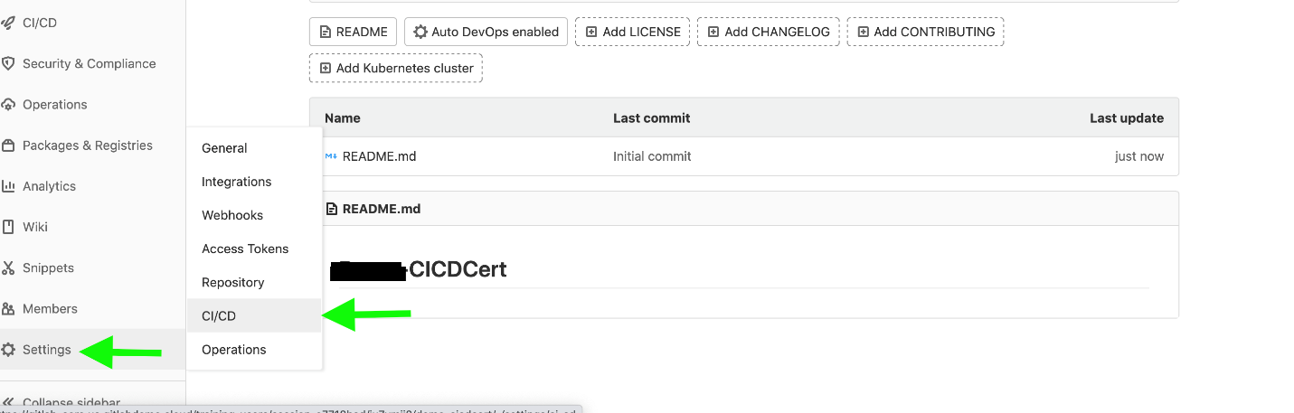

**2.** Click on "Expand" in the Runners section to register a new runner.

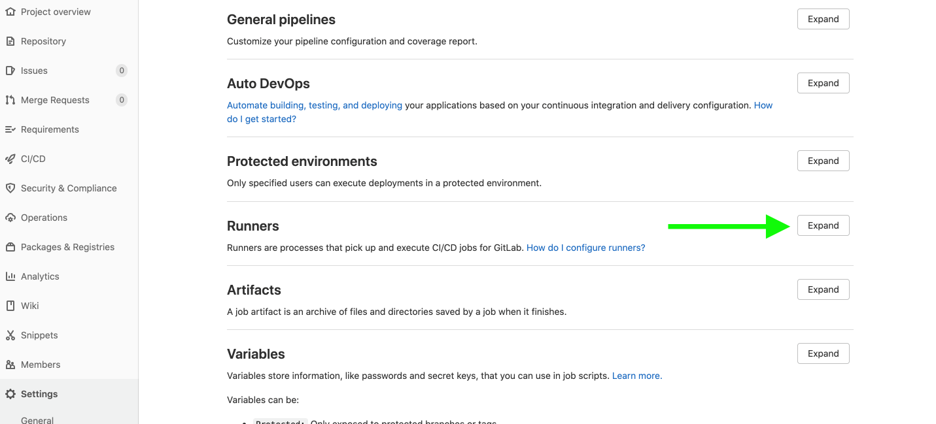

**3.**  Click on "Show Runner installation instructions".

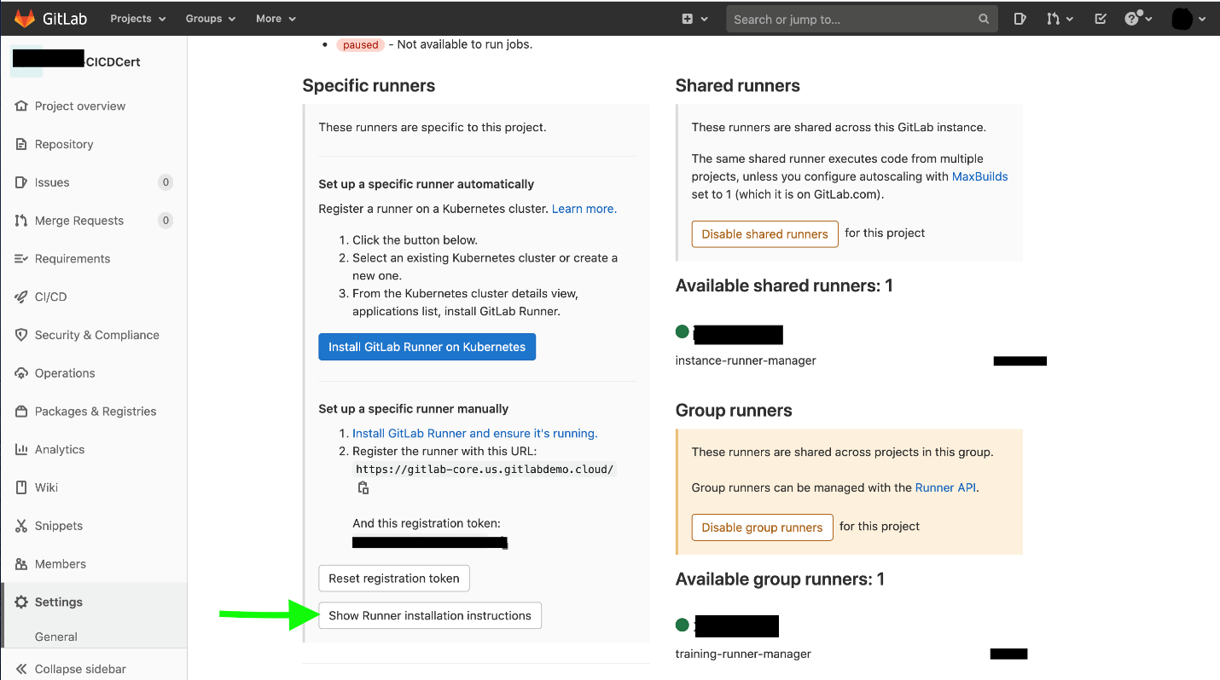

**4.** Select the required environment (OS) and follow the instruction given in the code blocks to download, install and register Runner.

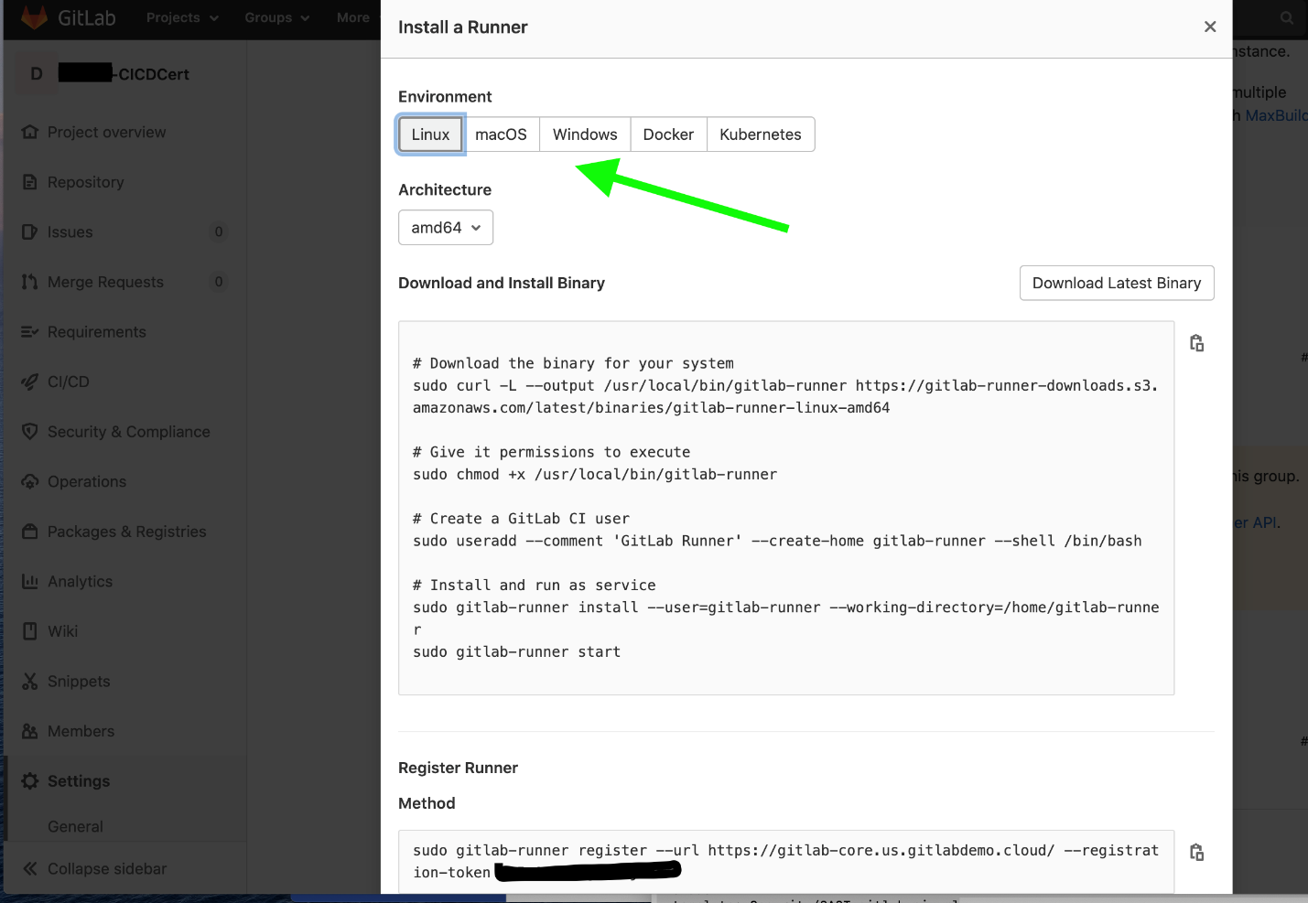

While running the command to register Runner, the command will prompt you for some inputs. If you want to use the default value, just hit the enter else, provide the required information.

          -   Provide docker_tag as a Runner tag,

          -   Provide docker as an Executor,

          -   Provide alpine as a default Docker image.

***Note:*** Make sure you have Docker running on your system before running above the given steps.

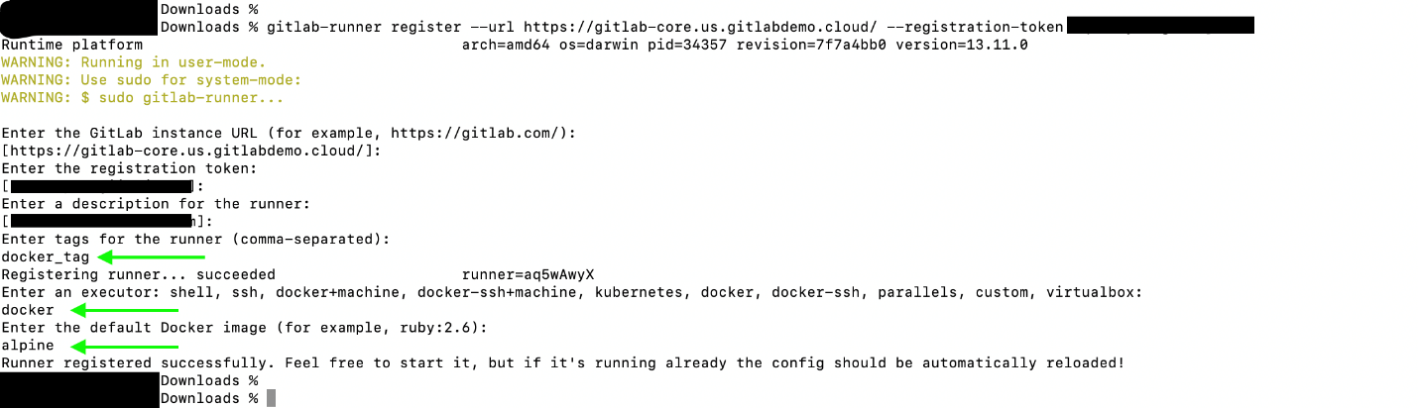

**5.**  Once you are done with the above steps, refresh the page and make sure a new Runner appears with green status and docker_tag.

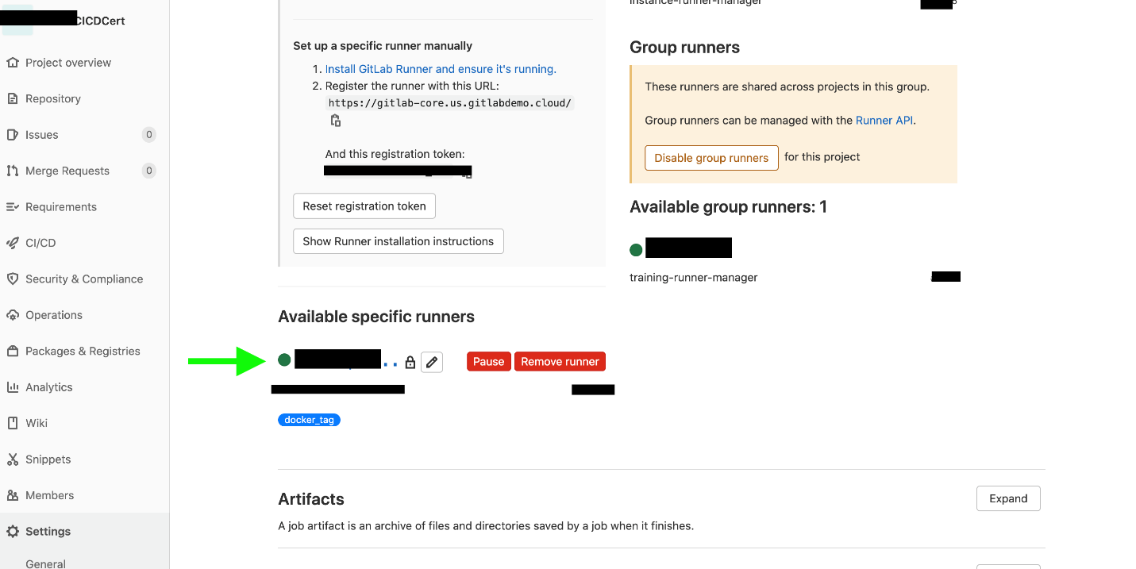

**Run Pipeline**

**1.** Click on "CI/CD" -> "Pipeline" and click on "Run Pipeline".

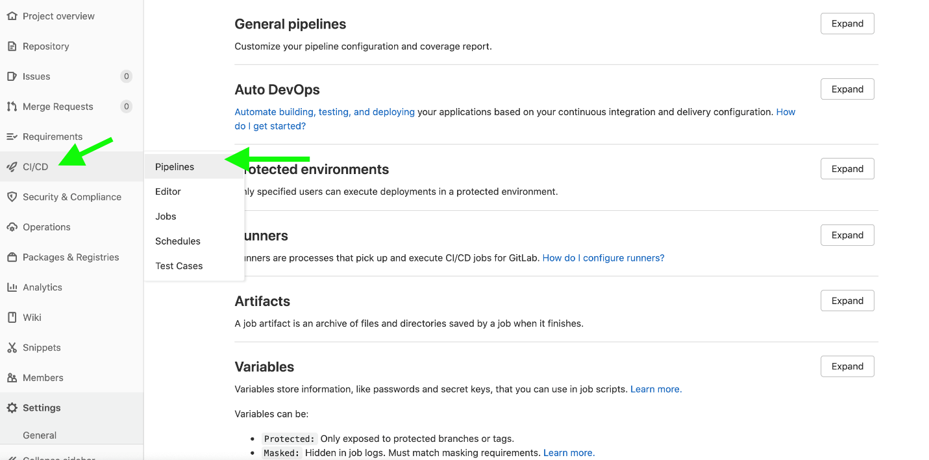

**2.**  Run Pipeline for master branch and wait for some time. Once the Test stage is complete, click on the play button as shown in the given screenshot.

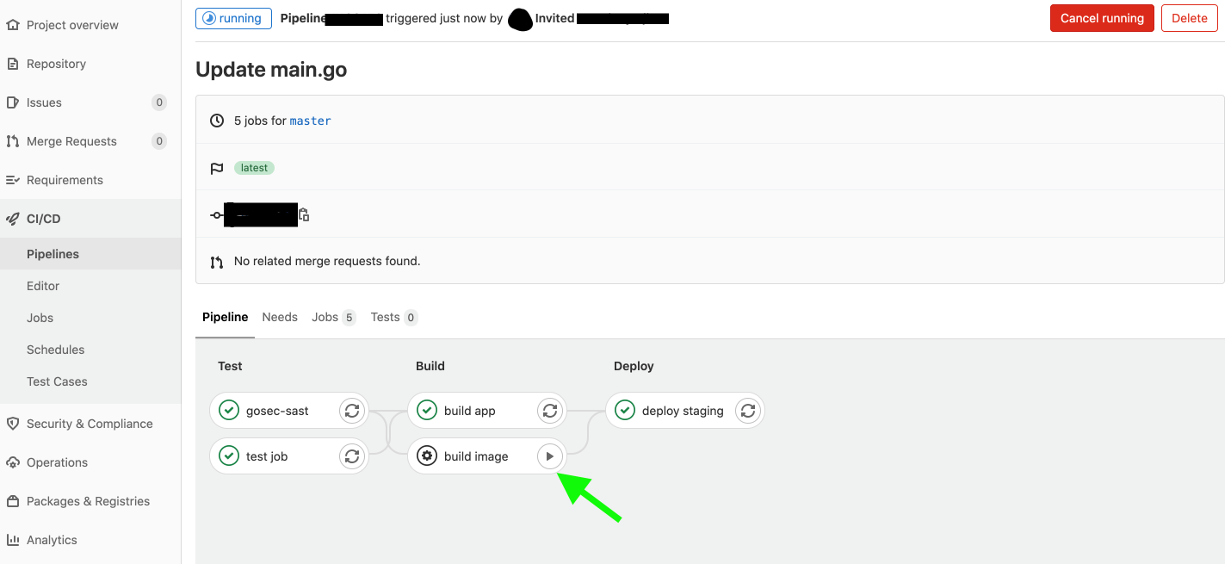

**3.**After clicking on the play button, wait for the pipeline to finish, and if everything is green, open the google form and select "Yes". We have asked similar questions in this practice test.

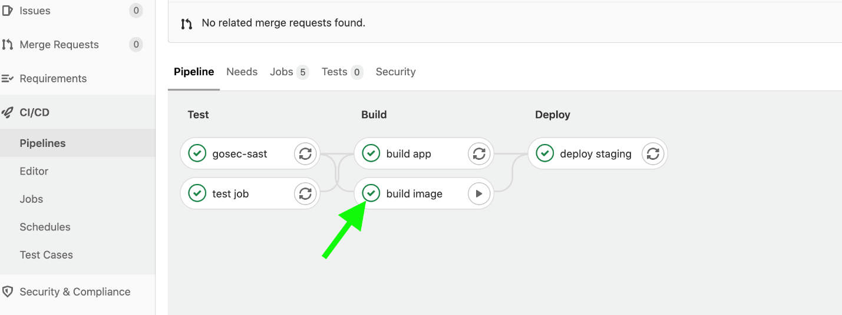

**Submit Hands-On Assessment**

Once your pipeline completes with green status, open the Google form, select "Yes" in all the questions, and submit it. Someone from GitLab will check your submission and will drop you an email in the next 7 days.

***NOTE:***We have asked similar questions in this practice test.

Bottom of Form

Top of Form

Question 2: **Correct**

Add a .gitlab-ci.yml file with test, build, review, and deploy stages.

**Explanation**

***NOTE:***See the explanation provided in question number one.

Bottom of Form

Top of Form

Question 3: **Correct**

Add an Image tag to your pipeline.

**Explanation**

***NOTE:***See the explanation provided in question number one.

Bottom of Form

Top of Form

Question 4: **Correct**

Define a default environment parameter for your pipeline.

**Explanation**

***NOTE:***See the explanation provided in question number one.

Bottom of Form

Top of Form

Question 5: **Correct**

Add environment variables to your pipeline.

* ​

Yes

**(Correct)**

* ​

No

**Explanation**

***NOTE:***See the explanation provided in question number one.

Bottom of Form

Top of Form

Question 6: **Correct**

Scaffold out a job policy pattern that uses feature branches and tags to gate review, release, and staging/production job execution.

* ​

Yes

**(Correct)**

* ​

No

**Explanation**

***NOTE:***See the explanation provided in question number one.

Bottom of Form

Top of Form

Question 7: **Correct**

Dockerize the application and publish a Docker image to the built-in GitLab Docker Registry.

* ​

Yes

**(Correct)**

* ​

No

**Explanation**

***NOTE:***See the explanation provided in question number one.

Bottom of Form

Top of Form

Question 8: **Correct**

Enable SAST on your pipeline.

* ​

Yes

**(Correct)**

* ​

No

**Explanation**

***NOTE:***See the explanation provided in question number one.

Bottom of Form

Top of Form

Question 9: **Correct**

In your CI/CD Settings, enable any specific runner available.

* ​

Yes

**(Correct)**

* ​

No

**Explanation**

***NOTE:***See the explanation provided in question number one.

Bottom of Form

Fullscreen

Default view

Course content

**Course content**

**Overview**

**Q&AQuestions and answers**

**Notes**

**Announcements**

**Reviews**

Top of Form

Question 1: **Correct**

Which of the following is always a component of a .gitlab-ci.yml?

* ​

build

* ​

push

* ​

deploy

* ​

stages

**(Correct)**

Bottom of Form

Top of Form

Question 2: **Correct**

What parameter is used to tell the pipeline which runners to execute on?

* ​

None of the above

* ​

Tags

**(Correct)**

* ​

Services

* ​

Variables

Bottom of Form

Top of Form

Question 3: **Correct**

True/False: The two main foundations of a CI/CD Pipeline at GitLab are a .gitlab-ci.yml file and a GitLab Runner.

* ​

False

* ​

True

**(Correct)**

Bottom of Form

Top of Form

Question 4: **Correct**

Which executor directly run commands as if writing them into terminal (bash or sh) or command prompt (cmd)?

* ​

Docker Machine

* ​

Shell

**(Correct)**

* ​

Docker

* ​

Kubernetes

Bottom of Form

Top of Form

Question 5: **Correct**

Which GitLab tiers have access to the CI/CD Pipelines Dashboard? (check all that apply)

* ​

GitLab Free

* ​

GitLab Premium

**(Correct)**

* ​

GitLab Ultimate

**(Correct)**

Bottom of Form

Top of Form

Question 6: **Correct**

What type of runner can be used by any project?

* ​

Shared

**(Correct)**

* ​

Untagged

* ​

Protected

* ​

Specific

Bottom of Form

Top of Form

Question 7: **Correct**

What is used to restrict when a job is executed on your pipeline?

* ​

branches

* ​

scripts

* ​

variables

* ​

rules

**(Correct)**

Bottom of Form

Top of Form

Question 8: **Correct**

Which of the following benefits of Artifacts does apply when using GitLab?

* ​

Used for stage results that will be passed between stages

* ​

Can be used on subsequent jobs if they have been added to the current active pipeline

* ​

Can have an expiration value to control disk usage

* ​

All of the above

**(Correct)**

Bottom of Form

Top of Form

Question 9: **Incorrect**

True/False: Continuous Delivery and Continuous Deployment are interchangeable terms with the same definition.

* ​

False

**(Correct)**

* ​

True

**(Incorrect)**

Bottom of Form

Top of Form

Question 10: **Correct**

What CI/CD executor runs as pods in clusters?

* ​

Docker

* ​

Kubernetes

**(Correct)**

* ​

Shell

* ​

SSH

Bottom of Form

Top of Form

Question 11: **Correct**

What allows you to start a downstream pipeline?

* ​

Extends

* ​

Parallel

* ​

Trigger

**(Correct)**

* ​

Needs

Bottom of Form

Top of Form

Question 12: **Correct**

True/False: The rules keyword is a way to set job policies that determine whether or not jobs are added to pipelines.

* ​

True

**(Correct)**

* ​

False

Bottom of Form

Top of Form

Question 13: **Correct**

Which of the following keywords are able to be used for Job names?

* ​

include

* ​

services

* ​

image

* ​

test

**(Correct)**

Bottom of Form

Top of Form

Question 14: **Correct**

What parameter defines a downstream pipeline?

* ​

stage

* ​

environment

* ​

trigger

**(Correct)**

* ​

scripts

Bottom of Form

Top of Form

Question 15: **Correct**

What parameter determines where an app is deployed?

* ​

When

* ​

Variables

* ​

Environment

**(Correct)**

* ​

Only

Bottom of Form

Retake test

Continue