1. **Course Number:**

51438

1. **Group Number:**

13

1. **Group Members:**
   * **Christina Depena** - ckd386
   * **Brandon Kerbow** -bwk352
   * **Isaac Tijerina** - Igt86
2. **Application Name:**

Binder

1. **Application Description:**

The application would serve as a tool to help high school and college students stay organized in their classes and evaluate their performance as the semester progresses. The app will consolidate common tasks by providing students with two major features: the ability to calculate the assignment grades required to obtain a desired overall average, and the ability to input - and be reminded of - deadlines. The calculation regarding what a student needs to get on a final exam in order to make an A in a class is an incredibly common task. Our app would make it easy to perform this calculation not only for a final exam, but for all remaining assignments and for any desired letter grade. The ability to view upcoming deadlines and see how heavily assignments are weighted in the same convenient location will make it easier for students to stay on top of and prioritize their coursework.

1. **Mockups & Operational Descriptions:**

Below are screenshots of each view controller followed by a brief description which includes how the user makes use of and interacts with it.

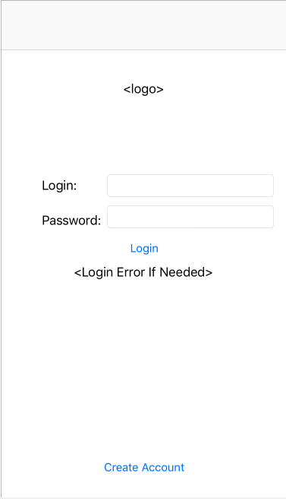

*Figure 1 – Login Screen View Controller*

This is the login screen. The user will enter a username and password which will be compared against a database. If the credentials are correct then the user will segue to the Main Tab Bar Controller (figure 3). If the user inputs incorrect credentials, an alert view will appear notifying the user that one of their inputs is incorrect. When the user clicks the “Create Account” button they will be segued to Account Creation View Controller (figure 3).

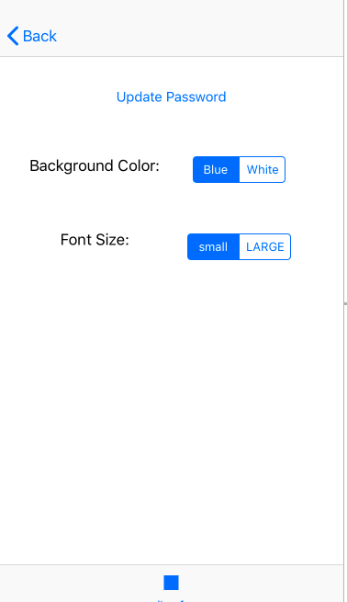

*Figure 2 – Settings View Controller*

This view controller, which is segued into when the user clicks the settings tab on the Main Tab View Controller (figure 4), allows the user to update their password (which segues into figure 5). It also had two segmented controls, for background color and font size. Both background color and font size will be applied across the entire app.

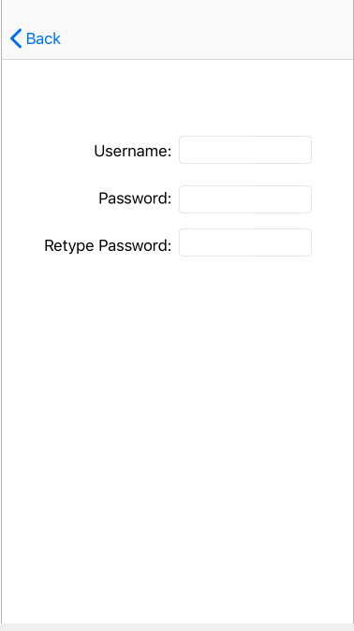.

*Figure 3 – Account Creation View Controller*

This view controller allows the user to create an account. Upon entering their desired username and password, the credentials will be saved to a database and an account will be initialized. The user can then click back to log in with this account.

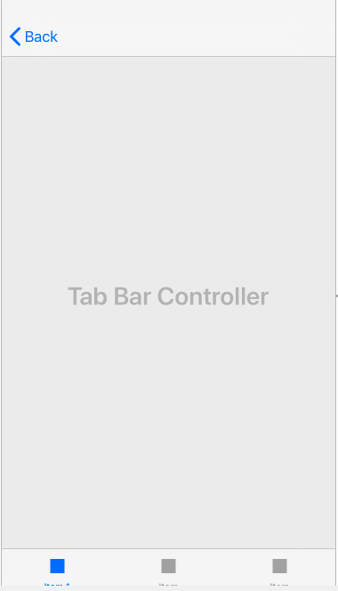

*Figure 4 – Main Tab Bar Controller*

This tab bar controller will control the movement between the starting points for the main features of our apps: adding courses and grades, a to-do list with reminders, and settings. These starting points are the Courses Table View Controller (figure 8), the Tasks Table View Controller (figure 9), and the Settings View Controller (figure 2). This tab bar controller - and consequently each of the aforementioned views embedded within it - will have a menu with a button for each of these views at the bottom. The initial view it will show is the Courses Table View Controller.

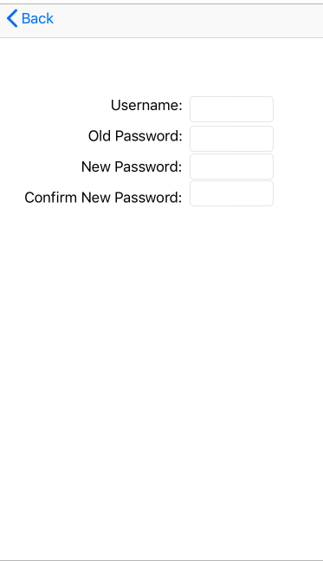

*Figure 5 – Update Password View Controller*

The view controller allows the user to change their password by entering in their username, old password, and new password twice. This updates the credentials in the login database.

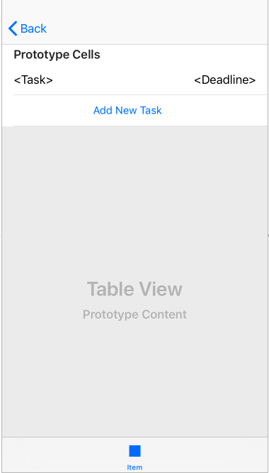

*Figure 6 – Tasks Table View Controller*

This view controller is accessed by tapping on a tab in the tab Main Tab View Controller (figure 4). It will list each task that the user has in a table cell. For each task it will display the name and its deadline. It will have an add new task button that will segue the user to the Add Task View Controller (figure 7). The back button currently takes the user back to the login screen.

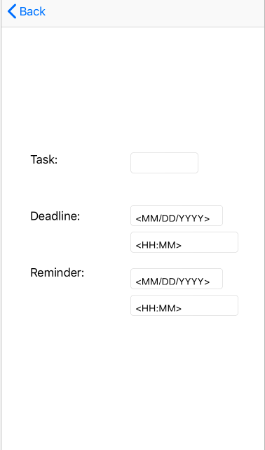

*Figure 7 – Add Task View Controller*

This view controller allows the user to add a task and specify the date and time of both the deadline and reminder. These pieces of data will be stored to core data and when the reminder time comes (if one is specified) a reminder will be sent to the user’s phone.

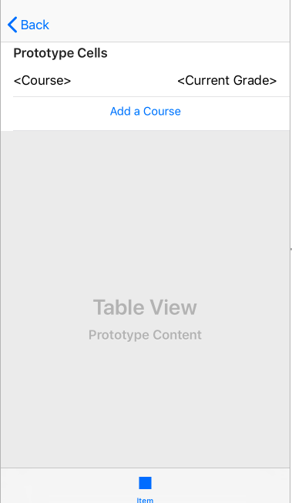

*Figure 8 – Courses View Controller*

This Courses Table View Controller is accessed by tapping on a tab in the Main Tab View Controller (figure 4). It shows the user’s list of courses and their current grade is each course. The way in which these fields are populated is detailed in subsequent view controller descriptions.

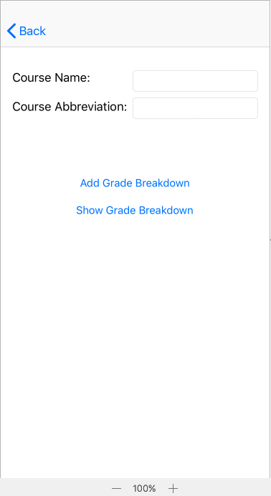

*Figure 9 – Add Course View Controller*

This view controller allows the user to add a course by entering the name, abbreviation, and grade breakdown. The “Add Grade Breakdown” button goes to the Add Grade Breakdown View Controller (figure 11) and the “Show Grade Breakdown” button goes to the Show Grade Breakdown Table View Controller (figure 10). The back button goes the Courses Table View Controller (figure 8).

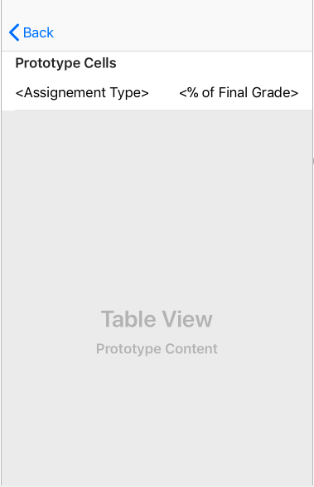

*Figure 10 – Show Grade Breakdown View Controller*

The view controller displays a list of assignment types (e.g. exams, homework) and their percent of the final grade. This is calculated using the breakdown that the user defines in the Add Grade Breakdown View Controller (figure 11). The back button goes to the Add Course View Controller (figure 9).

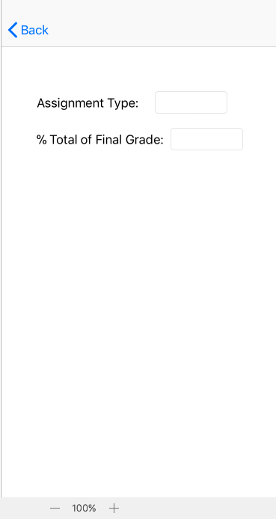

*Figure 11 – Add Grade Breakdown View Controller*

The view controller allows the user to create a new assignment type for the class by entering the name and percent of final grade. The back button goes Add Course View Controller (figure 9).

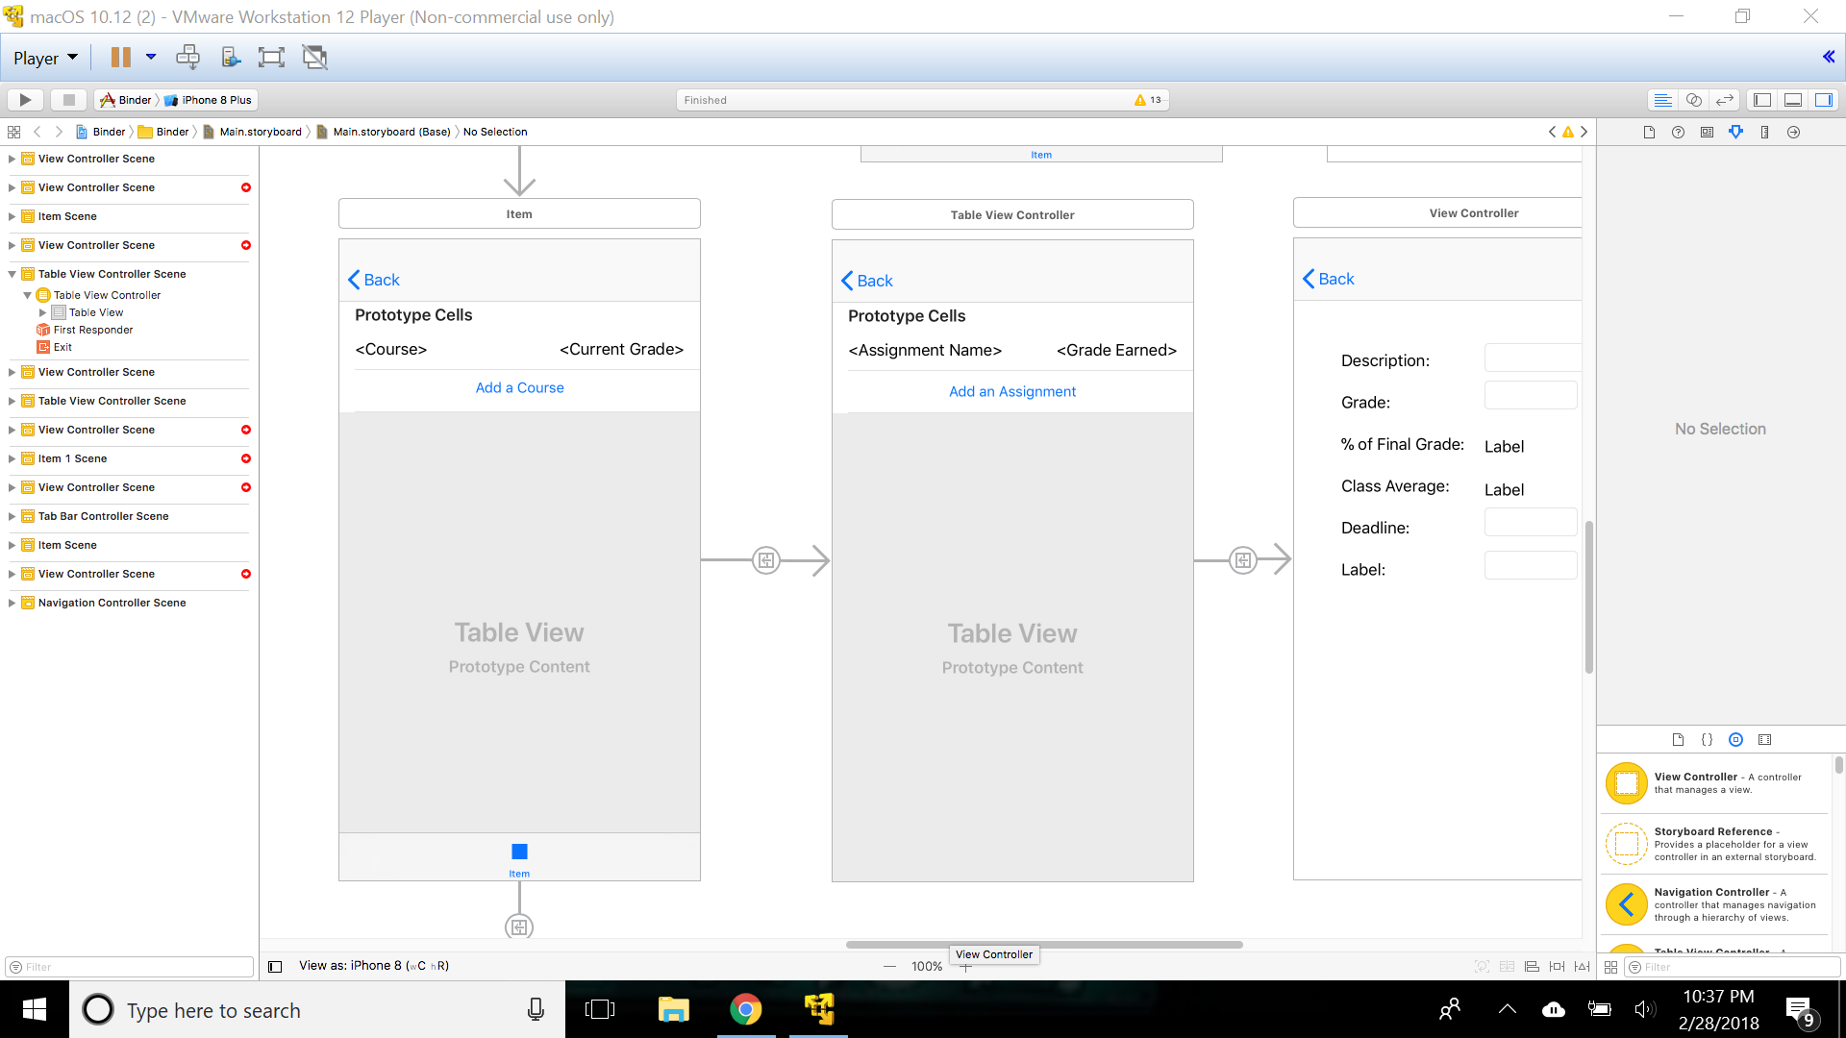

*Figure 12 – Assignment Table View Controller*

This view controller is displayed when the user clicks on a cell within the Courses View Controller (figure 8). It provides a further breakdown of the grade by listing each assignment and the grade that was received. The back button returns to the Courses View Controller.

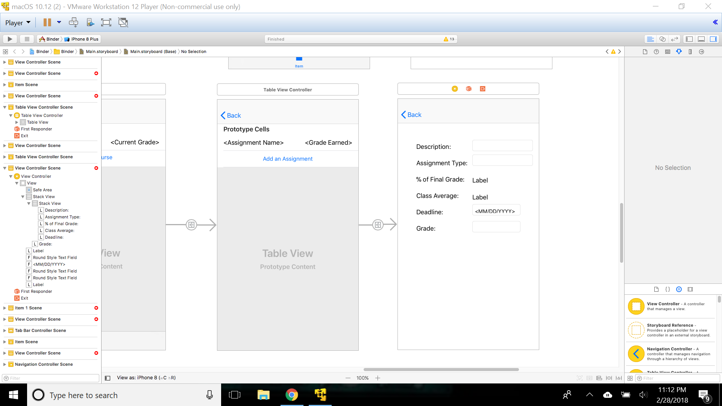

*Figure 13 – Add Assignment View Controller*

This view controller shows the details for a selected assignment within the Assignment Table View Controller (figure 12). It allows the user to add/change the description, grade, and deadline. It also allows the user to see the class average. The % of Final Grade label is determined by what the user inputted for this courses grade breakdown in the Add Grade Breakdown View Controller (figure 11). The back button takes the user to the Assignment Table View Controller.

1. **Application Flow Diagram:**

