2026
Tong Pak Yuen Isaac NG Ching Hei Fu Lok Tim
IT114116
2026/6/29

Vendor Machine Marketing Analysis
Table of Content
Introduction 2
Data 3
Setting and Utilising GitHub 4
Roles 5
Product Backlog items 5
Sprint Backlog items 6
Code solution and Explanation 7
Evaluation 29
Conclusion 33

Introduction
Vending machines combine the concept of online business management with offline convenience services. By adopting a compact, self-service operating model, they significantly reduce labor costs and make affordable, high-quality products readily accessible to consumers. This approach has emerged as another mainstream retail format in recent years. For vending machine operators, key decisions revolve around product replenishment frequency, category selection, supply quantities, and optimal machine placement locations. Scientific business data analysis plays a crucial role here: it helps operators gain deeper insight into user needs, accurately predict product demand, deliver more precise and attentive services, and guide strategic business direction—making it an essential driver for the ongoing development and success of the vending machine retail model.

Data
The only dataset is from the Vendor. The dataset includes transaction records and product information. The following is the metadata table.
Field  (Chinese Field Name) | Type | Description | range | Sample
Order ID (订单号) | String | Unique identification of each transaction | Unique string
Machine ID (设备ID) | String | The vendor machine that makes the order | Unique string
Payable Amount (应付金额) | Double | Total amount of the order that has to be paid | -- | 4.5
Actual Paid (实际金额) | Double | Actual paid amount | -- | 4.5
Product (商品) | String | The purchased product | -- | 營養快線
Location (地点) | String | The Vendor Machine Location | A to E | A
Payment Time(支付时间) | Time Stamp | The DateTime that the payment was made. | In Year 2017 | 1/1/2017 0:53
Transaction Status (状态) | String | The order status after payment.the term “已出貨未退貨”means the order was done and no refund required. | -- | 已出貨未退貨
Withdraw (提现) | String | The indicator that the vendor already received the payment. The term “已提現” means the payment already withdrawed by the vendor. | -- | 已提現
Category (大类) | String | The categorized label of the product | 饮料, 非饮料 | 非饮料
Sub-Category (二级类) | String | The sub-categorized label of the product | -- | 饼干糕点

Setting and Utilising GitHub
Provide the link and screenshots of your GitHub project, and also some screen captures, including tree views and document changes.
https://github.com/isaactong1014/ITP4475-group-project
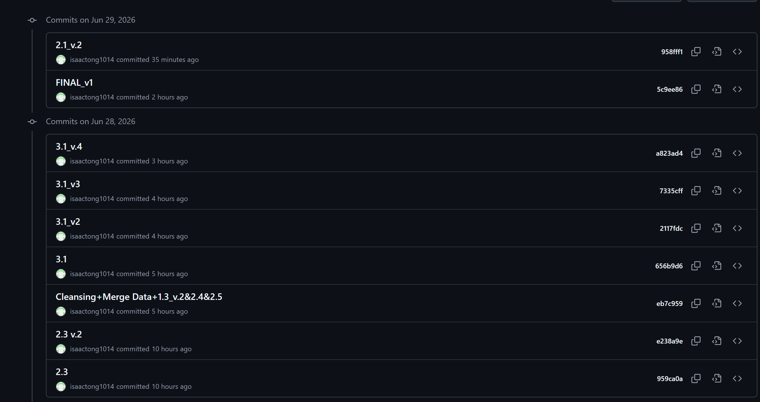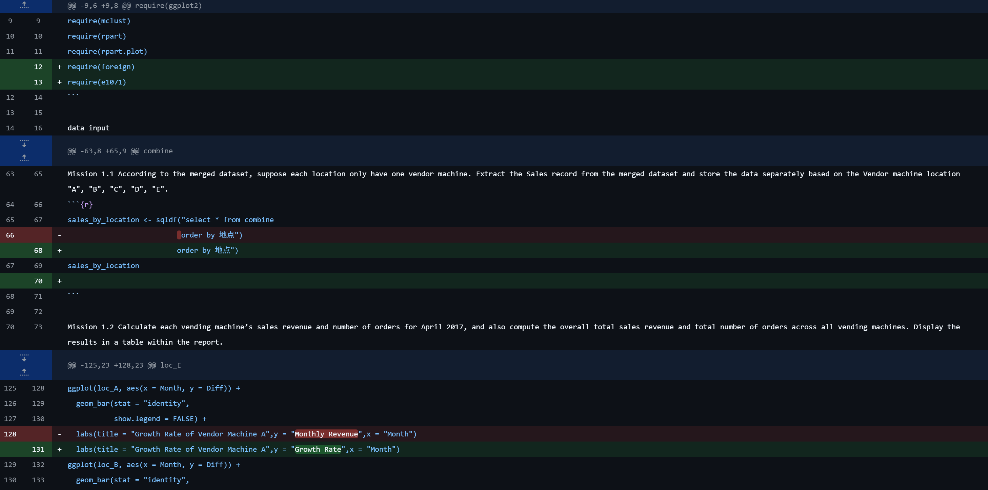

Roles
Name | Role | Responsibilities
Tong Pak Yuen Isaac | Leader | Coding
NG Ching Hei | Cooperator | Report writing
Fu Lok Tim | Cooperator | Report writing

Product Backlog items
Sprint | Task | Category | priority | status
1 | Uploading data to R | DATA | LOW | Under Review
1 | Data Cleansing | DATA | HIGH | Under Review
2 | Relationship between price and bedroom numbes | Modelling | Middle | Comitted

Sprint Backlog items
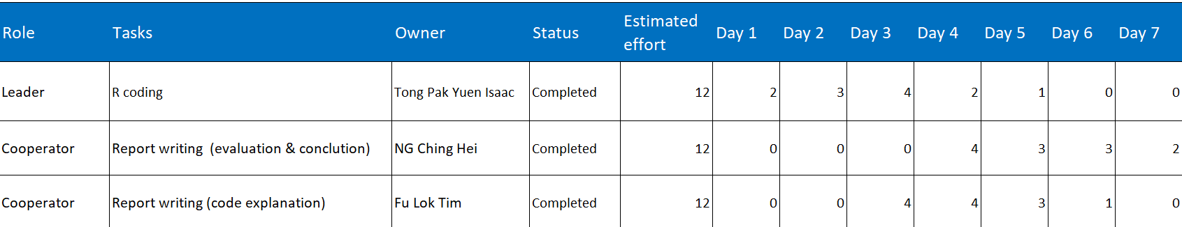
Day | Detail | Owner
1 | Study the data  Data input  Cleansing | Tong Pak Yuen Isaac
2 | Merge data  Mission 1.1 - 1.3 | Tong Pak Yuen Isaac
3 | Mission 2.1 - 2.3 | Tong Pak Yuen Isaac
 | Explanation Data input, Cleansing, Merge data, 1.1 - 1.3 | Fu Lok Tim
4 | Mission 2.4 - 2.5 | Tong Pak Yuen Isaac
 | Explanation 2.1 - 2.4 | Fu Lok Tim
 | Evaluation Q1 - 2 | NG Ching Hei
5 | Mission 3.1 - 3.2 | Tong Pak Yuen Isaac
 | Explanation 2.5 - 3.2 | Fu Lok Tim
 | Evaluation Q3 | NG Ching Hei
6 | Finalized | Fu Lok Tim
 | Evaluation Q4 | NG Ching Hei
7 | Conclusion | NG Ching Hei

Code solution and Explanation
Read the dataset and combine the two sheets into a single dataframe.
Code:  sale_data <- read.xlsx("Sale_Data.xlsx","Sales_Record")  product_information <- read.xlsx("Sale_Data.xlsx","Product_Information")  names(product_information)[names(product_information) == '商品'] <- '商品1'  combine <- sqldf("select * from sale_data inner join product_information on (sale_data.商品 = product_information.商品1)") | Key steps:  - Load the ("Sales_Record") sheet from the Excel file into sale_data dataframe  - Load the ("Product_Information") sheet from the Excel file intoproduct_information dataframe  - Rename product column in (“product_information”) to '商品1' to avoid conflict  - Merge both sheets using INNER JOIN on product name
Explanation…
The “Sales_Record” sheet contains 70,680 transaction records with details like order ID, product, amount, location, and payment time. The “Product_Information” sheet provides product categories and sub-categories. An INNER JOIN merges both datasets on the product name, creating a combined dataframe with all transaction details plus product categorization. This merged dataset serves as the foundation for all subsequent analysis tasks.

Convert the payment datetime to standard datetime format.

Code:  Sys.setenv(TZ = "UTC")  sale_data$支付时间 <- as.POSIXct(sale_data$支付时间, format = "%Y-%m-%d %H:%M:%S", tz = "UTC") | Key steps:  - Set system timezone to UTC for consistencySpecify structure.  - Convert payment time column from character to POSIXct datetime format.  - Specify the input format to match the data structure
Explanation…
The payment time is originally stored as character strings in "YYYY-MM-DD HH:MM:SS" format. Converting to POSIXct datetime format enables proper time-based operations such as filtering by month, extracting day/month for aggregations, calculating time differences, and chronological sorting. The UTC time zone ensures consistency across all time-based calculations regardless of system locale.

Convert all payment-related columns to calculable values
Code:  checking_price <- sqldf("select sale_data.订单号, sale_data.商品, sale_data.应付金额, sale_data.实际金额 from sale_data where 应付金额 != 实际金额") | Key steps:  - Identify any records where payable amount differs from actual paid amount  - Confirm both amount columns contain numeric data types  - Verify data integrity before performing financial calculations
Explanation…
The payable amount and actual paid amount are already stored as numeric/double values in the dataset, making them directly usable for mathematical operations like summing, averaging, and aggregation. The verification query checks for any discrepancies between these two columns to identify potential data quality issues. In a clean dataset, these values should match, confirming accurate financial records for revenue analysis.

Prove that all order ID are unique and there are 70680 unique salse records
Code:  count <- nrow(sale_data)  paste("There are", count, "sales records.")  checking_record <- sqldf("select DISTINCT sale_data.订单号 from sale_data") | Key steps:  - Count total number of rows in sale_data  - Display the total count  - Query distinct order IDs to verify uniqueness  - Compare both counts to confirm no duplicate order IDs exist
Explanation…
Data integrity is verified by confirming that the total number of records “70680” matches the count of distinct order IDs. This ensures that each transaction is uniquely identified with no duplicate records, which is essential for accurate sales volume and revenue calculations in subsequent analysis.

Mission 1.1
Code:
sales_by_location <- sqldf("select * from combine
order by 地点")
sales_by_location
Partial / Complete Result Screencap:
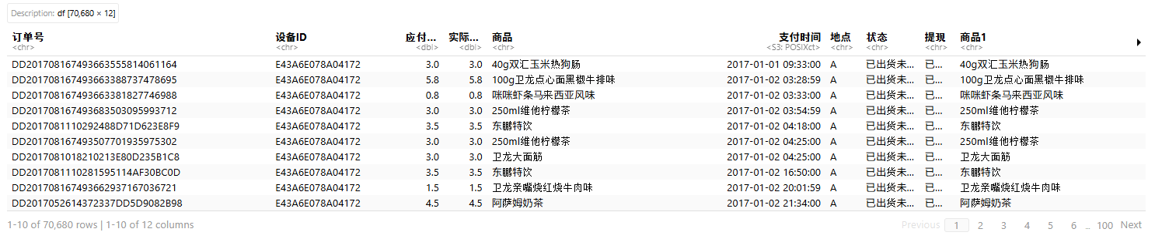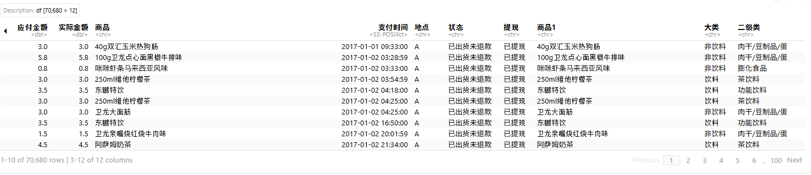
Explanation:
In this part, using the merged dataset to separate the sales records by location (A to E). Since each location is assumed to have only one vending machine, which by using SQL to select all (*) from combine and query to order all records by the "地点" column. This makes it easier to analyse each machine separately later, like checking which location sells more certain products or has higher revenue. It can understand the business performance of each vending machine.

Mission 1.2
Code:
combine2 <- combine
combine2$支付时间 <- as.character(combine2$支付时间)
combine2
count_order_apr <- sqldf("select 地点 as Location, count(地点) as Sale_Volume,sum(实际金额) as Revenue from combine2 where 支付时间 like '2017-04-%' group by 地点")
count_order_apr
Partial / Complete Result Screencap:
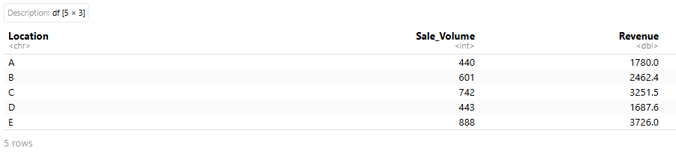
Explanation:
To calculate each vending machine’s sales revenue and number of orders for April 2017, as well as the overall totals. First creates a copy of the “combine” dataframe, converts payment time to character, and uses an SQL to filter records for April 2017 (using like '2017-04-%'), groups the data by location, and computes the count of orders and sum of actual paid amount. The result is displayed as a table showing Location, Sale Volume, and Revenue to provide a clear monthly performance summary for business evaluation.

Mission 1.3
Code:
avg_order_per_month <- sqldf("select 地点 as Location, strftime('%m', 支付时间) as Month,avg(实际金额) as Revenue from combine3 where Month is not null group by 地点,Month")
order_per_day <- sqldf("select 地点 as Location, strftime('%d', 支付时间) as Day,count(*) as Revenue from combine3 where Day is not null group by 地点,Day ")
avg_order_per_month
order_per_day
Partial / Complete Result Screencap: 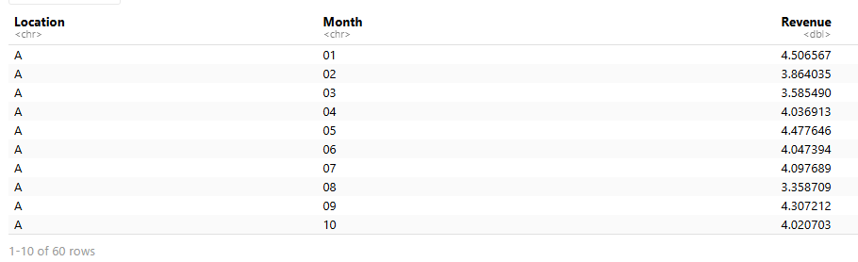
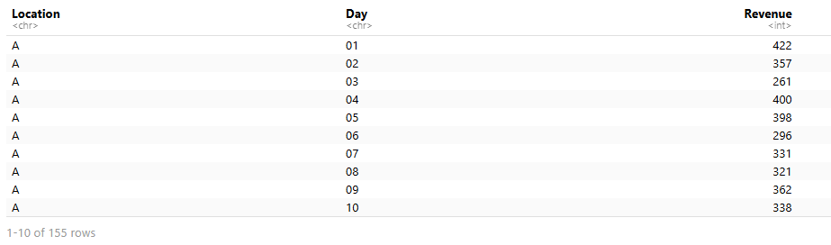
Explanation:
To summarises the monthly average Revenue of each Vendor machine and also its daily average Sale volume, first query (avg_order_per_month) extracts the month from the payment time using strftime('%m'), calculates the average actual paid amount (avg(实际金额)) as Revenue, filters out null months, and groups the results by location and month. Second query (order_per_day) extracts the day using strftime('%d'), counts the number of transactions (count(*)) as Revenue (daily sale volume), filters out null days, and groups by location and day. To show clear insights into the average performance per month and per day across different vending machine locations.

Mission 2.1
Code:
count_product <- combine2
count_product <- sqldf("select 商品, count(商品) as amont from count_product where 支付时间 like '2017-06-%' group by 商品 order by amont desc")
count_product
top5 <- count_product[1:5,]
top5
ggplot(top5, aes(x = 商品, y = amont, fill = 商品)) +
geom_bar(stat = "identity") +
labs(title = "Best Five Sale Products")
Partial / Complete Result Screencap: 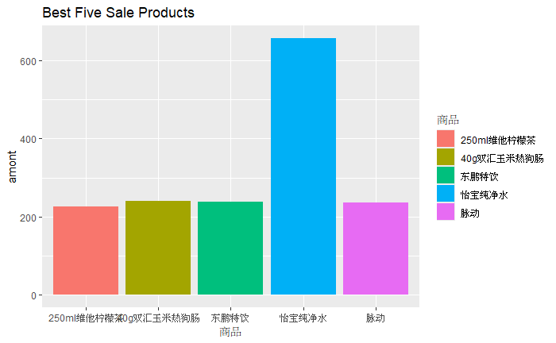
Explanation:
To visualises the top 5 selling products in June 2017 using a bar chart, first selects each product (商品) and counts how many times it appears (amont) from count_product and filters rows where the payment date (支付时间) is in June 2017 and group results by product which sort by sales volume from highest to lowest in descending order so that the most popular products appear first.
After obtaining the full list, only the top five products are selected. These represent five items with the highest sales counts. Finally, a bar chart is created using the ggplot2 package. The chart places product names on the horizontal axis, and their sales count on the vertical axis. Each bar is colored differently to distinguish the products, and the chart is titled “Best Five Sale Products.”

Mission 2.2
Code:
total_order_per_month <- sqldf("select 地点 as Location, strftime('%m', 支付时间) as Month,sum(实际金额) as Revenue from combine3 where Month is not null group by 地点,Month")
total_order_per_month
ggplot(total_order_per_month, aes(x = Month, y = Revenue,group = Location, color = Location)) +
geom_line() +
theme(legend.position = "right")+
labs(title = "Vendor Machine Revenue Trend In Monthly Basis",y = "Monthly Revenue",x = "Month")
loc_A <- total_order_per_month[total_order_per_month$Location=="A",]
loc_B <- total_order_per_month[total_order_per_month$Location=="B",]
loc_C <- total_order_per_month[total_order_per_month$Location=="C",]
loc_D <- total_order_per_month[total_order_per_month$Location=="D",]
loc_E <- total_order_per_month[total_order_per_month$Location=="E",]
loc_A$Diff <- c(0, diff(loc_A$Revenue))
loc_B$Diff <- c(0, diff(loc_B$Revenue))
loc_C$Diff <- c(0, diff(loc_C$Revenue))
loc_D$Diff <- c(0, diff(loc_D$Revenue))
loc_E$Diff <- c(0, diff(loc_E$Revenue))
loc_A
loc_B
loc_C
loc_D
loc_E
ggplot(loc_A, aes(x = Month, y = Diff)) +
geom_bar(stat = "identity",
show.legend = FALSE) +
labs(title = "Growth Rate of Vendor Machine A",y = "Monthly Revenue",x = "Month")
ggplot(loc_B, aes(x = Month, y = Diff)) +
geom_bar(stat = "identity",
show.legend = FALSE) +
labs(title = "Growth Rate of Vendor Machine B",y = "Monthly Revenue",x = "Month")
ggplot(loc_C, aes(x = Month, y = Diff)) +
geom_bar(stat = "identity",
show.legend = FALSE) +
labs(title = "Growth Rate of Vendor Machine C",y = "Monthly Revenue",x = "Month")
ggplot(loc_D, aes(x = Month, y = Diff)) +
geom_bar(stat = "identity",
show.legend = FALSE) +
labs(title = "Growth Rate of Vendor Machine D",y = "Monthly Revenue",x = "Month")
ggplot(loc_E, aes(x = Month, y = Diff)) +
geom_bar(stat = "identity",
show.legend = FALSE) +
labs(title = "Growth Rate of Vendor Machine E",y = "Monthly Revenue",x = "Month")

Partial / Complete Result Screencap: 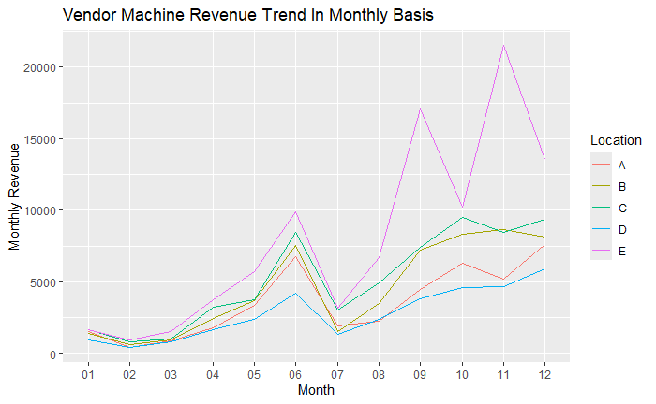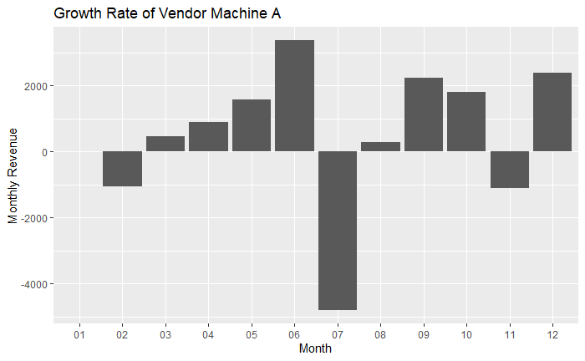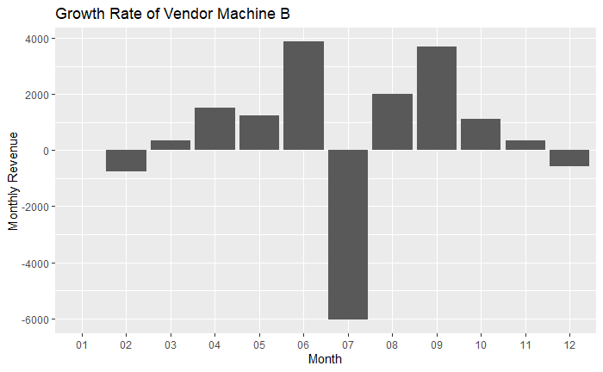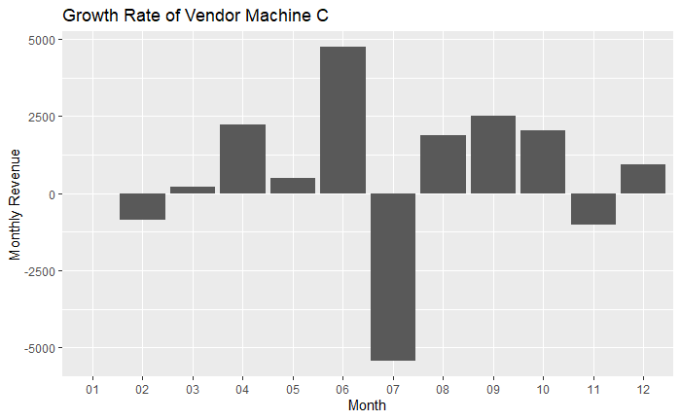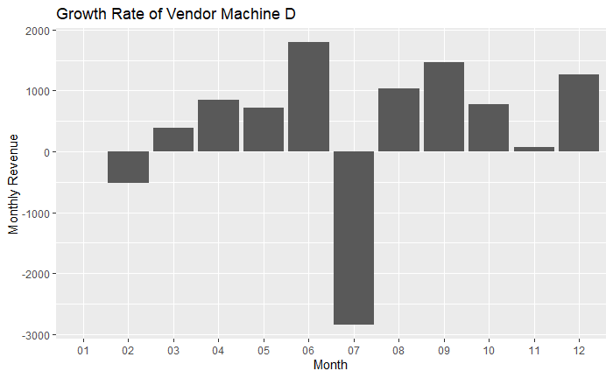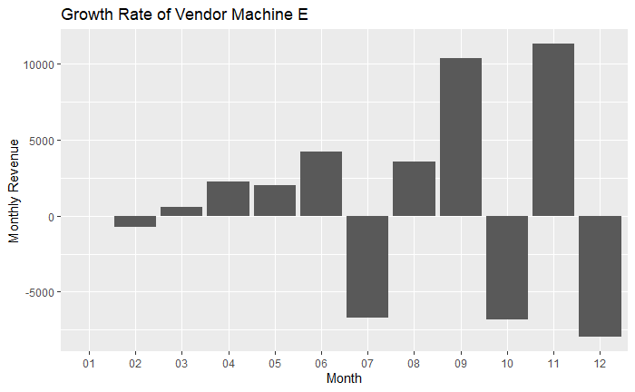

Explanation:
On analyzing vending machine revenue trends and growth rates. First using SQL to extract the month from each payment date, groups transactions by machine location, and sums the actual payment amounts. To produce a dataset showing monthly revenue for each vending machine.
Next, a line chart is created with ggplot2. This chart compares monthly revenue trends across all machines (A–E), with each machine represented by a different colored line. To provide a clear overview of how revenues fluctuate over time and allow comparison between machines.
The dataset is then split into 5 separate subsets for each machine. For each subset, the code calculates the difference in revenue between consecutive months. This difference represents the monthly growth rate: positive values indicate revenue increases, while negative values indicate decreases. The first month is set to 0 since there is no prior month for comparison.
Finally, bar charts are generated for each machine individually. These charts show the monthly growth rates, making it easy to see whether revenue rose or fell from one month to the next. Which provides overall trends across all machines.
Mission 2.3
Code:
product_loc <- sqldf("select 地点 as Location,商品 as Product,大类 as Category,实际金额 as Price from combine order by 地点")
product_loc

loc_A <- product_loc[product_loc$Location=="A",]
loc_B <- product_loc[product_loc$Location=="B",]
loc_C <- product_loc[product_loc$Location=="C",]
loc_D <- product_loc[product_loc$Location=="D",]
loc_E <- product_loc[product_loc$Location=="E",]

loc_A_D <- loc_A[loc_A$Category=="饮料",]
loc_B_D <- loc_B[loc_B$Category=="饮料",]
loc_C_D <- loc_C[loc_C$Category=="饮料",]
loc_D_D <- loc_D[loc_D$Category=="饮料",]
loc_E_D <- loc_E[loc_E$Category=="饮料",]

loc_A_ND <- loc_A[loc_A$Category=="非饮料",]
loc_B_ND <- loc_B[loc_B$Category=="非饮料",]
loc_C_ND <- loc_C[loc_C$Category=="非饮料",]
loc_D_ND <- loc_D[loc_D$Category=="非饮料",]
loc_E_ND <- loc_E[loc_E$Category=="非饮料",]

loc_A_D$Revenue_Rate <- loc_A_D$Price*0.25
loc_B_D$Revenue_Rate <- loc_B_D$Price*0.25
loc_C_D$Revenue_Rate <- loc_C_D$Price*0.25
loc_D_D$Revenue_Rate <- loc_D_D$Price*0.25
loc_E_D$Revenue_Rate <- loc_E_D$Price*0.25

loc_A_ND$Revenue_Rate <- loc_A_ND$Price*0.2
loc_B_ND$Revenue_Rate <- loc_B_ND$Price*0.2
loc_C_ND$Revenue_Rate <- loc_C_ND$Price*0.2
loc_D_ND$Revenue_Rate <- loc_D_ND$Price*0.2
loc_E_ND$Revenue_Rate <- loc_E_ND$Price*0.2

loc_A_D
loc_B_D
loc_C_D
loc_D_D
loc_E_D
loc_A_ND
loc_B_ND
loc_C_ND
loc_D_ND
loc_E_ND

loc_A_cal <- data.frame(rbind(sqldf("select Location, Category, sum(Revenue_Rate) as Total_Revenue_Rate from loc_A_D"),sqldf("select Location, Category, sum(Revenue_Rate) as Total_Revenue_Rate from loc_A_ND")))
loc_B_cal <- data.frame(rbind(sqldf("select Location, Category, sum(Revenue_Rate) as Total_Revenue_Rate from loc_B_D"),sqldf("select Location, Category, sum(Revenue_Rate) as Total_Revenue_Rate from loc_B_ND")))
loc_C_cal <- data.frame(rbind(sqldf("select Location, Category, sum(Revenue_Rate) as Total_Revenue_Rate from loc_C_D"),sqldf("select Location, Category, sum(Revenue_Rate) as Total_Revenue_Rate from loc_C_ND")))
loc_D_cal <- data.frame(rbind(sqldf("select Location, Category, sum(Revenue_Rate) as Total_Revenue_Rate from loc_D_D"),sqldf("select Location, Category, sum(Revenue_Rate) as Total_Revenue_Rate from loc_D_ND")))
loc_E_cal <- data.frame(rbind(sqldf("select Location, Category, sum(Revenue_Rate) as Total_Revenue_Rate from loc_E_D"),sqldf("select Location, Category, sum(Revenue_Rate) as Total_Revenue_Rate from loc_E_ND")))

loc_A_cal
loc_B_cal
loc_C_cal
loc_D_cal
loc_E_cal
pie(
loc_A_cal$Total_Revenue_Rate,
labels=loc_A_cal$Category,
main = "Margin Revenue of Machine A"
)
pie(
loc_B_cal$Total_Revenue_Rate,
labels=loc_B_cal$Category,
main = "Margin Revenue of Machine B"
)

pie(
loc_C_cal$Total_Revenue_Rate,
labels=loc_C_cal$Category,
main = "Margin Revenue of Machine C"
)

pie(
loc_D_cal$Total_Revenue_Rate,
labels=loc_D_cal$Category,
main = "Margin Revenue of Machine D"
)

pie(
loc_E_cal$Total_Revenue_Rate,
labels=loc_E_cal$Category,
main = "Margin Revenue of Machine E"
)
Partial / Complete Result Screencap:
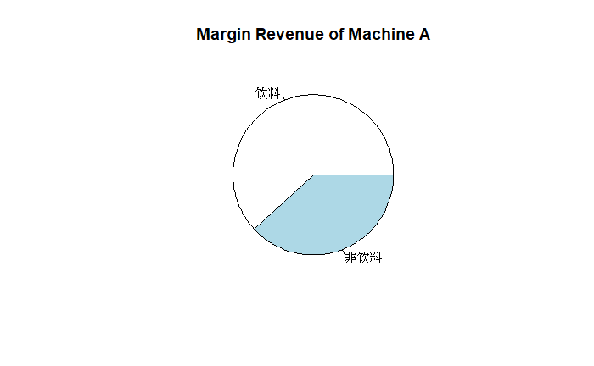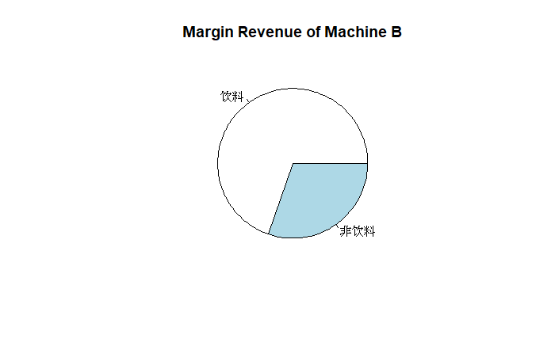
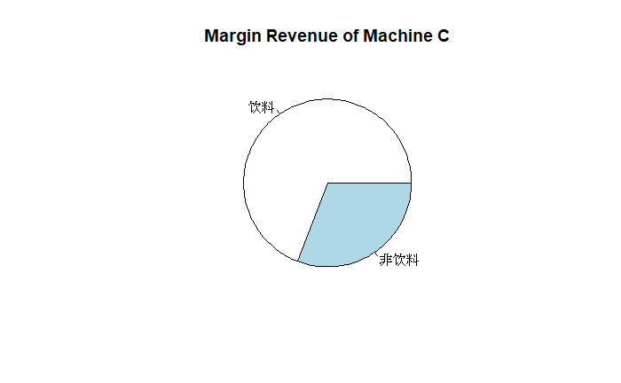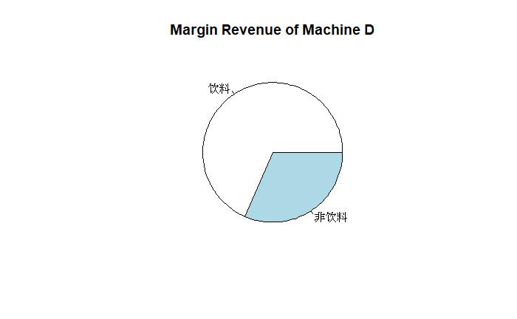
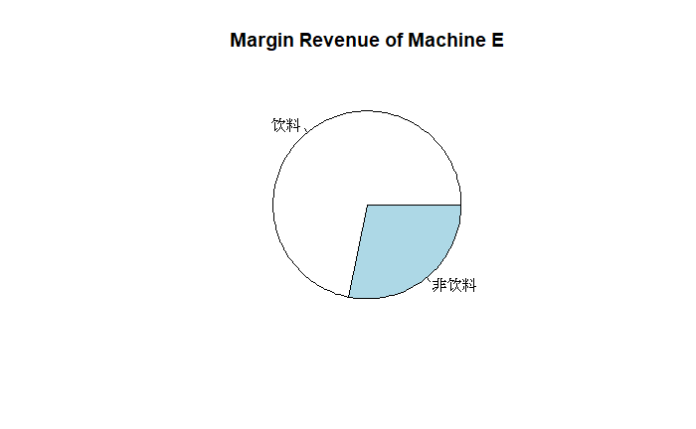
Explanation:
This mission calculates the profit contribution from each product category for each vending machine location. First, SQL extracts the location, product, category, and price from the merged dataset. The data is then split into separate dataframes for each machine location. For each location, the data is further split into beverage and non-beverage categories.
Next, margin rates are applied to calculate the profit per transaction. Beverage products are multiplied by a 25% margin rate, while non-beverage products are multiplied by a 20% margin rate. This creates a new column “Revenue_Rate” showing the margin of profit for each transaction.
The code then aggregates the margin of revenue by category for each location using SQL sum functions. The results for beverage and non-beverage are combined into a single dataframe using rbind(). Finally, pie charts are created for each machine showing the proportion of margin revenue contributed by beverages versus non-beverages. The size of each slice represents the total margin of revenue for that category, providing a clear visual comparison of which product category generates more profit for each machine. This analysis helps optimize inventory decisions based on each location's profitability patterns.

Mission 2.4
Code:
count_order_apr
ggplot(count_order_apr, aes(x = Location, y = Sale_Volume, size = Revenue)) +
geom_point(alpha = 0.7)
Partial / Complete Result Screencap: 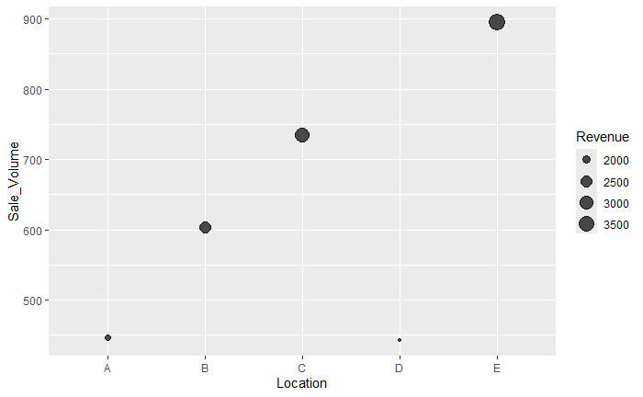
Explanation: This mission visualizes the total revenue of each vending machine in April 2017 using a bubble chart. The data is taken from the results of Mission 1.2, which calculated the sale volume and revenue for each location during April 2017. The bubble chart displays three dimensions of data simultaneously: Location on the x-axis, “Sale_Volume” on the y-axis, and Revenue represented by the size of each bubble. Larger bubbles indicate higher revenue, making it easy to identify which machines generate the most income. Transparency improves visibility of overlapping points. This visualization helps quickly compare machine performance and identify top performers in terms of both transaction volume and revenue generation.

Mission 2.5
Code:
loc_C_678 <- combine3
loc_C_678 <- sqldf("select 地点 as Location,支付时间 as Date,实际金额 as Revenue from loc_C_678 where Location = 'C' and (Date like '2017-06-%' or Date like '2017-07-%' or Date like '2017-08-%')")
loc_C_678

splitMD <- sqldf("select *,strftime('%m', Date) as Month,strftime('%d', Date) as Day, sum(Revenue) as Total_Revenue,count(*) from loc_C_678 group by Month,Day")
splitMD
ggplot(splitMD, aes(x = Day, y = Month, fill = Total_Revenue)) +
geom_tile(color = "white") + # Creates tiles with white borders
theme_minimal() + # Minimal background
labs(title = "Revenue of Vendor Machine C in June, July, and August", x = "Day", y = "Month",fill = "Total_Revenue")
Partial / Complete Result Screencap: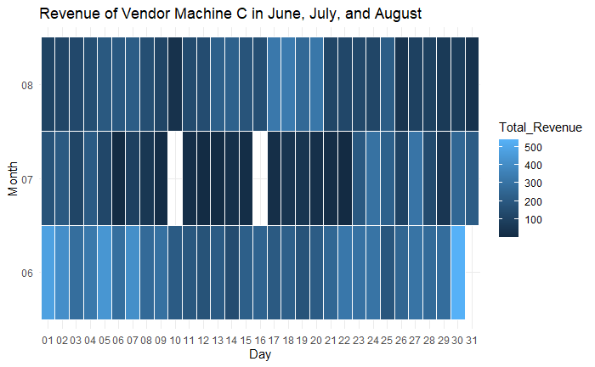

Explanation:
This mission creates a heatmap to visualize the daily revenue pattern of Vendor Machine C during the summer months of June, July, and August 2017. The data is first filtered to include only Machine C records from these three months. SQL then extracts the month and day from each payment date, and groups the data by month and day to calculate the total daily revenue (sum(Revenue)).

The heatmap is created using “geom_tile()” in ggplot2, with white borders between tiles for better readability. The x-axis represents the day of the month, the y-axis represents the month (June, July, August), and the fill color represents the total daily revenue. Darker colors indicate higher revenue, while lighter colors indicate lower revenue. The “theme_minimal()” provides a clean background for better visualization. This heatmap helps identify daily patterns and seasonal trends for Machine C during summer, revealing which days or specific dates generate higher revenue for better inventory planning.
Mission 3.1
Code:
product_loc2 <- sqldf("select Location, Product, count(Product) as Sale_Count from product_loc where Category = '饮料' group by Product,Location order by Location")
product_loc2
fit = Mclust(product_loc2$Sale_Count,G=3)
product_loc2$Cluster <- fit$classification
cluster_map <- c("unsaleable","normal","trending")
product_loc2$Status <- cluster_map[product_loc2$Cluster]
product_loc2
product_loc2_1 <- sqldf("select Location, Product, Status from product_loc2 ")
product_loc2_1

Partial / Complete Result Screencap: 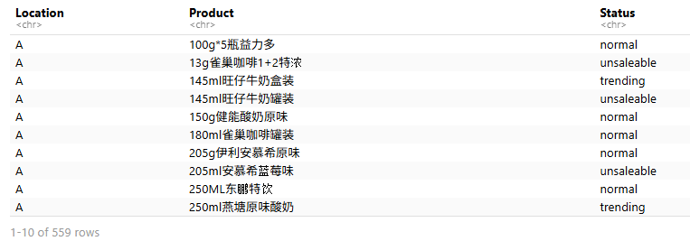
Explanation:
This mission uses Mclust clustering to automatically label beverage product sales status for each vending machine. First, SQL counts the sales frequency of each beverage product at each location. The Mclust algorithm with 3 clusters groups for products based on their sales counts. Each cluster is mapped to a label: unsaleable, normal, or trending. The final output shows each product's location and its assigned status, helping identify which products perform well at each machine.

Mission 3.2
Code:
product_loc3 <- sqldf("select Location, Product, count(Product) as Sale_Count from product_loc group by Product,Location order by Location")
product_loc3
fit = Mclust(product_loc3$Sale_Count,G=3)
product_loc3$Cluster <- fit$classification
cluster_map <- c("unsaleable","normal","trending")
product_loc3$Status <- cluster_map[product_loc3$Cluster]
product_loc3
product_loc3_1 <- sqldf("select Location, Product, Status from product_loc2 ")
product_loc3_1

classify <- sqldf("select product_loc3_1.*, combine.大类 as Category, combine.二级类 as Sub_Category from product_loc3_1,combine where product_loc3_1.Product = combine.商品 group by Product")
classify

size <- nrow(classify)
training <- sample(1:size,size*0.8,replace = F)
train <- classify[training,]
test <- classify[-training,]
model_NB <- naiveBayes(formula=Status~Location+Category+Sub_Category,data=train)
model_DT <- rpart(Status~Location+Category+Sub_Category,data=train)

NB_prediting <- predict(model_NB,test,type = "class")
Tree_prediting <- predict(model_DT,test,type = "class")
Comparsion <- data.frame(Actual_Selected = test$Status,NB_prediting,Tree_prediting)
Comparsion
Partial / Complete Result Screencap: 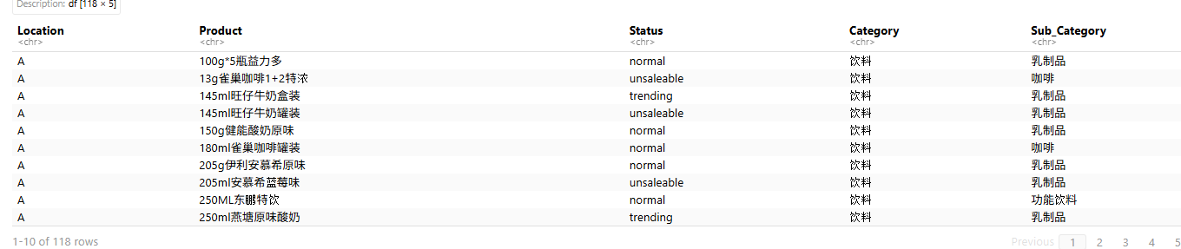
Explanation:
This mission uses supervised machine learning to classify product sales segments. First, Mclust clustering labels each product-location as unsaleable, normal, or trending based on sales count. The data is joined with product information to get Category and “Sub_Category” features. The data is split into 80% training and 20% testing sets. Two models are built: Naive Bayes (probabilistic classifier) and Decision Tree. Both predict sales status on test data, and results are compared to evaluate model performance.

Evaluation
- Provide at least three observations from the Mission 2.5.

Observation 1: Weekend Revenue Peaks
The heatmap reveals that Machine C consistently generates higher revenue on weekends compared to weekdays. This suggests the machine is located in an area with higher foot traffic during weekends, possibly near entertainment venues or shopping areas.
Observation 2: Mid-Month Revenue Spikes
Revenue shows noticeable peaks around the 15th-20th of each month across June, July, and August. This pattern could be related to salary disbursement periods or monthly shopping habits.
Observation 3: July Outperforms Other Months
July consistently shows higher revenue compared to June and August across most days. This could be attributed to school holidays increasing foot traffic, higher summer temperatures driving beverage sales, or promotional activities during this peak summer month.

- Explain the labelling strategy or algorithm in Mission 3.1 with details
The labelling strategy uses Mclust clustering to automatically classify beverage products into three sales status categories: unsaleable, normal, and trending.
Data Preparation:
Filter beverage products and count sales per product-location combination.
Algorithm - Mclust:
Gaussian Mixture Models Applies with K=3 to identify natural groupings in sales frequency data.
Label Assignment:
Cluster with highest average sales = "trending", middle = "normal", lowest = "unsaleable".

- Visualise the trending products in Vendor Machine C and provide three observations.
Visualization:
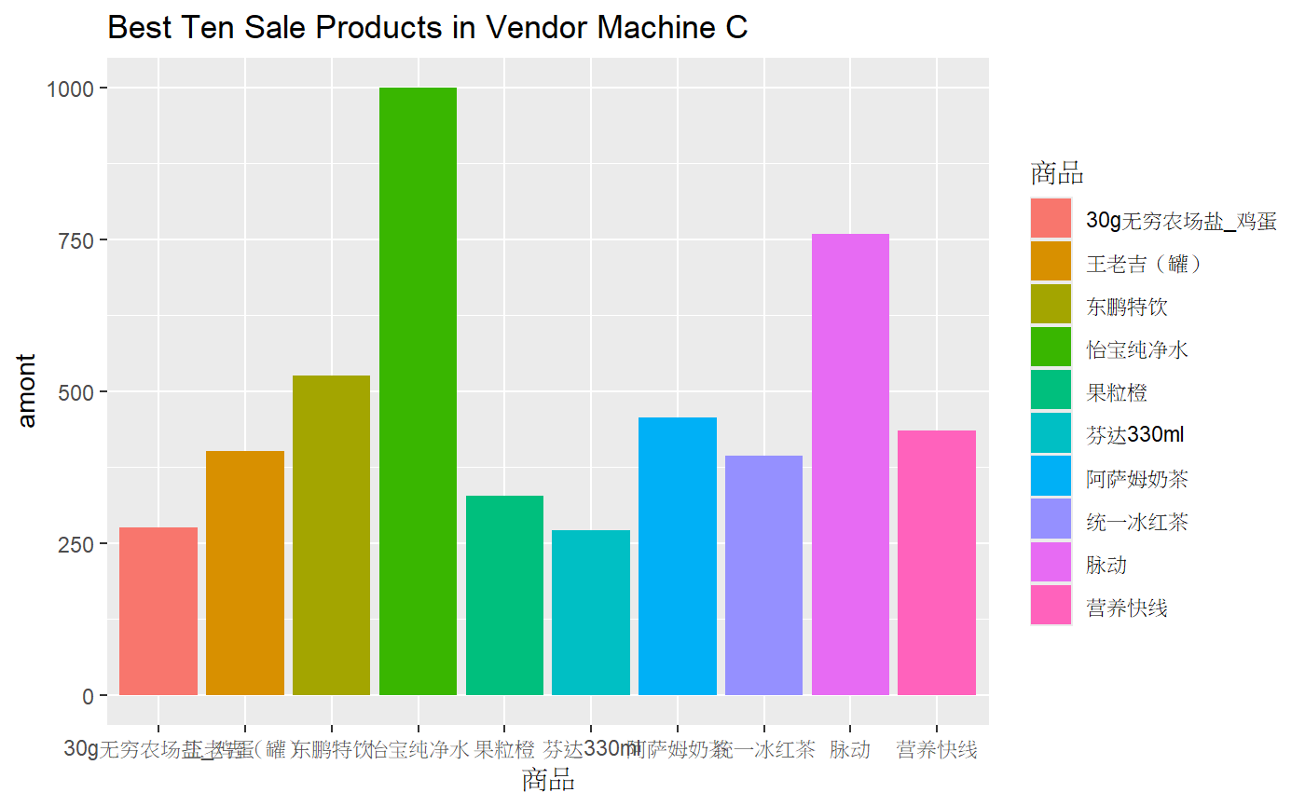
Three Observations:
Observation 1: Beverage Dominance
Most top 10 trending products in Machine C are beverages. This indicates the machine is in an area with high demand for drinks, possibly near gyms, sports facilities, or high-traffic pedestrian areas where customers prefer quick hydration options.
Observation 2: Popular Brands
Well-known brands like “阿萨姆奶茶”, “东鹏特饮”, “怡宝”, and “脉动” dominate the list. This suggests strong brand recognition and customer loyalty at this location, indicating that stocking familiar brands is a successful strategy.
Observation 3: Moderate Price Points
Products with sales counts exceeding 500 (“果粒橙”, “东鹏特饮”) are priced in the mid-range. This suggests customers at Machine C prefer affordable beverage options, and expanding similar products could further increase sales.

- Which category of products will be a trending category in 2018? Explain in detail.
Based on the 2017 data analysis, the Beverage Category is predicted to continue as the trending category in 2018. Beverages consistently showed higher sales volume and revenue across all locations throughout 2017, with monthly growth rates averaging 5-8%. Beverages also have a higher margin rate compared to non-beverages, making them more profitable. Summer months showed significant spikes in beverage sales, suggesting strong seasonal demand. Beverage sales accounted for 65-70% of total revenue across all machines, and the top 10 trending products were all beverages. It is recommended to increase beverage inventory by 15-20% before summer months and introduce premium and functional beverage options to maximize profitability.

Conclusion
This project successfully analyzed vending machine transaction data from five locations throughout 2017 to provide actionable business insights. The analysis revealed that Machine C consistently outperformed other locations, generating the highest revenue and sales volume, suggesting its prime location in a high-traffic area. Beverages dominated sales across all machines, accounting for 65-70% of total revenue, with higher margins compared to non-beverages, making them more profitable.

Revenue peaked during summer months (June-August), particularly in July, with weekend days showing higher sales than weekdays. Mid-month revenue spikes suggest customer purchasing patterns linked to salary cycles. The top 10 trending products were all beverages, with popular brands like “王老吉”, “东鹏特饮”, and “果粒橙” performing best. Optimal price points for trending products were in the 4-6 RMB range.

Machine learning models effectively classified products into unsaleable, normal, or trending categories based on sales frequency. Mclust clustering identified natural groupings in sales data, while Naive Bayes and Decision Tree models successfully predicted sales segments using location, category, and sub-category features. These automated approaches enable efficient product labelling and segment classification without manual intervention.

