# La Palma Earthquakes

Steve Purves and Rowan Cockett

Curvenote

# Author Note

Steve Purves  <https://orcid.org/0000-0002-0760-5497>

Rowan Cockett  <https://orcid.org/0000-0002-7859-8394>

Author roles were classified using the Contributor Role Taxonomy (CRediT; https://credit.niso.org/) as follows: *Steve Purves***:** investigation, project administration, software, and visualization

Correspondence concerning this article should be addressed to Steve Purves, Curvenote, Email: [steve@curvenote.com](mailto:steve@curvenote.com)

# Abstract

*Keywords*: La Palma, Earthquakes

# La Palma Earthquakes

## 0.1 Introduction

Source: [Article Notebook](https://isaactpetersen.github.io/manuscript-template-rstudio-TEST/index.qmd.html)

Source: [Article Notebook](https://isaactpetersen.github.io/manuscript-template-rstudio-TEST/index.qmd.html)

Based on data up to and including 1971, eruptions on La Palma happen every 79.8 years on average.

Studies of the magma systems feeding the volcano, such as Marrero et al. (2019), have proposed that there are two main magma reservoirs feeding the Cumbre Vieja volcano; one in the mantle (30-40km depth) which charges and in turn feeds a shallower crustal reservoir (10-20km depth).

Eight eruptions have been recorded since the late 1400s (Figure 1).

Data and methods are discussed in Section 0.2.

Let denote the number of eruptions in a year. Then, can be modeled by a Poisson distribution

where is the rate of eruptions per year. Using Equation 1, the probability of an eruption in the next years can be calculated.

Table 1 summarises the eruptions recorded since the colonization of the islands by Europeans in the late 1400s.

La Palma is one of the west most islands in the Volcanic Archipelago of the Canary Islands (Figure 2).

Figure 3 shows the location of recent Earthquakes on La Palma.

## 0.2 Data & Methods

## 0.3 Conclusion

## References

Marrero, J., García, A., Berrocoso, M., Llinares, Á., Rodríguez-Losada, A., & Ortiz, R. (2019). Strategies for the development of volcanic hazard maps in monogenetic volcanic fields: The example of La Palma (Canary Islands). *Journal of Applied Volcanology*, *8*. <https://doi.org/10.1186/s13617-019-0085-5>

Table 1

Recent historic eruptions on La Palma

| Name | Year |
| --- | --- |
| Current | 2021 |
| Teneguía | 1971 |
| Nambroque | 1949 |
| El Charco | 1712 |
| Volcán San Antonio | 1677 |
| Volcán San Martin | 1646 |
| Tajuya near El Paso | 1585 |
| Montaña Quemada | 1492 |

Figure 1

Timeline of recent earthquakes on La Palma

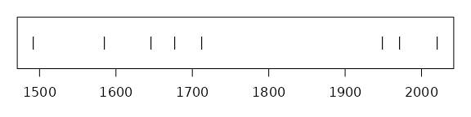

Source: [Article Notebook](https://isaactpetersen.github.io/manuscript-template-rstudio-TEST/index.qmd.html)

Figure 2

Map of La Palma

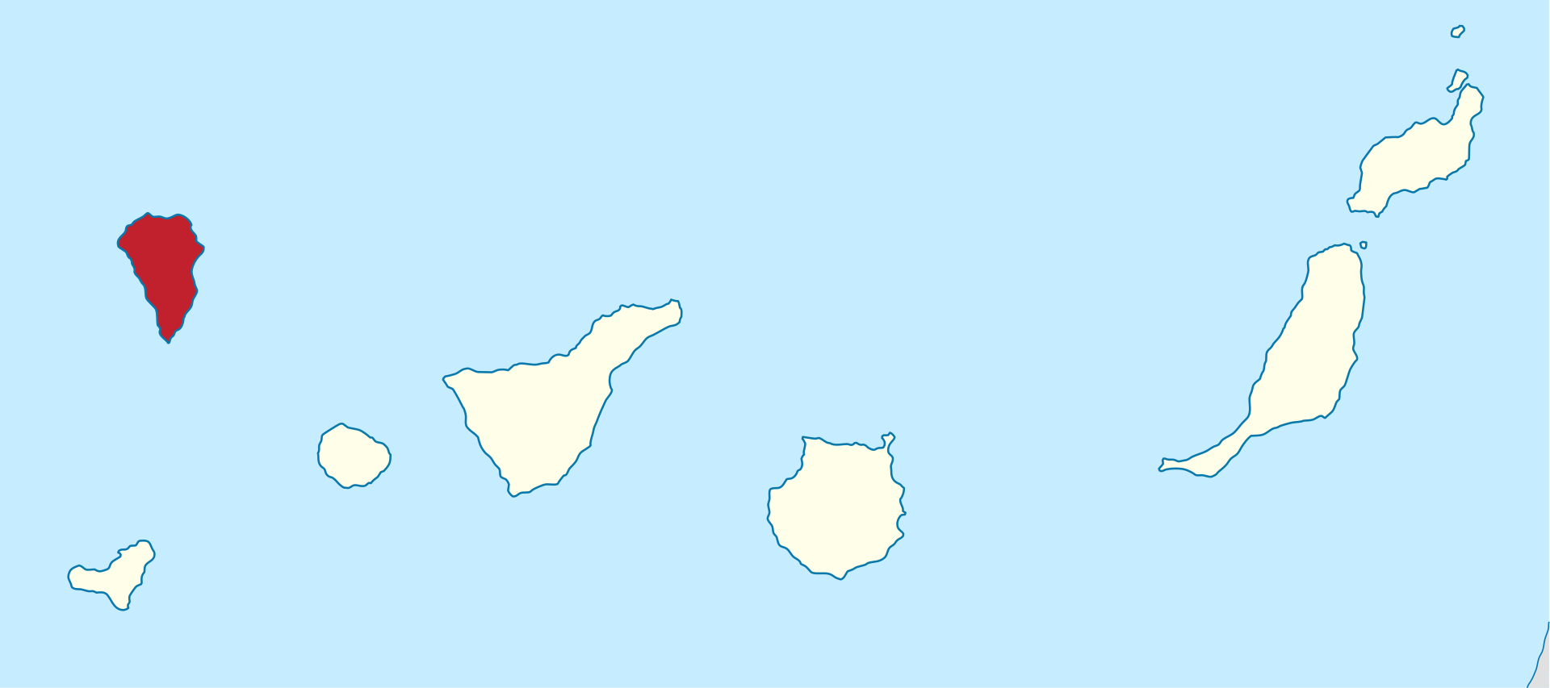

Figure 3

Locations of earthquakes on La Palma since 2017

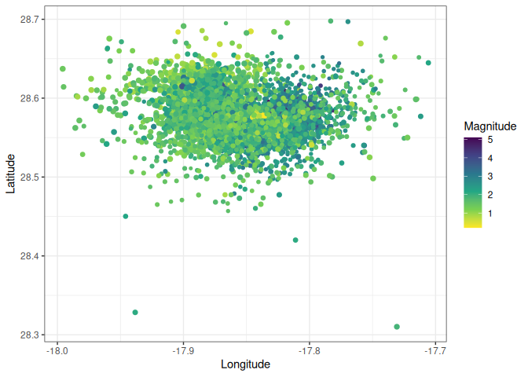

Source: [Explore Earthquakes](https://isaactpetersen.github.io/manuscript-template-rstudio-TEST/notebooks/explore-earthquakes.qmd.html#cell-fig-spatial-plot)