Point-in-Time Survival Model for Mortgage Portfolio Risk Management
Gaurav Law & Isaac Vergara
2025-12-05

Executive Summary
This analysis builds a point-in-time survival model for predicting mortgage delinquency in an existing loan portfolio. The model uses current loan characteristics as of October 2025 to predict future default risk.
Use Case: Portfolio risk management - “Given what we know about loans today, which are most likely to default in the coming months?”
library(tidyverse)
library(ggplot2)
library(ggfortify)
library(pROC)
library(GGally)
library(janitor)
library(broom)
library(xgboost)
library(gt)
library(gtExtras)
library(caret)
library(reshape2)
library(arrow)
library(survminer)
library(survival)
library(lubridate)
library(Hmisc) # For C-index calculation

Data Loading and Survival Preparation
scores <- read_parquet("data/merged_data.parquet") %>%
as_tibble() %>%
mutate(
# Duration: time at risk (Loan Age in months)
duration = `Loan Age`,
# Event: 1 = seriously delinquent (90+ days), 0 = censored
event = case_when(
as.numeric(`Current Loan Delinquency Status`) >= 3 ~ 1,
`Zero Balance Code` %in% c('01') ~ 0,
TRUE ~ 0
),
Delinquency_Status = ifelse(`Current Loan Delinquency Status` == 0, 0, 1)
) %>%
filter(!`Zero Balance Code` %in% c('02', '03', '09')) %>%
filter(duration > 0)
cat("Portfolio Snapshot (October 2025)\n")
## Portfolio Snapshot (October 2025)
cat("Total loans:", nrow(scores), "\n")
## Total loans: 1110838
cat("Events (delinquent 90+ days):", sum(scores$event), "\n")
## Events (delinquent 90+ days): 6980
cat("Event rate:", round(mean(scores$event) * 100, 2), "%\n\n")
## Event rate: 0.63 %

Feature Engineering
# Find numeric columns - first pass
num_df <- scores %>%
select(where(is.numeric))
# Remove constant columns (sd = 0 or all NA)
num_df <- num_df %>%
select(where(function(x) {
sd_val <- sd(x, na.rm = TRUE)
!is.na(sd_val) && sd_val != 0
})) %>%
drop_na('Current Interest Rate')
# Filter columns with excessive missing values
num_df <- num_df %>%
select(where(~ sum(is.na(.x)) <= 1000000))
# Manual high null value removals
high_null_vars <- c(
"Mortgage Insurance Percentage",
"Co-Borrower Credit Score Current",
"Co-Borrower Credit Score at Issuance",
"Mortgage Insurance Type",
"Co-Borrower Credit Score at Origination",
"Co-Borrower Credit Score At Issuance",
"Cumulative Credit Event Net Gain or Loss",
"loan_identifier",
"vs4_current_method",
"vs4_bimerge_lowest",
"vs4_bimerge_highest",
"vs4_bimerge_median",
"Borrower Credit Score At Issuance",
"Borrower Credit Score Current ",
"Metropolitan Statistical Area (MSA)"
)
num_df <- num_df[!names(num_df) %in% high_null_vars] %>%
drop_na()
# Remove multicollinear variables
multicollinear_vars <- c(
"Interest Bearing UPB",
"Current Interest Rate",
"Interest Rate UPB",
"Current Actual UPB",
"UPB at Issuance",
"Original Combined Loan to Value Ratio (CLTV)",
"Current Loan Delinquency Status"
)
num_df <- num_df[!names(num_df) %in% multicollinear_vars]
# Remove time-redundant variables
time_redundant_vars <- c(
"Remaining Months to Legal Maturity",
"Origination Date",
"Maturity Date",
"First Payment Date"
)
num_df <- num_df[!names(num_df) %in% time_redundant_vars]
# Add survival variables back
num_df <- num_df %>%
mutate(
duration = scores$duration[match(num_df$`Loan Identifier`, scores$`Loan Identifier`)],
event = scores$event[match(num_df$`Loan Identifier`, scores$`Loan Identifier`)],
Delinquency_Status = scores$Delinquency_Status[match(num_df$`Loan Identifier`, scores$`Loan Identifier`)]
)
# Add categorical features
categorical_data <- scores %>%
select('Loan Identifier',
'Property Type',
'Occupancy Status',
'Amortization Type',
'Modification Flag',
'Interest Only Loan Indicator')
num_df <- num_df %>%
left_join(categorical_data, by = "Loan Identifier") %>%
mutate(
# Create dummy variables
is_cashout_refi = ifelse('Loan Purpose' == 'C', 1, 0),
is_investor = ifelse('Occupancy Status' == 'I', 1, 0),
is_condo = ifelse('Property Type' == 'CO', 1, 0),
is_arm = ifelse('Amortization Type' == 'ARM', 1, 0),
has_modification = ifelse('Modification Flag' == 'Y', 1, 0),
is_interest_only = ifelse('Interest Only Loan Indicator' == 'Y', 1, 0)
)
cat("Final feature count:", ncol(num_df) - 5, "\n")
## Final feature count: 25

Train/Test Split
set.seed(123)
# Define features (exclude identifiers and targets)
exclude_vars <- c(
"Loan Identifier",
"Reference Pool ID",
"Zip Code Short",
"duration",
"event",
"Delinquency_Status",
# Exclude the raw categorical variables (we have dummies)
"Loan Purpose",
"Property Type",
"Occupancy Status",
"Amortization Type",
"Modification Flag",
"Interest Only Loan Indicator"
)
features <- setdiff(names(num_df), exclude_vars)
# Split
trainIndex <- sample(1:nrow(num_df), 0.8 * nrow(num_df))
train_data <- num_df[trainIndex, ]
test_data <- num_df[-trainIndex, ]
cat("Training set:", nrow(train_data), "loans\n")
## Training set: 882654 loans
cat("Test set:", nrow(test_data), "loans\n")
## Test set: 220664 loans
cat("Training event rate:", round(mean(train_data$event) * 100, 2), "%\n")
## Training event rate: 0.57 %
cat("Test event rate:", round(mean(test_data$event) * 100, 2), "%\n")
## Test event rate: 0.55 %
cat("Features used:", length(features), "\n\n")
## Features used: 19

Model 1: Baseline Cox Proportional Hazards
# Clean feature names by wrapping them in backticks
features_clean <- paste0("`", features, "`")
# Create formula with backticked names
cox_formula <- as.formula(paste("Surv(duration, event) ~",
paste(features_clean, collapse = " + ")))
# Fit Cox model
cat("Fitting baseline Cox model...\n")
## Fitting baseline Cox model...
cox_model <- coxph(
cox_formula,
data = train_data,
model = TRUE
)
# Extract key metrics
cox_concordance <- summary(cox_model)$concordance[1]
cat("\n===========================================\n")
##
## ===========================================
cat("Cox Model C-index (Training):", round(cox_concordance, 4), "\n")
## Cox Model C-index (Training): 0.9951
cat("===========================================\n")
## ===========================================

Model 1: Cox Model Evaluation on Test Set
# Predict on test set
test_data$cox_risk_score <- predict(cox_model, newdata = test_data, type = "risk")
test_data$cox_lp <- predict(cox_model, newdata = test_data, type = "lp")
# Calculate C-index using Harrell's concordance
cox_test_cindex_val <- rcorr.cens(-test_data$cox_lp,
Surv(test_data$duration, test_data$event))
cat("\n===========================================\n")
##
## ===========================================
cat("Cox Model C-index (Test):", round(cox_test_cindex_val["C Index"], 4), "\n")
## Cox Model C-index (Test): 0.9956
cat("Standard Error:", round(cox_test_cindex_val["S.D."]/2, 4), "\n")
## Standard Error: 4e-04
cat("===========================================\n")
## ===========================================
# Store for later
cox_test_cindex <- list(
c.index = as.numeric(cox_test_cindex_val["C Index"]),
se = as.numeric(cox_test_cindex_val["S.D."]/2)
)

Model 1: Cox Feature Importance
# Extract coefficients and significance
cox_coefs <- broom::tidy(cox_model) %>%
mutate(
abs_estimate = abs(estimate),
significance = case_when(
p.value < 0.001 ~ "***",
p.value < 0.01 ~ "**",
p.value < 0.05 ~ "*",
TRUE ~ ""
),
direction = ifelse(estimate > 0, "Increases Risk", "Decreases Risk")
) %>%
arrange(desc(abs_estimate)) %>%
slice_head(n = 20)
# Plot top 20 coefficients
cox_coefs %>%
ggplot(aes(x = reorder(term, abs_estimate), y = estimate,
fill = direction)) +
geom_col() +
coord_flip() +
scale_fill_manual(values = c("Increases Risk" = "coral",
"Decreases Risk" = "steelblue")) +
labs(
title = "Cox Model: Top 20 Features by Coefficient Magnitude",
subtitle = "Point-in-Time Model - Portfolio Risk Management",
x = "",
y = "Log Hazard Ratio",
fill = ""
) +
theme_minimal() +
theme(legend.position = "bottom")
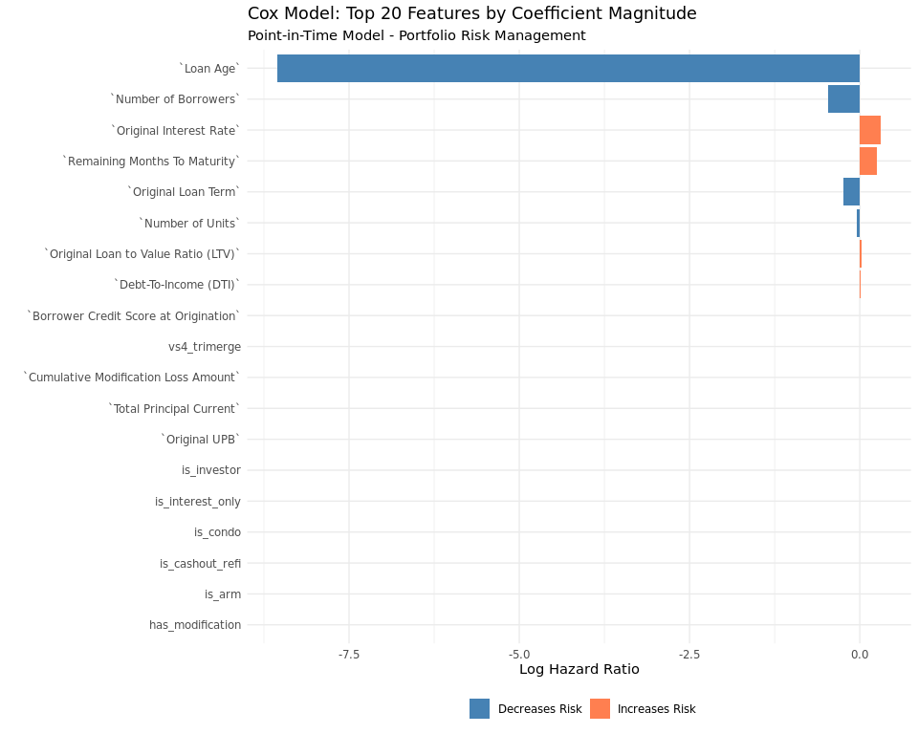

Model 2: XGBoost on Cox Residuals
# Calculate Cox residuals
train_data$cox_deviance <- residuals(cox_model, type = "deviance")
# Clean the data
train_clean <- train_data %>%
filter(is.finite(cox_deviance)) %>%
filter(!is.na(cox_deviance))
cat("Training samples:", nrow(train_clean), "\n\n")
## Training samples: 882649
dtrain <- xgb.DMatrix(
data = as.matrix(train_clean[, features]),
label = train_clean$cox_deviance
)
dtest <- xgb.DMatrix(
data = as.matrix(test_data[, features])
)
# XGBoost parameters
xgb_params <- list(
objective = "reg:squarederror",
eta = 0.05,
max_depth = 6,
subsample = 0.8,
colsample_bytree = 0.8,
min_child_weight = 5,
gamma = 0.1
)
# Cross-validation
# cv_result <- xgb.cv(
# params = xgb_params,
# data = dtrain,
# nrounds = 200,
# nfold = 5,
# early_stopping_rounds = 10,
# verbose = 0
# )
# optimal_rounds <- cv_result$best_iteration
# cat("Optimal rounds:", optimal_rounds, "\n\n")
# Train final model
xgb_residual_model <- xgboost(
params = xgb_params,
data = dtrain,
nrounds = 200,
verbose = 1
)
## [1] train-rmse:0.571656
## [2] train-rmse:0.546175
## [3] train-rmse:0.521161
## [4] train-rmse:0.497450
## [5] train-rmse:0.475528
## [6] train-rmse:0.455208
## [7] train-rmse:0.436049
## [8] train-rmse:0.418024
## [9] train-rmse:0.399910
## [10] train-rmse:0.383901
## [11] train-rmse:0.367619
## [12] train-rmse:0.353423
## [13] train-rmse:0.340007
## [14] train-rmse:0.327007
## [15] train-rmse:0.314208
## [16] train-rmse:0.302138
## [17] train-rmse:0.291911
## [18] train-rmse:0.280966
## [19] train-rmse:0.271396
## [20] train-rmse:0.261760
## [21] train-rmse:0.252744
## [22] train-rmse:0.244182
## [23] train-rmse:0.237072
## [24] train-rmse:0.230167
## [25] train-rmse:0.224081
## [26] train-rmse:0.217324
## [27] train-rmse:0.211339
## [28] train-rmse:0.206616
## [29] train-rmse:0.202089
## [30] train-rmse:0.196695
## [31] train-rmse:0.192881
## [32] train-rmse:0.189107
## [33] train-rmse:0.185866
## [34] train-rmse:0.182776
## [35] train-rmse:0.178882
## [36] train-rmse:0.176348
## [37] train-rmse:0.172938
## [38] train-rmse:0.170805
## [39] train-rmse:0.168098
## [40] train-rmse:0.165377
## [41] train-rmse:0.162841
## [42] train-rmse:0.161219
## [43] train-rmse:0.159722
## [44] train-rmse:0.157172
## [45] train-rmse:0.155890
## [46] train-rmse:0.154817
## [47] train-rmse:0.153018
## [48] train-rmse:0.152151
## [49] train-rmse:0.150559
## [50] train-rmse:0.148774
## [51] train-rmse:0.147174
## [52] train-rmse:0.146532
## [53] train-rmse:0.145465
## [54] train-rmse:0.144158
## [55] train-rmse:0.143669
## [56] train-rmse:0.143083
## [57] train-rmse:0.142067
## [58] train-rmse:0.140986
## [59] train-rmse:0.140135
## [60] train-rmse:0.139788
## [61] train-rmse:0.139372
## [62] train-rmse:0.139072
## [63] train-rmse:0.138782
## [64] train-rmse:0.138551
## [65] train-rmse:0.138297
## [66] train-rmse:0.138106
## [67] train-rmse:0.137789
## [68] train-rmse:0.137625
## [69] train-rmse:0.137446
## [70] train-rmse:0.137128
## [71] train-rmse:0.136580
## [72] train-rmse:0.136410
## [73] train-rmse:0.136270
## [74] train-rmse:0.136161
## [75] train-rmse:0.136067
## [76] train-rmse:0.135975
## [77] train-rmse:0.135682
## [78] train-rmse:0.135440
## [79] train-rmse:0.135278
## [80] train-rmse:0.135207
## [81] train-rmse:0.135126
## [82] train-rmse:0.135055
## [83] train-rmse:0.134917
## [84] train-rmse:0.134871
## [85] train-rmse:0.134811
## [86] train-rmse:0.134765
## [87] train-rmse:0.134626
## [88] train-rmse:0.134578
## [89] train-rmse:0.134532
## [90] train-rmse:0.134445
## [91] train-rmse:0.134270
## [92] train-rmse:0.134223
## [93] train-rmse:0.134175
## [94] train-rmse:0.134147
## [95] train-rmse:0.133791
## [96] train-rmse:0.133697
## [97] train-rmse:0.133649
## [98] train-rmse:0.133416
## [99] train-rmse:0.133382
## [100] train-rmse:0.133343
## [101] train-rmse:0.133252
## [102] train-rmse:0.133217
## [103] train-rmse:0.133192
## [104] train-rmse:0.133095
## [105] train-rmse:0.133078
## [106] train-rmse:0.133013
## [107] train-rmse:0.132967
## [108] train-rmse:0.132848
## [109] train-rmse:0.132614
## [110] train-rmse:0.132591
## [111] train-rmse:0.132569
## [112] train-rmse:0.132553
## [113] train-rmse:0.132538
## [114] train-rmse:0.132233
## [115] train-rmse:0.132205
## [116] train-rmse:0.132191
## [117] train-rmse:0.131987
## [118] train-rmse:0.131887
## [119] train-rmse:0.131728
## [120] train-rmse:0.131379
## [121] train-rmse:0.131366
## [122] train-rmse:0.131349
## [123] train-rmse:0.131027
## [124] train-rmse:0.130999
## [125] train-rmse:0.130959
## [126] train-rmse:0.130922
## [127] train-rmse:0.130900
## [128] train-rmse:0.130862
## [129] train-rmse:0.130841
## [130] train-rmse:0.130823
## [131] train-rmse:0.130808
## [132] train-rmse:0.130706
## [133] train-rmse:0.130619
## [134] train-rmse:0.130609
## [135] train-rmse:0.130597
## [136] train-rmse:0.130580
## [137] train-rmse:0.130542
## [138] train-rmse:0.130516
## [139] train-rmse:0.130485
## [140] train-rmse:0.130475
## [141] train-rmse:0.130461
## [142] train-rmse:0.130448
## [143] train-rmse:0.130441
## [144] train-rmse:0.130337
## [145] train-rmse:0.130145
## [146] train-rmse:0.130047
## [147] train-rmse:0.130033
## [148] train-rmse:0.130011
## [149] train-rmse:0.129894
## [150] train-rmse:0.129880
## [151] train-rmse:0.129873
## [152] train-rmse:0.129790
## [153] train-rmse:0.129532
## [154] train-rmse:0.129480
## [155] train-rmse:0.129465
## [156] train-rmse:0.129450
## [157] train-rmse:0.129435
## [158] train-rmse:0.129376
## [159] train-rmse:0.129363
## [160] train-rmse:0.129359
## [161] train-rmse:0.129323
## [162] train-rmse:0.129163
## [163] train-rmse:0.129136
## [164] train-rmse:0.129094
## [165] train-rmse:0.128975
## [166] train-rmse:0.128957
## [167] train-rmse:0.128927
## [168] train-rmse:0.128915
## [169] train-rmse:0.128827
## [170] train-rmse:0.128824
## [171] train-rmse:0.128812
## [172] train-rmse:0.128226
## [173] train-rmse:0.128217
## [174] train-rmse:0.128207
## [175] train-rmse:0.128197
## [176] train-rmse:0.128174
## [177] train-rmse:0.128159
## [178] train-rmse:0.128146
## [179] train-rmse:0.128134
## [180] train-rmse:0.127935
## [181] train-rmse:0.127883
## [182] train-rmse:0.127618
## [183] train-rmse:0.127427
## [184] train-rmse:0.127420
## [185] train-rmse:0.127412
## [186] train-rmse:0.127380
## [187] train-rmse:0.126899
## [188] train-rmse:0.126894
## [189] train-rmse:0.126878
## [190] train-rmse:0.126808
## [191] train-rmse:0.126798
## [192] train-rmse:0.126792
## [193] train-rmse:0.126771
## [194] train-rmse:0.126694
## [195] train-rmse:0.126671
## [196] train-rmse:0.126653
## [197] train-rmse:0.126641
## [198] train-rmse:0.126611
## [199] train-rmse:0.126567
## [200] train-rmse:0.126544
# Predict
test_data$xgb_residual_pred <- predict(xgb_residual_model, dtest)

Model 2: XGBoost Feature Importance
importance_xgb <- xgb.importance(feature_names = features,
model = xgb_residual_model) %>%
as_tibble() %>%
arrange(-Gain) %>%
slice_head(n = 20)
importance_xgb %>%
ggplot(aes(x = reorder(Feature, Gain), y = Gain)) +
geom_col(fill = "coral") +
coord_flip() +
labs(
title = "XGBoost: Feature Importance",
subtitle = "Captures non-linear patterns missed by Cox",
x = "",
y = "Relative Importance (Gain)"
) +
theme_minimal()


Model 3: Hybrid Model
# Combine Cox + XGBoost
test_data$hybrid_risk_score <- test_data$cox_lp + test_data$xgb_residual_pred
# Calculate C-index
hybrid_cindex_val <- rcorr.cens(-test_data$hybrid_risk_score,
Surv(test_data$duration, test_data$event))
cat("\n===========================================\n")
##
## ===========================================
cat("HYBRID Model C-index (Test):", round(hybrid_cindex_val["C Index"], 4), "\n")
## HYBRID Model C-index (Test): 0.9969
cat("Standard Error:", round(hybrid_cindex_val["S.D."]/2, 4), "\n")
## Standard Error: 4e-04
cat("===========================================\n")
## ===========================================
hybrid_cindex <- list(
c.index = as.numeric(hybrid_cindex_val["C Index"]),
se = as.numeric(hybrid_cindex_val["S.D."]/2)
)

Model Comparison
comparison_df <- tibble(
Model = c("Cox Baseline", "Hybrid (Cox + XGBoost)"),
C_Index = c(cox_test_cindex$c.index, hybrid_cindex$c.index),
SE = c(cox_test_cindex$se, hybrid_cindex$se)
) %>%
mutate(
CI_Lower = C_Index - 1.96 * SE,
CI_Upper = C_Index + 1.96 * SE,
Improvement = C_Index - first(C_Index),
Improvement_Pct = (Improvement / first(C_Index)) * 100
)
comparison_df %>%
gt() %>%
fmt_number(columns = c(C_Index, SE, CI_Lower, CI_Upper), decimals = 4) %>%
fmt_number(columns = c(Improvement, Improvement_Pct), decimals = 2) %>%
tab_header(
title = "Point-in-Time Survival Model Performance",
subtitle = "C-index on Test Set"
) %>%
tab_style(
style = cell_fill(color = "lightgreen"),
locations = cells_body(
columns = C_Index,
rows = C_Index == max(C_Index)
)
)
Table 1: Point-in-Time Survival Model Performance
C-index on Test Set
Model | C_Index | SE | CI_Lower | CI_Upper | Improvement | Improvement_Pct
Cox Baseline | 0.9956 | 0.0004 | 0.9947 | 0.9965 | 0.00 | 0.00
Hybrid (Cox + XGBoost) | 0.9969 | 0.0004 | 0.9961 | 0.9977 | 0.00 | 0.13
print(comparison_df)
## # A tibble: 2 × 7
## Model C_Index SE CI_Lower CI_Upper Improvement Improvement_Pct
## <chr> <dbl> <dbl> <dbl> <dbl> <dbl> <dbl>
## 1 Cox Baseline 0.996 4.43e-4 0.995 0.996 0 0
## 2 Hybrid (Cox + X… 0.997 4.20e-4 0.996 0.998 0.00130 0.131

Visualizations
# Create risk quartiles
test_data <- test_data %>%
mutate(
cox_risk_group = cut(cox_lp,
breaks = quantile(cox_lp, probs = 0:4/4),
labels = c("Low", "Medium-Low", "Medium-High", "High"),
include.lowest = TRUE),
hybrid_risk_group = cut(hybrid_risk_score,
breaks = quantile(hybrid_risk_score, probs = 0:4/4),
labels = c("Low", "Medium-Low", "Medium-High", "High"),
include.lowest = TRUE)
)
# Survival curves
fit_hybrid <- survfit(Surv(duration, event) ~ hybrid_risk_group, data = test_data)
ggsurvplot(
fit_hybrid,
data = test_data,
pval = TRUE,
conf.int = TRUE,
risk.table = TRUE,
title = "Survival Curves by Hybrid Risk Group",
xlab = "Months Since Origination",
ylab = "Probability of No Delinquency",
legend.title = "Risk Group",
palette = c("green", "yellow", "orange", "red")
)
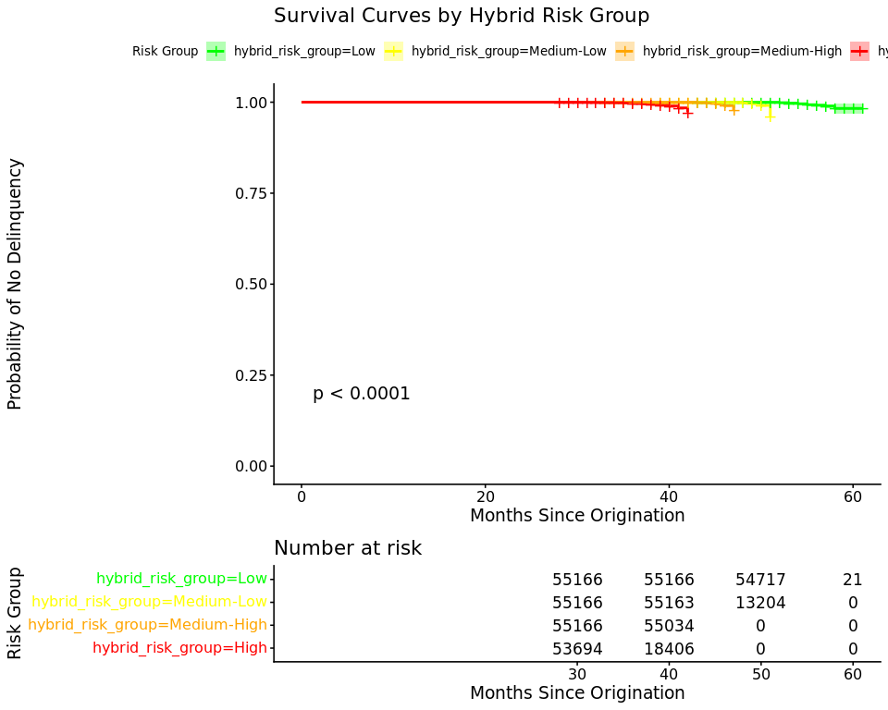

Risk Group Analysis
risk_analysis <- test_data %>%
group_by(hybrid_risk_group) %>%
summarise(
n_loans = n(),
n_events = sum(event),
event_rate = mean(event) * 100,
median_duration = median(duration),
mean_risk_score = mean(hybrid_risk_score)
) %>%
arrange(desc(mean_risk_score))
risk_analysis %>%
gt() %>%
fmt_number(columns = c(event_rate, median_duration, mean_risk_score), decimals = 2) %>%
tab_header(
title = "Event Rates by Hybrid Risk Group"
)
Table 1: Event Rates by Hybrid Risk Group
hybrid_risk_group | n_loans | n_events | event_rate | median_duration | mean_risk_score
High | 55166 | 435 | 0.79 | 38.00 | 76.18
Medium-High | 55166 | 378 | 0.69 | 45.00 | 9.38
Medium-Low | 55166 | 253 | 0.46 | 48.00 | -23.50
Low | 55166 | 155 | 0.28 | 53.00 | -62.99
print(risk_analysis)
## # A tibble: 4 × 6
## hybrid_risk_group n_loans n_events event_rate median_duration mean_risk_score
## <fct> <int> <dbl> <dbl> <dbl> <dbl>
## 1 High 55166 435 0.789 38 76.2
## 2 Medium-High 55166 378 0.685 45 9.38
## 3 Medium-Low 55166 253 0.459 48 -23.5
## 4 Low 55166 155 0.281 53 -63.0
# Calculate risk separation
low_risk_rate <- risk_analysis %>% filter(hybrid_risk_group == "Low") %>% pull(event_rate)
high_risk_rate <- risk_analysis %>% filter(hybrid_risk_group == "High") %>% pull(event_rate)
cat("\nRisk Separation:\n")
##
## Risk Separation:
cat("Low Risk:", round(low_risk_rate, 2), "%\n")
## Low Risk: 0.28 %
cat("High Risk:", round(high_risk_rate, 2), "%\n")
## High Risk: 0.79 %
cat("Relative Risk:", round(high_risk_rate / low_risk_rate, 2), "x\n")
## Relative Risk: 2.81 x
# Plot
risk_analysis %>%
ggplot(aes(x = hybrid_risk_group, y = event_rate, fill = hybrid_risk_group)) +
geom_col() +
geom_text(aes(label = paste0(round(event_rate, 2), "%")), vjust = -0.5) +
scale_fill_manual(values = c("green", "yellow", "orange", "red")) +
labs(
title = "Actual Delinquency Rates by Predicted Risk Group",
x = "Risk Group",
y = "Event Rate (%)"
) +
theme_minimal() +
theme(legend.position = "none")
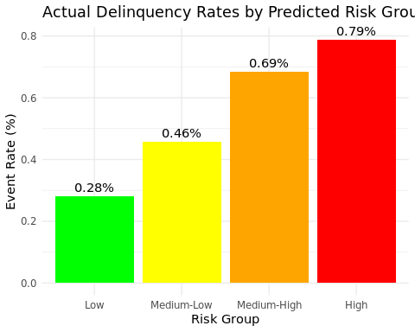

Calibration
test_data <- test_data %>%
mutate(risk_decile = ntile(hybrid_risk_score, 10))
calibration_df <- test_data %>%
group_by(risk_decile) %>%
summarise(
n = n(),
n_events = sum(event),
actual_rate = mean(event) * 100
)
calibration_df %>%
ggplot(aes(x = risk_decile, y = actual_rate)) +
geom_line(color = "steelblue", size = 1.2) +
geom_point(color = "coral", size = 3) +
scale_x_continuous(breaks = 1:10) +
labs(
title = "Model Calibration by Risk Decile",
x = "Risk Decile (1 = Lowest, 10 = Highest)",
y = "Actual Event Rate (%)"
) +
theme_minimal()
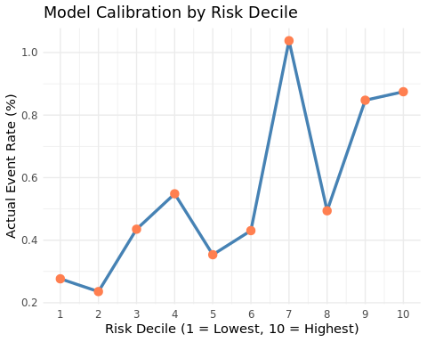
print(calibration_df)
## # A tibble: 10 × 4
## risk_decile n n_events actual_rate
## <int> <int> <dbl> <dbl>
## 1 1 22067 61 0.276
## 2 2 22067 52 0.236
## 3 3 22067 96 0.435
## 4 4 22067 121 0.548
## 5 5 22066 78 0.353
## 6 6 22066 95 0.431
## 7 7 22066 229 1.04
## 8 8 22066 109 0.494
## 9 9 22066 187 0.847
## 10 10 22066 193 0.875

Summary
cat("\n=======================================================\n")
##
## =======================================================
cat(" POINT-IN-TIME MODEL SUMMARY \n")
## POINT-IN-TIME MODEL SUMMARY
cat("=======================================================\n")
## =======================================================
cat("Model Type: Portfolio Risk Management (October 2025)\n")
## Model Type: Portfolio Risk Management (October 2025)
cat("\nDataset:\n")
##
## Dataset:
cat(" Test set:", nrow(test_data), "loans\n")
## Test set: 220664 loans
cat(" Events:", sum(test_data$event), "\n")
## Events: 1221
cat(" Event rate:", round(mean(test_data$event) * 100, 2), "%\n")
## Event rate: 0.55 %
cat("\nPerformance:\n")
##
## Performance:
cat(" Cox C-index:", round(cox_test_cindex$c.index, 4), "\n")
## Cox C-index: 0.9956
cat(" Hybrid C-index:", round(hybrid_cindex$c.index, 4), "\n")
## Hybrid C-index: 0.9969
cat(" Improvement:", round((hybrid_cindex$c.index - cox_test_cindex$c.index) /
cox_test_cindex$c.index * 100, 2), "%\n")
## Improvement: 0.13 %
cat("\nRisk Separation:\n")
##
## Risk Separation:
cat(" Relative Risk (High/Low):", round(high_risk_rate / low_risk_rate, 2), "x\n")
## Relative Risk (High/Low): 2.81 x
cat("\nUse Case: Portfolio monitoring and loss forecasting\n")
##
## Use Case: Portfolio monitoring and loss forecasting
cat("=======================================================\n")
## =======================================================
precision_analysis <- test_data %>%
group_by(hybrid_risk_group) %>%
summarise(
n = n(),
n_events = sum(event),
precision = mean(event) * 100
)
print(precision_analysis)
## # A tibble: 4 × 4
## hybrid_risk_group n n_events precision
## <fct> <int> <dbl> <dbl>
## 1 Low 55166 155 0.281
## 2 Medium-Low 55166 253 0.459
## 3 Medium-High 55166 378 0.685
## 4 High 55166 435 0.789
# For each age, what % have defaulted by that point?
cumulative_default <- test_data %>%
arrange(`Loan Age`) %>%
group_by(hybrid_risk_group) %>%
mutate(
cumulative_events = cumsum(event),
cumulative_rate = cumulative_events / n() * 100
) %>%
ungroup()
# Plot
ggplot(cumulative_default, aes(x = `Loan Age`, y = cumulative_rate,
color = hybrid_risk_group)) +
geom_smooth(se = FALSE, size = 1.2) +
scale_color_manual(values = c("green", "yellow", "orange", "red")) +
labs(
title = "Cumulative Default Rate by Loan Age",
x = "Loan Age (Months)",
y = "Cumulative % Defaulted",
color = "Risk Group"
) +
theme_minimal()
