Point-in-Time Survival Model for Mortgage Portfolio Risk Management
Gaurav Law & Isaac Vergara
2025-12-06

Executive Summary
This analysis builds a point-in-time survival model for predicting mortgage delinquency in an existing loan portfolio. The model uses current loan characteristics as of October 2025 to predict future default risk.
Use Case: Portfolio risk management - “Given what we know about loans today, which are most likely to default in the coming months?”

Data Loading and Survival Preparation
## Portfolio Snapshot (October 2025)
## Total loans: 1110838
## Events (delinquent 90+ days): 6980
## Event rate: 0.63 %

Feature Engineering
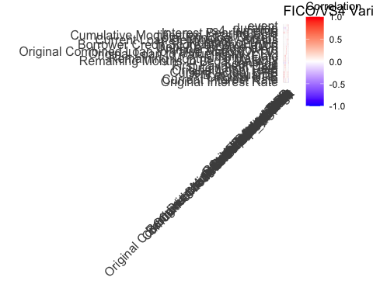
FICO/VS4 Correlation Plot
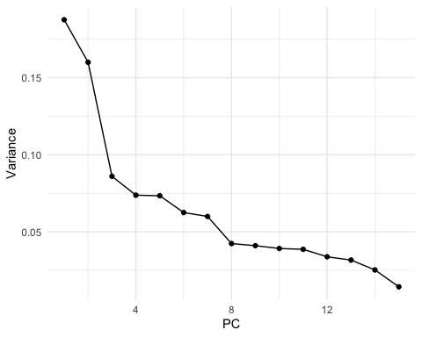
Principle Component Analysis on Fannie Mae Data
## PC1 PC2 PC3 PC4
## 1 -1.9530297 1.7974079 0.7916398 1.1237206
## 2 -2.9412504 -0.6314863 2.0904284 1.0954957
## 3 -2.6068094 -1.3937960 0.7812403 0.4874915
## 4 -3.1481752 -0.1656594 1.2073125 -0.1782207
## 5 -3.0098861 -0.9770311 2.1833066 1.1397116
## 6 -0.7848506 1.3989829 3.6376566 -1.4805919
## [[1]]
## # A tibble: 10 × 2
## variable PC1
## <chr> <dbl>
## 1 Loan Age -0.394
## 2 duration -0.394
## 3 Original Interest Rate 0.357
## 4 Current Interest Rate 0.357
## 5 Remaining Months to Legal Maturity 0.354
## 6 Current Actual UPB 0.231
## 7 Interest Bearing UPB 0.230
## 8 UPB at Issuance 0.211
## 9 Original UPB 0.210
## 10 Remaining Months To Maturity 0.198
##
## [[2]]
## # A tibble: 10 × 2
## variable PC2
## <chr> <dbl>
## 1 UPB at Issuance 0.439
## 2 Original UPB 0.439
## 3 Interest Bearing UPB 0.428
## 4 Current Actual UPB 0.428
## 5 Original Interest Rate -0.215
## 6 Current Interest Rate -0.215
## 7 Loan Age 0.178
## 8 duration 0.178
## 9 vs4_trimerge 0.150
## 10 Remaining Months to Legal Maturity -0.141
## Final feature count: 25

Train/Test Split
## Training set: 882654 loans
## Test set: 220664 loans
## Training event rate: 0.57 %
## Test event rate: 0.55 %
## Features used: 19

Model 1: Baseline Cox Proportional Hazards
## Cox Model C-index (Training): 0.9951

Model 1: Cox Model Evaluation on Test Set
## Cox Model C-index (Test): 0.9956
## Standard Error: 4e-04

Model 1: Cox Feature Importance
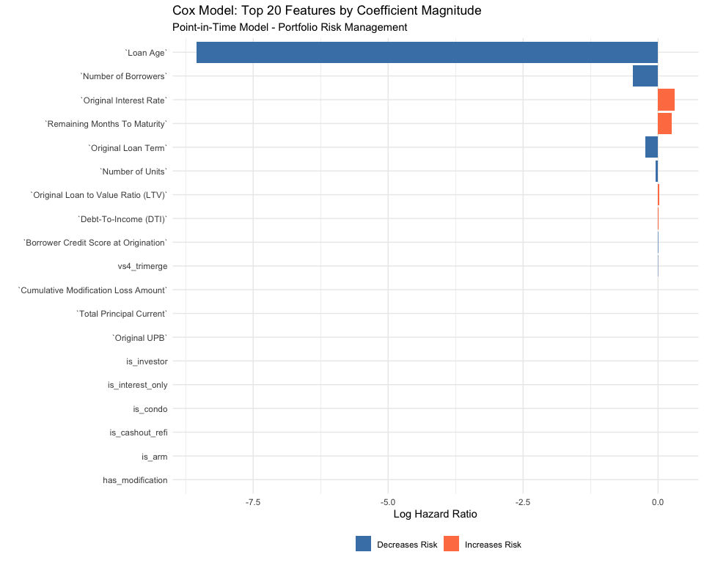
Cox Model Feature Importance PLot

Model 2: XGBoost on Cox Residuals
## Training samples: 882649
## [1] train-rmse:0.571656
## [51] train-rmse:0.142226
## [101] train-rmse:0.129233
## [151] train-rmse:0.125861
## [200] train-rmse:0.121906

Model 2: XGBoost Feature Importance
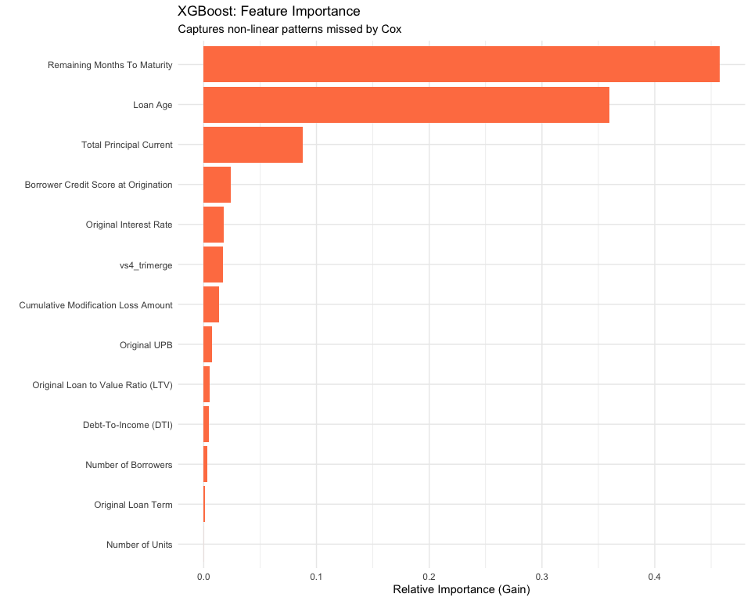

Model 3: Hybrid Model
## HYBRID Model C-index (Test): 0.9969
## Standard Error: 4e-04

Model Comparison
Table 1: Point-in-Time Survival Model Performance
C-index on Test Set
Model | C_Index | SE | CI_Lower | CI_Upper | Improvement | Improvement_Pct
Cox Baseline | 0.9956 | 0.0004 | 0.9947 | 0.9965 | 0.00 | 0.00
Hybrid (Cox + XGBoost) | 0.9969 | 0.0004 | 0.9961 | 0.9977 | 0.00 | 0.13
## # A tibble: 2 × 7
## Model C_Index SE CI_Lower CI_Upper Improvement Improvement_Pct
## <chr> <dbl> <dbl> <dbl> <dbl> <dbl> <dbl>
## 1 Cox Baseline 0.996 4.43e-4 0.995 0.996 0 0
## 2 Hybrid (Cox + X… 0.997 4.20e-4 0.996 0.998 0.00133 0.133

Visualizations
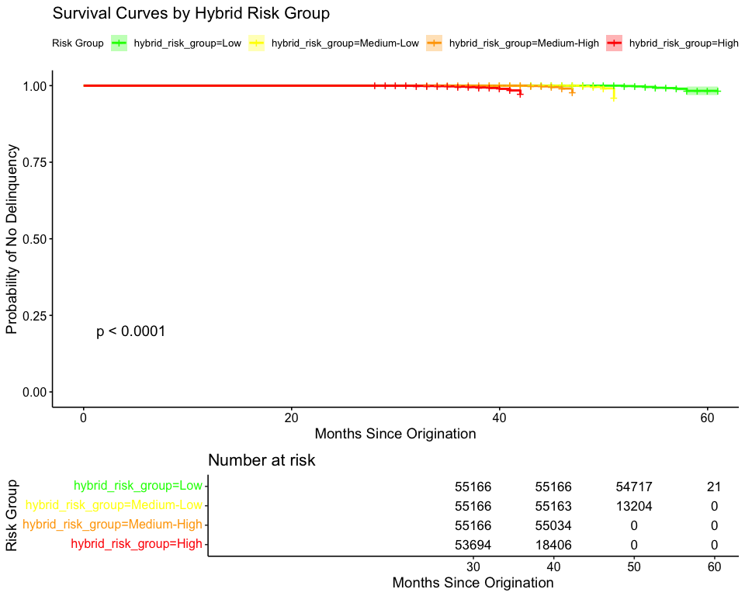
Hybride Model Survival Curves

Risk Group Analysis
Table 1: Event Rates by Hybrid Risk Group
hybrid_risk_group | n_loans | n_events | event_rate | median_duration | mean_risk_score
High | 55166 | 435 | 0.79 | 38.00 | 76.18
Medium-High | 55166 | 378 | 0.69 | 45.00 | 9.38
Medium-Low | 55166 | 253 | 0.46 | 48.00 | -23.50
Low | 55166 | 155 | 0.28 | 53.00 | -62.99
## # A tibble: 4 × 6
## hybrid_risk_group n_loans n_events event_rate median_duration mean_risk_score
## <fct> <int> <dbl> <dbl> <dbl> <dbl>
## 1 High 55166 435 0.789 38 76.2
## 2 Medium-High 55166 378 0.685 45 9.38
## 3 Medium-Low 55166 253 0.459 48 -23.5
## 4 Low 55166 155 0.281 53 -63.0
##
## Risk Separation:
## Low Risk: 0.28 %
## High Risk: 0.79 %
## Relative Risk: 2.81 x
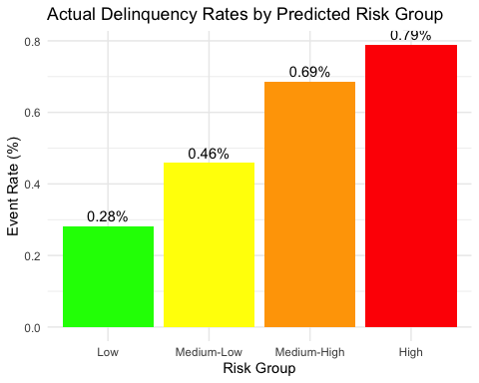
Predicted vs. Actual Delinquency Rates

Calibration
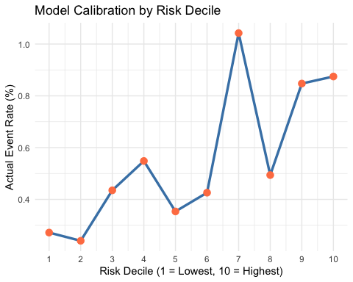
Model Calibration vs. Risk Decile
## # A tibble: 10 × 4
## risk_decile n n_events actual_rate
## <int> <int> <dbl> <dbl>
## 1 1 22067 60 0.272
## 2 2 22067 53 0.240
## 3 3 22067 96 0.435
## 4 4 22067 121 0.548
## 5 5 22066 78 0.353
## 6 6 22066 94 0.426
## 7 7 22066 230 1.04
## 8 8 22066 109 0.494
## 9 9 22066 187 0.847
## 10 10 22066 193 0.875

Summary
## POINT-IN-TIME MODEL SUMMARY
## =======================================================
## Model Type: Portfolio Risk Management (October 2025)
##
## Dataset:
## Test set: 220664 loans
## Events: 1221
## Event rate: 0.55 %
##
## Performance:
## Cox C-index: 0.9956
## Hybrid C-index: 0.9969
## Improvement: 0.13 %
##
## Risk Separation:
## Relative Risk (High/Low): 2.81 x
##
## Use Case: Portfolio monitoring and loss forecasting
## =======================================================
## # A tibble: 4 × 4
## hybrid_risk_group n n_events precision
## <fct> <int> <dbl> <dbl>
## 1 Low 55166 155 0.281
## 2 Medium-Low 55166 253 0.459
## 3 Medium-High 55166 378 0.685
## 4 High 55166 435 0.789
