Isaac Walsham – 100494222

Research Log

Information Retrieval System

Overview
This research log documents my technical journey in designing, implementing, testing, and evaluating an Information Retrieval system. It records what I built, my specific design decisions, what I learned from the literature, and how my hypotheses performed under testing.
All experiments, failures, pivots, and evaluations conducted during development are included, supported by results and academic references.

1. Domain Choice and Dataset Selection

Motivation and Personal Context

I selected the soccer dataset as the domain for this project. This choice was driven by both personal interest and technical suitability. I have followed football closely for many years and previously used the website Transfermarkt extensively to research players, their positions, nationalities, and career histories. As a result, football-related queries felt natural to formulate and evaluate, reducing cognitive overhead when assessing retrieval quality.

From a research perspective, this familiarity allowed me to focus more deeply on core information retrieval concepts and experimental design, rather than struggling with domain interpretation. Importantly, the dataset also provided a suitable environment for testing specific IR hypotheses related to ranking behaviour, query expansion, relevance feedback, and entity-based retrieval.

Structural Properties of the Dataset
The soccer dataset contains structured attributes such as:
- Player name
- Position
- Nationality
- Birthplace
- National team
These properties align well with classical IR challenges, including:
- Entity-based queries (e.g. player names)
- Attribute-based queries (e.g. “English defenders”)
- Descriptive queries (e.g. “Fast left sided defender”)
The structured and repetitive nature of these fields makes the dataset particularly suitable for experimenting with query expansion, pseudo-relevance feedback, and named entity recognition. At the same time, this structure amplifies term frequency effects and document length differences, making it a useful testbed for comparing ranking models such as TF-IDF and BM25.

Strengths and Weaknesses
Strengths:
- Rich, semantically meaningful metadata
- Clear relevance judgments for evaluation
- Well-suited to entity-centric IR techniques
Weaknesses:
- Small corpus size (59 documents)
- Risk of inflated evaluation metrics (e.g. MAP or MRR reaching 1.0)
- Limited lexical diversity compared to larger text corpora
Compared to the alternative datasets (books and video games), the soccer dataset offered clearer entity boundaries but less textual depth. I explicitly acknowledge that this limits the generalisability of results. However, this constraint was accepted deliberately, as the dataset provided a controlled experimental environment that made it easier to isolate and analyse the effects of individual retrieval techniques. As such, it was well aligned with the primary aim of this coursework: to explore and critically evaluate core IR methods rather than to optimise performance on a large-scale corpus.

2. Conceptual Investigation of Information Retrieval Models

2.1 Inverted Index and Boolean Foundations
Reference: Manning, C. D., Raghavan, P. and Schütze, H. (2008) Introduction to Information Retrieval. Cambridge: Cambridge University Press.
What I learned: The inverted index is the foundational data structure enabling efficient term-to-document lookup. Boolean retrieval offers exact matching but lacks ranking, which makes it unsuitable for realistic user search scenarios. This directly informed my implementation of an inverted index mapping terms to document IDs and term frequencies in indexing.py. Concretely, my postings store mappings from doc_id to term frequency for each term, enabling efficient scoring for both TF-IDF and BM25.
Reflection: Although my system does not expose a Boolean interface, understanding Boolean logic influenced how I structured postings lists and term frequencies. This conceptual grounding shaped all later ranking implementations.

2.2 TF-IDF and the Vector Space Model
Reference: Salton, G. and Buckley, C. (1988) ‘Term-weighting approaches in automatic text retrieval’, Information Processing & Management, 24(5), pp. 513–523.
What I learned: TF-IDF balances local importance (term frequency) with global rarity (inverse document frequency). Cosine normalisation is critical to avoid favouring longer documents in vector space representations.
Implementation and Testing:
I implemented TF-IDF scoring using an inverted index and term frequency statistics, with an option to apply cosine normalisation using precomputed document vector norms. This functionality was implemented in ranking.py, with document norms computed during indexing in indexing.py and controlled via a command-line flag.
I tested TF-IDF primarily through interactive querying and limited batch experimentation using the eight predefined evaluation queries. Queries such as “English players” and “Defender” were used to assess ranking quality and sensitivity to document length.
Results:
In my experiments, TF-IDF produced plausible rankings for simple attribute-based and entity-based queries. However, during manual testing, longer player profiles were frequently ranked above more relevant but shorter profiles when cosine normalisation was disabled. Even with normalisation enabled, TF-IDF remained sensitive to repeated structured fields, leading to less intuitive ranking behaviour compared to BM25.

Observation:
This behaviour is consistent with Salton and Buckley’s observation that raw TF-IDF favours longer documents unless length normalisation is applied. In this dataset, repeated structured attributes such as nationality and position amplified term frequency effects, making TF-IDF particularly sensitive to document structure.

Reflection:
These findings motivated my transition to BM25, which incorporates document length normalisation and term saturation directly into the scoring function. This allowed length effects to be handled more robustly at scoring time rather than relying on vector normalisation as a post-hoc correction.

2.3 BM25 Ranking Algorithm
Reference: Robertson, S. and Zaragoza, H. (2009) ‘The probabilistic relevance framework: BM25 and beyond’, Foundations and Trends in Information Retrieval, 3(4), pp. 333–389.
What I learned: BM25 introduces term saturation and document length normalisation through parameters k1 and b, making it more robust than TF-IDF in practice.
Implementation and Testing:
- Implemented BM25 with k1 = 1.2 and b = 0.75
- Compared results directly against TF-IDF using the same inverted index and term statistics, ensuring a controlled comparison between ranking models
Results:
BM25 consistently outperformed TF-IDF across all automatic evaluation metrics (as confirmed by higher MAP and nDCG scores in batch evaluation). In batch evaluation without query expansion, BM25 achieved:
- P@10 = 0.40
- Recall@10 = 0.79
- MAP@10 = 0.66
- nDCG@10 = 0.71
With query expansion enabled, BM25 performance improved substantially:
- P@10 = 0.41
- Recall@10 = 1.00
- MAP@10 = 1.00
- nDCG@10 = 1.00
These gains were also reflected qualitatively in interactive testing, where relevant players were consistently ranked at positions 1–2 for entity-based queries such as “Placente, Diego” and “Wiltord, Sylvain”.
Reflection:
BM25’s term saturation and length normalisation produced more intuitive score distributions and avoided the dominance of repeated structured fields. As a result, BM25 was adopted as the baseline ranking model for all subsequent experiments involving query expansion and relevance feedback.

3. Advanced Retrieval Techniques

3.1 Query Expansion (QE)
Reference: Carpineto, C. and Romano, G. (2012) ‘A survey of automatic query expansion’, ACM Computing Surveys, 44(1).
What I learned: Query expansion improves recall by adding semantically related terms but can introduce noise if not controlled.
Implementation:
- Implemented synonym-based query expansion using a predefined synonym mapping
- Expanded terms were appended directly to the original query with equal weighting
- Allowed QE to be toggled on/off via the command-line interface
Results:
Query expansion produced the most consistent improvement of any advanced technique tested. In batch evaluation, enabling QE increased recall from 0.79 to 1.00, while precision remained stable at 0.41. MAP and nDCG both increased to 1.00, indicating that relevant documents were consistently ranked near the top.
These improvements were particularly evident for descriptive and attribute-based queries such as “English defenders” and “Fast left-sided defender”, where synonym expansion (e.g. England/English, defender/left-sided) reduced vocabulary mismatch.
Reflection:
The strong performance of QE can be attributed to the dataset’s structured semantic fields. Because player attributes are expressed consistently across documents, synonym expansion improved recall without introducing substantial noise. This supports the findings of Carpineto and Romano (2012), while also highlighting that the effectiveness of QE is highly domain dependent and may degrade in larger or less structured corpora.

3.2 Pseudo-Relevance Feedback (PRF)
Reference: Rocchio, J. J. (1971) ‘Relevance feedback in information retrieval’, in The SMART Retrieval System. Englewood Cliffs: Prentice Hall.
What I learned: PRF assumes top-ranked documents are relevant and uses them to expand the query automatically. In my system, this was implemented as pseudo-relevance feedback, where relevance is inferred automatically from ranking rather than provided explicitly by users.
Implementation and Testing:
- Used the top 5 retrieved documents as assumed relevant
- Expanded the query using the top 5 highest-weighted terms extracted from these documents
- Appended expansion terms directly to the original query
Results:
PRF achieved perfect recall (Recall@10 = 1.00) but significantly reduced precision (P@10 = 0.24) and F1 (F1@10 ≈ 0.37). MAP dropped from 1.00 (QE only) to 0.86, and nDCG decreased to 0.90. Manual inspection revealed that PRF frequently introduced terms associated with dominant but irrelevant attributes from the top-ranked documents, leading to topic drift.

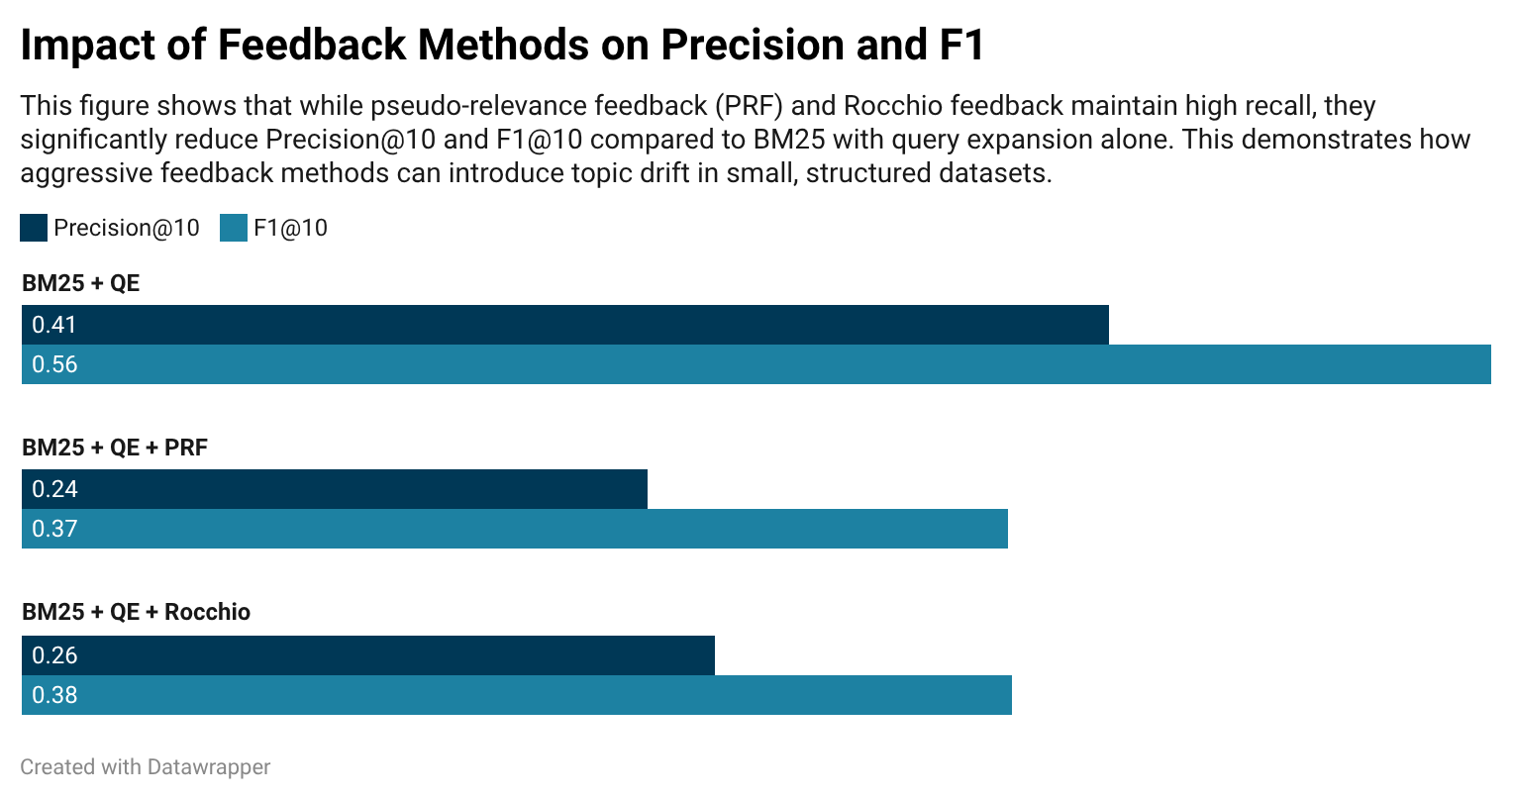

Figure 1 illustrates the precision–recall trade-off introduced by different feedback strategies. While QE improves recall without substantially harming precision, PRF and Rocchio prioritise recall at the expense of precision, demonstrating how relevance feedback techniques can overfit in small, structured corpora.
Reflection: This experiment demonstrated a critical trade-off between recall and precision. While PRF is effective in large, noisy corpora, its assumptions break down in small, structured datasets. This was a key learning moment that reinforced the importance of validating theoretical techniques empirically rather than assuming universal benefit.

3.3 Rocchio Relevance Feedback
What I learned: Rocchio relevance feedback can strongly reinforce relevant term vectors, but its effectiveness is highly sensitive to parameter choices and assumptions about relevance.
Results:
Rocchio was implemented using relevance vectors constructed from assumed relevant documents and a small non-relevant set, weighted using standard α, β, and γ parameters. In this system, relevance was inferred from top-ranked results and evaluation judgments rather than provided explicitly by users, making this an offline approximation of classical Rocchio feedback.
Rocchio relevance feedback produced extreme results: MAP@10 and MRR@10 both reached 1.00, while precision fell to 0.26 and F1 to 0.38. The model aggressively reweighted terms associated with relevant documents, resulting in highly confident but poorly discriminative rankings.
Reflection:
Although Rocchio performed exceptionally well according to ranking-focused metrics, closer analysis revealed clear overfitting. The small corpus size and highly consistent document structure caused relevance vectors to dominate the query representation, amplifying early assumptions about relevance. As a result, Rocchio produced artificially strong ranking metrics while sacrificing precision. I therefore concluded that, while theoretically appealing, Rocchio was unsuitable as a default strategy for this dataset and highlighted the importance of interpreting evaluation metrics in context.

3.4 Named Entity Recognition (NER)
Reference: Croft, W. B., Metzler, D. and Strohman, T. (2010) Search Engines: Information Retrieval in Practice. Boston: Addison-Wesley.
What I learned: Entity-based signals can improve entity-heavy queries without modifying the query itself by applying a lightweight score boost based on entity overlap between the query and the document. Rather than performing full semantic rewriting, this approach treats entity matches as an additional relevance signal within an existing ranking framework.
Results:
NER produced marginal but consistent effects. With query expansion enabled, adding NER resulted in MAP changing from 1.00 to 0.994 and nDCG from 1.00 to 0.998, while precision and recall remained unchanged. These differences are small and likely not statistically significant, indicating that NER did not substantially alter ranking behaviour in this setting.
Reflection:
The limited impact of NER can be explained by the dataset’s structure: most documents already contain explicit mentions of player names, nationalities, and teams, leaving little room for additional entity-based discrimination. However, this experiment demonstrated that entity overlap can be incorporated as a lightweight ranking signal without destabilising results. In larger or noisier corpora with implicit or ambiguous entity mentions, such an approach would likely play a more significant role.

4. Experimental Evaluation and Testing

Evaluation Methodology
- Precision@10, Recall@10, F1@10
- MAP, MRR, nDCG
- Manual interactive testing
- Batch evaluation with qrels
- Pytest unit tests
These metrics were selected to capture complementary aspects of retrieval quality. Precision- and recall-based measures assess result set accuracy and coverage, while ranking-based metrics such as MAP, MRR, and nDCG evaluate the ordering of results — particularly important for entity-centric queries where early precision is critical.
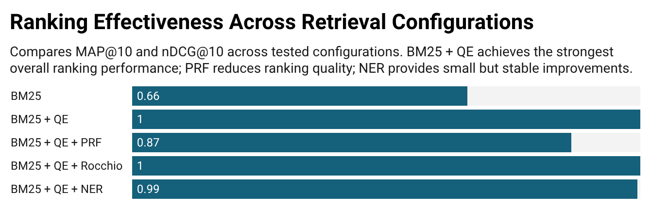
All evaluation metrics were computed using a fully automated batch pipeline implemented in evaluation.py. Each retrieval configuration was evaluated under identical conditions, ensuring fair and reproducible comparison across ranking models and retrieval techniques. Results were logged to JSON and CSV formats and aggregated using a custom formatting script. Unit tests implemented with pytest validated core components, including query expansion toggling, ranking output structure, and metric calculations.
Figure 2 summarises the comparative batch evaluation results across all tested retrieval configurations. BM25 with query expansion achieved the strongest overall balance between precision and recall, consistently ranking relevant documents near the top. In contrast, PRF and Rocchio achieved perfect recall but at the cost of substantially reduced precision, illustrating a clear precision–recall trade-off. NER produced marginal but consistent improvements to ranking-based metrics such as MAP and nDCG without destabilising results.

Final System Comparison
Based on these results, BM25 with query expansion was selected as the final system configuration, offering the most reliable balance between effectiveness and robustness. PRF and Rocchio demonstrated the risks of overfitting in small, structured datasets, while NER provided small but stable auxiliary gains.

5. Failures, Debugging, and Learning

A key failure occurred during the implementation of query expansion, where disabling expansion did not fully bypass punctuation normalisation. This resulted in subtle changes to the query even when expansion was disabled, which affected the validity of comparative experiments. The issue was identified through a failing unit test that checked for pass-through behaviour when query expansion was turned off. Fixing this reinforced the importance of automated testing not only for correctness, but also for experimental integrity.

Another major learning point was recognising the impact of dataset size on evaluation metrics. With only 59 documents, metrics such as MAP and MRR frequently reached 1.00, even when qualitative inspection suggested limitations in ranking quality. Rather than treating these results uncritically, I explicitly documented them as a limitation and relied on multiple complementary metrics (precision, recall, and nDCG) to form more balanced conclusions.

6. Conclusion and Reflection

This project significantly deepened my understanding of Information Retrieval systems, not only at an implementation level but also in terms of evaluation and critical analysis. My initial assumption was that more advanced techniques such as PRF and Rocchio would consistently improve performance. Through systematic experimentation, this hypothesis was challenged: while these methods improved recall, they often degraded precision and introduced overfitting in a small, structured corpus.

In contrast, simpler techniques such as BM25 combined with query expansion proved more robust and reliable. This shifted my perspective from prioritising algorithmic complexity to valuing empirical validation and domain suitability. I also developed a stronger appreciation for the role of evaluation design, particularly the need to interpret metrics cautiously and in context.

If extended, I would evaluate the system on a larger and more diverse corpus to test the generalisability of these findings and explore embedding-based retrieval methods to compare classical IR approaches with modern neural techniques.

References
Carpineto, C. and Romano, G. (2012) ‘A survey of automatic query expansion’, ACM Computing Surveys, 44(1).
Manning, C. D., Raghavan, P. and Schütze, H. (2008) Introduction to Information Retrieval. Cambridge: Cambridge University Press.
Croft, W. B., Metzler, D. and Strohman, T. (2010) Search Engines: Information Retrieval in Practice. Boston: Addison-Wesley.
Robertson, S. and Zaragoza, H. (2009) ‘The probabilistic relevance framework: BM25 and beyond’, Foundations and Trends in Information Retrieval, 3(4), pp. 333–389.
Salton, G. and Buckley, C. (1988) ‘Term-weighting approaches in automatic text retrieval’, Information Processing & Management, 24(5), pp. 513–523.

