**CSCE 312 - Computer Organization**

# **Summer 2021**

## **Lab Project Report**

**Project 5: Computer Architecture**

## **Full Name: Isaac Yeang**

## **Section: 200**

## **UIN: 727008477**

**OBJECTIVE**

The objective of this project is to create a simple HACK computer using previously built components. By using these previous components to create the CPU and RAM, we can build a simple computer (after including the pre-built ROM32) that can compute simple operations.

**METHODOLOGY**

**Bus16toBus15**

1. DESIGN HEURISTIC

To design this chip, we can use previously built OR gates. By passing the 16-bit input with a false input into each OR gate, we can output to the corresponding slot. Note that we skip in[15] because the point of this chip is to ignore the 15th bit.

1. LOGIC CIRCUIT DIAGRAM

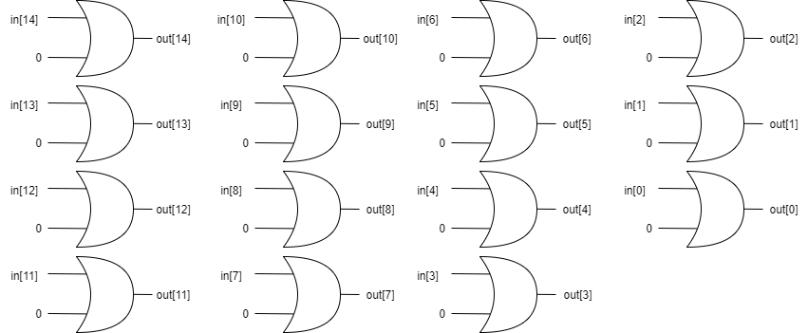Here, we have input bus in[16]. We pass in[0:14] through OR gates with false inputs and output to the corresponding output bus pins. This allows us to ignore the most significant bit.

1. HDL

