HIVE (ACP Elective)

Q2) Architecture of HIVE and its components

The following component diagram depicts the architecture of Hive:
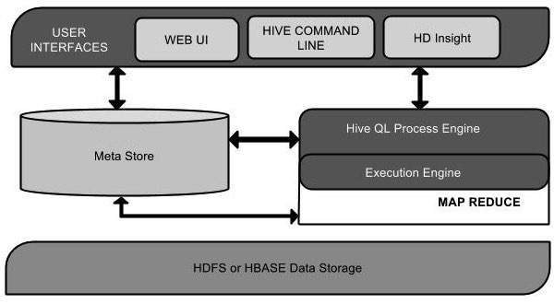
User Interface : - Hive is a data warehouse infrastructure software that can create interaction between user and HDFS.

Meta Store :- Hive chooses respective database servers to store the schema or Metadata of tables, databases, columns in a table, their data types, and HDFS mapping.

HiveQL Process Engine :- HiveQL is similar to SQL for querying on schema info on the Metastore. It is one of the replacements of traditional approach for MapReduce program.

Execution Engine : - The conjunction part of HiveQL process Engine and MapReduce is Hive Execution Engine. Execution engine processes the query and generates results as same as MapReduce results. It uses the flavor of MapReduce.

HDFS or HBASE :- Hadoop distributed file system or HBASE are the data storage techniques to store data into file system.

Q3) Working of HIVE
The following diagram depicts the workflow between Hive and Hadoop.
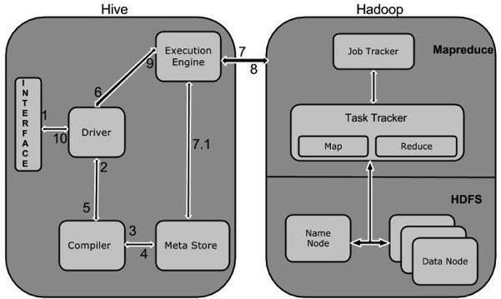
Execute Query : -The Hive interface such as Command Line or Web UI sends query to Driver (any database driver such as JDBC, ODBC, etc.) to execute.
Get Plan :- The driver takes the help of query compiler that parses the query to check the syntax and query plan or the requirement of query.
Get Metadata : - The compiler sends metadata request to Metastore (any database).
Send Metadata : - Metastore sends metadata as a response to the compiler.
Send Plan : - The compiler checks the requirement and resends the plan to the driver. Up to here, the parsing and compiling of a query is complete.
Execute Plan : - The driver sends the execute plan to the execution engine.
Execute Job : - Internally, the process of execution job is a MapReduce job. The execution engine sends the job to JobTracker, which is in Name node and it assigns this job to TaskTracker, which is in Data node. Here, the query executes MapReduce job.
Metadata Ops : - Meanwhile in execution, the execution engine can execute metadata operations with Metastore.
Fetch Results :- The execution engine receives the results from Data nodes.
Send Results : -The execution engine sends those resultant values to the driver.The driver sends the results to Hive Interfaces.

Q6) Role of metadata and metastore in HIVE
MetaStore:
- Database : namespace containing a set of tables.
- Holds table definitions(column types, physical layout)
- Partition Data
- Uses JPOX ORM for implementation,can be stored in Derby, MySQL and many other relational databases.
MetaData :
- Hive use an embedded Derby database to store metadata information.
- The metastore is the "glue" between Hive and HDFS. It tells Hive where your data files live in HDFS, what type of data they contain, what tables they belong to, etc.
- The Hive metastore service stores the metadata for Hive tables and partitions in a relational database, and provides clients (including Hive) access to this information via the metastore service API.

Q8) HIVE Vs. PIG
Hive PIG
1) Structured Data Semi Structured Data
2) Used as a declarative SQL Procedural Language
3) Used for reporting Used for programming
4) Supports Partition Doesnt
5) Supports Web Interface Doesnt

Q9) Key concepts
a) Partition
Hive organizes tables into partitions. It is a way of dividing a table into related parts based on the values of partitioned columns such as date, city, and department. Using partition, it is easy to query a portion of the data.
b) Buckets
Tables or partitions are sub-divided into buckets, to provide extra structure to the data that may be used for more efficient querying. Bucketing works based on the value of hash function of some column of a table.
c) User defined functions
User-defined functions let you code your own application logic for processing column values during an Impala query. For example, a UDF could perform calculations using an external math library, combine several column values into one, do geospatial calculations, or other kinds of tests and transformations that are outside the scope of the built-in SQL operators and functions.

d) Pluggable map-reduce scripts

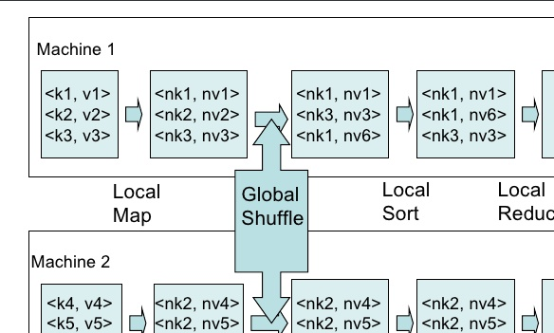

e)JOIN is a clause that is used for combining specific fields from two tables by using values common to each one. It is used to combine records from two or more tables in the database. It is more or less similar to SQL JOIN.
  - Join
  - Left outer join
  - Right outer join
  - Full outer join
f) Rollup and cube
- The general syntax is WITH CUBE/ROLLUP. It is used with the GROUP BY only. CUBE creates a subtotal of all possible combinations of the set of column in its argument. Once we compute a CUBE on a set of dimension, we can get answer to all possible aggregation questions on those dimensions
- GROUP BY a, b, c WITH CUBE is equivalent to GROUP BY a, b, c GROUPING SETS ( (a, b, c), (a, b), (b, c), (a, c), (a), (b), (c), ( )).

