CSIS 3290 – 004 – Final Project
Student Name: Isaac David Rangel Blanco Student ID: 300410730

Introduction and discovery
In this project, I am using a dataset of New York City Yellow taxi trips in January of 2026 obtained from nyc.gov webpage, to demonstrate my learning in this course and to apply the machine learning skills I have acquired. I will perform data analysis and build predictive models to estimate taxi trip fares based on features such as trip distance, passenger count, time of day, and surcharges.
nyc.gov is the official website of New York City government. The content on nyc.gov is made for New Yorkers by government employees or officials. They aim to be the most accurate and up-to-date online source for anything related to NYC government.
The Content on nyc.gov is usually written by city employees or officials, but sometimes, they use artificial intelligence (AI) tools to help with website content.
Link reference: https://www.nyc.gov/site/tlc/about/tlc-trip-record-data.page

Framing the problem
The goal of this analysis is to identify the main factors that influence taxi trip costs. Specifically, it aims to understand how variables like distance, time, payment type, and additional fees affect the total amount of a trip.
This is important to better understand pricing behavior and the key drivers behind taxi fares.
Initial Hypotheses
- Trip distance increases the total fare.
- Higher fares are associated with higher tips.
- Additional fees (airport fees, congestion) increase total cost.
- Payment type may influence tipping behavior.
- Longer trips (trip time) result in higher fares.

Data Preparation
The original dataset is in “.Parquet” format, which is a columnar storage file format commonly used for big data applications. For this project, I convert the dataset to .csv using pandas to simplify data handling in Python and to ensure compatibility with tools that may not support Parquet files. Also, I take a sample of the original data because this contains more than 3 million of rows, I select just 200k from the original dataset, more than enough data (>=10k).
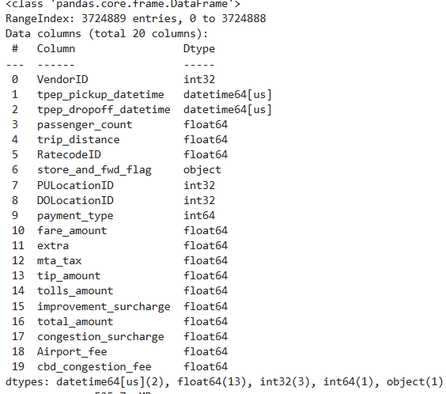
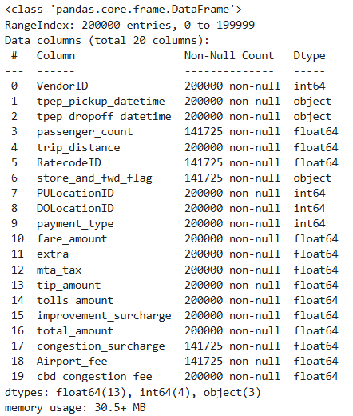

The dataset contains information about taxi trips, including trip details, locations, and pricing components.
Trip Information: Includes pickup and dropoff times, passenger count, and trip distance, which describe the characteristics and duration of each trip.
Location Data: Pickup and dropoff location IDs indicate where trips start and end.
Payment and Vendor Info: VendorID and payment_type provide information about the service provider and how the trip was paid.
Fare Components: Includes fare_amount, tip_amount, tolls_amount, extra charges, taxes, and surcharges, which together determine the total trip cost.
Total Cost: The total_amount represents the final price paid for each trip

Data Processing
The dataset contains the following variables, including their names and data formats:
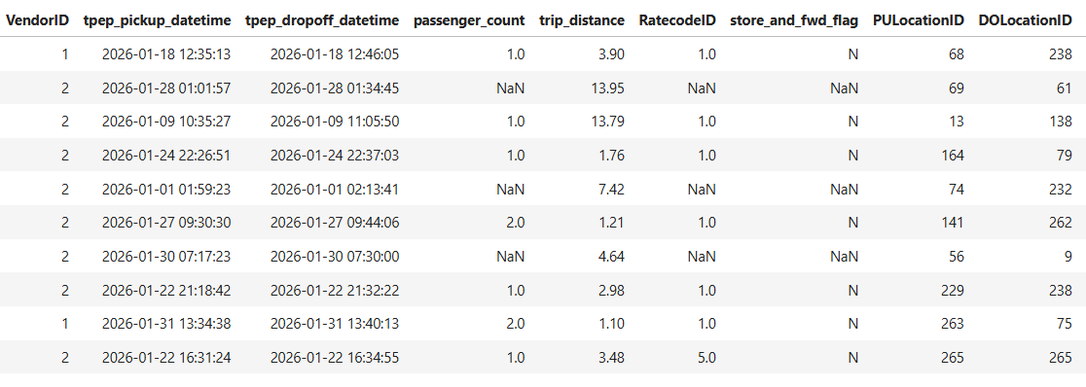
Some features, such as tpep_pickup_datetime and tpep_dropoff_datetime, can be transformed into more meaningful variables. These columns were used to derive a new feature representing the total trip duration. Additionally, since all records correspond to January 2026, only relevant components such as the day and hour were extracted from the datetime values to simplify the analysis.
Some columns in the dataset contain ID values. However, these do not represent unique identifiers, but rather categorical information related to service providers, fare types, and trip characteristics. Therefore, these variables were treated as categorical features and encoded appropriately before being used in the machine learning models.
The main categorical variables are described below:
VendorID: Indicates the TPEP provider of the record
(1 = Creative Mobile Technologies, LLC; 2 = Curb Mobility, LLC; 6 = Myle Technologies Inc; 7 = Helix)
RatecodeID: Represents the final rate code at the end of the trip
(1 = Standard rate; 2 = JFK; 3 = Newark; 4 = Nassau or Westchester; 5 = Negotiated fare; 6 = Group ride; 99 = Unknown)
payment_type: Indicates how the passenger paid for the trip
(0 = Flex Fare; 1 = Credit card; 2 = Cash; 3 = No charge; 4 = Dispute; 5 = Unknown; 6 = Voided trip)
PULocationID / DOLocationID: Represent the taxi zones where the trip started and ended.
Due to the high cardinality of the pickup and dropoff location variables (265 unique locations), these features may increase model complexity and risk of overfitting. One option is to remove them; however, a more effective approach is to map these IDs to their corresponding service zones using an external dataset, allowing the model to retain useful spatial information while reducing dimensionality.
Note: The previous descriptions of the variables were obtained from the Data Dictionary provided in the reference link.
Summary statistic of some features
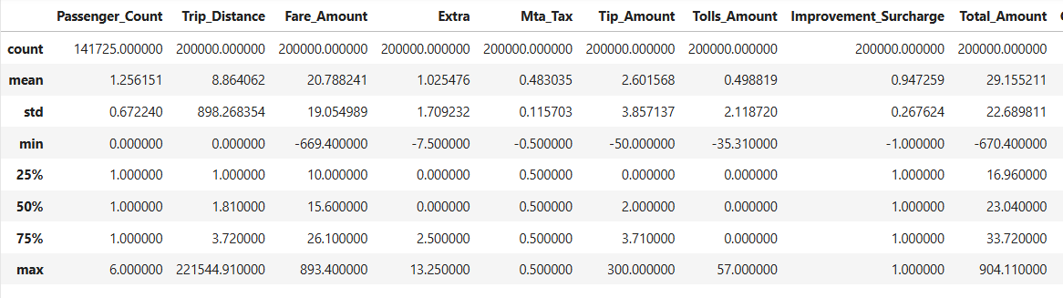
By examining the summary statistics and visualizing key features, it was possible to identify variables containing outliers. To preserve data quality, some observations were removed. For example, trips with distances greater than 35 miles were dropped based on the distribution observed in the plots. Similarly, extreme values in tip amounts and records with negative fare values were removed, as they are not realistic and could negatively affect model performance.
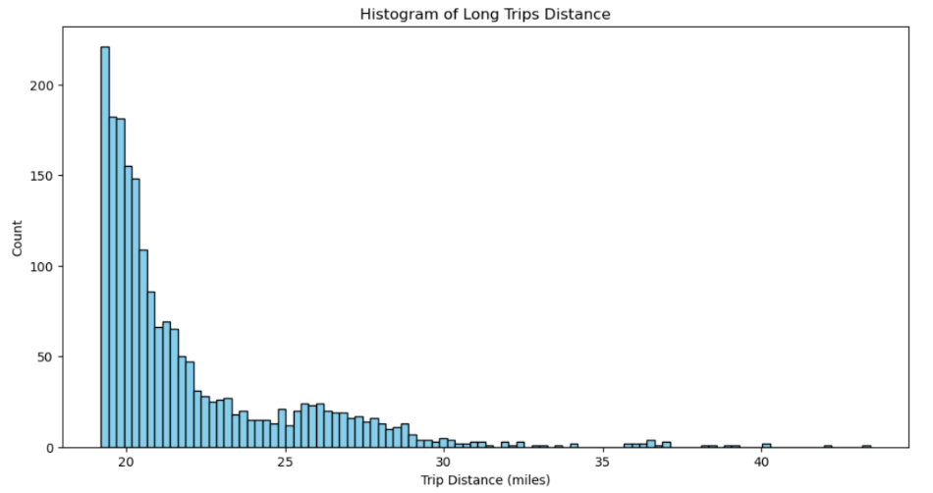

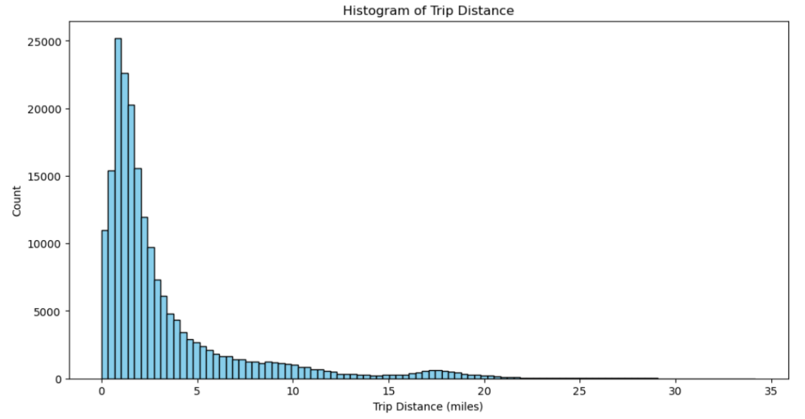

Distribution after dropping the outliers’ values:

Model Implementation
In this project, instead of relying on a single model, a pipeline with multiple regression models was implemented. This approach allows for a comprehensive comparison of different algorithms to identify the model that best captures the relationships in the data.
The models used includes Linear Regression, Decision Tree Regressor, Random Forest, Gradient Boosting, AdaBoost, XGBoost, CatBoost , LightGBM and SGD Regressor. These models were selected to represent both simple and complex approaches, ranging from linear methods to advanced ensemble techniques.
Using multiple models is appropriate because the dataset may contain both linear and non-linear relationships and different algorithms capture patterns differently. Therefore, a comparative approach ensures that the final model is not chosen arbitrarily, but based on performance.
The selected models help test the hypotheses by:
- Linear Regression: Evaluates whether relationships between variables are linear (e.g., distance vs fare)
- Tree-based models: Capture non-linear interactions and identify important features
- Boosting models: Improve predictive performance by learning from previous errors
- SGD Regressor: Provides a scalable linear approach for large datasets
By comparing these models, we can determine whether relationships are linear or complex, which features contribute most to predictions and which model generalizes best.
Results Interpretation and Implications
The pipeline implementation was complemented with several experiments to evaluate the impact of different feature configurations. Specifically, predictions were performed using:
- Only numerical features.
- Numerical features with feature selection.
- Numerical features combined with encoded categorical variables (dummies) and feature selection.

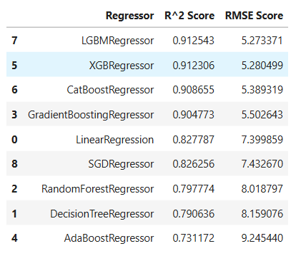
Experiment 1: Numerical Features Only
- Using all numerical features, the best-performing model was LGBMRegressor.
- Most boosting models achieved strong performance, with high R² scores.
- Simpler models such as Linear Regression and SGD Regressor performed slightly worse, but still showed acceptable results.
Experiment 2: Numerical Features with Feature Selection
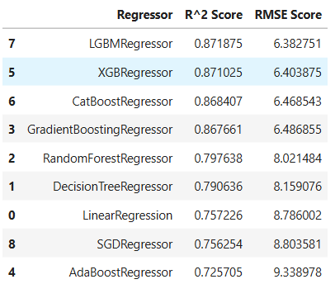
- The overall performance ranking of the models remained similar to the first experiment.
- Using all numerical features produced slightly better results than using SelectFromModel, although the difference was minimal.
- This is likely because a small number of features (Trip_Distance, Tip_Amount, Trip_Duration) dominate the prediction.
- However, this approach is considered more realistic, as it reduces reliance on all available features and focuses on the most relevant ones.
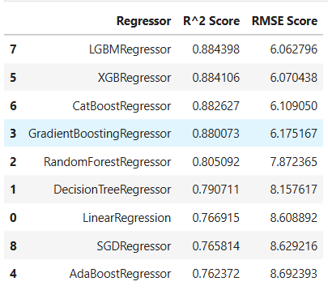
Experiment 3: Numerical + Categorical Features (Dummies) with Feature Selection
- Incorporating categorical features as one-hot encoded variables significantly improved model performance.
- The R² increased from approximately 0.871 to 0.884, while RMSE decreased from ~6.38 to ~6.06.
- This indicates that variables such as pickup/drop-off locations, rate type, and vendor may contain meaningful predictive information.

Final Model Selection
Based on the experiments, the most reliable and realistic approach is the model using SelectFromModel with encoded categorical features.
- Best Model: LGBMRegressor
- R²: 0.884
- RMSE: 6.06
This model provides a strong balance between performance and generalization, making it the preferred choice for predicting taxi trip fares.
Out-of-sample Predictions
The final prediction was performed using the best model on a new dataset from the same source as the training data, but collected in a different month of the same year (February-2026). This ensures the evaluation is done on unseen data while maintaining consistency in data origin.
The new dataset has the same format and structure as the training dataset, and therefore the same preprocessing and cleaning procedures were applied to maintain consistency for model prediction. Additional information can be found in the “New_Dataset_test.ipynb” file.
First, predictions were generated using the original dataset that was used to train the model. This was done to compare the results with those obtained using a new, unseen dataset.
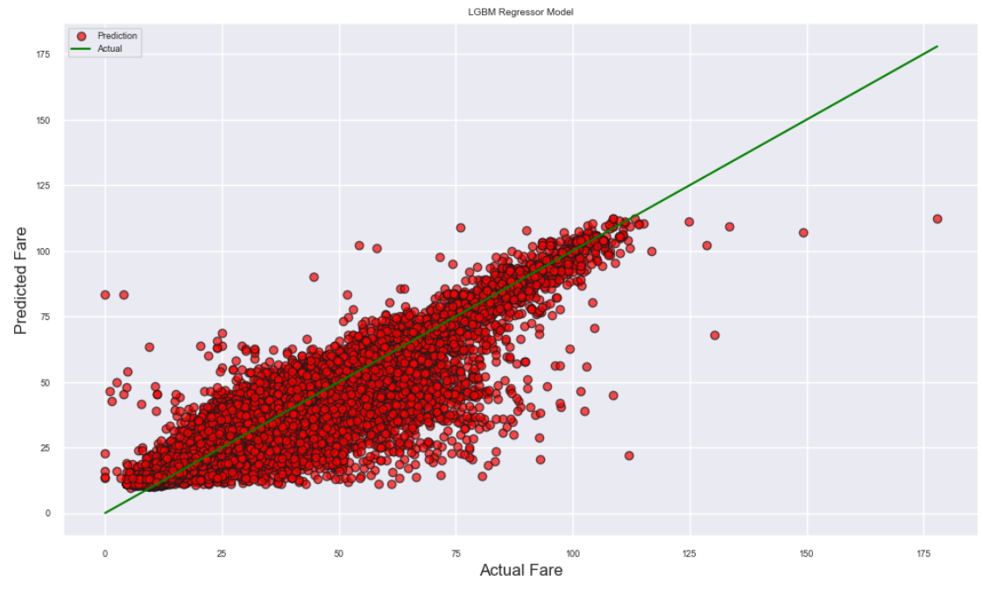
Prediction with original dataset:

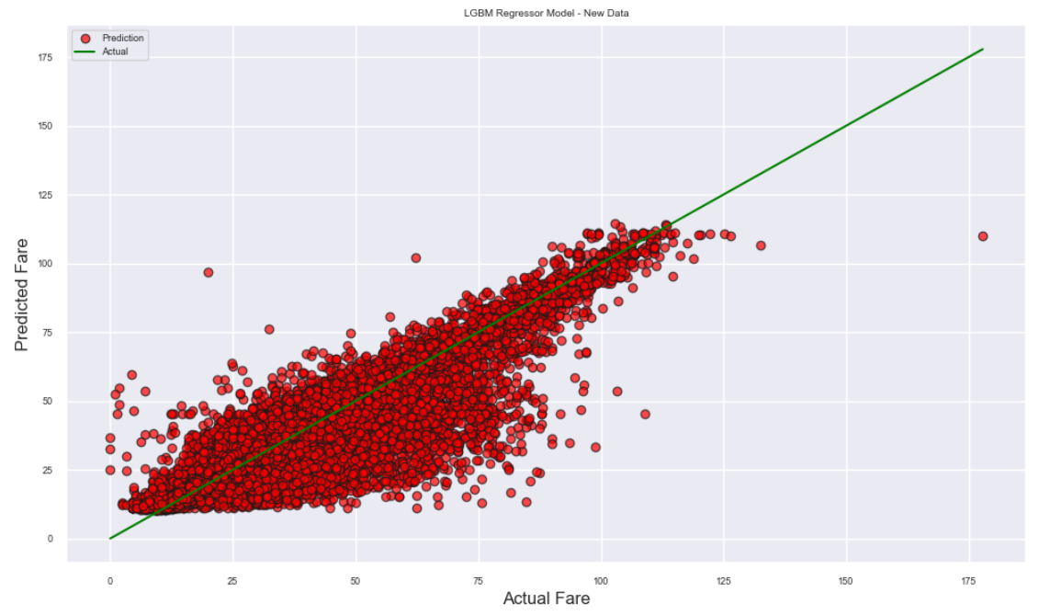
Prediction with New Dataset:

Concluding Remarks
This project involved a full analytics and machine learning pipeline, including data cleaning, feature engineering, feature selection, model training, and evaluation using multiple regression algorithms.
The results show that the model is generally accurate and successfully captures the overall relationship between the input features and taxi fare amounts. However, some dispersion around the ideal prediction line indicates the presence of moderate prediction error.
It was also observed that prediction errors increase as fare values become higher, with the model tending to slightly underestimate high-cost trips. Additionally, a few outliers were identified where predictions significantly deviate from actual values. Despite this, similar patterns were observed when evaluating the model on both the training dataset and an unseen dataset, suggesting good generalization performance.
From a modeling perspective, although using all numerical features produced slightly higher R² scores, these results may be inflated due to strong correlations with the target variable, potentially leading to data leakage. To address this, feature selection using SelectFromModel was applied, reducing redundancy and improving model robustness.
Furthermore, incorporating categorical variables through one-hot encoding improved the model’s ability to capture additional patterns in the data, leading to more realistic and stable predictions.
Video Presentation Link: https://youtu.be/Y6JZ1SCJvT4

