CSIS 3290 – 004 – Project 1
Student Name: Isaac David Rangel Blanco Student ID: 300410730
Project Drescription
This project is based on the prepared dataset from Lab 2, which contains information from a couple thousand courses. Several linear regression techniques will be implemented to predict the target feature and using feature selection techniques.

Task 2: Dataset Analysis
This dataset is the result of cleaning and transforming the original data set, which initially contained some issues that needed to be modified or removed to obtain an appropriate dataset. The preprocessing included correcting columns names, reducing some categories in the CourseCategory column, and applying transformation of the data by using Cbrt in some columns in order to achieve a more normal distribution.
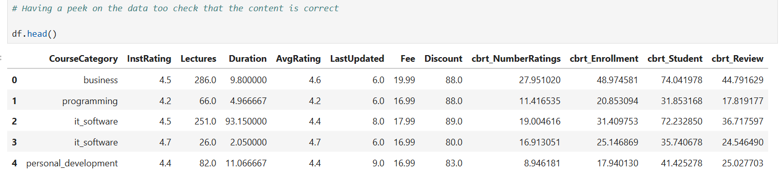
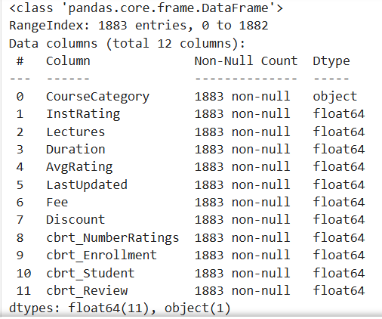
Next, the shapes of the original dataset and the dataset resulted from the lab 2 are presented:
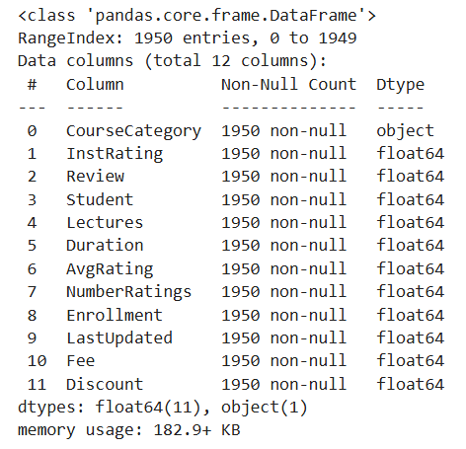

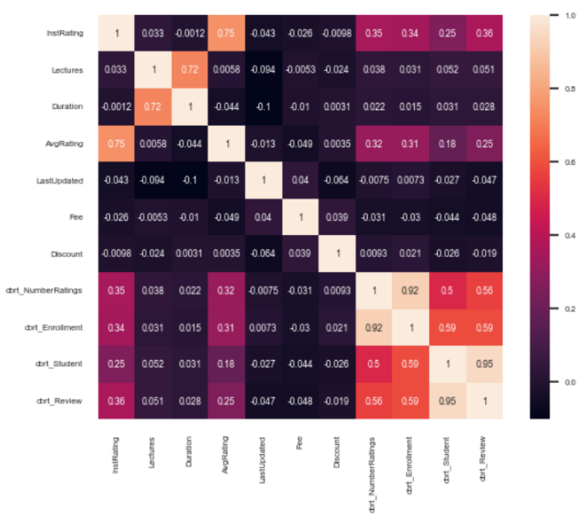
Task 3: EDA
- Heatmap of the correlation features
By looking in the heat map, and having as target the cbrt_NumberRatings column, was possible to see the correlations and confirm that cbrt_Enrrolment, cbrt_Student and cbrt_Review have an appropriate correlation value. Also, can observe that the correlation values and the heatmap are consistent with these results.
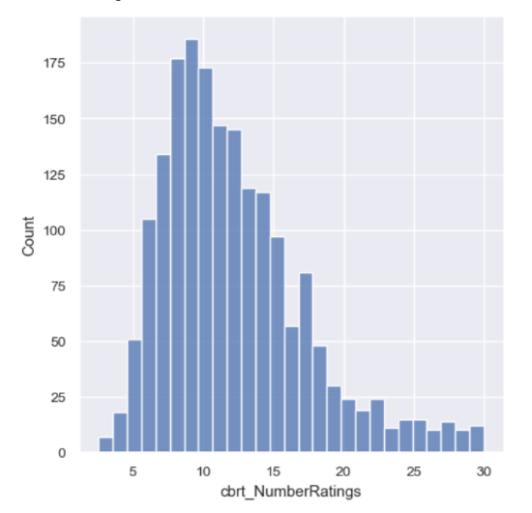
- Univariate Analysis of cbrt_NumberRatings
It was possible to observe some outliers for values around 25 or 30 on the x-axis. To achieve a more normal distribution, the records where cbrt_NumberRatings > 30 were dropped, although the distribution still shows a longer tail on the right side.

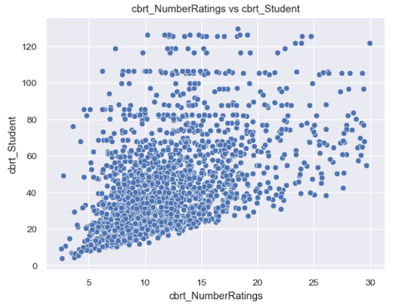
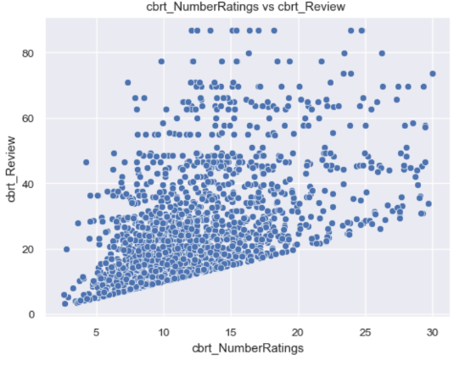
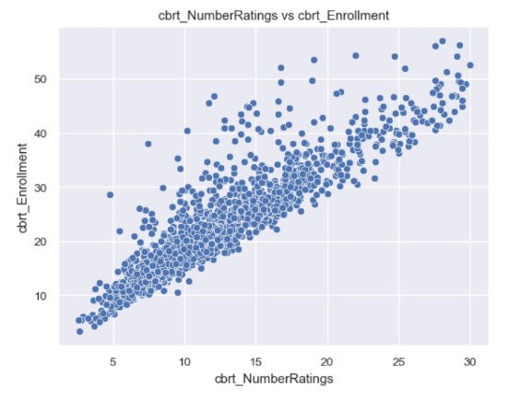
- Multivariate Analysis of cbrt_NumberRatings against other interesting features

By looking at the scatter plots, we can notice that there is an almost linear relationship between the selected features and the target. It also appears to be a strong positive relationship.
We can also observe a dispersion of the data as the values increase. This is more noticeable in the scatter plots with cbrt_student and cbrt_Review.
Task 4: Feature observation and hypothesis
Based on my observations, the most significant features are cbrt_Enrollment, cbrt_Student, and cbrt_Review. However, for the purpose of the project, we needed to select at least six features. I expect that the features I mentioned will have the largest influence on the final model. Some features will have a positive influence while others will have a negative influence on the coefficients, and selecting one feature instead of another with a similar effect would likely not produce a noticeable change in the model's predictions.

Task 5: Simple Linear Regression Report
For the purpose of the project, we needed to run experiments with different feature selection and transformation methods to compare them and determine which approach was most appropriate for creating the linear regression model and obtaining better predictions.
For the correlation-based selection: The features were chosen based on the correlation values calculated in Jupyter Notebook. I sorted these values in descending order and selected the first seven features that appeared in the list. The features selected using this method were 'cbrt_Enrollment', 'cbrt_Review', 'cbrt_Student', 'InstRating', 'AvgRating', 'Fee', 'Lectures'.
For the select K-Best method: The features were chosen based on the SelectKBest method that scores each feature individually against the target instead of looking at correlations between features. The features selected using this method were 'cbrt_Enrollment', 'cbrt_Review', 'cbrt_Student', 'InstRating', 'AvgRating', 'Fee', 'Discount'.
Using the two methods, I get almost the same seven features, but manually I selected Lectures, whereas with K-Best, Discount is selected instead.
The experiments using these features selected are as follows:
Experiment A
- Linear regression model using the selected features and Robust scaler transformation.
- Fit and predict the model using the test set and calculate the RMSE and R² metrics scores
Experiment B
- linear regression model using the selected features and use a log1p transform and the robust scaler transformation.
- Then fit and predict the model using the test set and calculate the RMSE and R² metrics scores.

Task 6: Analysis
For each method, a linear regression model was created, and the R² and RMSE metrics were calculated and saved in a separate dataframe. This dataframe was then used to compare the results from each method or experiment implemented.
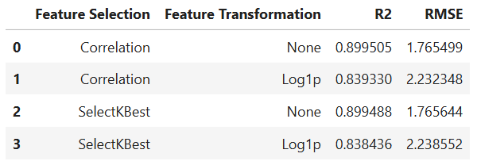
Then, I created a scatter plot to compare the outputs of the selected model (Y_pred) with the test dataset (Y_test) and obtained the list of coefficients for this model:
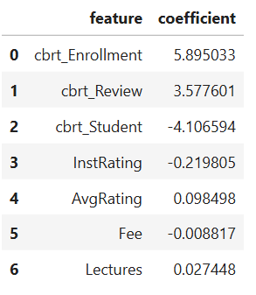
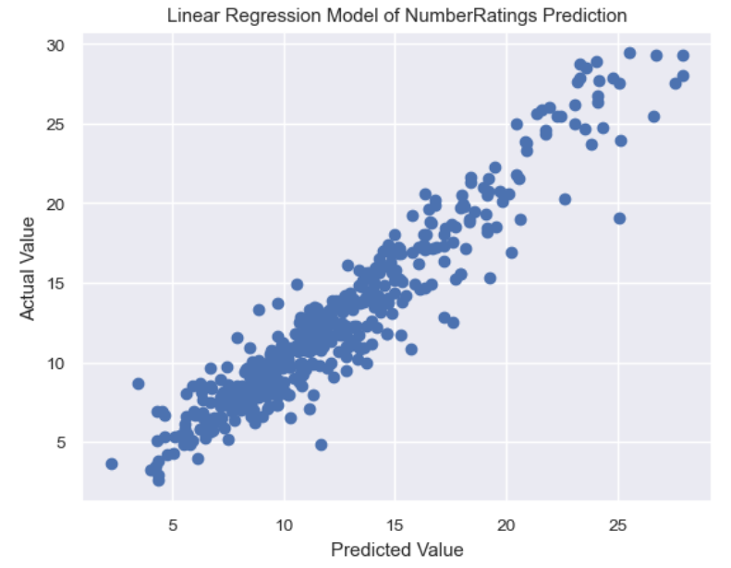
- The best results were obtained using Correlation for feature selection, None Feature transformation and just the Robust scaler, since it produced the highest R² (0.8995) and the lowest RMSE (1.7655).
- Applying the Log1p transformation reduced the model performance for both feature selection methods experiments.
- From the scatter plot, we can see that the model has good predictions and also that there are no relevant outliers.
- About the coefficients, it is possible to determine which features have a positive or negative influence on the final model. Using this information, we can also create the formula that represents the model.
- With these experiments, it was possible to observe that using different methods we can achieve similar results. It is also important to select the appropriate method to avoid overfitting and underfitting scenarios.
- Some additional observations are that we can still try selecting fewer or more features to improve the model. Also, applying other or additional transformations could lead to better results, and we can continue training the model until its performance improves sufficiently.

