a. Develop SQL code to create the entire database schema, reflecting the constraints identified in previous steps.

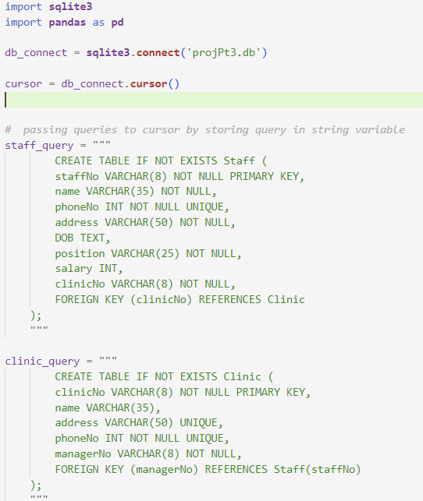

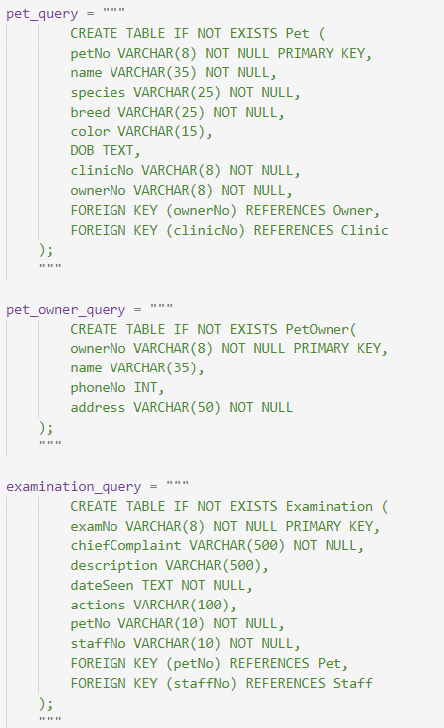

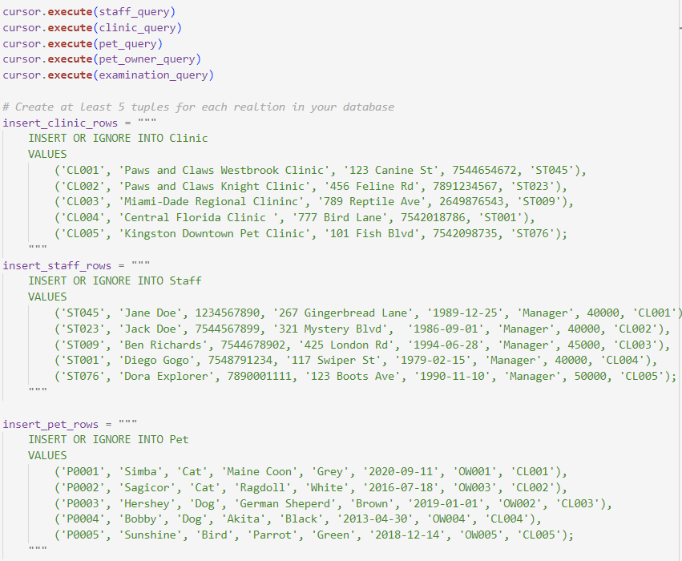

b. Create at least 5 tuples for each relation in your database.



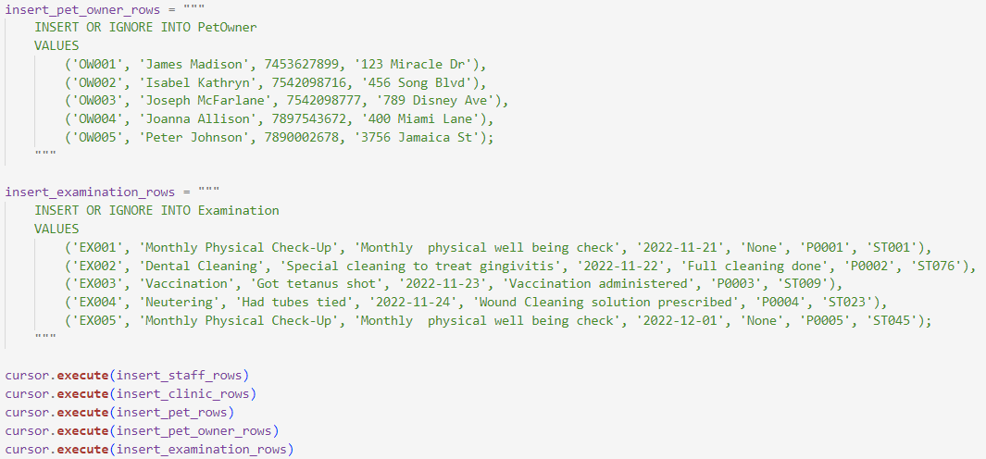

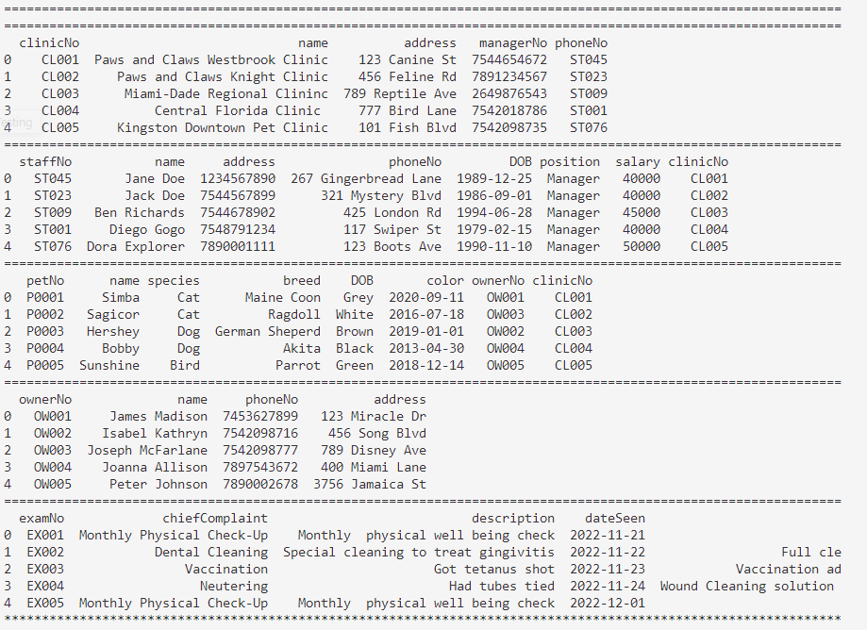

c. Develop 5 SQL queries using embedded SQL (see Python tutorial).

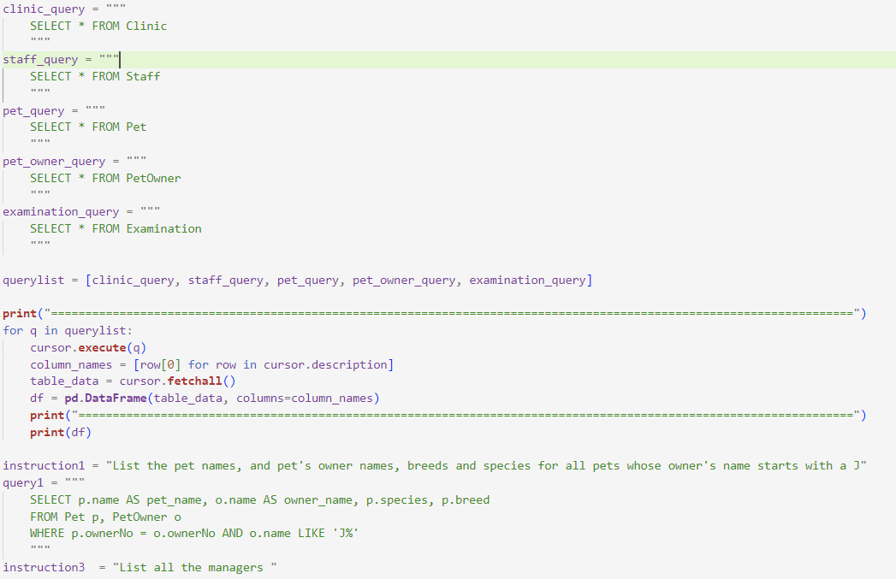

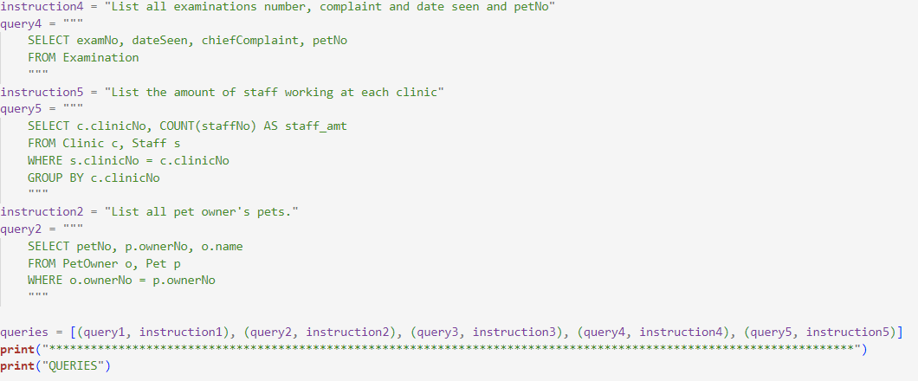

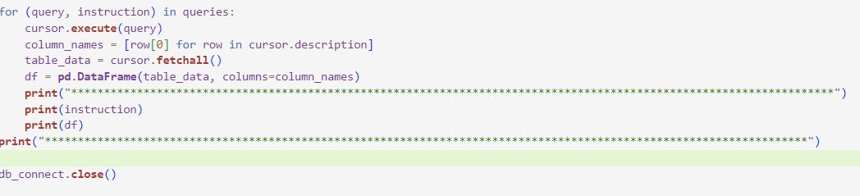

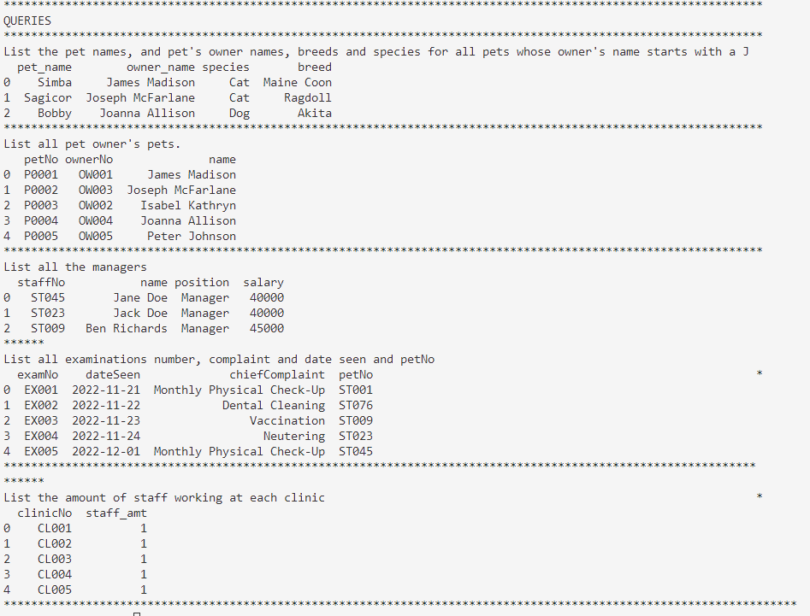

d. Upload all the code and documentation to GitHub.

See github repository at : <https://github.com/isabel-png/csc423>