Appendix

Isabel Renteria and Zuzu Trottier

cor(pre_covid_num)

## Student_Attendance_Year_2_Pct  
## Student_Attendance_Year_2_Pct 1.00000000  
## Teacher_Attendance_Year_2_Pct 0.09082425  
## Suspensions_Per_100_Students_Year_2_Pct -0.61486384  
## Misconducts_To_Suspensions_Year_2_Pct -0.14451478  
## Teacher_Attendance_Year_2_Pct  
## Student_Attendance_Year_2_Pct 0.09082425  
## Teacher_Attendance_Year_2_Pct 1.00000000  
## Suspensions_Per_100_Students_Year_2_Pct -0.06036052  
## Misconducts_To_Suspensions_Year_2_Pct -0.03518840  
## Suspensions_Per_100_Students_Year_2_Pct  
## Student_Attendance_Year_2_Pct -0.61486384  
## Teacher_Attendance_Year_2_Pct -0.06036052  
## Suspensions_Per_100_Students_Year_2_Pct 1.00000000  
## Misconducts_To_Suspensions_Year_2_Pct 0.20391880  
## Misconducts_To_Suspensions_Year_2_Pct  
## Student_Attendance_Year_2_Pct -0.1445148  
## Teacher_Attendance_Year_2_Pct -0.0351884  
## Suspensions_Per_100_Students_Year_2_Pct 0.2039188  
## Misconducts_To_Suspensions_Year_2_Pct 1.0000000

cor(post_covid_num)

## Student_Attendance_Year_2_Pct  
## Student_Attendance_Year_2_Pct 1.00000000  
## Teacher_Attendance_Year_2_Pct 0.28228203  
## Suspensions_Per_100_Students_Year_2_Pct -0.64916121  
## Misconducts_To_Suspensions_Year_2_Pct -0.09092687  
## Teacher_Attendance_Year_2_Pct  
## Student_Attendance_Year_2_Pct 0.28228203  
## Teacher_Attendance_Year_2_Pct 1.00000000  
## Suspensions_Per_100_Students_Year_2_Pct -0.07068021  
## Misconducts_To_Suspensions_Year_2_Pct -0.11753033  
## Suspensions_Per_100_Students_Year_2_Pct  
## Student_Attendance_Year_2_Pct -0.64916121  
## Teacher_Attendance_Year_2_Pct -0.07068021  
## Suspensions_Per_100_Students_Year_2_Pct 1.00000000  
## Misconducts_To_Suspensions_Year_2_Pct 0.13797463  
## Misconducts_To_Suspensions_Year_2_Pct  
## Student_Attendance_Year_2_Pct -0.09092687  
## Teacher_Attendance_Year_2_Pct -0.11753033  
## Suspensions_Per_100_Students_Year_2_Pct 0.13797463  
## Misconducts_To_Suspensions_Year_2_Pct 1.00000000

# generally independent, with some higher correlation values for (suspensions and   
# student attendance) and (suspensions and misconduct-to-suspensions)

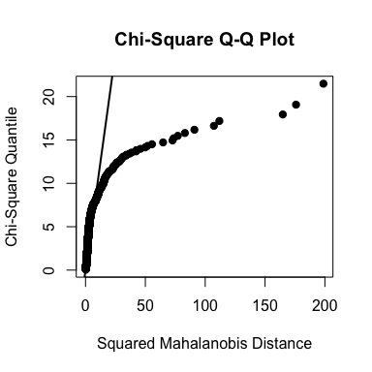

Figure 1: Multivariate QQ plot for pre covid data

# MVN  
mvn_pre$multivariateNormality

## Test HZ p value MVN  
## 1 Henze-Zirkler 90.40323 0 NO

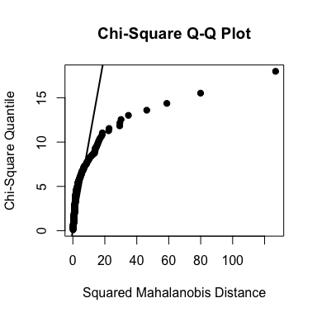

Figure 2: Multivariate QQ plot for post covid data

# MVN  
mvn_post$multivariateNormality

## Test HZ p value MVN  
## 1 Henze-Zirkler 21.63475 0 NO

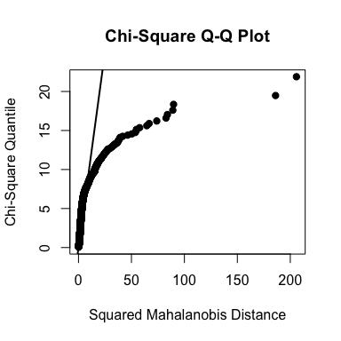

Figure 3: Multivariate QQ plot for all data

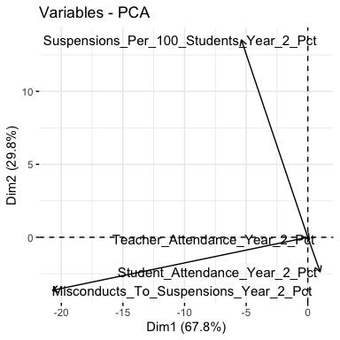

Figure 4: Biplot of variables for pre covid data’s PCA

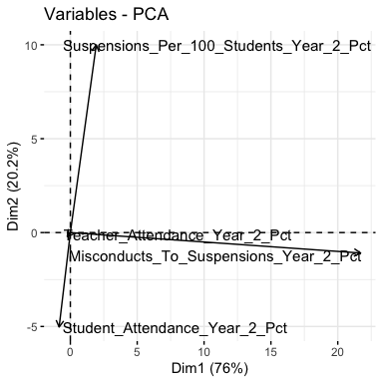

Figure 5: Biplot of variables for post covid data’s PCA

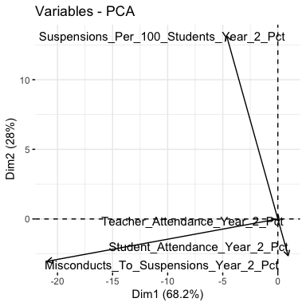

Figure 6: Biplot of variables for all data’s PCA

# PC selection  
PCA_pre <- prcomp(pre_covid_num, scale = sapply(pre_covid_num,sd))  
summary(PCA_pre)

## Importance of components:  
## PC1 PC2 PC3 PC4  
## Standard deviation 1.3111 0.9917 0.9572 0.6174  
## Proportion of Variance 0.4298 0.2459 0.2291 0.0953  
## Cumulative Proportion 0.4298 0.6756 0.9047 1.0000

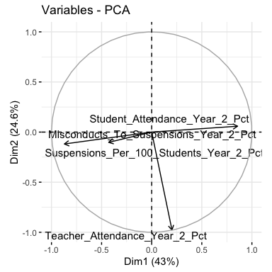

Figure 7: Biplot of variables for pre covid data’s PCA when scaled by standard deviation

# PC selection  
PCA_post <- prcomp(post_covid_num, scale = sapply(post_covid_num,sd))  
summary(PCA_post)

## Importance of components:  
## PC1 PC2 PC3 PC4  
## Standard deviation 1.3350 0.9995 0.9524 0.5582  
## Proportion of Variance 0.4456 0.2498 0.2268 0.0779  
## Cumulative Proportion 0.4456 0.6953 0.9221 1.0000

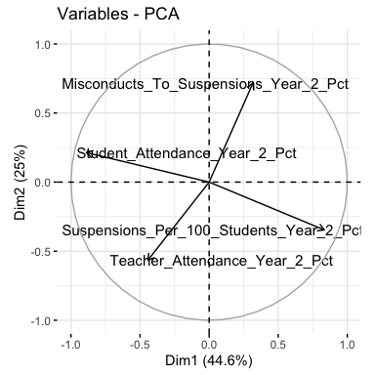

Figure 8: Biplot of variables for post covid data’s PCA when scaled by standard deviation

# PC selection  
PCA_all <- prcomp(all_data, scale = sapply(all_data,sd))  
summary(PCA_all)

## Importance of components:  
## PC1 PC2 PC3 PC4  
## Standard deviation 1.2642 0.9890 0.9604 0.7081  
## Proportion of Variance 0.3995 0.2445 0.2306 0.1253  
## Cumulative Proportion 0.3995 0.6441 0.8747 1.0000

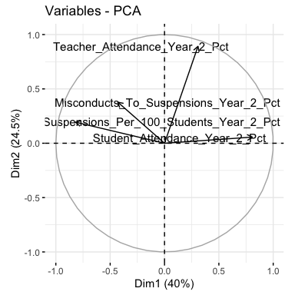

Figure 9: Biplot of variables for all data’s PCA when scaled by standard deviation

# MANOVA with Wilks-Lambda test for pre covid data  
mano_pre_PC <- manova( cbind(Suspensions_Per_100_Students_Year_2_Pct,  
 Misconducts_To_Suspensions_Year_2_Pct,  
 Teacher_Attendance_Year_2_Pct,  
 Student_Attendance_Year_2_Pct)   
 ~Primary_Category , data = box_pre)  
summary(mano_pre_PC, test="Wilks")

## Df Wilks approx F num Df den Df Pr(>F)   
## Primary_Category 2 0.49464 207.24 8 3930 < 2.2e-16 ***  
## Residuals 1968   
## ---  
## Signif. codes: 0 '***' 0.001 '**' 0.01 '*' 0.05 '.' 0.1 ' ' 1

# MANOVA with Wilks-Lambda test for post covid data  
mano_post_PC <- manova( cbind(Suspensions_Per_100_Students_Year_2_Pct,  
 Misconducts_To_Suspensions_Year_2_Pct,  
 Teacher_Attendance_Year_2_Pct,  
 Student_Attendance_Year_2_Pct)   
 ~Primary_Category , data = box_post)  
summary(mano_post_PC, test="Wilks")

## Df Wilks approx F num Df den Df Pr(>F)   
## Primary_Category 2 0.5848 30.459 8 792 < 2.2e-16 ***  
## Residuals 399   
## ---  
## Signif. codes: 0 '***' 0.001 '**' 0.01 '*' 0.05 '.' 0.1 ' ' 1

#pre ANOVAs  
summary.aov(mano_pre_PC)

## Response Suspensions_Per_100_Students_Year_2_Pct :  
## Df Sum Sq Mean Sq F value Pr(>F)   
## Primary_Category 2 93365 46682 282.76 < 2.2e-16 ***  
## Residuals 1968 324906 165   
## ---  
## Signif. codes: 0 '***' 0.001 '**' 0.01 '*' 0.05 '.' 0.1 ' ' 1  
##   
## Response Misconducts_To_Suspensions_Year_2_Pct :  
## Df Sum Sq Mean Sq F value Pr(>F)   
## Primary_Category 2 17546 8773.0 20.219 2.033e-09 ***  
## Residuals 1968 853930 433.9   
## ---  
## Signif. codes: 0 '***' 0.001 '**' 0.01 '*' 0.05 '.' 0.1 ' ' 1  
##   
## Response Teacher_Attendance_Year_2_Pct :  
## Df Sum Sq Mean Sq F value Pr(>F)  
## Primary_Category 2 10.3 5.1285 0.8069 0.4464  
## Residuals 1968 12508.1 6.3558   
##   
## Response Student_Attendance_Year_2_Pct :  
## Df Sum Sq Mean Sq F value Pr(>F)   
## Primary_Category 2 15691 7845.6 980.6 < 2.2e-16 ***  
## Residuals 1968 15746 8.0   
## ---  
## Signif. codes: 0 '***' 0.001 '**' 0.01 '*' 0.05 '.' 0.1 ' ' 1

#post ANOVAs  
summary.aov(mano_post_PC)

## Response Suspensions_Per_100_Students_Year_2_Pct :  
## Df Sum Sq Mean Sq F value Pr(>F)   
## Primary_Category 2 7769 3884.4 43.747 < 2.2e-16 ***  
## Residuals 399 35428 88.8   
## ---  
## Signif. codes: 0 '***' 0.001 '**' 0.01 '*' 0.05 '.' 0.1 ' ' 1  
##   
## Response Misconducts_To_Suspensions_Year_2_Pct :  
## Df Sum Sq Mean Sq F value Pr(>F)  
## Primary_Category 2 532 266.19 0.5621 0.5705  
## Residuals 399 188951 473.56   
##   
## Response Teacher_Attendance_Year_2_Pct :  
## Df Sum Sq Mean Sq F value Pr(>F)   
## Primary_Category 2 110.43 55.216 17.142 7.213e-08 ***  
## Residuals 399 1285.23 3.221   
## ---  
## Signif. codes: 0 '***' 0.001 '**' 0.01 '*' 0.05 '.' 0.1 ' ' 1  
##   
## Response Student_Attendance_Year_2_Pct :  
## Df Sum Sq Mean Sq F value Pr(>F)   
## Primary_Category 2 6768.1 3384.0 133.43 < 2.2e-16 ***  
## Residuals 399 10119.7 25.4   
## ---  
## Signif. codes: 0 '***' 0.001 '**' 0.01 '*' 0.05 '.' 0.1 ' ' 1

#pre box plot  
box_ta_pre <- ggplot(box_pre, aes(x = Primary_Category, y = Teacher_Attendance_Year_2_Pct)) +  
 geom_boxplot()   
box_sa_pre <- ggplot(box_pre, aes(x = Primary_Category, y = Student_Attendance_Year_2_Pct)) +  
 geom_boxplot()   
box_sus_pre <- ggplot(box_pre, aes(x = Primary_Category, y = Suspensions_Per_100_Students_Year_2_Pct)) +  
 geom_boxplot()   
box_mis_pre <- ggplot(box_pre, aes(x = Primary_Category, y = Misconducts_To_Suspensions_Year_2_Pct)) +  
 geom_boxplot()  
  
#post box plot  
box_ta_post <- ggplot(box_post, aes(x = Primary_Category, y = Teacher_Attendance_Year_2_Pct)) +  
 geom_boxplot()   
box_sa_post <- ggplot(box_post, aes(x = Primary_Category, y = Student_Attendance_Year_2_Pct)) +  
 geom_boxplot()   
box_sus_post <- ggplot(box_post, aes(x = Primary_Category, y = Suspensions_Per_100_Students_Year_2_Pct)) +  
 geom_boxplot()   
box_mis_post <- ggplot(box_post, aes(x = Primary_Category, y = Misconducts_To_Suspensions_Year_2_Pct)) +  
 geom_boxplot()

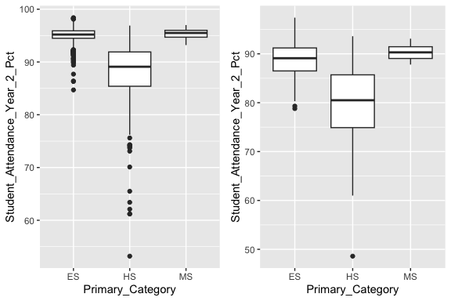

Figure 10: Box Plots of Student Attendance with pre covid on the left and post covid on the right

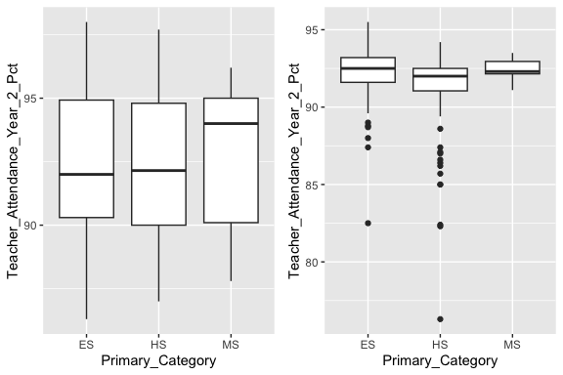

Figure 11: Box Plots of Teacher Attendance with pre covid on the left and post covid on the right

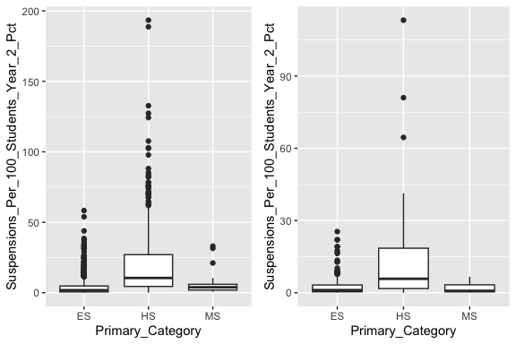

Figure 12: Box Plots of Suspensions with pre covid on the left and post covid on the right

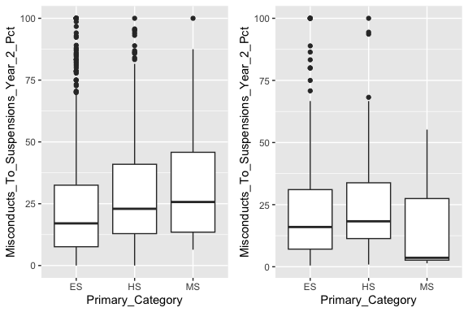

Figure 13: Box Plots of misconducts to suspensions with pre covid on the left and post covid on the right