|  |
| --- |
| Pomolangma Outdoor Equipment Co.,Ltd  Beihai Industrial Zone, Dongtai Town, Dongtai City, Jiangsu,China  Tel:86-515-85448996,,email:pomo@pomolangma.com |

**PACKING DECLARATION**

**Vessel name:**…… …HYUNDAI UNITY .**Voyage number:**… / 112S .…

**Consignment identifier or numerical link**……DRYU2220054/20GP/ 190535398

|  |  |  |  |  |  |  |  |
| --- | --- | --- | --- | --- | --- | --- | --- |
| **UNACCEPTABLE PACKAGING MATERIAL STATEMENT**  (Packaging material such as straw, peat, hay, chaff, used fruit & vegetable cartons are not permitted)  Q1 Have unacceptable packaging materials been used as packaging or dunnage in the consignments   |  | | --- | |  |   covered by this document?   |  |  |  |  |  |  | | --- | --- | --- | --- | --- | --- | | A1. | YES |  |  | NO | √ | |

|  |
| --- |
| **TIMBER/BAMBOO PACKAGING/DUNNAGE STATEMENT**  (Timber/bamboo packaging/dunnage includes: crates, cases, pallets, skids, and any other timber or bamboo  used as a shipping aid)  Q2 Has timber/bamboo packaging/dunnage been used in consignments covered by this document? |

|  |  |  |  |  |  |  |
| --- | --- | --- | --- | --- | --- | --- |
| A2. | YES Timber |  | YES Bamboo |  | NO (nil timber/bamboo) | √ |

**TREATMENT CERTIFICATION (ONLY IF TIMBER/BAMBOO PACKAGING/DUNNAGE IS DECLARED IN QUESTION 2)**

Q3 All timber/bamboo packaging/dunnage used in the consignment has been (Please Indicate  
 below)

|  |
| --- |
| **Treated and marked in compliance with ISPM 15** (Note: ISPM 15 is only applicable to timber packaging)  Or |
| **Treated in compliance with Department of Agriculture**  **and Water Resources treatment requirements**  (With accompanying treatment certificate) |
| Or  **Not treated** |

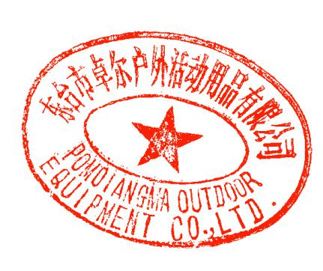 **CONTAINER CLEANLINESS STATEMENT** (**for FCL/X consignments only** - statement to be removed from document when not relevant)The container(s) covered by this document has/have been cleaned and is/are free from material of animal and/or plant origin and soil.

Signed: ........................................................... Printed name:..........ROSE ....................................

(Company representative)

Date of issue:....9th/Dec/2019................................