# Introduction

**Ocean Of Things** was born in 2014 as a CCONEC project (Cognitive Changes In Oceanic Navigation in Extreme Conditions). It was specifically built for the Barcelona World Race 2015 edition.

The Ocean Of Things team is made up of members who are experts on creating solutions that connect people, devices and services around the wireless supervision, control and data acquisition.

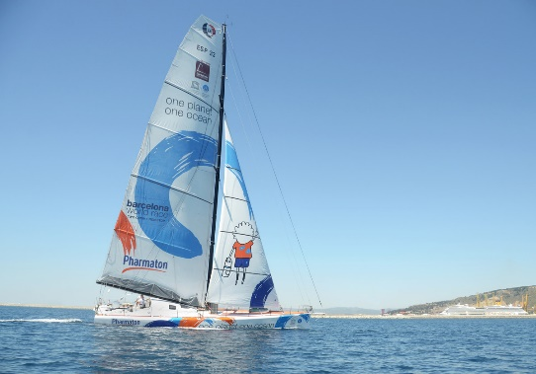

Boat “One Planet One Ocean”

The team aspires to create the scientific sailboat to be used in the next edition of the Barcelona World Race. The aim is to provide technological platforms with technological innovation, that includes the design and testing of new products of research and innovation within the nautical world of regattas.

The project, Ocean of Things, is composed of two parts:

1. **data acquisition**

* In the first part, we have some sensors connected to a PLC (that will be a Dragon Board or an Intel Joule). Since boats easily get wet, we have two sets of computer system, with the exact same architecture, in case one malfunctions when water gets in.
* The sensors include those for temperature, humidity, brightness, color, and barometer. We have a local copy of these data in an SD. Since most of the time they won’t have connection, we will do the synchronization once they have connectivity.
* The journey will be documented and all its data included. All these data, collected by performing a series of tasks to get information about the state of our oceans, will then be interpreted and processed by experts.
* Those scientific programs are: [surface temperature and salinity levels of seawaters](http://www.vg2016.com/salinity/), [citclops project](http://www.vg2016.com/proyecto-citclops/#fnoben), [argo beacons](http://www.vg2016.com/balizas-argo/#fnoben), and [microplastics and other contaminants](http://www.vg2016.com/microplastics/#fnoben).
* *(add more description about these programs if it’s necessary. It’s not relevant for the project, but it’s interesting)*

1. **Boat AutoPilot**

* The boat has an **NMEA** *Instrumentation Bus.*

With this device, they can gather crucial data like the torsion and tension of the main mast, efforts of the cables or sails, the magnitude or frequency of waves.

Not only can we get information, but we can also use the auto-pilot to configure sails and do all that while the boat is continuously moving towards a particular direction.

Last March 20, 2017, Microsoft held a three-day HackFest focused on IoT technologies. Approximately twenty people from different departments of the company helped seven customers across Europe to develop their projects.

During these three days, in the Ocean Of Things project, the following Microsoft employees participated:

• Erica Barone, Technical Evangelist from Italy as IoT Mentor

• Isabel Cabezas, Technical Evangelist, Spain.

They helped the Ocean of Things team formed by:

• Pep Lluis Bano, Team Manager

• Irene Medina, Staff Manager

• Mikel Irazabal. Scientific

• Marc Mundo, Engineer

For the development of this project in the hackathon we used some sensors; temperature, humidity, brightness, color and a barometer. All these are connected and sending data to a physical gateway. This gateway saves the data when the boat doesn't have Internet connection and eventually synchronizes it once the boat establishes a connection.

## Key Technologies:

Windows IoT Core  
Visual Studio (C++/ C# / nodeJS)  
Visual Studio Team Services  
Azure IoT Suite (IoT Hub, Azure IoT Gateway SDK)

NodeRed

Intel & ARM processors.  
Several types of sensors/devices and electronics.

## Customer profile

The “OceanOfThings” Project was born in 2014 due to the common will of a few people with the same interest in navigation and sport.

The team is composed of volunteers who combined their creativity, experience and passion to carry out a common project. Among themselves, they have a total of more than 32 years of experience working on Industrial Environments.

Their goal is to have a much higher level of efficiency and to get inspirations that will result to the best solution in this seascape.

This project is not backed by a legal company and is funded by the personal investments, of time and effort, of the group of technicians working on it.

All software created for this project was developed under open source software, and it is absolutely a non-profit activity.

The team does not have an official physical office to develop this project. They do it remotely, from their homes (distributed in several towns in the province of Girona, Spain). From time to time, they gather together to follow up the tasks, either at the home of one of the members or in a co-working space.

The members of this team have basically created their own non-profit organization for this specific project related to IoT in a maritime environment. In principle, it is not available either as a product or as a service.

<http://www.vg2016.com/>

<http://www.barcelonaworldrace.org/es/educacion/programa-educativo/explora/navegacion/el-imoca-60>

<http://www.barcelonaworldrace.org/es/equipos-2014-2015/one-planet-one-ocean-pharmaton>

### 

### About the boat:

The model of the sailboats that are used in this competition is called IMOCA Open 60.

IMOCA means “International Monohull Open Class Association”. The main task of this international association is organizing regattas and [single handed](https://en.wikipedia.org/wiki/Single-handed_sailing) circumnavigation regattas.

The class, which is a development class, is the main focus of IMOCA. As the name implies, the class is “open”. It means that it does not have any fixed designs and instead is defined by a “box rule” which means that as long as it meets certain restrictions (mostly for the security of the crew), any design is permitted.

But at the same time there are plenty of scope for innovation and the development of new ideas, quite revolutionary in this type of sailboats.

So each IMOCA 60 has their own features and properties. It is because of this specific features and properties that the Machine Learning model generated for this boat “One Planet, One Ocean” and its training will only be meaningful and applicable for this boat.

# Problem statement

Even with the advances in technology that we have today, going against natural elements is still not an easy feat.

One perfect example of this situation is this project, the Ocean of Things.

Working with electronic components on an 18-meter boat in the middle of the ocean is quite a challenging task.

We have faced several problems due to the inherent nature of the Project, like unreliable data connection, poor availability of electricity, frequent water splashes over our electronic components and lack of space in the boat.

Depending on the location and how far from the coast the boat is, our system will have or not Internet connection available. The unreliable data link makes it impossible to upload data to the cloud in real time.

In the hackfest, we tried several scenarios with and without connection to test the process of data saving in a local database. We then tested sending data to the cloud and the automatic synchronization in the case the data is saved in the local hdd and also when it gets the internet connection back.

For the electrical installation in the boat, we only have an electric line of 15 volts and an 5 ampere. So all of our system architecture has to work strictly within this unyielding tight limits. It is not possible to connect systems/hardware which require more electrical power than that.

Since boats and all its content easily get wet, we have two identical systems, with the exact same sensors: temperature, humidity, brightness, color and a barometer.

Although we have all our system in a watertight box and we trust that the water will not get in, we prefer to have a backup system, and everything duplicated. For good measure, we are not thinking about data redundancy in this case. Because in the event the system doesn’t work, we could lose months of irretrievable data.

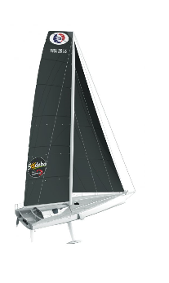

The “One planet, one ocean” boat is an IMOCA 60 yachts, specially designed for solo and double-handed ocean sailing. The length is 60 feet (18.29 meters) and the draught is 4.5 meters: so, only have small cabin where two people has to live continually for three months.

They don’t have so much space for themselves. They sleep in a deckchair and need to store food for three months.

The lack of space it’s why our computer system can’t be very big, we have some size restriction and the package with the watertight box shouldn’t be bigger than 0.30m^3

Fortunately, the technical team who was part of the project has a lot of experience: over 12 years. They are very knowledgeable about IoT, electronics and telecommunications.

We should design a system that could be remotely maintained: fix and update. Because if something fails in the middle of the ocean, our technical team won’t be able to have physical access to it.

In the initial state, the synchronization was implemented from scratch in C. Everything was coded and they didn’t use any library nor the Azure SDK.

Obviously, we didn’t have the boat in Madrid, so we couldn’t get access to the original NMEA Instrumentation Bus during the development/hackfest.

The team didn’t have any kind of experience with Machine Learning, and the aim was abstract and confused, we didn’t have any data scientist, nor a sailor or someone who has the know-how for the recovery of data which could be analyzed for the Machine Learning Algorithm.

# Solution and steps

## Previous work (done before the HackFest)

We can’t have the boat in Madrid nor access to the original NMEA Instrumentation Bus during the development/hackfest. So we have to mock the device and the data it generates.  
Before the hackfest, during the trainings of the last few months, data was being saved for having real data generated by the NMEA instrumentation Bus to be used during the HackFest.

In the previous edition of the Barcelona World race, when the boat "One ocean, one planet" sailed during the race, they already stored the data that generated the sensors. The code developed then is OpenSource and you can find it in this github repository: <https://github.com/mirazabal/OceansOfThings>

## Hardware

For the development of this project in the hackathon we used some sensors; temperature, humidity, brightness, color and a barometer. All these are connected to an [Intel Joule](https://software.intel.com/en-us/iot/hardware/joule) that collects the sensor data and sends it to a physical gateway. This gateway saves the data when the boat doesn't have Internet connection and eventually synchronizes it once the boat establishes a connection.

The first thing that we did in the HackFest, was build the same architecture system that will be used inside the boat. We worked with exactly the same kind of sensors and architecture.

You can see details about the used hardware in “Technical delivery” Section. [Link]

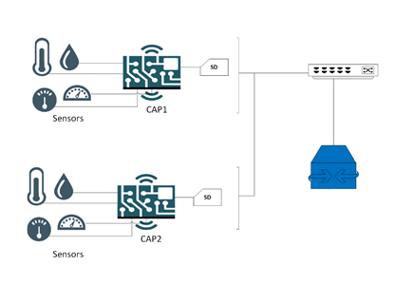

## Organization of work during the hackfest.

The group was divided into two teams.

The aim of the first team was to make a rapid prototype.

After making this prototype, data will be sent to the cloud through an IoT Hub instance and then we will start to analyze them and build a dashboard with Power BI.

The second team worked with Azure Gateway SDK. They started a proxy that established communication with the Cloud. The proxy’s function is to send the data to the cloud through an IoT Hub and control the synchronization when the device is offline.  
Unfortunately, the work with the Azure Gateway SDK couldn’t be completed during the HackFest. We don’t have a reliable and finalized version of the designed system with the Azure Gateway SDK.

## NodeRed Prototype

Development boards, called “CAP”, as shown in the illustration below, have the sensors connected and they gather data from them with a C++ application that you can find in this Github Respository:

<https://github.com/mirazabal/OceansOfThings/tree/master/IoT_Node>

This code is also responsible for saving these recovered data in the local database, represented as an “SD card”.

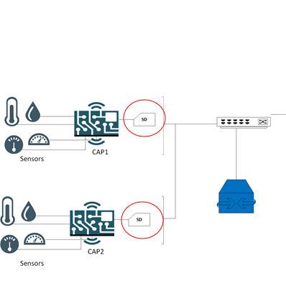

The data are then stored in a database inside the gateway, where we also have a NodeRED service running a script that will select the most recent data saved in the DB that have not been sent yet to the cloud.

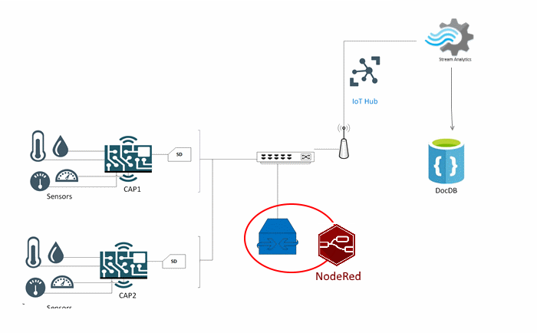

Still in relation to that, we have a column in the table to keep track whether the row was already sent or not.

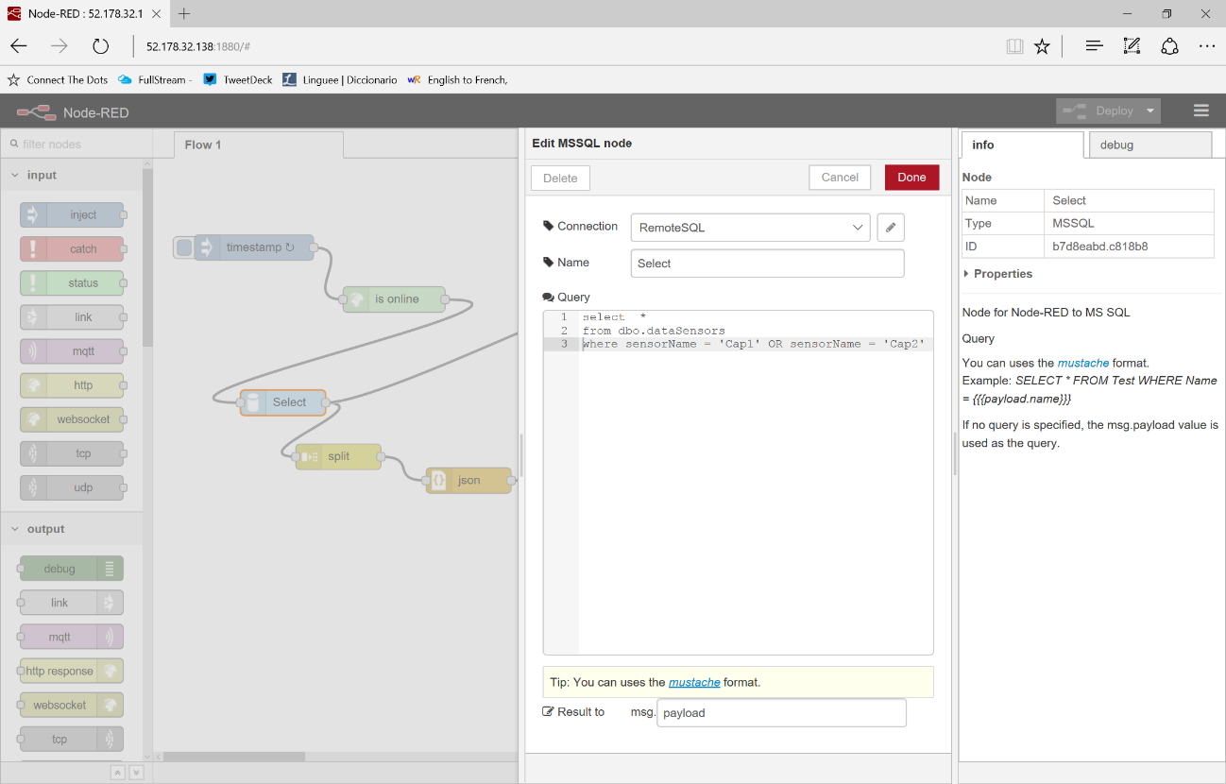

After getting *not-sent* data from the database, we send these data through Azure IoT Hub:

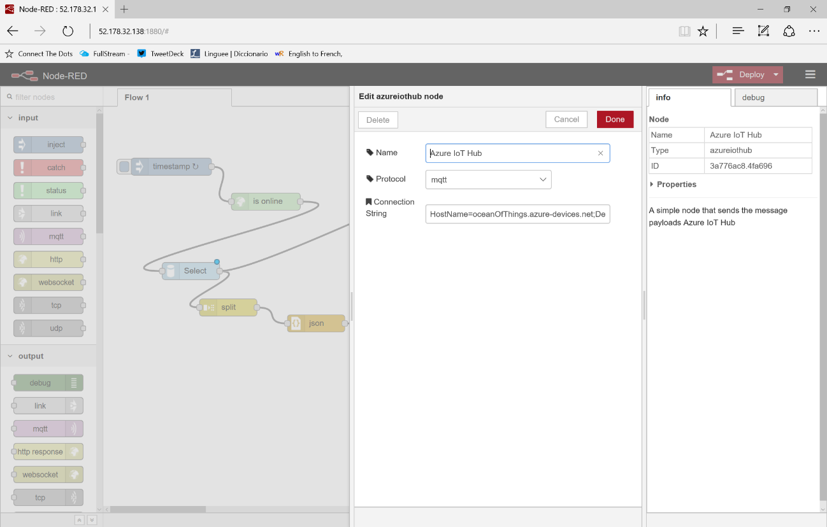

And after successfully sending it, we then update the local database column to flag it like “sent”.

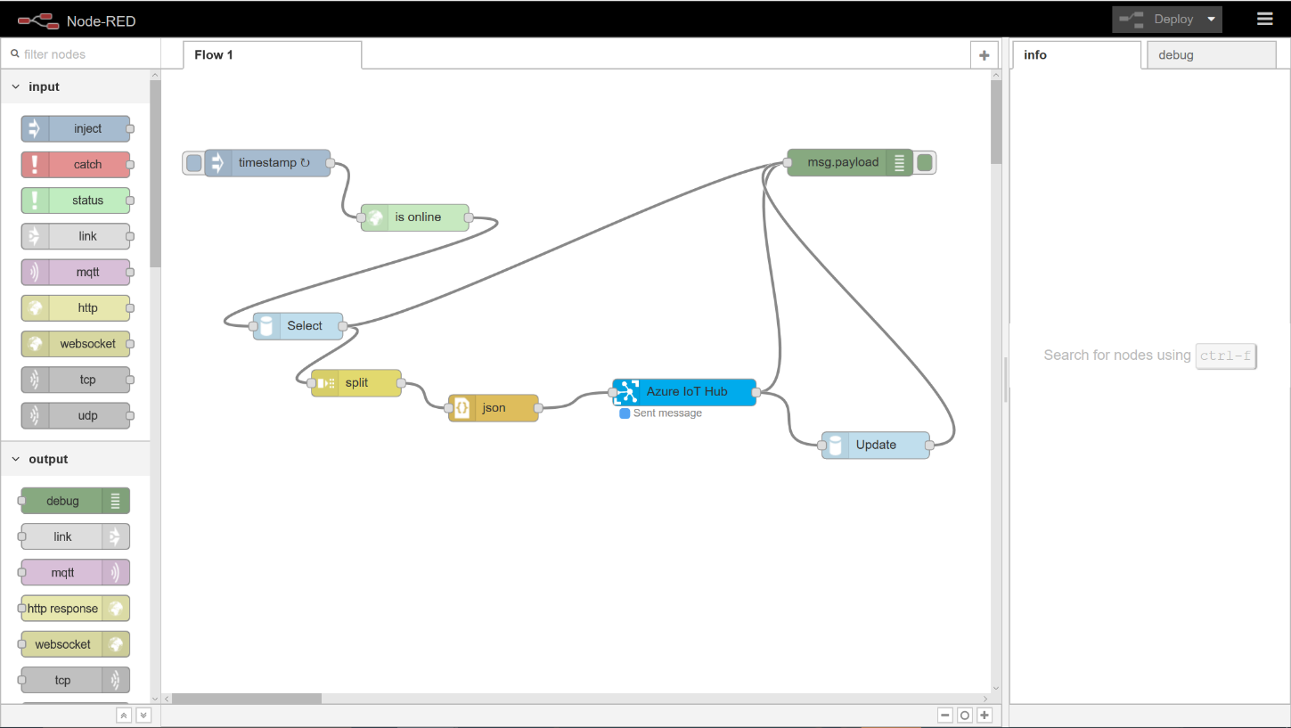

## Using Stream Analytics to save data from IoT Hub to Document DB

We used Azure DocumentDB as NoSQL database for saving data we collected from the sensors we have in the boat. We have chosen [Azure DocumentDB](https://azure.microsoft.com/services/documentdb/) for its high availability and guaranteed low latency and high throughput.

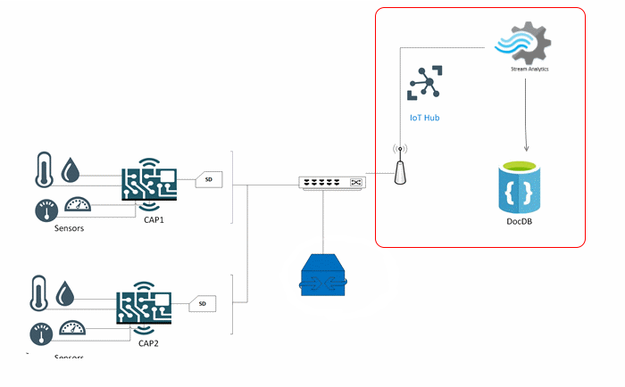

For building this architecture, we created an IoTHub service and then we registered the Intel Joule as a device.

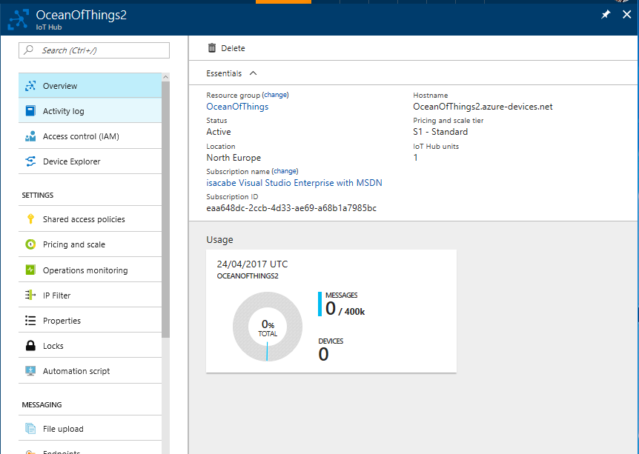

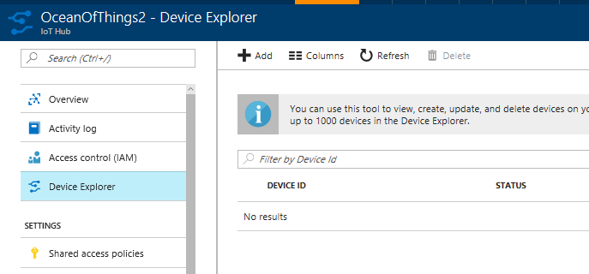

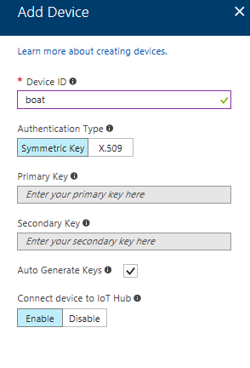

The id and key for the device were used in the NodeRED flow to connect the device with IoTHub and start sending data from the gateway.

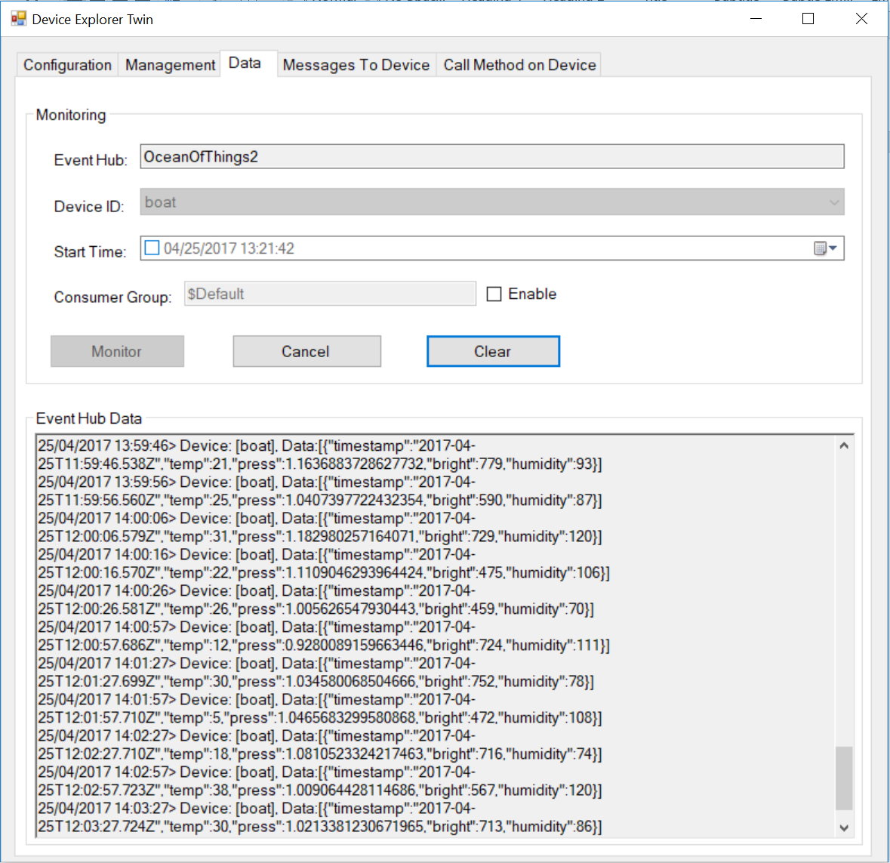

### Creating a Stream Analytics to connect the Iot Hub and the Document DB:

Once we have the data arriving to IoT Hub, we can connect it as an input for a Stream Analytics Job, that we will use to store all the incoming data into a DocumentDB collection.

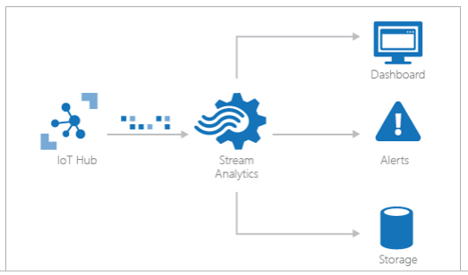

For this, we created the job:

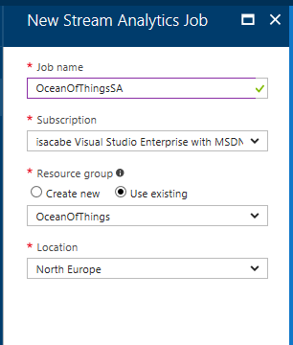

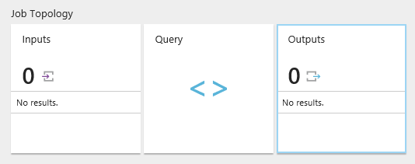

And then we defined the IoT Hub as an input:

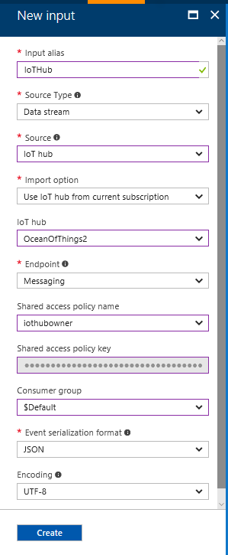

The output of the job was connected to an already created DocumentDB collection:

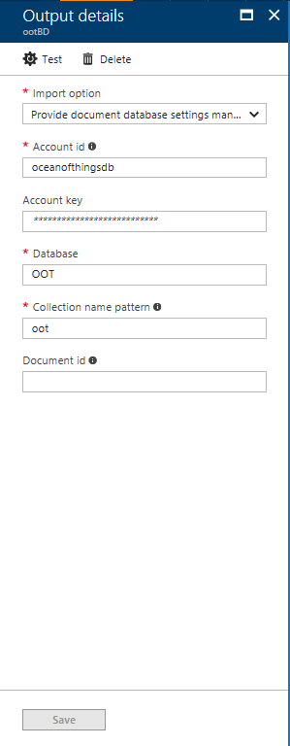

+ Output

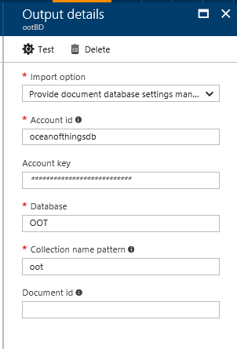

+ Query

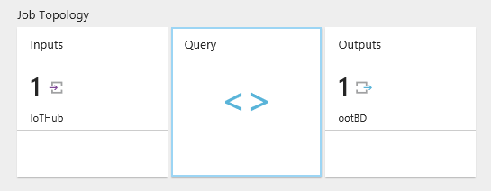

In order not to further encumber our first test of Stream Analytics, we add a simple query:

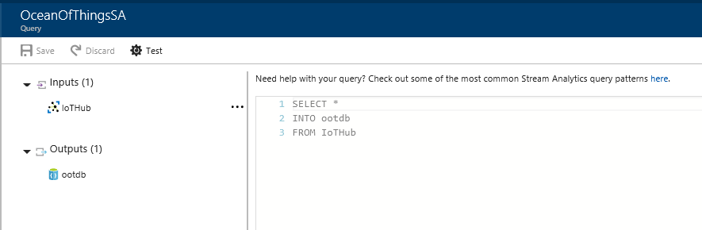

And finally we started the Stream Analytics job:

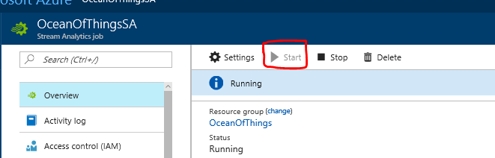

When the job finished to start up, we began to see the outputs in the DocumentDB:

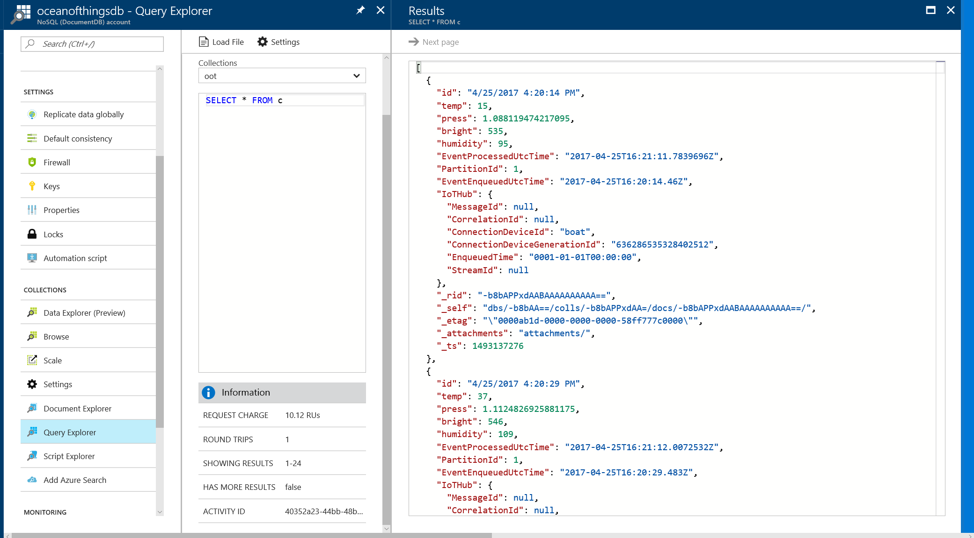

1. ./media/image24.png

## Building a graph from the boat data with PowerBI

Now, exporting data from Document DB into Power BI, we can create a dashboard to visualize the data:

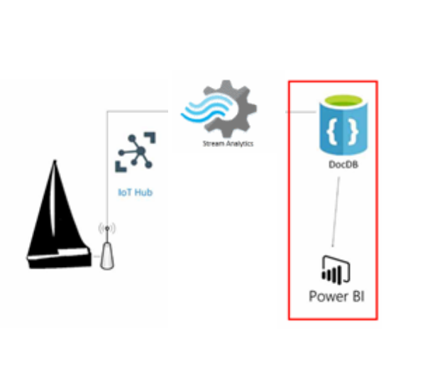

We are going to walk through the steps on how to connect to a DocumentDB account in Power BI Desktop, navigate to a collection where we want to extract the data using the Navigator, and transform JSON data into tabular format using Power BI Desktop Query Editor.

First we connect to a DocumentDB instance using the Get Data wizard:

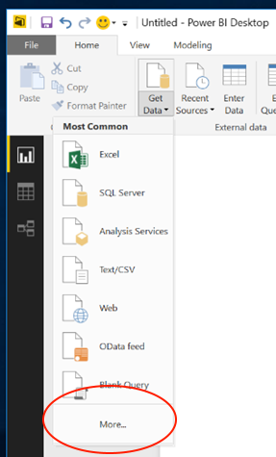

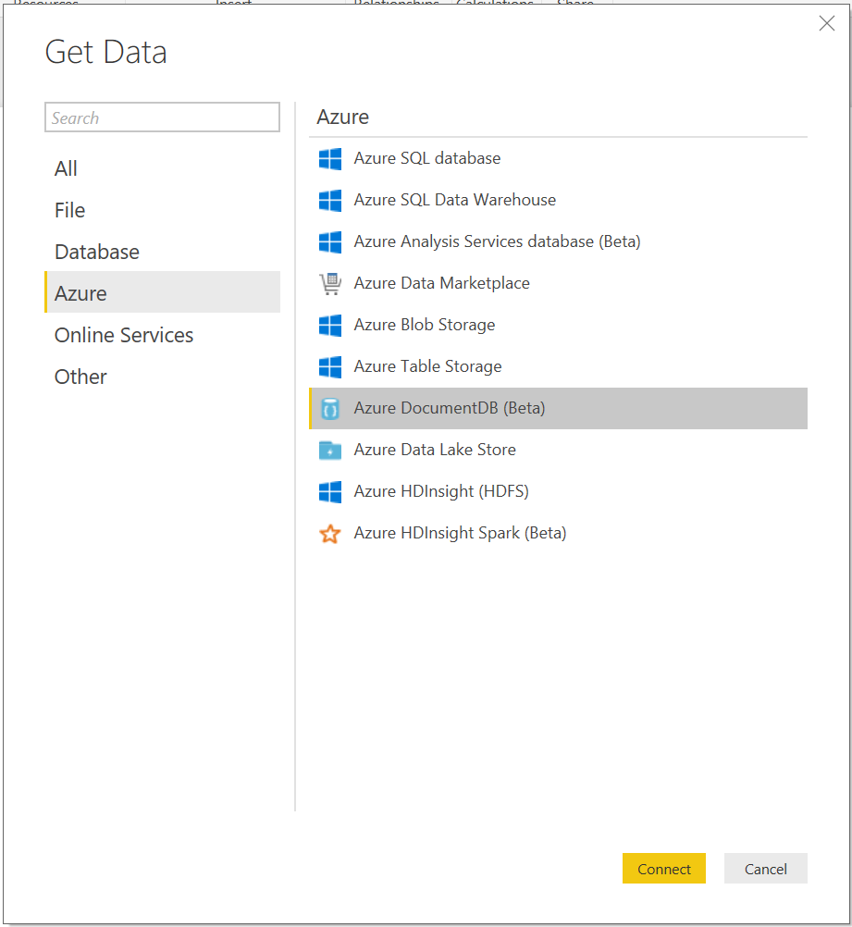

This gives us a one-column table with the documents. To get real data from DocumentDB into PowerBI, you have to click on the expander at the right side of the **Document** column header (red mark), and click on the “Close & Apply” (green mark) to build the graphs.

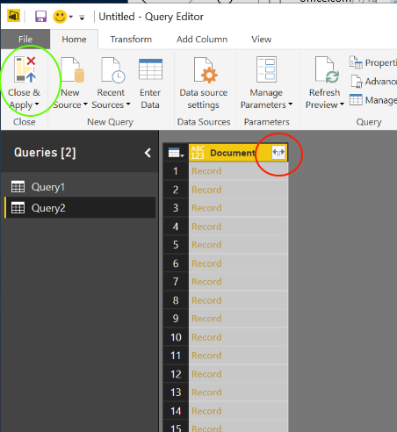

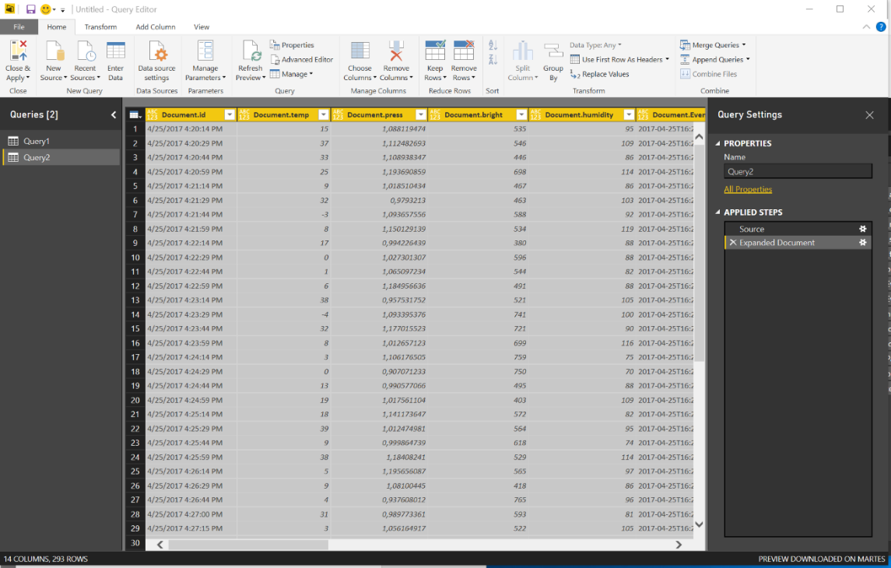

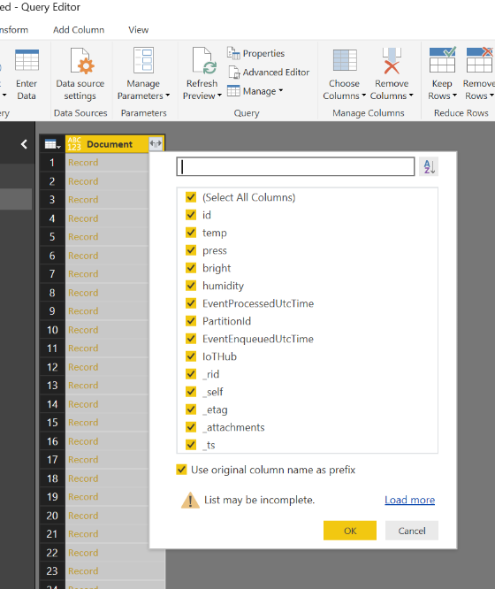

[Tip] If you can’t remove the function “count” applied to each column, try “Edit Queries” instead and change the type of the column to “number”:

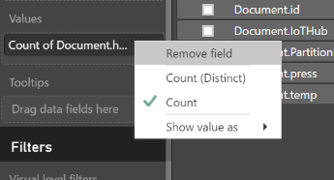

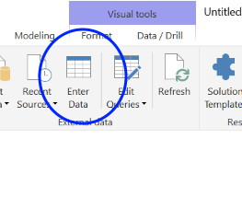

Finally, we easily created a dashboard to visualize the data with some charts:

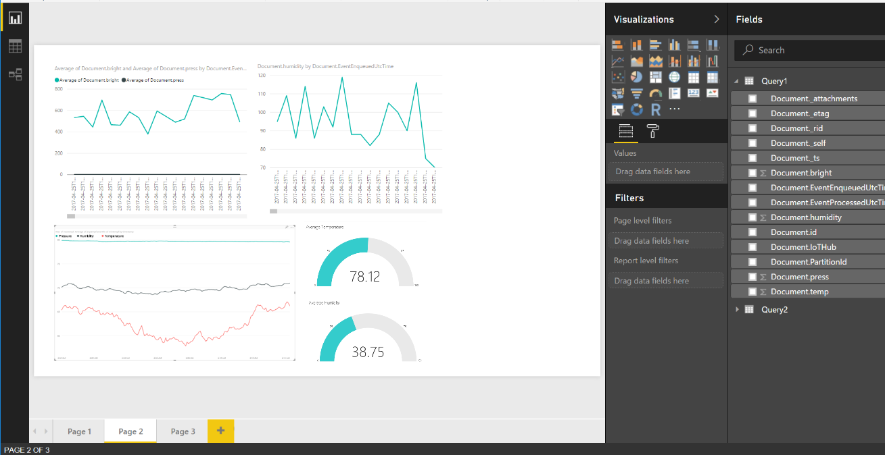

## Tuning the AutoPilot with Machine Learning

The **NMEA** *Instrumentation Bus 0183*, is the control panel for the boat:

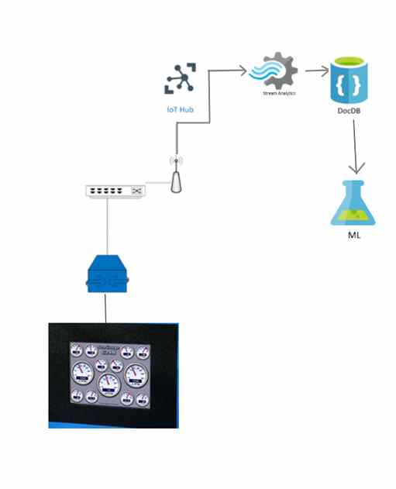

With this device, they have access to telemetry data like the torsion and tension of the main mast, efforts of the cables or sails, as well as the magnitude or frequency of waves. Not only can we get information, but we can also use the auto-pilot to configure sails and do all that while the boat continuously moves to particular direction.

It is connected via a USB port to the main PC of the boat.

The bus for the data extraction is similar to the standard [RS485](https://en.wikipedia.org/wiki/RS-485) and the extraction will be sent to the gateway using the MQTT protocol locally.

The NMEA Instrumentation Bus is a big central system totally integrated into the boat. It drives 3 NKE hydraulic drives and has one LG screen monitor installed in the master cabin.

As expected, we could not possibly bring the boat to the HackFest. The only way to develop the solution is to mock the data.

We used a Raspberry Pi 3, and data was recovered in the last trainings of the boat for simulating the NMEA Instrumentation Bus of the boat.

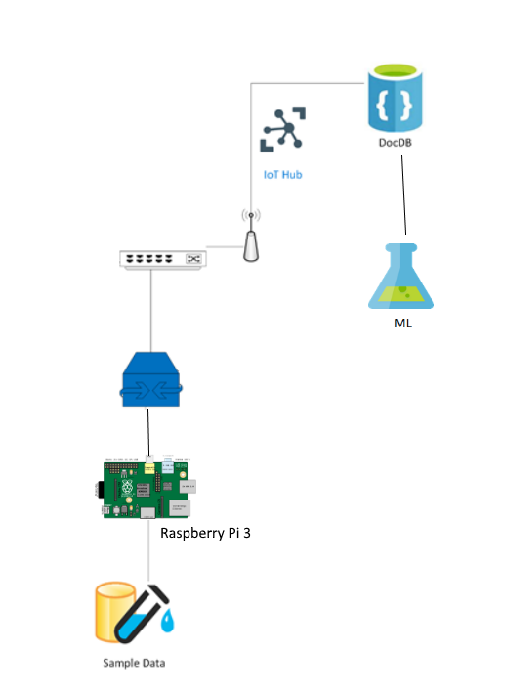

We simulated real data (of a navigation tool) with a Raspberry Pi 3 and we used this data for creating a machine learning model using AzureML, whose final objective is to create the automatic pilot of the boat.

The simulated architecture of our model is represented in this schema:

The version of MQTT we used is Mosquitto, and the library for node.js we used is called MQTT.js, available in NPM.

<https://www.npmjs.com/package/mqtt>

In our scenario, the Raspberry Pi 3 was the “broker” of the MQTT communication and the gateway acted as the local client. The script hosted on the Rasberry PI 3 is shorter than 10 lines: reads the data from one csv file with recopiled data, connects and publishes it. You can read how it works in the simple example of the documentation: <https://www.npmjs.com/package/mqtt>

The MQTT client, in our scenario is the proxy/gateway, during the hackfest we built a simulation in Node-Red. This step doesn’t has any difficulty. Just configure the *mqtt* imput node with the broker address and topic, convert the received string in a Javascript object and analyze.

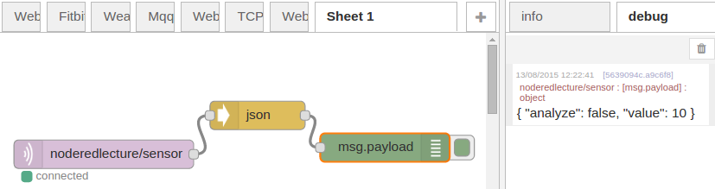

Send the processed data we need to the IoT Hub

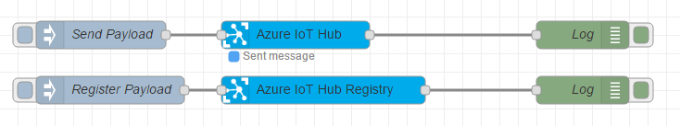

Node red ioT hub

## Saving data from the Autopilot in a DocumentDB

As we did in a previous example, we also saved data from IoT Hub to DocumentDB using Stream Analytics.

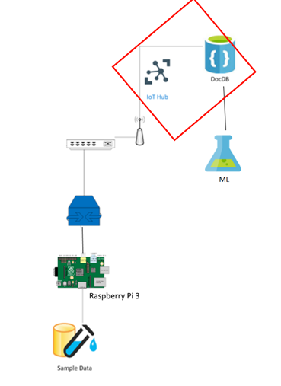

## Import data Into Machine Learning Studio from DocumentDB

Machine learning is not a solution for every kind of problem, but in this case we can’t determine a target value by using simple rules, computation or predetermined steps.

Sailing techniques are complex and they cannot be adequately solved using a simple rule-based solution. A large number of weather factors could influence in the sailing.

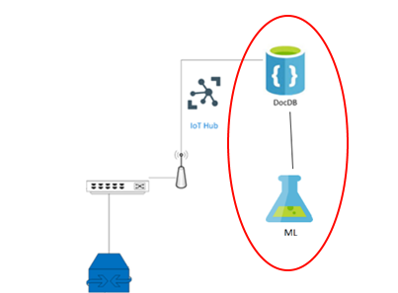

No one in our team had a extensive experience working with Machine Learning, so we rely on the [official Azure Machine Learning documentation](https://docs.microsoft.com/en-us/azure/machine-learning/machine-learning-algorithm-choice) to choose the between all the machine learning algorithms to find the better fit for our problem. As we need to predict a continous value (the halyard tension) from a large set of variables, it looked like a good case for a regression algorithm.

So, we started with a blank experiment to play with the data and see if we could get something from it:

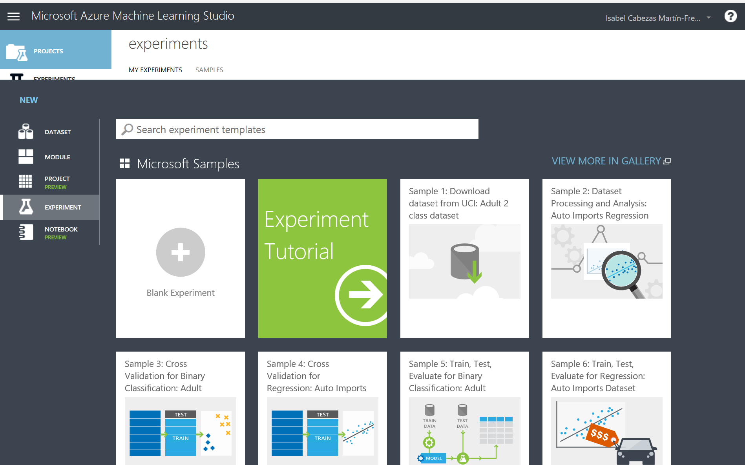

### Getting the data inside Azure ML

The connection from the DocumentDB where we saved our data, to our new experiment of machine learning is very easy to create.

In the “Import Data” node, we can look the sucesfully imported data from DocumentDB and data themselves if we select “Visualize” in the contextual menu:

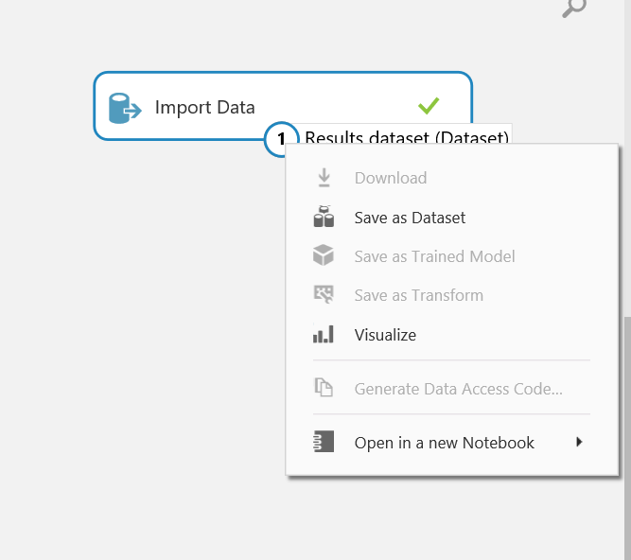

### Building the model

Even though we didn't have a Data Scientist nor a Technical Sailor expert, we could achieve a first approximation of the machine learning model. It is undoubtedly a first step, although the confidence level of the model doesn’t allows us put it in production by now.

When we took a look about data the boat / NMEA Instrumentation Bus recollected, we imagine what these data meaning and their influence in the future navigation delegate to the autopilot.

Fortunately, despite of our lack of experience, the Azure Machine Learning Studio tool is an easy-to-use, drag-and-drop tool that allows us to create a POC: an easy first machine learning model in a few hours.

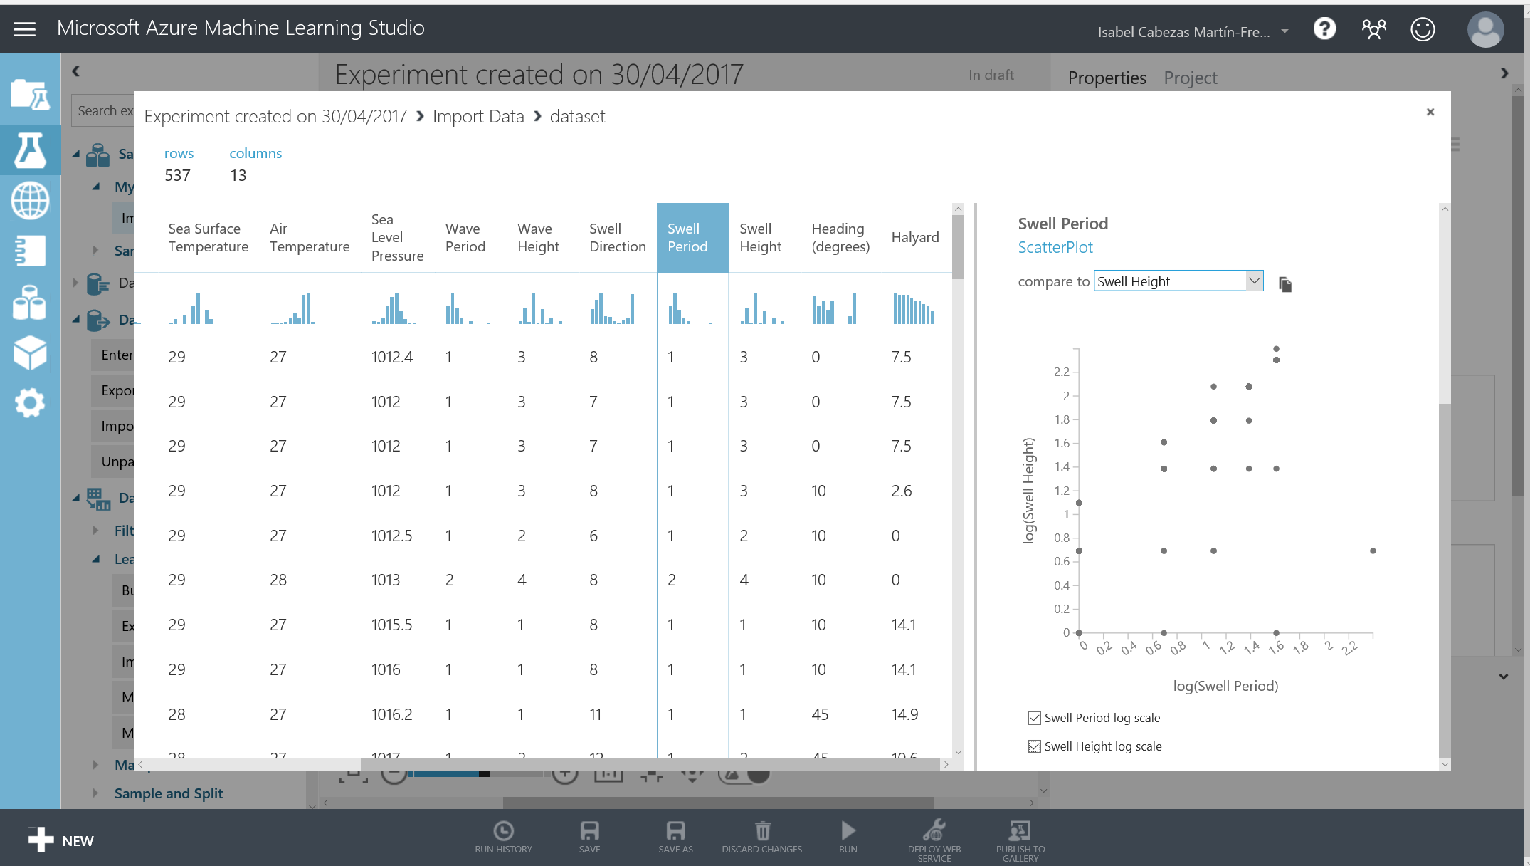

We chose a subset of columns from the dataset. We weren’t so sure, but the weather features influences in the sailing could be:

**Wind Direction**  
Wind Speed

Sea Surface Temperature

Air Temperature

Sea Level Pressure  
**Wave Period**  
**Wave Height**

**Swell Direction**

**Swell Period**

**Swell Height**

Heading (degrees)

Halyard: this is the label column we want to predict.

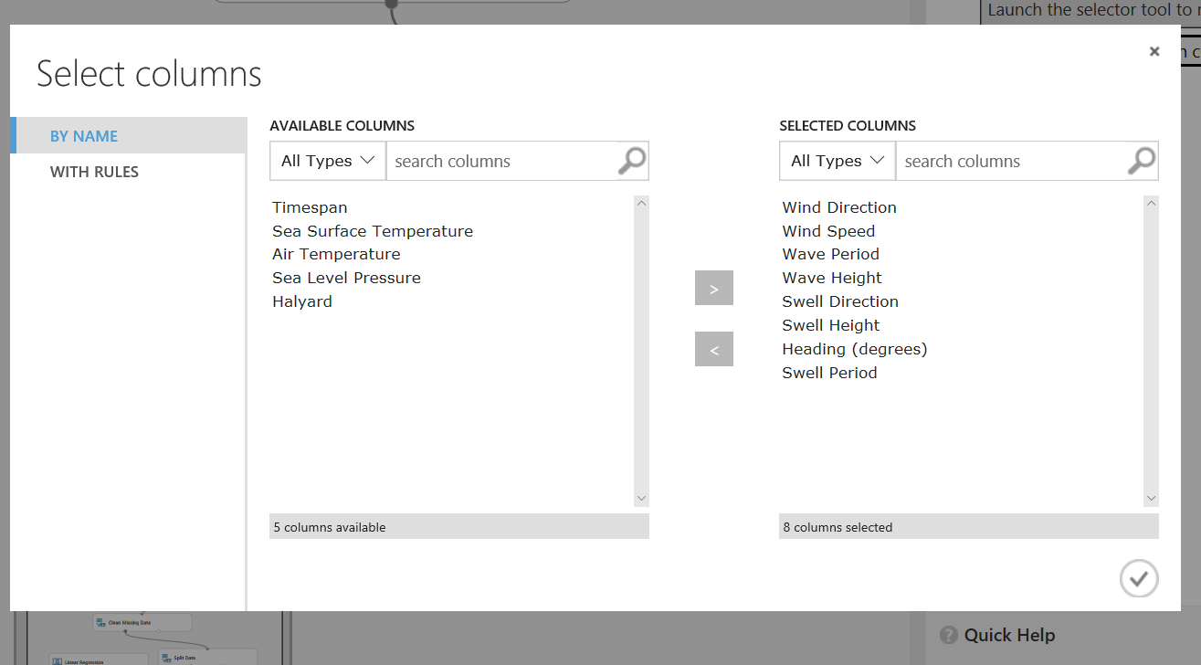

<https://msdn.microsoft.com/library/en-us/Dn905978.aspx>

We tested several regression algorithms to compare them: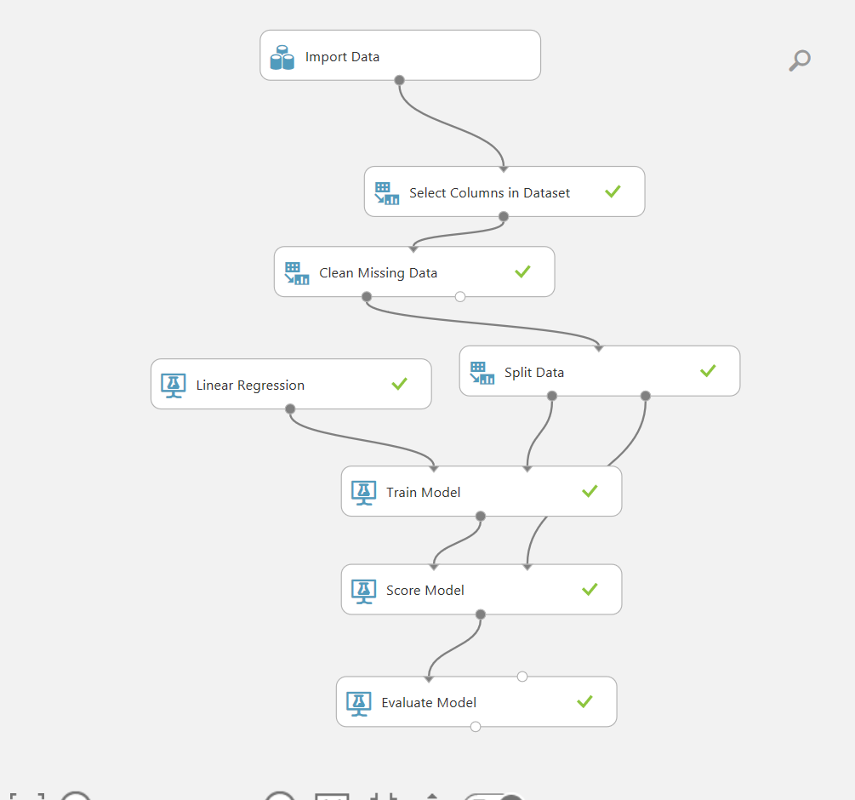

We added another aproximation method in the Linear Regression. In the first one, we use least squares and in the other one, gradient descent:

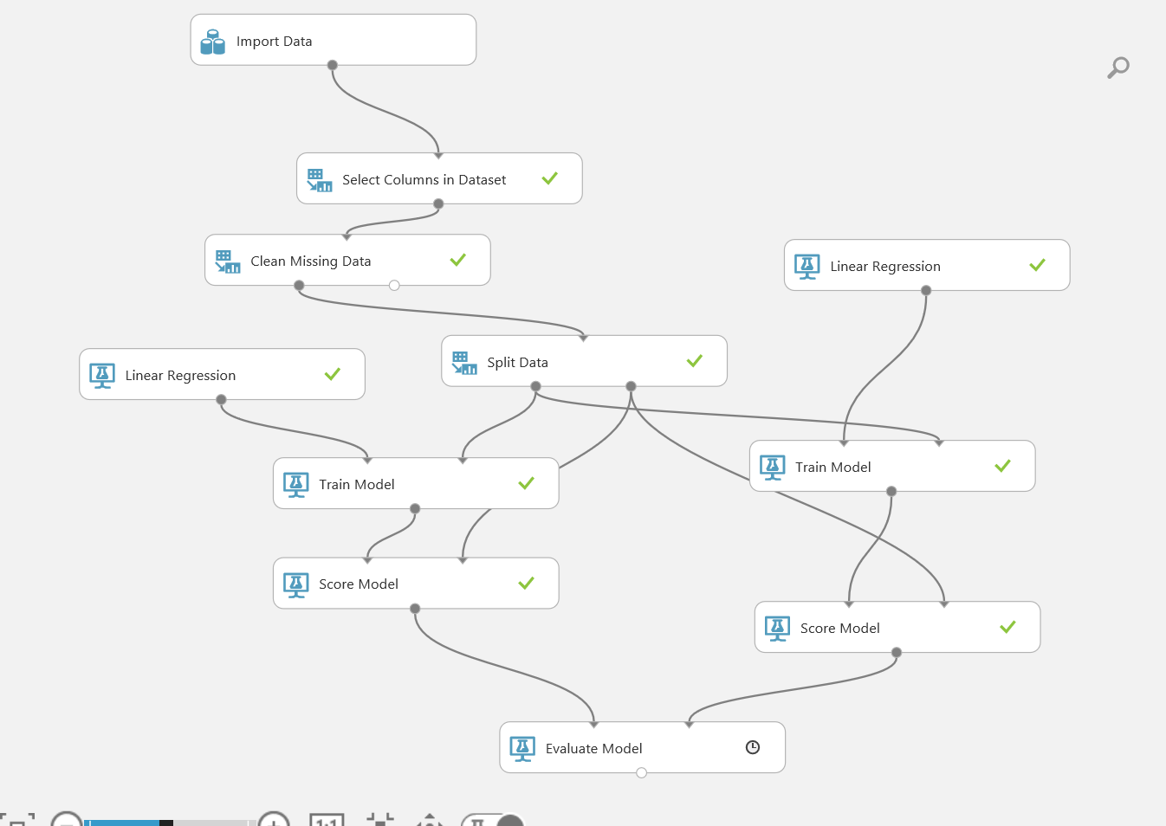

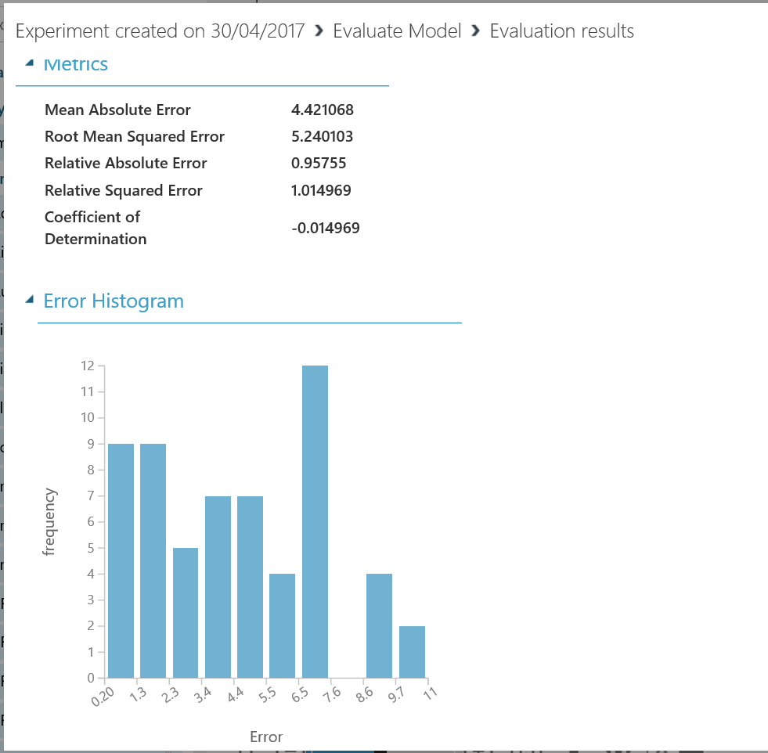

Then we compared the precision of both models:

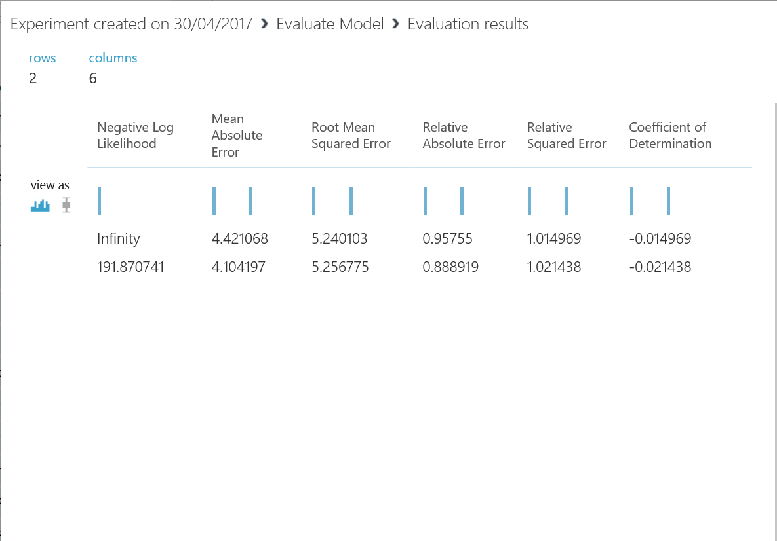

# Technical delivery

The first we did in the HackFest, was build the same architecture system that will be inside the boat. We worked with the exactly same kind of sensors and architecture.



## Intel Joule

We used this powerful system on module, the Intel Joule, to connect all our sensors to build this modular architecture, since we feel that is the best way to allow developers to quickly make changes and update the system, maintain the option of open up new possibilities.

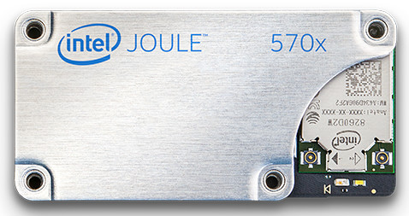

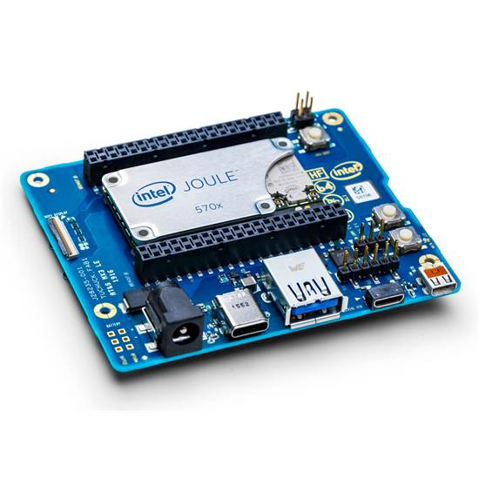

[Specs](https://software.intel.com/en-us/articles/joule-vs-edison): This small package contains an Intel® Atom™ quad-core processor, clocked at an impressive 1.7 GHz, with 4 gigabytes of LPDDR4 RAM, a dual band Wi-Fi antenna, Bluetooth®, and an Intel® HD Graphics processing unit. These specs make the Intel Joule module more powerful than any development board previously created by Intel.

## Temperature

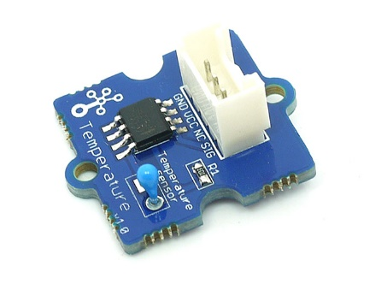

<https://seeeddoc.github.io/Grove-Temperature_Sensor/>  
The Grove - Temperature Sensor uses a [Thermistor](http://www.legacydistribution.co.uk/downloads/NTC-thermistors/TTC03.pdf) to detect the ambient temperature.

## Humidity:

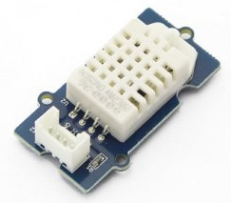

<http://wiki.seeed.cc/Grove-Temperature_and_Humidity_Sensor_Pro/>

The detecting range of this sensor is 5% RH - 99% RH, and -40°C - 80°C.

## Barometer:

Grove - Barometer Sensor barometric pressure and barometric temperature

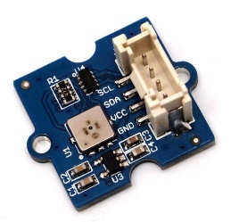

<http://wiki.seeed.cc/Grove-Barometer_Sensor/>

This Grove - Barometer Sensor features a Bosch BMP085 high-accuracy chip to detect barometric pressure and temperature.

## Light sensor:

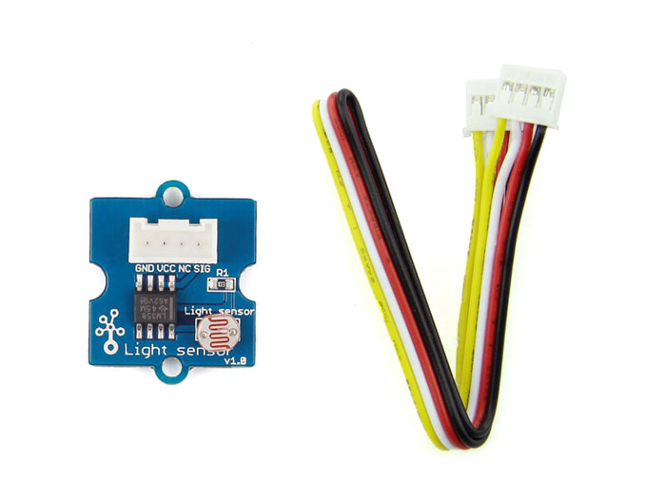

The [Grove - Light sensor](https://www.seeedstudio.com/Grove-Light-Sensor-p-746.html) module uses GL5528 photoresistor(light dependent resistor) to detect the intensity of light in the environment

<https://www.seeedstudio.com/Grove-Light-Sensor-p-746.html>

## Gateway (IBX-300BC)

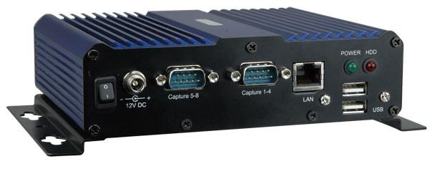

Resultado de imagen de ibx-300BC

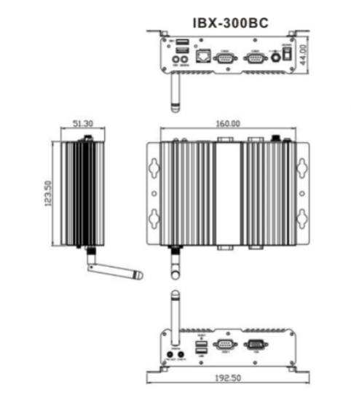

<http://www.ieiworld.com/files/file_pool/0A359000043549293678/file/IBX-300BC_UMN_v1.02.pdf>

## Raspberry Pi 3

This compute module is the development board to mock the NMEA Instrumental Bus.

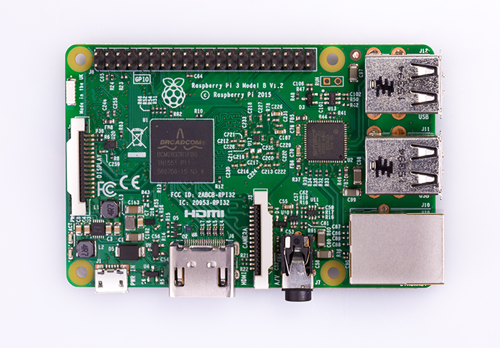

Specs:

A 1.2GHz 64-bit quad-core ARMv8 CPU

802.11n Wireless LAN

Bluetooth 4.1 and Bluetooth Low Energy (BLE)

1GB RAM, 4 USB ports, 40 GPIO pins

Full HDMI port, Ethernet port, Combined 3.5mm audio jack and composite video

Camera interface (CSI), Display interface (DSI)

Micro SD card slot (now push-pull rather than push-push)

VideoCore IV 3D graphics core

# 

# Conclusion

The code developed in the hackfest is a first step for a more ambitious project. At the moment, we are collecting high quality data and send them to the cloud (in arduous conditions as we have seen). This data will be used by the technical team for creating a machine learning model that will improve the boat navigation in the future.

The major difficulties of the project have consisted on adapting a system designed to the special aspect of this project naturally. Nevertheless, we have a wide variety of sensors, systems and technology nowadays. And this rich diversity enabled us to solve most of these challenges.

This Project shown us the ease of using tools like NodeRed for developing a pilot test. In only one day we could save data into the DocumentDB database and build graphs.

In addition, thanks to the technology agnostic of services like IoT Hub, DocumentDB, PowerBI, NodeRed… we could change some developed modules instead other ones, without remake not a single line of code. We started with a POC with NodeRed, while other group did tests with Gateway SDK, and we could easily replace them.

We needed a secure, easy and reliable data synchronization. As we had seen there are a lot of tools that allow us to do these tasks by automated means: IoT Hub, NodeRed and Azure Gateway SDK provide us the needed reliability and security.

We worked with a simplified dataset to create a first pilot of the machine learning model. This model is not finished yet. The navigation will depend on more features than the ones we initially selected. Sailing and building a machine learning model are very complex activities. Since in the hackfest we didn’t have any sailor nor any data scientist to help us with that, we wanted to keep it simple for the POC so it was easy to build and understand.

Building the machine learning model was easy with Azure ML, as the client team has been able to see for themselves. Even though they will need a mean to run the prediction in the field, we could easily build a first model in ML studio in the cloud to test different algorithms and see which one would better fit with the data.

Everytime the boat approaches to the coast and has data connection, the collected data will be send to the cloud. The machine learning model will be retrained with this information to enhance the trained model. This means the autopilot continues improving even the technical team is at the other side of the world.

Even with the advances in technology that we have today, going against wild weather conditions is still not an easy feat, and one perfect example of this situation is this project, the Ocean of Things.

# Additional resources

Intel Joule information:

<https://software.intel.com/en-us/iot/hardware/joule>

Official GitHub Repository of Ocean Of Things project: <https://github.com/mirazabal/OceansOfThings>

GitHub Repository we used while the HackFest:

<https://github.com/isabelcabezasm/OceanOfThings>

Documentation about target Azure DocumentDB for JSON output from Stream Analytics

<https://docs.microsoft.com/en-us/azure/stream-analytics/stream-analytics-documentdb-output>

Creating a connection from an IoT Hub to DocumentDB, using Stream Analytics, step by step:

<https://docs.microsoft.com/en-us/azure/stream-analytics/stream-analytics-build-an-iot-solution-using-stream-analytics>