**Table 1.** Participant demographics from final course evaluation (N=22)

|  |  |  |
| --- | --- | --- |
| Characteristic |  | N (%) |
| Location | Malawi  Mexico  Liberia  Rwanda  Haiti  Lesotho  Sierra Leone  USA | 4 (18%)  4 (18%)  3 (14%)  3 (14%)  2 (9%)  2 (9%)  2 (9%)  2 (9%) |
| Organization | Partners In Health  Ministry of Health | 20 (90%)  2 (10%) |
| Role | Monitoring and Evaluation  Researcher or analyst  Health program manager  Other | 13 (59%)  4 (18%)  3 (14%)  2 (9%) |
| Prior statistics training | Short courses, but no university-level courses  1 university-level course in statistics  2-3 university-level courses in statistics  >3 university-level courses, but degree is not statistics  I have a university-level degree in statistics | 4 (18%)  3 (4%)  7 (32%)  7 (32%)  1 (5%) |

**Table 2. Lecture and lab session content**

|  |  |  |
| --- | --- | --- |
| Session title | Lecture | Lab |
| 1. Indicator choices | * Selecting indicators for COVID-19 syndromic surveillance * Properties of a COVID-19 syndromic surveillance indicator (*Group Work*) * Health service utilization indicators | * Importing data in R * Introduction to tidyverse * Simple data summaries with tidyverse |
| 2. Fitting time series models, Part I | * Visual inspection of data (*Live Q&A*) * Detecting autocorrelation * Fitting simple time series models | * Introduction to ggplot2 * Fitting and plotting linear regressions |
| 3. Fitting time series models, Part II | * Accounting for time trends and seasonality * Using time series modeling for syndromic surveillance * Identifying deviations from what is expected (*Group Work*) | * Fitting time series models * Residual and autocorrelation plots to assess model fit * Model selection * Predicting future values to conduct syndromic surveillance |
| 4. Getting and cleaning data | * Health management information systems (HMIS) data accuracy and quality * Participant prior experience with HMIS data (*Live Q&A*) * Identifying and correcting outliers * Missing data considerations | * Cleaning and formatting data for analysis in tidyverse * Identifying outliers using Tukey’s rule |
| 5. Data visualization | * Best practices for data visualization * Feedback on various data visualization techniques (*Live Q&A*) * Data visualization for communicating syndromic surveillance results * Software available for visualization | * Syndromic surveillance activity using acute respiratory infection data * This activity addressed all skills learned in prior labs: data cleaning, model fitting, assessing model fit, predicting future values, and visualizing results |

**Figure 1.** How would you rate the pace, content, and clarity of the lectures?

**Figure 2.** How effective was X component of the lectures?

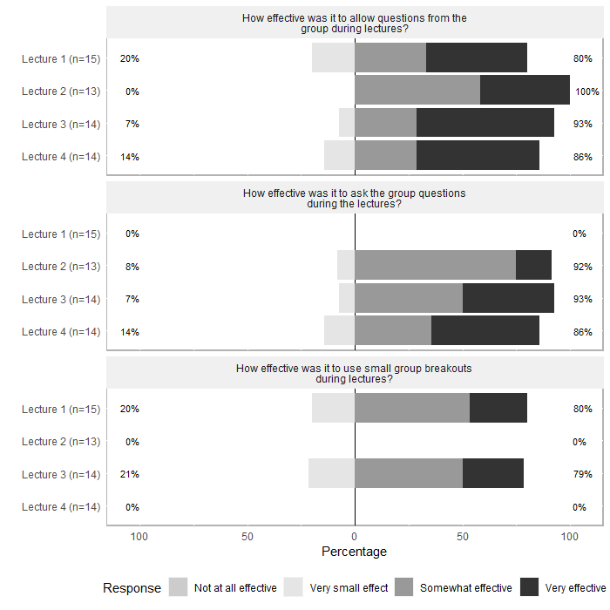

**Figure 3.** How would you rate the pace, content, and clarity of the labs?

**Figure 4.** How effective was X component of the labs?

**Figure 5.** How did the course affect your understanding of the following? (N=22)

**Figure 6.** How would you rate the following aspects of the lectures? (N=22)

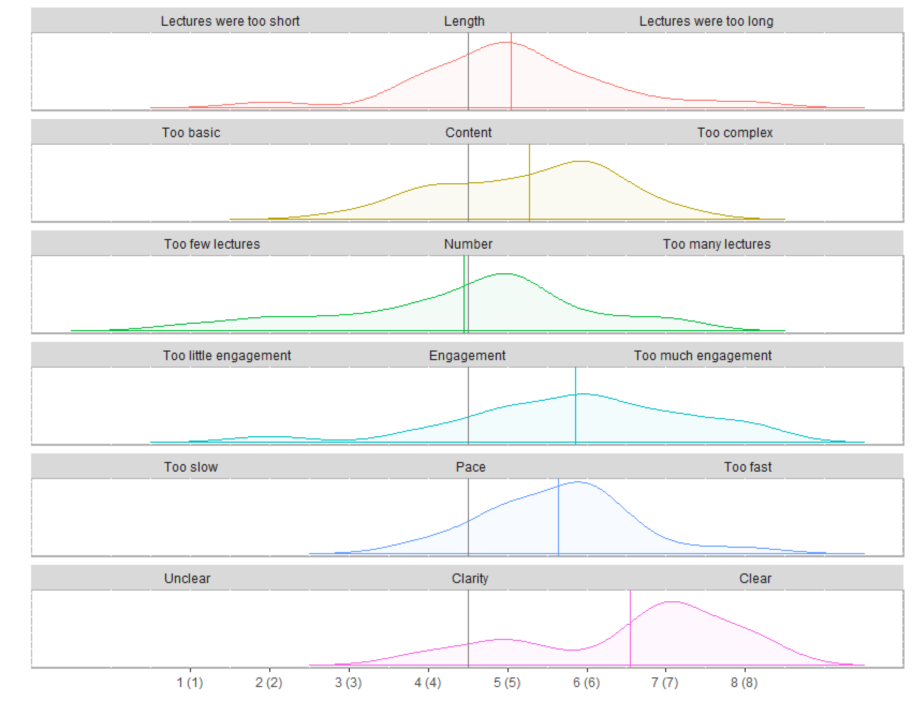

**Figure 7.** How would you rate the following aspects of the labs? (N=18)

