**Figure 1.** How would you rate the pace, content, and clarity of the lectures?

**Figure 2.** How effective was X component of the lectures?

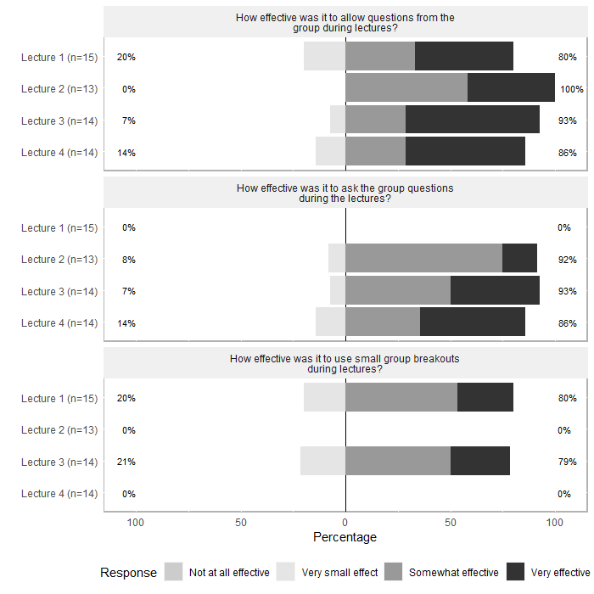

**Figure 5.** How did the course affect your understanding of the following? (N=22)

**Figure 6.** How would you rate the following aspects of the lectures? (N=22)

