Homework 4: Machine Learning

Isabel Gonzalez

2023-06-01

Table of Contents

# The Bechdel Test

<https://fivethirtyeight.com/features/the-dollar-and-cents-case-against-hollywoods-exclusion-of-women/>

The [Bechdel test](https://bechdeltest.com) is a way to assess how women are depicted in Hollywood movies. In order for a movie to pass the test:

1. It has to have at least two [named] women in it
2. Who talk to each other
3. About something besides a man

There is a nice article and analysis you can find here <https://fivethirtyeight.com/features/the-dollar-and-cents-case-against-hollywoods-exclusion-of-women/> We have a sample of 1394 movies and we want to fit a model to predict whether a film passes the test or not.

bechdel <- read_csv(here::here("data", "bechdel.csv")) %>%   
 mutate(test = factor(test))

## Rows: 1394 Columns: 10  
## ── Column specification ────────────────────────────────────────────────────────  
## Delimiter: ","  
## chr (4): title, test, rated, genre  
## dbl (6): year, budget_2013, domgross_2013, intgross_2013, metascore, imdb_ra...  
##   
## ℹ Use `spec()` to retrieve the full column specification for this data.  
## ℹ Specify the column types or set `show_col_types = FALSE` to quiet this message.

glimpse(bechdel)

## Rows: 1,394  
## Columns: 10  
## $ year <dbl> 2013, 2013, 2013, 2013, 2013, 2013, 2013, 2013, 2013, 20…  
## $ title <chr> "12 Years a Slave", "2 Guns", "42", "47 Ronin", "A Good …  
## $ test <fct> Fail, Fail, Fail, Fail, Fail, Pass, Pass, Fail, Pass, Pa…  
## $ budget_2013 <dbl> 2.00, 6.10, 4.00, 22.50, 9.20, 1.20, 1.30, 13.00, 4.00, …  
## $ domgross_2013 <dbl> 5.3107035, 7.5612460, 9.5020213, 3.8362475, 6.7349198, 1…  
## $ intgross_2013 <dbl> 15.8607035, 13.2493015, 9.5020213, 14.5803842, 30.424919…  
## $ rated <chr> "R", "R", "PG-13", "PG-13", "R", "R", "PG-13", "PG-13", …  
## $ metascore <dbl> 97, 55, 62, 29, 28, 55, 48, 33, 90, 58, 52, 78, 83, 53, …  
## $ imdb_rating <dbl> 8.3, 6.8, 7.6, 6.6, 5.4, 7.8, 5.7, 5.0, 7.5, 7.4, 6.2, 7…  
## $ genre <chr> "Biography", "Action", "Biography", "Action", "Action", …

How many films fail/pass the test, both as a number and as a %?

bechdel_pass <- bechdel %>%  
 filter(test == "Pass") %>%   
 nrow()  
  
bechdel_pass

## [1] 622

bechdel_fail <- bechdel %>%  
 filter(test == "Fail") %>%   
 nrow()  
  
bechdel_fail

## [1] 772

percent_pass <- (bechdel_pass / (bechdel_pass + bechdel_fail)* 100)   
  
percent_fail <- 100 - percent_pass  
   
percent_pass

## [1] 44.6198

percent_fail

## [1] 55.3802

## Movie scores

ggplot(data = bechdel, aes(  
 x = metascore,  
 y = imdb_rating,  
 colour = test  
)) +  
 geom_point(alpha = .3, size = 3) +  
 scale_colour_manual(values = c("tomato", "olivedrab")) +  
 labs(  
 x = "Metacritic score",  
 y = "IMDB rating",  
 colour = "Bechdel test"  
 ) +  
 theme_light()

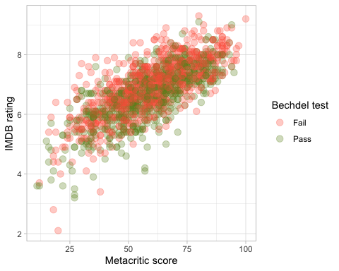

# Split the data

# **Split the data**  
  
set.seed(123)  
  
data_split <- initial_split(bechdel, # updated data  
 prop = 0.8,   
 strata = test)  
  
bechdel_train <- training(data_split)   
bechdel_test <- testing(data_split)

Check the counts and % (proportions) of the test variable in each set.

#counts and % in the train set   
  
bechdel_train_pass <- bechdel_train %>%  
 filter(test == "Pass") %>%   
 nrow()  
  
bechdel_train_pass

## [1] 497

bechdel_train_fail <- bechdel_train %>%  
 filter(test == "Fail") %>%   
 nrow()  
  
bechdel_train_fail

## [1] 617

percent_pass_train <- (bechdel_train_pass / (bechdel_train_pass + bechdel_train_fail)* 100)   
  
percent_fail_train <- 100 - percent_pass_train  
   
percent_pass_train

## [1] 44.614

percent_fail_train

## [1] 55.386

#counts and % in the test set   
  
bechdel_test_pass <- bechdel_test %>%  
 filter(test == "Pass") %>%   
 nrow()  
  
bechdel_test_pass

## [1] 125

bechdel_test_fail <- bechdel_test %>%  
 filter(test == "Fail") %>%   
 nrow()  
  
bechdel_test_fail

## [1] 155

percent_pass_test <- (bechdel_test_pass / (bechdel_test_pass + bechdel_test_fail)* 100)   
  
percent_fail_test <- 100 - percent_pass_test  
   
percent_pass_test

## [1] 44.64286

percent_fail_test

## [1] 55.35714

## Feature exploration

## Any outliers?

There aren’t any factors where we can say that there is a truly significant variable that defines pass or fail in the test, as in all of the graphs we can see that the ranges intersect, meaning that we fail with this data to say there is a significant difference. On the other hand there are several outliers in all of the data, fist we can see data points that are located far from the mean and also the ranges are relatively wide for mos of the variables.

bechdel %>%   
 select(test, budget_2013, domgross_2013, intgross_2013, imdb_rating, metascore) %>%   
  
 pivot_longer(cols = 2:6,  
 names_to = "feature",  
 values_to = "value") %>%   
 ggplot()+  
 aes(x=test, y = value, fill = test)+  
 coord_flip()+  
 geom_boxplot()+  
 facet_wrap(~feature, scales = "free")+  
 theme_bw()+  
 theme(legend.position = "none")+  
 labs(x=NULL,y = NULL)

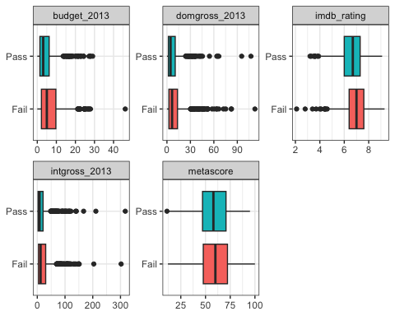

## Scatterplot - Correlation Matrix

Write a paragraph discussing the output of the following

Most of the variables have a left skewed distribution apart from imbd_rating that is slightly right skewed and metascore which has a normal distribution. The variables that have the highest correlation are internatinal gross and domestic gross which means that when a film does good domestically it also does good internationally, but towars the right part of the graph we can se a couple of outliers. In the case of imdb_rating and metascore we can also see a high correlation and a larger amount of data points.

bechdel %>%   
 select(test, budget_2013, domgross_2013, intgross_2013, imdb_rating, metascore)%>%   
 ggpairs(aes(colour=test), alpha=0.2)+  
 theme_bw()

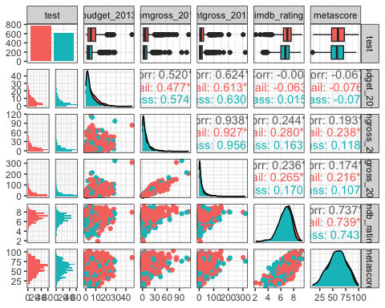

## Categorical variables

Write a paragraph discussing the output of the following

When seeing the proportion of pass and fail by genre we observe that there is no significant difference in most of the genres apart from Action where 70% of the movies fail the test, in the case mystery 75% of the movies fail the test but the number of observations is very low.

Finally, in terms of ratings, NC-17 seems to be the one where there is a higher difference with 83% of the movies failing the test, but the number of observations is not significant. Also G rated movies have a 61% of movies failing the test.

bechdel %>%   
 group_by(genre, test) %>%  
 summarise(n = n()) %>%   
 mutate(prop = n/sum(n))

## `summarise()` has grouped output by 'genre'. You can override using the  
## `.groups` argument.

## # A tibble: 24 × 4  
## # Groups: genre [14]  
## genre test n prop  
## <chr> <fct> <int> <dbl>  
## 1 Action Fail 260 0.707  
## 2 Action Pass 108 0.293  
## 3 Adventure Fail 52 0.559  
## 4 Adventure Pass 41 0.441  
## 5 Animation Fail 63 0.677  
## 6 Animation Pass 30 0.323  
## 7 Biography Fail 36 0.554  
## 8 Biography Pass 29 0.446  
## 9 Comedy Fail 138 0.427  
## 10 Comedy Pass 185 0.573  
## # ℹ 14 more rows

bechdel %>%   
 group_by(rated, test) %>%  
 summarise(n = n()) %>%   
 mutate(prop = n/sum(n))

## `summarise()` has grouped output by 'rated'. You can override using the  
## `.groups` argument.

## # A tibble: 10 × 4  
## # Groups: rated [5]  
## rated test n prop  
## <chr> <fct> <int> <dbl>  
## 1 G Fail 16 0.615  
## 2 G Pass 10 0.385  
## 3 NC-17 Fail 5 0.833  
## 4 NC-17 Pass 1 0.167  
## 5 PG Fail 115 0.561  
## 6 PG Pass 90 0.439  
## 7 PG-13 Fail 283 0.529  
## 8 PG-13 Pass 252 0.471  
## 9 R Fail 353 0.568  
## 10 R Pass 269 0.432

# Train first models. test ~ metascore + imdb_rating

lr_mod <- logistic_reg() %>%   
 set_engine(engine = "glm") %>%   
 set_mode("classification")  
  
lr_mod

## Logistic Regression Model Specification (classification)  
##   
## Computational engine: glm

tree_mod <- decision_tree() %>%   
 set_engine(engine = "C5.0") %>%   
 set_mode("classification")  
  
tree_mod

## Decision Tree Model Specification (classification)  
##   
## Computational engine: C5.0

lr_fit <- lr_mod %>% # parsnip model  
 fit(test ~ metascore + imdb_rating, # a formula  
 data = bechdel_train # dataframe  
 )  
  
tree_fit <- tree_mod %>% # parsnip model  
 fit(test ~ metascore + imdb_rating, # a formula  
 data = bechdel_train # dataframe  
 )

## Logistic regression

lr_fit %>%  
 broom::tidy()

## # A tibble: 3 × 5  
## term estimate std.error statistic p.value  
## <chr> <dbl> <dbl> <dbl> <dbl>  
## 1 (Intercept) 2.80 0.494 5.68 1.35e- 8  
## 2 metascore 0.0207 0.00536 3.86 1.13e- 4  
## 3 imdb_rating -0.625 0.100 -6.24 4.36e-10

lr_preds <- lr_fit %>%  
 augment(new_data = bechdel_train) %>%  
 mutate(.pred_match = if_else(test == .pred_class, 1, 0))

### Confusion matrix

lr_preds %>%   
 conf_mat(truth = test, estimate = .pred_class) %>%   
 autoplot(type = "heatmap")

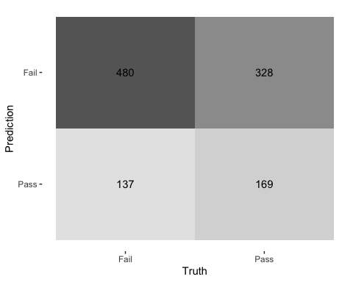

## Decision Tree

tree_preds <- tree_fit %>%  
 augment(new_data = bechdel) %>%  
 mutate(.pred_match = if_else(test == .pred_class, 1, 0))

tree_preds %>%   
 conf_mat(truth = test, estimate = .pred_class) %>%   
 autoplot(type = "heatmap")

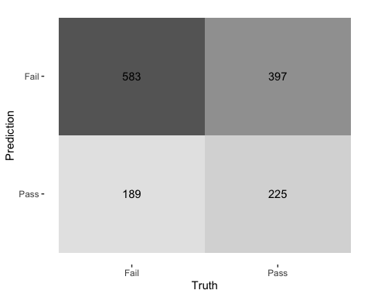

## Draw the decision tree

draw_tree <-   
 rpart::rpart(  
 test ~ metascore + imdb_rating,  
 data = bechdel_train, # uses data that contains both birth weight and `low`  
 control = rpart::rpart.control(maxdepth = 5, cp = 0, minsplit = 10)  
 ) %>%   
 partykit::as.party()  
plot(draw_tree)

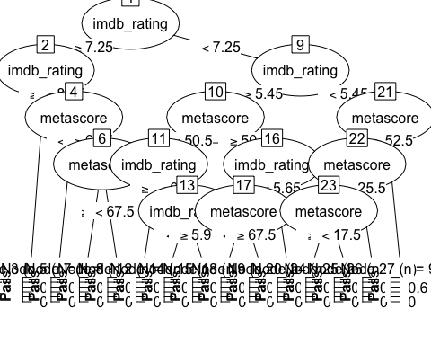

# Cross Validation

Run the code below. What does it return? It returns a table with 10 rows which are the 10 folds we are gonna use to train the model

set.seed(123)  
bechdel_folds <- vfold_cv(data = bechdel_train,   
 v = 3,   
 strata = test)  
bechdel_folds

## # 3-fold cross-validation using stratification   
## # A tibble: 3 × 2  
## splits id   
## <list> <chr>  
## 1 <split [742/372]> Fold1  
## 2 <split [742/372]> Fold2  
## 3 <split [744/370]> Fold3

## fit_resamples()

Trains and tests a resampled model.

lr_fit <- lr_mod %>%  
 fit_resamples(  
 test ~ metascore + imdb_rating,  
 resamples = bechdel_folds  
 )  
  
  
tree_fit <- tree_mod %>%  
 fit_resamples(  
 test ~ metascore + imdb_rating,  
 resamples = bechdel_folds  
 )

## collect_metrics()

Unnest the metrics column from a tidymodels fit_resamples()

collect_metrics(lr_fit)

## # A tibble: 2 × 6  
## .metric .estimator mean n std_err .config   
## <chr> <chr> <dbl> <int> <dbl> <chr>   
## 1 accuracy binary 0.585 3 0.0143 Preprocessor1_Model1  
## 2 roc_auc binary 0.602 3 0.0190 Preprocessor1_Model1

collect_metrics(tree_fit)

## # A tibble: 2 × 6  
## .metric .estimator mean n std_err .config   
## <chr> <chr> <dbl> <int> <dbl> <chr>   
## 1 accuracy binary 0.554 3 0.00458 Preprocessor1_Model1  
## 2 roc_auc binary 0.524 3 0.0122 Preprocessor1_Model1

tree_preds <- tree_mod %>%   
 fit_resamples(  
 test ~ metascore + imdb_rating,   
 resamples = bechdel_folds,  
 control = control_resamples(save_pred = TRUE) #<<  
 )  
  
# What does the data for ROC look like?  
tree_preds %>%   
 collect_predictions() %>%   
 roc_curve(truth = test, .pred_Fail)

## # A tibble: 9 × 3  
## .threshold specificity sensitivity  
## <dbl> <dbl> <dbl>  
## 1 -Inf 0 1   
## 2 0.346 0 1   
## 3 0.430 0.0342 0.977   
## 4 0.554 0.137 0.890   
## 5 0.556 0.471 0.556   
## 6 0.569 0.761 0.272   
## 7 0.819 0.952 0.0762  
## 8 0.867 0.990 0.0276  
## 9 Inf 1 0

# Draw the ROC  
tree_preds %>%   
 collect_predictions() %>%   
 roc_curve(truth = test, .pred_Fail) %>%   
 autoplot()

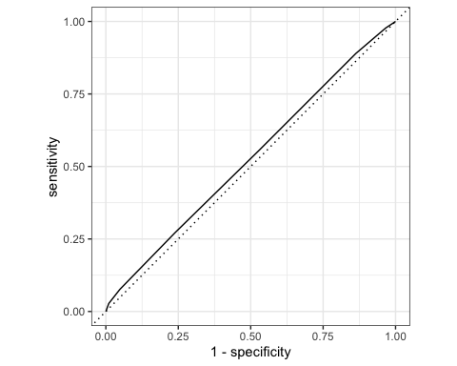

# Build a better training set with recipes

## Preprocessing options

* Encode categorical predictors
* Center and scale variables
* Handle class imbalance
* Impute missing data
* Perform dimensionality reduction
* … …

## To build a recipe

1. Start the recipe()
2. Define the variables involved
3. Describe **prep**rocessing [step-by-step]

## Collapse Some Categorical Levels

Do we have any genre with few observations? Assign genres that have less than 3% to a new category ‘Other’ Yes. the following: mystery, fantasy, sci-fi, thriller, documentary and musical

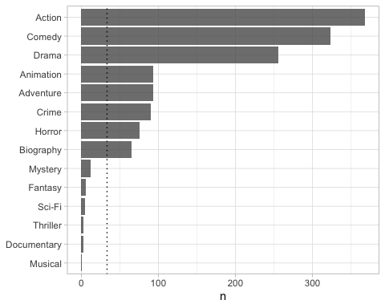

movie_rec <-  
 recipe(test ~ .,  
 data = bechdel_train) %>%  
   
 # Genres with less than 5% will be in a category 'Other'  
 step_other(genre, threshold = .03)

## Before recipe

## # A tibble: 14 × 2  
## genre n  
## <chr> <int>  
## 1 Action 293  
## 2 Comedy 254  
## 3 Drama 213  
## 4 Adventure 75  
## 5 Animation 72  
## 6 Crime 68  
## 7 Horror 68  
## 8 Biography 50  
## 9 Mystery 7  
## 10 Fantasy 5  
## 11 Sci-Fi 3  
## 12 Thriller 3  
## 13 Documentary 2  
## 14 Musical 1

## After recipe

movie_rec %>%   
 prep() %>%   
 bake(new_data = bechdel_train) %>%   
 count(genre, sort = TRUE)

## # A tibble: 9 × 2  
## genre n  
## <fct> <int>  
## 1 Action 293  
## 2 Comedy 254  
## 3 Drama 213  
## 4 Adventure 75  
## 5 Animation 72  
## 6 Crime 68  
## 7 Horror 68  
## 8 Biography 50  
## 9 other 21

## step_dummy()

Converts nominal data into numeric dummy variables

movie_rec <- recipe(test ~ ., data = bechdel) %>%  
 step_other(genre, threshold = .03) %>%   
 step_dummy(all_nominal_predictors())   
  
movie_rec

##

## ── Recipe ──────────────────────────────────────────────────────────────────────

##

## ── Inputs

## Number of variables by role

## outcome: 1  
## predictor: 9

##

## ── Operations

## • Collapsing factor levels for: genre

## • Dummy variables from: all_nominal_predictors()

## Let’s think about the modelling

What if there were no films with rated NC-17 in the training data?

* Will the model have a coefficient for rated NC-17? No, it would no have data to estimate the correlation
* What will happen if the test data includes a film with rated NC-17? The model gives an error because it hasn’t been trained to predict for this data. We use step_novel to have the model ignore those values in the test set

## step_novel()

Adds a catch-all level to a factor for any new values not encountered in model training, which lets R intelligently predict new levels in the test set.

movie_rec <- recipe(test ~ ., data = bechdel) %>%  
 step_other(genre, threshold = .03) %>%   
 step_novel(all_nominal_predictors) %>% # Use *before* `step_dummy()` so new level is dummified  
 step_dummy(all_nominal_predictors())

## step_zv()

Intelligently handles zero variance variables (variables that contain only a single value)

movie_rec <- recipe(test ~ ., data = bechdel) %>%  
 step_other(genre, threshold = .03) %>%   
 step_novel(all_nominal(), -all_outcomes()) %>% # Use *before* `step_dummy()` so new level is dummified  
 step_dummy(all_nominal(), -all_outcomes()) %>%   
 step_zv(all_numeric(), -all_outcomes())

## step_normalize()

Centers then scales numeric variable (mean = 0, sd = 1)

movie_rec <- recipe(test ~ ., data = bechdel) %>%  
 step_other(genre, threshold = .03) %>%   
 step_novel(all_nominal(), -all_outcomes()) %>% # Use *before* `step_dummy()` so new level is dummified  
 step_dummy(all_nominal(), -all_outcomes()) %>%   
 step_zv(all_numeric(), -all_outcomes()) %>%   
 step_normalize(all_numeric())

## step_corr()

Removes highly correlated variables

movie_rec <- recipe(test ~ ., data = bechdel) %>%  
 step_other(genre, threshold = .03) %>%   
 step_novel(all_nominal(), -all_outcomes()) %>% # Use *before* `step_dummy()` so new level is dummified  
 step_dummy(all_nominal(), -all_outcomes()) %>%   
 step_zv(all_numeric(), -all_outcomes()) %>%   
 step_normalize(all_numeric())  
#we dind't end up using step_corr because it made the computer run for ages  
  
movie_rec

##

## ── Recipe ──────────────────────────────────────────────────────────────────────

##

## ── Inputs

## Number of variables by role

## outcome: 1  
## predictor: 9

##

## ── Operations

## • Collapsing factor levels for: genre

## • Novel factor level assignment for: all_nominal(), -all_outcomes()

## • Dummy variables from: all_nominal(), -all_outcomes()

## • Zero variance filter on: all_numeric(), -all_outcomes()

## • Centering and scaling for: all_numeric()

# Define different models to fit

## Model Building  
  
# 1. Pick a `model type`  
# 2. set the `engine`  
# 3. Set the `mode`: regression or classification  
  
# Logistic regression  
log_spec <- logistic_reg() %>% # model type  
 set_engine(engine = "glm") %>% # model engine  
 set_mode("classification") # model mode  
  
# Show your model specification  
log_spec

## Logistic Regression Model Specification (classification)  
##   
## Computational engine: glm

# Decision Tree  
tree_spec <- decision_tree() %>%  
 set_engine(engine = "C5.0") %>%  
 set_mode("classification")  
  
tree_spec

## Decision Tree Model Specification (classification)  
##   
## Computational engine: C5.0

# Random Forest  
library(ranger)  
  
rf_spec <-   
 rand_forest() %>%   
 set_engine("ranger", importance = "impurity") %>%   
 set_mode("classification")  
  
  
# Boosted tree (XGBoost)  
library(xgboost)

##   
## Attaching package: 'xgboost'

## The following object is masked from 'package:dplyr':  
##   
## slice

xgb_spec <-   
 boost_tree() %>%   
 set_engine("xgboost") %>%   
 set_mode("classification")   
  
# K-nearest neighbour (k-NN)  
knn_spec <-   
 nearest_neighbor(neighbors = 4) %>% # we can adjust the number of neighbors   
 set_engine("kknn") %>%   
 set_mode("classification")

# Bundle recipe and model with workflows

log_wflow <- # new workflow object  
 workflow() %>% # use workflow function  
 add_recipe(movie_rec) %>% # use the new recipe  
 add_model(log_spec) # add your model spec  
  
# show object  
log_wflow

## ══ Workflow ════════════════════════════════════════════════════════════════════  
## Preprocessor: Recipe  
## Model: logistic_reg()  
##   
## ── Preprocessor ────────────────────────────────────────────────────────────────  
## 5 Recipe Steps  
##   
## • step_other()  
## • step_novel()  
## • step_dummy()  
## • step_zv()  
## • step_normalize()  
##   
## ── Model ───────────────────────────────────────────────────────────────────────  
## Logistic Regression Model Specification (classification)  
##   
## Computational engine: glm

## A few more workflows  
  
tree_wflow <-  
 workflow() %>%  
 add_recipe(movie_rec) %>%   
 add_model(tree_spec)   
  
rf_wflow <-  
 workflow() %>%  
 add_recipe(movie_rec) %>%   
 add_model(rf_spec)   
  
xgb_wflow <-  
 workflow() %>%  
 add_recipe(movie_rec) %>%   
 add_model(xgb_spec)  
  
knn_wflow <-  
 workflow() %>%  
 add_recipe(movie_rec) %>%   
 add_model(knn_spec)

HEADS UP

1. How many models have you specified? 5 models
2. What’s the difference between a model specification and a workflow? in the model specification we first set up the blank models and in the workflow part is where we select the recipe that we want the model to work on
3. Do you need to add a formula (e.g., test ~ .) if you have a recipe? no, it’s already specified in the recipe

# Model Comparison

You now have all your models. Adapt the code from slides code-from-slides-CA-housing.R, line 400 onwards to assess which model gives you the best classification.

## Evaluate Models  
  
## Logistic regression results{.smaller}  
  
log_res <- log_wflow %>%   
 fit_resamples(  
 resamples = bechdel_folds,   
 metrics = metric_set(  
 recall, precision, f_meas, accuracy,  
 kap, roc_auc, sens, spec),  
 control = control_resamples(save_pred = TRUE))

## → A | warning: glm.fit: algorithm did not converge

## There were issues with some computations A: x1 → B | warning: prediction from rank-deficient fit; attr(*, "non-estim") has doubtful cases  
## There were issues with some computations A: x1There were issues with some computations A: x1 B: x1There were issues with some computations A: x2 B: x1There were issues with some computations A: x2 B: x2There were issues with some computations A: x3 B: x2There were issues with some computations A: x3 B: x3There were issues with some computations A: x3 B: x3

# Show average performance over all folds (note that we use log_res):  
log_res %>% collect_metrics(summarize = TRUE)

## # A tibble: 8 × 6  
## .metric .estimator mean n std_err .config   
## <chr> <chr> <dbl> <int> <dbl> <chr>   
## 1 accuracy binary 0.434 3 0.0150 Preprocessor1_Model1  
## 2 f_meas binary 0.346 3 0.0772 Preprocessor1_Model1  
## 3 kap binary -0.0916 3 0.0140 Preprocessor1_Model1  
## 4 precision binary 0.470 3 0.0244 Preprocessor1_Model1  
## 5 recall binary 0.290 3 0.0978 Preprocessor1_Model1  
## 6 roc_auc binary 0.450 3 0.0115 Preprocessor1_Model1  
## 7 sens binary 0.290 3 0.0978 Preprocessor1_Model1  
## 8 spec binary 0.614 3 0.0918 Preprocessor1_Model1

# Show performance for every single fold:  
log_res %>% collect_metrics(summarize = FALSE)

## # A tibble: 24 × 5  
## id .metric .estimator .estimate .config   
## <chr> <chr> <chr> <dbl> <chr>   
## 1 Fold1 recall binary 0.184 Preprocessor1_Model1  
## 2 Fold1 precision binary 0.463 Preprocessor1_Model1  
## 3 Fold1 f_meas binary 0.264 Preprocessor1_Model1  
## 4 Fold1 accuracy binary 0.430 Preprocessor1_Model1  
## 5 Fold1 kap binary -0.0751 Preprocessor1_Model1  
## 6 Fold1 sens binary 0.184 Preprocessor1_Model1  
## 7 Fold1 spec binary 0.735 Preprocessor1_Model1  
## 8 Fold1 roc_auc binary 0.464 Preprocessor1_Model1  
## 9 Fold2 recall binary 0.485 Preprocessor1_Model1  
## 10 Fold2 precision binary 0.515 Preprocessor1_Model1  
## # ℹ 14 more rows

## `collect_predictions()` and get confusion matrix{.smaller}  
  
log_pred <- log_res %>% collect_predictions()  
  
log_pred %>% conf_mat(test, .pred_class)

## Truth  
## Prediction Fail Pass  
## Fail 179 192  
## Pass 438 305

log_pred %>%   
 conf_mat(test, .pred_class) %>%   
 autoplot(type = "mosaic") +  
 geom_label(aes(  
 x = (xmax + xmin) / 2,   
 y = (ymax + ymin) / 2,   
 label = c("TP", "FN", "FP", "TN")))

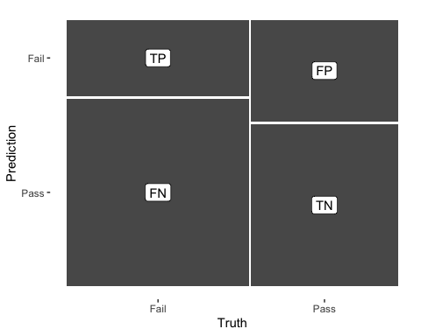

log_pred %>%   
 conf_mat(test, .pred_class) %>%   
 autoplot(type = "heatmap")

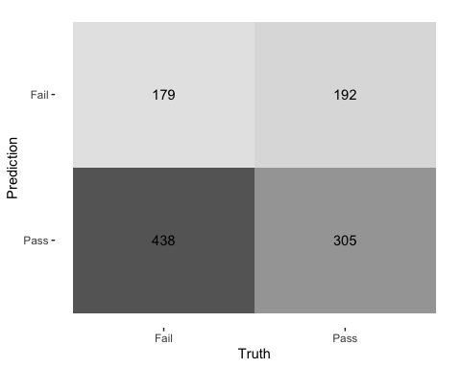

## ROC Curve  
  
log_pred %>%   
 group_by(id) %>% # id contains our folds  
 roc_curve(test, .pred_Fail) %>%   
 autoplot()

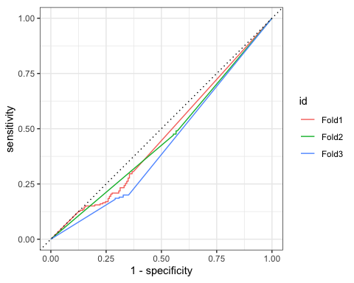

## Decision Tree results  
  
tree_res <-  
 tree_wflow %>%   
 fit_resamples(  
 resamples = bechdel_folds,   
 metrics = metric_set(  
 recall, precision, f_meas,   
 accuracy, kap,  
 roc_auc, sens, spec),  
 control = control_resamples(save_pred = TRUE)  
 )   
  
tree_res %>% collect_metrics(summarize = TRUE)

## # A tibble: 8 × 6  
## .metric .estimator mean n std_err .config   
## <chr> <chr> <dbl> <int> <dbl> <chr>   
## 1 accuracy binary 0.588 3 0.0147 Preprocessor1_Model1  
## 2 f_meas binary 0.633 3 0.0244 Preprocessor1_Model1  
## 3 kap binary 0.163 3 0.0257 Preprocessor1_Model1  
## 4 precision binary 0.623 3 0.0105 Preprocessor1_Model1  
## 5 recall binary 0.647 3 0.0473 Preprocessor1_Model1  
## 6 roc_auc binary 0.589 3 0.0151 Preprocessor1_Model1  
## 7 sens binary 0.647 3 0.0473 Preprocessor1_Model1  
## 8 spec binary 0.515 3 0.0393 Preprocessor1_Model1

## Random Forest  
  
rf_res <-  
 rf_wflow %>%   
 fit_resamples(  
 resamples = bechdel_folds,   
 metrics = metric_set(  
 recall, precision, f_meas,   
 accuracy, kap,  
 roc_auc, sens, spec),  
 control = control_resamples(save_pred = TRUE)  
 )   
  
rf_res %>% collect_metrics(summarize = TRUE)

## # A tibble: 8 × 6  
## .metric .estimator mean n std_err .config   
## <chr> <chr> <dbl> <int> <dbl> <chr>   
## 1 accuracy binary 0.634 3 0.00727 Preprocessor1_Model1  
## 2 f_meas binary 0.702 3 0.00975 Preprocessor1_Model1  
## 3 kap binary 0.238 3 0.0177 Preprocessor1_Model1  
## 4 precision binary 0.640 3 0.00999 Preprocessor1_Model1  
## 5 recall binary 0.780 3 0.0332 Preprocessor1_Model1  
## 6 roc_auc binary 0.665 3 0.0140 Preprocessor1_Model1  
## 7 sens binary 0.780 3 0.0332 Preprocessor1_Model1  
## 8 spec binary 0.453 3 0.0448 Preprocessor1_Model1

## Boosted tree - XGBoost  
  
xgb_res <-   
 xgb_wflow %>%   
 fit_resamples(  
 resamples = bechdel_folds,   
 metrics = metric_set(  
 recall, precision, f_meas,   
 accuracy, kap,  
 roc_auc, sens, spec),  
 control = control_resamples(save_pred = TRUE)  
 )   
  
xgb_res %>% collect_metrics(summarize = TRUE)

## # A tibble: 8 × 6  
## .metric .estimator mean n std_err .config   
## <chr> <chr> <dbl> <int> <dbl> <chr>   
## 1 accuracy binary 0.606 3 0.00256 Preprocessor1_Model1  
## 2 f_meas binary 0.657 3 0.0107 Preprocessor1_Model1  
## 3 kap binary 0.195 3 0.00120 Preprocessor1_Model1  
## 4 precision binary 0.634 3 0.00426 Preprocessor1_Model1  
## 5 recall binary 0.684 3 0.0288 Preprocessor1_Model1  
## 6 roc_auc binary 0.635 3 0.00299 Preprocessor1_Model1  
## 7 sens binary 0.684 3 0.0288 Preprocessor1_Model1  
## 8 spec binary 0.509 3 0.0303 Preprocessor1_Model1

## K-nearest neighbour  
  
knn_res <-   
 knn_wflow %>%   
 fit_resamples(  
 resamples = bechdel_folds,   
 metrics = metric_set(  
 recall, precision, f_meas,   
 accuracy, kap,  
 roc_auc, sens, spec),  
 control = control_resamples(save_pred = TRUE)  
 )

## → A | warning: While computing binary `precision()`, no predicted events were detected (i.e. `true_positive + false_positive = 0`).   
## Precision is undefined in this case, and `NA` will be returned.  
## Note that 206 true event(s) actually occured for the problematic event level, 'Fail'.  
## There were issues with some computations A: x1There were issues with some computations A: x1

knn_res %>% collect_metrics(summarize = TRUE)

## # A tibble: 8 × 6  
## .metric .estimator mean n std_err .config   
## <chr> <chr> <dbl> <int> <dbl> <chr>   
## 1 accuracy binary 0.518 3 0.0359 Preprocessor1_Model1  
## 2 f_meas binary 0.713 2 0.000120 Preprocessor1_Model1  
## 3 kap binary 0 3 0 Preprocessor1_Model1  
## 4 precision binary 0.554 2 0.000145 Preprocessor1_Model1  
## 5 recall binary 0.667 3 0.333 Preprocessor1_Model1  
## 6 roc_auc binary 0.553 3 0.0284 Preprocessor1_Model1  
## 7 sens binary 0.667 3 0.333 Preprocessor1_Model1  
## 8 spec binary 0.333 3 0.333 Preprocessor1_Model1

## Model Comparison  
  
log_metrics <-   
 log_res %>%   
 collect_metrics(summarise = TRUE) %>%  
 # add the name of the model to every row  
 mutate(model = "Logistic Regression")   
  
tree_metrics <-   
 tree_res %>%   
 collect_metrics(summarise = TRUE) %>%  
 mutate(model = "Decision Tree")  
  
rf_metrics <-   
 rf_res %>%   
 collect_metrics(summarise = TRUE) %>%  
 mutate(model = "Random Forest")  
  
xgb_metrics <-   
 xgb_res %>%   
 collect_metrics(summarise = TRUE) %>%  
 mutate(model = "XGBoost")  
  
knn_metrics <-   
 knn_res %>%   
 collect_metrics(summarise = TRUE) %>%  
 mutate(model = "Knn")  
  
# create dataframe with all models  
model_compare <- bind_rows(log_metrics,  
 tree_metrics,  
 rf_metrics,  
 xgb_metrics,  
 knn_metrics)   
  
#Pivot wider to create barplot  
 model_comp <- model_compare %>%   
 select(model, .metric, mean, std_err) %>%   
 pivot_wider(names_from = .metric, values_from = c(mean, std_err))   
  
# show mean are under the curve (ROC-AUC) for every model  
model_comp %>%   
 arrange(mean_roc_auc) %>%   
 mutate(model = fct_reorder(model, mean_roc_auc)) %>% # order results  
 ggplot(aes(model, mean_roc_auc, fill=model)) +  
 geom_col() +  
 coord_flip() +  
 scale_fill_brewer(palette = "Blues") +  
 geom_text(  
 size = 3,  
 aes(label = round(mean_roc_auc, 2),   
 y = mean_roc_auc + 0.08),  
 vjust = 1  
 )+  
 theme_light()+  
 theme(legend.position = "none")+  
 labs(y = NULL)

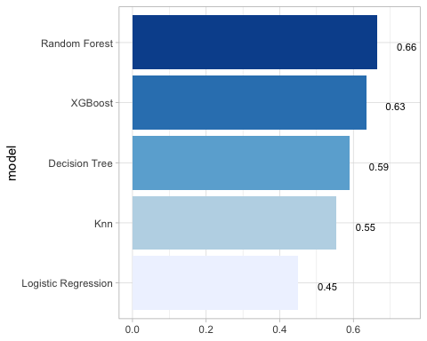

## `last_fit()` on test set  
  
# - `last_fit()` fits a model to the whole training data and evaluates it on the test set.   
# - provide the workflow object of the best model as well as the data split object (not the training data).   
   
last_fit_xgb <- last_fit(xgb_wflow,   
 split = data_split,  
 metrics = metric_set(  
 accuracy, f_meas, kap, precision,  
 recall, roc_auc, sens, spec))  
  
last_fit_xgb %>% collect_metrics(summarize = TRUE)

## # A tibble: 8 × 4  
## .metric .estimator .estimate .config   
## <chr> <chr> <dbl> <chr>   
## 1 accuracy binary 0.568 Preprocessor1_Model1  
## 2 f_meas binary 0.630 Preprocessor1_Model1  
## 3 kap binary 0.114 Preprocessor1_Model1  
## 4 precision binary 0.599 Preprocessor1_Model1  
## 5 recall binary 0.665 Preprocessor1_Model1  
## 6 sens binary 0.665 Preprocessor1_Model1  
## 7 spec binary 0.448 Preprocessor1_Model1  
## 8 roc_auc binary 0.610 Preprocessor1_Model1

#Compare to training  
xgb_res %>% collect_metrics(summarize = TRUE)

## # A tibble: 8 × 6  
## .metric .estimator mean n std_err .config   
## <chr> <chr> <dbl> <int> <dbl> <chr>   
## 1 accuracy binary 0.606 3 0.00256 Preprocessor1_Model1  
## 2 f_meas binary 0.657 3 0.0107 Preprocessor1_Model1  
## 3 kap binary 0.195 3 0.00120 Preprocessor1_Model1  
## 4 precision binary 0.634 3 0.00426 Preprocessor1_Model1  
## 5 recall binary 0.684 3 0.0288 Preprocessor1_Model1  
## 6 roc_auc binary 0.635 3 0.00299 Preprocessor1_Model1  
## 7 sens binary 0.684 3 0.0288 Preprocessor1_Model1  
## 8 spec binary 0.509 3 0.0303 Preprocessor1_Model1

## Variable importance using `{vip}` package  
  
library(vip)  
  
last_fit_xgb %>%   
 pluck(".workflow", 1) %>%   
 pull_workflow_fit() %>%   
 vip(num_features = 10) +  
 theme_light()

## Warning: `pull_workflow_fit()` was deprecated in workflows 0.2.3.  
## ℹ Please use `extract_fit_parsnip()` instead.  
## This warning is displayed once every 8 hours.  
## Call `lifecycle::last_lifecycle_warnings()` to see where this warning was  
## generated.

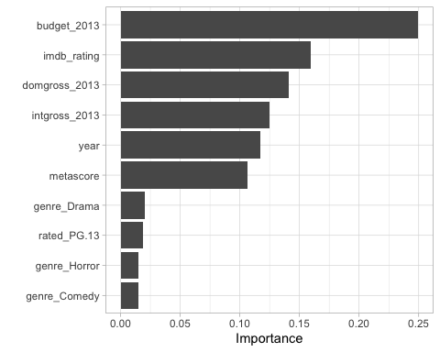

## Final Confusion Matrix  
  
last_fit_xgb %>%  
 collect_predictions() %>%   
 conf_mat(test, .pred_class) %>%   
 autoplot(type = "heatmap")

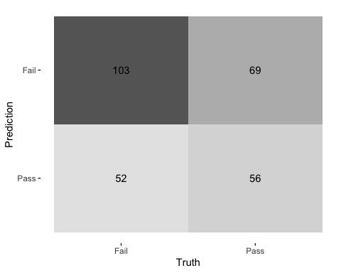

## Final ROC curve  
last_fit_xgb %>%   
 collect_predictions() %>%   
 roc_curve(test, .pred_Fail) %>%   
 autoplot()

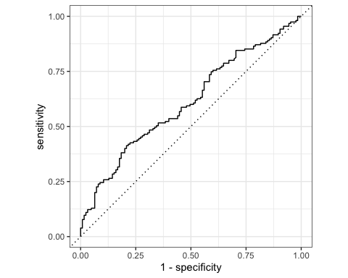

# Deliverables

There is a lot of explanatory text, comments, etc. You do not need these, so delete them and produce a stand-alone document that you could share with someone. Knit the edited and completed R Markdown (Rmd) file as a Word or HTML document (use the “Knit” button at the top of the script editor window) and upload it to Canvas. You must be commiting and pushing your changes to your own Github repo as you go along.

# Details

* Who did you collaborate with: Paula, Nicho
* Approximately how much time did you spend on this problem set: 3 hours
* What, if anything, gave you the most trouble:

**Please seek out help when you need it,** and remember the [15-minute rule](https://dsb2023.netlify.app/syllabus/#the-15-minute-rule). You know enough R (and have enough examples of code from class and your readings) to be able to do this. If you get stuck, ask for help from others, post a question on Slack– and remember that I am here to help too!

As a true test to yourself, do you understand the code you submitted and are you able to explain it to someone else?

# Rubric

13/13: Problem set is 100% completed. Every question was attempted and answered, and most answers are correct. Code is well-documented (both self-documented and with additional comments as necessary). Used tidyverse, instead of base R. Graphs and tables are properly labelled. Analysis is clear and easy to follow, either because graphs are labeled clearly or you’ve written additional text to describe how you interpret the output. Multiple Github commits. Work is exceptional. I will not assign these often.

8/13: Problem set is 60–80% complete and most answers are correct. This is the expected level of performance. Solid effort. Hits all the elements. No clear mistakes. Easy to follow (both the code and the output). A few Github commits.

5/13: Problem set is less than 60% complete and/or most answers are incorrect. This indicates that you need to improve next time. I will hopefully not assign these often. Displays minimal effort. Doesn’t complete all components. Code is poorly written and not documented. Uses the same type of plot for each graph, or doesn’t use plots appropriate for the variables being analyzed. No Github commits.