Final Group 18 project

Group 18 Paula Lagos, Ignacio Nino, Nicholas Arnovitz, Isabel Gonzalez

2023-06-08

Table of Contents

# The problem: predicting credit card fraud

The goal of the project is to predict fraudulent credit card transactions.

We will be using a dataset with credit card transactions containing legitimate and fraud transactions. Fraud is typically well below 1% of all transactions, so a naive model that predicts that all transactions are legitimate and not fraudulent would have an accuracy of well over 99%– pretty good, no?

You can read more on credit card fraud on [Credit Card Fraud Detection Using Weighted Support Vector Machine](https://www.scirp.org/journal/paperinformation.aspx?paperid=105944)

The dataset we will use consists of credit card transactions and it includes information about each transaction including customer details, the merchant and category of purchase, and whether or not the transaction was a fraud.

## Obtain the data

The dataset is too large to be hosted on Canvas or Github, so please download it from dropbox <https://www.dropbox.com/sh/q1yk8mmnbbrzavl/AAAxzRtIhag9Nc_hODafGV2ka?dl=0> and save it in your dsb repo, under the data folder.

As we will be building a classifier model using tidymodels, there’s two things we need to do:

1. Define the outcome variable is_fraud as a factor, or categorical, variable, instead of the numerical 0-1 varaibles.
2. In tidymodels, the first level is the event of interest. If we leave our data as is, 0 is the first level, but we want to find out when we actually did (1) have a fraudulent transaction

## Rows: 671,028  
## Columns: 14  
## $ trans_date_trans_time <dttm> 2019-02-22 07:32:58, 2019-02-16 15:07:20, 2019-…  
## $ trans_year <dbl> 2019, 2019, 2019, 2019, 2019, 2019, 2019, 2020, …  
## $ category <chr> "entertainment", "kids_pets", "personal_care", "…  
## $ amt <dbl> 7.79, 3.89, 8.43, 40.00, 54.04, 95.61, 64.95, 3.…  
## $ city <chr> "Veedersburg", "Holloway", "Arnold", "Apison", "…  
## $ state <chr> "IN", "OH", "MO", "TN", "CO", "GA", "MN", "AL", …  
## $ lat <dbl> 40.1186, 40.0113, 38.4305, 35.0149, 39.4584, 32.…  
## $ long <dbl> -87.2602, -80.9701, -90.3870, -85.0164, -106.385…  
## $ city_pop <dbl> 4049, 128, 35439, 3730, 277, 1841, 136, 190178, …  
## $ job <chr> "Development worker, community", "Child psychoth…  
## $ dob <date> 1959-10-19, 1946-04-03, 1985-03-31, 1991-01-28,…  
## $ merch_lat <dbl> 39.41679, 39.74585, 37.73078, 34.53277, 39.95244…  
## $ merch_long <dbl> -87.52619, -81.52477, -91.36875, -84.10676, -106…  
## $ is_fraud <fct> 0, 0, 0, 0, 0, 0, 0, 0, 0, 0, 0, 0, 0, 0, 0, 0, …

The data dictionary is as follows

| column(variable) | description |
| --- | --- |
| trans_date_trans_time | Transaction DateTime |
| trans_year | Transaction year |
| category | category of merchant |
| amt | amount of transaction |
| city | City of card holder |
| state | State of card holder |
| lat | Latitude location of purchase |
| long | Longitude location of purchase |
| city_pop | card holder’s city population |
| job | job of card holder |
| dob | date of birth of card holder |
| merch_lat | Latitude Location of Merchant |
| merch_long | Longitude Location of Merchant |
| is_fraud | Whether Transaction is Fraud (1) or Not (0) |

We also add some of the variables we considered in our EDA for this dataset during homework 2.

card_fraud <- card_fraud %>%   
 mutate( hour = hour(trans_date_trans_time),  
 wday = wday(trans_date_trans_time, label = TRUE),  
 month_name = month(trans_date_trans_time, label = TRUE),  
 age = interval(dob, trans_date_trans_time) / years(1)  
) %>%   
 rename(year = trans_year) %>%   
   
 mutate(  
   
 # convert latitude/longitude to radians  
 lat1_radians = lat / 57.29577951,  
 lat2_radians = merch_lat / 57.29577951,  
 long1_radians = long / 57.29577951,  
 long2_radians = merch_long / 57.29577951,  
   
 # calculate distance in miles  
 distance_miles = 3963.0 * acos((sin(lat1_radians) * sin(lat2_radians)) + cos(lat1_radians) * cos(lat2_radians) * cos(long2_radians - long1_radians)),  
  
 # calculate distance in km  
 distance_km = 6377.830272 * acos((sin(lat1_radians) * sin(lat2_radians)) + cos(lat1_radians) * cos(lat2_radians) * cos(long2_radians - long1_radians))  
  
 )

## Exploratory Data Analysis (EDA)

You have done some EDA and you can pool together your group’s expertise in which variables to use as features. You can reuse your EDA from earlier, but we expect at least a few visualisations and/or tables to explore the dataset and identify any useful features.

Group all variables by type and examine each variable class by class. The dataset has the following types of variables:

1. Strings
2. Geospatial Data
3. Dates
4. Date/Times
5. Numerical

Strings are usually not a useful format for classification problems. The strings should be converted to factors, dropped, or otherwise transformed.

***Strings to Factors***

* category, Category of Merchant
* job, Job of Credit Card Holder

***Strings to Geospatial Data***

We have plenty of geospatial data as lat/long pairs, so I want to convert city/state to lat/long so I can compare to the other geospatial variables. This will also make it easier to compute new variables like the distance the transaction is from the home location.

* city, City of Credit Card Holder
* state, State of Credit Card Holder

## Exploring factors: how is the compactness of categories?

* Do we have excessive number of categories? Do we want to combine some?

card_fraud %>%   
 count(category, sort=TRUE)%>%   
 mutate(perc = n/sum(n))

## # A tibble: 14 × 3  
## category n perc  
## <chr> <int> <dbl>  
## 1 gas_transport 68046 0.101   
## 2 grocery_pos 63791 0.0951  
## 3 home 63597 0.0948  
## 4 shopping_pos 60416 0.0900  
## 5 kids_pets 58772 0.0876  
## 6 shopping_net 50743 0.0756  
## 7 entertainment 48521 0.0723  
## 8 food_dining 47527 0.0708  
## 9 personal_care 46843 0.0698  
## 10 health_fitness 44341 0.0661  
## 11 misc_pos 41244 0.0615  
## 12 misc_net 32829 0.0489  
## 13 grocery_net 23485 0.0350  
## 14 travel 20873 0.0311

card_fraud %>%   
 count(job, sort=TRUE) %>%   
 mutate(perc = n/sum(n))

## # A tibble: 494 × 3  
## job n perc  
## <chr> <int> <dbl>  
## 1 Film/video editor 5106 0.00761  
## 2 Exhibition designer 4728 0.00705  
## 3 Naval architect 4546 0.00677  
## 4 Surveyor, land/geomatics 4448 0.00663  
## 5 Materials engineer 4292 0.00640  
## 6 Designer, ceramics/pottery 4262 0.00635  
## 7 IT trainer 4014 0.00598  
## 8 Financial adviser 3959 0.00590  
## 9 Systems developer 3948 0.00588  
## 10 Environmental consultant 3831 0.00571  
## # ℹ 484 more rows

The predictors category and job are transformed into factors.

card_fraud <- card_fraud %>%   
 mutate(category = factor(category),  
 job = factor(job))

category has 14 unique values, and job has 494 unique values. The dataset is quite large, with over 670K records, so these variables don’t have an excessive number of levels at first glance. However, it is worth seeing if we can compact the levels to a smaller number.

### Why do we care about the number of categories and whether they are “excessive”?

Consider the extreme case where a dataset had categories that only contained one record each. There is simply insufficient data to make correct predictions using category as a predictor on new data with that category label. Additionally, if your modeling uses dummy variables, having an extremely large number of categories will lead to the production of a huge number of predictors, which can slow down the fitting. This is fine if all the predictors are useful, but if they aren’t useful (as in the case of having only one record for a category), trimming them will improve the speed and quality of the data fitting.

If I had subject matter expertise, I could manually combine categories. If you don’t have subject matter expertise, or if performing this task would be too labor intensive, then you can use cutoffs based on the amount of data in a category. If the majority of the data exists in only a few categories, then it might be reasonable to keep those categories and lump everything else in an “other” category or perhaps even drop the data points in smaller categories.

## Do all variables have sensible types?

Consider each variable and decide whether to keep, transform, or drop it. This is a mixture of Exploratory Data Analysis and Feature Engineering, but it’s helpful to do some simple feature engineering as you explore the data. In this project, we have all data to begin with, so any transformations will be performed on the entire dataset. Ideally, do the transformations as a recipe_step() in the tidymodels framework. Then the transformations would be applied to any data the recipe was used on as part of the modeling workflow. There is less chance of data leakage or missing a step when you perform the feature engineering in the recipe.

## Which variables to keep in your model?

You have a number of variables and you have to decide which ones to use in your model. For instance, you have the latitude/lognitude of the customer, that of the merchant, the same data in radians, as well as the distance_km and distance_miles. Do you need them all?

## Fit your workflows in smaller sample

You will be running a series of different models, along the lines of the California housing example we have seen in class. However, this dataset has 670K rows and if you try various models and run cross validation on them, your computer may slow down or crash.

Thus, we will work with a smaller sample of 10% of the values the original dataset to identify the best model, and once we have the best model we can use the full dataset to train- test our best model.

# select a smaller subset  
my_card_fraud <- card_fraud %>%   
 # select a smaller subset, 10% of the entire dataframe   
 slice_sample(prop = 0.10) %>%   
 select(is_fraud,amt,distance_km,age,hour,category)

## Split the data in training - testing

# **Split the data**  
  
set.seed(123)  
  
data_split <- initial_split(my_card_fraud, # updated data  
 prop = 0.8,   
 strata = is_fraud)  
  
card_fraud_train <- training(data_split)   
card_fraud_test <- testing(data_split)  
  
#Validating that amount distributes better when logaritmic  
card_fraud %>%   
 ggplot()+  
 aes(x=log(amt))+  
 geom_histogram()

## `stat_bin()` using `bins = 30`. Pick better value with `binwidth`.

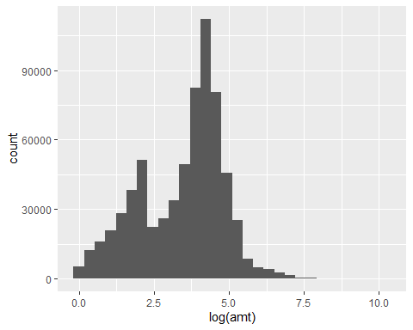

## Cross Validation

Start with 3 CV folds to quickly get an estimate for the best model and you can increase the number of folds to 5 or 10 later.

set.seed(123)  
cv_folds <- vfold_cv(data = card_fraud_train,   
 v = 3,   
 strata = is_fraud)  
cv_folds

## # 3-fold cross-validation using stratification   
## # A tibble: 3 × 2  
## splits id   
## <list> <chr>  
## 1 <split [35787/17894]> Fold1  
## 2 <split [35787/17894]> Fold2  
## 3 <split [35788/17893]> Fold3

## Define a tidymodels recipe

What steps are you going to add to your recipe? Do you need to do any log transformations? Yes we need to do a log transformation on the amount given the data was heavily skewed to the left. Few number of very large transactions.

# #fraud_rec <- recipe(is_fraud ~ ., data = card_fraud_train) %>%  
# # step_log(amt)%>%  
# step_novel(all_nominal(), -all_outcomes()) %>% # Use before `step_dummy()` so new level is dummified  
# step_dummy(hour,wday,month_name, -all_outcomes()) %>%   
# step_zv(is_fraud, amt,distance_km,age,hour,wday,month_name, -all_outcomes()) %>%   
# step_normalize(amt,distance_km,age) %>%   
# step_naomit(everything(), skip = TRUE)  
#card_fraud_test2<-as.data.frame(card_fraud_test)  
  
fraud_rec <- recipe(is_fraud ~ ., data = card_fraud_train) %>%  
 step_log(amt) %>%   
 step_naomit(everything(), skip = TRUE) %>%   
 step_novel(all_nominal(), -all_outcomes()) %>% # Use before `step_dummy()` so new level is dummified  
 step_normalize(all_numeric()) %>%   
 step_dummy(all_nominal(), -all_outcomes()) %>%   
 step_zv(all_numeric(), -all_outcomes())

Once you have your recipe, you can check the pre-processed dataframe

prepped_data <-   
 fraud_rec %>% # use the recipe object  
 prep() %>% # perform the recipe on training data  
 juice() # extract only the preprocessed dataframe   
  
glimpse(prepped_data)

## Rows: 53,681  
## Columns: 18  
## $ amt <dbl> -1.00672809, 0.95519096, -0.91266008, -0.85217…  
## $ distance_km <dbl> 0.4336860, -1.9444395, 0.4791187, 0.7591824, -…  
## $ age <dbl> 1.0819679, -0.6662613, -0.8833407, 0.6758051, …  
## $ hour <dbl> -1.87594834, -1.28970954, 1.49492479, 0.762126…  
## $ is_fraud <fct> 0, 0, 0, 0, 0, 0, 0, 0, 0, 0, 0, 0, 0, 0, 0, 0…  
## $ category_food_dining <dbl> 0, 0, 0, 0, 0, 0, 0, 0, 0, 0, 0, 0, 0, 0, 0, 0…  
## $ category_gas_transport <dbl> 0, 0, 0, 0, 0, 0, 0, 0, 0, 0, 0, 0, 1, 0, 0, 1…  
## $ category_grocery_net <dbl> 0, 0, 0, 0, 0, 0, 0, 0, 0, 0, 0, 0, 0, 0, 0, 0…  
## $ category_grocery_pos <dbl> 0, 1, 0, 0, 0, 0, 0, 0, 0, 0, 0, 0, 0, 0, 0, 0…  
## $ category_health_fitness <dbl> 0, 0, 0, 0, 1, 0, 0, 0, 0, 0, 0, 0, 0, 0, 0, 0…  
## $ category_home <dbl> 0, 0, 0, 0, 0, 0, 0, 0, 0, 0, 0, 0, 0, 0, 1, 0…  
## $ category_kids_pets <dbl> 0, 0, 0, 1, 0, 0, 0, 0, 1, 1, 1, 0, 0, 0, 0, 0…  
## $ category_misc_net <dbl> 0, 0, 0, 0, 0, 0, 0, 0, 0, 0, 0, 0, 0, 0, 0, 0…  
## $ category_misc_pos <dbl> 1, 0, 0, 0, 0, 0, 0, 0, 0, 0, 0, 0, 0, 0, 0, 0…  
## $ category_personal_care <dbl> 0, 0, 0, 0, 0, 0, 0, 0, 0, 0, 0, 0, 0, 0, 0, 0…  
## $ category_shopping_net <dbl> 0, 0, 0, 0, 0, 1, 1, 1, 0, 0, 0, 0, 0, 0, 0, 0…  
## $ category_shopping_pos <dbl> 0, 0, 0, 0, 0, 0, 0, 0, 0, 0, 0, 0, 0, 1, 0, 0…  
## $ category_travel <dbl> 0, 0, 1, 0, 0, 0, 0, 0, 0, 0, 0, 0, 0, 0, 0, 0…

## Define various models

You should define the following classification models:

1. Logistic regression, using the glm engine
2. Decision tree, using the C5.0 engine
3. Random Forest, using the ranger engine and setting importance = "impurity")
4. A boosted tree using Extreme Gradient Boosting, and the xgboost engine
5. A k-nearest neighbours, using 4 nearest_neighbors and the kknn engine

## Model Building   
  
# 1. Pick a `model type`  
# 2. set the `engine`  
# 3. Set the `mode`: classification  
  
  
# 1. Logistic regression, using the `glm` engine  
  
# 2. Decision tree, using the `C5.0` engine  
# 3. Random Forest, using the `ranger` engine and setting `importance = "impurity"`)   
# 4. A boosted tree using Extreme Gradient Boosting, and the `xgboost` engine  
# 5. A k-nearest neighbours, using 4 nearest_neighbors and the `kknn` engine   
# Logistic regression  
log_spec <- logistic_reg() %>% # model type  
 set_engine(engine = "glm") %>% # model engine  
 set_mode("classification") # model mode  
  
# Show your model specification  
log_spec

## Logistic Regression Model Specification (classification)  
##   
## Computational engine: glm

# Decision Tree  
tree_spec <- decision_tree() %>%  
 set_engine(engine = "C5.0") %>%  
 set_mode("classification")  
  
tree_spec

## Decision Tree Model Specification (classification)  
##   
## Computational engine: C5.0

# Random Forest  
library(ranger)  
  
rf_spec <-   
 rand_forest() %>%   
 set_engine("ranger", importance = "impurity") %>%   
 set_mode("classification")  
  
  
# Boosted tree (XGBoost)  
library(xgboost)

##   
## Attaching package: 'xgboost'

## The following object is masked from 'package:dplyr':  
##   
## slice

xgb_spec <-   
 boost_tree() %>%   
 set_engine("xgboost") %>%   
 set_mode("classification")   
  
# K-nearest neighbour (k-NN)  
knn_spec <-   
 nearest_neighbor(neighbors = 4) %>% # we can adjust the number of neighbors   
 set_engine("kknn") %>%   
 set_mode("classification")

## Bundle recipe and model with workflows

log_wflow <- # new workflow object  
 workflow() %>% # use workflow function  
 add_recipe(fraud_rec) %>% # use the new recipe  
 add_model(log_spec) # add your model spec  
  
# show object  
log_wflow

## ══ Workflow ════════════════════════════════════════════════════════════════════  
## Preprocessor: Recipe  
## Model: logistic_reg()  
##   
## ── Preprocessor ────────────────────────────────────────────────────────────────  
## 6 Recipe Steps  
##   
## • step_log()  
## • step_naomit()  
## • step_novel()  
## • step_normalize()  
## • step_dummy()  
## • step_zv()  
##   
## ── Model ───────────────────────────────────────────────────────────────────────  
## Logistic Regression Model Specification (classification)  
##   
## Computational engine: glm

## A few more workflows  
  
tree_wflow <-  
 workflow() %>%  
 add_recipe(fraud_rec) %>%   
 add_model(tree_spec)   
  
rf_wflow <-  
 workflow() %>%  
 add_recipe(fraud_rec) %>%   
 add_model(rf_spec)   
  
xgb_wflow <-  
 workflow() %>%  
 add_recipe(fraud_rec) %>%   
 add_model(xgb_spec)  
  
knn_wflow <-  
 workflow() %>%  
 add_recipe(fraud_rec) %>%   
 add_model(knn_spec)  
  
## Bundle recipe and model with `workflows`  
  
  
log_wflow <- # new workflow object  
 workflow() %>% # use workflow function  
 add_recipe(fraud_rec) %>% # use the new recipe  
 add_model(log_spec) # add your model spec

## Fit models

You may want to compare the time it takes to fit each model. tic() starts a simple timer and toc() stops it

tic()  
log_res <- log_wflow %>%   
 fit_resamples(  
 resamples = cv_folds,   
 metrics = metric_set(  
 recall, precision, f_meas, accuracy,  
 kap, roc_auc, sens, spec),  
 control = control_resamples(save_pred = TRUE))   
time <- toc()

## 1.49 sec elapsed

log_time <- time[[4]]  
  
## Evaluate Models  
  
## Logistic regression results{.smaller}  
  
log_res <- log_wflow %>%   
 fit_resamples(  
 resamples = cv_folds,   
 metrics = metric_set(  
 recall, precision, f_meas, accuracy,  
 kap, roc_auc, sens, spec),  
 control = control_resamples(save_pred = TRUE))   
  
# Show average performance over all folds (note that we use log_res):  
log_res %>% collect_metrics(summarize = TRUE)

## # A tibble: 8 × 6  
## .metric .estimator mean n std_err .config   
## <chr> <chr> <dbl> <int> <dbl> <chr>   
## 1 accuracy binary 0.995 3 0.000634 Preprocessor1_Model1  
## 2 f_meas binary 0.129 3 0.0310 Preprocessor1_Model1  
## 3 kap binary 0.128 3 0.0310 Preprocessor1_Model1  
## 4 precision binary 0.631 3 0.117 Preprocessor1_Model1  
## 5 recall binary 0.0721 3 0.0177 Preprocessor1_Model1  
## 6 roc_auc binary 0.841 3 0.0159 Preprocessor1_Model1  
## 7 sens binary 0.0721 3 0.0177 Preprocessor1_Model1  
## 8 spec binary 1.00 3 0.0000650 Preprocessor1_Model1

# Show performance for every single fold:  
log_res %>% collect_metrics(summarize = FALSE)

## # A tibble: 24 × 5  
## id .metric .estimator .estimate .config   
## <chr> <chr> <chr> <dbl> <chr>   
## 1 Fold1 recall binary 0.0909 Preprocessor1_Model1  
## 2 Fold1 precision binary 0.714 Preprocessor1_Model1  
## 3 Fold1 f_meas binary 0.161 Preprocessor1_Model1  
## 4 Fold1 accuracy binary 0.994 Preprocessor1_Model1  
## 5 Fold1 kap binary 0.160 Preprocessor1_Model1  
## 6 Fold1 sens binary 0.0909 Preprocessor1_Model1  
## 7 Fold1 spec binary 1.00 Preprocessor1_Model1  
## 8 Fold1 roc_auc binary 0.859 Preprocessor1_Model1  
## 9 Fold2 recall binary 0.0886 Preprocessor1_Model1  
## 10 Fold2 precision binary 0.778 Preprocessor1_Model1  
## # ℹ 14 more rows

## `collect_predictions()` and get confusion matrix{.smaller}  
  
log_pred <- log_res %>% collect_predictions()  
  
log_pred %>% conf_mat(is_fraud, .pred_class)

## Truth  
## Prediction 1 0  
## 1 21 12  
## 0 277 53371

log_pred %>%   
 conf_mat(is_fraud, .pred_class) %>%   
 autoplot(type = "mosaic") +  
 geom_label(aes(  
 x = (xmax + xmin) / 2,   
 y = (ymax + ymin) / 2,   
 label = c("TP", "FN", "FP", "TN")))

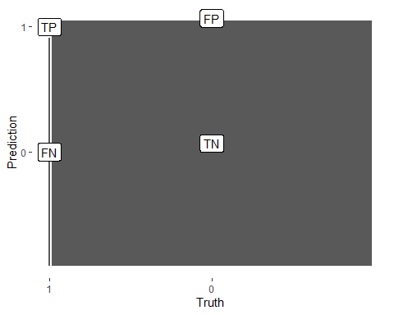

log_pred %>%   
 conf_mat(is_fraud, .pred_class) %>%   
 autoplot(type = "heatmap")

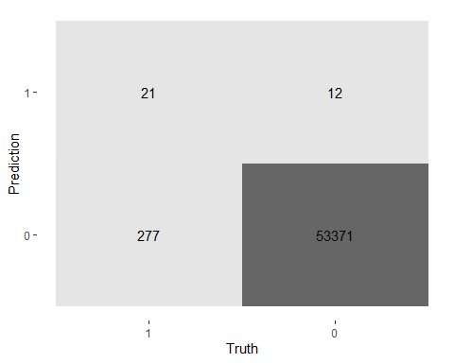

## ROC Curve  
  
log_pred %>%   
 group_by(id) %>% # id contains our folds  
 roc_curve(is_fraud, .pred_1) %>%   
 autoplot()

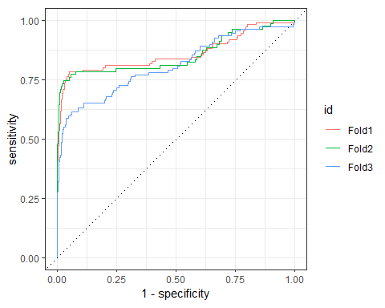

## Decision Tree results  
  
tree_res <-  
 tree_wflow %>%   
 fit_resamples(  
 resamples = cv_folds,   
 metrics = metric_set(  
 recall, precision, f_meas,   
 accuracy, kap,  
 roc_auc, sens, spec),  
 control = control_resamples(save_pred = TRUE)  
 )   
  
tree_res %>% collect_metrics(summarize = TRUE)

## # A tibble: 8 × 6  
## .metric .estimator mean n std_err .config   
## <chr> <chr> <dbl> <int> <dbl> <chr>   
## 1 accuracy binary 0.997 3 0.000308 Preprocessor1_Model1  
## 2 f_meas binary 0.739 3 0.0188 Preprocessor1_Model1  
## 3 kap binary 0.737 3 0.0188 Preprocessor1_Model1  
## 4 precision binary 0.871 3 0.0166 Preprocessor1_Model1  
## 5 recall binary 0.641 3 0.0195 Preprocessor1_Model1  
## 6 roc_auc binary 0.877 3 0.00821 Preprocessor1_Model1  
## 7 sens binary 0.641 3 0.0195 Preprocessor1_Model1  
## 8 spec binary 0.999 3 0.0000751 Preprocessor1_Model1

## Random Forest  
  
rf_res <-  
 rf_wflow %>%   
 fit_resamples(  
 resamples = cv_folds,   
 metrics = metric_set(  
 recall, precision, f_meas,   
 accuracy, kap,  
 roc_auc, sens, spec),  
 control = control_resamples(save_pred = TRUE)  
 )   
  
rf_res %>% collect_metrics(summarize = TRUE)

## # A tibble: 8 × 6  
## .metric .estimator mean n std_err .config   
## <chr> <chr> <dbl> <int> <dbl> <chr>   
## 1 accuracy binary 0.997 3 0.000378 Preprocessor1_Model1  
## 2 f_meas binary 0.653 3 0.0446 Preprocessor1_Model1  
## 3 kap binary 0.652 3 0.0447 Preprocessor1_Model1  
## 4 precision binary 0.959 3 0.0154 Preprocessor1_Model1  
## 5 recall binary 0.499 3 0.0515 Preprocessor1_Model1  
## 6 roc_auc binary 0.975 3 0.00939 Preprocessor1_Model1  
## 7 sens binary 0.499 3 0.0515 Preprocessor1_Model1  
## 8 spec binary 1.00 3 0.0000324 Preprocessor1_Model1

## Boosted tree - XGBoost  
  
xgb_res <-   
 xgb_wflow %>%   
 fit_resamples(  
 resamples = cv_folds,   
 metrics = metric_set(  
 recall, precision, f_meas,   
 accuracy, kap,  
 roc_auc, sens, spec),  
 control = control_resamples(save_pred = TRUE)  
 )   
  
xgb_res %>% collect_metrics(summarize = TRUE)

## # A tibble: 8 × 6  
## .metric .estimator mean n std_err .config   
## <chr> <chr> <dbl> <int> <dbl> <chr>   
## 1 accuracy binary 0.998 3 0.000378 Preprocessor1_Model1  
## 2 f_meas binary 0.780 3 0.0355 Preprocessor1_Model1  
## 3 kap binary 0.779 3 0.0357 Preprocessor1_Model1  
## 4 precision binary 0.920 3 0.00563 Preprocessor1_Model1  
## 5 recall binary 0.681 3 0.0536 Preprocessor1_Model1  
## 6 roc_auc binary 0.976 3 0.00450 Preprocessor1_Model1  
## 7 sens binary 0.681 3 0.0536 Preprocessor1_Model1  
## 8 spec binary 1.00 3 0.0000650 Preprocessor1_Model1

## K-nearest neighbour  
  
knn_res <-   
 knn_wflow %>%   
 fit_resamples(  
 resamples = cv_folds,   
 metrics = metric_set(  
 recall, precision, f_meas,   
 accuracy, kap,  
 roc_auc, sens, spec),  
 control = control_resamples(save_pred = TRUE)  
 )   
  
knn_res %>% collect_metrics(summarize = TRUE)

## # A tibble: 8 × 6  
## .metric .estimator mean n std_err .config   
## <chr> <chr> <dbl> <int> <dbl> <chr>   
## 1 accuracy binary 0.996 3 0.000281 Preprocessor1_Model1  
## 2 f_meas binary 0.562 3 0.0134 Preprocessor1_Model1  
## 3 kap binary 0.560 3 0.0134 Preprocessor1_Model1  
## 4 precision binary 0.627 3 0.0337 Preprocessor1_Model1  
## 5 recall binary 0.518 3 0.0422 Preprocessor1_Model1  
## 6 roc_auc binary 0.832 3 0.0203 Preprocessor1_Model1  
## 7 sens binary 0.518 3 0.0422 Preprocessor1_Model1  
## 8 spec binary 0.998 3 0.000197 Preprocessor1_Model1

log_metrics <-   
 log_res %>%   
 collect_metrics(summarise = TRUE) %>%  
 # add the name of the model to every row  
 mutate(model = "Logistic Regression")   
  
tree_metrics <-   
 tree_res %>%   
 collect_metrics(summarise = TRUE) %>%  
 mutate(model = "Decision Tree")  
  
rf_metrics <-   
 rf_res %>%   
 collect_metrics(summarise = TRUE) %>%  
 mutate(model = "Random Forest")  
  
xgb_metrics <-   
 xgb_res %>%   
 collect_metrics(summarise = TRUE) %>%  
 mutate(model = "XGBoost")  
  
knn_metrics <-   
 knn_res %>%   
 collect_metrics(summarise = TRUE) %>%  
 mutate(model = "Knn")  
  
# create dataframe with all models  
model_compare <- bind_rows(log_metrics,  
 tree_metrics,  
 rf_metrics,  
 xgb_metrics,  
 knn_metrics)  
#Pivot wider to create barplot  
 model_comp <- model_compare %>%   
 select(model, .metric, mean, std_err) %>%   
 pivot_wider(names_from = .metric, values_from = c(mean, std_err))   
  
# show mean are under the curve (ROC-AUC) for every model  
model_comp %>%   
 arrange(mean_roc_auc) %>%   
 mutate(model = fct_reorder(model, mean_roc_auc)) %>% # order results  
 ggplot(aes(model, mean_roc_auc, fill=model)) +  
 geom_col() +  
 coord_flip() +  
 scale_fill_brewer(palette = "Blues") +  
 geom_text(  
 size = 3,  
 aes(label = round(mean_roc_auc, 2),   
 y = mean_roc_auc + 0.08),  
 vjust = 1  
 )+  
 theme_light()+  
 theme(legend.position = "none")+  
 labs(y = NULL)

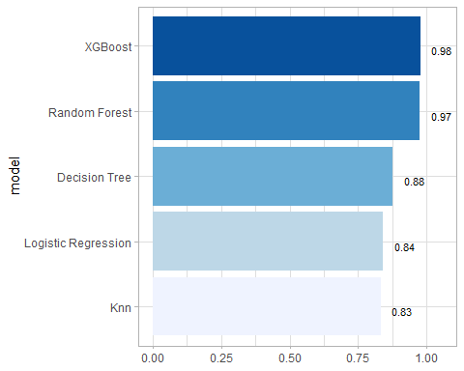 ## Which metric to use

This is a highly imbalanced data set, as roughly 99.5% of all transactions are ok, and it’s only 0.5% of transactions that are fraudulent. A naive model, which classifies everything as ok and not-fraud, would have an accuracy of 99.5%, but what about the sensitivity, specificity, the AUC, etc?

## `last_fit()

## `last_fit()` on test set  
  
# - `last_fit()` fits a model to the whole training data and evaluates it on the test set.   
# - provide the workflow object of the best model as well as the data split object (not the training data).   
   
last_fit_xgb <- last_fit(xgb_wflow,   
 split = data_split,  
 metrics = metric_set(  
 accuracy, f_meas, kap, precision,  
 recall, roc_auc, sens, spec))  
  
last_fit_xgb %>% collect_metrics(summarize = TRUE)

## # A tibble: 8 × 4  
## .metric .estimator .estimate .config   
## <chr> <chr> <dbl> <chr>   
## 1 accuracy binary 0.998 Preprocessor1_Model1  
## 2 f_meas binary 0.736 Preprocessor1_Model1  
## 3 kap binary 0.735 Preprocessor1_Model1  
## 4 precision binary 0.812 Preprocessor1_Model1  
## 5 recall binary 0.672 Preprocessor1_Model1  
## 6 sens binary 0.672 Preprocessor1_Model1  
## 7 spec binary 0.999 Preprocessor1_Model1  
## 8 roc_auc binary 0.959 Preprocessor1_Model1

#Compare to training  
xgb_res %>% collect_metrics(summarize = TRUE)

## # A tibble: 8 × 6  
## .metric .estimator mean n std_err .config   
## <chr> <chr> <dbl> <int> <dbl> <chr>   
## 1 accuracy binary 0.998 3 0.000378 Preprocessor1_Model1  
## 2 f_meas binary 0.780 3 0.0355 Preprocessor1_Model1  
## 3 kap binary 0.779 3 0.0357 Preprocessor1_Model1  
## 4 precision binary 0.920 3 0.00563 Preprocessor1_Model1  
## 5 recall binary 0.681 3 0.0536 Preprocessor1_Model1  
## 6 roc_auc binary 0.976 3 0.00450 Preprocessor1_Model1  
## 7 sens binary 0.681 3 0.0536 Preprocessor1_Model1  
## 8 spec binary 1.00 3 0.0000650 Preprocessor1_Model1

## Get variable importance using vip package

## Variable importance using `{vip}` package  
  
library(vip)  
  
last_fit_xgb %>%   
 pluck(".workflow", 1) %>%   
 pull_workflow_fit() %>%   
 vip(num_features = 10) +  
 theme_light()

## Warning: `pull_workflow_fit()` was deprecated in workflows 0.2.3.  
## ℹ Please use `extract_fit_parsnip()` instead.  
## This warning is displayed once every 8 hours.  
## Call `lifecycle::last_lifecycle_warnings()` to see where this warning was  
## generated.

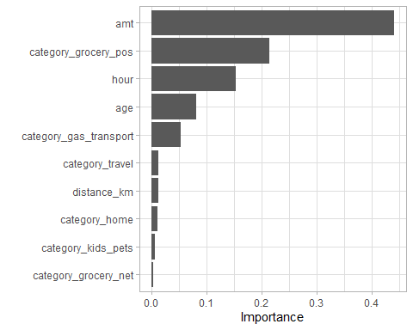 ## Plot Final Confusion matrix and ROC curve

## Final Confusion Matrix  
  
last_fit_xgb %>%  
 collect_predictions() %>%   
 conf_mat(is_fraud, .pred_class) %>%   
 autoplot(type = "heatmap")

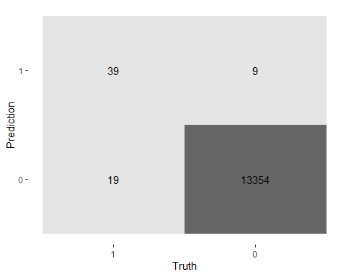

## Final ROC curve  
last_fit_xgb %>%   
 collect_predictions() %>%   
 roc_curve(is_fraud, .pred_1) %>%  
 autoplot()

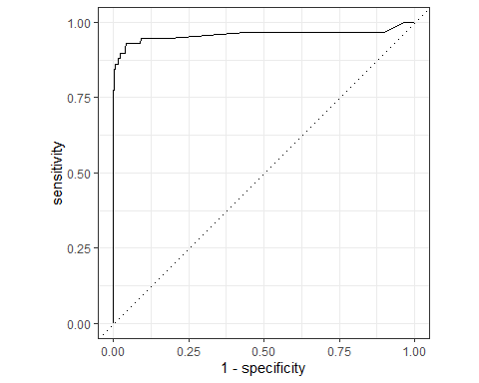

## Compare models

## Model Comparison  
  
log_metrics <-   
 log_res %>%   
 collect_metrics(summarise = TRUE) %>%  
 # add the name of the model to every row  
 mutate(model = "Logistic Regression",  
 time = log_time)  
  
# add mode models here  
  
# create dataframe with all models  
model_compare <- bind_rows(log_metrics,  
 tree_metrics,  
 rf_metrics,  
 xgb_metrics,  
 knn_metrics  
 ) %>%   
 # get rid of 'sec elapsed' and turn it into a number  
 mutate(time = str_sub(time, end = -13) %>%   
 as.double()  
 )

## Calculating the cost of fraud to the company

* How much money (in US$ terms) are fraudulent transactions costing the company? Generate a table that summarizes the total amount of legitimate and fraudulent transactions per year and calculate the % of fraudulent transactions, in US$ terms. Compare your model vs the naive classification that we do not have any fraudulent transactions.

best_model_preds <-   
 rf_wflow %>%   
 fit(data = card_fraud_train) %>%   
   
 ## Use `augment()` to get predictions for entire data set  
 augment(new_data = card_fraud)  
  
best_model_preds %>%   
 conf_mat(truth = is_fraud, estimate = .pred_class)

## Truth  
## Prediction 1 0  
## 1 2092 69  
## 0 1844 667023

cost <- best_model_preds %>%  
 select(is_fraud, amt, pred = .pred_class)   
  
cost <- cost %>%  
 mutate(naive_false <- sum(pred != is_fraud),  
false_negatives <- sum(pred == 0 & is_fraud == 1),  
false_positives <- sum(pred == 1 & is_fraud == 0),  
true_positives <- sum(pred == 1 & is_fraud == 1),  
true_negatives <- sum(pred ==0&is_fraud==0))  
   
  
 # naive false-- we think every single transaction is ok and not fraud  
  
  
 # false negatives-- we thought they were not fraud, but they were  
  
   
   
 # false positives-- we thought they were fraud, but they were not  
  
   
   
 # true positives-- we thought they were fraud, and they were   
  
  
   
 # true negatives-- we thought they were ok, and they were   
  
   
# Summarising  
  
cost_summary <- cost %>%   
 summarise(across(starts_with(c("false","true", "amt")),   
 ~ sum(.x, na.rm = TRUE)))  
  
cost_summary

## # A tibble: 1 × 5  
## false_negatives <- sum(pred ==…¹ false_positives <- s…² true_positives <- su…³  
## <int> <int> <int>  
## 1 1237375632 46300932 1403790576  
## # ℹ abbreviated names: ¹​`false_negatives <- sum(pred == 0 & is_fraud == 1)`,  
## # ²​`false_positives <- sum(pred == 1 & is_fraud == 0)`,  
## # ³​`true_positives <- sum(pred == 1 & is_fraud == 1)`  
## # ℹ 2 more variables: `true_negatives <- sum(pred == 0 & is_fraud == 0)` <dbl>,  
## # amt <dbl>

glimpse(cost_summary)

## Rows: 1  
## Columns: 5  
## $ `false_negatives <- sum(pred == 0 & is_fraud == 1)` <int> 1237375632  
## $ `false_positives <- sum(pred == 1 & is_fraud == 0)` <int> 46300932  
## $ `true_positives <- sum(pred == 1 & is_fraud == 1)` <int> 1403790576  
## $ `true_negatives <- sum(pred == 0 & is_fraud == 0)` <dbl> 447591109644  
## $ amt <dbl> 47183904

* If we use a naive classifier thinking that all transactions are legitimate and not fraudulent, the cost to the company is .
* With our best model, the total cost of false negatives, namely transactions our classifier thinks are legitimate but which turned out to be fraud, is .
* Our classifier also has some false positives, , namely flagging transactions as fraudulent, but which were legitimate. Assuming the card company makes around 2% for each transaction (source: <https://startups.co.uk/payment-processing/credit-card-processing-fees/>), the amount of money lost due to these false positives is
* The $ improvement over the naive policy is .