

Microsoft Office Word 2003 XSLT Inference Tool: Creating a Seed Document
White Paper
Published: October 2004
Table of Contents
Introduction 1
Creating the Seed Document 1
Formatting the Seed Document 2
Simple Formatting 2
Formatting Repeated Elements 3
Formatting Based on Attributes 4
Formatting with Mixed Content 4
Working with Extraneous Content 5
Formatting with Tables 5
Seeing the End Result 7
Data Binding 9

Microsoft Office Word 2003 XSLT Inference Tool: Creating a Seed Document
White Paper

Published: October 2004
For the latest information, please see http://msdn.microsoft.com/office/
Learn to create a "seed document" for the Microsoft® Office Word 2003 XSLT Inference tool. The Transform Inference tool helps you create XSL Transformations (XSLT), enabling you to quickly transform similar XML files into documents with rich formatting.

Introduction
The Transform Inference tool allows you to easily create XSL Transformations (XSLT) that can help you quickly transform similar XML files into documents with complex and rich formatting. The process begins with a raw XML file that is representative of the XML files you wish to transform. You then apply formatting to the XML file in Office Word 2003 such that it becomes a template of how you would like all other similar XML files to be formatted. When completed, this document is called the seed document and is used by the Transform Inference tool to create the transform.

Creating the Seed Document
All you have to do to create a seed document is open a raw XML file in Office Word 2003, apply some formatting, and use Save As to save it. In the Save As dialog, choose "XML Document (*.xml)" as the type, and be sure to uncheck "Save data only" or else necessary information to create the transform will be removed.
You can create a seed document from a pre-existing XML file, or create the XML file directly in Office Word 2003. The idea is to format each element in the file the way you would like that element formatted in other similar files that you will be applying the transform to. The files that receive the transform are called input files. Therefore, as a general rule, the seed document should contain at least one of every element that will appear in the input files.
Once you have formatted all the elements and saved the seed document, it is used as an argument when running the Transform Inference tool to create a transformation.
Note Using the XSLT Inference Tool is covered in a separate document included with the Microsoft Office 2003 WordprocessingML Transform Inference tool.

Formatting the Seed Document
For the topics below, assume the very simple sample raw XML file here. It will be used to demonstrate the various ways to format seed documents.
<?xml version="1.0" encoding="UTF-8" standalone="no"?>
<log xmlns="logs">
<logon>Logon</logon>
<shutdown>Shutdown</shutdown>
<restart>Restart</restart>
<logoff>Logoff</logoff>
</log>

Simple Formatting
Most XML schemas contain elements that can be repeated up to a limited or unlimited number of times. For example, an element may denote tasks in a "To do" list or purchases in an invoice that should be formatted the same way every time they appear in a document. When you format repeating elements in the seed document, they will be recognized and picked up by the Transform Inference tool and contained in the resulting transformation. In the seed document, the formatting of an element is considered any formatting that is applied both to its contents as well as some surrounding elements. Therefore, an element will take the exact formatting of the text contained within it. Examples of using formatting that surrounds an element, such as a table, are discussed further below. For a simple example, consider the following raw XML file, which is representative of generated log XML files.
When opened in Word 2003, the XML file looks like this:
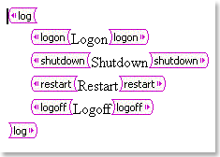
Figure 1. XML file opened in Word 2003
Now formatting is ready to be applied to the elements. Say you want distinctly different formatting for each of the child elements of <log>. You might use different fonts, colors, and highlighting and change it like this:
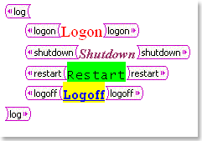
Figure 2. XML file with distinct formatting of elements
All formatting applied to the text within the begin and end tags of an element in the seed document will also be applied to the contents of all instances of that same element in raw XML input files when the resulting transform is applied to them. For example, this seed document will result in a transform that formats the text of all <logon> elements with the Times New Roman font in red and the text of all <logoff> elements with the Rockwell font that is dark blue, underlined, and yellow highlighted, etc.

Formatting Repeated Elements
You're not limited to just one type of formatting for each element. If you have three instances of the same element in your seed document, the input document will get the exact same formatting as you applied to them in the seed, and any further elements will take the formatting of the last instance specified. Take the following:
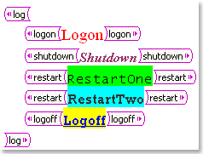
Figure 3. XML file with same elements formatted differently
The resulting transform will apply the Lucida Console font with black text and green highlighting to the first <restart> element it encounters and the Rockwell font with dark blue text with turquoise highlighting to all the remaining <restart> elements. You can format as many of the same element differently as you like.
When this seed document is used to create a transform, the resulting file will have the following two lines:
/ns0:log/ns0:restart[1]
/ns0:log/ns0:restart[position() >= 2]

The first template is associated with only the first <restart> element, as indicated by the number one in square brackets. The second template is associated with the second and any other <restart> elements, as signified by the position() >= 2 in its square brackets.

Formatting Based on Attributes
It is not possible to format an element differently based solely on the value of one of its attributes with just the seed document. However, it can be done with the seed document together with repeat element formatting and a slight edit of the .XSL file created by the XSLT Inference tool. Say a seed document has a <restart> element with a Boolean attribute called automatic and you want it formatted one way when it's true and another when it's false. In this case you format the <restart> element twice, once for each possible value of the attribute. One has the formatting you want when it is false, the other for when it's true. At this point the seed document looks like it is formatted for repeating elements, just like in the above topic. The purpose of doing this is to get two versions of the same element in the transform. You next use the XSLT Inference tool to create the transform and then open it in an editor. The tool will put two lines in the XSL file for the <restart> element that you can modify to differ by attribute rather than position. This example seed document would result in a transform with the following two lines:
/ns0:log/ns0:restart[1]
/ns0:log/ns0:restart[position() >= 2]

You can now remove the position data within the square brackets and replace it with attribute data:
/ns0:log/ns0:restart[not@automatic]
/ns0:log/ns0:restart[@automatic]

Now <restart> elements with automatic set to true will be formatted like the first <restart> element in the seed document and those with automatic set to false will be formatted like the second <restart> element in the seed document.

Formatting with Mixed Content
Mixed content is considered content outside XML elements. When the XSLT Inference tool encounters mixed content it will treat it as a fixed part of formatting, bringing it into all the seed documents. This is a useful way to bring in banners, footers, or any other piece of static formatting. A transformation created from the seed document below applies the "My Log File" banner once at the top of the parent <log> element because it's not contained within any of the leaf elements of the <log> start and end tags. The transform positions it above the child element (<logon>) because that's where it's positioned in the seed document. The clipart inserted at the beginning of the <shutdown> element will appear at the beginning of every <shutdown> element since it's a part of the contents of <shutdown>. Similarly, the divider will appear at the end of every <logoff> element.
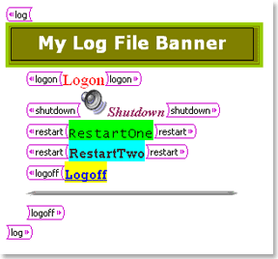
Figure 4. XML file with mixed content

Working with Extraneous Content
Before a seed document is used to create a transform, the tool cleans up various items in the document that don't make sense for formatting XML elements. For example, all comments, revisions, smart tags, and spelling and grammar issues are removed. Therefore, it is advisable that these not be added to seed documents. Since annotations, smart tags, and revisions may contain text, and that text cannot be captured by the tool, a warning appears if the tool encounters any of them.

Formatting with Tables
You can use tables in seed documents to either group elements together or to wrap single elements by themselves. The difference, which is subtle but very important, is whether entire elements are contained in a table, or whether only the contents of a single element are contained in a table. Consider the following seed document:
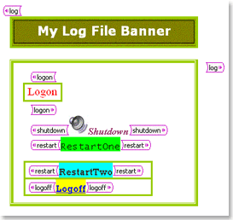
Figure 5. XML file with three tables
Here we have three tables. One is a single-cell, single-row table that outlines all of the child nodes of the <log> element. Notice that it does not include the banner. A second one-row, one-cell table contains only the contents of the <logon> element—its begin and end tags are outside the table. A third table has two one-cell rows, one with the second <restart> element and one with the <logoff> element. Each has not only contents (the text), but also begin and end tags in the table. This tells the transform to append the second and any subsequent <restart> elements and all <logoff> elements to the same table, each in their own respective row. Note that the first <logoff> element will never appear in the table.
Let's say the following raw XML file is opened in Word:
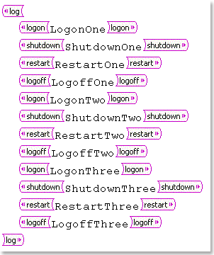
Figure 6. Raw XML file opened in Word
If you take the transform created with the seed document that was just described with tables and apply it to this raw XML, the formatting looks as follows.
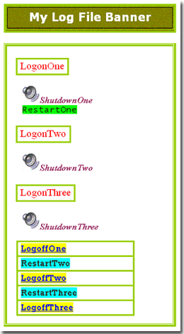
Figure 7. XML file with transform applied
Notice how the tables follow the same pattern as in the seed document. Also notice how the elements that are not encapsulated in a table row, <shutdown> and the first <restart>, appear to stand alone, even though they are inside the single-cell table in the <log> element with all the other leaf nodes.

Seeing the End Result
Once you have your seed document, you can create and then apply the transform. Here we show what you can expect from the formatting previously discussed. For more information about how to use the XSLT Inference tool, see the UsingXSLTInferenceTool_readme.htm included in this download.
Note For clarity, the result of table formatting is demonstrated earlier in this topic under "Formatting with Tables."
The seed document below contains simple text formatting, formatting of multiple elements (the <restart> element), and mixed content in the form of a banner, clipart, and a divider.
Figure 8. Seed document with formatting and mixed content
Here is a sample raw XML file to which the transform will be applied. Note that it contains the same elements that are in the seed document. Raw XML files that have the transform applied to them are referred to as "input files."
Figure 9. Sample raw XML file opened in Word
Using the seed file, the XSLT Inference tool is able to generate a transform (.xsl file) that captures all of its formatting. Here we have the input file shown after the transform created with the sample seed document has been applied to it.
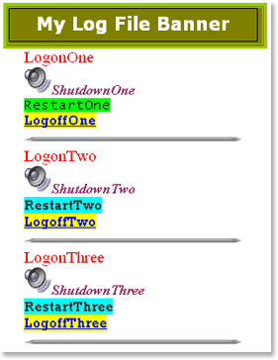
Figure 10. Input file after transform has been applied
Notice how the text of each element assumes the exact formatting of its respective element in the seed document and how static items like banners and clipart come through. Also note the difference between the first <restart> element and the rest of the <restart> elements and recall how you can format the same element more than once in the seed document

Data Binding
Data binding is a mode in which the Transform Inference tool takes into account the fact that some elements may contain nothing more than child elements. In a case like this there is no need to create a template in the transform for elements that do not contain any content to format, so the tool is able to create XPaths to the relevant leaf elements that do contain content when it runs in data binding mode. The data is, in essence, bound within XPaths comprised of some elements that don't require formatting.
As an example, take this sample raw XML file:
<?xml version="1.0" encoding="UTF-8" standalone="no"?>
<purchase xmlns="Purchases">
<customer>
<name>
<first></first>
<last></last>
</Name>
</customer>
<item>
<total></total>
</item>
</purchase>

Suppose you want a table that has one row for each purchase, and each row contains three columns, one for the first name, one for the last name, and one for the total. This is a good case for using data binding because there is no formatting associated with the <customer>, <name>, or <item> elements. Seed documents created for data binding are put together differently than the seed documents previously mentioned. Rather than begin with a raw XML file, it's best to load the schema on which your input files are based and then create the document from scratch. In this example, you begin by constructing a table with one row that will act as a model customer row plus any header rows, and then add the necessary elements. When adding the elements, it is important to ensure that each is added within its parent element so that proper XPaths are constructed in the seed document. For example, the path of the <first> element must look like:
<purchase><customer><name><first>...</first></name></customer></purchase>

When in data binding mode, if an element contains nothing but other nodes, the tool interprets it as part of an XPath and therefore no template is created for it in the transform. The table might look something like this:
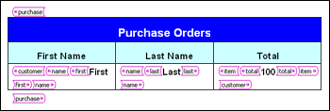
Figure 11. Purchase order table
Notice how the <first>, <last>, and <total> elements are wrapped in a hierarchy that resolves to a valid XPath up to the parent node of <purchase>.
To use this seed document in data binding mode, save it as an XML file (make sure Save data only is unchecked) and pass it to the tool in the command window with the -db option. If the file is titled purchases.xml, you would enter this:
wml2xslt purchases.xml –db

The resulting transform will be called purchases.xsl. When it's applied to an input file that is based on the schema used to create the seed file, a table with the same format as the one in the seed file will appear with a row for each customer that contains columns for the first name, the last name, and the total.

For more information: http://www.microsoft.com/office/
For information about privacy: http://www.microsoft.com/info/privacy.mspx.

Note For more information about how to use the XSLT Inference tool, see the UsingXSLTInferenceTool_readme.htm included in this download.


The information contained in this document represents the current view of Microsoft Corporation on the issues discussed as of the date of publication. Because Microsoft must respond to changing market conditions, it should not be interpreted to be a commitment on the part of Microsoft, and Microsoft cannot guarantee the accuracy of any information presented after the date of publication.

This White Paper is for informational purposes only. MICROSOFT MAKES NO WARRANTIES, EXPRESS, IMPLIED OR STATUTORY, AS TO THE INFORMATION IN THIS DOCUMENT.

Complying with all applicable copyright laws is the responsibility of the user. Without limiting the rights under copyright, no part of this document may be reproduced, stored in or introduced into a retrieval system, or transmitted in any form or by any means (electronic, mechanical, photocopying, recording, or otherwise), or for any purpose, without the express written permission of Microsoft Corporation.

Microsoft may have patents, patent applications, trademarks, copyrights, or other intellectual property rights covering subject matter in this document. Except as expressly provided in any written license agreement from Microsoft, the furnishing of this document does not give you any license to these patents, trademarks, copyrights, or other intellectual property.
 2004 Microsoft Corporation. All rights reserved.

Microsoft is either a registered trademark or a trademark of Microsoft Corporation in the United States and/or other countries.

The names of actual companies and products mentioned herein may be the trademarks of their respective owners.

