eMine build instruction

1. System Requirements

- Operating Systems: Windows® XP or above
- Software
- Eclipse 3.8.x Windows (32-bit) (Eclipse Classic package is recommended)
http://archive.eclipse.org/eclipse/downloads/drops/R-3.8.2-201301310800/
- EGit http://eclipse.org/egit/download/
- Java Runtime Environment (JRE) 5.0 or above (32-bit)
http://java.sun.com/javase/downloads/index.jsp
(see http://www.eclipse.org/downloads/moreinfo/jre.php for more details)
- Internet Explorer 7.0 or above
Note: Please use 32-bit version of Eclipse and JRE whether your OS is 64-bit or 32-bit.

2 Installation of ACTF Visualization SDK
You can install ACTF Visualization SDK by using Eclipse Update mechanism.
Step 1: Select Help -> Install New Software menu.
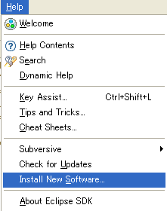

Step 2: Type ACTF update-site URL (http://download.eclipse.org/technology/actf/1.1/update-site) into “Work with:” input box.
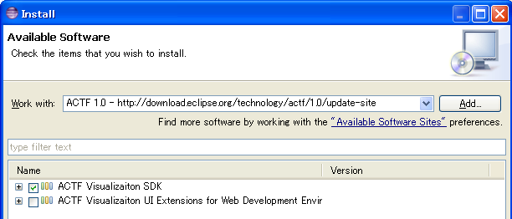
Step 3: Select ACTF Visualization SDK, and press Next button. Then, please follow instruction of the update wizard.

3. Download eMine source code
1. Download zipped Team Project Set file for eMine.
http://www.eclipse.org/downloads/download.php?file=/technology/actf/psf/anonymous/emine.zip

2. Unzip the downloaded file and import Team Project Set file (emine.psf) from Eclipse's 'File' -> 'Import' -> 'Team' -> 'Team Project Set' menu.

4. Launch eMine
Select and open “org.eclipse.actf.examples.emine” project.

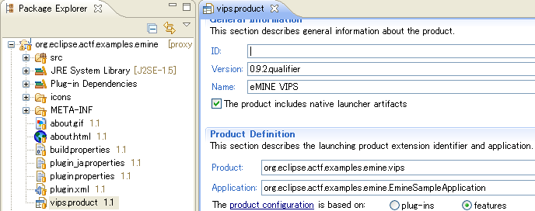

Then, select (double click) vips.product file and open it in a product editor. In the editor, select 'Launch an Eclipse Application' under 'Testing' section.

5. Build eMine

Select and open vips.product file in “org.eclipse.actf.examples.emine” project as in step 4.
Open an export product wizard by selecting 'Eclipse product export wizard' under 'Exporting' section and follow the wizard.

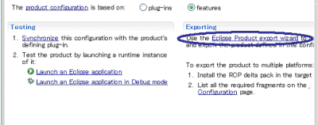

Please turn off all options in “Export Options” section.
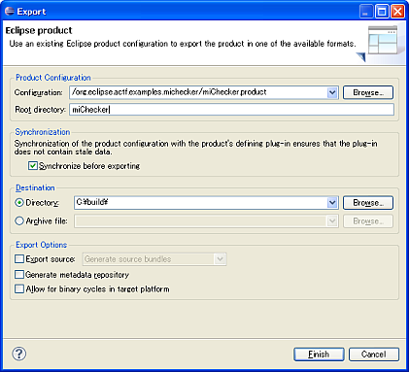

6. Access to ACTF source code
Anyone can access to ACTF CVS repository. Please visit the ACTF Contributors Information page below and get ACTF source code.
http://www.eclipse.org/actf/contributors.php

7. Communication with ACTF team

7.1 Bug report

If you find any issues, please submit a bug report from URL below:
https://bugs.eclipse.org/bugs/enter_bug.cgi?product=ACTF

(Please create your bugzilla account from https://bugs.eclipse.org/bugs/createaccount.cgi )
You can also attach your change as patch file.
Please export your change by using “Team”->”Create Patch” menu, and attach the file to bugzilla entry.

7.2 Questions and feedbacks

If you have any questions or feedbacks about ACTF, please post it to our News Group.

http://www.eclipse.org/newsportal/thread.php?group=eclipse.technology.actf

You can post your message by using “New message” and/or “Reply to this” menu.

(Please create your bugzilla account from https://bugs.eclipse.org/bugs/createaccount.cgi )

7.3 Development discussions

If you want to get more involved into ACTF development discussions, please join the actf-dev Mailing List from URL below.

https://dev.eclipse.org/mailman/listinfo/actf-dev

We are looking forward to working with you!!

© 2012, 2013 by IBM Corporation and others; made available under the EPL v1.0

