ACTF HTML Checker example
build instruction

1. System Requirements

- Operating Systems
Windows 7, Windows 8.1, Windows 10

- Software
- Eclipse 4.5.x (Windows 32-bit) (RCP and RAP Developers version is recommended)
https://eclipse.org/downloads/index-developer.php

- Java Runtime Environment (JRE) 7.0 or above (Version 8 is recommended)
https://java.com/ja/download/
- Internet Explorer 11.0 or above
Note: Please use 32-bit version of Eclipse and JRE whether your OS is 64-bit or 32-bit.

2 Installation of ACTF Visualization SDK
You can install ACTF Visualization SDK by using Eclipse Update mechanism.
Step 1: Select Help -> Install New Software menu.
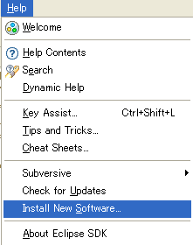

Step 2: Type ACTF update-site URL (http://download.eclipse.org/technology/actf/1.1/update-site) into “Work with:” input box.
Step 3: Select ACTF Visualization SDK, and press Next button. Then, please follow instruction of the update wizard.

ACTF Visualization SDK includes developer guide (API references, etc.). Please open Eclipse Help from ‘Help’ -> ‘Help Contents’ menu and select ‘Eclipse Visualization SDK Developer Guide’.

3. Download HTML Checker source code
1. Download zipped Team Project Set file for HTML Checker.
http://www.eclipse.org/downloads/download.php?file=/technology/actf/psf/anonymous/htmlchecker.zip

2. Unzip the downloaded file and import Team Project Set file (htmlchecker.psf) from Eclipse's 'File' -> 'Import' -> 'Team' -> 'Team Project Set' menu.

4. Launch HTML Checker

Select and open “org.eclipse.actf.examples.htmlchecker” project.

Then, select (double click) htmlchecker.product file and open it in a product editor. In the editor, select 'Launch an Eclipse Application' under 'Testing' section.

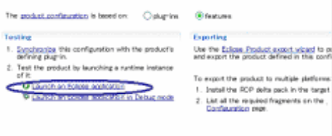

In this case, ACTF HTML Checker assumes that a target HTML file list (htmllist.txt) is placed in Eclipse’s folder (e.g., “c:\eclipse\htmllist.txt” ).
A sample “htmllist.txt” file is in “org.eclipse.actf.examples.htmlchecker-feature” project’s “rootfiles” folder. So, please copy it into your Eclipse’s folder and edit it.
You can also specify a file path of your target HTML file list. Select “Run” -> “Run Configurations” menu of Eclipse, and specify an option below into “Program arguments” area of “Arguments” tab.

-f “c:\test\htmllist.txt”

In above case, HTML Checker will read target HTML file list from “c:\test\htmllist.txt”.

The results of HTML check will be placed into “result” folder in Eclipse’s folder. Error messages will be written into “log.txt” in Eclipse’s folder.

5. Build HTML Checker
Select and open “org.eclipse.actf.examples.htmlchecker” project as in step 4.
Open an export product wizard by selecting 'Eclipse product export wizard' under 'Exporting' section and follow the wizard.
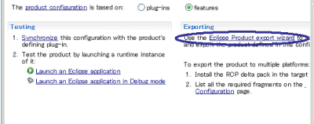
Please turn off all options in “Export Options” section, and please select “Finish” button.

Then, htmlchecker.exe will be generated into the folder specified at “Directory” option. A sample htmllist.txt will be placed into the same folder with htmlchecker.exe. Please modify it and launch htmlchecker.exe to check target html files. After that, results will be placed into “result” folder.

You can also specify a file path of your target HTML file list from command line, as below.

htmlchecker.exe –f “../../htmllist2.txt”

6. Access to ACTF source code
Anyone can access to ACTF CVS repository. Please visit the ACTF Contributors Information page below and get ACTF source code.
http://www.eclipse.org/actf/contributors.php

7. Communication with ACTF team

7.1 Bug report

If you find any issues, please submit a bug report from URL below:
https://bugs.eclipse.org/bugs/enter_bug.cgi?product=ACTF

(Please create your bugzilla account from https://bugs.eclipse.org/bugs/createaccount.cgi )
You can also attach your change as patch file.
Please export your change by using “Team”->”Create Patch” menu, and attach the file to bugzilla entry.

7.2 Questions and feedbacks

If you have any questions or feedbacks about ACTF, please post it to our News Group.

http://www.eclipse.org/newsportal/thread.php?group=eclipse.technology.actf

You can post your message by using “New message” and/or “Reply to this” menu.

(Please create your bugzilla account from https://bugs.eclipse.org/bugs/createaccount.cgi )

7.3 Development discussions

If you want to get more involved into ACTF development discussions, please join the actf-dev Mailing List from URL below.

https://dev.eclipse.org/mailman/listinfo/actf-dev

We are looking forward to working with you!!

