APIs
In general, all properties can be assigned and modified at the following points:
- In the widget declaration
- In the start (onConstructionFunction) function of the handler or widget
- During runtime (for example, an onClick event handler function)

Values can be set and changed:
- From null to a value
- From a value to another value
- Form a value to null

View (DojoMobileView.egl)

A view is container for widgets in a mobile application. Mobile applications are made up of one or more views, each containing tabs, lists, or other widgets. A view typically has a header area across the top, with an optional button for navigating back to the previous view. Generally, views should be declared as part of the initialUI of the Rich UI handler, but this is not a requirement.

Image 1 General view of a DojoMobileView
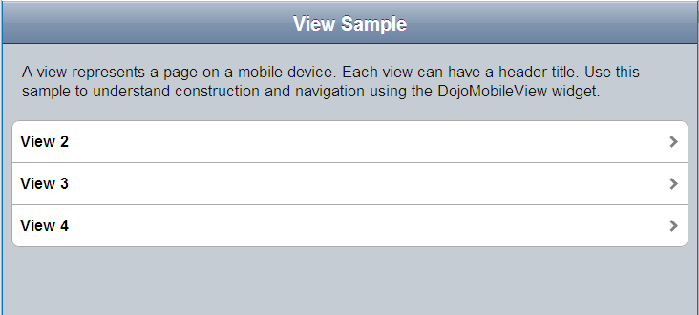

Image 2 Click inside of a view
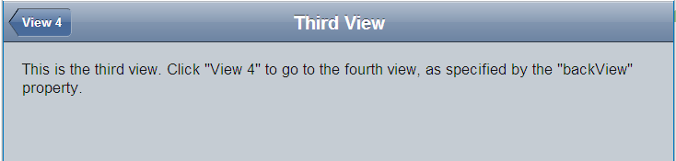

APIs:
- headerTitle String; // optional – title text shown at the top of the view. Setting this value to “” or null will cause the header area to not appear.
- backText String; // optional – text for header “back” button that appears at upper left of the header. If backText is specified and backView isn’t specified, pressing the back button will jump to an empty view. .
- backView View; // optional – view to show when the “back” button is clicked.
- selected boolean; // If selected is true, the view will show in the page. Otherwise, it is hidden. Usually you should have only one selected view in a container.
- children Widgets[] // just like any other container

Code Sample:
handler DojoMobileViewSample type RUIhandler {initialUI = [View], cssFile="css/com.ibm.egl.rui.dojo.mobile.samples_0.7.0.css",
title="DojoMobileViewSample"}

intro Div { margin = 20, font = "Arial", children = [
new HTML { text="A view represents a page on a mobile device. Each view can have a header title. Use this sample to understand construction and navigation using the DojoMobileView widget." , marginBottom=20}]};

View DojoMobileView{ selected = true, id="myDojoMobileView1", headerTitle = "View Sample", children = [ intro,
new DojoMobileList { style = DojoMobileLib.LIST_STYLE_ROUNDED_RECTANGLE, children = [
new DojoMobileListItem{ text = "View 2", actionView = View2, icon = "dojo/mobile/images/i-icon-1.png" },
new DojoMobileListItem{ text = "View 3", actionView = View3, icon = "dojo/mobile/images/i-icon-1.png" },
new DojoMobileListItem{ text = "View 4", actionView = View4, icon = "dojo/mobile/images/i-icon-1.png" }
]} ]};

View2 DojoMobileView{
selected = false, id="myDojoMobileView2", headerTitle = "Second View",
backText = "View 1", backView = View,
children = [ new HTML { text="This is the second view. Click \"View 1\" to return to the first view, as specified by the \"backView\" property.", margin=20}]
};

View3 DojoMobileView{
selected = false, id="myDojoMobileView3", headerTitle = "Third View",
backText = "View 4", backView = View4,
children = [ new HTML { text="This is the third view. Click \"View 4\" to go to the fourth view, as specified by the \"backView\" property.", margin=20}]
};

View4 DojoMobileView{ selected = false, id="myDojoMobileView4", headerTitle = "Fourth View",
backText = "View 1", backView = View,
children = [ new HTML { text="This is the fourth view. Click \"View 1\" to return to the first view, as specified by the \"backView\" property.", margin=20}]
};

end

Notes:
If a view contains a TabContainer, user should set headerTitle to null to hide the header.

List (DojoMobileList.egl)

Provides a container for list items and categories.

Image 3 Edge to edge list
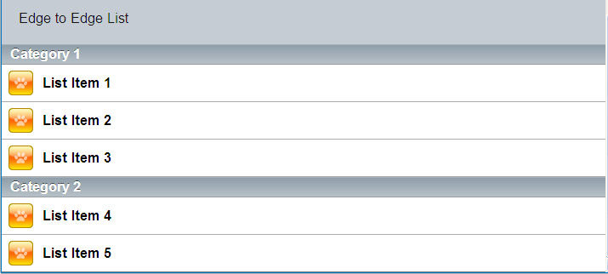

Image 4 Round rectangle list
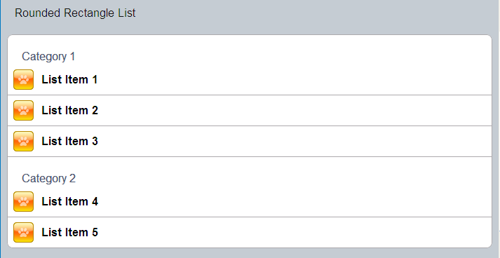

APIs:
style String; // optional (default is rounded rectangle). Valid values: DojoMobileLib.LIST_STYLE_EDGE_TO_EDGE or DojoMobileLib.LIST_STYLE_ROUNDED_RECTANGLE. The style property can be set in the widget variable declaration and onConstruction function. However, changing the style will have no effect once the widget is initialized (at runtime).
- children Widget[]; // 0 or more categories or list item widgets. If the a child is not DojoMobileListCategory or DojoMobileListItem type, an exception will be thrown.
Code sample:
RoudedRectangleList DojoMobileList{
style = DojoMobileLib.LIST_STYLE_ROUNDED_RECTANGLE,
children = [
new DojoMobileListCategory{ title = "Category 1" },
new DojoMobileListItem{ text = "List Item 1", icon = "dojo/mobile/images/i-icon-1.png" } new DojoMobileListItem{ text = "List Item 2", icon = "dojo/mobile/images/i-icon-1.png" },
new DojoMobileListItem{ text = "List Item 3", icon = "dojo/mobile/images/i-icon-1.png" },
new DojoMobileListCategory{ title = "Category 2" },
new DojoMobileListItem{ text = "List Item 4", icon = "dojo/mobile/images/i-icon-1.png" },
new DojoMobileListItem{ text = "List Item 5", icon = "dojo/mobile/images/i-icon-1.png" }
]
};

EdgeToEdgeList DojoMobileList{
style = DojoMobileLib.LIST_STYLE_EDGE_TO_EDGE
};

EdgeToEdgeList.children = [
new DojoMobileListCategory{ title = "Category 1" },
new DojoMobileListItem{ text = "List Item 1", icon = "dojo/mobile/images/i-icon-1.png" },
new DojoMobileListItem{ text = "List Item 2", icon = "dojo/mobile/images/i-icon-1.png" }, new DojoMobileListItem{ text = "List Item 3", icon = "dojo/mobile/images/i-icon-1.png" },
new DojoMobileListCategory{ title = "Category 2" },
new DojoMobileListItem{ text = "List Item 4", icon = "dojo/mobile/images/i-icon-1.png" },
new DojoMobileListItem{ text = "List Item 5", icon = "dojo/mobile/images/i-icon-1.png" }
];

Notes:
In Dojo, “edge-to-edge list” and “rounded rectangle list” are separate widgets, but have been combined into a single EGL widget to simplify the APIs and make it easier to change styles later.

ListCategory (DojoMobileListCategory.egl)

Titled separator within a list. A list category can be useful for alphabetic or logical grouping of list items.

APIs:
- title String; // required title

Code sample:
List1 DojoMobileList{
style = DojoMobileLib.LIST_STYLE_ROUNDED_RECTANGLE,
children = [
new DojoMobileListCategory{ title = "Rounded Rectangle Category 1" },
new DojoMobileListItem{ text = "List Item 1", icon = "dojo/mobile/images/i-icon-1.png" },
new DojoMobileListCategory{ title = "Rounded Rectangle Category 2" },
new DojoMobileListItem{ text = "List Item 2", icon = "dojo/mobile/images/i-icon-1.png"
]
};

Notes:
- The styling of the category is determined by the style of the parent list (“edge to edge” or “rounded rectangle”)
- List categories cannot have children widgets (list items are added to the same parent List as the category)

ListItem (DojoMobileListItem.egl)

Item within a mobile list.

Image 5 List Item Sample
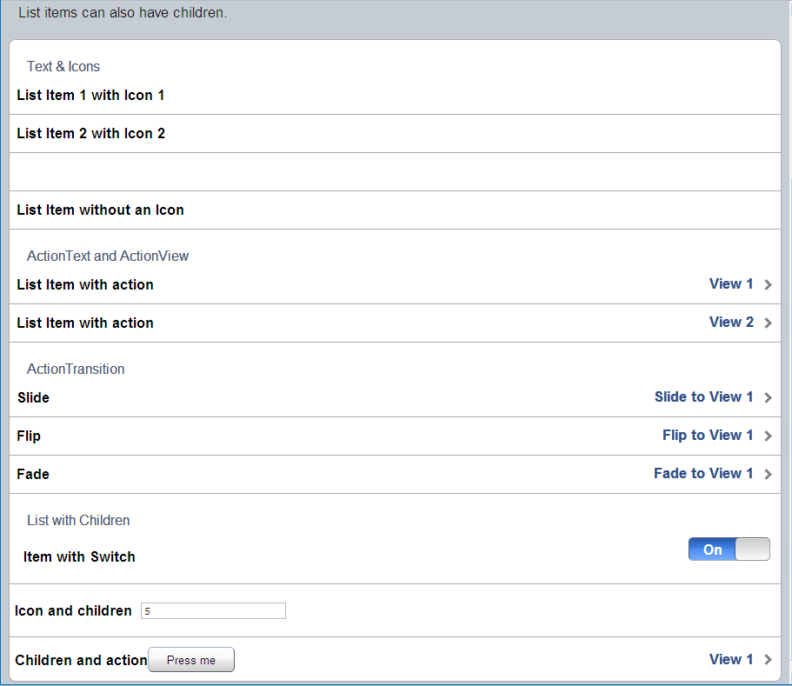

APIs:
- icon String; // optional - path to icon, relative to Web content directory (like an EGL Image widget)
- text String; // optional - text to display on the list item.
- children Widget[]; // optional – widgets to display in the list item, instead of text (i.e. if children are set, the value of “text” is ignored)
- actionText string; // optional – text to show on the right side of the item
- actionView View; // optional – view to show if the item is selected
- actionTransition string; // optional – can be DojoMobileLib.TRANSITION_SLIDE , DojoMobileLib.TRANSITION_FADE, DojoMobileLib.TRANSITION_FLIP. The default setting is SLIDE.

Code sample:
new DojoMobileList{
style = DojoMobileLib.LIST_STYLE_ROUNDED_RECTANGLE,
children = [
new DojoMobileListCategory{ title = "Text & Icons" },
new DojoMobileListItem{ text = "List Item 1 with Icon 1",
icon = "dojo/mobile/images/i-icon-4.png" },
new DojoMobileListItem{ text = "List Item 2 with Icon 2",
icon = "dojo/mobile/images/i-icon-5.png" },
new DojoMobileListItem{ icon = "dojo/mobile/images/i-icon-4.png" },
new DojoMobileListItem{ text = "List Item without an Icon" },
new DojoMobileListCategory{ title = "ActionText and ActionView" },
new DojoMobileListItem{ text = "List Item with action",
icon = "dojo/mobile/images/i-icon-1.png",
actionText = "View 1", actionView = View1 },
new DojoMobileListItem{ text = "List Item with action",
icon = "dojo/mobile/images/i-icon-1.png",
actionText = "View 2", actionView = View2 },
new DojoMobileListCategory{ title = "ActionTransition" },
new DojoMobileListItem{ text = "Slide",
icon = "dojo/mobile/images/i-icon-1.png",
actionText = "Slide to View 1", actionView = View1,
actionTransition = DojoMobileLib.TRANSITION_SLIDE },
new DojoMobileListItem{ text = "Flip", icon = "dojo/mobile/images/i-icon-1.png",
actionText = "Flip to View 1", actionView = View1,
actionTransition = DojoMobileLib.TRANSITION_FLIP },
new DojoMobileListItem{ text = "Fade", icon = "dojo/mobile/images/i-icon-1.png",
actionText = "Fade to View 1", actionView = View1,
actionTransition = DojoMobileLib.TRANSITION_FADE },
new DojoMobileListCategory{ title = "List with Children" },
new DojoMobileListItem{ text="switch",
children = [new Span{text="Item with Switch", margin = 10}, Switch
//the list item's text property is ignored
]
},
new DojoMobileListItem{ text = "List Item With Children",
icon = "dojo/mobile/images/i-icon-1.png",
children = [
new Span { text="Icon and children"},
//list item's text property is ignored
new TextField{ text="5", margin = 10 }]
},
new DojoMobileListItem{ actionText = "View 1", actionView = View1,
children = [
new Span { text="Children and action"},
new DojoMobileButton {text = "Press me", width="100px"}
]}
]
}

TabContainer (DojoMobileTabContainer.egl)

Tab folder optimized for mobile devices.

Image 6 TabContainer
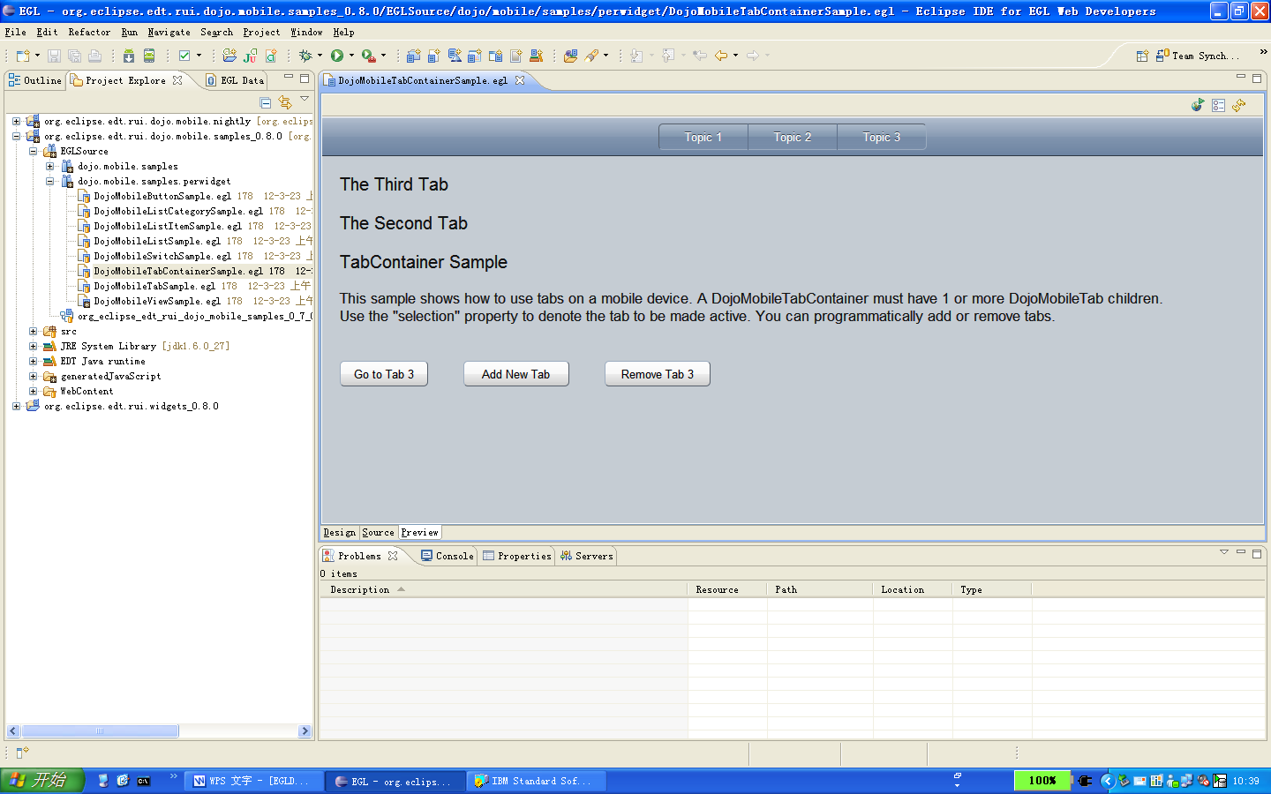

APIs:
- children Widget[]; // 1 or more DojoMobileTab widgets
- selection int; // 1-based index of the tab to select
- addTab(DojoMobileTab, index) function - adds the specified tab at the specified 1-based index. Note: the new tab is not automatically selected; use the selection field to activate.
- removeTab(index) function, Remove the tab at the specified 1-based index.

Code sample:
View DojoMobileView{
selected = true,
children = [
TabContainer
]
};

TabContainer DojoMobileTabContainer{
selection = 1,
children = [
new DojoMobileTab { title = "Topic 1",children = [
new TextLabel { text = "TabContainer Sample", fontSize = "20px", margin = 20 },
new HTML { margin = 20, text = "This sample shows how to use tabs on a mobile device. A DojoMobileTabContainer must have 1 or more DojoMobileTab children.<br/>" +
"Use the \"selection\" property to denote the tab to be made active. You can programmatically add or remove tabs."},
button, button1, button2
] },
new DojoMobileTab { title = "Topic 2", children = [
new TextLabel { text = "The Second Tab", fontSize = "20px", margin = 20 }
]},
new DojoMobileTab { title = "Topic 3", children = [
new TextLabel { text = "The Third Tab", fontSize = "20px", margin = 20 }
]}
]
};

Try embed it in a view with backView, and try the view transition in Dojo. If it won’t work, we should document it.

Tab (DojoMobileTab.egl)

Individual tab on a tab container.

APIs:
- title string; // optional – title for the tab
- icon String; // optional – icon to show on the tab. Note: this setting is only applicable on Android devices.

Code sample:
new DojoMobileTab {
title = "Topic 1",
children = [
new TextLabel { text = "Tab Sample",fontSize = "20px", margin = 20 },
new HTML {
margin = 20,
text = "This sample shows how to use tabs within a TabContainer on mobile devices. Each tab has a \"title\" property to set the tab text, and an \"icon\" property to show a tab icon (Android only)."}
]
}

Notes:
- Parent must be a DojoMobileTabContainer.

Button (DojoMobileButton.egl)

Simple, clickable button.

APIs:
- text String; // text to show on the button
- onClick event; // fired when the button is clicked by the user
- className String; //Dojo has some built-in class http://archive.dojotoolkit.org/dojo-2012-03-24/dojotoolkit/dojox/mobile/tests/test_Button.html

Code sample:
button DojoMobileButton {
text = "Press this button", width = "150", margin = 20, onClick ::= myClick
};

function myClick(e Event in)
syslib.writeStdout("button pressed");
button.text = "Button pressed";

end

Slider (DojoMobileSlider.egl)

A control that allows changing a numeric value by touching and dragging a slide handle.

APIs:
Value String; // current value of the widget
Orientation String; // Display style, H(horizontal), V(vertical) & auto for slider handle to move
Minimum int; // minimum value of the widget
Maximum int; // maximum value of the widget
Step int; // delta from step value to the next.
onChange event; // change notification

Code sample:
SliderH DojoMobileSlider{ minimum = -50, maximum= 50, step = 2, onChange ::= Slider_onChange,orientation = DojoMobileLib.SLIDER_HORIZONTAL,value = 10};
SliderV DojoMobileSlider{ minimum = 0, maximum= 200, step = 10, onChange ::= Slider_onChange,orientation = DojoMobileLib.SLIDER_VERTICAL, value = 50};

function Slider_onChange(event Event in)
slider DojoMobileSlider = event.widget;
message.text ::= "the current value is -- " + slider.value + " ; \n" ;
clearJob.schedule(20000);
end

Image: <Slider>

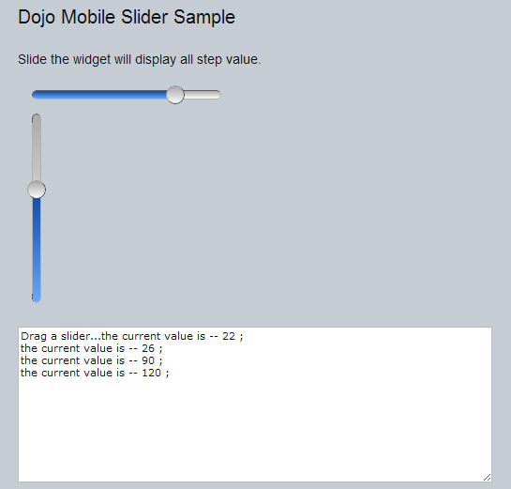

Switch (DojoMobileSwitch.egl)

Switch is a toggle switch with a sliding knob. You can either tap or slide the knob to toggle the switch.

Image 7 Swith Example
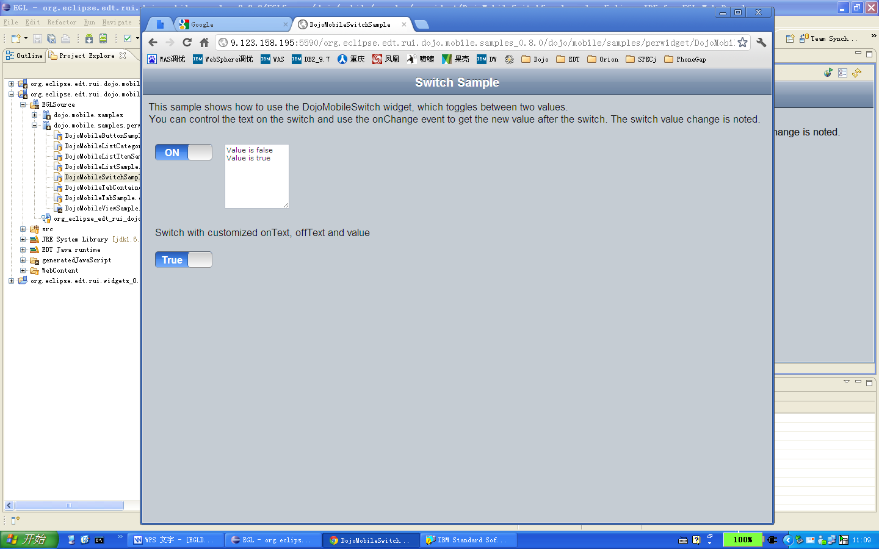

APIs:
- onText string; // optional – text to show when switch is “on”. Default is “On”
- offText string; // optional – text to show when switch is “off”. Default is “Off”
- value boolean;
- onChange event - fired when the value is changed by the user

Code sample:
Switch DojoMobileSwitch{
margin = 10, onChange ::= changeSwitch
};

TextArea TextArea{
margin = 10, width = 100, height = 100
};

Switch1 DojoMobileSwitch{
margin = 20,
onText = "True",
offText = "False",
value = false
};

Box Box{
margin = 10,
children = [ Switch, TextArea ]
};

function changeSwitch(e event in)
TextArea.append("Value is " + Switch.value + "\n");
end

