Publisher Survey of Ethiopic Layout  
& Formatting Practices

A Survey of the   
W3C Ethiopic Layout Requirements Task Force

Purpose of This Survey

This goal of this survey is to determine the best practices of layout and formatting for literature written in the Ethiopic script. The information gathered from the survey will be used to define an international standard governed by the World Wide Web Consortium. The resulting standard will be free to use by software companies who in turn may then apply the information to correctly format Ethiopian literature in electronic forms such as web pages, eBooks, and by word processors.

Many languages have a long history of writing in Ethiopic script and have developed different conventions and styles of writing. All of these styles can be supported by software provided that the appropriate information is collected. The aim of this survey is to collect the necessary information to support all writing traditions present and past –many of which may be unknown to the survey team. Please feel free to provide any additional information that you feel is important. The questions in the survey primarily attempt to resolve discrepancies in the most commonly observed practices of general literature.

This survey process and the standardization work activity are conducted by volunteers with a deep interest in Ethiopic literature and layout and who do not stand to profit from their involvement. You are also invited to join them to follow the work as well as to participate in its development as you desire.

**References and Points of Contact:**

The Ethiopic Layouts Requirements draft specification:

http://w3c.github.io/elreq/

The W3C Ethiopic Layout Task Force’s mail archive with subscription information:

https://lists.w3.org/Archives/Public/public-i18n-ethiopic/

Respondents Contact

Name:______________________________________________________________________________________________

Company or Institute:____________________________________________________________________________

Role at Institute: _________________________________________________________________________________

_____________________________________________________________________________________________________

Years involved with literature or publishing: _________________________________________________

Literature or publishing languages: ____________________________________________________________

Areas of expertise: _______________________________________________________________________________

_____________________________________________________________________________________________________

Email: ____________________________________________

Phone: ___________________________________________

Instructions:

Please respond to the survey questions to the best of your ability based on practical experience. Survey question cover a very wide range of topics *-please do not guess an answer*. It is preferred that a question is left unanswered when the respondent is uncertain or the topic is outside of one’s experience and expertise.

Please use additional space as needed. Questions on the meaning of survey questions may be addressed to the provider of this survey. You are welcome and encouraged to provide any additional information that you think is relevant.

# Letter Shape and Appearance

## Height of English Used with Ethiopic

In many Ethiopic documents with English (or European) text, the English letters might appear shorter or taller than the Ethiopic. This effect is complicated by the changing heights of Ethiopic letters against the fixed heights of English letters, therefore comparison against an average or reference height for Ethiopic should be made. Examples:

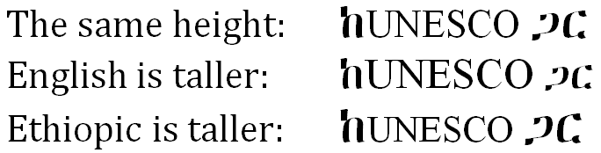

**Survey Questions:**

1. When used together in a sentence, how tall should English letters be?  
   ☐ No opinion  
   ☐ The same height  
   ☐ English is taller  
   ☐ Ethiopic is taller

## English Font Weights

The historic “weight” (the letter thickness) of Ethiopic is heavier than found in European writing. When European words appear in a document, they are sometimes made heavier to match the Ethiopic letters. For Example:

ካገላበጥኳቸው ስራዎች ውስጥ ግን ታዬ አሰፋ እና ሽፈራው በቀለ የተባሉ ምሁራን በጋራ ያሳተሙት The Study of Amharic Literature: An Overview የሚለው ጥናት አጥጋቢ መልስ የሚሰጥ ሆኖ አግኝቼዋሉ።

English words have their usual weight.

ካገላበጥኳቸው ስራዎች ውስጥ ግን ታዬ አሰፋ እና ሽፈራው በቀለ የተባሉ ምሁራን በጋራ ያሳተሙት **The Study of Amharic Literature: An Overview** የሚለው ጥናት አጥጋቢ መልስ የሚሰጥ ሆኖ አግኝቼዋሉ።

English words are made heavier.

**Survey Questions:**

1. When publishing in the classical Ethiopic weight, how should English words appear  
   ☐ No opinion ☐ English default weight ☐ Matching Ethiopic weight

☐ Other: ______________________________________________________________________________________

1. If heavier Latin letters are desirable, how much so?

☐ No opinion ☐ Equal to Ethiopic letter thickness  
☐ Other: ______________________________________________________________________________________

## Ethiopicized Punctuation

Modern Ethiopic borrows a number of foreign symbols to show currency, express emphasis, time, mathematics, or communicate with Internet protocols (such as “@” , “://”). The following are believed to be in common use:

1234567890 ? ! ¡ . / () [] {} < = > \ # % & $ : , € @ … _ - + ± × ÷ ‘ ’ “ ” ‹ › « »

**Survey Questions:**

1. Are there any additional western symbols required for Ethiopic writing?   
   ☐ No opinion ☐ No ☐ Yes – if so which?

_________________________________________________________________________________________________

1. Are any symbols from other foreign script (Chinese, Arabic, etc.) that should be included?   
   ☐ No opinion ☐ No ☐ Yes – if so which?

_________________________________________________________________________________________________

A number of fonts will provide the western punctuation with a change of shape to visually match better with Ethiopic letters. For example:

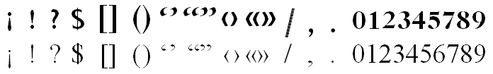

**Survey Questions:**

1. What symbols benefit from shape change? ☐ No opinion

_________________________________________________________________________________________________

1. What symbols benefit from weight change (but not shape)? ☐ No opinion

_________________________________________________________________________________________________

## Quotation of Foreign Phrases

When Ethiopicized punctuation is in use and a foreign phrase is to be quoted, an issue appears regarding the proper weight and style of the quotation marks. Should the quotation marks use the Ethiopic style or those of the foreign phrase? Some examples:

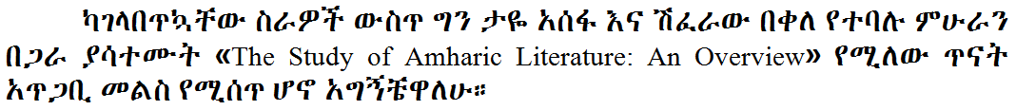

A: Latin text enclosed with European weight guillemets.

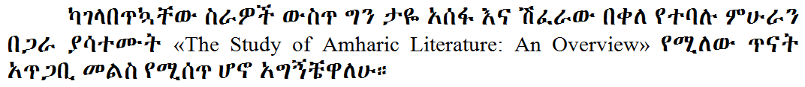

B: Latin text enclosed with Ethiopic weight guillemets.

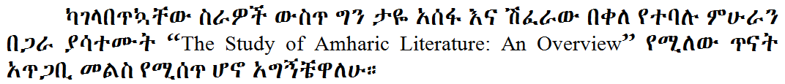

C: Latin text enclosed with Ethiopic weight quotes.

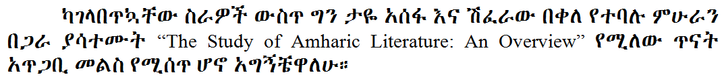

D: Latin text enclosed with European weight quotes.

**Survey Questions:**

1. What quotation weight should be used around European phrases:   
   ☐ No opinion ☐ European ☐ Ethiopic  
   ☐ Other: ______________________________________________________________________________________

## Positioning of the Gemination Mark (ጥበቅ)

The Ethiopic germination mark has at least a century of use yet is not commonly found outside of linguistic literature. The mark, known as ጥበቅ, helps indicate stress on a consonant (e.g. ገና compared to ገና፟) and may appear in a single dot form. Outside of linguistic works, the gemination mark appears most famously in Haddis Alemayehu’s used a *Fikre Eske Makber* where the single dot mark is used. The choice of one or two dots, as well as its position, might be different when written by hand versus a printing technology. For example:

.፟

|  |  |
| --- | --- |
| አሰ፟ጠ | Fixed height |
| አሰ፟ጠ  .፟ | Floating height |

**Survey Questions:**

1. The best style for modern publishing is: ☐ No opinion ☐ Fixed ☐ Floating   
   ☐ Other: _________________________________________________________________________________

# Lines and Paragraph Formatting

## Line Breaking

Word processors and text readers such as web browsers, eBook devices, etc. will automatically format the sentences of a paragraph over a number of lines as allowable by the available width of the viewing area. These software systems apply formatting rules that govern where and how a line may end and a new line begin. Line breaking rules for Ethiopic are given in the following.

A line may start with:

* A letter.
* A number.
* A tab.
* A non-terminal or non-joining punctuation (such as « ‹ “ $ ( [ { ).

Conversely, a line may not start with:

* Space, “ ”.
* A terminal or joining punctuation (such as: ? ! ¡ ።) ] } / % **–** ” › » ፡ ፣ ፤ ፥ ፦ space, math operators).

**Survey Questions:**

1. Are the above rules valid?  
   ☐ No opinion ☐ Yes ☐ No (Please Correct):  
   _________________________________________________________________________________________________

_________________________________________________________________________________________________

1. Are any additional rules needed to govern how a line may end or begin?  
   ☐ No opinion ☐ No ☐ Yes (Please Explain):  
   _________________________________________________________________________________________________

_________________________________________________________________________________________________

## Hyphenation

In traditional Ethiopic writing the wordspace separator symbol, “፡”, negated the need for word hyphenation across a line of text. When wordspace fell out of favor in modern writing the practice of splitting a word across lines of text continued. The reader would know to mentally reconstruct a word by relying on knowledge of lexicon and context.

**Survey Questions:**

1. When wordspace, “፡”, is used, what rules for splitting a word across lines apply?  
   ☐ No opinion ☐ None, a word may be split anywhere ☐ The following rules:  
   _________________________________________________________________________________________________

_________________________________________________________________________________________________

1. When space, “ ”, is used, should Ethiopic writing use a hyphen “‐” to split words across lines?  
   ☐ No opinion ☐ Never ☐ Author’s decision ☐ Other (Please Explain):  
   _________________________________________________________________________________________________

_________________________________________________________________________________________________

1. When space, “ ”, is used, and if words should be split across lines (with or without a hyphen), are the following rules for word splitting suitable?

* Words are split at a morpheme boundary, for example: ቤተ‐  
  መንግሥት .
* Words are split at a syllable boundary.
* Words of a single syllable are not split over lines.
* Words of two letters are not split over lines.
* Words are split after a prefix.
* Words are split before a suffix.
* Numbers are not split over lines.
* Words are not split at the final letter.

☐ No opinion ☐ Yes ☐ No, a word may be split  
☐ No or Incomplete (Please Explain):  
_________________________________________________________________________________________________

_________________________________________________________________________________________________

_________________________________________________________________________________________________

## First Paragraph Rule

Paragraph indentation is a regular practice in Ethiopic publishing, and not common in hand written manuscripts where a Hareg or Mekfel will be used instead. Some Western publishers will apply a special rule where the first paragraph of a section is *not* indented. It is unknown if this rule is also appropriate for Ethiopic publishing. An example follows:

መቅድም ።

ፊደል፡ማለት፡የነገር፡የቃል፡ምልክት፡አምሳል፡ወይም፡መግለጫ፡ማስታወቂያ፡ማለት፡ነው፤ሥዕል፡እንደ፡ማለት።ዐይነተኛ፡ፍችው፡ይህ፡ነው፡የቀረውን፡በግስ፡ይመለከቷል።የፊደል፡ተራ፡የተፋለሰና፡አልፍ፡አ፡ከርስቱ፡ከቀዳማዊነት፡ተነቅሎ፡በርሱ፡ፋንታ፡ሆይ፡ሀ፡መዠመሪያ፡ፊደል፡የኾነ፡ከሣቴ፡ብርሃን፡ከሚባለ

**⋮ ⋮ ⋮ ⋮ ⋮ ⋮**

Example: First paragraph of section with indentation.

መቅድም ።

ፊደል፡ማለት፡የነገር፡የቃል፡ምልክት፡አምሳል፡ወይም፡መግለጫ፡ማስታወቂያ፡ማለት፡ነው፤ሥዕል፡እንደ፡ማለት።ዐይነተኛ፡ፍችው፡ይህ፡ነው፡የቀረውን፡በግስ፡ይመለከቷል።የፊደል፡ተራ፡የተፋለሰና፡አልፍ፡አ፡ከርስቱ፡ከቀዳማዊነት፡ተነቅሎ፡በርሱ፡ፋንታ፡ሆይ፡ሀ፡መዠመሪያ፡ፊደል፡የኾነ፡ከሣቴ፡ብርሃን፡ከሚባለው፡ካንደ

**⋮ ⋮ ⋮ ⋮ ⋮ ⋮**

Example: First paragraph of section *without* indentation.

**Survey Questions:**

1. How much should a regular paragraph be indented?  
   ☐ No opinion ☐ Same as English indentation ☐ Other (Please Explain):  
   ________________________________________________________________________________________
2. Should the first paragraph of a section be indented?  
   ☐ No opinion ☐ Never ☐ Always ☐ Under special rules or context (Please Explain):  
    ________________________________________________________________________________________
3. Should a new paragraph be indented following a list?  
   ☐ No opinion ☐ Never ☐ Always ☐ Under special rules or context (Please Explain):   
   ________________________________________________________________________________________
4. Are there any other special rules for when to, or not to, indent a paragraph?  
   ☐ No opinion

________________________________________________________________________________________

# Layout & Pages

## Page Margins

Proper document layout is very import for religious works in the Ge’ez traditions. Certain works like homiliaries (such as ድርሳነ፡ሚካኤል) are consistently formatted in two columns and the Synaxarium (መጽሐፈ፡ስንክሳር) in three. Margins in this class of literature will most common exhibit a 1x2x4 ratio where the top and fore edge margins are twice that of the gutter and half that of the bottom (see figure below).

These practices are not well understood by the survey team and comprehensive input is sought from respondents.

Page margins in Ge’ez literature.

1

4

2

2

2

4

1

2

**Survey Questions:**

1. For the types of literary works you are familiar with, what are the margin requirements? ☐ No opinion  
   ___________________________________________________________________________________________

___________________________________________________________________________________________

___________________________________________________________________________________________

1. What works should be in multiple columns? How many columns and what width and spacing should be between them? ☐ No opinion  
   ___________________________________________________________________________________________

___________________________________________________________________________________________

___________________________________________________________________________________________

1. Is header formatting different for Ethiopic documents than Western?  
   ☐ No opinion ☐ No ☐ Yes (Please Explain):  
   ___________________________________________________________________________________________
2. Is footer formatting different for Ethiopic documents than Western?  
   ☐ No opinion ☐ No ☐ Yes (Please Explain):  
   ___________________________________________________________________________________________
3. Is page number positioning and formatting different for Ethiopic documents than Western?  
   ☐ No opinion ☐ No ☐ Yes (Please Explain):  
   ___________________________________________________________________________________________
4. Does Ethiopic page layout have any special requirements that are different from Western?  
   ☐ No opinion ☐ No ☐ Yes (Please Explain):  
   ___________________________________________________________________________________________

___________________________________________________________________________________________

___________________________________________________________________________________________

## Page Numbering

In Ethiopic book publishing, the first numbered page will generally be seen on the መቅድም section. When a መቅድም section is not present, numbering is expected to begin at the መግቢያ. The prevailing modern Ethiopic practice is to begin counting pages from the inner cover page (this is a matter of perception, by some views the outer cover is the first page and the inner cover, which is generally empty, is not counted). Thus the first printed number appearing at either the መቅድም or መግቢያ is not “1” (or “፩”) but the physical page count up to this point (for example “4” or “5”).

**Survey Questions:**

1. Where in a book is page 1 counted from?  
   ☐ No opinion ☐ Front Cover ☐ First internal page ☐ First printed page  
   ☐ Other (Please Explain):  
   ___________________________________________________________________________________________

___________________________________________________________________________________________

1. Where does the first printed page appear?  
   ☐ No opinion ☐ መቅድም ☐ መግቢያ ☐ Other (Please Explain):  
   ___________________________________________________________________________________________

___________________________________________________________________________________________

1. Are there any other special considerations with page numbering? For example, page numbering of appendices, etc. ☐ No opinion

___________________________________________________________________________________________

___________________________________________________________________________________________

## Preface Page Numbering

Increasingly, modern authors and publishers are adding additional front sections and moving “page 1” out to either the መቅድም or መግቢያ. Prior to “page 1” preceding pages may be numbered in one of two ways. In the first convention where pages are numbered with Ethiopic numerals, the preface numbering may be alphabetic in the ሀለሐመ counting system or in the አበገደ sequence (for example in Deste Tekle Wold's “ዐዲስ፡ያማርኛ፡መዝገበ፡ቃላት።”).

In the second convention where pages are numbers with Western numerals, the preface page numbering will apply Ethiopic numerals. Under both conventions the preface page number begins on the first printed page after the cover.

**Survey Questions:**

1. Are the above descriptions accurate?  
   ☐ No opinion ☐ Yes ☐ No ☐ Other (Please Explain):  
   _________________________________________________________________________________________________

_________________________________________________________________________________________________

1. Are there any other page numbering conventions that should be supported by software?  
   ☐ No opinion ☐ Yes ☐ No ☐ Other (Please Explain):  
   _________________________________________________________________________________________________

_________________________________________________________________________________________________

## Footnotes & Superscript

Footnote counters are simple superscripted cardinal numbers. Microsoft Word, for example, will “top-aligned” the superscripted text with the reference text. Other text presentation systems, such as web browsers, may raise the superscripted text further. Both alignment styles work well when letters have a fixed height, but may not be visually optimal in a variable letter height writing system. The changing heights of Ethiopic letters introduces the same “fixed-vs-floating” issue with superscript text as discussed in the previous section on the Ethiopic gemination mark.

1

3

2

|  |  |
| --- | --- |
| …ን …ጠ…ች  1  3 | Fixed height |
| …ን …ጠ…ች  2 | Floating height |

**Survey Questions:**

1. What do stakeholders feel should be the default positioning style?  
   ☐ No opinion ☐ Fixed ☐ Floating ☐ Other (Please Explain):  
   _________________________________________________________________________________________________

_________________________________________________________________________________________________

1. What should the relative height of the superscripted text be? The English default is a 7/12ths ratio.  
   ☐ No opinion ☐ Same ratio as English ☐ Other (Please Explain):  
   _________________________________________________________________________________________________

_________________________________________________________________________________________________

1. Are Ethiopic numerals used for footnote counting?  
   ☐ No opinion ☐ Yes ☐ No ☐ Other (Please Explain):  
   _________________________________________________________________________________________________

_________________________________________________________________________________________________

1. Top-alignment of superscript text may only be an Microsoft Word practice; superscript in web documents does not appear to follow the same vertical alignment rules.  
   ☐ No opinion ☐ Yes ☐ No ☐ Other (Please Explain):  
   _________________________________________________________________________________________________

_________________________________________________________________________________________________

# List Styles

## Bullet Lists

Bullet lists are utilized regularly in Ethiopic literature. Authors using a computer or typewriter will work with the list marker symbols made available by their software or machine. Many marker, or “bullet”, symbols are accepted for Ethiopic literature though not all will be considered optimal.

100%

አሐዱ

ክልኤቱ

ሠለስቱ

አሐዱ

ክልኤቱ

ሠለስቱ

75%

አሐዱ

ክልኤቱ

ሠለስቱ

40%

አሐዱ

ክልኤቱ

ሠለስቱ

50%

አሐዱ

ክልኤቱ

ሠለስቱ

60%

Circle bullet size relative to letter height.

100%

አሐዱ

ክልኤቱ

ሠለስቱ

አሐዱ

ክልኤቱ

ሠለስቱ

75%

አሐዱ

ክልኤቱ

ሠለስቱ

40%

አሐዱ

ክልኤቱ

ሠለስቱ

50%

አሐዱ

ክልኤቱ

ሠለስቱ

60%

Square bullet size relative to letter height.

100%

አሐዱ

ክልኤቱ

ሠለስቱ

አሐዱ

ክልኤቱ

ሠለስቱ

75%

አሐዱ

ክልኤቱ

ሠለስቱ

40%

አሐዱ

ክልኤቱ

ሠለስቱ

50%

አሐዱ

ክልኤቱ

ሠለስቱ

60%

Diamond bullet size relative to letter height.

**Survey Questions:**

1. What is the preferred default bullet shape?  
   ☐ No opinion ☐ Circle ☐ Square ☐ Diamond ☐ Other: _________________________________________________________________________________________________
2. Diamond shaped bullets are found commonly and may represent a desired default. The Unicode standard provides a number of similar diamond shaped symbols. From this set of diamond symbols, those suitable for adorning Ethiopic bullet lists must be determined.

◆ “Black Diamond”  
♦ “Black Diamond Suit”  
❖ “Black Diamond Minus White X”

Which diamond shapes are appropriate for Ethiopic bullet lists?  
☐ No opinion ☐ The following: __________________________________________________________

1. Are other bullet shapes needed for Ethiopic literature? For example, some authors have used the Ethiopic symbols “፠” and “፨”:   
   ☐ No opinion ☐ No ☐ Yes, the following: ____________________________________________
2. What are the preferred shape sequences in nested lists (e.g. bullet hierarchy)?  
   ☐ No opinion ☐ The following: __________________________________________________________
3. What is bullet height and width relative to letter dimensions?  
   ☐ No opinion ☐ Same spacing as English ☐ Other proportions: ___________________
4. What is the default distance of the list item text from the bullet?  
   ☐ No opinion ☐ Same spacing as English ☐ Other amount: ________________________
5. Are lists indented from the left margin?   
   ☐ No opinion ☐ No ☐ Same as English spacing ☐ Other amount: ________________
6. Do copy editors or publishers set a policy for list symbols, or leave it up to the author to decide?  
   ☐ No opinion ☐ No ☐ Yes ☐ Other Policy (Please Explain):  
   _________________________________________________________________________________________________
7. Of historic interest: when are bullet lists first found in Ethiopic writing and in what form?  
   ☐ No opinion ☐ In the following publication and year:

_________________________________________________________________________________________________

## Ordered List Counter Suffix

In Ethiopic ordered lists a number of symbols are used for the list marker (or “suffix”). For example “/” , “፦” , “.” , “)” and even “፡”.

**Survey Questions:**

1. What is the best default marker symbol?  
   ☐ No opinion ☐ / ☐ ፦ ☐ ) ☐ . ☐ ፡ ☐ Software default  
   ☐ Other (Please Explain): __________________________________________________________________  
   _________________________________________________________________________________________________
2. How much, if any, white space follows the suffix?

☐ No opinion ☐ Same as with western lists ☐ Other Policy (Please Explain):  
_________________________________________________________________________________________________

1. Do copy editors or publishers set a policy for list counter suffix, or leave it up to the author to decide?  
   ☐ No opinion ☐ No ☐ Yes ☐ Other Policy (Please Explain):  
   _________________________________________________________________________________________________
2. Of historic interest: when are ordered lists first found in Ethiopic writing and in what form?  
   ☐ No opinion ☐ In the following publication and year:

_________________________________________________________________________________________________

## List Counter Suffix Alignment

Ethiopic corpus will present lists with two styles of alignment. These are a left side alignment at the list counter, or alignment along the list marker (“suffix”). Layout software will align a list at the marker in keeping with the later style. The former style (left justified at counter) may reflect a limitation of the layout technology employed and not a preference of the author, copy editor or typesetter. A depiction of these two alignment styles is presented in the following figures:

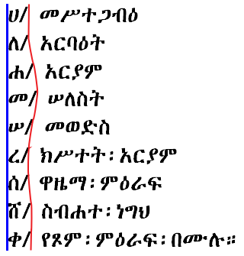 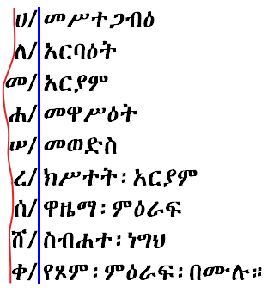

|  |  |
| --- | --- |
| **A:** Alphabetical list aligned justified on   counter left. | **B:** Alphabetical list aligned on marker. |

**Survey Questions:**

1. Which alignment style is preferable?  
   ☐ No opinion  
   ☐ Align along left side of letter (Style A)  
   ☐ Align along the right side of the marker (Style B)  
   ☐ Other (Please Explain): __________________________________________________________________  
   _________________________________________________________________________________________________

## Inline Lists

Inlined enumerated lists are commonly found in Ethiopic documents. Inline lists will follow the same sequences as regular lists. However, the spacing after the counter suffix may be different. Typically a regular keyboard space is observed following the suffix, if any. This is most likely a matter of convenience for the author and not necessarily representative of good formatting.

…፡በዘመናት፡ከአራት፡ከፍላ፡ሀ/ክረምት፡ለ/መጸው፡ሐ/ጸደይ፡መ/ሐጋይ፡በማለት፡ከዓመት፡እስከ፡ዓመት፡…

…፡በዘመናት፡ከአራት፡ከፍላ፡ሀ/ክረምት፡ለ/መጸው፡ሐ/ጸደይ፡መ/ሐጋይ፡በማለት፡ከዓመት፡እስከ፡ዓመት፡…

…፡በዘመናት፡ከአራት፡ከፍላ፡ሀ/ክረምት፡ለ/መጸው፡ሐ/ጸደይ፡መ/ሐጋይ፡በማለት፡ከዓመት፡እስከ፡ዓመት፡…

Ethiopic inline list sample using wordspaces with three spacings   
(none, hair and thin) following list marker.

…በዘመናት ከአራት ከፍላ ሀ/ክረምት ለ/መጸው ሐ/ጸደይ መ/ሐጋይ በማለት ከዓመት እስከ ዓመት…

…በዘመናት ከአራት ከፍላ ሀ/ክረምት ለ/መጸው ሐ/ጸደይ መ/ሐጋይ በማለት ከዓመት እስከ ዓመት…

…በዘመናት ከአራት ከፍላ ሀ/ክረምት ለ/መጸው ሐ/ጸደይ መ/ሐጋይ በማለት ከዓመት እስከ ዓመት…

Ethiopic inline list sample using spaces with three spacings   
(none, hair and thin) following list marker.

**Survey Questions:**

1. How much space (what width) should appear after the counter suffix?  
   ☐ No opinion ☐ None ☐ Hair Space ☐ Thin Space ☐ Regular Space   
   ☐ Other (Please Explain): ____________________________________________________________
2. Is the space after the counter suffix different when Ethiopic Wordspace is used?  
   ☐ No opinion ☐ No ☐ Yes ☐ Other rules (Please Explain):  
   _____________________________________________________________________________________________

## Numbered Lists

Ethiopic literature will apply ordered numbered list using both Ethiopic and Western numeral systems. The question of best list counter suffix for Ethiopic literature arises here as well. Examples for consideration:

|  |  |  |  |  |
| --- | --- | --- | --- | --- |
| **Ethiopic Numeral Lists** | | | | |
| ፩፡…  ፪፡…  ፫፡…  ፬፡…  ⋮ | ፩/…  ፪/…  ፫/…  ፬/…  ⋮ | ፩)…  ፪)…  ፫)…  ፬)…  ⋮ | ፩. …  ፪. …  ፫. …  ፬. …  ⋮ | ፩፦ …  ፪፦ …  ፫፦ …  ፬፦ …  ⋮ |
| **Western Numeral Lists** | | | | |
| 1፡…  2፡…  3፡…  4፡…  ⋮ | 1/…  2/…  3/…  4/…  ⋮ | 1)…  2)…  3)…  4)…  ⋮ | 1. …  2. …  3. …  4. …  ⋮ | 1፦ …  2፦ …  3፦ …  4፦ …  ⋮ |

**Survey Questions:**

1. What is the best list counter marker for Ethiopic numeral lists?  
   ☐ No opinion ☐ / ☐ ፦ ☐ ) ☐ . ☐ ፡ ☐ Software default  
   ☐ Other (Please Explain): __________________________________________________________________  
   _________________________________________________________________________________________________
2. What is the list counter suffix preference with western numbers (0-9)?  
   ☐ No opinion ☐ Same used for Ethiopic numbers ☐ Software default  
   ☐ Other (Please Explain): __________________________________________________________________  
   _________________________________________________________________________________________________
3. Are there any sub-list (nested list) considerations?  
   ☐ No opinion ☐ No ☐ Yes (Please Explain): _________________________________________________________________________________________________

## Alphabetical (ሀለሐመ) Lists

The Unicode standard encodes Ethiopic syllables for many languages using Ethiopic script past and present. Alphabetic lists are commonplace in Ethiopic literature, but will conform to the letter inventory of the language of the surrounding content. The alphabetical style lists specified here do not encompass all languages using Ethiopic, but only those with a demonstrated requirement as found in corpus or stakeholder input.

|  |  |  |  |  |
| --- | --- | --- | --- | --- |
| **Ge'ez** | **Amharic** | **Blin** | **Tigrinya (Eritrean)** | **Tigrinya (Ethiopian)** |
| * ሀ/ * ለ/ * ሐ/ * መ/ * ሠ/ * ረ/ * ሰ/ * ቀ/ * በ/ * ተ/ * ኀ/ * ነ/ * አ/ * ከ/ * ወ/ * ዐ/ * ዘ/ * የ/ * ደ/ * ገ/ * ጠ/ * ጰ/ * ጸ/ * ፀ/ * ፈ/ * ፐ/ | * ሀ/ * ለ/ * ሐ/ * መ/ * ሠ/ * ረ/ * ሰ/ * ሸ/ * ቀ/ * በ/ * ተ/ * ቸ/ * ኀ/ * ነ/ * ኘ/ * አ/ * ከ/ * ኸ/ * ወ/ * ዐ/ * ዘ/ * ዠ/ * የ/ * ደ/ * ጀ/ * ገ/ * ጠ/ * ጨ/ * ጰ/ * ጸ/ * ፀ/ * ፈ/ * ፐ/ | * ሀ/ * ለ/ * ሐ/ * መ/ * ረ/ * ሰ/ * ሸ/ * ቀ/ * ቐ/ * በ/ * ተ/ * ቸ/ * ኀ/ * ነ/ * ኘ/ * አ/ * ከ/ * ኸ/ * ወ/ * ዐ/ * ዘ/ * ዠ/ * የ/ * ደ/ * ጀ/ * ገ/ * ጘ/ * ጠ/ * ጨ/ * ጰ/ * ጸ/ * ፀ/ * ፈ/ * ፐ/ | * ሀ/ * ለ/ * ሐ/ * መ/ * ረ/ * ሰ/ * ሸ/ * ቀ/ * ቐ/ * በ/ * ተ/ * ቸ/ * ነ/ * ኘ/ * አ/ * ከ/ * ኸ/ * ወ/ * ዐ/ * ዘ/ * ዠ/ * የ/ * ደ/ * ጀ/ * ገ/ * ጠ/ * ጨ/ * ጰ/ * ጸ/ * ፈ/ * ፐ/ | * ሀ/ * ለ/ * ሐ/ * መ/ * ሠ/ * ረ/ * ሰ/ * ሸ/ * ቀ/ * ቐ/ * በ/ * ተ/ * ቸ/ * ኀ/ * ነ/ * ኘ/ * አ/ * ከ/ * ኸ/ * ወ/ * ዐ/ * ዘ/ * ዠ/ * የ/ * ደ/ * ጀ/ * ገ/ * ጠ/ * ጨ/ * ጰ/ * ጸ/ * ፀ/ * ፈ/ * ፐ/ |

**Survey Questions:**

1. Are there any mistakes with the above lists?  
   ☐ No opinion ☐ No ☐ Yes (Please Explain):   
   _____________________________________________________________________________________________
2. Should “ሀለሐመ” lists be added for other languages?

☐ No opinion ☐ No ☐ Yes (Please Explain):

_____________________________________________________________________________________________

1. Should “ቨ” be included in lists other than Ge'ez?  
    ☐ No opinion ☐ No ☐ It depends (Please Explain):  
   _____________________________________________________________________________________________
2. How is end of sequence handled?
   * No opinion
   * Sequence as radix, e.g.: ... ፈ ... ፐ ... ሀሀ ... ሀለ ...
   * Columnar radix, e.g.: ... ፈ ... ፐ ... ሀሁ ... ሀሉ ...
   * Wrap to next column, e.g.: ... ፈ ... ፐ ... ሁ ... ሉ ...
   * Other (Please Explain): _________________________________________________________  
     ____________________________________________________________________________________
3. How should the end of the syllabary matrix handled? ☐ No opinion

­_____________________________________________________________________________________________

## Abegede (አበገደ) Lists

The አበገደ ordering is potentially desirable to any language using the Ethiopic syllabary. The ordering is less likely to be found in the writing practices of languages that have a written tradition of under a hundred years. The language specific orders shown here are only those found utilized in corpus.

|  |  |  |  |
| --- | --- | --- | --- |
| **Ge'ez** | **Amharic** | **Tigrinya (Eritrean)** | **Tigrinya (Ethiopian)** |
| * አ/ * በ/ * ገ/ * ደ/ * ሀ/ * ወ/ * ዘ/ * ሐ/ * ጠ/ * የ/ * ከ/ * ለ/ * መ/ * ነ/ * ሠ/ * ዐ/ * ፈ/ * ጸ/ * ቀ/ * ረ/ * ሰ/ * ተ/ * ኀ/ * ፀ/ * ጰ/ * ፐ/ | * አ/ * በ/ * ገ/ * ደ/ * ጀ/ * ሀ/ * ወ/ * ዘ/ * ዠ/ * ሐ/ * ጠ/ * ጨ/ * የ/ * ከ/ * ኸ/ * ለ/ * መ/ * ነ/ * ኘ/ * ሠ/ * ዐ/ * ፈ/ * ጸ/ * ቀ/ * ረ/ * ሰ/ * ሸ/ * ተ/ * ቸ/ * ኀ/ * ፀ/ * ጰ/ * ፐ/ | * አ/ * በ/ * ገ/ * ደ/ * ጀ/ * ሀ/ * ወ/ * ዘ/ * ዠ/ * ሐ/ * ጠ/ * ጨ/ * የ/ * ከ/ * ኸ/ * ለ/ * መ/ * ነ/ * ኘ/ * ዐ/ * ፈ/ * ጸ/ * ቀ/ * ቐ/ * ረ/ * ሰ/ * ሸ/ * ተ/ * ቸ/ * ጰ/ * ፐ/ | * አ/ * በ/ * ገ/ * ደ/ * ጀ/ * ሀ/ * ወ/ * ዘ/ * ዠ/ * ሐ/ * ጠ/ * ጨ/ * የ/ * ከ/ * ኸ/ * ለ/ * መ/ * ነ/ * ኘ/ * ሠ/ * ዐ/ * ፈ/ * ጸ/ * ቀ/ * ቐ/ * ረ/ * ሰ/ * ሸ/ * ተ/ * ቸ/ * ኀ/ * ፀ/ * ጰ/ * ፐ/ |

**Survey Questions:**

1. Are there any mistakes with the above lists?  
   ☐ No opinion ☐ No ☐ Yes (Please Explain):   
   _____________________________________________________________________________________________
2. Should “አበገደ” lists be added for other languages?

☐ No opinion ☐ No ☐ Yes (Please Explain):

_____________________________________________________________________________________________

1. Should “ቨ” be included in lists other than Ge'ez?  
    ☐ No opinion ☐ No ☐ It depends (Please Explain):  
   _____________________________________________________________________________________________
2. How is end of sequence handled?
   * No opinion
   * Sequence as radix, e.g.: ... ጰ ... ፐ ... አአ ... አበ ...
   * Columnar radix, e.g.: ... ጰ ... ፐ ... አቡ ... አጉ ...
   * Wrap to next column, e.g.: ... ጰ ... ፐ ... ቡ ... ጉ ...
   * Other (Please Explain): _________________________________________________________  
      ____________________________________________________________________________________
3. How should the end of the syllabary matrix handled? ☐ No opinion

­_____________________________________________________________________________________________

## Inline End of List Continuation

An observed formatting practice is to begin a paragraph in-line with the last item in a list. The paragraph may flow immediately from the last item, or some indentation (“offset”) may be applied. This practice is illustrated in the following figure:

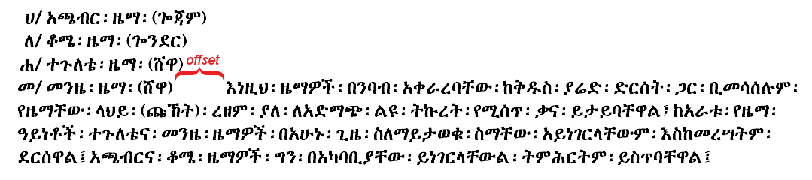Sample for in-lined paragraph continuation at end of list.

**Survey Questions:**

1. Should a paragraph continue directly from the end of a list?  
   ☐ Never ☐ Always ☐ Under special rules or context (Please Explain): _____________________________________________________________________________________________
2. When appropriate, what is the width of the paragraph offset (if any) from the final list item?  
   ☐ Same as paragraph indentation ☐ No offset ☐ Other (Please Explain): _____________________________________________________________________________________________

# Ethiopic Numeral Formatting

## Ge’ez Numeral Bars

The Ge’ez numbers can be found written in two styles where the upper and lower bars (lines) can be either separated or connected.

|  |  |
| --- | --- |
|  | Isolated style – the numeral bars do not connect. |
| Joining style – the numeral bars are connected. |

**Survey Questions:**

1. Which style should be the default? ☐ No opinion ☐ Isolated ☐ Joined
2. Are both styles desirable? ☐ No opinion ☐ Yes ☐ No
3. If both styles are desired:  
   1. When would the isolated style be used? Please explain:  
      ________________________________________________________________________________________  
      ________________________________________________________________________________________
   2. When would the joined style be used? Please explain:

________________________________________________________________________________________

________________________________________________________________________________________

## Ge’ez Numeral Vertical Alignment

The Ge’ez numbers use a system where an amount greater than “ten” can be written with a single numeral. For example “fifty” uses the single numeral “፶” and “one hundred” uses the single numeral “፻”. This difference leads to different ways the numbers can be aligned vertically. Three examples are:

|  |  |
| --- | --- |
| **Left Justify** | **Centered** |
| ............... ፻፲፩  ............... ፲፩  ............... ፩  ............... ፻  ............... ፲  ............... ፩ | ............... ፻፶፭  ............... ፶፭  ............... ፭  ............... ፻  ............... ፲  ............... ፩ |
| **Decimal Place Justify** | **Right Justify** |
| ............... ፻፲፩  ............... ፲፩  ............... ፩  ............... ፻  ............... ፲  ............... ፩ | ............... ፻፲፩  ............... ፲፩  ............... ፩  ............... ፻  ............... ፲  ............... ፩ |

**Survey Questions:**

1. Which alignment style makes the best default?

☐ No opinion ☐ Left ☐ Center ☐ Right ☐ Decimal ☐ Other (Please Explain):

_________________________________________________________________________________________________

_________________________________________________________________________________________________

# Ethiopic Wordspace (፡) Formatting

## Justification

In justified text, the non-printed or “white space” between words is treated as “stretchable”. The width of the white space can be stretched to some aesthetically pleasing size that may vary between individual words across a printed line. In Ethiopic justification, the white space between the Ethiopic word separator, “፡”, and the words it separates is likewise allowed to stretch. This stretching of white space may be either symmetrical (“centered”) or, in the asymmetrical case, the stretching is always between the right side of “፡” and the following word –this style is referred to here as the “word bound” justification.

### Justification with Punctuation and Wordspace in Word Bound Style

In “word bound” justification the word separator, which may be either an Ethiopic Wordspace, “፡”, or a punctuation symbol, appears to adhere to the word on the left side as if it were its final character of the word. The following figure illustrates the “word bound” style:

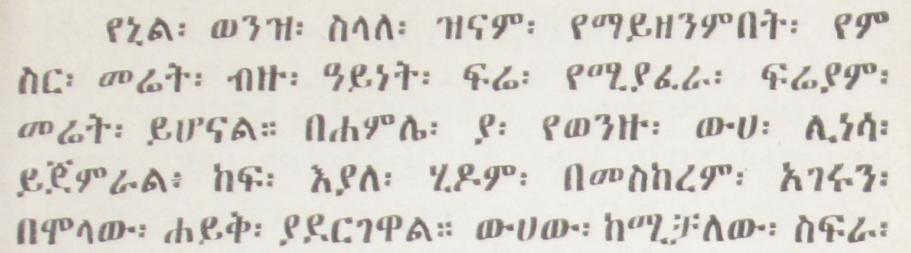

Ethiopic justification in word bounded style (Erikson, 1921 (1913 EC))

### Justification with Centered Wordspace and Punctuation

In the second major form of Ethiopic justification the white space around word separators is stretched equally on both the left and right sides; giving the appearance of the separator being centered between the words it divides. The following figure illustrates the “centered” style:

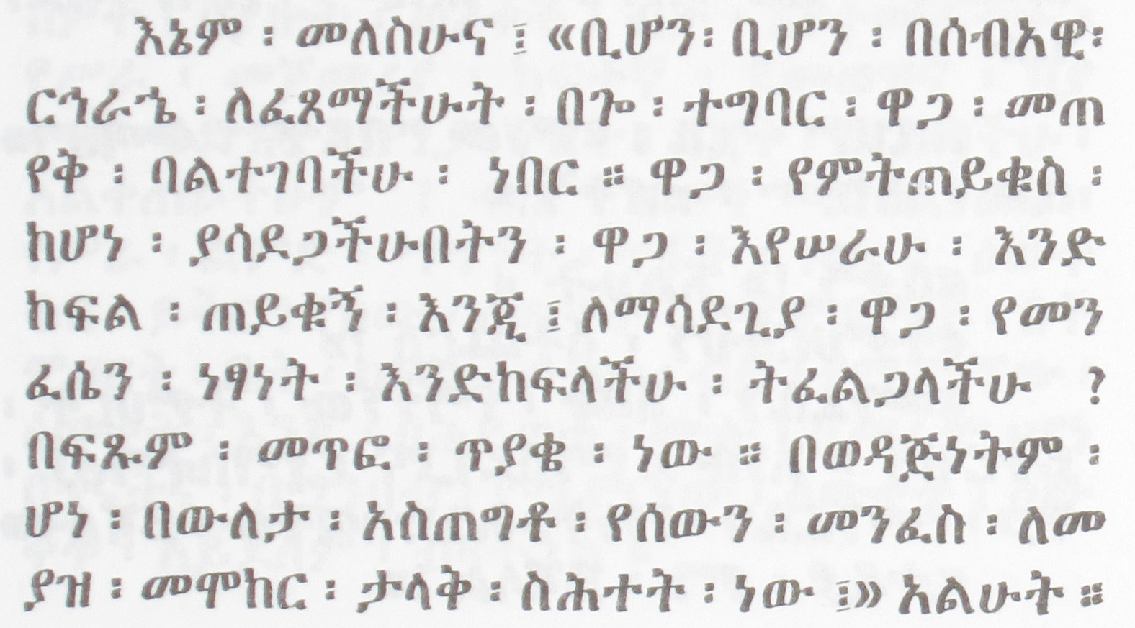 Ethiopic justification in centered style (Gubenya, 1973 (1966 EC)).

The following figure presents the stretching of white space from the point of view of the symbol’s typographic bounding box. Here the “design white space” (*d*) is the space between the visible symbol and the box border, is itself stretched (*e*) as needed to meet line justification:

|  |  |  |
| --- | --- | --- |
| **Regular Alignment** | **Justification** | |
| *e*  *e*  *d*  *e*  *d*  *d*    **Regular Style** | **Word-Bound Style** | **Centered Style** |

Depiction of white space around Ethiopic Wordspace for three modes of text justification.

**Survey Questions:**

1. Which justification spacing style should be the default used by applications?  
   ☐ No opinion ☐ Word Bound Style ☐ Centered Style ☐ Other (Please Explain): _____________________________________________________________________________________________
2. Are both styles appropriate? If so, in what contexts can the two styles be used:  
   _____________________________________________________________________________________________  
   _____________________________________________________________________________________________
3. Are names known for these different formatting styles? ☐ No opinion  
   _____________________________________________________________________________________________

### Spacing Threshold Following Full Stop

In the regular mode of Ethiopic justification, Ethiopic full stop, “።”, will be treated equally with all other punctuation symbols. In a second mode, the Ethiopic full stop will have special spacing rules whereby more space is allowed following the symbol and the start of the next word. An illustration of this mode is depicted in the following:

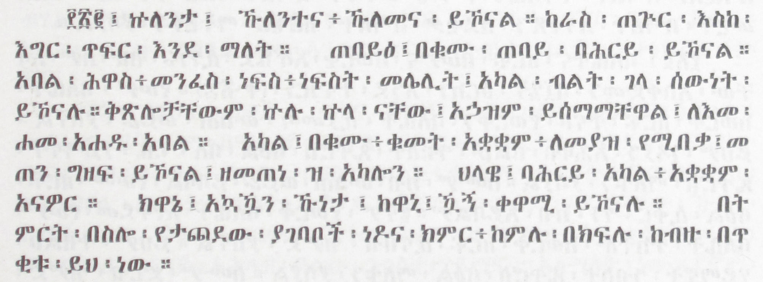  
Justification Sample from Maṣḥafa Sawāsew, Page 159 (Kifle, 1955 (1948 EC))

**Survey Questions:**

1. When should additional space be added after full stop?  
   ☐ No opinion ☐ In justified lines only ☐ Other (Please Explain): _________________________________________________________________________________________________
2. Does the additional spacing after full stop apply to other Ethiopic punctuation? Note that the above sample applies extra space after “፤” on the first line.

☐ No opinion ☐ No ☐ Yes (Please indicate which punctuation and how much space): ________________________________________________________________________________________ _________________________________________________________________________________________________

1. Is additional spacing after punctuation desirable by current day publishers?  
   ☐ No opinion ☐ No ☐ Yes ☐ Yes, but it is a special style (Please Explain): _________________________________________________________________________________________________

## Symbols Preceding and Following Ethiopic Wordspace

It modern literature where punctuation may be borrowed from Western writing, inconsistent formatting practices are found with respect to the presence of Ethiopic Wordspace (“፡”) alongside borrowed punctuation. It is helpful to establish rules for Ethiopic Wordspace in the presence of other symbols so that software grammar and formatting checkers can offer corrections leading to better quality and more consistent literature. The following rules are proposed:

* A letter or number may border either side of Ethiopic Wordspace.
* Ethiopic Wordspace may appear before, *but not after*, an opening punctuation, such as: ( , [ , { , « , ‹ , “ .
* Ethiopic Wordspace may appear after, *but not before*, a closing punctuation, such as: ) , ] , } , » , › , ” .  
    
  *Example:*

Incorrect: … ፅፋት፡(ፅፍዓት፡)፡ከመ፡ኪደተ፡ንስር፡(እንደ፡አሞራ፡ፈጣን፡)።  
 ፅፋት፡(ፅፍዓት፡)ከመ፡ኪደተ፡ንስር፡(እንደ፡አሞራ፡ፈጣን፡)።

Correct: … ፅፋት፡(ፅፍዓት)፡ከመ፡ኪደተ፡ንስር፡(እንደ፡አሞራ፡ፈጣን)።

* No other punctuation may border Ethiopic Wordspace.
* A new line may follow, but not precede, an Ethiopic Wordspace (a wordspace may not start a new line).
* Whitespace may not follow or precede an Ethiopic Wordspace (note, this does not include stretchable space used in line justification).
* An Ethiopic Wordspace followed by another Ethiopic Wordspace must be interpreted as an Ethiopic Full Stop (“።”).

**Survey Questions:**

1. Are the above rules valid?  
   ☐ No opinion ☐ Yes ☐ No or Incomplete (Please Explain):  
   _____________________________________________________________________________________________

_____________________________________________________________________________________________

## Rules of Applying Whitespace in Ethiopic Text

When Ethiopic Wordspace is used to separate words, there may still be some valid application for white space, “ ”. White space is permissible for the following formatting needs:

* Indentation.
* Following a list counter suffix.
* Within a numeric sequence, like a phone number.
* Within a date format (sometimes, not always).
* Within a scripture reference (sometimes not always).
* Before and following quotation marks.
* Following an ellipsis.
* Within a block of embedded foreign script.

*[TBD: Provide examples for some of the above scenarios]*

**Survey Questions:**

1. Are the above rules valid?  
   ☐ No opinion ☐ Yes ☐ No or Incomplete (Please Explain):  
   _________________________________________________________________________________________________

_________________________________________________________________________________________________

1. For the above cases where white space is valid, can the spacing width rules applied for Latin text be applied for Ethiopic?  
   ☐ No opinion ☐ Yes ☐ No, other spacing rules apply (Please Explain):  
   _________________________________________________________________________________________________

_________________________________________________________________________________________________

# Writing Style Best Practices

## Abbreviation Formation

Abbreviations in Ethiopic languages will apply an abbreviation marker (“/” or “.”) placed between the first letters of each word in a phrase. In a multi-word abbreviations the last word may sometimes remain whole. Abbreviation of a single word will keep the first and final letters of the word separated by slash “/”. Older literature that uses the Ethiopic Wordspace may not use an abbreviation marker and instead will rely on the Ethiopic Wordspace to separate initial letter abbreviations that will be understood from context: (e.g. ዓመተ፡ምሕረት፡ ⇒ ዓ፡ም፡).

**Examples:**

Single Word

ሚኒስትር ⇒ ሚ/ር  
ሆስፒታል ⇒ ሆ/ል

Multi-Word

ጠቅላይ ሚኒስትር ⇒ ጠ/ሚ/ር  
ኢትዮጵያ ኦርቶዶክስ ተዋሕዶ ቤተ ክርስቲያን ⇒ ኢ/ኦ/ተ/ቤ/ክ

**Survey Questions:**

1. When “.” is used as the abbreviation marker, it is sometimes found at the end of the abbreviation. For example “አ.አ.ዩ” compared to “አ.አ.ዩ.”. Which style is preferred?  
   ☐ No opinion ☐ Ending dot ☐ No ending dot ☐ It depends (Please Explain):  
   _________________________________________________________________________________________________
2. Are the abbreviations rules shown in the examples correct?

☐ No opinion ☐ No ☐ Yes ☐ Other rules (Please Explain):  
_________________________________________________________________________________________________

1. Are both “/” and “.” appropriate? Some well-established abbreviations apply a “.” as the marker, for example “አዲስ አበባ ዩኒቨርሲቲ” becomes “አ.አ.ዩ”. This may reflect the chosen convention of the institute. While “/” is used with other words.

☐ No opinion ☐ No ☐ Yes ☐ It depends (Please Explain):  
__________________________________________________________________________________________________________

1. What symbol is applied for foreign words transcribed into an Ethiopic languages?

☐ No opinion ☐ The symbol used in the foreign language  
☐ Amharic abbreviation symbol ☐ It depends (Please Explain):  
_________________________________________________________________________________________________

1. Do copy editors or publishers set a policy for abbreviation, or leave it up to the author to decide?  
   ☐ No opinion ☐ No ☐ Yes ☐ Other Policy (Please Explain):  
   _________________________________________________________________________________________________
2. Of historic interest: when are abbreviations first found in Ethiopic writing and in what form?  
   ☐ No opinion ☐ In the following publication and year:

_________________________________________________________________________________________________

## Ordinal Notation

An ordinal is formed in Amharic when “ኛ”, and in Tigrinya when “ይ”, follows a cardinal number. The ordinal marker is often, but not always, rendered in superscript form. The superscript practice is most prevalent with ordinals in western numerals, but is also applied with Ethiopic numerals.

|  |  |
| --- | --- |
| Regular ordinal: | ፬ኛ |
| Superscript ordinal: | ፬ኛ |

**Survey Questions:**

1. When is a superscript “ኛ” appropriate in Amharic documents?

☐ No opinion ☐ Never ☐ After western numbers (0-9) ☐ After Ethiopic numbers   
☐ After both western and Ethiopic numbers ☐ Other (Please Explain): _________________________________________________________________________________________________

1. What other letters should be superscripted, and it what languages and contexts? For example, “ሳ” and “ብር” may also be superscripted in presentation of prices but is not common in print (found mostly in store front advertising). ☐ No opinion  
   _________________________________________________________________________________________________

_________________________________________________________________________________________________

1. What should the relative height of the superscripted text be? The English default is a 7/12ths ratio.  
   ☐ No opinion ☐ Same ratio as English ☐ Other (Please Explain):  
   _________________________________________________________________________________________________

_________________________________________________________________________________________________

1. How high should the superscript text be raised?

☐ No opinion ☐ Same size as English ☐ 50% ☐ 75% ☐ Other (Please Explain):

_________________________________________________________________________________________________

## Ethiopic Comma Usage

The role of a “comma” in Ethiopic writing is often a point of confusion. The following describes what is believed to be contemporary usage.

**፣ –** ነጠላ ሠረዝ (ትግርኛ**/** ንጽል ሰረዝ)is used in Amharic and Tigrinya to form lists and partition a sentence in the same way as a “comma” in English. In modern Eritrean practices the symbol is used as a semicolon.

**፥ –** ንዑስ ሠረዝ is another form of **፣** that is used in Ge'ez writing. Its use in Amharic is primarily for religious literature to make reference to biblical verses (e.g. ማቴ4፥23 , ዮሐ13፥16 ). Some authors may prefer ንዑስ ሠረዝ over ነጠላ ሠረዝ.

**፡ –** ሁለት ነጥብ (ግዕዝ**/** ንዑስ ነጥብ , ትግርኛ**/** ክልተ ነጥቢ) in keeping with Ge'ez heritage, is used as the word separator (i.e. space) in the classical writing practices of both Eritrean and Ethiopia. In modern Eritrean practices the symbol is used as a comma.

**, –** Commais utilized in Eritrean and Ethiopian writing practices in the formatting of western numbers only (e.g. 12,345).

**Survey Questions:**

1. Are the above descriptions correct?

☐ No opinion ☐ Yes ☐ No (Please Explain):

__________________________________________________________________________________________________________

__________________________________________________________________________________________________________

__________________________________________________________________________________________________________

1. Should authors be able to set a default comma (፣,፥,፡) in software?

☐ No opinion ☐ Yes ☐ No ☐ Other Policy (Please Explain):  
__________________________________________________________________________________________________________

1. Should authors be able to set a default space symbol in software?

☐ No opinion ☐ Yes ☐ No ☐ Other Policy (Please Explain):

__________________________________________________________________________________________________________

## Parenthetical Expressions

Parenthetical expressions are found regularly in modern Ethiopic writing and will apply any of the enclosing symbol pairs: // , () and [].



Inner Parenthetical Expression from Maṣḥafa Sawāsew, Page 65 (Kifle, 1955 (1948 EC))

**Survey Questions:**

1. What are the preferred parenthetical enclosing symbol pairs for modern writing?

☐ No opinion ☐ ( ) ☐ // ☐ [ ] ☐ Other ______ ☐ It depends (Please Explain): _________________________________________________________________________________________________

1. Do special rules apply for inner expressions?

☐ No opinion ☐ No ☐ Yes (Please Explain):

_________________________________________________________________________________________________

1. Do copy editors or publishers set a policy for parenthesis symbols, or leave it up to the author to decide?  
   ☐ No opinion ☐ No ☐ Yes ☐ Other Policy (Please Explain):  
   _________________________________________________________________________________________________
2. Of historic interest: when are parenthesis first found in Ethiopic writing and in what form?  
   ☐ No opinion ☐ In the following publication and year:

_________________________________________________________________________________________________

## Quotation

Classical Ethiopic literature applying quotation marks will employ double guillemet (« ») in a primary style and single guillemets (‹ ›) in a secondary style. Single guillemets will be used for inner-quotation and single word quotation. Modern Ethiopic writing will additionally utilize Latin quotation marks similarly (“ ”, ‘ ’). The choice of Latin script quotation may represent either an author preference or a software limitation that made guillemets unavailable or difficult to access.

**Survey Questions:**

1. Which style should be the default for Ethiopic literature: ☐ No opinion ☐ « » ☐ “ ”
2. Are both styles appropriate for Ethiopic literature? ☐ No opinion ☐ No  
   ☐ Yes (Please Explain): _____________________________________________________________________  
   _________________________________________________________________________________________________
3. What form is appropriate for outer quotation: ☐ No opinion ☐ Single ☐ Double
4. What form is appropriate for inner quotation: ☐ No opinion ☐ Single ☐ Double
5. What are the preferred quotation marks for modern Ethiopic literature?  
   ☐ No opinion ☐ « » ☐ “ ” ☐ It depends (Please Explain): _________________________________________________________________________________________________
6. Is the single quotation mark usage statement correct?

☐ No opinion ☐ No ☐ Yes ☐ Other rules (Please Explain):  
_________________________________________________________________________________________________

1. Do any other rules apply to quotation usage in Ethiopic writing?

☐ No opinion ☐ No ☐ Yes (Please Explain):  
_________________________________________________________________________________________________

1. Do copy editors or publishers set a policy for quotation mark choice, or leave it up to the author to decide?

☐ No opinion ☐ No ☐ Yes ☐ Other Rules (Please Policy):  
_________________________________________________________________________________________________

1. Do the same rules apply for Ethiopic Wordspace surrounding a closing quotation mark as with a closing parenthesis?  
   ☐ No opinion ☐ No ☐ Yes ☐ Other Rules (Please Explain):  
   _________________________________________________________________________________________________
2. Of historic interest: when are quotation marks first found in Ethiopic writing and in what form?  
   ☐ No opinion ☐ In the following publication and year:

_________________________________________________________________________________________________

## Ellipsis

Both punctuation-baseline and raised ellipses are found in Ethiopic literature. In Ethiopic publishing ellipsis may have anywhere from 3 to 6 dots used regularly. The presence of one style over the other may simply be an artifact of the publishing technology and not necessarily in line with the publisher's preference.

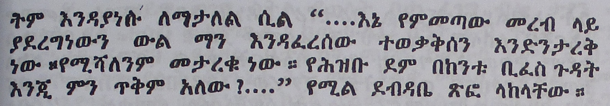

Example: Raised 4-dot ellipsis.

**Survey Questions:**

1. How many dots should be in an ellipsis?  
   ☐ No opinion ☐ 3 (English standard) ☐ Author’s choice ☐ Other (Please Explain): _____________________________________________________________________________________
2. Which ellipsis position is preferred as the default?  
   ☐ No opinion ☐ Bottom aligned with other punctuation ☐ Raised  
   ☐ Other (Please Explain): ___________________________________________________________________
3. How much spacing between dots is desirable?  
   ☐ No opinion ☐ Same as for English ☐ Other (Please Explain): __________________________________________________________________________________________________________
4. What shape is preferred for the ellipsis dots?

☐ No opinion ☐ Circles ☐ Squares ☐ Other (Please Explain): _________________________________________________________________________________________________

1. What spacing (if any) *before* the ellipsis dots?

☐ No opinion ☐ None ☐ regular space ☐ punctuation space   
☐ Other (Please Explain): _________________________________________________________________  
_________________________________________________________________________________________________

1. What spacing (if any) *after* the ellipsis dots?

☐ No opinion ☐ None ☐ regular space ☐ punctuation space   
☐ Other (Please Explain): __________________________________________________________________ _________________________________________________________________________________________________

## Bibliographic Citation

A formally recognized standard for bibliographic citation of Ethiopic publications is not found in the Ethiopian publishing community, and bibliographic convention is left to the discretion of individual authors. Establishing a standard is recommended by the survey team and will aid in document consistency and in the machine processing of reference citations. Dereje Gebre of the AAU Amharic Language Department, and past Vice President of the Ethiopian Writer's Association Professor employs the following convention which is a useful starting point:

<Author Full Name> "፤" <Publication Date> "፤" *<Title> ("።")* <City> "፤" <Publisher> "።"

The Ethiopic Full Stop, ።, is only added between <Title> and <City> if the <Title> itself does not end with a terminating punctuation such as “፡ ፤ ። ?” .

An example:

ደረጀ ገብሬ፤ ሚያዝያ 1996፤ *ተግባራዊ፡የጽህፈት፡መማሪያ።* ንግድ ማተሚያ ድርጅት፤ አዲስ አበባ።

**Survey Questions:**

1. Do stakeholders endorse any conventions for media citation? If so, which:  
    ☐ No opinion ☐ None endorsed ☐ Some Endorsed (Please Explain): _________________________________________________________________________________________________
2. What are formats for other media types?  
    ☐ No opinion ☐ No other formats ☐ Additional (Please Explain): _________________________________________________________________________________________________