Publisher Survey of Ethiopic Layout & Formatting Practices

A Survey of the   
W3C Ethiopic Layout Requirements Task Force

# Letter Presentation Styles

## English Font Weights

The historic “weight” (the letter thickness) of Ethiopic is heavier than found in European writing. When European words appear in a document, they are sometimes made heavier to match the Ethiopic letters. For Example:

ካገላበጥኳቸው ስራዎች ውስጥ ግን ታዬ አሰፋ እና ሽፈራው በቀለ የተባሉ ምሁራን በጋራ ያሳተሙት The Study of Amharic Literature: An Overview የሚለው ጥናት አጥጋቢ መልስ የሚሰጥ ሆኖ አግኝቼዋሉ።

English words have their usual weight.

ካገላበጥኳቸው ስራዎች ውስጥ ግን ታዬ አሰፋ እና ሽፈራው በቀለ የተባሉ ምሁራን በጋራ ያሳተሙት The Study of Amharic Literature: An Overview የሚለው ጥናት አጥጋቢ መልስ የሚሰጥ ሆኖ አግኝቼዋሉ።

English words are made heavier.

1. When publishing in the classical Ethiopic weight, should English words appear in their default English weight?

☐ Yes ☐ No

1. If heavier Latin letters are desirable, how much so?

☐ The same as Ethiopic line thickness  
Other: ________________________________________________________________________________________

## Quotation

In Ethiopic literature two styles of citation marks can be found. They are the quillemets « » and the quote marks “ ”. Both styles have compliments in singular mark forms: ‹ › and ‘ ’.

1. Which style should be the default for Ethiopic literature: ☐ « » ☐ “ ”
2. Are both styles appropriate for Ethiopic literature? ☐ No ☐ Yes (Explain)

________________________________________________________________________________________  
________________________________________________________________________________________

1. What form is appropriate for outer quotation: ☐ Single ☐ Double
2. What form is appropriate for inner quotation: ☐ Single ☐ Double

## Ethiopicized Punctuation

Modern Ethiopic borrows a number of foreign symbols to show currency, express emphasis, time, mathematics, or communicate with Internet protocols (such as "@" , "://"). The following are believed to be in common use:

1234567890 ? ! ¡ . / () [] {} < = > \ # % & $ : , € @ … _ - + ± × ÷ ‘ ’ “ ” ‹ › « »

1. Are there any additional western symbols required for Ethiopic writing? If so which:

________________________________________________________________________________________

1. Are any symbols from other foreign script (Chinese, Arabic, etc.) that should be included? If so which:

________________________________________________________________________________________

A number of fonts will provide the western punctuation with a change of shape to visually match better with Ge’ez letters. For example:

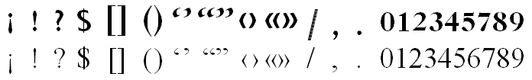

1. What symbols benefit from shape change?

________________________________________________________________________________________

1. What symbols benefit from weight change (but not weight)?

________________________________________________________________________________________

## Quotation of Foreign Phrases

When Ethiopicized punctuation is in use and a foreign phrase is to be quoted, an issue appears regarding the proper weight and style of the quotation marks. Should the quotation marks use the Ethiopic style or those of the foreign phrase? Some examples:

## Macintosh HD:Users:dmekonnen:git:elreq:images:Punctuation-At-Latin-Boundary-Ethiopic-Guillemets.png

A: Latin text enclosed with European weight guillemets.

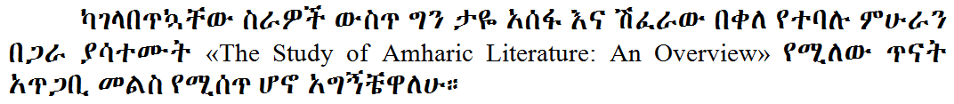

B: Latin text enclosed with Ethiopic weight guillemets.

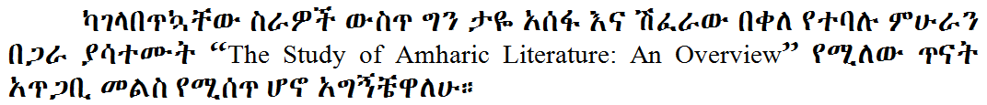

C: Latin text enclosed with Ethiopic weight quotes.

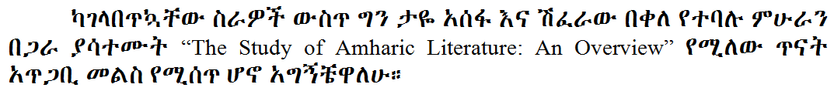

D: Latin text enclosed with European weight quotes.

1. What quotation weight should be used around European phrases:   
    ☐ European ☐ Ethiopic

## Positioning of the Gemination Mark (ጥበቅ)

The Ethiopic germination mark has at least a century of use yet is not commonly found outside of linguistic literature. The mark, known as ጥበቅ, helps indicate stress on a consonant (e.g. ገና compared to ገና፟) and may appear in a single dot form. Outside of linguistic works, the germination mark appears most famously in Haddis Alemayehu’s used a *Fikre Eske Makber* where the single dot mark is used. The choice of one or two dots, as well as its position, might be different when written by hand versus a printing technology. For example:

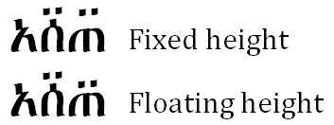

1. The best style for modern publishing is: ☐ fixed ☐ floating

# Height of English Used with Ethiopic

In many Ethiopic documents with English (or European) text the English letters might appear shorter or taller than the Ethiopic. For example:

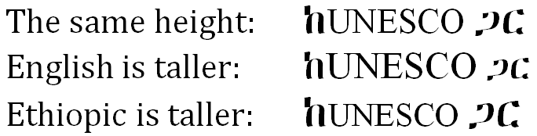

1. When used together in a sentence, how tall should English letters be?

☐ The same height

☐ English is taller

☐ Ethiopic is taller

# Number Layout

## Ge’ez Numeral Bars

The Ge’ez numbers can be found written in two styles where the upper and lower bars (lines) can be either separated or connected.

|  |  |
| --- | --- |
|  | Isolated style – the numeral bars do not connect. |
| Joining style – the numeral bars are connected. |

**Survey Questions:**

1. Which style should be the default? ☐ Isolated ☐ Joined
2. Are both styles desirable? ☐ Yes ☐ No
3. If both styles are desired:
   1. When would the isolated style be used? Please explain:  
      ________________________________________________________________________________________  
      ________________________________________________________________________________________
   2. When would the joined style be used? Please explain:

________________________________________________________________________________________

________________________________________________________________________________________

## Ge’ez Numeral Vertical Alignment

The Ge’ez numbers use a system where an amount greater than 10 can be written with a single number. For example 50 uses the single number ፶ and 100 uses the single number ፻. This difference leads to different ways the numbers can be aligned vertically. Three examples are:

|  |  |  |
| --- | --- | --- |
| **Left Justify** | **Decimal Place Justify** | **Right Justify** |
| ............... ፻፶፭  ............... ፶፭  ............... ፭  ............... ፻  ............... ፲  ............... ፩ | ............... ፻፶፭  ............... ፶፭  ............... ፭  ............... ፻  ............... ፲  ............... ፩ | ............... ፻፶፭  ............... ፶፭  ............... ፭  ............... ፻  ............... ፲  ............... ፩ |

1. Which alignment style makes the best default?

☐ Left ☐ Right ☐ Decimal ☐ Other (Explain Below)

________________________________________________________________________________________

________________________________________________________________________________________

1. Are the vertical alignment rules applied for Roman numerals applicable for Ethiopic [TBD: determine the Roman numeral rules]?

☐ Yes ☐ No