# HydroDEM_AccumAdjust (Exercise 1)

(This exercise is run on data in the ‘exercise_1 workspace)

Obtain necessary data.

NED:

For this exercise, 4 tiles have already been downloaded from the USGS seamless server (<http://seamless.usgs.gov>).

WBD:

Use sample HUC data file that I tweaked for match NRCS WBD Data. Or, from the NRCS Data Gateway (<http://datagateway.nrcs.usda.gov>) use the ‘Get Data’ link. Use the ‘Quick State’ link on the lower left. Then download the ‘12 digit Watershed Boundary Dataset 1:24,000.’

NHD:

From NHD prestaged 4digit in FileGDB format from the FTP site (<ftp://nhdftp.usgs.gov/SubRegions/High/FileGDB>) download by HUC of interest

**First Step, Setup ArcHydro database**

1. Create an output folder in ArcCatalog called ‘archydro’ that will house all of the resultant exercise data.
2. In ArcCatalog add the StreamStats v3.10 toolbox and open the toolset ‘Setup tools’ and double click ‘**Database Setup’**
3. Set the Output Workspace name to the ‘archydro’ folder set above
4. For ‘Main ArcHydro Geodatabase Name’ type in ‘source_data’ for this new file geodatabase, which will be used to house the huc feature class (generated here) and the raster catalog (generated in the ‘Second Step, NED Tools’)
5. For ‘WBD Dataset’ select the ‘sample_wbd’ shapefile (under ‘WBD’ in the ‘exercise_data’ folder) which in this case is already projected in the final state projection of choice (otherwise the ‘WBD Dataset is already projected’ button would need to be unchecked and the ‘WBD Projection Template if unprojected’ optional menu item would need to be populated with a feature dataset or shapefile that is already in the proper projection).
6. Be sure the HUC_8 and HUC_12 fields are set correctly for your dataset
7. The ‘HUC Buffer Distance (m)’ should be set to 2000 (meters). This buffer distance is used for TopoGrid processing which is trimmed back down to the HUC boundary in subsequent steps.
8. Select the path to the NHD 4-digit High Resolution data (select ‘NHD’ under exercise_data). You must have already downloaded all 4-digit hydro regions covering your study area
9. Select one of your unprojected NED datasets to use as a source template for ‘NED Projection Template’ (under exercise_data\NED, enter one of the four folders and select the grid)
10. Run the script.

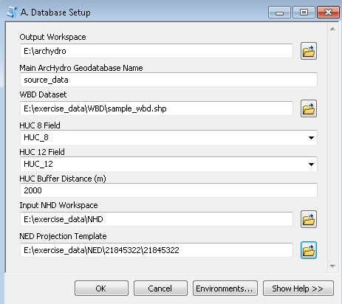

After running, open ArcMap. Under the ‘archydro’ folder, examine the feature class outputs for one of the newly generated ‘input_data’ file geodatabases in one of the newly generated local workspaces (note the local workspaces have the name of the 8-digit HUC). Also examine the ‘huc8index’ feature class in the new ‘source_data’ file geodatabase (also in the ‘archydro’ folder). Compare all data to the original NED, NHD and WBD datasets. Several observations:

‘dendrite_edit’ and ‘NHDFlowline’ are identical line feature classes. ‘dendrite_edit’, however, will be modified to your satisfaction as the input dataset for HydroDEM ‘burning’

‘huc8’ and ‘huc12’ datasets appear identical (the attribute tables are different). Typically this would not be the case. However for this exercise we are using the source huc12 features as a surrogate huc8 datasets to cut down on processing time. ‘huc8_buffer_dd83’ is used as input for the ‘Extract Polygon Area From NED’ tool which is used below (under NED Tools).

‘inwall_edit’ should have all interior WBD boundaries that will be used for ‘walling’. Here, there is nothing for the same reason as explained in the previous bullet. This dataset could be modified at this time to include more interior boundaries such as gage boundaries

‘huc8_buffer’ includes a 2000 meter buffer area which will be used in TopoGrid to clip the DEM data. These buffer areas overlap.

‘NHDArea’ and ‘NHDWaterbody’ are used as input into bathymetric gradient processing.

ArcGIS 10.2 addition) Create huc8_line & huc12 line featureclass.

In ArcMap, search 🡪 tools 🡪 polygon to line (data management)

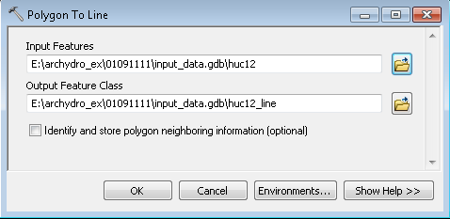

Repeat for 2222,3333 & 4444. Plus convert the 4 huc8 polygons to huc8_lines These line featureclass will be used in the NHD-WDB intersect tool.

(THIS TOOL CAN BE BATCHED)

Quit out of ArcMap without saving.

**Second Step, 2. NED Tools**

1. In ArcCat, Run the first ‘NED Tools’ tool: ‘A. **Make NED Index’**
2. ‘Output Geodatabase’: Select the ‘source_data’ file geodatabase you created with the ‘Database Setup’ tool
3. ‘Output Raster Catalog Name’: Keep the default (IndexRC)
4. ‘Coordinate System’: Import the source coordinate system (GCS_North_American_1983) using one of the source grids
5. ‘Input NED Workspace’: Select the NED folder
6. ‘Output Polygon Feature Class’: Keep the default (IndexPolys)
7. Run the script

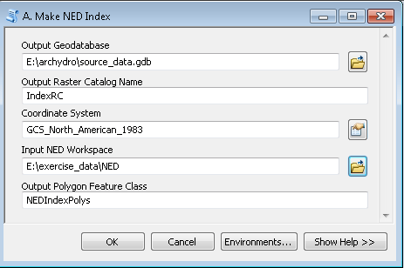

After running, load and view the output in ArcMap (IndexPolys, IndexRC). View the attribute tables. Quit out of Arcmap without saving.

1. In ArcCat, Run the 2nd tool in the ‘NED Tools’: ‘B. **Extract Polygon Area From NED’**, which is run on each ‘local’ workspace in the ‘archydro’ folder.
2. ‘Output Workspace’: ‘01091111’ (in the ‘archydro’ folder)
3. ‘NED Index Polygons’: Select ‘NEDIndexPolys’ in the ‘source_data’ file geodatabase
4. ‘Clip Polygon’: Select ‘huc8_buffer2000_dd83’ in the archydro\01091111\input_data file geodatabase
5. ‘Output Grid’: Keep the default (‘dem_dd’)

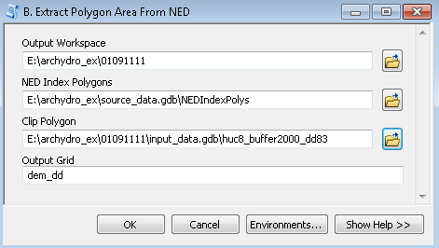

(THIS TOOL CAN BE BATCHED)

Repeat the ‘Extract Polygon Area From NED’ on the other 3 ‘local’ workspaces (01092222, 01093333 and 01094444)

After running, load and view the one of the ‘local’ folder output ‘dem_dd’ grids in ArcMap (note the inclusion of the 2000 meter buffer area, which again, is needed for TopoGrid). Quit out of Arcmap without saving.

Run the 3rd tool in the ‘NED Tools’: ‘**C. CheckNodata’**

1. InGrid: ‘dem_dd’ (in 01091111)
2. OutPolys.shp: ‘NoDataChk’ (put in 01091111). The output (default = C:\tmp\RasterT_Singleo<value_increment>.shp) should show up as a donut hole polygon area with no ‘GRIDCODE’ values of 1 showing up within. If there were NODATA polys then you would either run the next tool, ‘**Fill NODATA Cells’** (which replaces NODATA values in a grid with mean values within a 3x3 window) or acquire better NED data if available.
3. Repeat CheckNodata on 01092222, 01093333, and 01094444

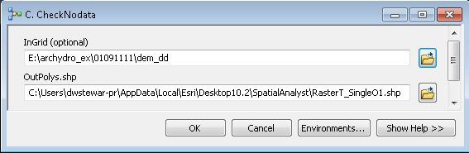

In ArcCat Run the 5th tool in the ‘NED Tools’: ‘**E. Project and Scale NED’**

(** this tool also sets a rounded origin coordinate for the output grid **)

1. Input Workspace: 01091111
2. Input Grid: Keep the default (dem_dd)
3. Output Grid: Keep the default (dem_raw)
4. Output Coordinate System: Import the coordinate system for huc8index in the ‘source_data’ file geodatabase in the archydro root folder. The coordinate system is USA Albers USGS.
5. Output Cell Size: 10 (the projection is Albers, meters)
6. Registration Point: For all StreamStats projects, this should be left alone (15 15)

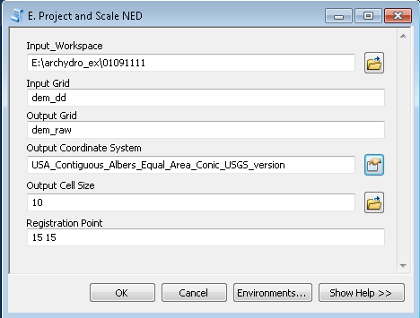

(THIS TOOL CAN BE BATCHED)

Repeat ‘Project and Scale NED’ for 01092222, 01093333, and 01094444. Note that the output zunits are in integer centimeters (the input was in floating point meters). Also note that the output ‘dem_raw’ grid includes a line in the projection file ‘ZUNITS 100’. This custom (non-default) value is needed by several basin characteristics, including basin slope, since the Z value (centimeters) is different from the XY values (meters). Otherwise basin slope would be exaggerated 100 times.

**Third Step: Editing NHD**

Open ArcMap. Navigate to the 01091111 folder and add the features in the ‘input_data’ file geodatabase.

Turn all layers off except ‘huc8’ and ‘dendrite_edit’.

Under ‘File’ select ‘Add Data from ArcGIS online’. Load the ‘US Topo Maps’ and ‘World Imagery’ web services to your view. Turn these layers off for now (they slow things down).

Observe the stream overlapping the Northern boundary of the huc. This is problematic. Although the streamline represents flow in a wetland, the wetland straddles the boundary and flows in 2 directions (entering and exiting the huc).

Zoom into this general area and turn on the topo image. There is another issue. A small disconnect just South of the letter ‘D’ in ‘Dead Swamp’. This gap is so narrow, if HydroDEM were to be run, the resulting flow accumulation would hop across the gap. There are many other reasons to clean up an NHD dataset, but for this exercise, we need to address this one now.

Start an edit session on the ‘input_data’ file geodatabase. Choose ‘dendrite_edit’ as your target layer. Select the flowline in the swamp and delete it. Save your edit.

Turn the topo image off and zoom back out to the extent of the huc8. The flow in the basin is generally North to South, with the outlet at the Southern most point of the HUC. Note near the outlet, there is disconnect in the flow. Zoom to this location and bring up the World imagery. This disconnect is likely an underground conduit connecting the reservoir to the stream on the South side of the major road. Let’s correct the problem.

The target layer remains ‘dendrite_edit’

Set ‘dendrite_edit’ Snapping to ‘End’

Digitize in a connector line in the direction of flow (North/South)

Save Edits

Remove all layers from the Table of Contents

Add all layers in the local 0109444 input_data gdb

Turn all layers off and turn back on ‘huc8’ and ‘dendrite_edit’

Zoom to ‘huc8’

This is the receiving HUC for the other 3 local HUCs. Observe the 3 locations where those 3 upstream HUCs flow into this one. Zoom into one of these locations

The ‘dendrite_edit’ feature class is eventually used in the burning process. Any feature in this dataset that is an inlet for a downstream HUC needs to be trimmed just inside the HUC. Otherwise, the ‘walling’ process can get compromised at the boundary edge. This trimming should only be a cell or 2 in length (10 – 20 meters).

Editor > Start Editing

Target: ‘dendrite_edit’

Select the feature that overlaps the boundary.

Measure a distance

Split the feature

Delete the segment

Repeat this for the other 2 inlet features

Save and Stop editing

Quit out of ArcMap without saving

Note: There will typically be other edits to review for both the NHD and WBD. This is why we isolate an edit-able copy for both (‘dendrite_edit’ and ‘inwall_edit’). Also, for ‘dendrite_edit’ it may be helpful to occasionally reestablish a geometric network to check flow connectivity. The best tools to do this are typically NHD tools, but to use them the feature class name typically needs to be ‘NHDFlowline’ and this dataset typically needs to be in a ‘Hydrography’ feature dataset. Some manipulation of the ‘dendrite_edit’ feature class (including temporarily loading into a separate geodatabase) may be necessary.

**Forth Step, NHD-WBD Conflicts**

The WBD (huc12) polygons and/or streamgage basin boundaries are generally used as the inner walls in the “walling” process. Also, the WBD (huc8) polygons are used as the outer walls. Each huc12 and huc8 polygon should only have a single outlet.

Occasionally, the NHD and the WBD lines intersect in places they shouldn’t or the 2 lines come very close to each other and could create an unwanted breach in an inner or outer wall.

A tool has been developed by Kim Jones USGS UT WSC to identify NHD-WBD conflicts. The tool rasterizes the NHDFlowlines and WBD boundaries, using the snap grid and cell size that will be used in the ‘burning and walling’ process. Locations where the 2 grids intersect are identified and need to be visually examined and sometimes corrected. Most of the time, the WBD boundary is adjusted.

In ArcMap, add the toolbox called StreamStats_NHD-WBD_Intersect_tool.tbx



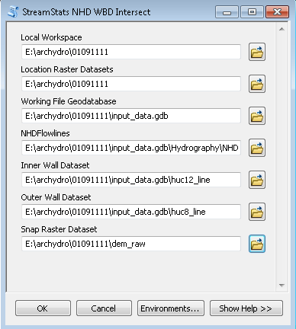

The tool creates a feature dataset called “Reference” in the working file geodatabase and 2 featureclasses to review; one for called nhd-inwall_intersect and the other for the nhd_outwall_intersects.

Add Data input_data.gdb 🡪Reference 🡪 nhd_inwall_interset and nhd_outwall_intersect.

Add Data input_data.gdb 🡪Hydrography🡪NHDFlowlines, huc8_line and huc12_line.

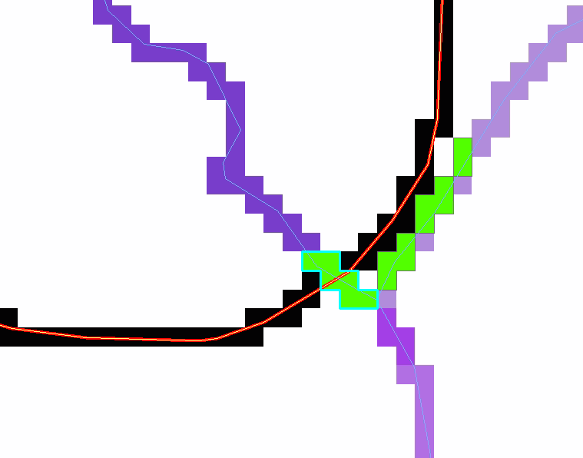

**01091111 data generates the above results w/ NHD WBD Intersect tool**.

Red line is the HUC8 (outer wall) boundary, yellow line is the HUC12 (inner wall) boundary,

Black cells are the rasterized HUC8 boundary.

Blue lines are the NHD, and purple cells are the rasterized NHD.

Green cells are the locations that need to be reviewed.

Places where the green and black cells overlap will cause a break in the wall. In this case, the tool found the HUC8 outlet, where the NHD and HUC8 are supposed to overlap, so the “intersect” is OK in the area outlined by cyan. The tool also identified a row of cells to the NE of the outlet (shown in green) where the NHD and WDB are right next to each other - this should not cause a problem.

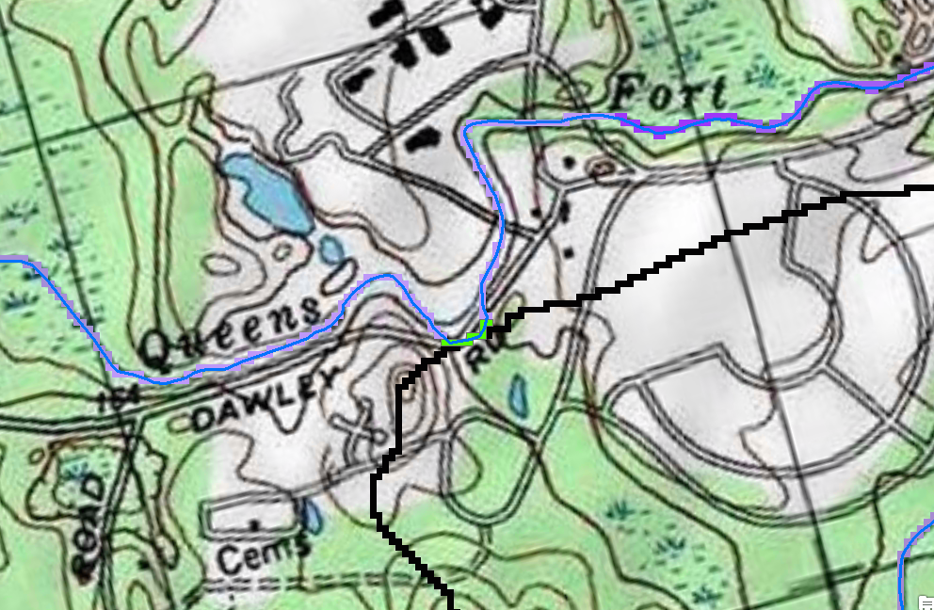

**01091111 data generates the above results w/ NHD WBD Intersect tool**. Same colors as mentioned above. The green cells are where the NHD overlaps w/ the HUC8 (outer wall) and either the NDH or WBD need to be modified. You can see where stream jumps a few contour lines, so the stream should be adjusted.

**Fifth Step, 4. HydroDEM Tools**

**A. Bathymetric Gradient Setup** from ArcCat

1. Run ‘Bathymetric Gradient Setup’ on a local HUC to prepare 2 grids for the HydroDEM program

2. Set the ‘Output Workspace’ to the local HUC workspace (01091111)

3. Set the ‘DEM’ grid to ‘dem_raw’ here.

4. Set the ‘Dissolved HUC8 Dataset’ to ‘huc8’

5. Set the NHDArea to the same name in the source NHD feature dataset (under the ‘input_data’ file geodatabase).

6. Set the NHDFlowline to ‘NHDFLowline’. (NOTE: Do NOT use NHDFlowline_orig from the NHD here. You want the version you edited.)

7. Set the NHDWaterbody to the same name in the source NHD feature dataset (under the ‘input_data’ file geodatabase).

8. Set the NHDFlowline Selection Buffer to 5 meters (default)

9. Ensure the Checkbox for ‘NHD Data already projected’ is checked

10. Click OK

**Two grids are created: wb_srcg (waterbody areas) and nhd_wbg (flowline cells).**

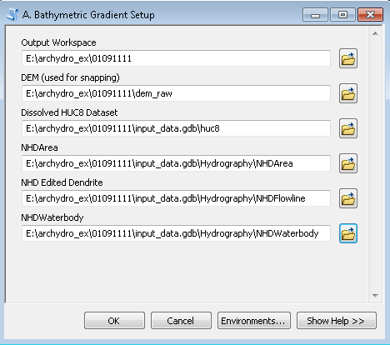

Enter ArcMap and view these grids in context with the source NHD. Quit out of ArcMap without saving. (NOTE: When you are working on your own data, you may see cases in which the NHDWaterbody or NHDArea may need to be edited in order to prevent imposing a gradient on areas that shouldn’t be done. This would be quite rare, but if you do see this, copy the feature class to an “edit” one like we have done for dendrite_edit and inwall_edit, so you will know there have been edits. Then use the edited feature classes as inputs to this tool, i.e. in steps 1d and/or 1f above.)

Repeat ‘Bathymetric Gradient Setup’ for 01092222, 01093333, and 01094444

B. (NOTE: These are not coastal hucs, so we are skipping the Coastal Processing step. otherwise we will need to do coastal processing. )

C. **Pre HydroDEM Processing** from ArcCat

Run the ‘Pre HydroDEM Processing’ tool to create the input coverages for HydroDEM (from the source file geodatabases), and define the input DEM as either the raw DEM (‘dem_raw’). The chosen DEM will be copied and named ‘dem’

1. Output Workspace: select the ‘01091111’ workspace
2. Dissolved HUC8 Dataset: ‘huc8’ (in the ‘input_data’ gdb
3. Dendritic NHD Dataset: ‘NHDFlowline’
4. Inner Wall Dataset: ‘huc12_line’
5. DEM to be used in HydroDEM: ‘dem_raw’
6. Sink Points Dataset (optional): leave blank
7. Run the program (‘OK’)

Run the remaining 3 HUCs through ‘Pre HydroDEM Processing’ (the ‘Sink Points Dataset (optional)’ menu item will be left blank for all three).

**Grids Created: dem**

**Coverages Created: huc8, inwall, nhdrch**

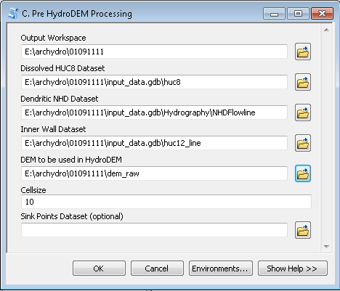

**D. Run HydroDem.aml** from ArcMap

Make sure the directory is refreshed and not being accessed by any ArcMap or Windows Explorer window. It may make sense to close ArcCatalog and open again before you run step D.

Run the ‘HydroDEM.aml’ tool on 01091111 (the remaining 3 will be run in batch mode, but here we get to showcase the “validation code” for Python scripts, which populates fields > a thanks to Curtis Price for this code. You can see the code on the Validation tab if you right-click on the script in ArcToolbox and go to Properties.)

Output Workspace: select the ‘01091111’ workspace

The remaining fields (including the optional ‘Drain plug coverage’ field) are populated!

*copy the snapgrid into the huc folder, and set that as the Snapgrid, instead of the one that is auto populated*

Click OK

View results in ArcMap. Drape the dendrite_edit feature class and drain_plugs polygon layer on top of the fac grid. Scan around.

*examine the dem_enforced and zoom back to the nhd_inwall_intersect areas that were edited. make sure the inwalls only have one outlet for each stream.

Quit out of ArcMap without saving

Run the ‘HydroDEM.aml’ tool in batch mode for the other 3 HUCs

Right click the tool and select ‘Batch’

In the empty ‘Output Workspace’ field, right click and select ‘Browse’

Hilite all the remaining 3 HUC folders and select ‘Add’

Back in the batch window, with the 3 newly populated rows (for ‘Output Workspace’) selected, click the check values check box on the right. All other fields are populated!

Click OK to run the batch process

View some results in ArcMap. Quit out of ArcMap without saving

Grids Created in HUC folder:

buffg, dem_enforced, dem_ridge8, dem_ridge8wbd, elevgrid, eucd, fac, fdr, fil, inwallg

inwallg_tmp, nhdgrd, ridge_exp, ridge_nl, ridge_w,

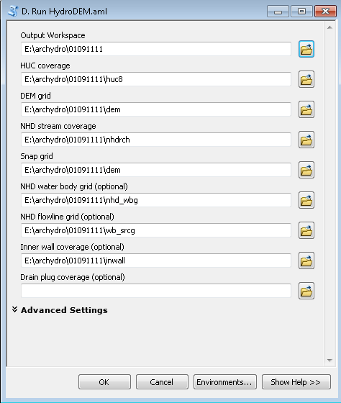

NOTE: the results will contain some very strange looking stuff, this is normal.

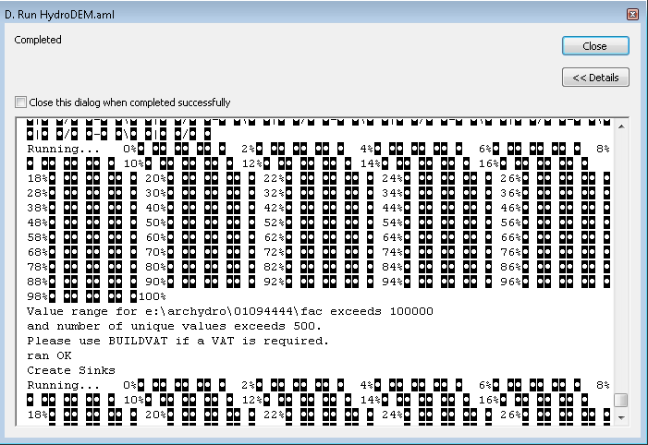

E. Flow Accumulation Adjust (**Optional, & currently not being used by StreamStats**)

Flow Accumulation needs to be adjusted at the inlets of downstream HUCs to account for the flow coming into the HUC (which needs to be recognized for the ArcHydro tools to work correctly). By default, local DEM derivatives like flow accumulation stand alone and do not recognize incoming flow. This tool adjusts for incoming flow.

Open the ‘Flow Accum Adjust’ tool

Downstream (receiving FAC): Add in the FAC (flow accumulation) grid under 01094444 (which is the only receiving HUC in this exercise)

Upstream FAC(s): Add in each of the three upstream FAC grids by surfing into each local workspace

Click OK

Open ArcMap and view the results. Load the new ‘fac_global’ for 01094444 and compare to the original ‘fac’

F. b) **Post HydroDEM.aml Processing (No Sinks)**

1. Start a fresh ArcMap document. (Important: Don’t just hit the “New Map Document” button. This will copy the XML setup from the currently open MXD. We want a completely fresh MXD, so you must start ArcMap from scratch. (Don’t save it yet, either. Wait till step 3 below.)
2. Add the fdr and fac grids from the 01091111 workspace to the mxd.  Be sure to add the grids first, before anything else. This ensures the projection is set right.
3. Save the MXD as 01091111.mxd in the 01091111 folder.
4. Run the “F. b) Post HydroDEM.aml Processing (No Sinks)” model/tool. Be sure that the appropriate grid ***layers*** for each input using the little pulldown arrow. Do NOT use the file folder browse tool to specify the grids. Set the first Threshold to 150,000, the second to 900**.**

Notice in the folder that extra files appear. There will appear a 01092222.gdb folder, which is a file Geodatabase that will contain the vector layers. Also created is a 01091111.AHD file, which stores the ArcHydro Tools configuration, in XML format, plus a 01091111.xml file. (If you are having trouble in a folder, try deleting these files, including the MXD, and starting over.)

1. Look at the results. Do the streams900cells and DrainageLines match well with the input dendrite_edit? Look at the sinks_poly coverage. Are there large areas that were filled and flattened? Could these areas be better represented by adding some lines to the dendrite_edit, e.g. to break through a dam or some other blockage? Use the “raindrop” (Flow Path Tracing) tool to see how the HydroDEM is routing flow. Once you are satisfied, save the mxd and close ArcMap.
2. Open ArcCatalog.  Browse into the 01091111 workspace. Right-click on and Compact (NOT Compress) the 0101111.mdb geodatabase.
3. Notice the software also created a “Layers” folder, and it contains several grids. Use ArcCatalog to **copy all the grids up one layer to the 01091111 folder**,
4. The other 3 HUCs can be processed in a similar manner, **always starting a new ArcMap session.**
5. **Run the Cleanup Workspace** tool to clean out the temporary data sets that were created in our processes.