Wiseman 1.0 Creating Annotated(Metadata-Flavored) Resources Tutorial (Draft)

Author: Simeon Pinder(simeon.pinder@hp.com)

Date: May 9, 2007

Targetted Version: WsManagement 1.0 (version A)

1. Abstract: Quick description of topic as is used by this implementation and in this context.

Woefully missing from the current version of the published WsManagement specifications(as of this writing) is a clear means of determining exactly how to access an exposed WsManagement service. The Wiseman-Wsdl-Work.doc and ‘Creating Resources.pdf’ documents describe the detailed steps involved in creating and exposing a WSDL for a WsManagement service with Wiseman. Both documents describes a mechanism, beyond the specification defined behavior, to expose Action-Dispatching WsManagement resources, through the traditional/familiar Webservice interface, the WSDL. All of the existing webservice toolkits required a little nudging to successfully consume these WsManagement-flavored WSDLs and the process is non-trivial.
To simplify the steps required to expose your web service to new clients, the Wiseman metadata mechanism, described in Wiseman-MetaData-DeveloperDocs, is highly recommended. Once adopted, the mechanism of consuming and exposing crucial metadata for your web service is simplified immensely. Essentially you will no longer be exposing or maintaining a WSDL for each service. Replacing that document is a human readable document/description of the required schemas and what each exposed WsManagement service operation expects. Following is a desciption of some of the developer usage patterns for making your Wiseman web services easily consumable.

2. Resources: List of additional resources one may require/reference when consuming this tutorial or using this feature.

-Web Services Metadata Exchange 1.1(August 2006) [http://specs.xmlsoap.org/ws/2004/09/mex/WS-MetadataExchange.pdf]
-Ws-Management specification 1.0(Version a.) [http://www.dmtf.org/standards/published_documents/DSP0226.pdf]
-Wiseman-MetaData-DeveloperDocs.doc
[see developer documentation directory for Wiseman]
- WSDL guidelines.doc
[see developer documentation directory for Wiseman]
- Wiseman-Client-Framework.doc
[see developer documentation directory for Wiseman]

3. Under the covers: Describe the technological basis and design details

Once you’ve decided to use the optional Wiseman metadata mechanism as an alternative to the traditional WSDL, then you need to be aware of what’s involved in creating these ‘Metadata-Flavored’ resources. However before proceeding, I’ll quickly summarize the mechanism here to ensure we’re on the same page(No pun intended). Skip beyond it if you’re already familiar with this information.

Wiseman Webservice Creation/Exposure:

When developing a Wiseman webservice it is helpful to remember that Wiseman is responsible for building the protocol specific elements on client/server side, and defers the model specific processing to the client and server respectively. In other words, Wiseman is Model-Agnostic in it’s processing.

Figure 1. Wiseman – Model Agnostic
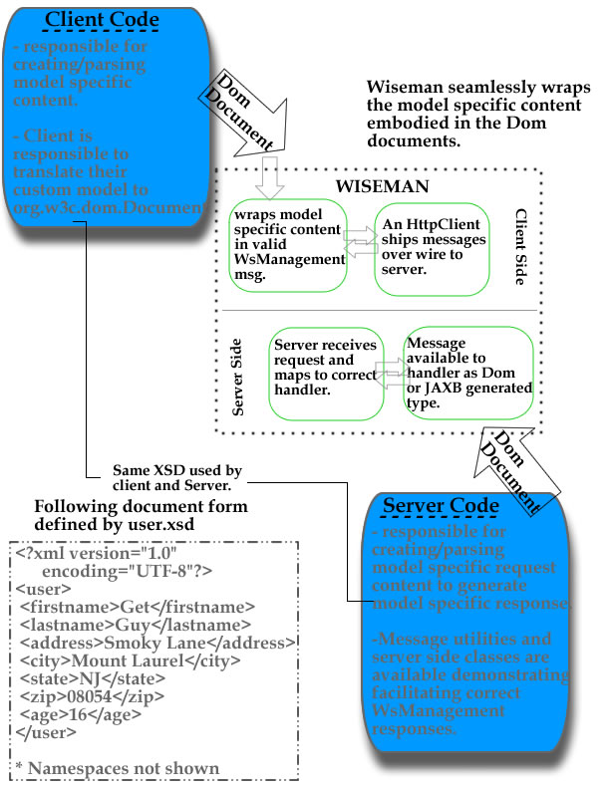

In that regard it is often helpful to consider the process from two sides: i) Client side ii) Server side as delineated above:

Client Side: This basically amounts to some action, usually an api call from some client library, creating a valid WsManagement request. For Wiseman users, we’ve provided the ManagementUtility, TransferUtility, EventingUtility and EnumerationUtility classes to facilitate client message creation. Server response message consumption is facilitated by the ‘Wiseman-Client-Framework.doc’ mechanism. When more indepth content parsing is required, XSD generated artifacts for consuming these model specific response elements is encouraged.

Server Side: The bulk of the model specific processing for each defined service is described and handled here. Wiseman logically delineates each service as a handler instance on the server side that optionally supports a list of Transfer[CRUD], Enumeration, Eventing or other custom operations. Using the ‘Metadata Flavoring’, each handler is then annnotated to correctly describe what is exposed and how to request and consume the subsequent responses. Some images should help here:

Figure 2. Wiseman Client<-> Server Architecture
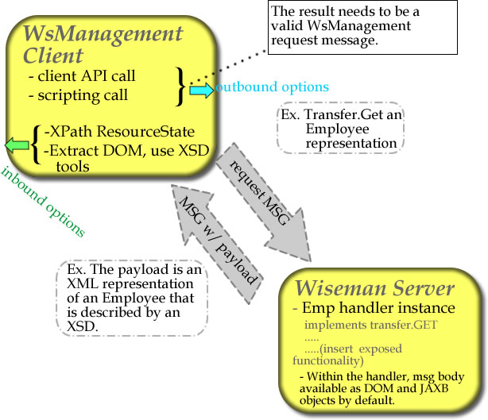

While this higher level abstraction does illuminate the architecture of the client and server portions and how they should exchange messages, it doesn’t really address the issue of describing how an arbitrary WsManagement client should generate model specific wire requests. Basically, at this point you, as the developer, have generated a nice server implementation that serves up the correct User/Employee information content via WsManagement, but you’ve not communicated what the exact form of the returned XML for that client should be look like. Is the employee last name in the first field or the third for that matter? Of more crucial importance is where you get the information for what fields to set on the outbound message so that it can locate the correct server, port, resource handler and subsequently the specific employee that you care about? All good questions.
To solve this problem and to more clearly define your web service interface, let us return to the server implementation for a short moment. Conceptually the developer has already defined the correct WsManagement Default Addressing Model components to access the service that exposes Employee data, and expects that such a request may look like this:

Figure 2: WsManagement GET Employee message from client
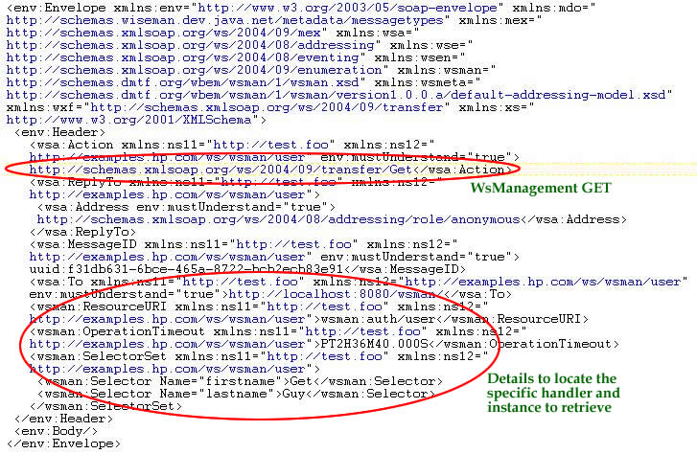

However your client, lacking this a priori knowledge, doesn’t have or want to parse some WSDL to extract those details, especially since their respective toolkits don’t handle the WsManagement DefaultAddressingModel or multiple empty body responses very well. Programmatic access to the above must be discoverable for practical automated access to be possible. At this point, following the ‘Wiseman-MetaData-DeveloperDocs’ document the developer goes back into his handler implementation and annotates that handler with:
-all of the DefaultAddressingModel components(TO,ResourceURI,SelectorSets,etc..) which are likely instance level discriminants.
-all of the schemas(XSD’s) that were used to represent the back end model on the server side.
-all of the operations that the clients should be able to access. Both for the request messages(write/update activities) and for the responses defining the xsd types that represent the payload returned via the WsManagement messages.
-enables metadata and adds the class to the metadata-handlers.properties files.
-redeploys the service

Figure 3: An annotated handler instance with metadata that clients need in the server code.
@WsManagementDefaultAddressingModelAnnotation(
getDefaultAddressDefinition=
@WsManagementAddressDetailsAnnotation(
//define destination to use for this server
wsaTo=contacts_Handler.DESTINATION,
//define the resourceURI to locate this handler
wsmanResourceURI=contacts_Handler.RESOURCE_URI,
//define the selectors to use to isolate desired contact
wsmanSelectorSetContents={
contacts_Handler.selector1,
contacts_Handler.selector2
}
),
//define a unique and simple metadataResourceId
resourceMetaDataUID = contacts_Handler.DESTINATION+"Bill.Gates",
//define the list of schemas and their location available via HTTP.
schemaList={
"usr="+contacts_Handler.DESTINATION+"schemas/user.xsd"
},
//define the operations available off of this service
definedOperations={
@WsManagementOperationDefinitionAnnotation(
//operation name
operationName = "Get",
//specify the input details
operationInputTypeMap = "", //Empty body. No payload required/expected. DefaultAddMod contains details
//specify the output details
operationOutputTypeMap = "usr:UserType=http://schemas.xmlsoap.org/ws/2004/09/transfer/GetResponse"
)
}
)
public class contacts_Handler implements Handler {

/** As per the handler mechanism for Wiseman, this method
* is implemented.
*
*/
public void handle(String action, String resource,

As you’ve annotated your handler with all of the relevant metadata for interoperability and consumption, then a client should be able to define correct message requests and parse those responses correctly. Being the diligent developer, you will want to fire up the MetaDataViewer to verify that the service that you annotated is actually being exposed/annotated correctly.

Figure 4: Using the gui to verify that metadata is correctly exposed.
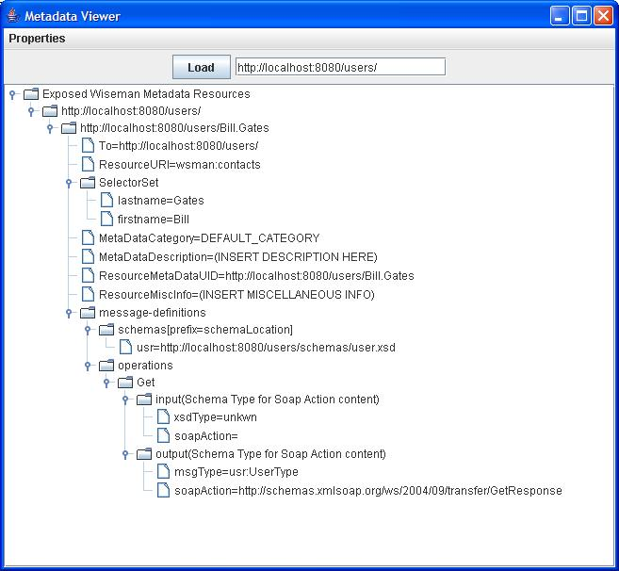
*Note:This specific metadata instance is a bit artificial as you would not really expose a metadata description, complete with selectors, for every instance of a ‘Contact’. A service backed by numerous instances, would best be handled by an Enumeration that describes a recipe for locating contacts ‘via lastname’ for example. This example, available in the samples directory, is done to show the power of metadata-flavored Wiseman services.
The diligent client/consumer now has access to the metadata if they know how to talk MetadataExchange 1.1 and more specifically the specific dialect that we’ve defined. While the information is described in a manner that is compliant with the open standard for metadata, that means that the client now has to learn how to consume it and act accordingly. Actually this is a lot easier than you’d think if you use our AnnotationProcessor.findAnnotatedResourceByUID() mechanism. Remember to point the request at the correct server and to supply any HTTP credentials that you may need to access the metadata exposed. What is returned to you is a Management instance prepopulated with all of the required defaultAddressingModel components and already filled in. You’ll need to run this instance through the ManagementUtility class to populate all the other components like the MessageId field(etc..), but you’ve got the envelope and all of it’s required data for submission. At this point you need to figure out which of the exposed service’s mechanisms that you want to exercise, set the Management.Action accordingly and insert the relevant message body if any.

Figure 4: What the sample code for client access looks like.
String serviceAddress="http://localhost:8080/users/";
String metaDataUID=serviceAddress+"Bill.Gates";
//Locate the metadata necessary to make the call
Management get = AnnotationProcessor.findAnnotatedResourceByUID(
metaDataUID,serviceAddress);
//set Action to request of the service
get.setAction(Transfer.GET_ACTION_URI);
//run this Management instance through ManagementUtility
get = ManagementUtility.buildMessage(get, null);
//Use the default HttpClient or your own here to send the message off
Addressing response =HttpClient.sendRequest(get);

Now that we’ve sent the model specific message in the request and didn’t receive any exceptions then we’ll know that the server has created our model specific component on the other side. Let’s test that. From the MetadataViewer we can see that the service also supports Transfer.GET and we know that the payload of a response from that GET has a representation that is described by the xsd type User. Here’s what the client side get code looks like:

Figure 5: What the sample client get-response code and processing looks like.

Addressing response =HttpClient.sendRequest(get);
//Check for faults
if (response.getBody().hasFault()){
SOAPFault fault = response.getBody().getFault();
throw new SOAPException(fault.getFaultString());
}
//With the content returned, convert it to ResourceStateDocument
// so that we can use XPath to process the results
ResourceStateDocument resState = ManagementUtility.getAsResourceState(response);
//We'll use the [local-name] syntax to avoid specifying namespaces
String billsAge = resState.getValueText("//*[local-name()='age']");

Figure 6: What the GetResponse payload looks like
….. complete message not shown…..
</env:Header>
<env:Body>
<ns9:user xmlns="http://www.w3.org/2003/05/soap-envelope"
xmlns:ns2="http://schemas.xmlsoap.org/ws/2004/08/addressing"
xmlns:ns3="http://schemas.xmlsoap.org/ws/2004/08/eventing"
xmlns:ns4="http://schemas.xmlsoap.org/ws/2004/09/enumeration"
xmlns:ns5="http://schemas.xmlsoap.org/ws/2004/09/transfer"
xmlns:ns6="http://schemas.dmtf.org/wbem/wsman/1/wsman.xsd"
xmlns:ns7="http://schemas.xmlsoap.org/ws/2004/09/mex"
xmlns:ns8="http://schemas.wiseman.dev.java.net/metadata/messagetypes" xmlns:ns9="http://examples.hp.com/ws/wsman/user">
<ns9:firstname>Bill</ns9:firstname>
<ns9:lastname>Gates</ns9:lastname>
<ns9:address>149 Bilney Avenue</ns9:address>
<ns9:city>Stanford</ns9:city>
<ns9:state>IA</ns9:state>
<ns9:zip>39000</ns9:zip>
<ns9:age>34</ns9:age>
</ns9:user>
</env:Body>
</env:Envelope>

At this point we have successfully located the fictional person Bill Gates from the contacts service and extracted the age value of 34 without ever involving the JAVA⬄XML binding JAXB framework complexity. By combining MetaData-Flavored resources and the ResourceStateDocument technology, the client side access becomes extremely simple and palatable for the end clients.

To Summarize:
For this mechanism to work:
-i) as the developer, when you are completely done with handler implementation details, you should take the 30 seconds required to fill out the annotation details to describe how you intended this resource to be accessed.
ii) enable metadata exposure for your service

That’s it. On the client side, other Wiseman implementations have very little to do to successfully access your implementations. That’s pretty cool.

What about traditional Webservice consumers looking for a WSDL?
For traditional websevice consumers as there is no WSDL being exposed, this seems to be a horrible answer. In actuality it is not. It turns out to be fairly simple to create a valid WSDL to expose the Wiseman service details. The problem is that none of the associated/popular frameworks, like AXIS, JAXWS or .NET are prepared or have the tools to consume an Action-Dispatching WSDL with all of the additional DefaultAddressing headers out of the box(This is not a unique problem when exposing complicated model data via traditional webservices). This is not to say that they have no options, as described in “WSDL guidelines.doc”, with a little bit of custom work on each of these toolkits, their respective clients can be taught to generate valid WsManagement messages. However you’ve just realized that to interoperate they will need to do some custom work to make that happen. Not because the WSDL is invalid, but because the WSDL is unfamiliar to traditional webservice toolkits. The WSDL language is too vague in some respects as is evidenced by the real world difficulty of truly interoperating over all but trivial models. At this point it is probably easier to get the java client toolkit elements exposed and navigate the exposed metadata as described above. One of the benefits of using the Wiseman toolkit is that you still have both options available to you.

4. Use Cases: This should be an open ended list of known uses of this metadata
SCENARIO 1: described above.

