Wiseman 1.0 Client Framework Access Tutorial (Draft)

Author: Simeon Pinder(simeon.pinder@hp.com)

Date: May 24, 2007

Targetted Version: WsManagement 1.0 (version A)

1. Abstract: Quick description of topic as is used by this implementation and in this context.

Most of the current webservice implementations neglect the client side access model and expose a WSDL, expecting clients to simply consume it. WSDL is not human readable or easily conumable. The barrier to entry to these ‘traditional’ webservices is quite high. The Wiseman Client access model was designed to hide/shield the user from needing to be and expert in a specific java<->XML binding technology or extremely knowledgeable about WsManagement intricate details. For the smoothest and easiest experience using the client framework, you will need:
- a high level description of WsManagement resource model
- some basic knowledge of XPath
- high level understanding of how SOAP, XML and XSD are used to expose Webservices that are backed by some resource.
- use the suggested access approaches that we’ve defined for accessing Wiseman services. This last one is optional but provides the simplest interface.

2. Resources: List of additional resources one may require/reference when consuming this tutorial or using this feature.

-Web Services Metadata Exchange 1.1(August 2006) [http://specs.xmlsoap.org/ws/2004/09/mex/WS-MetadataExchange.pdf]
-Ws-Management specification 1.0(Version a.) [http://www.dmtf.org/standards/published_documents/DSP0226.pdf]
-Wiseman-MetaData-DeveloperDocs.doc
[see developer documentation directory for Wiseman]
- WSDL guidelines.doc
[see developer documentation directory for Wiseman]
- Metadata-FlavoredResources.doc
[see developer documentation directory for Wiseman]

3. Under the covers: Describe the technological basis and design details

Before we begin it is important that we explain at a high level the Wiseman webservice creation model and the role that the client side access is to play in this model. Skip beyond it if you’re already familiar with this information.

Wiseman Webservice Creation/Exposure:

When developing a Wiseman webservice it is helpful to remember that Wiseman is responsible for building the protocol specific elements on client/server side, and defers the model specific processing to the client and server respectively. In other words, Wiseman is Model-Agnostic in it’s message processing.

Figure 1. Wiseman – Model Agnostic
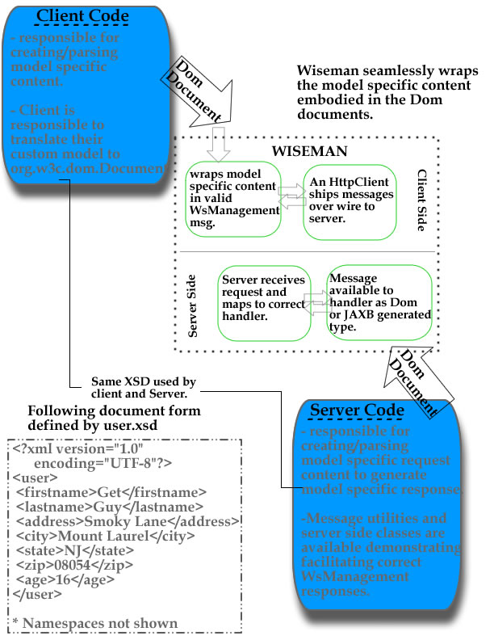

In that regard it is often helpful to consider the process from two sides: i) Client side ii) Server side as delineated above:

Client Side: This basically amounts to some action, usually an api call from some client library, creating a valid WsManagement request. For Wiseman users, we’ve provided the ManagementUtility, TransferUtility, EventingUtility and EnumerationUtility classes to facilitate client message creation. Server response message consumption is facilitated by the practices outlined in this ‘Wiseman-Client-Framework.doc’ mechanism. When more indepth content parsing is required, XSD generated artifacts for consuming these model specific response elements is encouraged. This is where the end user can involve their JAVA⬄XML binding framework of choice to represent the message payload as a familiar Java object for easier access.

Server Side: The bulk of the model specific processing for each defined service is described and handled here. Wiseman logically delineates each service as a handler instance on the server side that optionally supports a list of Transfer[CRUD], Enumeration, Eventing or other custom operations. Using the ‘Metadata Flavoring’, each handler is then annnotated to correctly describe what is exposed and how to request and consume the subsequent responses. Some images should help here:

Figure 2. Wiseman Client<-> Server Architecture
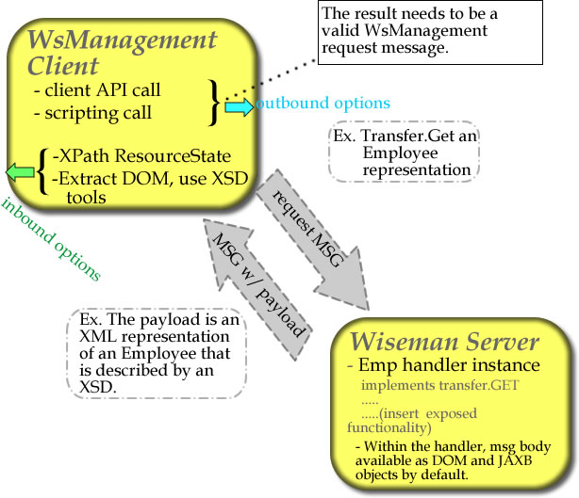

The Client-Side Access Model:
Now that the focus of the client-side is a little more defined, we’ll simplify the client actions a little further into:
i) Outbound: from the client to the server. Ex.Transfer.Get message to the server.
ii) Inbound: from the server responding to the client. Ex. Transfer.GetResponse from the server.

OutBound Messages:
At a high level, the WsManagement specification focuses the type and kind of outbound messages that you will want to send out. If you are interested in singular resources where you will need Create,Read,Update,Delete[CRUD] functionality, then those interactions are defined by WS-Transfer specification and the WsManagement extensions to the same. For large numbers of entities that are being defined then you will need to traverse these Enumerations/Collections then these interactions are defined by WS-Enumeration. Notifications are defined by WS-Eventing. To help with correctly generating the outbound messages from the client side, Wiseman has provided the following utility classes to ease message creation:

-TransferUtility and TransferMessageValues -> Singular access methods
-EnumerationUtility and EnumerationMessageValues -> Collection access
-EventingUtility and EventingMessageValues -> Notification access
-ManagementUtility and ManagementMessageValues -> DefaultAddressing details

The typical pattern for building a Transfer message for example is to
create a TransferMessageValues instance, which is a huge message property container with getter and setter methods for all things you may want to set on your Transfer message.

Figure 1. Example of <AccessType>MessageValues pattern
TransferMessageValues settings = TransferMessageValues.newInstance();
//insert the WsManagement server endpoint details.
settings.setResourceUri("wsman:contacts");
settings.setTo("http://localhost:8080/users/");
//Specify the ActionDispatching action to be used
settings.setTransferMessageActionType(Transfer.GET_ACTION_URI);

//Define the instance level descriminant. AKA which specific one to get.
HashMap<String,String> contactKeys = new HashMap<String, String>();
contactKeys.put("firstname", "Bill");
contactKeys.put("lastname", "Gates");
Set<SelectorType> selectorSet =
ManagementUtility.createSelectorType(contactKeys);
settings.setSelectorSet(selectorSet);

After creating the <AccessType>MessageValues instance with the appropriate specific details, then you run this MessageValues property setup through the <AccessType>Utility.buildMessage() method which will take those elements and generate the correct message.

Figure 2. Example of <AccessType>Utility pattern
Transfer transfer = TransferUtility.buildMessage(null,settings);

At this point you have a message object/container that you can use the default HttpClient provided with and send the messages off to the server. The patterns described also apply for the Enumeration and Eventing message types as well.

WsManagement Message Payloads:
However to understand what type of outbound messages the client would want to send, you inevitably need to know some context about the back end model. To bring this point home, a client may want to retrieve book, item or employee description served up by some WsManagement server. To request any of these items you will need to know how to correctly specify the instance level descriminants for the server and any other special parameters that may be required. A valid request requires some amount of a priori information. Basically, the client has to know some identifying information about the book, perhaps a title, or a first and last name for a person. However with WsManagement endpoints/services, the DefaultAddressingModel described in the specification, does define additional information and mechanisms for uniquely identifying the resource and additional processing/filtering that may accompany this request. A real world example of this is if you have an employee database and to access the employee data you will need to know:

- address of server: how to locate the server on the network
- resourceUri of the handler: how to locate a specific handler responsible for the service
- Instance level descriminants: selectors like firstname, lastname identifying specific instance that we want the resource information for.
- filtering: whether you need to further filter all matches with an additional criteria
- SOAPAction: WsManagement is action-dispatching and defines this type of operation as a Transfer.GET so we know what the SOAP Action needs to be
- payload processing instructions: optional and helpful is the XSD that describes what the Transfer.GetResponse payload is going to look like. Or use the ResourceStateDocument mechanism.

In Wiseman all of this information is all termed useful and in most cases required Metadata information. Your two options are to gain knowledge of all the required Metadata(significan a priori information needed) before you build the request message, or to have the service developer team define all or most of these details for you as metadata available for your consumption via APIs and maybe even a graphical viewer. See the Metadata-Develpers guide for more information. If your developers have exposed the relevant metadata then you may peruse this information in a human readable form via the MetadataViewer:

Figure 3: MetaDataViewer
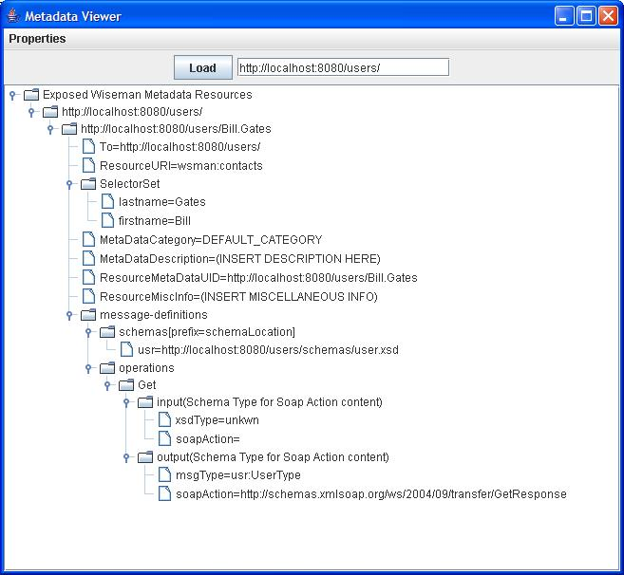

or use the provided APIs to retrieve the metadata programatically and populate all the remaining message fields:

Figure 4: Programmatic access to metadata
String serviceAddress="http://localhost:8080/users/";
String metaDataUID=serviceAddress+"Bill.Gates";
//Locate the metadata necessary to make the call
Management get = AnnotationProcessor.findAnnotatedResourceByUID(
metaDataUID,serviceAddress);
//set Action to request of the service
get.setAction(Transfer.GET_ACTION_URI);
//run this Management instance through ManagementUtility
get = ManagementUtility.buildMessage(get, null);
//Use the default HttpClient or your own here to send the message off
Addressing response =HttpClient.sendRequest(get);

For those methods where you will need to build a message where you will be sending new content for the server side to process, you will usually need to involve your JAVA⬄XML binding technology of choice to provide valid XML message content and add it to the outbound message.

Figure 5: Programmatic access to metadata with content example

String serviceAddress="http://localhost:8080/users/";
String metaDataUID=serviceAddress+"Bill.Gates";
//Locate the metadata necessary to make the call
Management put = AnnotationProcessor.findAnnotatedResourceByUID(
metaDataUID,serviceAddress);
//set Action to request of the service
put.setAction(Transfer.PUT_ACTION_URI);
//run this Management instance through ManagementUtility
put = ManagementUtility.buildMessage(get, null);
//Generate model specific content[JAXB,XMLBeans,etc.]
Document content = Management.newDocument();
UserType user = userFactory.createUserType();
user.setLastname(lName);
user.setFirstname(fName);
//. . . . . more binding specific editing of xml content
// model specific content serialization to org.w3c.dom.Document
JAXBElement<UserType> userElement = userFactory.createUser(user);
try {
binding.marshal(userElement, content);
} catch (JAXBException e1) {
e1.printStacktrace();
}
//add the content to the message object that was just created.
put.getBody().addDocument(content);
//Use the default HttpClient or your own here to send the message off
Addressing response =HttpClient.sendRequest(put);

InBound Message Processing:
Now that we’ve outlined how the outbound messages should be generated, I’ll discuss the three major mechanisms that we expect that you will use to access inbound messages from Wiseman services on the client side. As a visual aid, the following sample Get Response message payload is listed for you:

Figure 6: What the GetResponse payload might look like
….. complete message not shown…..
</env:Header>
<env:Body>
<ns9:user xmlns="http://www.w3.org/2003/05/soap-envelope"
xmlns:ns2="http://schemas.xmlsoap.org/ws/2004/08/addressing"
xmlns:ns3="http://schemas.xmlsoap.org/ws/2004/08/eventing"
xmlns:ns4="http://schemas.xmlsoap.org/ws/2004/09/enumeration"
xmlns:ns5="http://schemas.xmlsoap.org/ws/2004/09/transfer"
xmlns:ns6="http://schemas.dmtf.org/wbem/wsman/1/wsman.xsd"
xmlns:ns7="http://schemas.xmlsoap.org/ws/2004/09/mex"
xmlns:ns8="http://schemas.wiseman.dev.java.net/metadata/messagetypes" xmlns:ns9="http://examples.hp.com/ws/wsman/user">
<ns9:firstname>Bill</ns9:firstname>
<ns9:lastname>Gates</ns9:lastname>
<ns9:address>149 Bilney Avenue</ns9:address>
<ns9:city>Stanford</ns9:city>
<ns9:state>IA</ns9:state>
<ns9:zip>39000</ns9:zip>
<ns9:age>34</ns9:age>
</ns9:user>
</env:Body>
</env:Envelope>

1)ResourceStateDocument/ResourceState model
We’ve already seen how to build the outbound messages and get the inbound response messages back as Addressing instances. Using the ManagementUtility.getAsResourceState(Addressing) api call you can retrieve and message response payload into and XPATH parseable container.

Figure 7: What the sample client get-response code and processing looks like.

Addressing response =HttpClient.sendRequest(get);
//Check for faults
if (response.getBody().hasFault()){
SOAPFault fault = response.getBody().getFault();
throw new SOAPException(fault.getFaultString());
}
//With the content returned, convert it to ResourceStateDocument
// so that we can use XPath to process the results
ResourceStateServer resState = ManagementUtility.getAsResourceState(response);
//We'll use the [local-name] syntax to avoid specifying namespaces
String billsAge = resState.getValueText("//*[local-name()='age']");

2) Custom XML binding framework model
If the ResourceStateDocument/ResourceState mechanism does not provide you enough countrol or easy enough access your model details, you may want to use your custom XML binding of choice to convert the returned payload into the familiar java objects. An example using JAXB is provided below:

Figure 8: Example of Custom binding retrieval
//No faults so attempt to extract the contents returned
Management contactMessage = new Management(response);
//extracted content as org.w3c.dom element
Node content = contactMessage.getBody().getFirstChild();

XmlBinding binding = new XmlBinding(null);
JAXBElement<UserType> unmarshal = (JAXBElement<UserType>) binding
.unmarshal(content);
JAXBElement<UserType> userReturnedElement = unmarshal;
UserType returnedUser = (UserType) userReturnedElement.getValue();
System.out.println("@@@ A Priori: Bill's Age:"+returnedUser.getAge());

3) Command line tool
Yet another option if you simply want to view the contents in the console and perhaps redirect such output to a file, is the command line tool. See the command Line Develeoper documentation for more information.

Usage: wise -a -d -r [ -s | -b | -x | -m | -u | -p ]

Delivery of Client side access tools:
Given the lightweight nature of the client toolkit model, it is suggested that the developer or client side developer, abstract out a few api elements/messages, that they feel the clients will want to use to access the service and deliver these elements as a jar or executable jar to the end consumers. This means that if you know that have a Contacts/People database that is being exposed via some WsManagement service and you have determined that:

-most access to the service will be read only and they will really only want to search via first and last names from a website

then the developer may provide customized access jars to be used from within a servlet or other web container which directly make these api calls. The jars can also be exposed on the end website where the customers are expected to visit to query the service. With the usage of java and JNLP mechanisms, complex GUIs that automatically download and seamlessly acces the back in models are quite possible.

The client side framework is simple and it can be used to hide the binding/model specific processing behind an XPath exterior. By delivering an executable or extractable java bundle, the client side framework can be used on any platform where java run.

