Wiseman 1.0 MetaData Developer Tutorial (Draft)

Author: Simeon Pinder(simeon.pinder@hp.com)

Date: April 20, 2007

Targetted Version: WsManagement 1.0 (version A)

1. Abstract: Quick description of topic as is used by this implementation and in this context.

Metadata can have many different meanings depending on the context in which you will use it. There is a clear need for Wiseman/WsManagement developers to be able to uniformly describe how to access the Transfer, Enumeration and Eventing instances that they have created. More specifically the EPRs, Addressing.To, ResourceURIs, SelectorSets, Options and usage guidelines needed to access these same endpoints/WsManagement enabled instances just developed. The WsManagement specificiation 1.0(version A) does not explicitly describe how to address this need. Management catalog is alluded to but the published version, as of this analysis, is still in the pre-DMTF namespace and unfinished.

Below is a description of how Wiseman has implemented portions of the WS-MetadataExchange specification to fill this small meta data need for the 1.0 release in the May timeframe. This means that this meta decoration of Wiseman server side instances is not WsManagement specification defined, but it is a proprietary implementation done in accordance with the public WS-MetadataExchange specification. Wiseman does not fully implement the specification as of the time of this writing.

2. Resources: List of additional resources one may require/reference when consuming this tutorial or using this feature.

-Web Services Metadata Exchange 1.1(August 2006) [http://specs.xmlsoap.org/ws/2004/09/mex/WS-MetadataExchange.pdf]
-Ws-Management specification 1.0(Version a.) [http://www.dmtf.org/standards/published_documents/DSP0226.pdf]

3. Under the covers: Describe the technological basis and design details

To summarize, Wiseman implements metadata exposure for Wiseman enabled servers/clients by exposing metadata content via Transfer.Get calls to a metadata endpoint/address enabled for Wiseman implementations. This functionality must be enabled and described using the appropriate properties in the metadata.properties file. Annotations must be written to decorate the handler classes implementing com.sun.ws.management.server.Handler. All annotated handler class names need to be added to the metadata-handlers.properties file. When enabled, decorated handler classes will have their metadata exposed on the metadata resource.

Preparing the annotations:

The annotations must be applied to the root handler class implementing com.sun.ws.management.server.Handler. There are two annotations that can/should be defined and populated for WsManagement instances for which you would like metadata exposed com.sun.ws.management.metadata.annotations.*
- WsManagementDefaultAddressingModelAnnotation
- WsManagementEnumerationAnnotation

WsManagementDefaultAddressingModelAnnotation abstracts the general details for a WsManagement instance that supports the DefaultAddressingModel type defined in the WsManagement specification. Also in this DefaultAddressingModelAnnotation is the ability to list schemas, associated scema types and the ability to decorate each Handler operation with the schema types previously defined. This annotation is primarily meant to define all information necessary to connect to and interact with WsManagement instances.
WsManagementEnumerationAnnotation includes a WsManagementDefaultAddressingModelAnnotation annotation while adding a few more fields that should be useful for developers attempting to describe Enumerations. This annotation is meant for developers annotating resources exposing enumerations.

See the Java docs for each type for more definitive information, but here are two example annotation elements.

Example 1 (Simple transfer soruce):
@WsManagementDefaultAddressingModelAnnotation(
getDefaultAddressDefinition=
@WsManagementAddressDetailsAnnotation(
wsaTo=”http://localhost:8080/wsman/”,
wsmanResourceURI=”wsman:employee”
),
resourceMetaDataUID = “uuid:TRANS-84763554ao2q”,
schemaList={
“tl=http://localhost:8080/wsman/schemas/light.xsd”
},
definedOperations={
@WsManagementOperationDefinitionAnnotation(
operationName = “Create”,
operationInputTypeMap = “tl:TrafficLightTypeMessage=http://schemas.xmlsoap.org/ws/2004/09/transfer/Create”,
operationOutputTypeMap = ” wxf:ResourceCreated=http://schemas.xmlsoap.org/ws/2004/09/transfer/CreateResponse”
)
}
)

Example 2 (Enumeration source including DefaultAddMod details):
@WsManagementEnumerationAnnotation(
getDefaultAddressModelDefinition=
@WsManagementDefaultAddressingModelAnnotation(
getDefaultAddressDefinition=
@WsManagementAddressDetailsAnnotation(
wsaTo=”http://localhost:8080/wsman/”,
wsmanResourceURI=”wsman:enumer”
),
resourceMetaDataUID = “uuid:9476309284763554ao2q”
),
resourceEnumerationAccessRecipe = “Use Get with lastname=’srcParam’”
,
resourceFilterUsageDescription = “4 Best results filter on hireDate”
)

Register handlers for monitoring:
Finally take the annotated handler class names and add them to the metadata-handlers.properties file.
Ex.

# This property file is meant to contain a scalable list of
# annotated handler instances that will be parsed to expose
# metadata for the listed instances.
# Ex. annotated.handler.1=com.sun.ws.management.server.handler.wsman.auth.user_Handler
# Ex.2 annotated.handler.2=com.sun.ws.management.server.handler.wsman.auth.create_Handler
annotated.handler.1=com.sun.ws.management.server.handler.wsman.auth.user_Handler

Consuming the Annotations:

i)The MetaData location:
All WsManagement implementations should implement and facilitate client calls for Identify. For this implementation Wiseman returns a few additional Identify elements that describe how to access the metadata resource. These properties are configurable in the wsman.properties file using the following properties(note escaped characters ‘:’, should be handled by default):

metadata.refresh.interval=900000
metadata.refresh.enabled=true
metadata.index.to=http\://localhost\:8080/wsman/
metadata.index.enabled=true
metadata.index.resourceURI=wsman\:metadata
metadata.index.description=The meta-data endpoint/index provides information to access resources on this server. Submit Transfer GET request to meta-data-to and meta-data-resourceuri

SAMPLE Identify response
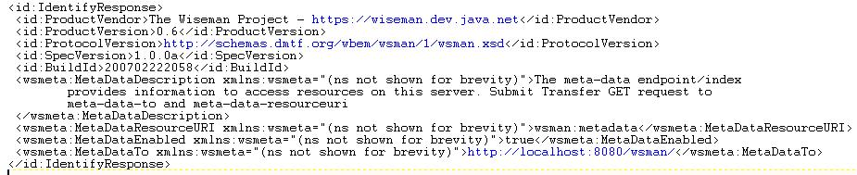

ii) Consuming initial metadata address:
- With wiseman apis, use the following pattern to submit the request:
//Request identify info to get MetaData root information
final Identify identify = new Identify();
identify.setIdentify();
//Send identify request
final Addressing response = HttpClient.sendRequest(identify.getMessage(), DESTINATION);
- You can use the following pattern to extract identify information
SOAPElement el = IdentifyUtility.locateElement(id,
AnnotationProcessor.META_DATA_RESOURCE_URI);
//retrieve the MetaData ResourceURI
String resUri=el.getTextContent();

iii) Build/send the metadata request message:
//Build the GET request to be submitted for the metadata
Management m = TransferUtility.createMessage(metTo, resUri,
Transfer.GET_ACTION_URI, null, null, 30000, null);
//Parse the getResponse for the MetaData
final Addressing getResponse = HttpClient.sendRequest(m);

- Use the ManagementUtility class to convert the MetadataExchange request to familiar Management instances.
//retrieve all the metadata descriptions
Management[] metaDataList =
ManagementUtility.extractEmbeddedMetaDataElements(getResponse);

iv) Consume the messages:
The metadata elements returned are Management instances so one can simply change the relevant remaining fields and begin requests to those servers.

4. Use Cases: This should be an open ended list of known uses of this metadata
SCENARIO 1:
i) Define a resource that exposes basic employee information.
ii) Annotate the resource on the server side to describe how that information should be exposed.
iii) Use the steps defined above, locate the metatdata resource, request the metadata that is being stored.
iv) Use the *Utility classes to extract a Management instance already populated with the correct connection details.
v) Begin interacting with the resource as you normally would except this time you do not require A Priori knowledge of how to connect to the WsManagement instances.

5. Metadata Explorer: A Swing GUI to be used as a development tool and rudimentary metadata explorer.
The com.sun.ws.management.metadata.viewer.MetadataViewer has a main() method and can be run standalone. The tool makes an Http connection to a Wiseman enabled web server and requires the following System properties to be defined as command line parameter or set within the GUI tool before hitting the ‘Load’ button:

-Dwsman.basicauthentication=true
-Dwsman.user=wsman
-Dwsman.password=secret

The following are a few screen shots of the tool in operation. Please use and submit comments and suggestions.

i) unpopulated
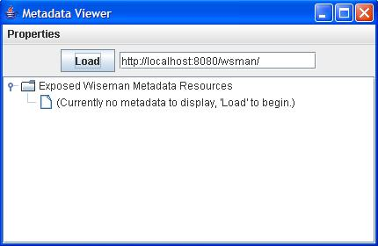
ii) Properties editor view to set necessary parameters if not passed in as –D values to VM.
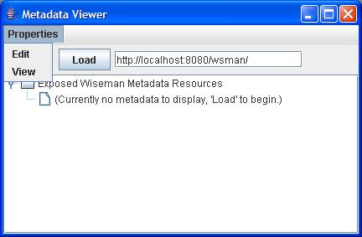
iii) loaded metadata viewer with test annotation data:
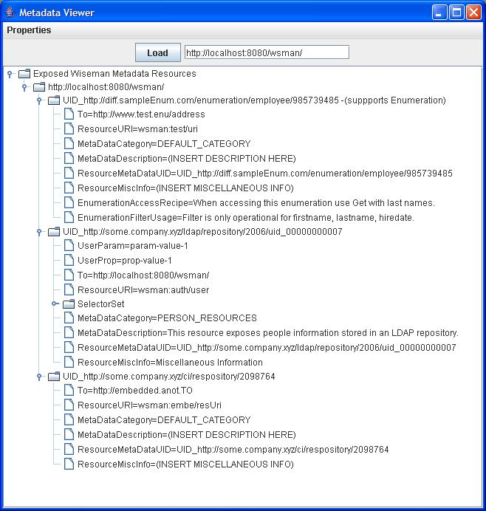

iv) Loaded metadata instance with schema and message details defined
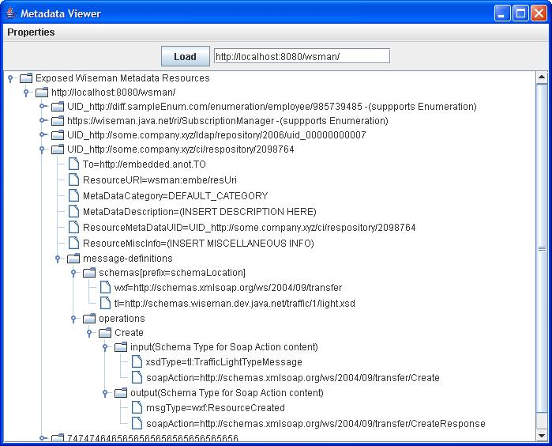

6. Best Practices: Notes, tidbits, information, etc… when using this feature
- Be sure to define unique ResourceMetaDataUID for each annotation that you define. This is useful for programmatically locating metaData information instances.
- Be succint filling out annotation details.
- Fill out all of the annotation details with as much unique information as possible.

7. Advanced: List additional content/tips/features/info for the advanced user.
- For numerous annotations on a single handler, in addition to decorating the class itself, any number of fields inside the same class can be annotated with these two annotations. This mechanism scales.
- To prevent metadata from going stale, developers can customize content to the metadata_handler.refreshMetaData() method to periodically update their underlying Annotation content. This is rarely used at this time.
- This metadata implementation is just a Wiseman handler implementation which means that dynamically adding/removing/updating annotation information is possible with the correct Transfer.* method support on the server side. This is another mechanism for advanced metadata support. The reference implementation provided does expose any of the Transfer.* operations.
- Some annotation logging content is available at FINE log level.

8. Limitations: High level description of limitations/known bugs/etc..
-Not a full implementation of MetadataExchange.
-Only supports Transport.GET requests at this time.
-Requests to the wsman:Identify will require authentication. This is discouraged by the current WsManagement specification version.

9. Todos: Tasks/Action Items still remaining for this task.

-All documentation for this feature should explicitly state that this format/data is not defined by the Ws-Man specification and they should not expect other vendors to have such implementations.
-Add support to enforce unique DefaultAddressingModel UIDs.
-Add support for Mex:GetMetaData. MetadataExchange specific element.
-Support for OptionSets in/for annotation MetaData proecessing.
-Enhance for Eventing?.
-Provide support for Metadata wsdl dialects to allow for exposing WSDLs as part of Wiseman metadata.

