Wiseman 1.0 Enumeration Developer Tutorial (Draft)

Author: Denis Rachal (denis.rachal@hp.com)

Date: March 19, 2007

Targetted Version: WsManagement 1.0 (version A)

1. Abstract: Quick description of topic as is used by this implementation and in this context.

Enumeration is a concept by which bulk read can be implemented in manageable chunks. It works much like a standard C fopen, fread, & fclose API allows an application to read the contents of a file. You first fopen the file and are given a FILE structure to track your context. You then made multiple fread calls using the FILE structure and finally issue an fclose to release the context.
With Enumeration the user issues an Enumerate call and gets back an enumeration context. You can then issue multiple Pull calls with this context to read the resources, and finally issue a Release call to release the context.

WS Enumeration & the extensions defined by WS Management are implemented by Wiseman. The following discusses this implementation and how an application developer can use the Wiseman toolkit to expose resources compliant with this WS API.

2. Resources: List of additional resources one may require/reference when consuming this tutorial or using this feature.

- Web Service Enumeration (WS-Enumeration) September 2004 [http://schemas.xmlsoap.org/ws/2004/09/enumeration/]
-Ws-Management specification 1.0(Version a.) [http://www.dmtf.org/standards/published_documents/DSP0226.pdf]

3. Under the covers: Describe the technological basis and design details

An application developer that wishes to expose a resource type that has more than one instance, should support the Enumeration/Pull/Release operations. Wiseman has provided several support classes to assist the developer in this effort. These classes provide the following functionality to the developer:
- Maintain Enumeration context between WS calls such as Enumerate, Pull and Release.
- Monitoring for expiration of enumeration context and proper cleanup of resources.
- Managing of OperationTimeout for a particular WS call.
- Filtering of the response objects.
- Processing of Enumerate, Pull and Release requests
- Building proper Enumerate, Pull and Release responses
Much of the above work is done by the com.sun.ws.management.server.EnumerationSupport class. This is the main Wiseman support class used by application developers to provide Enumeration support for their resource instances.

The following diagram gives a depiction of the basic architecture on the Wiseman server side. Items in blue are Wiseman code. Items in green are Application developer code. Just about in the center you can see where EnumerationSupport will fit into the picture.

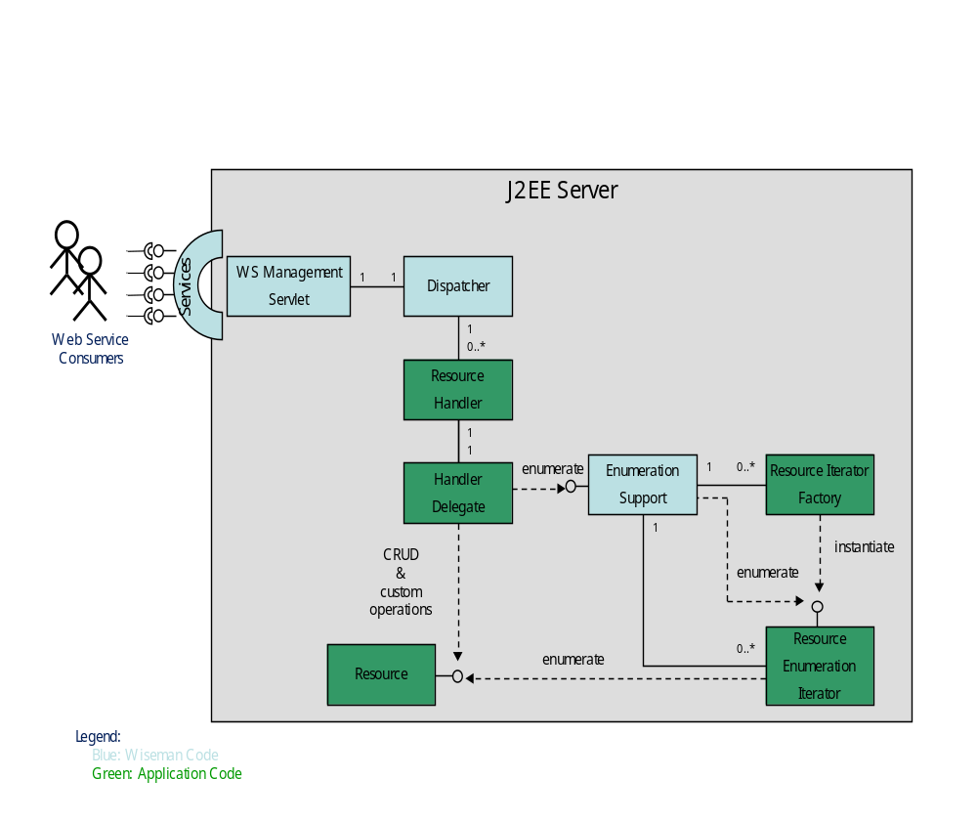

Basically, the application developer’s Handler Delegate will call EnumerationSupport to initiate and process an Enumeration, Pull or Release call. EnumerationSupport will then query the Resource Enumeration Iterator to collect the resource instances and build a response for the client. The following gives this in more detail:

Enumerate

- A Web Service consumer builds an Enumerate call to initiate the enumeration request and sends the request to the WS Management service.
- The Wiseman WS Management servlet receives the request and builds a request and response document to track the request. They are passed on to the Wiseman Dispatcher.
- The Wiseman Dispatcher uses the Resource URI in the request to locate the proper handler and passes the request on to the Resource Handler.
- The application developer’s Resource Handler checks for supported actions and passes the request on to the application developer’s Handler Delegate.
- In the case of an enumerate, the Handler Delegate passes the request on to EnumerationSupport.enumerate() for further processing. NOTE: The Handler Delegate is normally subclassed to the Wiseman EnumerationHandler class, or the ResourceHandler class. These classes, by default, will automatically call EnumerationSupport.enumerate() for an enumeration request, so the application developer only needs to subclass the Handler Delegate to the Wiseman EnumerationHandler or ResourceHandler. The superclass will call EnumerationSupport for the Handler Delegate.
- EnumerationSupport.enumerate() processes the Enumerate request. To do so it will need to instantiate a Resource Iterator to provide the resource instances. The Resource Iterator is written by the application developer. To instantiate the Resource Iterator EnumerationSupport.enumerate() will use the Resource Iterator Factory, also written by the application developer. For each resource URI there is one Resource Iterator Factory registered with EnumerationSupport. Once EnumerationSupport.enumerate() has validated the request and created the Iterator to provide the resource instances, it will create a context ID and context to maintain the context between WS calls. EnumerationSupport.enumerate() then builds a response message with the context ID and returns the response message to the Handler Delegate.
- The Handler Delegate can add any additional information to the message and return it back to the Resource Handler who in turn returns the response to the Wiseman Dispatcher. Eventually the response message is returned to the Web Service Consumer.
- Once the consumer has received the response with the enumeration context, he may begin issuing Pull requests in order to obtain the resource instances.

Pull

- A Web Service consumer builds a Pull call to request the resource instances from the WS Management service. The context obtained from the Enumerate response is specified in the Pull request.
- The Wiseman WS Management servlet receives the request and builds a request and response document to track the request. They are passed on to the Wiseman Dispatcher.
- The Wiseman Dispatcher uses the Resource URI in the request to locate the proper handler and passes the request on to the Resource Handler.
- The application developer’s Resource Handler checks for supported actions and passes the request on to the application developer’s Handler Delegate.
- In the case of a pull, the Handler Delegate passes the request on to EnumerationSupport.pull() for further processing. NOTE: The Handler Delegate is normally subclassed to the Wiseman EnumerationHandler class, or the ResourceHandler class. These classes, by default, will automatically call EnumerationSupport.pull() for a pull request, so the application developer only needs to subclass the Handler Delegate to the Wiseman EnumerationHandler or ResourceHandler. The superclass will call EnumerationSupport for the Handler Delegate.
- EnumerationSupport.pull() checks if the request has a valid enumeration context ID and locates the context. If it is not valid, the proper fault is returned to the Web Service consumer, otherwise the request is processed. EnumerationSupport.pull() will locate the Iterator instance for this context and begin calling hasNext() & next() to obtain the resource instances from the Iterator. As it does so it will apply any filter specified by the WS Consumer and collect the number of instances requested by the WS Consumer. Once the requested number of resource instances are collected from the Iterator EnumerationSupport.pull() will build a response message to return to the Handler Delegate.
- The Handler Delegate can add any additional information to the message and return it back to the Resource Handler who in turn returns the response to the Wiseman Dispatcher. Eventually the response message is returned to the Web Service Consumer.
- Once the consumer has received the response with the resource instances, he may issue more Pull requests until all resources have been obtained from the Service. This is indicated by an end of sequence flag in the final Pull response.
- When the Iterator returns “false” from hasNext() this indicates end of sequence has been reached, EnumerationSupport.pull() will set the end of sequence flag in the response and release the context. After this response the context is no longer valid.

Release

- Should the WS Consumer wish to end the enumeration before Pull returns end of sequence, he may do so by issuing a Release request.
- The Wiseman WS Management servlet receives the request and builds a request and response document to track the request. They are passed on to the Wiseman Dispatcher.
- The Wiseman Dispatcher uses the Resource URI in the request to locate the proper handler and passes the request on to the Resource Handler.
- The application developer’s Resource Handler checks for supported actions and passes the request on to the application developer’s Handler Delegate.
- In the case of a release, the Handler Delegate passes the request on to EnumerationSupport.release() for further processing. NOTE: The Handler Delegate is normally subclassed to the Wiseman EnumerationHandler class, or the ResourceHandler class. These classes, by default, will automatically call EnumerationSupport.release() for a release request, so the application developer only needs to subclass the Handler Delegate to the Wiseman EnumerationHandler or ResourceHandler. The superclass will call EnumerationSupport for the Handler Delegate.
- EnumerationSupport.release() checks if the request has a valid enumeration context ID and locates the context. If it is not valid, the proper fault is returned to the Web Service consumer, otherwise the request is processed. EnumerationSupport.release() will locate the Iterator instance and call release() on the Iterator in order to indicate to the Iterator that it may release any resources it has. EnumerationSupport.release() then release the context and builds the release response message for the WS Consumer. The response message is then returned to the Handler Delegate.
- The Handler Delegate can add any additional information to the message and return it back to the Resource Handler who in turn returns the response to the Wiseman Dispatcher. Eventually the response message is returned to the Web Service Consumer.

The above gives an overall picture of the interaction between the application developer components and the Wiseman components on the server side. Further specific topics follow.

Resource Iterator Factory
There is one Resource Iterator Factory for each resource URI supported. This is written by the application developer and must implement the com.sun.ws.management.ser.IteratorFactory interface.

public interface IteratorFactory {
/**
* EnumerationIterator creation.
*
* @param context the HandlerContext
* @param request the Enumeration request that this iterator is to fufill
* @param db the DocumentBuilder to use for items created by this iterator
* @param includeItem if true the requester wants the item returned, otherwise
* just the EPR if includeEPR is true
* @param includeEPR if true the requestor wants the EPR for each item returned, otherwise
* just the item if includeItem is true. If EPRs are not supported by the iterator,
* the iterator should throw an UnsupportedFeatureFault.
*
* @throws com.sun.ws.management.UnsupportedFeatureFault If EPRs are not supported.
* @throws com.sun.ws.management.soap.FaultException If a WS-MAN protocol related exception occurs.
* @return An enumeration iterator for the request
*/
public EnumerationIterator newIterator(final HandlerContext context,
final Enumeration request,
final DocumentBuilder db,
final boolean includeItem,
final boolean includeEPR)
throws UnsupportedFeatureFault, FaultException;
}

This interface has just one method, newIterator(). If the Wiseman code generation tool Wsdl2Wsman is used by the application developer, an Iterator Factory class and template Iterator class will automatically be generated for the developer, otherwise the developer is free to create their own Iterator Factory class. The newIterator() method must return an instance of EnumerationIterator.

The Resource Iterator Factory is registered with EnumerationSupport by calling EnumerationSupport.registerIteratorFactory(). This is only done once during the lifetime of the Web Service. It can typically be done in the constructor of the Delegating Handler, as this handler is only instantiated once by the Wiseman Dispatcher, and reused for all WS Consumer requests. If the Wiseman code generation tool Wsdl2Wsman is used by the application developer, a Delegating Handler will automatically be generated with the proper call to EnumerationSupport.registerIteratorFactory() already in the constructor.

Example 1 (Traffic light Iterator factory registration):

public LightHandler() {
super();
final String uri =
"urn:resources.wiseman.dev.java.net/traffic/1/light";

// Initialize our member variables
log = Logger.getLogger(LightHandler.class.getName());
try {
// Register the IteratorFactory with EnumerationSupport
EnumerationSupport.registerIteratorFactory(uri,
new LightIteratorFactory(uri));
} catch (Exception e) {
throw new InternalErrorFault(e);
}
}

Resource Enumeration Iterator
For each WS Consumer Enumerate request, a Resource Enumeration Iterator instance is created. The instance is created by EnumerationSupport.enumerate() calling the Resource Iterator Factory newInstance() method for the specified resource URI. This class is written by the application developer and must implement the com.sun.ws.management.ser.EnumerationIterator interface.

/**
* The inteface to be presented by a data source that would like to be
* enumerated by taking advantage of the functionality present in
* {@link EnumerationSupport EnumerationSupport}.
*
* @see EnumerationSupport
*/
public interface EnumerationIterator {

/**
* Estimate the total number of elements available.
*
* @return an estimate of the total number of elements available
* in the enumeration.
* Return a negative number if an estimate is not available.
*/
int estimateTotalItems();

/**
* Indicates if the iterator has already been filtered.
* This indicates that further filtering is not required
* by the framwork.
*
* @return {@code true} if the iterator has already been filtered,
* {@code false} otherwise.
*/
boolean isFiltered();

/**
* Indicates if there are more elements remaining in the iteration.
*
* @return {@code true} if there are more elements in the iteration,
* {@code false} otherwise.
*/
boolean hasNext();

/**
* Supply the next element of the iteration. This is invoked to
* satisfy a {@link org.xmlsoap.schemas.ws._2004._09.enumeration.Pull Pull}
* request. The operation must return within the
* {@link org.xmlsoap.schemas.ws._2004._09.enumeration.Pull#getMaxTime timeout}
* specified in the
* {@link org.xmlsoap.schemas.ws._2004._09.enumeration.Pull Pull} request,
* otherwise {@link #release release} will
* be invoked and the current thread interrupted. When cancelled,
* the implementation can return the result currently
* accumulated (in which case no
* {@link com.sun.ws.management.soap.Fault Fault} is generated) or it can
* return {@code null} in which case a
* {@link com.sun.ws.management.enumeration.TimedOutFault TimedOutFault}
* is returned.
*
* @return an {@link EnumerationElement Elements} that is used to
* construct proper responses for a
* {@link org.xmlsoap.schemas.ws._2004._09.enumeration.PullResponse PullResponse}.
*/
EnumerationItem next();

/**
* Release any resources being used by the iterator. Calls
* to other methods of this iterator instance will exhibit
* undefined behaviour, after this method completes.
*/
void release();

}

There are five methods the application developer must implement. If the Wiseman code generation tool Wsdl2Wsman is used by the application developer, a class will automatically be generated for the application developer. The developer need only add specific code to access the specific resources. Code that needs to be added is clearly marked with “TODO” comments.

EnumerationItem
EnumerationItem is an object used to hold a single resource instance and an endpoint reference to that resource instance. It is the return value from the next() method in the Enumeration Iterator. For each call to next() the application developer will create an EnumerationItem that holds a resource item and its EPR.

WS Consumers can request either the resource alone, the resource and its EPR or the EPR alone. This is specified in the Enumerate call and is passed to the Iterator Factory newIterator() method. In general, it is best to always set both in the EnumerationItem, and allow EnumerationSupport to choose which are returned to the WS Consumer. If EnumerationSupport filters the request it will always need the resource itself in order to apply the filter, even in the case where the WS Consumer only wants the EPR.

The following example is taken from the generated code for the sample traffic light and shows how to build the EnumerationItem in the next() method.

Example 2 (Traffic light next() method):

public final EnumerationItem next() {
if (hasNext() == false) {
throw new NoSuchElementException();
}

// Create the data value object
final TrafficLightType value = new TrafficLightType();

// TODO: Call the setter methods to fill in the value object
// with the values for the next element.

// Create the JAXBElement from the value object
final JAXBElement<TrafficLightType> item =
this.factory.createTrafficlight(value);
EndpointReferenceType epr = null;

if (this.includeEPR) {
// Create a map to hold the selectors
final Map<String, String> selectorMap =
new HashMap<String, String>();

// Assign the key values to the selectorMap
selectorMap.put(“name”, value.getName());

// Create the EPR
epr = EnumerationSupport.createEndpointReference(this.address,
this.resourceURI,
selectorMap);
}
// Create and fill in the return object
final EnumerationItem ee;

// Always return item if filtering is done by EnumerationSupport
if ((this.includeItem) || (this.isFiltered == false)) {
ee = new EnumerationItem(item, epr);
} else {
ee = new EnumerationItem(null, epr);
}

return ee;
}

The resource item passed in the EnumerationItem must be an element that can be marshaled by the XmlBinding class. A JAXBContext will be used to do the marshalling so this can either be a org.w3c.dom.Document, org.w3c.dom.Element, or a JAXBElement recognized by the XmlBinding object. See below for more information on XmlBinding.

XmlBinding
The com.sun.ws.management.xml.XmlBinding class is responsible for marshalling and unmarshalling of objects. The Wiseman Servlet has a member variable that is instantiated upon construction that holds an XmlBinding object that is used to unmarshall the request message from the WS Consumer and marshall the response message. It contains a JAXBContext object to do the marshalling and unmarshalling.

This XmlBinding object may be accessed and set in the request and response message by using the getXmlBinding() and setXmlBinding() methods.
At instantiation the package names for all JAXB object factories must be given to the JAXBContext. By default all package names for WS Management objects are given for the Wiseman servlet XmlBinding object created. Package names for application developer JAXB packages must be separately given. On the server side this is done via the binding.properties files included in the classes directory of the warfile. Below is an example of this file. Code generation will automatically generate a file for you.

Example 3 (binding.properties):
# a comma-separated list of custom package names for initializing JAXBContext
com.sun.ws.management.xml.custom.packagenames = net.java.dev.wiseman.schemas.traffic._1.light

# flag to control enabling and disabling of xml validation
com.sun.ws.management.xml.validate = true

EndpointReference
Endpoint References (EPRs) are part of the WS Addressing definition. Wiseman & WS Management 1.0 use the August 2004 version of the WS Addressing standard. The definition in the standard states:

“A Web service endpoint is a (referenceable) entity, processor, or resource where Web service messages can be targeted. Endpoint references convey the information needed to identify/reference a Web service endpoint, and may be used in several different ways: endpoint references are suitable for conveying the information needed to access a Web service endpoint, but are also used to provide addresses for individual messages sent to and from Web services.”

Endpoint references are used in WS Enumeration to address a single resource as well as a set of resources. An EPR with no selector set will typically address all resources instances at a WS endpoint, e.g. all traffic light instances for the sample traffic light endpoint. An EPR with the selector Name=”name” and value of “Light1” will address the single light resource with the name “Light1”.

Similarly an EPR with the selector Name=”color” and value of “red” would address the subset of lights that are red. NOTE: If the application developer wishes to support this type of subset addressing, he must examine the selector set in the Enumerate request message from the WS Consumer and appropriately filter the response objects. The sample traffic light program does not support this feature.

Filtering
Filtering, by default, is done by EnumerationSupport for XPath filters and any other filter dialect registered with com.sun.ws.management.BaseSupport. Wiseman automatically registers an XPath 1.0 filter. Other filters may be registered by individual applications. For reasons such as performance or custom filter support, the Enumeration Iterator may wish to pre-filter the resource instances and disable filtering by EnumerationSupport. The application developer can disable EnumerationSupport filtering by always returning “true” to calls to the Iterator isFiltered() method. This will disable EnumerationSupport filtering.

XmlFragment Processing
WS Management allows for the XPath filter to select only fragments of a resource. This is also called projection. When this is done, only selected parts of the resource are returned to the WS Consumer. EnumerationSupport filtering supports XmlFragment processing. In case the application wishes to allow EnumerationSupport to do XmlFragment processing, it must return “false” for the Iterator method isFiltered(). It may still pre-filter the resources and allow EnumerationSupport to do the XmlFragment processing on the pre-filtered resources.

Timeout Processing
For WS Enumeration there are basically two types of timeouts that concern the WS Consumer: Expires and OperationTimeout. They are both discussed below.

Expires
This timeout is defined by WS Enumeration. In the Enumerate request the WS Consumer may request an Expires timeout. This feature sets a timeout for the entire enumeration operation from enumerate request to release. If the timeout occurs before the WS consumer has completed the enumeration, the server may invalidate the enumeration context and release any resources.

EnumerationSupport provides support for the Expires timeout. A background thread monitors all enumeration contexts and will release the context if the expiration occurs. When the context is released, EnumerationSupport will call the Iterator release() method to indicate to the Iterator that it may release any resources it is holding.

OperationTimeout
This timeout is defined by WS Management. For each enumeration operation, the WS Consumer may set an OperationTimeout in the request. The request must not take any longer to complete than the specified OperationTimeout.

EnumerationSupport.pull() keeps track of the OperationTimeout as it loops over the next() call. If the time expires before the requested number of MaxElements are collected, EnumerationSupport will return the number of elements collected up to this point.

The next() call should NOT block for any extended length of time. If for any reason the next item is not readily available, the Iterator should return null to indicate that the next item is not available at this time. This is different from the hasNext() method which indicates that there are no more items at all to be expected from this Iterator. EnumerationSupport.pull() will call wait(<OperationTimeout>) on the Iterator and block waiting for the next item, if no items have yet been collected, otherwise it will return any items it has already collected and end the current pull request.

When the next item becomes available, the Iterator should indicate that it is now available by calling notifyAll() on the Iterator. This MUST be done by the application developer in a separate thread, and is usually used in Eventing Pull operations. The notifyAll() will awake any pending EnumerationSupport wait(<OperationTimeout>) call on the Iterator and EnumerationSupport will continue with processing the pull request.

If the OperationTimeout occurs before the next item becomes available, and no items have yet been collected, EnumerationSupport will return a wsman:TimedOut fault to the WS Consumer.

4. Use Cases: This should be an open ended list of known uses of this metadata

5. Best Practices: Notes, tidbits, information, etc… when using this feature
- Always return both the item and the EPR regardless of whether the WS Consumer wants one or both. This will allow EnumerationSupport to do any filtering.
- If XPath filtering is being used and the Iterator filters the requests, the Iterator should still set isFiltered() to false, as EnumerationSupport will then provide XmlFragment support for the filtered items.
- The Iterator next() method should not block for any extended length of time, or it may cause the OperationTimeout to be exceeded. See OperationTimeout above.
- Enumeration Iterator Factories should be registered with EnumerationSupport. Eventing Iterator Factories used in Eventing Pull should be registered with EventingSupport. Both are called by EnumerationSupport.pull().
- Release any Iterator resources when the Iterator release() method is called.
- Set the address in any EPRs created to the actual address of the service, and NOT the anonymous address. This saves work on the client side. The address can be obtained from the EPR in the request or the HandlerContext specified in the newIterator() call.
- EPRs created in Enumeration are used to address individual resource for Read, Put, or Delete operations, therefore they must address the WS endpoint for these operations.
- It is good practice to use one Resource URI for all operations, e.g. Enumeration, Create, Read, Put & Delete, as well as custom operations.

6. Advanced: List additional content/tips/features/info for the advanced user.
If the Application developer requires notification of the beginning and end of a pull sequence, he should implement the EnumerationPullIterator interface.

public interface EnumerationPullIterator extends EnumerationIterator {

public void startPull(final HandlerContext context,
final Enumeration request);

public void endPull(final Enumeration response);
}

This interface provides two additional method that are called to provide additional information to the Iterator.

If an application developer requires notification of creation and deletion of an enumeration context, it should implement the ContextListener interface and pass this object in the EnumerationSupport.enumerate() call. This will notify the listener when the enumeration context is bound and unbound.

7. Limitations: High level description of limitations/known bugs/etc..

- wsman:MaxEnvelopeSize is NOT supported at this time
- wsen:MaxCharacters is NOT supported at this time.
- There is no concept of handler chains like in Apache Axis available at this time
- Renew, GetStatus, and EnumerationEnd operations are NOT supported as recommended by the WS Management standard.
- No out of the box support for XPath 2.0 or Xquery filtering
- There is no support in EnumerationSupport for filtering enumeration requests using the Selector Set, although the Iterator may implement this on its own.
8. Todos: Tasks/Action Items still remaining for this task.
- Add Use Cases
- Add additional examples

