Wiseman 1.0 Eventing Developer Tutorial (Draft)

Author: Simeon Pinder(simeon.pinder@hp.com)

Date: May 20, 2007

Targetted Version: WsManagement 1.0 (version A)

1. Abstract: Quick description of topic as is used by this implementation and in this context.

Implementing Eventing/Notifications as described by the WS-Eventing and it’s WS-Management enhancements, is perhaps the least clearly defined area of WS-Management. It is a fairly simple concept to describe why one would need to be able to register for notifications from a Resource/WebService of interest but quite another to fully implement it. The Wiseman tools and framework do provide you with all the JAXB types for all of the Eventing elments that you need to build out a full implementation consistent with the specification. In practice building out a full implementation that successfully emits events can be simple or incredibly complicated. Much of your model specific decisions begins to leak into the Eventing/Notification implementations that you decide to implement. It is because of this that a full Eventing implementation is considered an advanced implementation topic of Wiseman.
It is expected that the reader has consumed and understood all of the other Transfer*, Enumeration*, DefaultAddressingModel* and MetaData* documentation content provided on Wiseman up to this point. It would also be a good idea to have read over the WS-Eventing and WS-Management specifications before proceeding. It is helpful to recall here that a ‘Resource’ in Wiseman is essentially a handler that optionally supports a list of WsManagment Actions or Custom Actions. Following is a description of a few ways that you may elect to implement an Eventing/Notification specification using Wiseman 1.0. The following list is by no means exhaustive.

2. Resources: List of additional resources one may require/reference when consuming this tutorial or using this feature.

-Web Services Metadata Exchange 1.1(August 2006) [http://specs.xmlsoap.org/ws/2004/09/mex/WS-MetadataExchange.pdf]
-Ws-Management specification 1.0(Version a.) [http://www.dmtf.org/standards/published_documents/DSP0226.pdf]
-Ws-Eventing specification 2004/8 [http://specs.xmlsoap.org/ws/2004/08/eventing/WS-Eventing.pdf]
-Wiseman tooling/framework documentation.

3. Under the covers: Describe the technological basis and design details

Assuming you’ve digested the background material, I’ll summarize the key points that we can abstract from the implementation specifications. An eventing implementation requires at least a pair of listeners/servers representing the Event Source and the Event Sink(a rehash of Eventing element definitions is below), but may require more listeners/servers if the Event Source and Subscription Manager are running in/on different machines/virtual machines/geographical locations. (See Figure 1.1 below for a diagram of this logical delineation of functionality.) While this may not be apparent from the documentation, if you do not separate your Event Source and Subscription Manager implementations then every Event Source must also be a Subscription Manager if you hope to allow a Subscriber the ability to Subscribe and Unsubscribe from your Resource. This is because the specifications mandate that Subscribe functionality lies with the Event Source while Unsubscribe functionality is hosted by the Subscription Manager. If you imagine a WsManagement resource farm ,where many resources generate numerous different types of events, then it’s logical to want a single Subscription Manager to host and manage all of these disparate subscriptions. Otherwise one would need to have apriori knowledge of each of the Event Sources available and remember to subscribe and unsubscribe from each one. While the Event Source notification functionality is model specific, Subscription Management functionality is fairly generic and will be duplicated across each Event Source as well. You will need to choose where your Subscription Manager functionality is best located.

Eventing Elements Defined:
Four distinct entities may be necessary for a typical and basic implementation of eventing using the Wiseman code base. Note that for performance or simply by implementers choice, some or all of these components can be designed to all run within the same JVM. The following outlines the entities below to identify the necessary logical constructs for a basic implementation. Figure 1.1 attached for a visual description of the components.

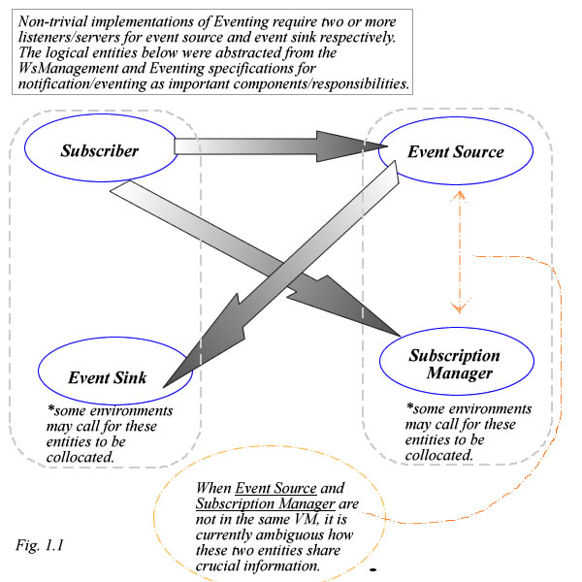

-i) Subscriber: represents the entity or simply an API call to initiate a subscription. Essentially this can be abstracted down to the message initiating a subscription or a filtered subscription. The source of the subscribe message is irrelevant as all necessary information for action on the subscription should be included in the message itself.

-ii) Event Source: the entity responsible for receiving the subscribe requests and for generating events in response for appropriate stimuli. The specification does not define where storage of events should occur, but in some situations it may make the most sense for the Subscription Manager to store the events. Either way, for installations where the Event Source and the Subscription Manager instances are geographically/locationally/virtual machine different, then a new communications problem emerges between the Event Source and its relevant Subscription Manager. All of the information received in a subscribe request needs to be added/forwarded to the assigned Subscription Manager at the time that the subscription is defined. Also, every event notification will have transmission lag as Subscription Manager must be contacted by the Event Source to either emit events or to retrieve the latest valid subscriber list. Even if the Event Source stores/caches events and the subscriber list, the Subscription Manager still will need to communicate with the Event Source running in the remote VM to determine whether Renew/Unsubscribe requests still have relevant subscriptions to apply these operations to.

iii) Subscription Manager: The Renew, GetStatus and Unsubscribe messages are all sent to the subscription manager. Intuitively this makes sense as its job is to manage the subscriptions.

iv) Event Sink: This is simply the EPR/address where the events need to be sent to when they are emitted. All recipients who register to receive events/notifications are considered event sinks.

Eventing Complexity:
As you may have noticed by now, a few of the Eventing goals make the tasks of defining and subscribing to a Resource that emits events a rather complicated enterprise to get desired functionality.

A Few of the Eventing Goals(Following extracted from WS-Eventing specification): “
- • Define means to create and delete event subscriptions.

- • Define how one Web service can subscribe on behalf of another.
- • Define how an event source delegates subscription management to another Web service.
- • Allow subscribers to specify how event messages should be delivered.
- • Support complex eventing topologies that allow the originating event source and the final event sink to be decoupled.
- • Provide extensibility for more sophisticated and/or currently unanticipated subscription scenarios.
“

There are quite a few new problems to solve that the specification doesn’t really give you enough guidance with. The communications problem between the Event Source and the Subscription Manager is perhaps the most complicated. Despite these complexities Wiseman does provide some guidance and tools when implementing Eventing.

Implementing Eventing with Wiseman:
Option 1) Defining only those elements that are necessary for your model implementation.

As is defined by the WsManagement specification, you are encouraged to use the functionality that you require but define it in a WsManagement defined way. If you want to represent and update a singular resource then you should use WS-Transfer as described in WsManagement. Similarly if you would like for that resource to generate events/notifications then you may elect to add the Subscribe operation to your Transfer resource. Using the Wiseman Metadata implementation you can then annotate your resource to expose those additional elements. The simplest approach is to co-locate both the Event Source and the Subscription Manager as you will eliminate some or most of the difficulties that were described above.
Such an implementation is left as an exercise for the developer as the earlier documentation and samples show how to add desired documentation to a Wiseman handler/resource. The desired Delivery mechanisms(Push,Pull,etc…) supported and the message format for your specific notification, are both model-specific design decisions that will color which implementation details you elect to support in your implementations.

Sample implementation(See unit tests implementation for src):
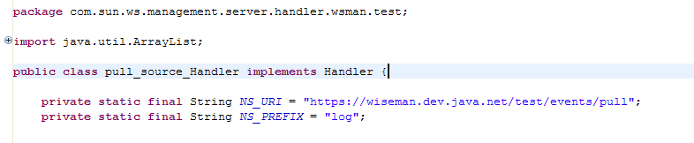
…
….
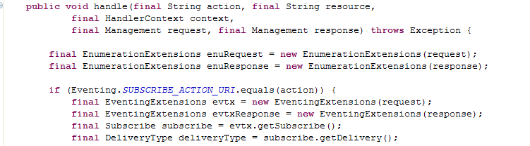
…
….
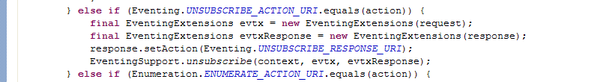
Create the resource handler as you would any other time but add action processing for Subscribe/Unsubscribe. Resources that emit events come in many different forms and adding Notification emission to your custom model is highly implementation speceific.

Option 2) Using Metadata and WsManagement framework classes provided by Wiseman to build out a simple implementation.

In this approach you may elect to use Wiseman apis and interfaces to guide you in building out an implementation where the SubscriptionManager and the Event Source are implemented as two separate Web services. The Wiseman Metadata mechanism and the WsManagement protocol(WS-Transfer and WS-Enumeration) itself is used to implement the ‘ambiguous’ communication protocol between two geographically distinct(Event Source and Subscription Manager) web services. The example shown below should serve as guide to how one Subscription Manager implementation can be used by many different varied Event Sources and can simulataneously serve as an enumeration of available Event Sources. Only simple eventing functionality is presented why may serve to guide you in your own model specific implementations of Eventing using Wiseman.
The sample code for this implementation is quite involved. You are encouraged to look at the implementation source code for the “dice.war” application in the samples/template directory.

The Sample:
The sample uses three separate Wiseman Resources representing the SubscriptionManager, EventSink and EventSource respectively.
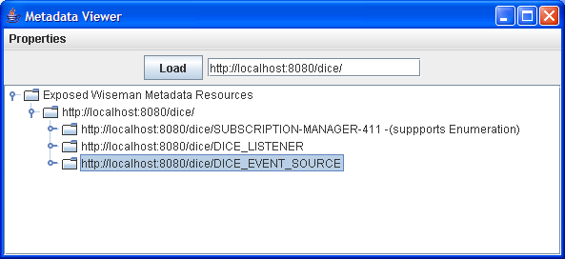

The SubscriptionManager implements the com.sun.ws.management.framework.eventing.SubscriptionManagerInterface
While the EventSource implements the
com.sun.ws.management.framework.eventing.EventSourceInterface interface. Both interfaces attempt to guide you by directing some of the design choices that you will make when implementing your custom eventing model.
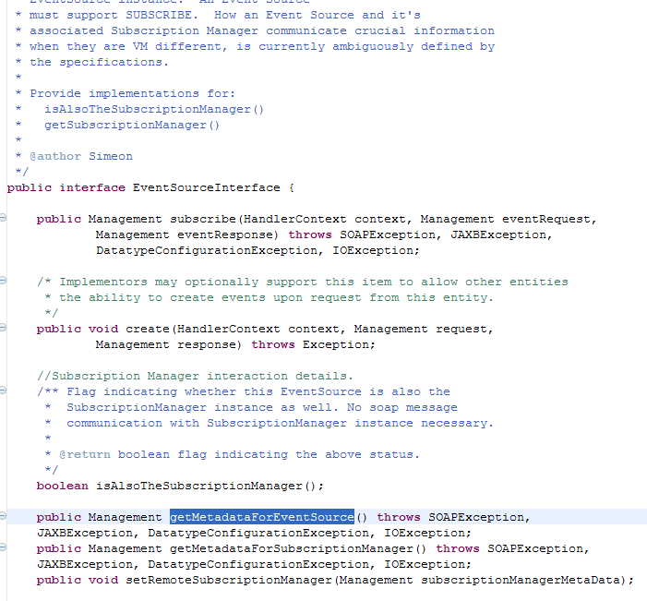

To aid in the description of a how these elements interact we will enlist the help of a metadata aware tool, Metadata Resource Accessor, to set up this ‘Dice’ eventing sample model. For the example provided, the DICE_EVENT_SOURCE has set it’s Metadata Category to “EVENT_SOURCE” and so automatically pops up as an available Event Source when an Enumerate message is sent to the SUBSCRIPTION-MANAGER resource. As the SubscriptionManager stores a record or all ‘subscriptions’ to unsubscribe from, it is helpful if it can expose the list of available Event Sources that a subscriber can register/unregister with/from.

Figure: Shows Enumerate request/response listing available Event Sources
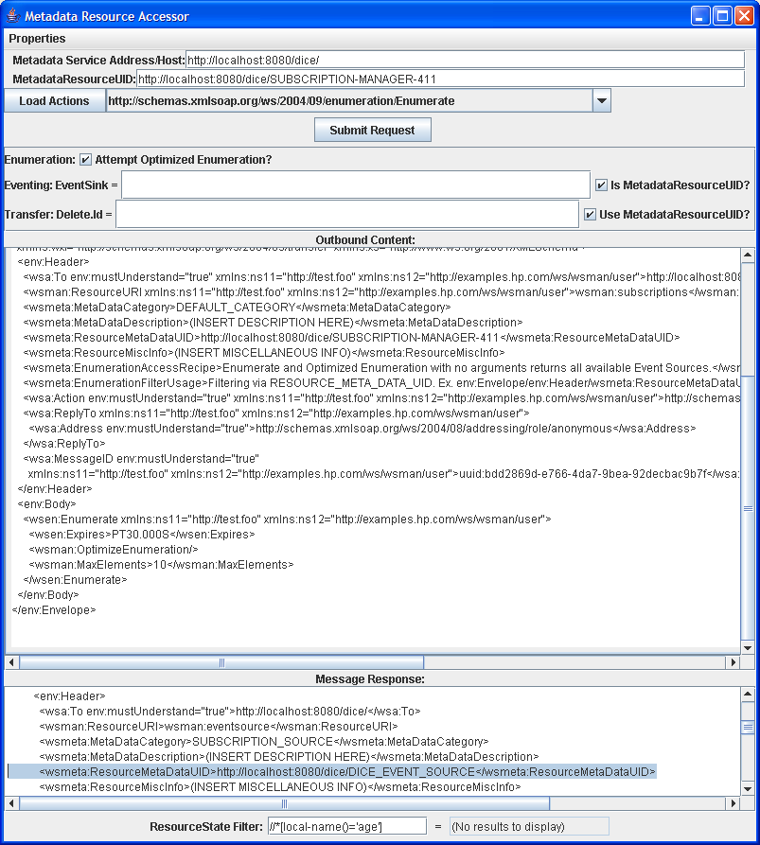

With this located EventSource described by the MetadataResourceUID, we can populate the available actions off of that resource as below, after specifying the i)Metadata Service Host and the
ii)Metadata identifier for the Event Source, in a drop down list.
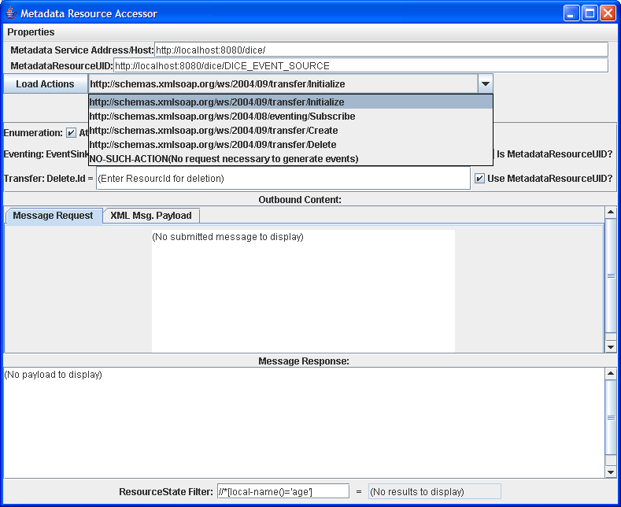

The DICE_EVENT_SOURCE’s setup is complicated enough that we’ve implemented a custom action for Initializing the Event Source before it is able to accept Subscription requests. Primarily because the DICE_EVENT_SOURCE and SUBSCRIPTION_MANAGER-411 both implement the EventSourceInterface and the SubscriptionManagerInterfaces, respectively, we are able to use the MetadataUtility.registerEventSourceWithSubscriptionManager method to hide the communication details of linking the two webservices.

Figure: Event Source initialization where EventSink registered with SubscriptionManager
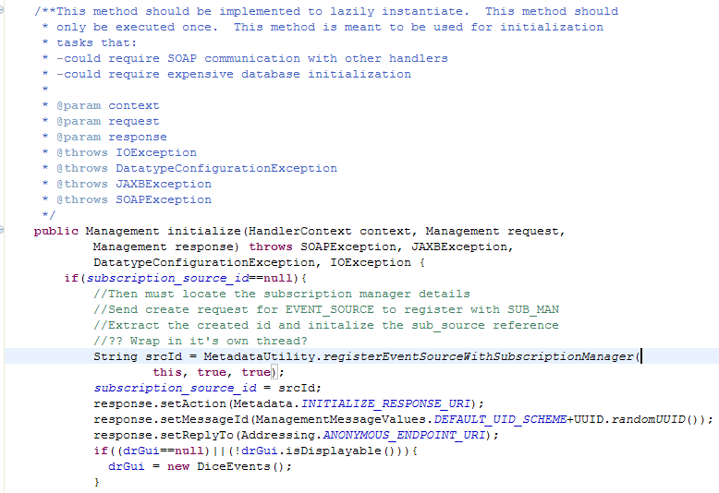

After the initialization step is completed the following graphical event creator instance, which is linked to the back end DICE_EVENT_SOURCE resource is now ready to emit events.
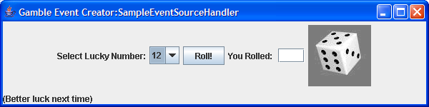

The application is a graphical way for users to roll dice until they roll a combination that matches the ‘Lucky Number’ displayed on the left.
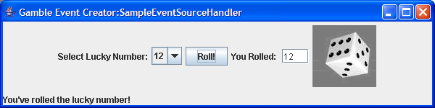
Immediately a WsManagement event is emitted to all subscribers. As no-one has yet subscribed to this Event Source, no actual notifications are generated.
Using the Metadata Resource Accessor we submit a Subscribe request to the Event Source with the DICE_LISTENER as the Event Sink. Upon the first event sent to the registered subscriber another simple graphical user interface showing the successfully received events is displayed.
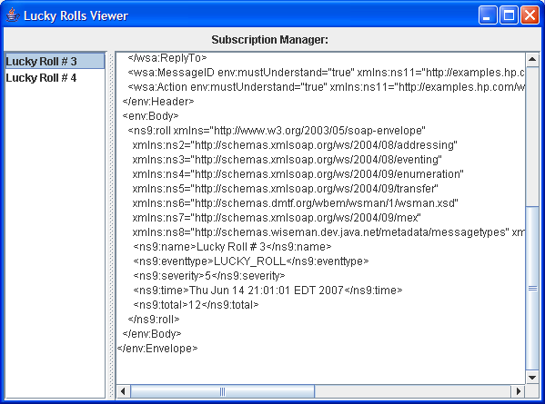

Also exposed off of the SubscriptionManager implementation is the Unsubscribe operation. As shown above the Metadata Resource Accessor is used to then submit and unsubscribe request to the SubscriptionManager and the notifications stop.

Summary:
When adding Eventing functionality to a WsManagement resource using Wiseman there are many implementation options that are available to you because the underlying specifications are not clear enough in defining this complex behavior.

-How do I find out which WsManagement resources are available for me to subscribe to? Using the Wiseman metadata model can provide help here.

-What does the schema representation for the notification event emitted look like? Using the Wiseman metadata model can provide help here.

-If my Event Source and Subscription Manager are separate resources, which entity maintains the list of subscribers? Both? What protocol do these two entities use to communicate that information? The Option 2 sample above attempts to demonstrate how you may use Wiseman to answer this question.

-If I elect to make my Event Source and Subscription Manager the same WsManagement Resource what are the consequences? This depends upon your model. If you only have one resource that emits events then that model should suffice. If you have many WsManagement Notification Resources then this model can become quite cumbersome as there is no central repository(excluding the Wiseman metadata repository) where all EventSources of interests are exposed. Locating the addressing details for each webservice that you wish to be notified from and subscribing/unsubscribing from each one becomes a tedious process. The Wiseman metadata model can help to facilitate such an implementation.

You should take into account all of these concerns and your model specific goals when deciding whether you would like to add Eventing/Notification to your implementation. There is distinct transmission lag overhead involved during marshalling/unmarshalling of the model specific content to XML and transmitting these elements over the wire. In many cases you will find that there are much faster mechanisms of emitting notifications about your model. You are encouraged to apply this model or elements of it as you see fit.

