Wiseman 1.0 Your Resources in Wiseman (Draft)

Author: Simeon Pinder(simeon.pinder@hp.com)

Date: May 31, 2007

Targetted Version: WsManagement 1.0 (version A)

1. Abstract: Quick description of topic as is used by this implementation and in this context.

Wiseman takes a different approach to representing resources than is offered by plain old webservice implementations. More structure and metadata around a webservice implementation is defined for those subscribing to WsManagement. The approach calls for consumers and service developers to look at the notion of a resource more abstractly. Here is a guide to help you figure out where your resource may fit if you’d like to use WsManagement to expose it in a uniform manner.

2. Resources: List of additional resources one may require/reference when consuming this tutorial or using this feature.

-Ws-Management specification 1.0(Version a.) [http://www.dmtf.org/standards/published_documents/DSP0226.pdf]
-Wiseman-MetaData-DeveloperDocs.doc
[see developer documentation directory for Wiseman]

3. Under the covers: Describe the technological basis and design details

Before we begin it is important that we explain at a high level the Wiseman webservice creation model and the role that the client side access is to play in this model. Skip beyond it if you’re already familiar with this information.

Wiseman Webservice Creation/Exposure:

When developing a Wiseman webservice it is helpful to remember that Wiseman is responsible for building the protocol specific elements on client/server side, and defers the model specific processing to the client and server respectively. In other words, Wiseman is Model-Agnostic in it’s message processing.

Figure 1. Wiseman – Model Agnostic
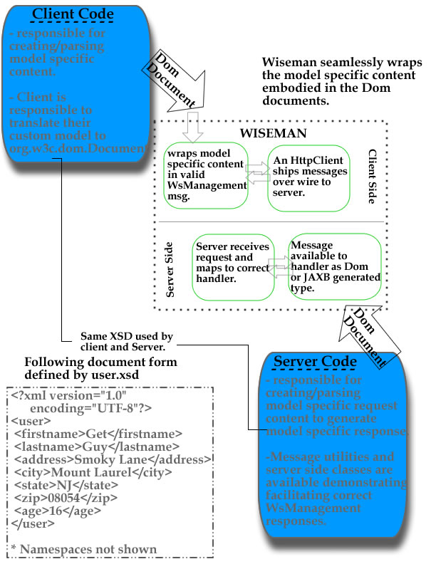

In that regard it is often helpful to consider the process from two sides: i) Client side ii) Server side as delineated above:

Client Side: This basically amounts to some action, usually an api call from some client library, creating a valid WsManagement request. For Wiseman users, we’ve provided the ManagementUtility, TransferUtility, EventingUtility and EnumerationUtility classes to facilitate client message creation. Server response message consumption is facilitated by the practices outlined in this ‘Wiseman-Client-Framework.doc’ mechanism. When more indepth content parsing is required, XSD generated artifacts for consuming these model specific response elements is encouraged. This is where the end user can involve their JAVA⬄XML binding framework of choice to represent the message payload as a familiar Java object for easier access.

Server Side: The bulk of the model specific processing for each defined service is described and handled here. Wiseman logically delineates each service as a handler instance on the server side that optionally supports a list of Transfer[CRUD], Enumeration, Eventing or other custom operations. Using the ‘Metadata Flavoring’, each handler is then annnotated to correctly describe what is exposed and how to request and consume the subsequent responses. Some images should help here:

Figure 2. Wiseman Client<-> Server Architecture
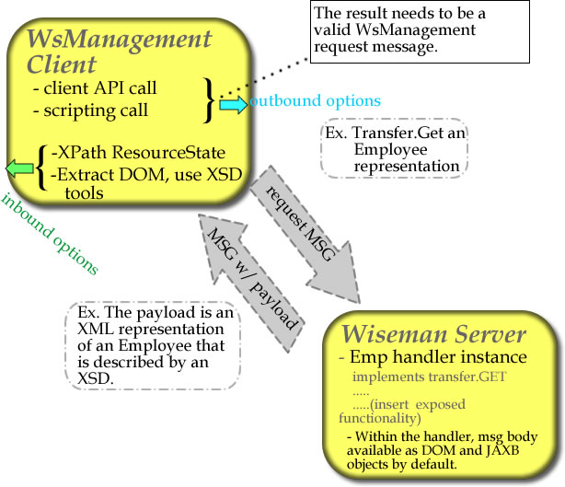

How your resource fits into the Wiseman Framework:
Now that we’ve defined the client and server side from a high level we can now talk about how your custom model can or may fit into the Wiseman frameork. To start out with, lets focus the definition of a resource to be:

Resource: any finite object or concept that you can represent as XML and that same document must be defined via XSD(XML Schema Definition).

With such a vague representation we realize that you can define a representation of a book, car, financial service or potentially a fiendishly complex business model if you were to get really creative. Your options are open, but in the context of WsManagement you should choose to represent and serve up content for items that are actually suited for SOAP communication. This is to say that if your model cannot be easily represented via simple XML documents that will need to be built and parsed on both the client and server side, and all the associated serialization or bindings in a timely manner, that this may not be the solution for you. At the end of the day, the decisions about your model and whether Wiseman can help implement is up to you.

A few guidelines:
1) If your resource has a singular representation and needs to be Created/Read/Updated/Deleted(CRUD) then you should focus on the WS-Transfer specification and the extensions to it that are defined by WsManagement.
2) For situations where you have numerous or a collection of resources then you wish to expose to potential webservice clients then you should follow Ws-Enumeration and the extensions described via WsManagement specification as well.
3) For the situation where a singular resource is responsible for emitting events/notifications in response to some stimuli or condition, then you will want to follow Ws-Eventing and the WsManagement extensions to the same.
4) Resources that cannot be cleanly defined/implemented via some combination of the above are then defined by some custom actions.
5) The DefaultAddressingModel and WsManagement extensions to the above outline a fairly flexible mechanism for describing the addressing and instance descriminant information(ResourceURI, selectorsets, optionsets,etc..) for a wide array of exposed resources. Following the outlined mechanism will help to facilitate interoperability if you use the defined structure and the suggested metadata elements to uniformly describe your resources.

What the Wiseman framework looks like:

Intended Consumers:

WsManagement Message Payloads:

However to understand what type of outbound messages the client would want to send, you inevitably need to know some context about the back end model. To bring this point home, a client may want to retrieve book, item or employee description served up by some WsManagement server. To request any of these items you will need to know how to correctly specify the instance level descriminants for the server and any other special parameters that may be required. A valid request requires some amount of a priori information. Basically, the client has to know some identifying information about the book, perhaps a title, or a first and last name for a person. However with WsManagement endpoints/services, the DefaultAddressingModel described in the specification, does define additional information and mechanisms for uniquely identifying the resource and additional processing/filtering that may accompany this request. A real world example of this is if you have an employee database and to access the employee data you will need to know:

- address of server: how to locate the server on the network
- resourceUri of the handler: how to locate a specific handler responsible for the service
- Instance level descriminants: selectors like firstname, lastname identifying specific instance that we want the resource information for.
- filtering: whether you need to further filter all matches with an additional criteria
- SOAPAction: WsManagement is action-dispatching and defines this type of operation as a Transfer.GET so we know what the SOAP Action needs to be
- payload processing instructions: optional and helpful is the XSD that describes what the Transfer.GetResponse payload is going to look like. Or use the ResourceStateDocument mechanism.

In Wiseman all of this information is all termed useful and in most cases required Metadata information. Your two options are to gain knowledge of all the required Metadata(significan a priori information needed) before you build the request message, or to have the service developer team define all or most of these details for you as metadata available for your consumption via APIs and maybe even a graphical viewer. See the Metadata-Develpers guide for more information. If your developers have exposed the relevant metadata then you may peruse this information in a human readable form via the MetadataViewer:

Figure 3: MetaDataViewer
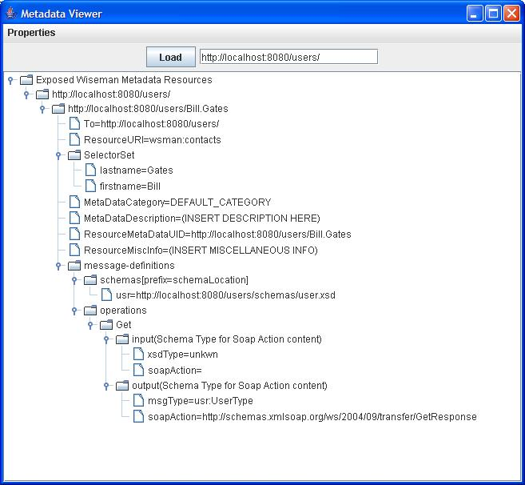

or use the provided APIs to retrieve the metadata programatically and populate all the remaining message fields:

