Homework5

Isabella Natke

3/3/2021

# Homework 5   
library(tidyverse)

## ── Attaching packages ────────────────────────────────────────────────────────────────────────────────────────────────────────── tidyverse 1.3.0 ──

## ✓ ggplot2 3.3.2 ✓ purrr 0.3.4  
## ✓ tibble 3.0.3 ✓ dplyr 1.0.2  
## ✓ tidyr 1.1.2 ✓ stringr 1.4.0  
## ✓ readr 1.3.1 ✓ forcats 0.5.0

## ── Conflicts ───────────────────────────────────────────────────────────────────────────────────────────────────────────── tidyverse_conflicts() ──  
## x dplyr::filter() masks stats::filter()  
## x dplyr::lag() masks stats::lag()

library(Sleuth3)  
library(broom)  
  
# An investor sued his broker for lack of diversification.   
# Below are the rates of return (in percent) for the investor’s portfolio over 39 months (data from Moore, McCabe, and Craig (2017)).   
# The average of the S&P 500 stock index for the same period was 0.95%. Does the broker perform worse than average?   
  
Stockreturns <- c(-8.36, 1.63, -2.27, -2.93, -2.70,   
 -2.93, -9.14, -2.64, 6.82, -2.35,   
 -3.58, 6.13, 7.00, -15.25, -8.66,  
 -1.03, -9.16, -1.25, -1.22, -10.27,  
 -5.11, -0.80, -1.44, 1.28, -0.65,  
 4.34, 12.22, -7.21, -0.09, 7.34,   
 5.04, -7.24, -2.14, -1.01, -1.41,   
 12.03, -2.53, 4.33, 1.35)  
Stockreturns

## [1] -8.36 1.63 -2.27 -2.93 -2.70 -2.93 -9.14 -2.64 6.82 -2.35  
## [11] -3.58 6.13 7.00 -15.25 -8.66 -1.03 -9.16 -1.25 -1.22 -10.27  
## [21] -5.11 -0.80 -1.44 1.28 -0.65 4.34 12.22 -7.21 -0.09 7.34  
## [31] 5.04 -7.24 -2.14 -1.01 -1.41 12.03 -2.53 4.33 1.35

# 1) Use and show R code to find the mean of the sample data.  
mean(Stockreturns)

## [1] -1.124615

# 2) Use and show R code to find the standard deviation of the sample data  
sd(Stockreturns)

## [1] 5.977673

# 3) Assuming a normal distribution, use and show R code to find the proportion of returns that are less than -1.5.  
pnorm(q = -1.5, mean = -1.124615, sd = 5.977673)

## [1] 0.4749637

# 4) Assuming a normal distribution, use and show R code to find return value that is above 70% of the returns  
qnorm(p = 0.70, mean = -1.124615, sd = 5.977673)

## [1] 2.01008

# 5) Use and show R code to find Q1 for the data.  
summary(Stockreturns)

## Min. 1st Qu. Median Mean 3rd Qu. Max.   
## -15.250 -3.255 -1.410 -1.125 1.490 12.220

# Q1 is -3.255  
  
# 6) Explore the data by producing and examining a boxplot and checking for normality.  
boxplot(Stockreturns)

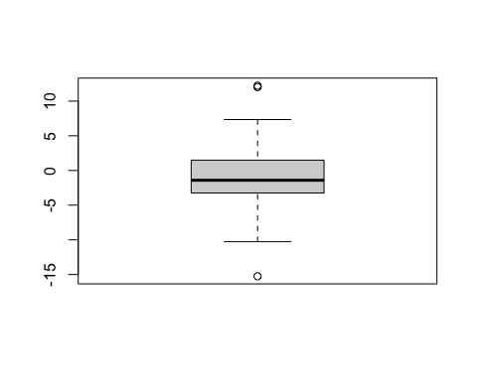

qqnorm(Stockreturns)  
qqline(Stockreturns)

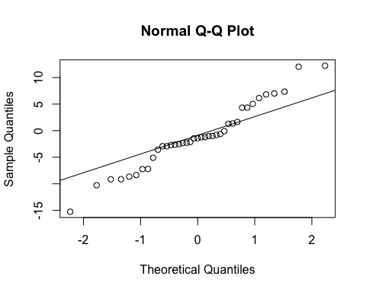

# The Stockreturns data contains outliers and the qqplot shows that the points do not fully follow the line.  
# This is something to consider moving forward.  
  
# 7) State the appropriate null and alternative hypothesis required for the appropriate t test.  
# H(0) : µ = .95  
# H(A) : µ < .95  
  
# 8) Use and show R code that will output the needed p value and confidence interval to determine if the null hypothesis should be rejected.  
t.test(Stockreturns,mu=.95, alternative = "less", conf.level = .95)

##   
## One Sample t-test  
##   
## data: Stockreturns  
## t = -2.1674, df = 38, p-value = 0.01827  
## alternative hypothesis: true mean is less than 0.95  
## 95 percent confidence interval:  
## -Inf 0.4891698  
## sample estimates:  
## mean of x   
## -1.124615

# CI = -infinity to 0.489  
# p-value = 0.01827  
  
# 9) Now answer the question originally stated. Does the broker perform worse than average? (Explain or justify in two or three sentences)  
# With a p-value of 0.01827, there is sufficient evidence to reject the null hypothesis.  
# This means that the broker performs worse than average. Also, the 95% confidence interval does not contain .95.