**American University, CSC 336, Spring, 2021**

**Homework Assignment 1: Coffee shop website (20pts +5pts bonus)**

**Due: Sunday, Feb 21st, end of the day.**

**You must finish this work independently. No line-by-line copy is allowed. Feel free to be inspired from Internet websites but make sure you understand what you are doing since a commercial website usually have much more features that we haven’t learned. Do not copy codes.**

This assignment tests your understanding of HTML 5, CSS box model and page layout, navigation bar, font choice, etc. You will be making a new-realistic coffee shop front page for a fictional DC coffee shop called “sun flower cafe” that sells organic fair trade coffee.

You will be given a folder (**SkeletonFiles)**_that contains a **skeleton** starter.html file and a bunch of useful images/icons. Your goal is to create a page that looks like the attached screen shot. In the starter .html script, most of the contents are there but there is little information about sections and layout. You should add div/span and create id and classes so that your **style.css** file can refer to them.

**You will create a similar page below. Your page must match the appearance.**  We do not expect you to produce a pixel-perfect page that exactly matches this image. But your page should follow the styles specified in this document and match the look, layout, and behavior shown here as closely as possible. I will try to give you as much as color and font information. But feel free to use slightly different color/fonts.

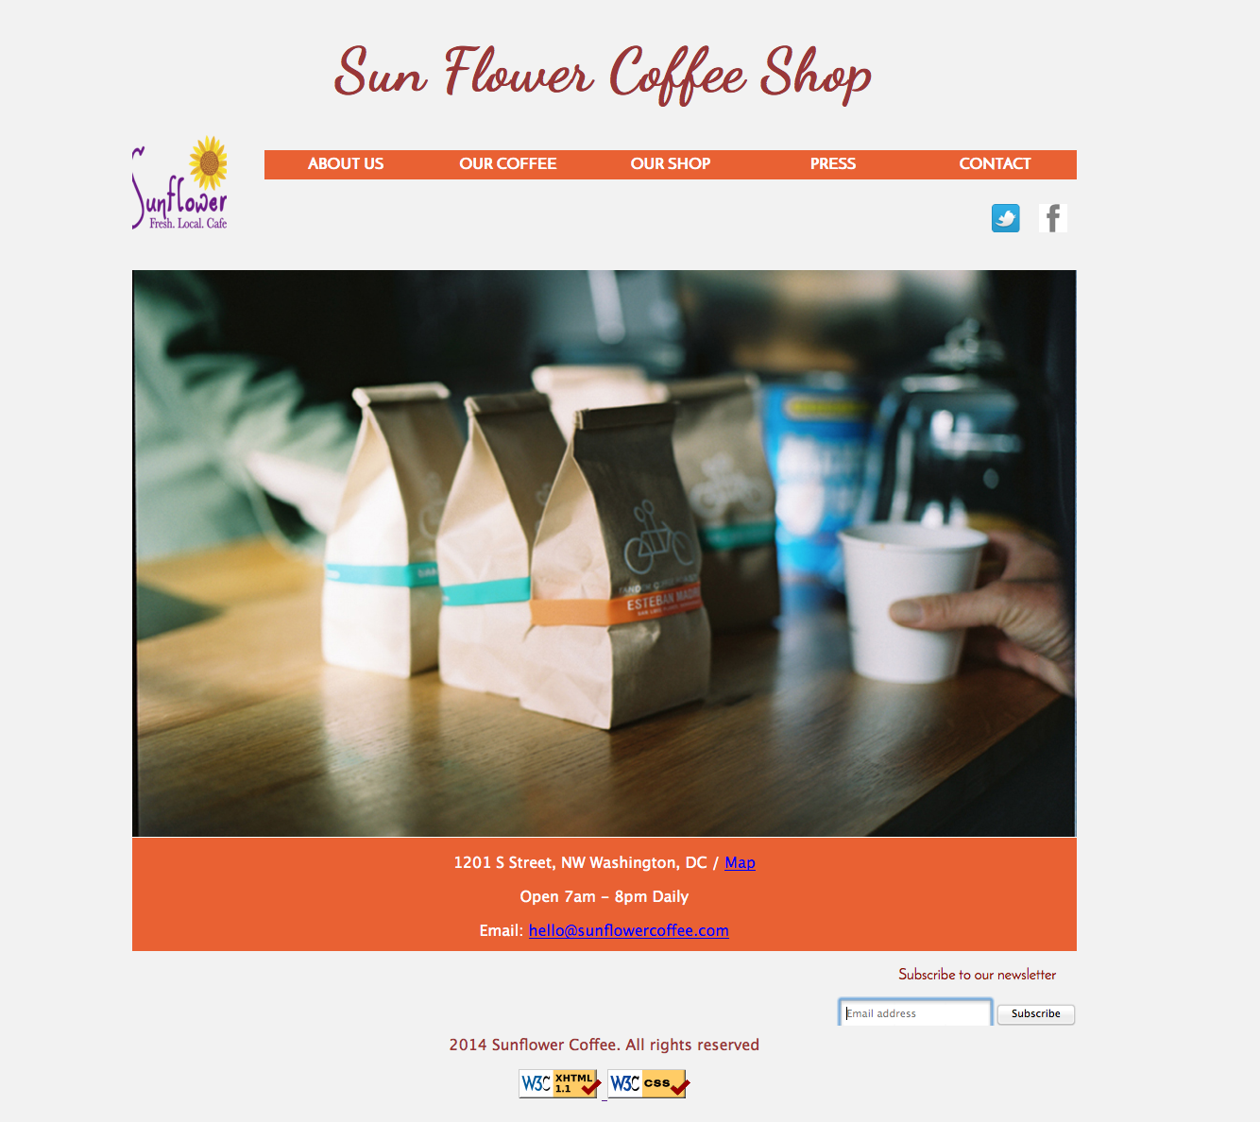

**Appearance detail**

The page is linked to subsequent pages. The nav bar background color changes when you hover over them. I used the following two colors for active and visitied:

#e96133 and #672526.

The font face for the header is “Dancing Script” and font face for navigation bar text, and footer is “Josefin Sans”. You can request them from Google.

The font size of the header is 24pt.

The background color of the page body is #f2f2f2.

The main container has a width roughly 1200px.

The navbar, logo image and social network image has the SAME length as the main container.

The page's bottom has links to the W3C validators. All other style elements on the page are subject to the preference of the web browser. Be very aware of them and test across multiple browsers.

Make sure the social network logos (facebook, twitter) links to a fictional facebook page.

**Deliverables**

You must put all of your .html, .css and image files in a SINGLE folder and zip it and submit to blackboard. Your folder should have the following format:

Firstname_lastname_hw1.zip

You must use ONLY have one .css files.

Your .html file should be called coffee.html and the .css file should be called style. css

You are also expected to submit your files onto your web server. If that happens, make sure all the links work and do not publicize until due date.

**Grading scheme:**

1. 75% grade is earned if you can successfully recreate the appearance of the front page of the coffee shop.
2. The next 25% grade you can earn by doing the following:
3. (5%) Stylize the information section in the front page to have the following appearance. This can be done use three divs or a table and stylize accordingly:



1. (10%) Create **at least one** additional linked page, such as aboutus.html that displays a bit history of the owner and the coffee shop. Feel free to use whatever images you find suitable. But be sure that the page layout and background color to be as consistent as possible to the page layout you have used for your front page. Make sure it is easy to go back to the front page. This means you might want to use the same .css file as well as keeping the same ID and Class in your .html file.
2. (5%) Stylize the subscription forms. This can be done by stylize different elements of the input and submit fields. And add the feature that when user about to enter information in the input field, the box frame becomes bolder in color. Think about what method (post or get) you should use here.
3. (5%) Make a dropdown menu of of “our coffee” such that it shows different types of coffee you can roast (e.g. dark roast, medium roast, draft latte, etc). Then you can show images of these different coffee and their prices and recipes.

You can reference “<https://www.lacolombe.com/>

1. **Extra features for extra credits** (up to 20% of total grade). These are pure suggestions. Feel free to improvise. The goal is to make a nice looking user friendly website.
2. Add additional linked pages to the coffee shop. For example, you can add additional locations of the same coffeeshop called “Cafes.html” that displays images of other locations of the same coffee shops.
3. Add a nice banner image to top of the front page.
4. Add a contact.html and display a map of the location. You can also include more forms in this page.
5. Change the navbar style and font so that looks less bulky.
6. Add another navbar at the end of the webpage. These were usually smaller fonts and less intrusive.
7. Include the social logos into the nav bar as well as the contact information.
8. Make the page responsive such that it looks good in all device (this is perhaps more for students who have web design experiences).

Some nice-looking reference DC coffee shop web pages:

<https://compasscoffee.com/>

<https://www.lacolombe.com/>

<https://www.littleredfoxdc.com/>

A guide to use contrasting fonts:

<http://webdesign.tutsplus.com/articles/a-beginners-guide-to-pairing-fonts--webdesign-5706>

## More instructions:

1. Submit your files (.html, .css) as a zipped folder in blackboard. Your folder name must be firstname_lastname_homework2. Put all of your multimedia files on a sub folder (please do not include large files).
2. We strongly recommend that you use the Chrome Web Inspector or Firefox Page Inspector add-ons on this assignment. Using these to inspect elements will help you find problems with the box model and your styles. We suggest using the “Layout” tab at bottom right to see the box model settings for particular elements.
3. For full credit, your page must use valid HTML5 and successfully pass the W3C HTML5 validator. Do not express style information in the HTML, such as inline styles or presentational HTML tags such as b or font. Use organizational tags such as header, footer, aside, article, section, and nav for dividing your page into sections, though note that you do NOT need to change any existing tags. Prefer using organizational tags over ids and classes when appropriate.
4. Part of your grade comes from expressing your CSS concisely and without unnecessary or redundant styles. For example, the two main columns of reviews share many (if not all) styles in common, **so you should not specify those styles twice in your CSS file**. As another example, if the page uses the same color or font family for multiple elements, group those elements into a single CSS rule, so that it would be possible to change the page’s color/font by modifying a single place in the CSS.