Right click on server (Postgre)->create database->(name the database)

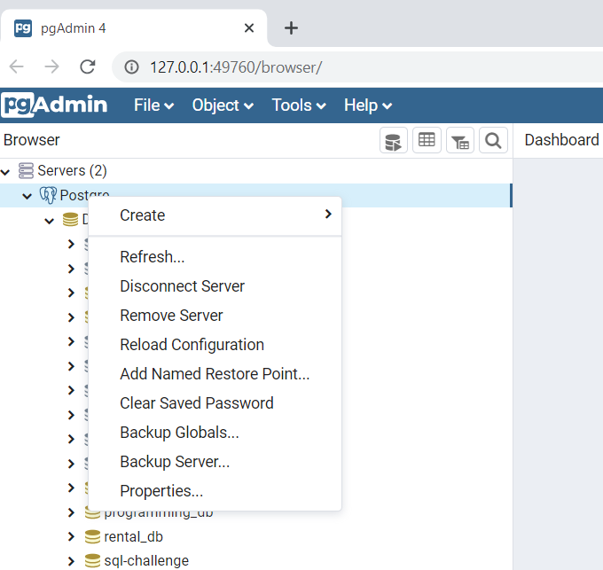

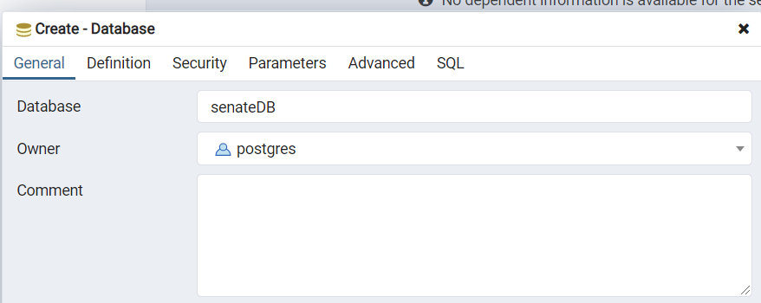

Go to Securtiy

Grantee -> postgres

Privilledge click all ->save

