Isabelle Anno
Shanda Yaeger, CPD123
SQL Final Project Report
12/5/2022
Redmont Realty Co. Database

Scenario/Description:
This database is designed after a company on a Minecraft server called Redmont Realty Co. I play on a rather large multiplayer server with hundreds of other players. This server is like a little economy. Players can buy plots of land to build things like shops, offices, or houses. We decided to start a company where other players can hire us to create a building for them, or help them find a plot to buy. Each building project can either be realty, architecture, interior design, or both interior and exterior (a full build). There could also be more than one employee working on the same project at the same time. One employee could also be working on multiple projects at the same time. (So there is a many-to-many relationship between projects and employees, hence the need for an associative table.) One client can hire an employee for multiple projects at once, as well.
Besides being an architecture and interior design company, Redmont Realty Co also buys plots of land from the government, builds something on it, and sells it for a profit. A client could come to us and ask if we have certain kinds of plots available within a certain budget. The plots in this database are only the plots owned by Redmont Realty Co. A plot may or may not be involved in a project- it's only involved if the project is of type Realty.

CREATE DATABASE:

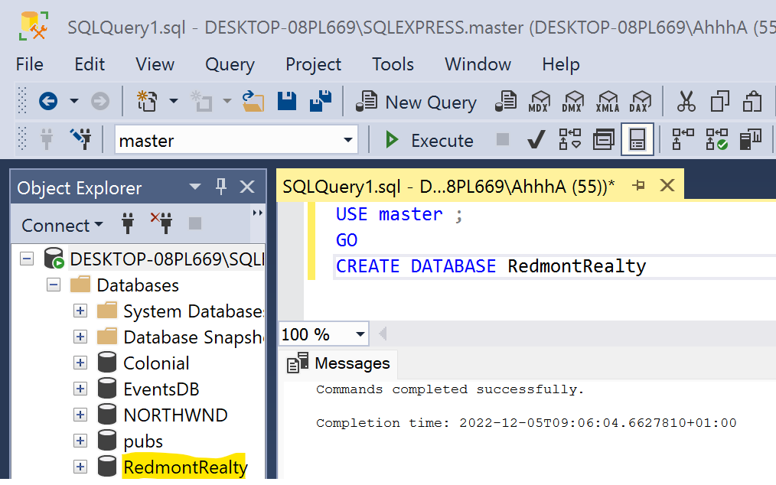
USE master;
GO
CREATE DATABASE RedmontRealty

CREATE TABLES:

First I created the four main tables and their primary keys:

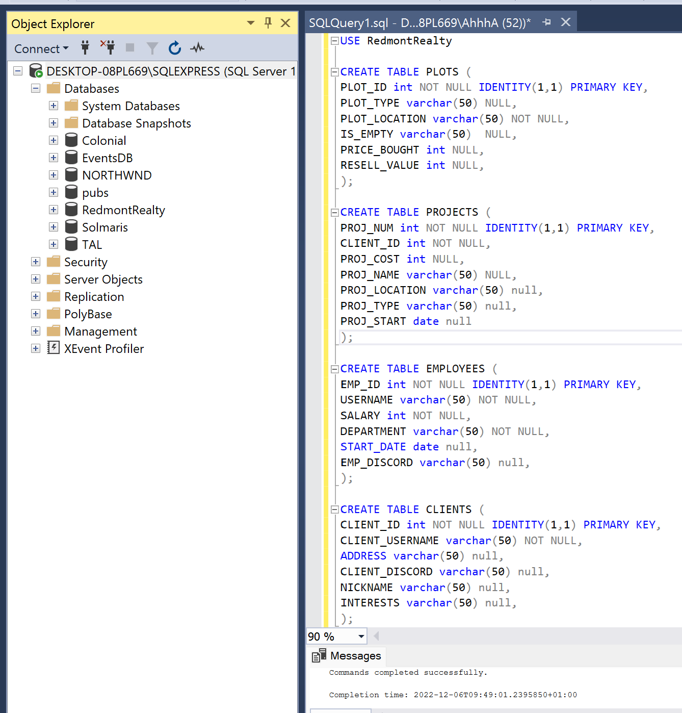

USE RedmontRealty

CREATE TABLE PLOTS (
PLOT_ID int NOT NULL IDENTITY(1,1) PRIMARY KEY,
PLOT_TYPE varchar(50) NULL,
PLOT_LOCATION varchar(50) NOT NULL,
IS_EMPTY varchar(50) NULL,
PRICE_BOUGHT int NULL,
RESELL_VALUE int NULL,
);

CREATE TABLE PROJECTS (
PROJ_NUM int NOT NULL IDENTITY(1,1) PRIMARY KEY,
CLIENT_ID int NOT NULL,
PROJ_COST int NULL,
PROJ_NAME varchar(50) NULL,
PROJ_LOCATION varchar(50) null,
PROJ_TYPE varchar(50) null,
PROJ_START date null
);

CREATE TABLE EMPLOYEES (
EMP_ID int NOT NULL IDENTITY(1,1) PRIMARY KEY,
USERNAME varchar(50) NOT NULL,
SALARY int NOT NULL,
DEPARTMENT varchar(50) NOT NULL,
START_DATE date null,
EMP_DISCORD varchar(50) null,
);

CREATE TABLE CLIENTS (
CLIENT_ID int NOT NULL IDENTITY(1,1) PRIMARY KEY,
CLIENT_USERNAME varchar(50) NOT NULL,
ADDRESS varchar(50) null,
CLIENT_DISCORD varchar(50) null,
NICKNAME varchar(50) null,
INTERESTS varchar(50) null,
);

Next, I created the associative tables and defined their primary keys.

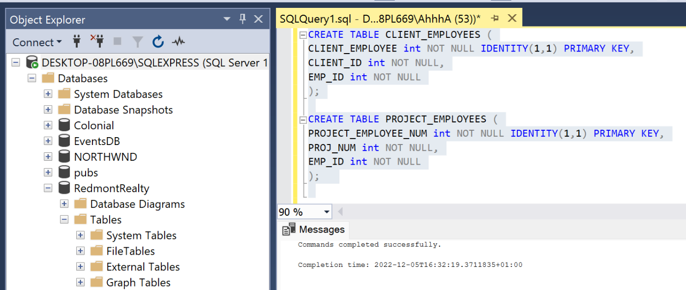

CREATE TABLE CLIENT_EMPLOYEES (
CLIENT_EMPLOYEE int NOT NULL IDENTITY(1,1) PRIMARY KEY,
CLIENT_ID int NOT NULL,
EMP_ID int NOT NULL
);

CREATE TABLE PROJECT_EMPLOYEES (
PROJECT_EMPLOYEE_NUM int NOT NULL IDENTITY(1,1) PRIMARY KEY,
PROJ_NUM int NOT NULL,
EMP_ID int NOT NULL
);

Now I’m adding foreign keys necessary for every table in the database and a check constraint to the PROJ_TYPE column in the projects table that only accepts certain values for what type of project this could be:

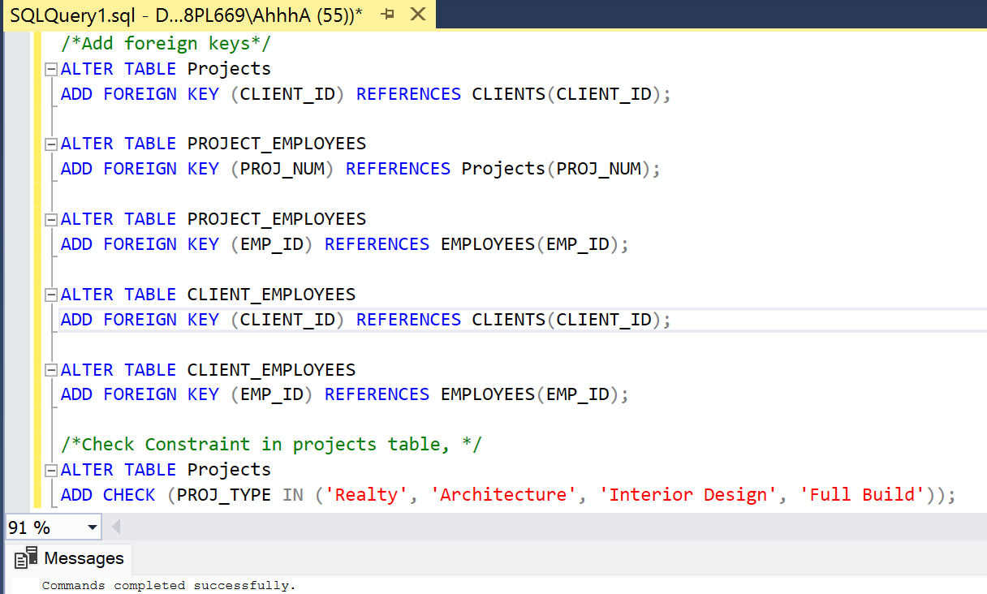

/*Add foreign keys*/
ALTER TABLE Projects
ADD FOREIGN KEY (CLIENT_ID) REFERENCES CLIENTS(CLIENT_ID);

ALTER TABLE PROJECT_EMPLOYEES
ADD FOREIGN KEY (PROJ_NUM) REFERENCES Projects(PROJ_NUM);

ALTER TABLE PROJECT_EMPLOYEES
ADD FOREIGN KEY (EMP_ID) REFERENCES EMPLOYEES(EMP_ID);

ALTER TABLE CLIENT_EMPLOYEES
ADD FOREIGN KEY (CLIENT_ID) REFERENCES CLIENTS(CLIENT_ID);

ALTER TABLE CLIENT_EMPLOYEES
ADD FOREIGN KEY (EMP_ID) REFERENCES EMPLOYEES(EMP_ID);

/*Check Constraint in projects table, */
ALTER TABLE Projects
ADD CHECK (PROJ_TYPE IN ('Realty', 'Architecture', 'Interior Design', 'Full Build'));

Lastly, I populated the 4 main tables with data.

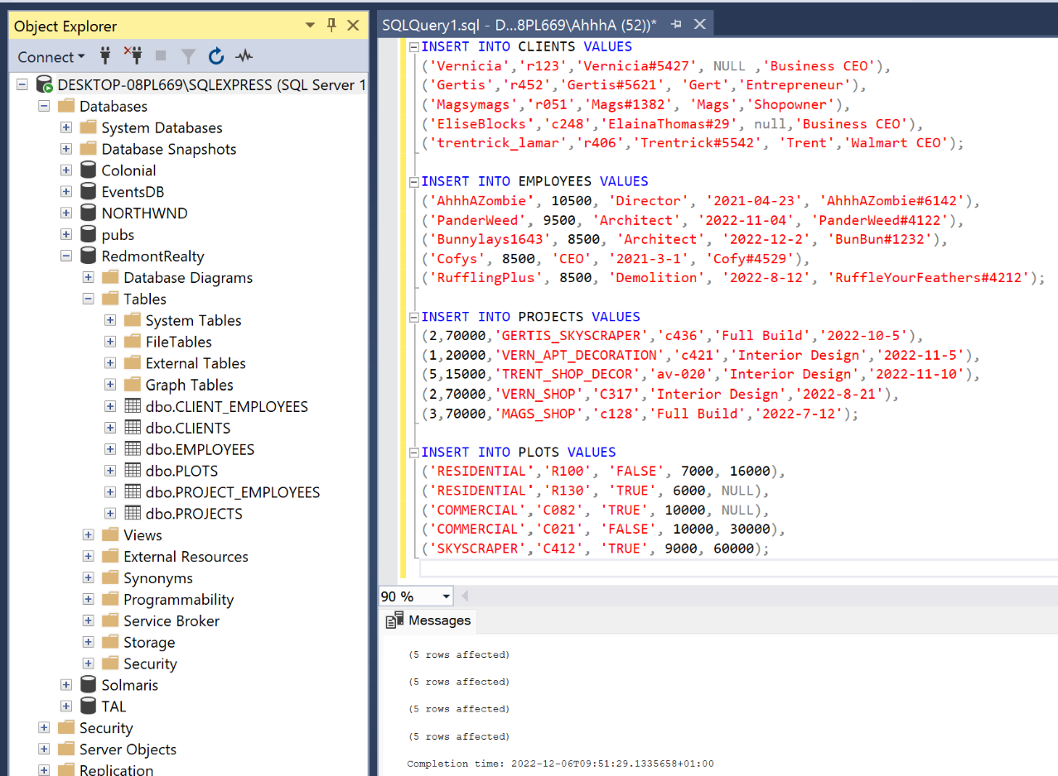
INSERT INTO CLIENTS VALUES
('Vernicia','r123','Vernicia#5427', NULL ,'Business CEO'),
('Gertis','r452','Gertis#5621', 'Gert','Entrepreneur'),
('Magsymags','r051','Mags#1382', 'Mags','Shopowner'),
('EliseBlocks','c248','ElainaThomas#29', null,'Business CEO'),
('trentrick_lamar','r406','Trentrick#5542', 'Trent','Walmart CEO');

INSERT INTO EMPLOYEES VALUES
('AhhhAZombie', 10500, 'Director', '2021-04-23', 'AhhhAZombie#6142'),
('PanderWeed', 9500, 'Architect', '2022-11-04', 'PanderWeed#4122'),
('Bunnylays1643', 8500, 'Architect', '2022-12-2', 'BunBun#1232'),
('Cofys', 8500, 'CEO', '2021-3-1', 'Cofy#4529'),
('RufflingPlus', 8500, 'Demolition', '2022-8-12', 'RuffleYourFeathers#4212');

INSERT INTO PROJECTS VALUES
(2,70000,'GERTIS_SKYSCRAPER','c436','Full Build','2022-10-5'),
(1,20000,'VERN_APT_DECORATION','c421','Interior Design','2022-11-5'),
(5,15000,'TRENT_SHOP_DECOR','av-020','Interior Design','2022-11-10'),
(2,70000,'VERN_SHOP','C317','Interior Design','2022-8-21'),
(3,70000,'MAGS_SHOP','c128','Full Build','2022-7-12');

INSERT INTO PLOTS VALUES
('RESIDENTIAL','R100', 'FALSE', 7000, 16000),
('RESIDENTIAL','R130', 'TRUE', 6000, NULL),
('COMMERCIAL','C082', 'TRUE', 10000, NULL),
('COMMERCIAL','C021', 'FALSE', 10000, 30000),
('SKYSCRAPER','C412', 'TRUE', 9000, 60000);

6 QUERIES:

1 simple:
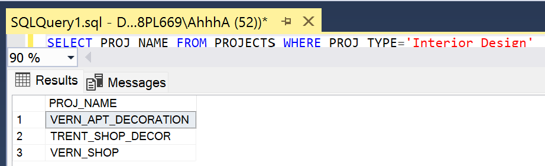
SELECT PROJ_NAME FROM PROJECTS WHERE PROJ_TYPE='Interior Design'

2 with aggregate functions/HAVING clause:
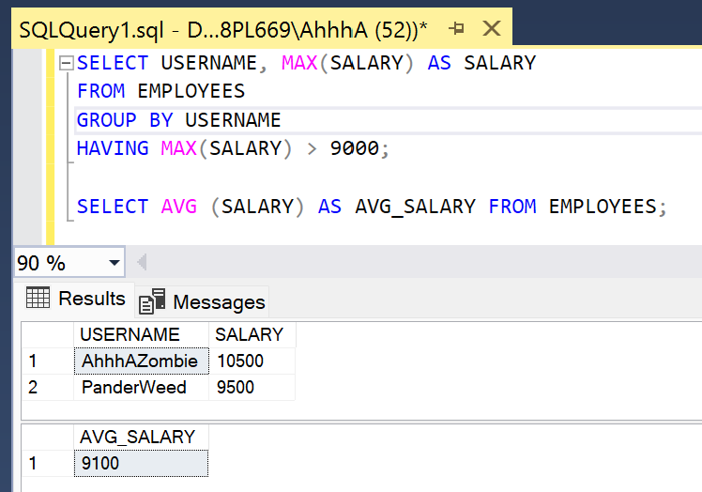
SELECT AVG (SALARY) FROM EMPLOYEES;
SELECT USERNAME, MAX(SALARY) AS SALARY
FROM EMPLOYEES
GROUP BY USERNAME
HAVING MAX(SALARY) > 9000;

3 with JOINS (USING WHERE CLAUSE)
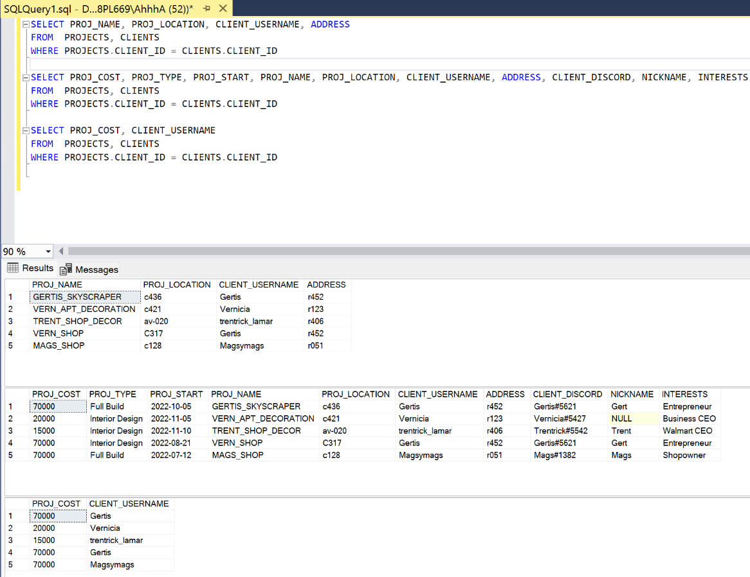

SELECT PROJ_NAME, PROJ_LOCATION, CLIENT_USERNAME, ADDRESS
FROM PROJECTS, CLIENTS
WHERE PROJECTS.CLIENT_ID = CLIENTS.CLIENT_ID
SELECT PROJ_COST, PROJ_TYPE, PROJ_START, PROJ_NAME, PROJ_LOCATION, CLIENT_USERNAME, ADDRESS, CLIENT_DISCORD, NICKNAME, INTERESTS
FROM PROJECTS, CLIENTS
WHERE PROJECTS.CLIENT_ID = CLIENTS.CLIENT_ID

SELECT PROJ_COST, CLIENT_USERNAME
FROM PROJECTS, CLIENTS
WHERE PROJECTS.CLIENT_ID = CLIENTS.CLIENT_ID

Those same 3 joins using INNER JOIN
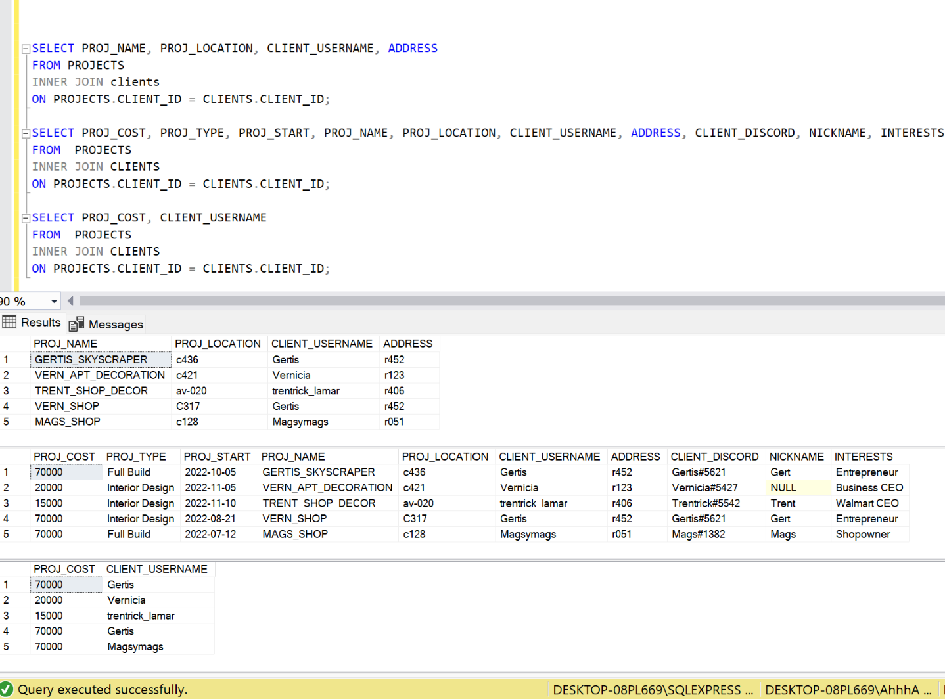

SELECT PROJ_NAME, PROJ_LOCATION, CLIENT_USERNAME, ADDRESS
FROM PROJECTS
INNER JOIN clients
ON PROJECTS.CLIENT_ID = CLIENTS.CLIENT_ID;

SELECT PROJ_COST, PROJ_TYPE, PROJ_START, PROJ_NAME, PROJ_LOCATION, CLIENT_USERNAME, ADDRESS, CLIENT_DISCORD, NICKNAME, INTERESTS
FROM PROJECTS
INNER JOIN CLIENTS
ON PROJECTS.CLIENT_ID = CLIENTS.CLIENT_ID;

SELECT PROJ_COST, CLIENT_USERNAME
FROM PROJECTS
INNER JOIN CLIENTS
ON PROJECTS.CLIENT_ID = CLIENTS.CLIENT_ID;

SUMMARY:

This project went pretty well, but I did encounter some problems when trying to insert data into the tables, although I was able to fix all the errors. One error was because I didn’t write the syntax of dates properly. I had another error because I made a typo on “interior design” which is the column with the “check” constraint. The last error took me a while to figure out, but I wasn’t specifying a length for my varchar’s so it said, “string or binary data would be truncated.” After googling the error code and trying different things out, I landed on this solution. Overall, I think the project went well, it was a great review of everything we learned this semester, I had a lot of fun and I feel much more confident in my SQL skills.

Updated ERD:

