Isabelle Anno
11/21/2022
Chapter 8 Exercises Part 2
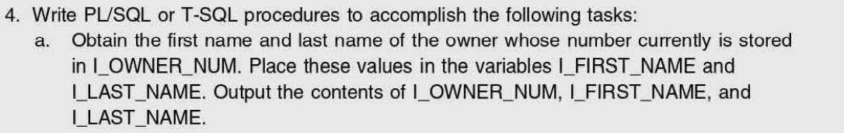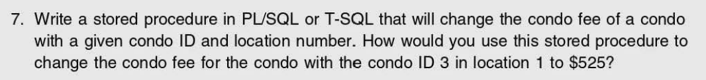
4a.)
CREATE PROC sp_OwnerInfo
@I_FIRST_NAME char(25),
@I_LAST_NAME char(25),
@I_OWNER_NUM char(5)
AS
SELECT @I_LAST_NAME, @I_FIRST_NAME, @I_OWNER_NUM FROM OWNER WHERE @I_OWNER_NUM IS NOT NULL
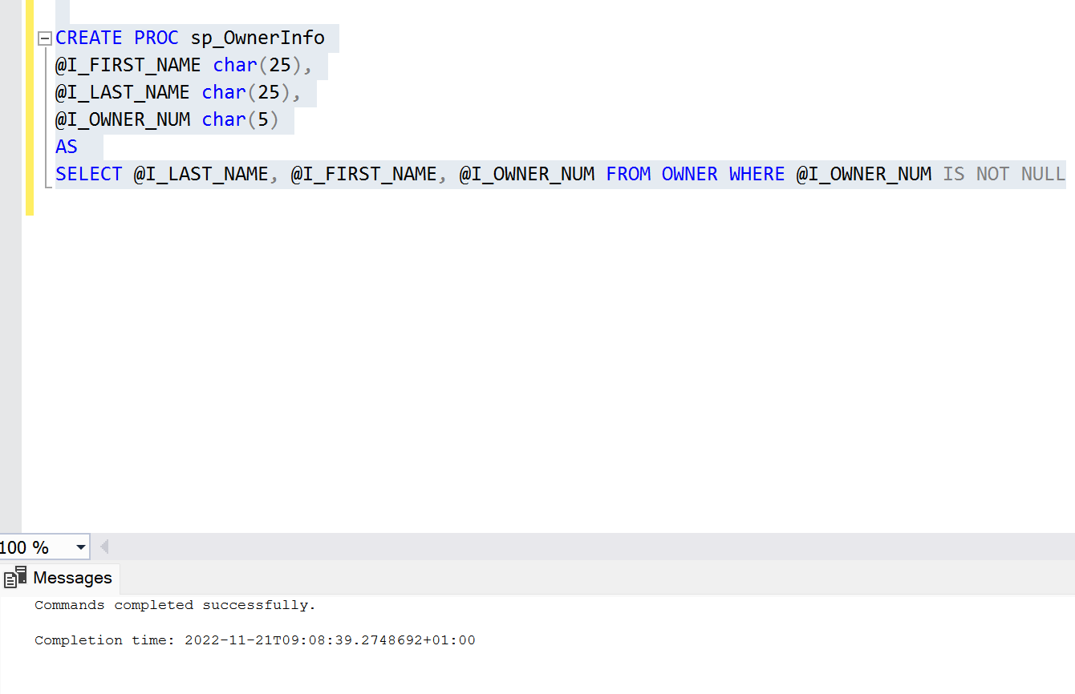

7.)
CREATE PROC sp_ChangeFee
@CONDO_FEE decimal(6,2),
@LOCATION_NUM decimal(2,0),
@CONDO_ID decimal(4,0)
AS
UPDATE CONDO_UNIT
SET CONDO_FEE = @CONDO_FEE
WHERE CONDO_ID = @CONDO_ID AND LOCATION_NUM = @LOCATION_NUM

Exec sp_ChangeFee
@CONDO_FEE = '525',
@CONDO_ID = '3',
@LOCATION_NUM = '1';
