Isabelle Anno
10/27/2022
Chapter 7 Exercises Part 1-CAT #2a-d
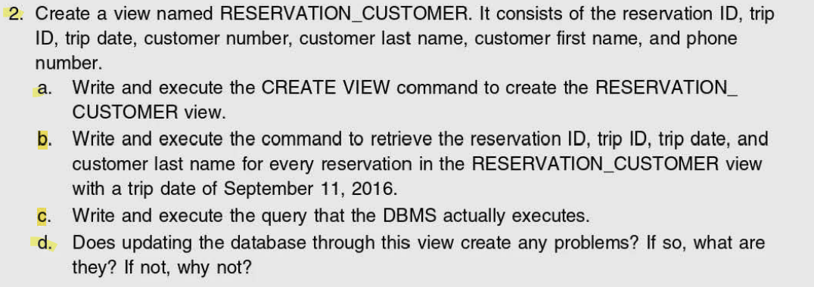
2a.)
CREATE VIEW RESERVATION_CUSTOMER AS
SELECT RESERVATION_ID,TRIP_ID,TRIP_DATE,CUSTOMER.CUSTOMER_NUM,LAST_NAME, FIRST_NAME,PHONE
FROM RESERVATION, CUSTOMER
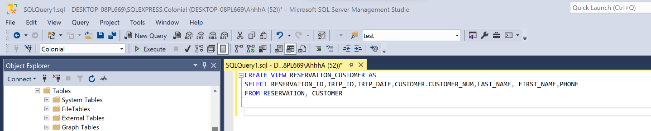

2b.)
SELECT RESERVATION_ID,TRIP_ID,TRIP_DATE,LAST_NAME
FROM RESERVATION_CUSTOMER WHERE TRIP_DATE = '2016-09-11'

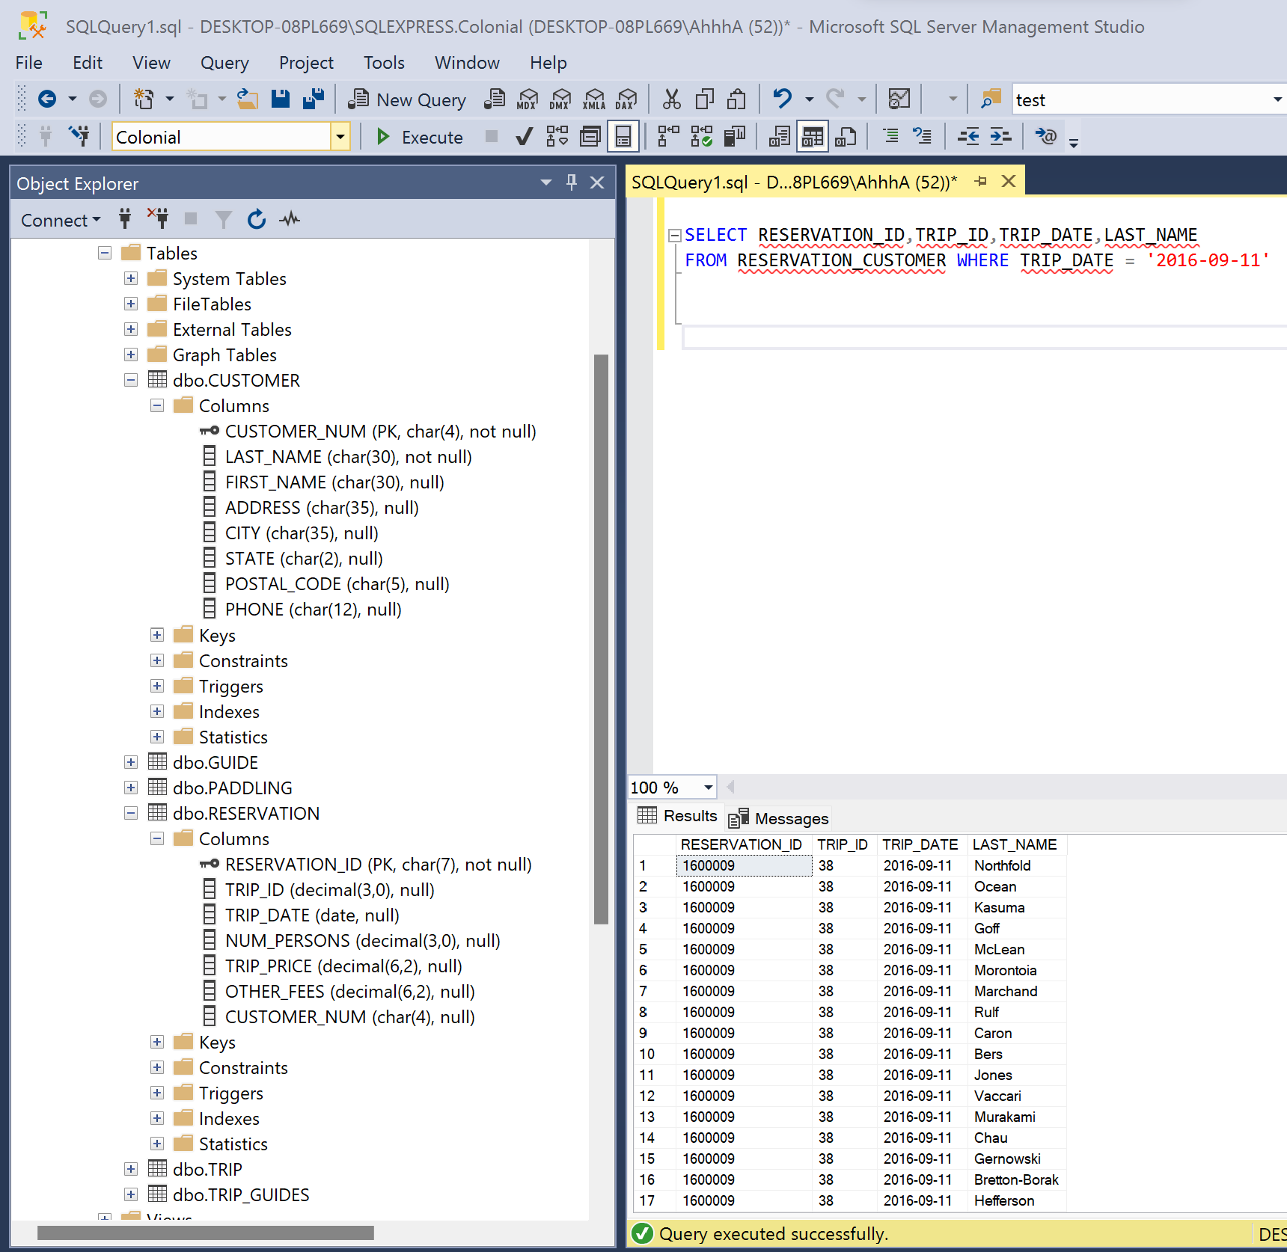

2c.)
SELECT RESERVATION_ID,TRIP_ID,TRIP_DATE,LAST_NAME
FROM RESERVATION, CUSTOMER WHERE TRIP_DATE = '2016-09-11'
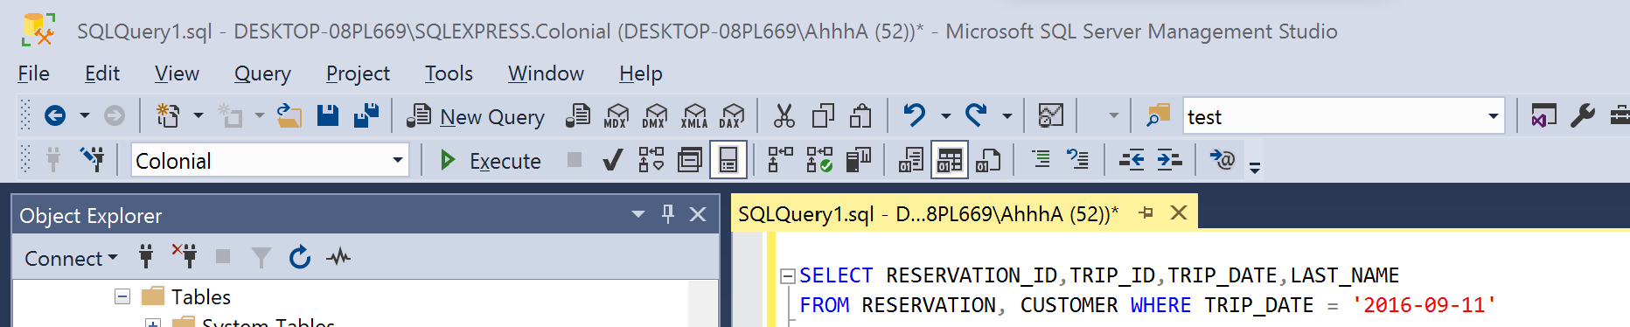
2d.)
Although the user of this view only sees a part of both the customer and the reservation tables, inserting new data using this view would not be a problem because all the columns that are not included in the view can be NULL. It also includes both primary keys of the underlying tables, so it wouldn’t be a problem to update or delete data.

