Isabelle Anno
11/2/2022
Chapter 7 Exercises Part 2
Solmaris Condominium Group (#4a-h, 6c, 7)
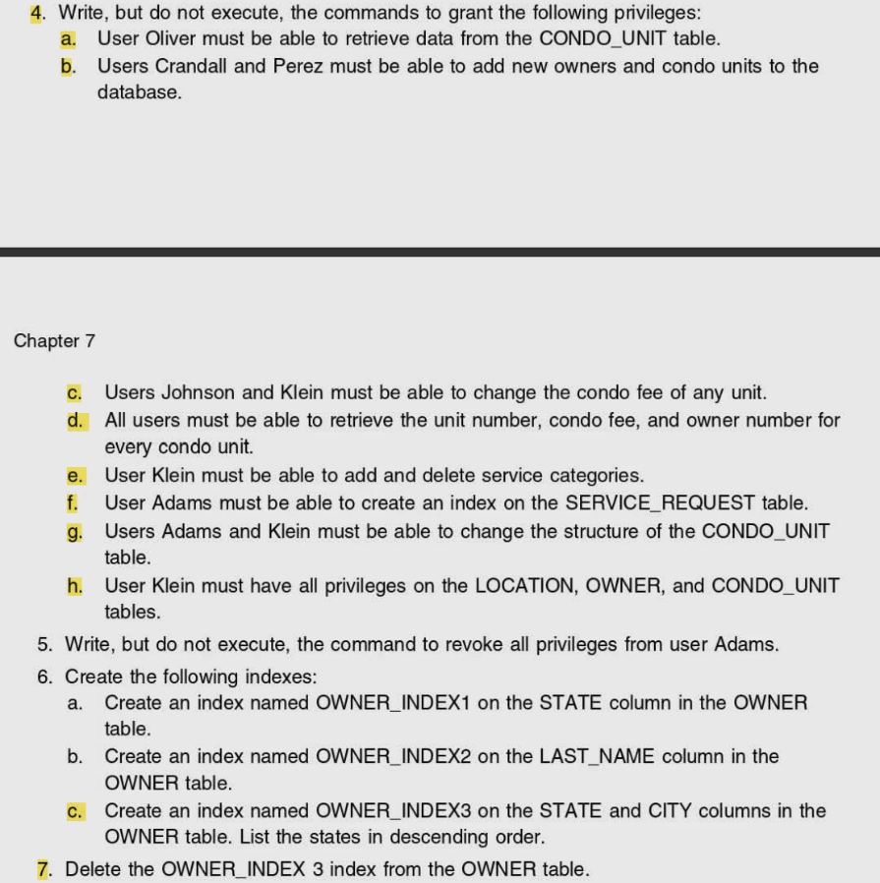
4a.) GRANT SELECT ON CONDO_UNIT TO Oliver;
4b.) GRANT INSERT (UNIT_NUM, CONDO_FEE, OWNER_NUM) ON CONDO_UNIT TO Crandall, Perez;
4c.) GRANT UPDATE (CONDO_FEE) ON CONDO_UNIT TO Johnson, Klein;
4d.) GRANT SELECT (UNIT_NUM, CONDO_FEE, OWNER_NUM) ON CONDO_UNIT TO PUBLIC;
4e.) GRANT INSERT, DELETE ON SERVICE_CATEGORY TO Klein;
4f.) GRANT INDEX ON SERVICE_REQUEST TO Adams;
4g.) GRANT ALTER ON CONDO_UNIT TO Adams, Klein;
4h.) GRANT ALL ON LOCATION, OWNER, CONDO_UNIT TO Klein;

6c.) CREATE INDEX OWNER_INDEX3 ON OWNER (STATE DESC, CITY);
7.)DROP INDEX OWNER.OWNER_INDEX3;

