Dear PeerJ,

We apologize for taking so long to return this revision. Thank you for the reviews: the comments have improved the manuscript. Details on our revisions are given below.

Sincerely,
Heather Piwowar and Todd Vision

Editor's comments

- One reviewer suggests the second part (patterns in data reuse) of the paper could be shortened and more information on this aspect may need to be provided in the Introduction.

In response to the reviewer we have added information to the introduction and shortened the second part of the paper. Details on these changes are given in our response to Point 4.

- Please try to address the reviewers' concerns about "open access citation benefit" and the usage of some terms including the maybe too positive "boost".

We have eliminated all instances of “boost” and replaced them with “benefit” as suggested by Reviewer 1 in Point 5, and removed the word “robust” as suggested by Reviewer 2 in Point 13. We’ve also responded to Reviewer 2 about our use of the term “open data” in Point 16.

- Both reviewers raise questions about tables and figures used in the manuscript.

We have addressed these questions by moving a figure to supplementary information adding a table, and removing another figure. Details on these changes are given in response to Points 4, 6, 7, 10 and 11.

Reviewer 1

- The paper is well organized and clear, but the second objective was less convincingly introduced than the first one, although it makes an important part of the manuscript (especially in terms of number of figures). I found this second part a bit lengthy, and I suggest that the authors shorten it by removing data and/or figures (for example, Fig. 5 and 6) give the same basic information, and one of the two could be deleted while giving only results for the second one in the text.

We have addressed this concern in two ways. First, we have introduced the second section more thoroughly in the introduction. Second, we have moved what was previously Figure 6 to supplementary information.

For reference, here are the two paragraphs we added to the introduction:
Estimating the citation differential is not enough: crafting good data archiving policy requires an understanding of its origins. How quickly do data reuse citations accrue? Are the additional citations due to data reuse -- as we might expect -- or instead simply increased exposure or trust in the original study? How often do data reuse studies attribute data from more than one source?

It is difficult to examine data reuse patterns on a large scale because it is difficult to automatically isolate reuse that has been attributed through a citation to a study from citations made for other purposes. In this study we approach this issue in two ways. First, we do a small-scale manual review of citation context to understand the proportion of citations that are made in the context of data reuse. Second, we use attribution through mentions of data accession numbers, rather than citations, to explore patterns in data reuse at a much larger scale.

- Isn’t the term “boost” a bit too strong for a 9-10% higher citation rate? Wouldn’t “benefit” be more appropriate?

Point taken. We have replaced all mention of “boost” with the word “benefit”.

- Some minor points to modify in the text and/or figures:
  - - p. 2, line 11: delete one of the “characterized”
  - - p. 2, line 42: this repeats the sentence of p. 2 lines 13-17
  - - p. 3, line 2: Table 1 does not show the content discussed in the text (attributes that correlate with citation rates);
  - - p. 3, line 14: give a reference for MeSH terms
  - - p. 3, line 37: add "they" between "because" and "included"
  - - Fig. 2 and Table 3 give the same information: remove Table 3
  - - p 7, line 16: chage "two" by "to”

Thanks very much for finding and listing these. We have corrected all of them, including removing what was formerly Table 3. Before submitting this revision we also sent the manuscript to a professional copyediting service.

- The first aim is addressed using a data set of 10,555 papers screened using full-text query method, but I could not find the number of papers in each category: with or without publicly available data. This information should be provided.

Agreed! Thanks for catching this oversight.. we had the proportion but not the raw number. The italicized sentence has now been added to the start of the Results section:

We identified 10557 articles published between 2001 and 2009 as collecting gene expression microarray data. Publicly available datasets in GEO or ArrayExpress had been found for 2617 of these articles (25%, 95% confidence interval 24% to 26%).

- p. 4, line 7 : why switch to a different source of data here (use of ISI web of knowledge instead of Scopus: p. 2, lines 17-21)

We have added a sentence to the methods section to explain this decision:
Web of Science was used to identify citations for this step, rather than the Scopus citation database used in previous steps. This is because extracting citations in this step did not require the (at the time) Scopus-only feature of searching by PubMed ID, and the investigators had access to the Web of Science through an institutional subscription.

- I found the last part of the result section (p. 8, lines 1-18) and figures 8 and 9 a bit overdone, all the more that this aspect of the paper is not properly introduced ealier, especially in the introduction. I would recommend shortening the second part of the result section pertaining to data reuse, which increases substantially the amount fo data presented in the paper and tends to dilute its main messages. Given that this aspect is only poorly introduced, shortening this part would certainly strengthen the paper.

We appreciate this concern about imbalance. To address it we have increased the attention given to the second section in the introduction and shortened the second section slightly. Details on these changes are given above in response to Point 4.

Reviewer 2 (Iain Hrynaszkiewicz)

- In the ‘Primary analysis’ section, is a table mislabelled or missing? The authors state: “We used a subset of the 124 attributes from (Piwowar, 2011d) previously shown or suspected to correlate with citation rate (Table 1).” I expected to see the list of attributes but Table one is headed: “Proportion of sample published in most common journals” If so, this needs to be resolved before publication.

Yes, sorry about that! Table 1 has been added, and the subsequent tables have been renumbered. For details on Table 1 see Point 11 below.

- I am also interested in the evidence on which the correlates are based.

The now-included Table 1 provides this information. It is here for easy reference, with the slightly edited introductory sentences:

To explore which variables to include in these regressions, we looked at correlations between the number of citations and a set of candidate variables. We also calculated correlations amongst all variables to investigate collinearity. We explored a subset of the 124 attributes from (Piwowar, 2011d) previously shown or suspected to correlate with citation rate. We selected covariates found to have a strong pairwise correlation (positive or negative) with citation rate, using Pearson correlations for numeric variables and polyserial correlations for binary and categorical variables. These included: the date of publication, the journal which published the study, the journal impact factor, the journal citation half-life, the number of articles published by the journal, the journal's open access policy, whether the journal is considered a core clinical journal by MEDLINE, the number of authors of the study, the country of the corresponding author, the citation score of the institution of the corresponding author, the publishing experience of the first and last author, and the subject of the study itself (Table 1).

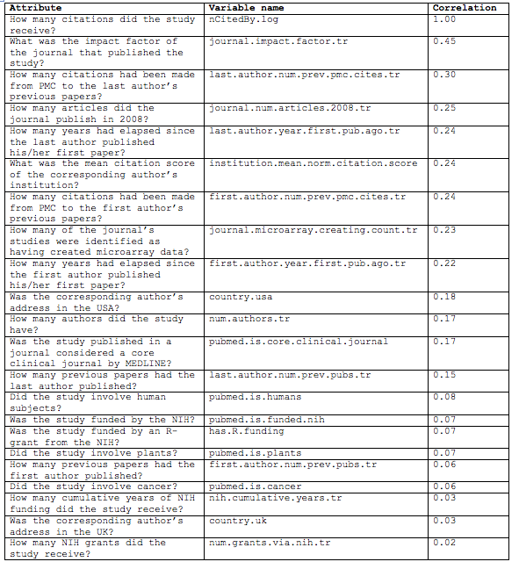
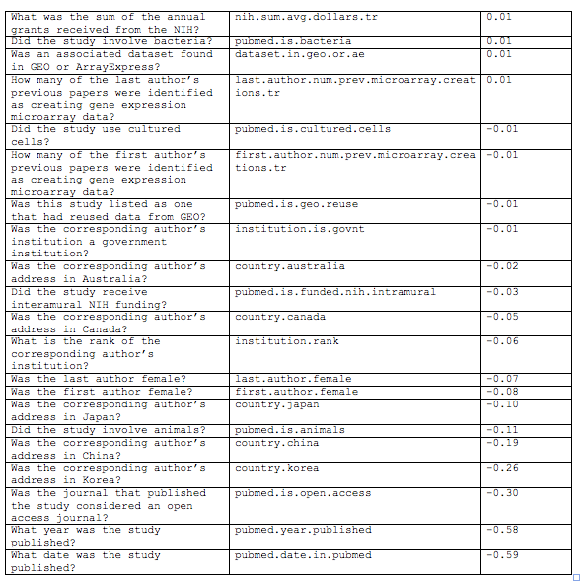

Table 1: Univariate correlations between article attributes and number of citations. Citations were log transformed and count variables were square root transformed. Pearson correlations were used for numeric variables and polyserial correlations for binary and categorical variables.

- The authors mention the open access citation advantage a few times in their paper, for example. Have they assumed that open access papers receive more citations in the present analysis? The open access citation benefit is much debated. Furthermore, my understanding of the cited paper by Craig et al 2007 is that it documents *decreasing* evidence of a citation benefit for open access articles. I am not aware of a systematic review of the impact of open access on citations, but a bibliography of studies, which the authors may find relevant, is here http://opcit.eprints.org/oacitation-biblio.html

Our argument does not require that open access papers do, in fact, receive more citations than non-OA papers, only that some of the potential factors have analogues for case of open data. But we agree our sentence citing Craig et al. (2007) was confusing. We’ve rewritten it:

The literature that has considered the possibility of an Open Access citation benefit (e.g. Craig et. al. 2007) suggests a number of other factors that may also be relevant to open data.

- I feel the authors should tone down the positivity of the language used to describe the citation increase in their conclusions (“robust”; a “boost”, etc), given the citation benefit is just 9%.

We have replaced all mention of “boost” with the word “benefit”. We have also removed or replaced the word “robust” to clarify that we wish to draw attention to the improved statistical precision of the citation benefit rather than its magnitude:

- We find a robust statistically well-supported citation benefit from open data, although a smaller one than previously reported.
- Nonetheless, robust evidence of personal benefit will help as science transitions from "data not shown" to a culture that simply expects data to be part of the published record. [“robust” removed]

- I wondered if the authors could comment on if and how much their results could be generalised to other areas of research. Also, where should the research community’s priorities be for establishing citation or other benefits to individuals from sharing their research? Which fields? Which benefits? We know, for example, that clinical trialists are willing to share their data but practical issues and fears over inappropriate reanalysis are more important barriers to sharing –than lack of individual incentives/citations (Rathi et al. http://dx.doi.org/10.1136/bmj.e7570).

We agree that this is an important area for exploration but feel it is outside the scope of the current paper. Nonetheless, we have added the following sentences to the Discussion:

While we cannot generalize from these detailed patterns of data reuse and citation to other datatypes or domains, the cumulative citation benefit seems to be quantitatively similar in a number of different fields (Gleditsch & Strand, 2003 ; Piwowar et. al. 2007 ; Ioannidis et. al. 2009 ; Pienta et. al. 2010 ; Henneken & Accomazzi, 2011 ; Sears, 2011 ; Dorch, 2012).

We also recognize that scientists may weigh a variety of both positive and negative incentives when deciding whether and how to share their data, and the potential for increasing citations is only one of these.

The authors have an ongoing study into the attitudes and experiences of scientists with respect to data sharing (http://studyonimpactofjournaldatapolicies.wordpress.com/) and plan to address some of the wider issues in the context of that paper.

- I assume the opening quote is not intended to add colour to paper but to provide the opening part of the introduction. As such, I found the author quoting themselves at this length from a 6 year old study was not the best way to open a paper.

Thanks for this feedback. We can see the reviewer’s point that the method of attribution was clumsy and called unnecessary attention to the attribution. We wish to reuse the text from the previous paper because we believe it still serves as an appropriate introduction and that text reuse should be welcome in such circumstances. To address the reviewer’s point and improve the flow of the introduction we have removed the quotation marks and moved the attribution to the Acknowledgements section with the following sentence:

The first paragraph of the introduction is verbatim from (Piwowar et. al. 2007); its original publication was under a CC-BY license.

- Throughout the manuscript the authors refer to “open data” meaning, I assume in this context, data which are freely accessible on the web. However, there is growing recognition that “open” data means data which are available under legal terms – a license or waiver – which permit sharing and reuse with the minimum of barriers. Open data is about more than just accessibility. “Open” data must be free to “download, copy, analyse, re-process, pass them to software or use them for any other purpose without financial, legal, or technical barriers other than those inseparable from gaining access to the internet itself” [http://pantonprinciples.org/] . To my knowledge the authors are aware of the appropriate use of “open” in open data and open access and I recommend they use an alternate term to “open data” in the present manuscript to avoid engendering confusion about the term “open data”.

We appreciate this concern; we also want to keep the definition and use of the phrase “open data” clean and clear. We believe that GEO data meets the definition of open data. The copyright status page for the NCBI databases (http://www.ncbi.nlm.nih.gov/About/disclaimer.html) describes data reuse rights as follows:

Databases of molecular data on the NCBI Web site include such examples as nucleotide sequences (GenBank), protein sequences, macromolecular structures, molecular variation, gene expression, and mapping data. They are designed to provide and encourage access within the scientific community to sources of current and comprehensive information. Therefore, NCBI itself places no restrictions on the use or distribution of the data contained therein. Nor do we accept data when the submitter has requested restrictions on reuse or redistribution. [bold added]

While this is not as simple and straightforward as a CC0 declaration, we believe it meets the definition of open data as defined in the Panton Principles. We do note, however, that the NCBI continues the description above with the following disclaimer:

However, some submitters of the original data (or the country of origin of such data) may claim patent, copyright, or other intellectual property rights in all or a portion of the data (that has been submitted). NCBI is not in a position to assess the validity of such claims and since there is no transfer or rights from submitters to NCBI, NCBI has no rights to transfer to a third party. Therefore, NCBI cannot provide comment or unrestricted permission concerning the use, copying, or distribution of the information contained in the molecular databases.

Such a disclaimer is necessary because the NCBI databases were created before releasing data under CC0 was accepted as a best practice. That said, people use publicly-available NCBI data as if the above disclaimer did not exist. Data within NCBI databases can safely be considered and called open data because it passes the “duck test” for open data: it is thought of, treated, and assumed to be open data by all who use it in our experience, and has no contradictory license in evidence, so we feel comfortable calling it open data.

- I’m not convinced the account of the authors’ problems in obtaining access to Scopus should be included in the current manuscript. It seems tangential to thrust of the manuscript and its analysis and would be more appropriate for a blog (I believe some of this was described on Piwowar’s blog) or commentary, and would make the manuscript more focused. Also, elsewhere in the paper the authors note that Scopus now has an API for programmatic access. The authors have previously written about the problems faced by researchers in gaining access to the literature for research – text mining, citation analysis – elsewhere.

We thank the reviewer for this perspective and are aware that others may agree. However, in contrast, we have received at least three expressions of thanks from peers for including these details in the published preprint: it is a case where opinions differ. One of us (HP) has documented these details on a blog, however, we don’t believe that having described this to a small, specialized readership on a blog makes it inappropriate for inclusion in this paper. It represents a very real methodological challenge to future data collection efforts attempting to validate or extend our results, and to other studies of this nature. Finally, the passage is only 164 words long and within a self-contained section in the Discussion, so it can be easily skipped over if a reader feels it to be tangential.

- I noticed a few typos (this is not an exhaustive list) e.g. “The lack of conventions and tool support for data Attribution”; “Which types of data reuse are facilitates by robust data standards and which types are unaffected?”

Yes, thanks, and sorry about that. Before submitting this revision we sent the manuscript to a professional copyediting service. We have corrected the errors above and others.

- I am aware one of the authors has previously discussed publicly the present study’s data and preliminary results (http://researchremix.wordpress.com/2012/07/16/many-datasets-are-reused-not-just-an-elite-few/). Open science should not preclude papers being published, and the fact the authors discussed the data from this study before submission of their paper should have no influence on the paper’s acceptance or rejection. However, best practice regarding potentially duplicate or overlapping publications would be to state in the paper and cite the previous publications, including blogs, posters etc, in the submitted manuscript.

The reviewer raises a good point. We now mention the blog posts, presentations, and preprint in the Acknowledgements section:

Finally, the authors thank their peers for feedback on preliminary and preprint versions of this manuscript. The methods and results were previously discussed on an author’s blog (e.g. http://researchremix.wordpress.com/2012/07/16/many-datasets-are-reused-not-just-an-elite-few/), in presentations (e.g. http://dx.doi.org/10.7287/peerj.preprints.14v1 and http://www.slideshare.net/tjvision/vision-ievobio12), and published online as a preprint manuscript (http://dx.doi.org/10.7287/peerj.preprints.1v1).

