Workshop: SQL Public Library Management
Workshop Tasks
Part 1: Basic SQL Operations and JOIN Queries
- Basic Selection: Retrieve the titles and publication years of all books published after 2000, ordered by publication year (newest first).
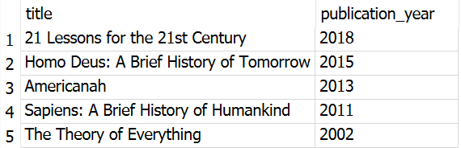
SELECT title, publication_year
FROM Books
WHERE publication_year > 2000
ORDER BY publication_year DESC;

- Filtering: Find all books with more than 5 copies owned in the fiction genre (genre_id = 1).
SELECT title, copies_owned, genre_id
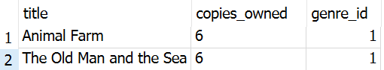
FROM Books
WHERE copies_owned > 5
AND genre_id = 1;
- Pattern Matching: List all books whose titles contain the word "History".
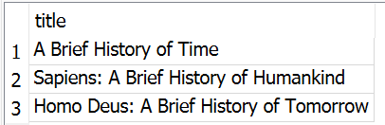
SELECT title
FROM Books
WHERE title LIKE '%History%';

- JOIN Operations: Display loan information (loan_id, checkout_date, due_date) along with patron details (first_name, last_name, email) for all loans made in January 2023.
SELECT checkout_date
FROM Loans
ORDER BY checkout_date;
SELECT
Loans.loan_id,
Loans.checkout_date,
Loans.due_date,
Patrons.first_name,
Patrons.last_name,
Patrons.email
FROM Loans
JOIN Patrons
ON Loans.patron_id = Patrons.patron_id

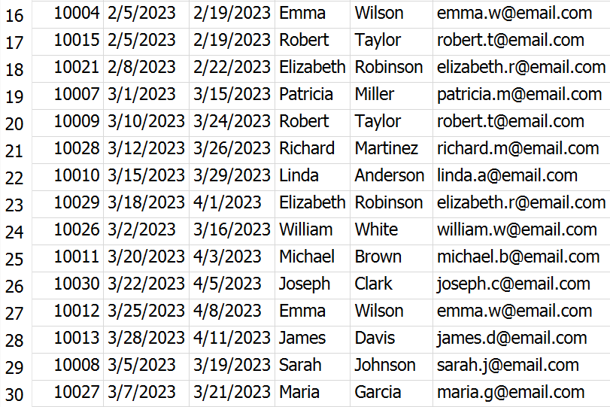
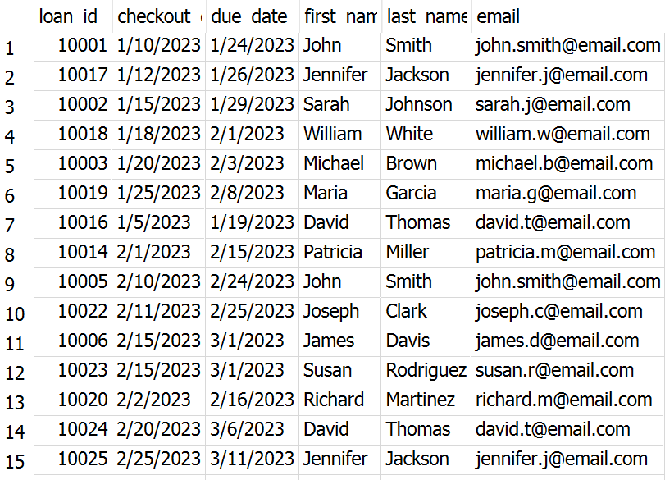

- ORDER BY Loans.checkout_date;Multi-table JOIN: Show book details (title, author's full name, genre_name) for each loan, along with the checkout_date and due_date.
SELECT
Books.title,
Authors.first_name || ' ' || Authors.last_name AS author_name,
Genres.genre_name,
Loans.checkout_date,
Loans.due_date
FROM Loans
JOIN Books
ON Loans.book_id = Books.book_id
JOIN Authors
ON Books.author_id = Authors.author_id
JOIN Genres
ON Books.genre_id = Genres.genre_id;
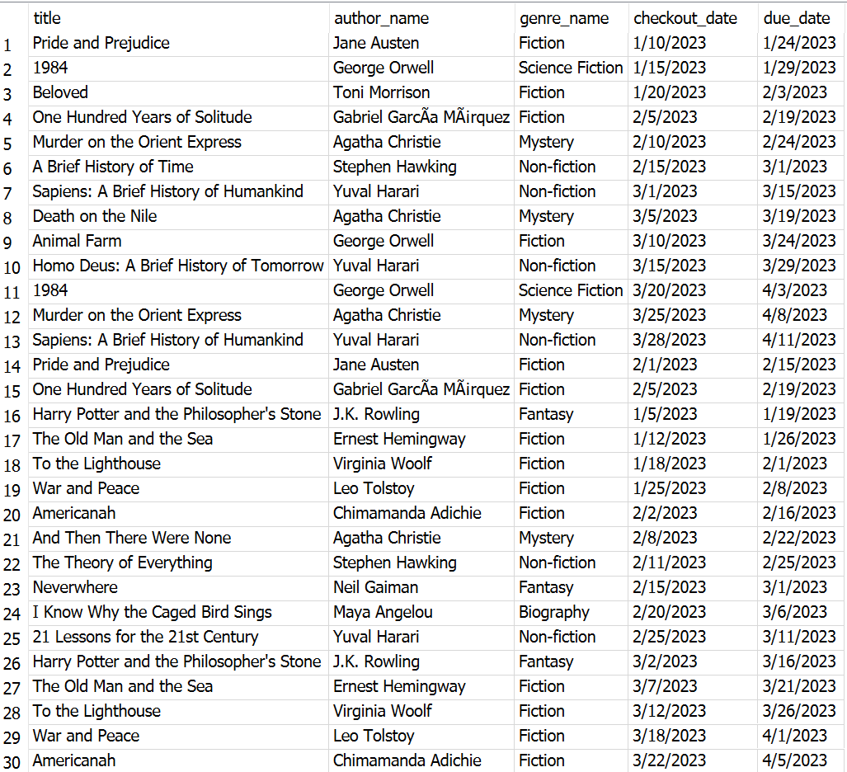

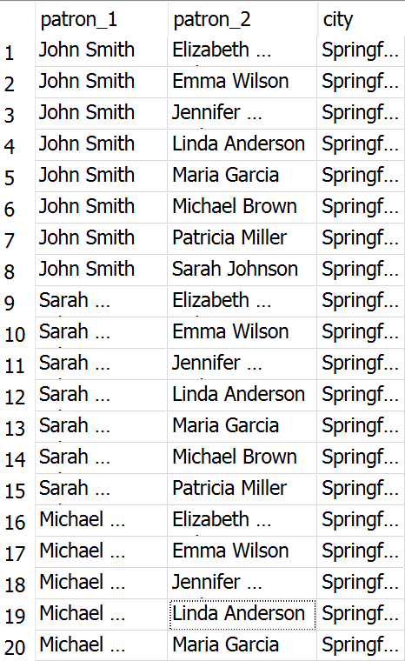
- Self JOIN: Find pairs of patrons who live in the same city. Show both patrons' names and their city.
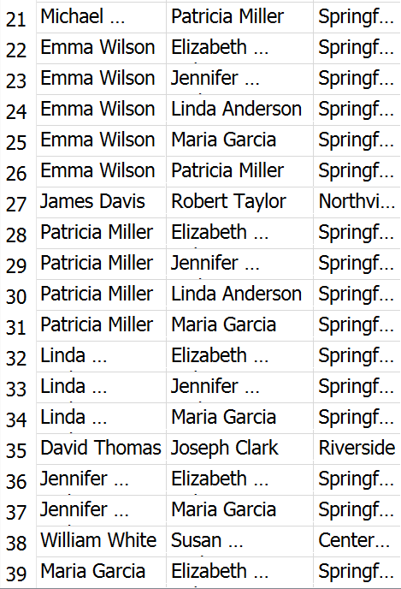
SELECT
p1.first_name || ' ' || p1.last_name AS patron_1,
p2.first_name || ' ' || p2.last_name AS patron_2,
p1.city
FROM Patrons p1
JOIN Patrons p2
ON p1.city = p2.city
AND p1.patron_id < p2.patron_id;

- Multi-table JOIN with filtering: Find all fiction books (genre_id = 1) that have been borrowed, along with the patron name and the branch where they were borrowed from.
SELECT
Books.title,
Patrons.first_name || ' ' || Patrons.last_name AS patron_name,
Branches.branch_name
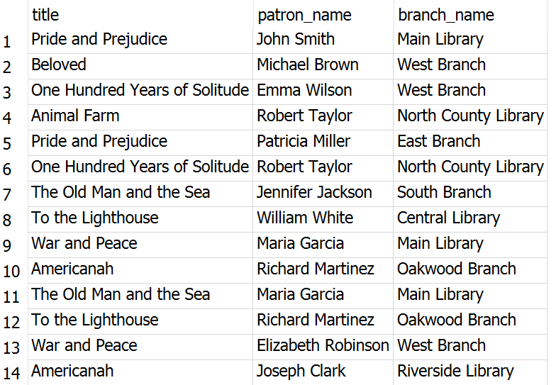
FROM Loans
JOIN Books
ON Loans.book_id = Books.book_id
JOIN Patrons
ON Loans.patron_id = Patrons.patron_id
JOIN Branches
ON Loans.branch_id = Branches.branch_id
WHERE Books.genre_id = 1;

Part 2: Aggregation and GROUP BY Operations
- COUNT aggregation: Count the number of books in each genre category.
SELECT
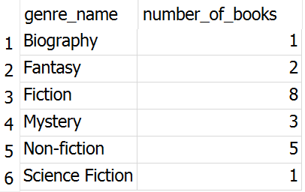
Genres.genre_name,
COUNT(Books.book_id) AS number_of_books
FROM Genres
JOIN Books
ON Genres.genre_id = Books.genre_id
GROUP BY Genres.genre_name;
- Multiple aggregations: Calculate the average, minimum, and maximum loan duration (days between checkout and return) for each library branch. Include only returned books.
SELECT
Branches.branch_name,
ROUND(AVG(julianday(Loans.return_date) - julianday(Loans.checkout_date)), 2) AS average_loan_duration,
MIN(julianday(Loans.return_date) - julianday(Loans.checkout_date)) AS minimum_loan_duration,
MAX(julianday(Loans.return_date) - julianday(Loans.checkout_date)) AS maximum_loan_duration
FROM Loans
JOIN Branches
ON Loans.branch_id = Branches.branch_id
WHERE Loans.return_date IS NOT NULL
GROUP BY Branches.branch_name;

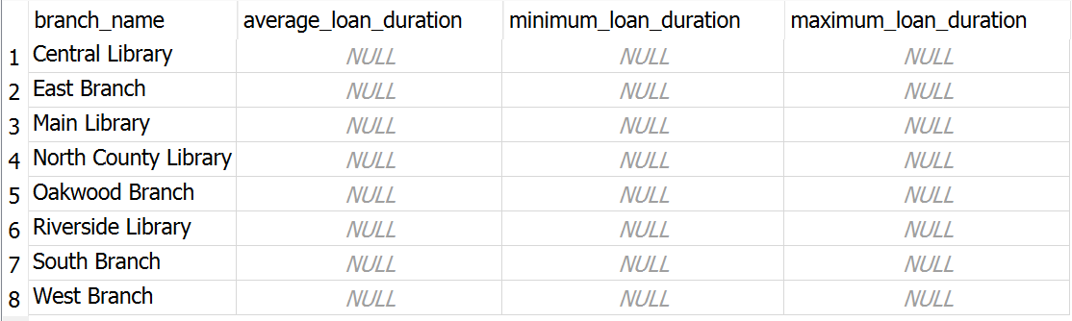

- Conditional aggregation: Find patrons with overdue books (due_date < CURRENT_DATE and return_date = ' '), along with the count of overdue books they have.
SELECT
Patrons.first_name,
Patrons.last_name,
COUNT(Loans.loan_id) AS overdue_books
FROM Loans
JOIN Patrons
ON Loans.patron_id = Patrons.patron_id
WHERE Loans.due_date < date('now')
AND (Loans.return_date IS NULL OR Loans.return_date = '')
GROUP BY Patrons.patron_id,
Patrons.first_name,
Patrons.last_name;

- Time-based analysis: Analyze monthly borrowing trends. Show the year, month, number of loans, and number of unique patrons for each month.
SELECT
strftime('%Y', checkout_date) AS year,
strftime('%m', checkout_date) AS month,
COUNT(loan_id) AS number_of_loans,
COUNT(DISTINCT patron_id) AS unique_patrons
FROM Loans
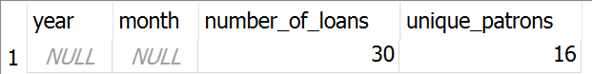
GROUP BY year, month
ORDER BY year, month;
BONUS: Write a query to create a simple data dictionary for the library database schema, listing table names, column names, data types, and whether they are primary keys.
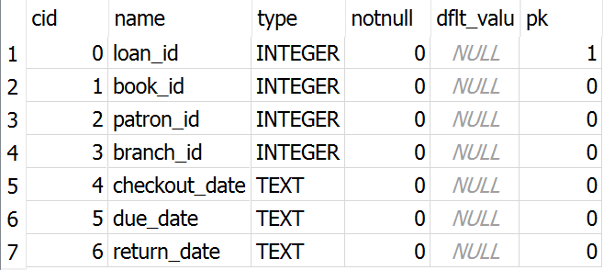
PRAGMA table_info(Branches);
PRAGMA table_info(Patrons);
PRAGMA table_info(Genres);
PRAGMA table_info(Authors);
PRAGMA table_info(Books);
PRAGMA table_info(Loans);

Discussion Questions
- In our library database, we track which branch a book was borrowed from, but books can exist at multiple branches. How would you modify the schema to track the actual inventory at each branch?
I would add a new table to track book inventory by branch. Right now, the Books table only has copies_owned, but it does not show how many copies are at each branch. A better design would be a table like:
Branch_Inventory (
branch_id INTEGER,
book_id INTEGER,
copies_available INTEGER,
copies_total INTEGER
)

This would let the library know which books are available at each branch.

- Based on the provided data model, what business questions could library administrators answer using SQL queries that we haven't covered in our exercise?
Library administrators could answer questions like which branch has the most loans, which genres are borrowed the most, and which patrons borrow the most books. They could also check which books are not borrowed often and may not need many copies. This would help the library make better decisions about staffing, book purchases, and branch inventory.
- How would you extend this schema to track additional patron interactions, such as reserved books, late fees, or participation in library programs?
I would add new tables for things like reservations, late fees, and library programs. For example, a Reservations table could track which patron reserved a book and the reservation date. A Late_Fees table could track unpaid fees. A Programs table could track events and which patrons attended. This would give the library a better picture of how patrons use library services.
- For tasks 1-3, how could you combine them into a single, more complex query that finds recent history books with multiple copies?
Tasks 1–3 can be combined by looking for books published after 2000, with more than 5 copies, and with "History" in the title. The query would be:
SELECT title, publication_year, copies_owned
FROM Books
WHERE publication_year > 2000
AND copies_owned > 5
AND title LIKE '%History%'
ORDER BY publication_year DESC;

This combines basic selection, filtering, pattern matching, and sorting.
- What performance considerations should be kept in mind when running complex joins and aggregations on large library datasets?
For larger library datasets, complex joins and aggregations can take longer to run. It is better to select only the columns needed instead of using SELECT *. It also helps to filter early with WHERE before joining large tables. Indexes on common columns like book_id, patron_id, branch_id, and genre_id would also make queries faster, as joins can be resource-intensive, so it is important to keep queries focused.

