Workshop: SQL Online Music Store
Workshop Tasks
Using the schema above, write SQL queries to answer the following questions:
- Basic Selection: Retrieve the titles and release dates of all songs released in 2022, ordered by release date (newest first).
SELECT title, release_date
FROM Songs
WHERE release_date BETWEEN '2022-01-01' AND '2022-12-31'
ORDER BY release_date DESC;
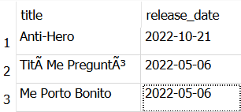

- Filtering: Find all songs with a popularity score greater than 80 and a duration less than 4 minutes (240 seconds).
SELECT title, popularity_score, duration_seconds
FROM Songs
WHERE popularity_score > 80
AND duration_seconds < 240;

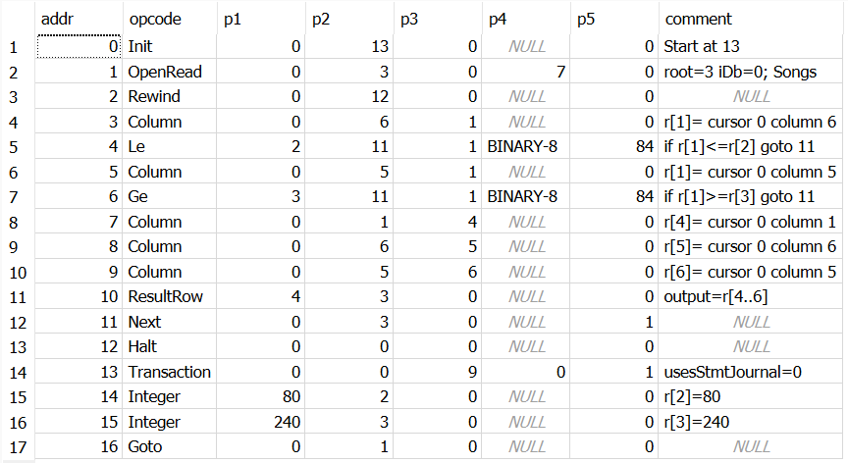

- Pattern Matching: List all artists whose names start with "The".
SELECT artist_name
FROM Artists
WHERE artist_name LIKE 'The%';
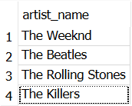

- Multiple Conditions: Find all premium customers who joined in 2022.
SELECT first_name, last_name, email, join_date, premium_member
FROM Customers
WHERE premium_member = 1
AND join_date BETWEEN '2022-01-01' AND '2022-12-31';
- Calculations and Aliasing: Calculate the total duration (in minutes) of all songs in the database and display the result with an appropriate column name.
SELECT
ROUND(SUM(duration_seconds) / 60.0, 2) AS total_duration_minutes
FROM Songs;
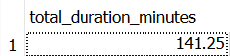

- Advanced Filtering: Find the top 5 most expensive song purchases in the database.
SELECT purchase_id, customer_id, song_id, purchase_date, price
FROM Purchases
ORDER BY price DESC
LIMIT 5;
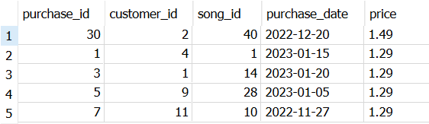

- Using Multiple Tables Separately: First, find all song_ids from songs with a popularity score above 90. Then, use those song_ids to find purchases of those songs.
SELECT song_id, title, popularity_score
FROM Songs
WHERE popularity_score > 90;
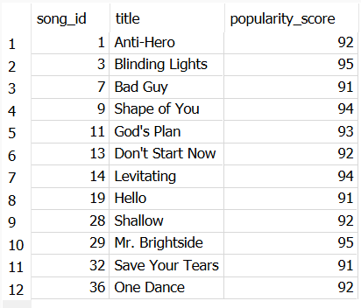

SELECT purchase_id, customer_id, song_id, purchase_date, price
FROM Purchases
WHERE song_id IN (
SELECT song_id
FROM Songs
WHERE popularity_score > 90
);

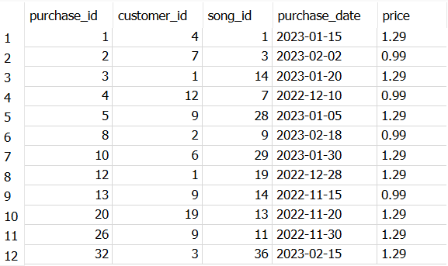

- Range Checking: Find all purchases made between January 1, 2023 and March 31, 2023.
SELECT purchase_id, customer_id, song_id, purchase_date, price
FROM Purchases
WHERE purchase_date BETWEEN '2023-01-01' AND '2023-03-31';
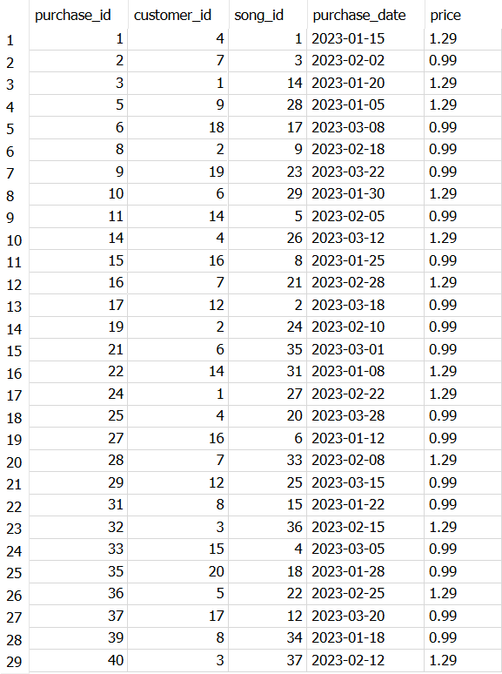

- Advanced Filtering with ORDER BY: Identify the songs with the highest popularity scores (above 90).
SELECT title, popularity_score
FROM Songs
WHERE popularity_score > 90
ORDER BY popularity_score DESC;
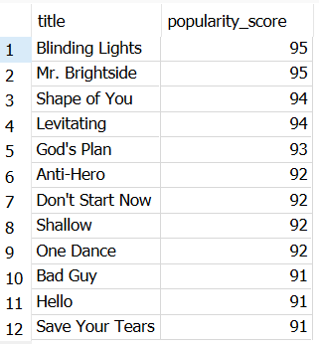

Discussion Questions
- In our database design, we separated purchases and streams into different tables. What are the benefits of this approach versus having a single "user_interactions" table?
Keeping purchases and streams in separate tables makes the data easier to organize and analyze. Purchases are related to sales and revenue, while streams are related to listening activity. If everything was stored in one table, it could become more confusing and harder to query. By separating them, the company can quickly analyze sales data or streaming data depending on what they need.
- Based on the provided data model, what business questions could music executives answer using SQL queries that we haven't covered in our exercise?
Music executives could answer many other questions with this data. For example, they could find out which artists make the most money, which songs are streamed the most, or whether premium customers buy more music than regular customers. They could also look at which genres are most popular and how customer activity changes over time. These insights could help with marketing and business decisions.
- How would you extend this schema to track more detailed user behavior, such as when users skip songs or how much of a song they listen to before skipping?
I would add another table to store more information about listening behavior. This table could include things like how many seconds a customer listened to a song, whether they skipped it, and what device they were using. This would help the company understand which songs keep people interested and which songs are skipped often. The information could also be used to improve recommendations and playlists.
- For tasks 1-3, how could you combine them into a single, more complex query that finds popular short songs by artists whose names start with "The"?
Tasks 1-3 can be combined by joining the Songs and Artists tables and adding all the conditions into one query. The query would look for songs released in 2022, with a popularity score above 80, a duration under 4 minutes, and an artist name that starts with "The." This type of query is useful because it answers a more specific business question and shows how multiple SQL concepts can work together in a single query.

