IMDb Movie Dataset Analysis Report
1. Dataset Introduction
Dataset Source
The dataset used for this project was an IMDb movie dataset that contains information about highly rated films from multiple countries and decades. The dataset includes movie titles, release dates, genres, runtime, country of origin, content ratings, directors, box office revenue, audience votes, and IMDb scores.
Dataset Size
- Number of records: 100 movies
- Number of columns: 11 variables
- Number of tables: 1
Subject Matter
The dataset focuses on the film industry and contains information relevant to movie performance, audience reception, and financial success. The data can be used to evaluate factors that contribute to critical acclaim and commercial performance.
2. Data Cleaning and Transformation
The dataset required several cleaning steps before it could be used for Excel pivot table analysis and SQL analysis. The goal of the cleaning process was to preserve the analytical value of the dataset while correcting formatting issues, missing values, inconsistent labels, and data type problems.
The dataset required several cleaning and standardization procedures before analysis could be performed. The following actions were completed:
- Removed empty rows and columns to improve dataset organization and prevent import issues.
- Corrected inconsistent movie title formatting within the Original Title column to ensure readability and consistency.
- Converted the Release Year field into a valid date format and changed the display to Short Date format for easier analysis in Excel and SQL.
- Replaced missing values in the Duration column with the average duration of all movies in the dataset to preserve records while maintaining analytical value.
- Standardized the Income column by correcting currency formatting and preparing the values for revenue analysis and SQL import.
- Corrected numeric formatting issues within the Votes and Score columns using Excel formatting tools, Flash Fill, and manual corrections where necessary.
- Standardized country names by correcting entries such as:
  - Italy1 → Italy
  - New Zesland → New Zealand
  - US. → USA
- Standardized content rating values by replacing inconsistent entries such as:
  - Non Rated → #NA
  - Approved → #NA
  - Unrated → #NA
- Corrected formatting and spelling issues in the Director column to ensure accurate director-based analysis.
- Corrected movie title spelling and formatting issues, including:
  - Seven
  - La vita e bella
  - Leon
  - WALL·E
  - Le fabuleux destin d'Amelie Poulain
  - Per qualche dollaro in piu
Data Validation
After completing the cleaning process, the dataset was reviewed to verify that:
- All unnecessary blank rows and columns had been removed.
- Dates were formatted correctly.
- Numerical fields could be used for calculations and sorting.
- Country names, content ratings, director names, and movie titles were standardized.
- Missing values were addressed appropriately.
- The dataset remained complete and suitable for Excel and SQL analysis.
These cleaning procedures improved the overall quality, consistency, and reliability of the dataset while preserving the information necessary for meaningful business analysis.
3. Pivot Table Analysis
Three pivot tables were created to examine different aspects of movie performance within the IMDb dataset. Each pivot table was designed to answer a specific business question and provide insights that could support decision-making within the film industry.
Pivot Table 1: Average Movie Rating by Director
Business Question
Which directors consistently produce highly rated movies?
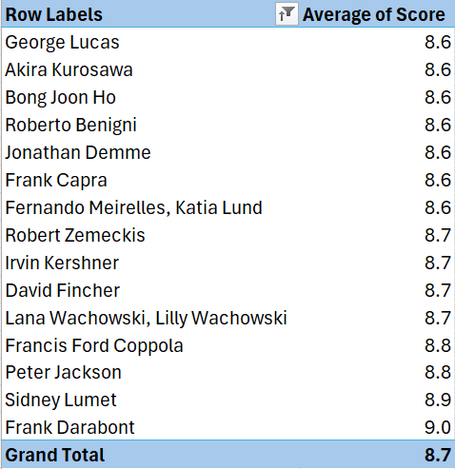

Key Insights
The analysis revealed that Frank Darabont achieved the highest average IMDb rating of 8.95 across two films. Sidney Lumet followed with an average rating of 8.90, while Peter Jackson and Francis Ford Coppola both achieved average ratings of 8.80. These directors consistently produced films that received strong audience ratings, indicating a high level of creative success and audience approval.
Business Implications
Production companies and streaming platforms can use this information when selecting directors for future projects. Directors with a history of producing highly rated films may increase audience satisfaction, improve critical reception, and reduce investment risk.
Pivot Table 2: Average IMDb Rating by Movie Runtime
Business Question
Do longer movies tend to receive higher audience ratings?
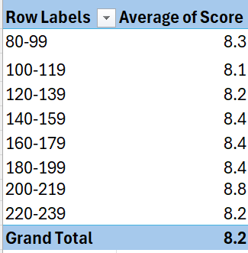

Key Insights
Movies with runtimes between 200 and 219 minutes achieved the highest average IMDb rating of 8.75. Films longer than 140 minutes generally performed above the overall dataset average rating of 8.20. In contrast, movies between 100 and 119 minutes received the lowest average rating of 8.08.
Business Implications
The results suggest that audiences may respond positively to movies that allow for greater character development and storytelling depth. While runtime alone does not determine success, studios may consider allowing additional runtime for projects with complex narratives and detailed storylines.
Pivot Table 3: Top Grossing Movies
Business Question
Which movies generated the highest box office revenue?
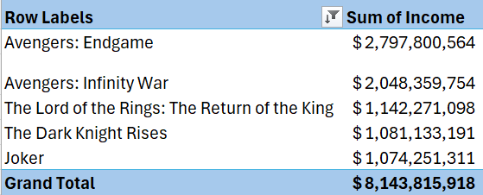

Key Insights
Avengers: Endgame generated approximately $2.8 billion in revenue, making it the highest-grossing movie in the dataset. Avengers: Infinity War generated approximately $2.0 billion, while The Lord of the Rings: The Return of the King earned more than $1.1 billion. Franchise-based films dominated the highest-grossing movies in the dataset, demonstrating the strong financial performance of established intellectual property and blockbuster productions.
Business Implications
The analysis highlights the financial value of successful franchises and recognizable brands. Film studios may use these findings when evaluating sequel development, franchise expansion opportunities, and long-term investment strategies.
Combined Analysis
4. Data Visualization Analysis
Three visualizations were created to support and enhance the pivot table findings. Each chart provides a visual representation of the underlying data and helps identify patterns that may not be immediately apparent from tables alone.
Visualization 1: Top Directors by Average IMDb Rating (Bar Chart)
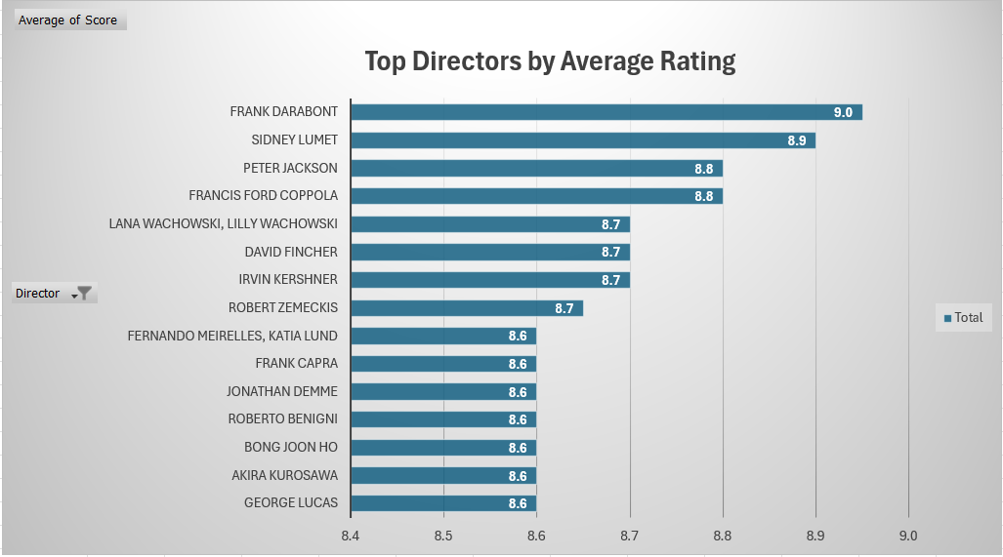

Description
This bar chart compares the average IMDb ratings of the highest-performing directors in the dataset. Frank Darabont, Sidney Lumet, Peter Jackson, and Francis Ford Coppola appear among the top performers, demonstrating consistently strong audience ratings and critical success.
Business Insight
The visualization suggests that certain directors repeatedly produce films that resonate with audiences. Studios may use this information to identify directors with proven track records of success when evaluating future projects and allocating production budgets.
Visualization 2: Average IMDb Rating by Movie Runtime (Line Chart)
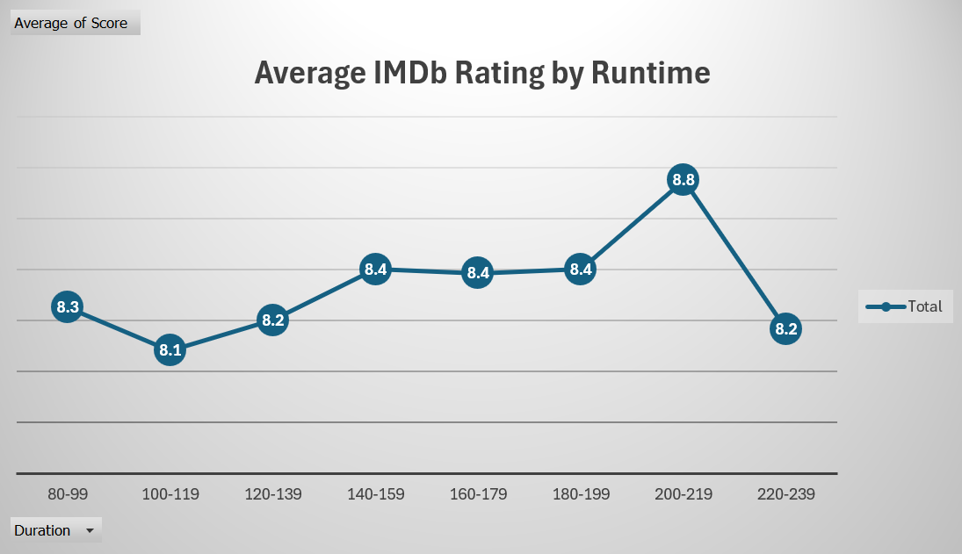

Description
This line chart illustrates the relationship between movie runtime and average audience ratings. Runtime groups above 140 minutes generally achieved ratings above the overall dataset average, while shorter runtime groups received slightly lower ratings. The highest average rating was observed in the 200–219 minute runtime category.
Business Insight
The chart suggests a modest positive relationship between runtime and audience reception. While longer movies do not guarantee success, audiences may appreciate the additional storytelling opportunities and character development provided by longer productions.
Visualization 3: Revenue Share of the Top 5 Highest-Grossing Movies (Pie Chart)
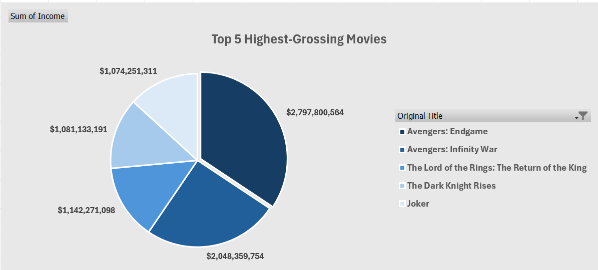

Description
This pie chart illustrates the distribution of revenue among the five highest-grossing movies in the dataset. Avengers: Endgame represents the largest share of total revenue, followed by Avengers: Infinity War, The Lord of the Rings: The Return of the King, The Dark Knight Rises, and Joker. The visualization highlights how a relatively small number of blockbuster films account for a substantial portion of total revenue.
Business Insight
The chart demonstrates the concentration of box office revenue among a few exceptionally successful films. Studios may use this information to understand the financial impact of blockbuster productions and the importance of investing in successful franchises, sequels, and well-established intellectual property.
Summary of Visualization Findings
The visualizations reinforced the findings from the pivot table analysis. Director performance, movie runtime, and revenue concentration all appear to influence different dimensions of movie success. Together, these charts provide a comprehensive view of audience satisfaction, movie characteristics, and financial performance, allowing stakeholders to make more informed business decisions. The results suggest that highly rated directors, longer narrative-driven films, and blockbuster franchise films are associated with stronger performance outcomes in the film industry.
5. Data Import and Verification
The cleaned IMDb movie dataset was imported into SQLiteStudio as a database table named imdb_movies. After importing the data, several verification queries were used to confirm that the dataset imported correctly and maintained its structure.
The first verification query counted the total number of records in the table. The result confirmed that the table contained 100 movie records, matching the cleaned Excel dataset.
-- Query 1: Verify total row count SELECT COUNT(*) AS total_records FROM imdb_movies;
A second query previewed the first ten records to confirm that movie titles, genres, directors, income values, votes, and IMDb scores appeared in the correct columns.
-- Query 2: Preview imported data SELECT * FROM imdb_movies LIMIT 10;
The table structure was also reviewed using PRAGMA table_info(imdb_movies); to check column names and data types.
-- Query 3: Check table structure and data types PRAGMA table_info(imdb_movies);
A duplicate check was performed using the IMDb title ID as the unique identifier. The query grouped records by imdb_title_id and searched for IDs appearing more than once. No duplicate records were identified, which confirmed that each movie appeared only one time in the imported dataset.
-- Query 4: Check for duplicate movie IDs SELECT imdb_title_id, COUNT(*) AS duplicate_count FROM imdb_movies GROUP BY imdb_title_id HAVING COUNT(*) > 1;
6. Exploratory Query Analysis
Exploratory SQL queries were created to better understand the structure and patterns within the IMDb movie dataset. These queries were designed to summarize the data, identify major categories, and explore possible directions for deeper business analysis.
Exploratory Query 1: Count of Movies by Country
SELECT country, COUNT(*) AS movie_count FROM imdb_movies GROUP BY country ORDER BY movie_count DESC;
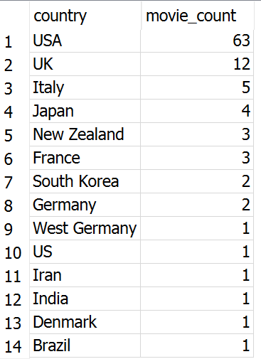

This query counted the number of movies produced by each country. The purpose of this query was to understand the geographic distribution of films in the dataset. USA with 63 movies followed by UK with 12. The results showed which countries contributed the largest number of movies and helped identify whether the dataset was concentrated in a small number of film-producing countries, such as the US.
Exploratory Query 2: Average IMDb Score by Country
SELECT country, ROUND(AVG(score), 2) AS average_score FROM imdb_movies GROUP BY country ORDER BY average_score DESC;
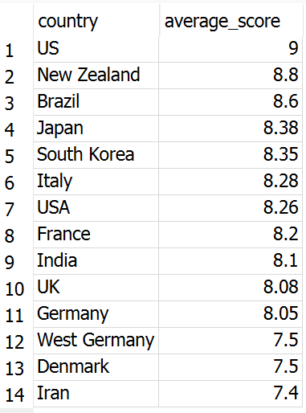

This query calculated the average IMDb score for each country. US was the highest followed by New Zealand. The purpose was to compare audience reception across countries and identify which countries had the highest-rated films on average. This analysis provided a geographic perspective on movie quality and audience satisfaction.
Exploratory Query 3: Highest, Lowest, and Average IMDb Scores
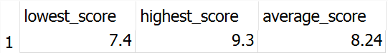

This query calculated the minimum, maximum, and average IMDb score across the dataset. Lowest 7.4, Highest 9.3 and average 8.24. The purpose was to understand the overall rating range and establish a benchmark for comparing individual movies, directors, runtime groups, and countries.
Exploratory Query 4: Text Search Using LIKE
SELECT original_title, release_year, score, income FROM imdb_movies WHERE original_title LIKE '%Star Wars%';

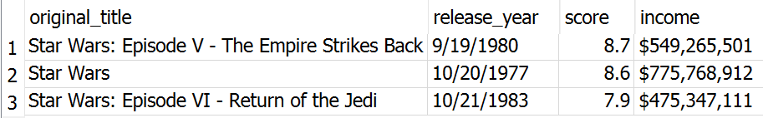
A text pattern query was used to identify movies containing “Star Wars” in the title. This demonstrated how SQL can be used to search for specific franchises or keywords within text fields. This type of query is useful for analyzing franchise performance, brand recognition, or grouped movie series.
7. Business Query Analysis
Business insight queries were developed to answer more specific questions related to movie performance, audience ratings, and financial outcomes.
Business Query 1: Top 10 Highest-Grossing Movies
SELECT original_title, director, country, score, CAST(REPLACE(REPLACE(REPLACE(income, '$', ''), ',', ''), ' ', '') AS REAL) AS cleaned_income FROM imdb_movies ORDER BY cleaned_income DESC LIMIT 10;
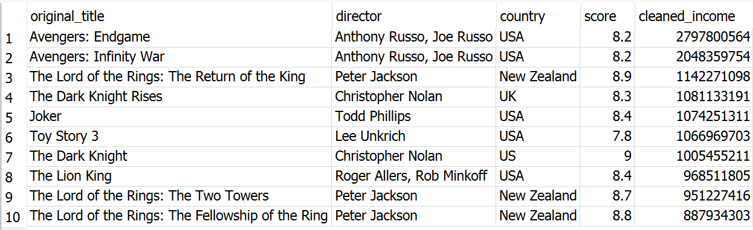

This query ranked movies by box office revenue. Because the income field contained currency formatting, the query removed dollar signs, commas, and extra spaces before sorting the revenue values numerically. The results identified the movies with the highest financial performance in the dataset. Avengers: Endgame and Avengers: Infinity War appeared among the top revenue-generating films, supporting the conclusion that franchise-based films can produce strong financial returns.
Business Query 2: Directors with the Highest Average IMDb Ratings
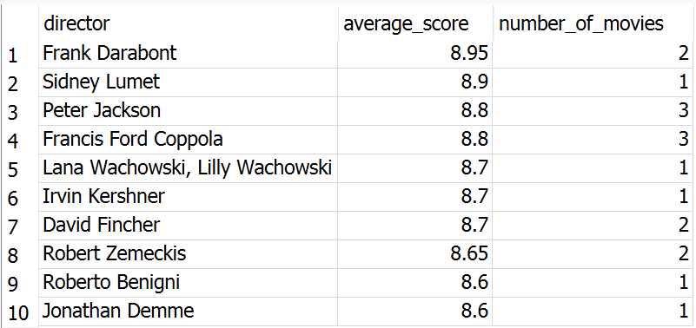
SELECT director, ROUND(AVG(score), 2) AS average_score, COUNT(*) AS number_of_movies FROM imdb_movies GROUP BY director ORDER BY average_score DESC LIMIT 10;

This query grouped movies by director and calculated the average IMDb score for each director. It also counted the number of movies associated with each director. The results helped identify directors whose films consistently received strong audience ratings. This query supports the pivot table analysis by confirming that directors such as Frank Darabont with 3 movies, Sidney Lumet with 1 movie, Peter Jackson with 3 movies, and Francis Ford Coppola also with 3 movies were among the highest-rated directors in the dataset.
Business Query 3: Runtime Groups and Average IMDb Score
SELECT CASE WHEN duration BETWEEN 80 AND 99 THEN '80-99' WHEN duration BETWEEN 100 AND 119 THEN '100-119' WHEN duration BETWEEN 120 AND 139 THEN '120-139' WHEN duration BETWEEN 140 AND 159 THEN '140-159' WHEN duration BETWEEN 160 AND 179 THEN '160-179' WHEN duration BETWEEN 180 AND 199 THEN '180-199' WHEN duration BETWEEN 200 AND 219 THEN '200-219' WHEN duration BETWEEN 220 AND 239 THEN '220-239' ELSE 'Other' END AS runtime_group, ROUND(AVG(score), 2) AS average_score, COUNT(*) AS movie_count FROM imdb_movies GROUP BY runtime_group ORDER BY runtime_group;
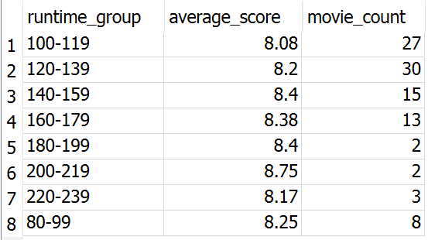

This query grouped movies into runtime categories and calculated the average IMDb score for each group. The purpose was to determine whether longer movies tend to receive higher audience ratings. The results showed that movies in the 200–219 minute runtime group had the highest average rating, while several runtime groups above 140 minutes performed above the overall dataset average.
Business Query 4: Revenue Ranking Using a Window Function
SELECT original_title, director, CAST(REPLACE(REPLACE(REPLACE(income, '$', ''), ',', ''), ' ', '') AS REAL) AS cleaned_income, RANK() OVER ( ORDER BY CAST(REPLACE(REPLACE(REPLACE(income, '$', ''), ',', ''), ' ', '') AS REAL) DESC ) AS revenue_rank FROM imdb_movies LIMIT 10;

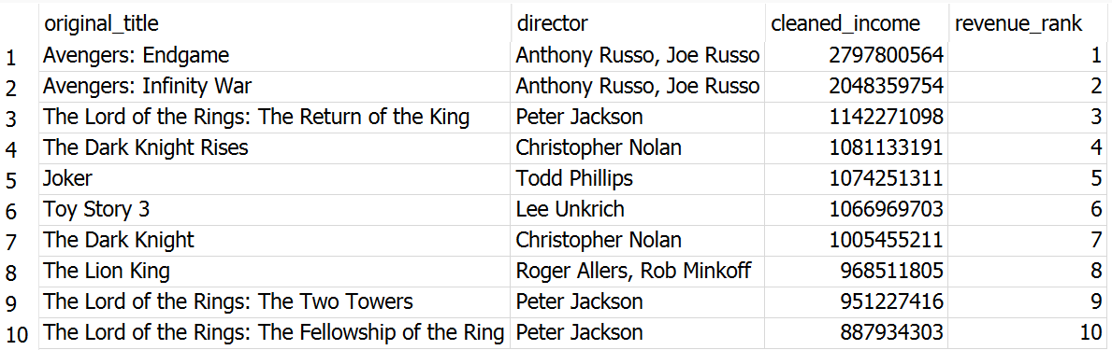

This query used the RANK() window function to rank movies by revenue. Window functions allow analysis across rows while preserving individual movie-level detail. This query provided a more advanced ranking approach and reinforced the financial performance analysis from the pivot tables and visualizations.
8. Documentation and Insight Reporting
The SQL analysis included both exploratory and business-focused queries. Exploratory queries were used to understand the dataset, including record counts, country distribution, rating averages, rating ranges, and text-based searches. Business queries were used to answer more targeted questions related to box office revenue, director performance, and the relationship between movie runtime and audience ratings.
The most significant insights from the SQL analysis were:
- The dataset contained 100 movie records after import.
- No duplicate IMDb title IDs were identified.
- Movie performance varied across countries, directors, runtime groups, and revenue levels.
- Franchise-based movies generated the highest revenue.
- Directors with strong average IMDb ratings may represent lower-risk creative investments.
- Longer runtime groups generally performed well in terms of IMDb score.
These insights could inform business decisions in the film industry by helping studios, streaming platforms, and investors evaluate creative talent, movie characteristics, and revenue potential.
9. Business Recommendations
Based on the Excel and SQL analysis, several recommendations can be made. First, film studios should consider working with directors who have demonstrated strong audience ratings across previous films. Directors with high average IMDb scores may improve the likelihood of positive audience reception and critical success. Second, runtime should be considered as part of the creative planning process. The analysis showed that longer movies, especially those above 140 minutes, generally received strong ratings. While runtime alone does not guarantee success, more complex stories may benefit from additional screen time.
Third, studios should continue investing in franchise-based content and recognizable intellectual property. The highest-grossing movies in the dataset were dominated by blockbuster franchises, including Marvel, The Lord of the Rings, Batman, and other well-known brands. This suggests that sequels, cinematic universes, and established franchises may offer strong revenue potential. Finally, decision-makers should evaluate both audience ratings and revenue together. Some movies may achieve strong critical reception without generating the highest revenue, while others may generate significant income through franchise recognition and global marketing. A balanced approach that considers both creative quality and commercial performance can support better investment decisions.

