Part 1 – Sales Performance
Business Question 1
Which product category sold the highest number of products?
SELECT product_type,
SUM(CAST (number_of_products_sold AS INTEGER) ) AS total_products_sold
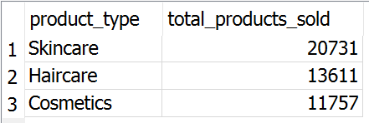
FROM supply_chain
GROUP BY product_type
ORDER BY total_products_sold DESC;
Business Question 2
Which product category generated the highest revenue?
SELECT product_type,
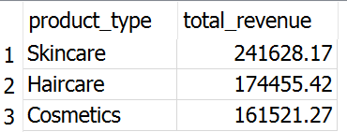
ROUND(SUM(CAST (REPLACE(REPLACE(revenue_generated, '$', ''), ',', '') AS REAL) ), 2) AS total_revenue
FROM supply_chain
GROUP BY product_type;
Business Question 3
Which customer demographic generated the highest revenue?
SELECT customer_demographics,
ROUND(SUM(CAST (REPLACE(REPLACE(revenue_generated, '$', ''), ',', '') AS REAL) ), 2) AS total_revenue
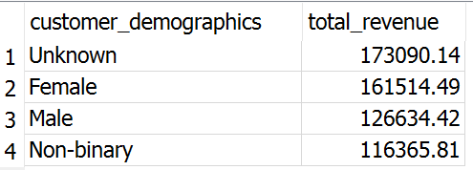
FROM supply_chain
GROUP BY customer_demographics
ORDER BY total_revenue DESC;
Business Question 4
Which customer demographic purchased the most products?
SELECT customer_demographics,
SUM(CAST (number_of_products_sold AS INTEGER) ) AS total_products_sold
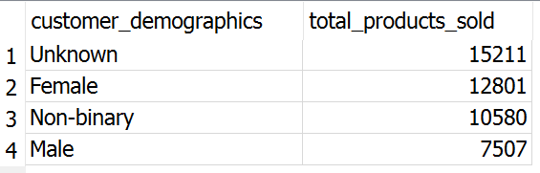
FROM supply_chain
GROUP BY customer_demographics
ORDER BY total_products_sold DESC;
Part 2 – Supply Chain Efficiency
Business Question 5
Which suppliers have the longest average manufacturing lead time?
SELECT supplier_name,
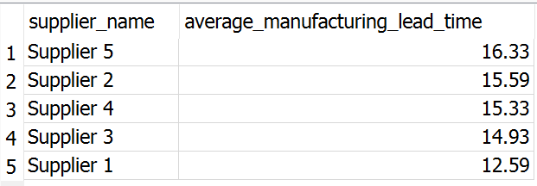
ROUND(AVG(CAST (manufacturing_lead_time AS REAL) ), 2) AS average_manufacturing_lead_time
FROM supply_chain
GROUP BY supplier_name
ORDER BY average_manufacturing_lead_time DESC;
Business Question 6
Which transportation mode has the highest average shipping cost?
SELECT transportation_modes,
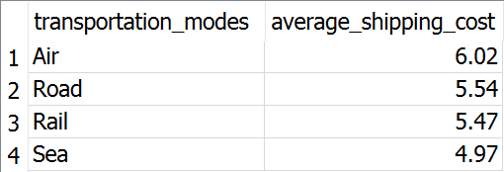
ROUND(AVG(CAST (REPLACE(REPLACE(shipping_costs, '$', ''), ',', '') AS REAL) ), 2) AS average_shipping_cost
FROM supply_chain
GROUP BY transportation_modes
ORDER BY average_shipping_cost DESC;
Business Question 7
Which transportation mode carries the largest order volume?
SELECT transportation_modes,
SUM(CAST (order_quantities AS INTEGER) ) AS total_order_quantity
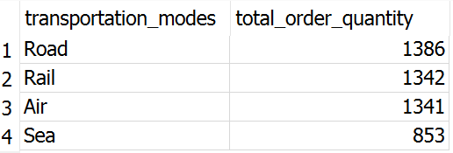
FROM supply_chain
GROUP BY transportation_modes
ORDER BY total_order_quantity DESC;
Business Question 8
Which shipping carrier performs best based on shipping cost and shipping time?
SELECT shipping_carriers,
ROUND(AVG(CAST (REPLACE(REPLACE(shipping_costs, '$', ''), ',', '') AS REAL) ), 2) AS average_shipping_cost,
ROUND(AVG(CAST (shipping_times AS REAL) ), 2) AS average_shipping_time
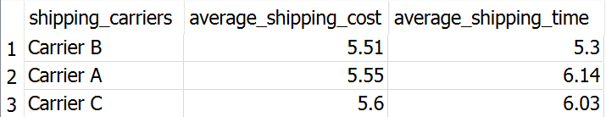
FROM supply_chain
GROUP BY shipping_carriers
ORDER BY average_shipping_cost ASC,
average_shipping_time ASC;
Part 3 – Product Quality
Business Question 9
Which inspection result occurs most frequently?
SELECT inspection_results,
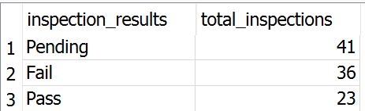
COUNT( * ) AS total_inspections
FROM supply_chain
GROUP BY inspection_results
ORDER BY total_inspections DESC;
Business Question 10
Which product category has the highest average defect rate?
SELECT product_type,
ROUND(AVG(CAST (defect_rates AS REAL) ), 2) AS average_defect_rate
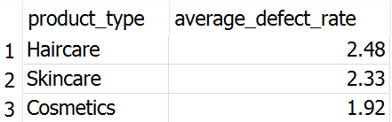
FROM supply_chain
GROUP BY product_type
ORDER BY average_defect_rate DESC;

Business Question 11
Which suppliers have the highest average defect rates?
SELECT supplier_name,
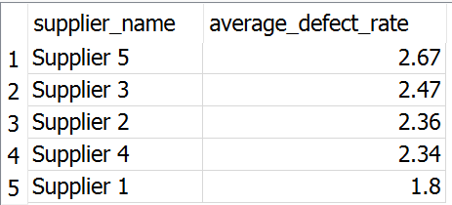
ROUND(AVG(CAST (defect_rates AS REAL) ), 2) AS average_defect_rate
FROM supply_chain
GROUP BY supplier_name
ORDER BY average_defect_rate DESC;
Part 4 – Inventory
Business Question 12
Which product category has the highest average stock level?
SELECT product_type,
ROUND(AVG(CAST (stock_levels AS REAL) ), 2) AS average_stock_level
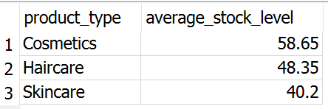
FROM supply_chain
GROUP BY product_type
ORDER BY average_stock_level DESC;
Business Question 13
Which product category has the highest average product availability?
SELECT product_type,
ROUND(AVG(CAST (availability AS REAL) ), 2) AS average_availability
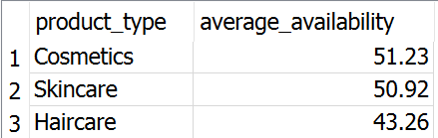
FROM supply_chain
GROUP BY product_type
ORDER BY average_availability DESC;
Business Question 14
Which product category has the highest sales but the lowest average stock level?
SELECT product_type,
SUM(CAST (number_of_products_sold AS INTEGER) ) AS total_products_sold,
ROUND(AVG(CAST (stock_levels AS REAL) ), 2) AS average_stock_level
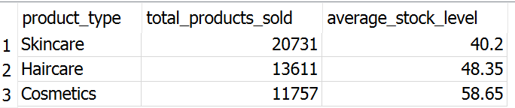
FROM supply_chain
GROUP BY product_type
ORDER BY total_products_sold DESC;

