Project Name;
MiyaraTrader Ecosystem
Description
A cloud-based trading platform, affiliate management system, and SaaS ecosystem that integrates with the Deriv API to provide trading tools, educational resources, affiliate tracking, and white-label mentor portals.
The system has 11 major modules;
- Trading Platform
●For traders.
Features:
》Deriv login
》Trading dashboard
》Bot trading
》Signal area
》Strategy builder
》Account management\Copy Trading
- Education Platform
●For students.
Features:
》Courses
》Live classes
》Videos
》Community
》Notifications
》Progress tracking
- Affiliate Platform
✅️For me.
Features:
》Referral tracking
》Commission dashboard
》Student management
》Analytics
》Reports
- Commission & Wallet Management Module

✅️For: Affiliates and Mentors

Features:

- Commission Dashboard
- Monthly Earnings Summary
- Available Commission Balance
- Commission Breakdown (Direct Referrals, Sub-Partner Commissions, Bonuses)
- Secure Wallet
- Automatic Withdrawal Requests
- Withdrawal History
- Payment History
- Real-Time Wallet Balance Updates
- Notifications for Successful or Failed Withdrawals

Supported Withdrawal Methods

- M-Pesa
- Bank Transfer
- Cryptocurrency
- Other payment methods (Future Updates)

- Automated Payout System

✅️For: Super Admin

Features:

- Automatic commission calculation
- Automatic monthly commission distribution
- Automatic sub-partner commission distribution
- Automatic payout processing based on predefined rules
- Automatic payment confirmations
- Failed payment detection and retry system
- Transaction logs and audit trail
- Fraud detection and security checks
- Admin dashboard for monitoring payouts
- Manual override in case of payment failures or exceptional circumstances

Payout Logic

The system shall automatically calculate all eligible commissions and distribute payments to affiliates and mentors according to the configured commission structure.

No manual approval should be required for successful payouts unless a transaction fails, is flagged by the security system, or requires administrative review.

Every completed payout must be recorded automatically in the user’s wallet and payment history, with a corresponding transaction reference.

- Mentor SaaS Platform
✅️For other mentors.
●Each mentor gets:
》Their own website
》Their own branding
》Their own students
》Their own dashboard
》Their own referral system
■While I manage the infrastructure.
The type of software I want is this;
FinTech SaaS Platform
Built around:
》Deriv API
》Trading Automation
》Affiliate Marketing
》White-label Technology

- Authentication & Security

For: All Users

Features:

- User Registration
- Secure Login
- Two-Factor Authentication (2FA)
- Email Verification
- Password Recovery
- Device & Session Management
- Role-Based Access Control (Admin, Mentor, Student)
- End-to-End Data Encryption
- Secure API Authentication
- Activity Logs
- Fraud Detection
- Automatic Security Monitoring

- Notification System

For: All Users

Features:

- Email Notifications
- SMS Notifications
- Push Notifications
- In-App Notifications
- Commission Payment Alerts
- Withdrawal Notifications
- Student Enrollment Notifications
- Live Class Reminders
- Trading Bot Alerts
- System Maintenance Notifications

- System Administration

For: Super Admin

Features:

- User Management
- Mentor Management
- Student Management
- Affiliate Management
- Commission Management
- Wallet Management
- Content Management
- Course Management
- Live Class Management
- Reports & Analytics
- Audit Logs
- System Configuration
- Platform Monitoring
- Backup & Restore

- API & Third-Party Integrations

Integrations:

- Deriv API
- Deriv Partner API
- Payment Gateway APIs
- M-Pesa API
- Bank Payment APIs
- Cryptocurrency Payment APIs
- Email Service API
- SMS Service API
- Push Notification API
- Google Analytics
- Cloud Storage Integration

- Cloud Infrastructure

Features:

- Cloud Hosting
- High Availability
- Automatic Scaling
- Secure Database
- Automatic Backups
- Disaster Recovery
- SSL Security
- CDN (Content Delivery Network)
- Performance Monitoring
- System Health Monitoring
- Error Logging
- Load Balancing

IN SIMPLE TERMS ;
I want to build a cloud-based FinTech SaaS platform integrated with the Deriv API. The platform should support trading tools, bot automation, affiliate management, educational content, and a white-label mentor system where multiple mentors can operate their own branded portals under a central infrastructure.

I WANT IT IN THIS PHASES:
Phase 1: Independent MiyaraTrader platform.
Phase 2: Trading bots and education.
Phase 3: Affiliate dashboard and analytics.
Phase 4: Nexora White-label Platform for mentors.
BODY✅️;
I’m building out the next phase of my trading business, and I want to completely move away from relying on a third-party white-label platform. I’ve been thinking through the architecture, and I’d like your opinion on whether it’s the right approach and whether we can build it together over time.

Phase 1 – Keep Existing Students Running

I currently have 66 active students trading through a DForge white-label system.

I don’t want to interfere with that setup because they’re already mapped to my affiliate tracking and continue generating commissions.

The only thing I’d like is for miyaratrader.site to have an “Existing Member Login (DForge)” button that simply redirects them to the current DForge login page.

No backend changes—just preserve what already works.

Phase 2 – Build Our Own Independent Platform

For all future students, I want to bypass DForge completely.

The idea is to rebuild miyaratrader.site as our own independent platform hosted on something like Vercel, Netlify, or a VPS.

The plan is to:

- Register an official Deriv application and obtain our own App ID.
- Integrate directly with the Deriv API.
- Build a lightweight trading interface.
- Allow users to connect using their own Deriv API tokens.
- Eventually, build our own trading bots and automation tools.
Ensure every new signup uses my official Deriv Partner referral link so commissions are tracked directly through my Partner account.

Phase 3 – Build a Master Partner Platform

In the long term, I’d like to launch a separate platform (something like DERIV HUB) where other mentors can onboard, become Deriv partners through my master partner referral, and receive their own branded trading portals.

One feature I really want us to build is an automatic commission-sharing system, similar to how DForge works.

For example:

Every mentor operates under our platform.
The platform automatically tracks each mentor’s commission.
The system automatically allocates 80% to the mentor and 20% to the platform owner (me) without any manual calculations.

Each mentor should have their own dashboard showing:

- Total commissions earned.
- Platform share (20%).
- Net earnings (80%).
- Withdrawal history.

The admin dashboard should show:

- Total commissions across all mentors.
- Platform earnings from every mentor.
- User management.
- Reports and analytics.
- Withdrawal approvals.

Basically, I want us to build our own ecosystem instead of depending on DForge, so in the future, we own the technology and can continue improving it ourselves.

Project Objectives

• Build a fully independent trading ecosystem integrated with the Deriv API.

• Eliminate dependence on third-party white-label providers for future growth.

• Provide traders with trading tools, educational content, and trading automation in one platform.

• Create a scalable affiliate and commission management system.

• Build an automated wallet and payout infrastructure.

• Develop a white-label SaaS platform that allows mentors to launch their own branded trading businesses.

• Build a secure, cloud-based platform capable of supporting thousands of users globally.

• Establish MiyaraTrader Ecosystem as a long-term FinTech company built on innovation, automation, and scalable technology.

I already have the Deriv API documentation, partner links, and technical references ready.

I really believe this could grow into a serious long-term business if we build it properly.

MIYARA TRADER,

Thank you!

Platform Visual Concepts

MiyaraTrader Vision


Nexora White-label Platform
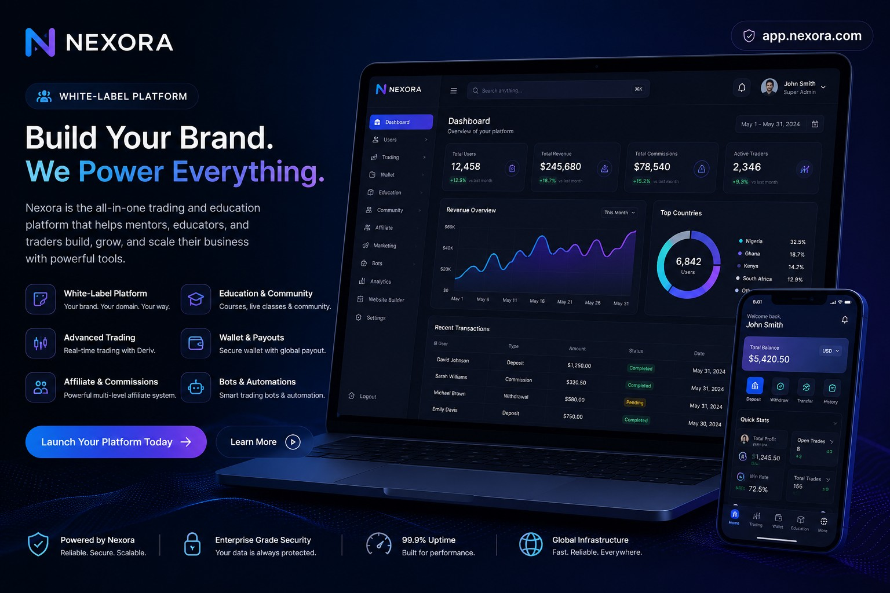

Nexora Dashboard
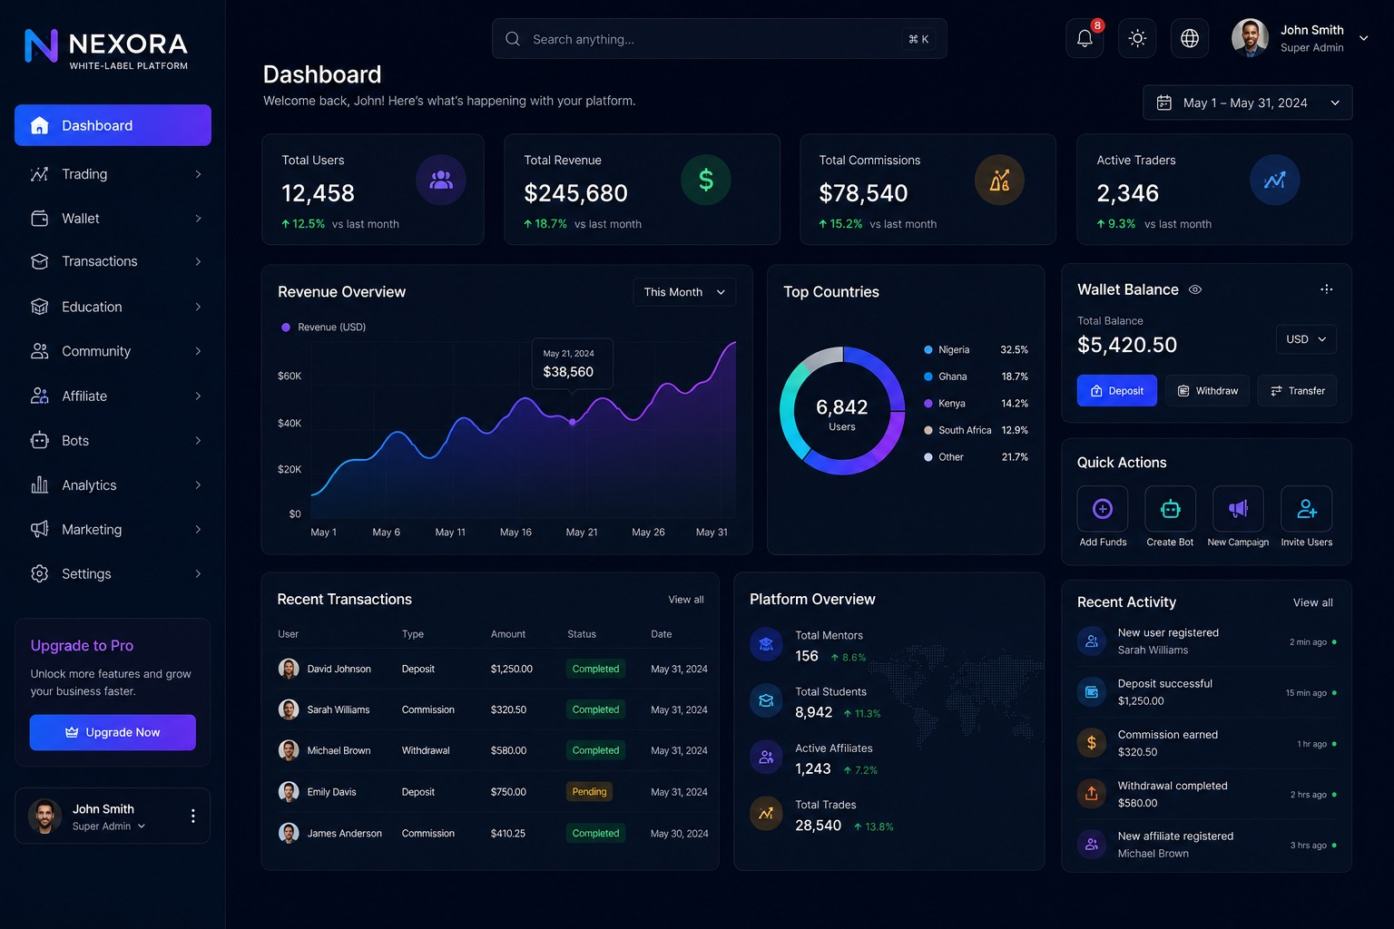

Education Platform
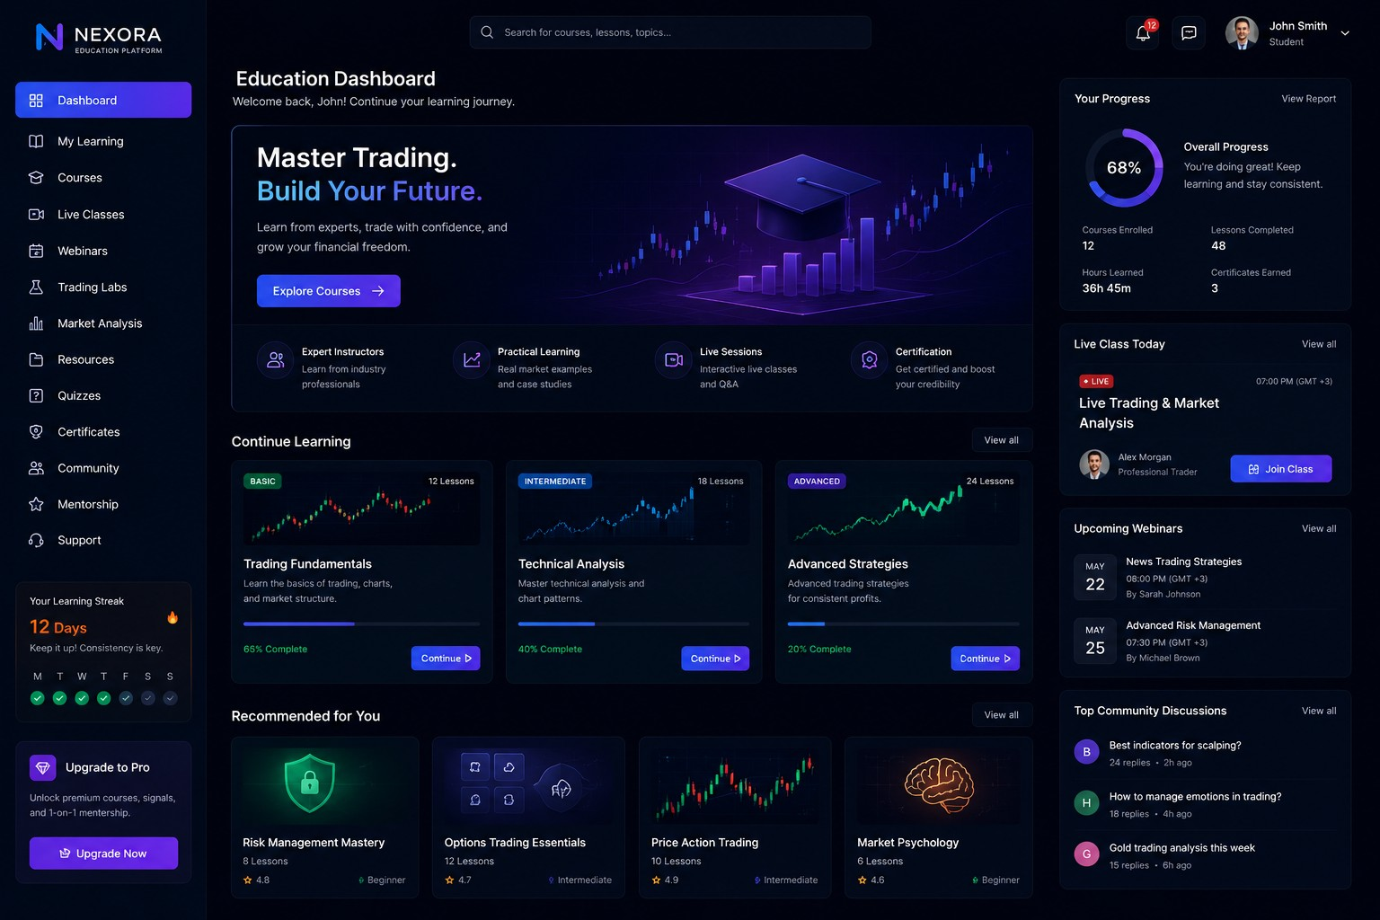

Trading Automation
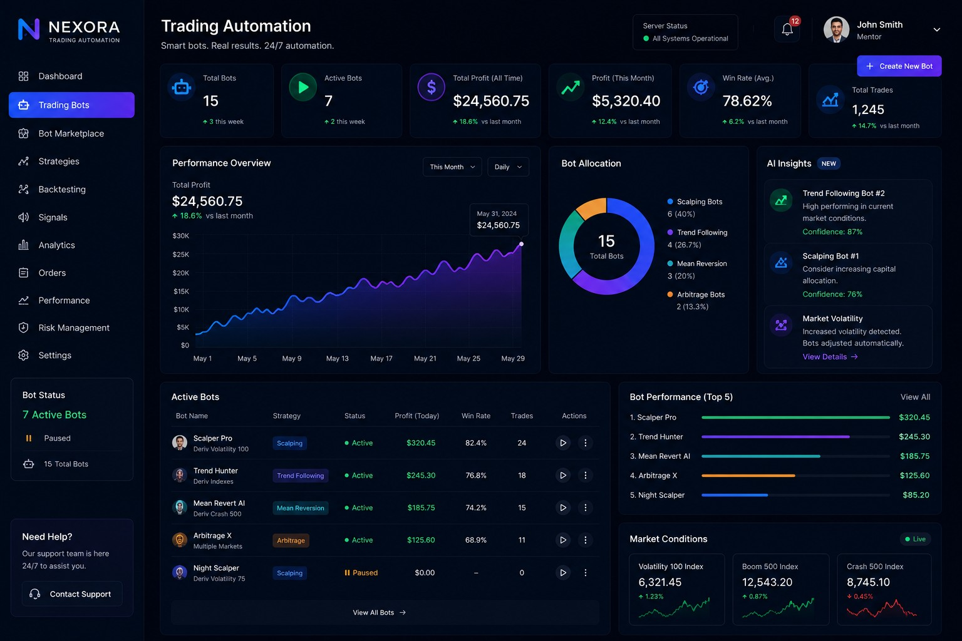

Affiliate & Wallet Dashboard
