Software Requirements and Design Document

For

Group 21

Version 1.0

Authors:
Robert B
Isabella C

Overview (5 points)
Give a general overview of the system in 1-2 paragraphs (similar to the one in the project proposal).

Our project is a website, called Garnet & Gather, that will be a place to help students plan meetups with their friends or create/find club/classes/group events/meetups happening around campus. We are implementing tools to help users manage their schedules, pick what events they want to attend, etc. We included role-base accesses for clubs/classes/groups that want to create events, and a schedule assistant for group availability.

Functional Requirements (10 points)
List the functional requirements in sentences identified by numbers and for each requirement state if it is of high, medium, or low priority. Each functional requirement is something that the system shall do. Include all the details required such that there can be no misinterpretations of the requirements when read. Be very specific about what the system needs to do (not how, just what). You may provide a brief design rationale for any requirement which you feel requires explanation for how and/or why the requirement was derived.

- Allow users to create accounts and authenticate user secure login
  - Priority: High
- Allow students to browse for upcoming campus events, including event description, name, date, time, and location
  - Priority: High
- Allow authorized users to create, edit, or delete events for their specific group/club/organization
  - Priority: High
- Allow users to form informal meetups with friends by specifying who, what, where, and when
  - Priority: High
- Allow users to join, leave, RSVP for events/meetups
  - Priority: Medium
- Should notify users when an event’s time, date, or location change
  - Priority: Medium
- Provide a dining selector to help users choose from the dining options around campus for meetups
  - Priority: Medium
- Should display event meetup locations user a campus map interface
  - Priority: Low

Non-functional Requirements (10 points)
List the non-functional requirements of the system (any requirement referring to a property of the system, such as security, safety, software quality, performance, reliability, etc.) You may provide a brief rationale for any requirement which you feel requires explanation as to how and/or why the requirement was derived.
- Should respond to user actions, like loading events, submitting forms, clicking buttons within a short time frame
- Should provide a consistent and easy to use user interface to reduce the learning curve
- Should be maintainable to allow for future feature expansion
- Should make sure user data is securely stores and protected
  - Rationale: Protects user privacy and prevents unauthorized access

Use Case Diagram (10 points)
This section presents the use case diagram and the textual descriptions of the use cases for the system under development. The use case diagram should contain all the use cases and relationships between them needed to describe the functionality to be developed. If you discover new use cases between two increments, update the diagram for your future increments.
Textual descriptions of use cases: For the first increment, the textual descriptions for the use cases are not required. However, the textual descriptions for all use cases discovered for your system are required for the second and third iterations.

Use Case Diagram (10 points)
This section presents the use case diagram and the textual descriptions of the use cases for the system under development. The use case diagram should contain all the use cases and relationships between them needed to describe the functionality to be developed. If you discover new use cases between two increments, update the diagram for your future increments.
Textual descriptions of use cases: For the first increment, the textual descriptions for the use cases are not required. However, the textual descriptions for all use cases discovered for your system are required for the second and third iterations.

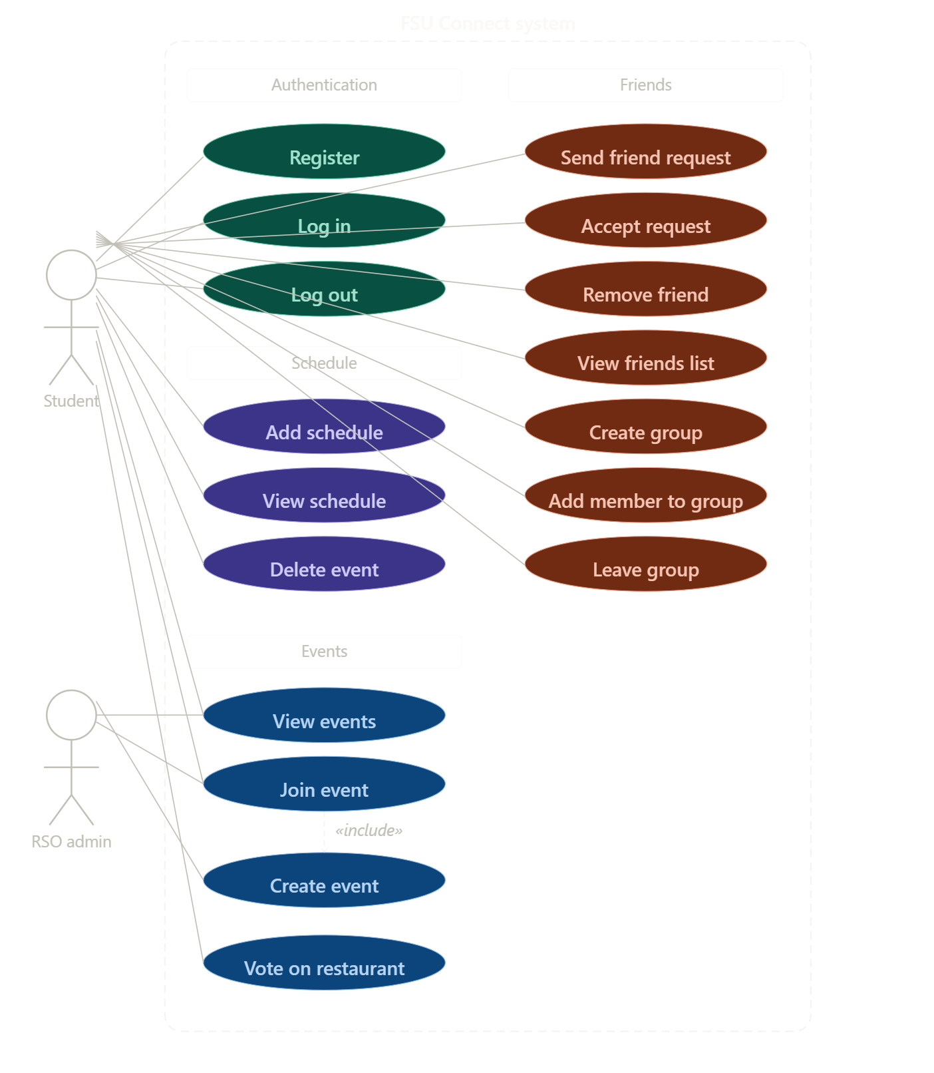

Class Diagram and/or Sequence Diagrams (15 points)
This section presents a high-level overview of the anticipated system architecture using a class diagram and/or sequence diagrams.

If the main paradigm used in your project is Object Oriented (i.e., you have classes or something that acts similar to classes in your system), then draw the Class Diagram of the entire system and Sequence Diagrams for the three (3) most important use cases in your system.

If the main paradigm in your system is not Object Oriented (i.e., you do not have classes or anything similar to classes in your system) then only draw Sequence Diagrams, but for all the use cases of your system. In this case, we will use a modified version of Sequence Diagrams, where instead of objects, the lifelines will represent the functions in the system involved in the action sequence.

Class Diagrams show the fundamental objects/classes that must be modeled with the system to satisfy its requirements and the relationships between them. Each class rectangle on the diagram must also include the attributes and the methods of the class (they can be refined between increments). All the relationships between classes and their multiplicity must be shown on the class diagram.

A Sequence Diagram simply depicts interaction between objects (or functions - in our case - for non-OOP systems) in a sequential order, i.e. the order in which these interactions take place. Sequence diagrams describe how and in what order the objects in a system function.
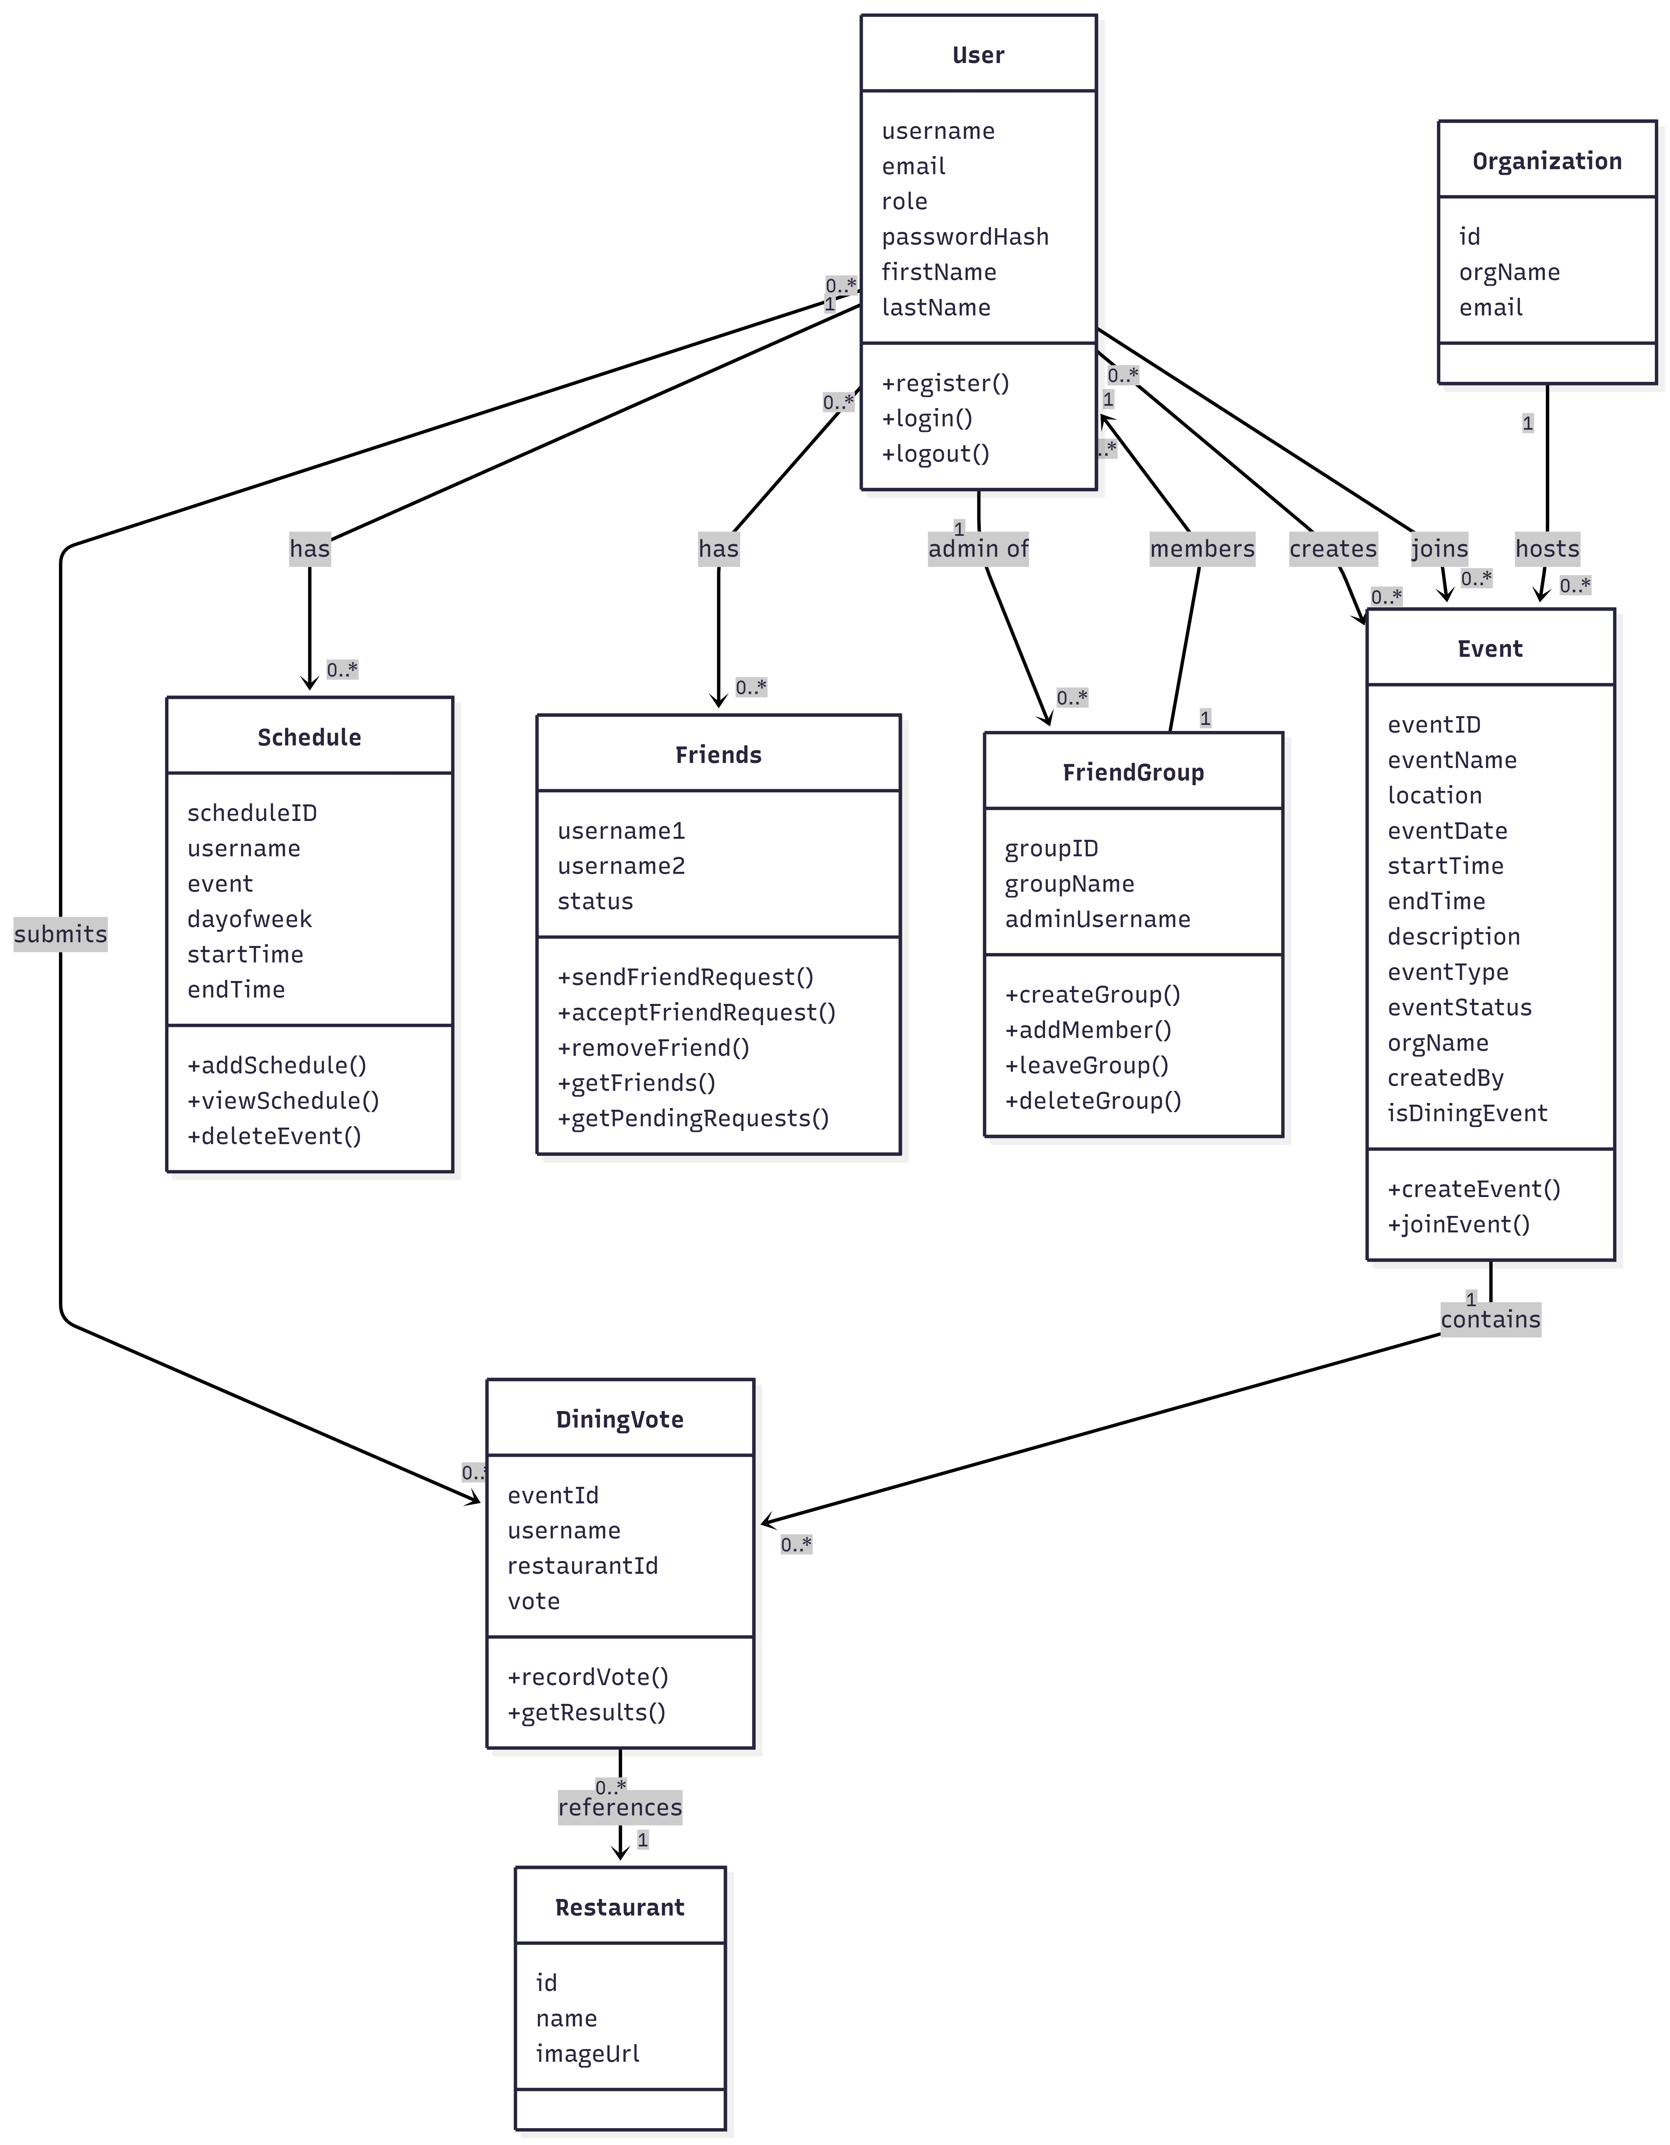

Class Diagram and/or Sequence Diagrams (15 points)
This section presents a high-level overview of the anticipated system architecture using a class diagram and/or sequence diagrams.

If the main paradigm used in your project is Object Oriented (i.e., you have classes or something that acts similar to classes in your system), then draw the Class Diagram of the entire system and Sequence Diagrams for the three (3) most important use cases in your system.

If the main paradigm in your system is not Object Oriented (i.e., you do not have classes or anything similar to classes in your system) then only draw Sequence Diagrams, but for all the use cases of your system. In this case, we will use a modified version of Sequence Diagrams, where instead of objects, the lifelines will represent the functions in the system involved in the action sequence.

Class Diagrams show the fundamental objects/classes that must be modeled with the system to satisfy its requirements and the relationships between them. Each class rectangle on the diagram must also include the attributes and the methods of the class (they can be refined between increments). All the relationships between classes and their multiplicity must be shown on the class diagram.

A Sequence Diagram simply depicts interaction between objects (or functions - in our case - for non-OOP systems) in a sequential order, i.e. the order in which these interactions take place. Sequence diagrams describe how and in what order the objects in a system function.

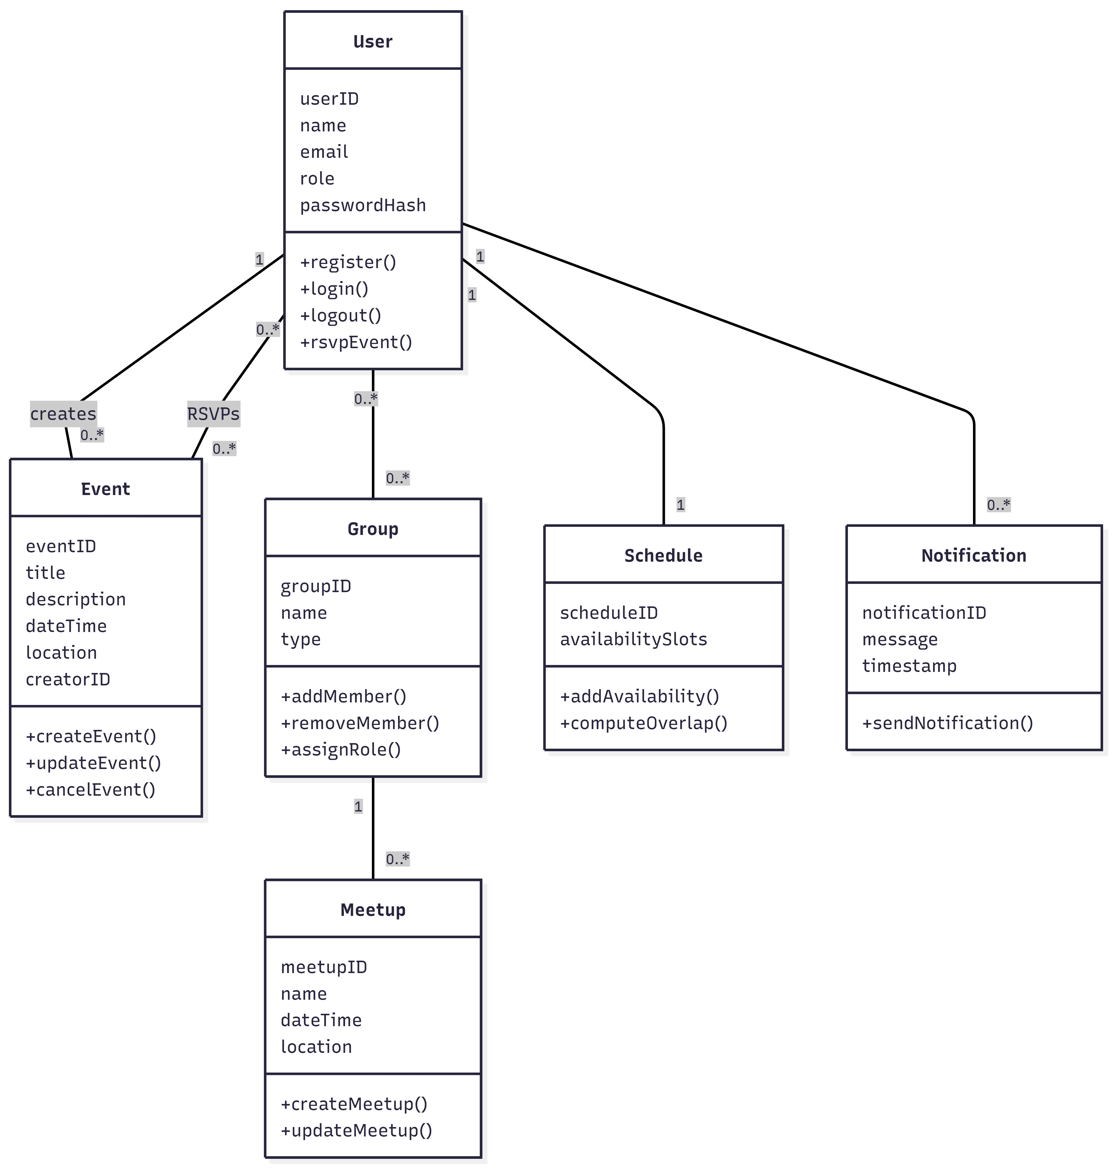

Operating Environment (5 points)
Describe the environment in which the software will operate, including the hardware platform, operating system and versions, and any other software components or applications with which it must peacefully coexist.

Garnet & Gather will operate as a web-based application accessible through browsers like Edge or Chrome. The frontend will run on client devices like laptops, tablets, and smartphones using HTML. The backend will run on a server environment supporting Python and Flask, with SQL database system. It will work hand in hand with other campus web services like event feeds.

Assumptions and Dependencies (5 points)
List any assumed factors (as opposed to known facts) that could affect the requirements stated in this document. These could include third-party or commercial components that you plan to use, issues around the development or operating environment, or constraints. The project could be affected if these assumptions are incorrect, are not shared, or change. Also identify any dependencies the project has on external factors, such as software components that you intend to reuse from another project.

Assumptions:
- Users will accurately provide their availability for scheduling
- Campus event data will be available through an accessible feed or API
- Users will have consistent internet access

Dependencies:
- Third-party libraries, like React and Flask
- Database

