A Review of Student-led Initiatives in European

Space Activities
Maximilian von Arnim
__________________________________________________________________________
Abstract
Space is becoming ever more accessible to university students. Over the past ten to fifteen years, a broad ecosystem of student-led initiatives has formed across Europe. A key enabler have been government programs that provide funding, experiment platforms, launch sites and expertise to student teams. Further important players are private enterprises, recognizing the value offered by spaceflight, and of course the universities themselves, who supply the necessary tools, laboratories and academic supervision. This contribution provides a comprehensive overview of recent and currently ongoing student projects across Europe. We find that virtually all European universities with space engineering programs foster such teams, but also many whose focus lies in other domains such as life sciences, physics or applied engineering. Key international programs open to student proposals are the European Rover Challenge (ERC), the European Rocketry Challenge (EUROC), REXUS/BEXUS for sounding rockets and balloons, as well as ESA's Fly Your Satellite and Academy Experiments programs. Beyond that, we find national programs like the German "Überflieger" student competition for ISS experiments, or the French C'Space campaign for student launchers. Among these opportunities, national differences become visible. French teams participate rarely in international events but profit from a wide array of domestic opportunities. We find Polish universities especially strong in robotics and Portuguese teams over-represented in rocketry, likely linked to them being host countries for the respective competitions, while international programs provide valuable opportunities to students in states with less developed space sectors. Remarkably, a small number of universities is highly active across all domains, attesting to their importance in the European space sector. Nonetheless, it is also observed that some student initiatives are short-lived or are discontinued despite initial successes. Recognizing the importance of continuity and institutional representation, overarching support can be provided by either student-led federations of associations, as well as similar supervision by national space agencies, non-governmental organizations or federations of universities. This contribution concludes with a reflection on the interaction between different European higher education systems and the success of student-led spaceflight initiatives.
Keywords
Student Club, Space Competition, Hands-on Education
__________________________________________________________________________

Acronyms/Abbreviations
CDR Critical Design Review
CNES The French space agency
DLR The German Aerospace Center
ERC European Rover Challenge
ESA European Space Agency
EUROC European Rocketry Challenge
FYS Fly Your Satellite
PETRI Practical Education in Technology, Research and Innovation
SNSA The Swedish National Space Agency
- Introduction
Since 2009, the European Space Agency (ESA) has developed a wealth of educational programs, notably the “Your Thesis” program covering microgravity experiments in parabolic flights (“Fly Your Thesis”), drop towers (“Drop Your Thesis”) or on the ISS (“Orbit Your Thesis”), as well as hypergravity experiments on centrifuges (“Spin Your Thesis”). In 2022, these were merged into a unified program, Practical Education in Technology, Research and Innovation (PETRI) [1], which has since been renamed ESA Academy Experiments and expanded to also cover in-orbit demonstrations–using the Space Rider platform–and orbital robotics [2]. Additionally, ESA offers student teams the “Fly Your Satellite” (FYS) program to accompany CubeSat projects from the Critical Design Review (CDR) to launch and operations [3].
ESA further collaborates with several initiatives led by member states. Among these, we find REXUS/BEXUS, a Swedish-German cooperation between the German Aerospace Center (DLR) and the Swedish National Space Agency (SNSA) offering student teams to conduct experiments on sounding rockets and balloons [4; 5]. Another one is the European Rocketry Challenge (EUROC), a rocketry competition organized by the Portuguese Space Agency [6].
In terms of competitions, a second major player is the European Rover Challenge (ERC), challenging student teams to develop technologies for space rovers [7]. ERC is not linked to ESA; instead, it is led by the European Space Foundation and financed, among others, by Poland and the European Union.
Other competitions beyond the scope of this contribution exist for drones and CanSats, with the latter often oriented towards secondary education.
On the national level, many European states organize programs or competitions open to university student teams. These are usually only open to students of the respective state or states. The French space agency (CNES) has been organizing C'Space [8] since 1963, offering initially only rocketry, later also balloon, competitions to university students. Additionally, parabolic flight opportunities are provided [9]. Germany in cooperation with Luxembourg ran two rounds of the “Überflieger” program in 2017 and 2021, respectively, offering experiment opportunities on ISS [10; 11]. DLR further launched the STERN program in 2012, supporting German student groups for sounding rocket development [12]. Norway initiated student-led satellite development with the ANSAT program between 2007 and 2013 [13]. Portugal launched the first round of “CubeSat Portugal” in 2024 [14], with a selection among seven teams expected mid-2026 [15]. In the UK, UKSEDS organizes competitions for satellite payloads and CubeSats, rovers, rocketry and in-orbit robotics [16].
Many student groups conduct independent activities, often funded by local actors or integrated in educational activities. This is especially common for light-weight high-altitude balloons, CanSats and small model rockets, as they require minimal infrastructure or investment. While we find such projects in many of the surveyed groups, their decentralized and often fast-paced nature makes it hard to provide an exhaustive list.
Lastly, many universities conduct space activities under the leadership of faculty members. Especially satellites demand long-term supervision, expertise and financing beyond what typical student groups can provide. These projects may involve students and can be included in educational activities but are not considered self-organized student groups in the context of this contribution. However, these projects draw their students from such groups and, in some cases, have led to the founding of independent student groups.
- Methodology
This contribution presents a survey of student group activities in European space education. Finding student groups is the first hurdle to pass. To do so, the programs and competitions were searched to obtain the names and home universities of the participating groups. The years when groups were active were noted as well, especially the year when the group was founded. Where available, each group's internet and social media presence was added to their entry. From this dataset, we extracted statistics concerning the type of activities (robotics, rocketry, satellites), the groups' 'lifespans', and their distribution in Europe.
- Results
First, a map-based analysis shows the wide distribution of universities that competed in at least one of the fields, with Figure 1 showing all projects while Figure 2 focuses on independent student teams only. Following that, we evaluate team properties of each of the competitions.
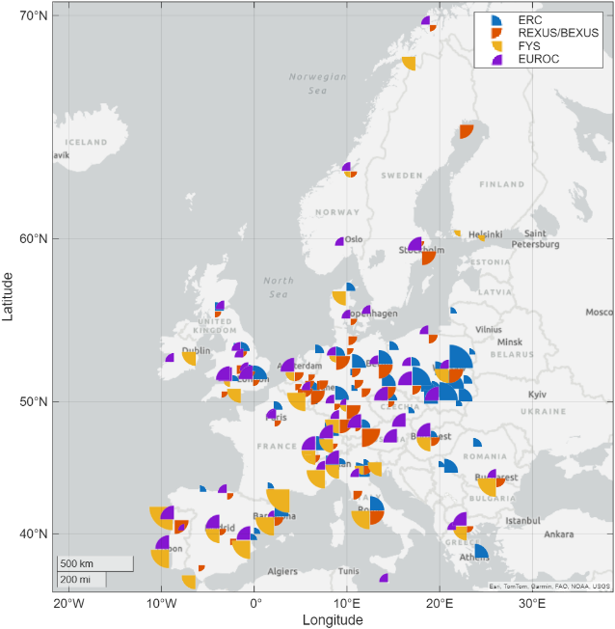
Figure 1. Map of all projects surveyed. Each slice of the pie chart represents the type of competition while its size indicates the years of activity in the respective domain.

  - REXUS/BEXUS
Several self-organizing student groups have formed only after participating in an institutional program, or even several. For example, students from TU Dresden participated in multiple REXUS/BEXUS rounds before creating the student group STAR Dresden in 2017. Similar paths led to the creation of WueSpace at JMU Würzburg, the Space Team Aachen at RWTH Aachen / FH Aachen, or KTHAero at KTH in Stockholm in 2019.
Others were kick-started by entering such a program. Among this group, we find KSat Stuttgart at the University of Stuttgart, which was founded in 2014 before participating in their first REXUS/BEXUS round.
Nonetheless, many teams form only for a single iteration of such a structured program, disbanding shortly thereafter. In some cases, for example the PHOS and U-PHOS projects at the University of Pisa, a succession is established, but the lack of permanent student-organized structures makes it hard to keep this effort going when a project ends. Critically, a lack of continuity forces each team to establish once more a network of sponsors and faculty support. In exceptional cases, though, continuous participation of spontaneously formed groups has been found, for example at Lulea University of Technology with participation in nearly every iteration of REXUS/BEXUS, or TU Berlin's TUPEX series of experiments. This speaks towards strong support for student initiatives by the university.
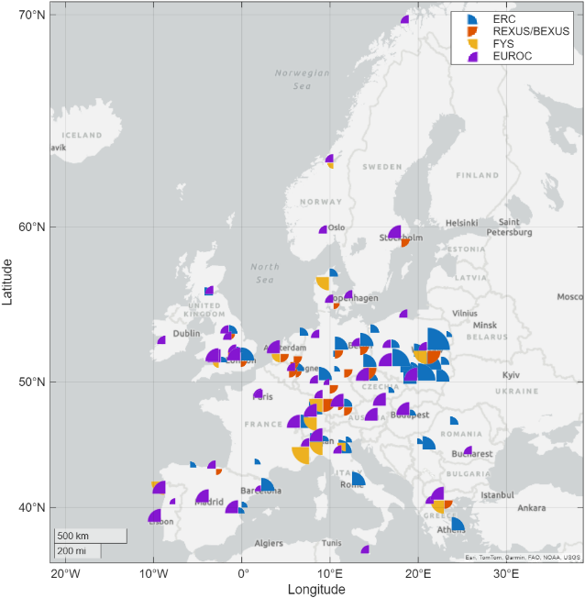
Figure 2. Map of only the projects led by an independent student team. Each slice of the pie chart represents the type of competition while its size indicates the years of activity in the respective domain.

Independent project-specific teams pose challenges for the long-term availability of documentation, as their websites stop being maintained and servers go offline. What remains is typically only the record on the event organizers' sites–though these mentions can be incomplete and hard to crawl–and the social media presence, even if no longer updated. This justifies the importance many programs such as REXUS/BEXUS assign to public outreach. Still, creating new accounts for each mission forces their followers to move accordingly, curbing the reach of their posts, a key metric for credibility and sponsorship attractiveness.
Projects leave a legacy in the scientific domain, of course, though publications can be hard to find (not all IAC contributions are found on Google Scholar, for example) and difficult to associate with student-led groups if the authors register under the name of their home university, or if the project name is not unique.
Looking at the 56 universities and 5 multi-university collaborations (for a total of 62 individual institutions) that provided the 138 teams participating in REXUS/BEXUS launches between 2015 and 2025, 15 (25%) organized all projects through an independent student club, 36 (59%) saw only spontaneous project-specific student initiatives, 5 (8%) had both types of projects, and another 5 (8%) were organized by a permanent non-student-led structure. Figure 3 shows the distribution of these by state; here, universities that saw both types of project were counted twice.
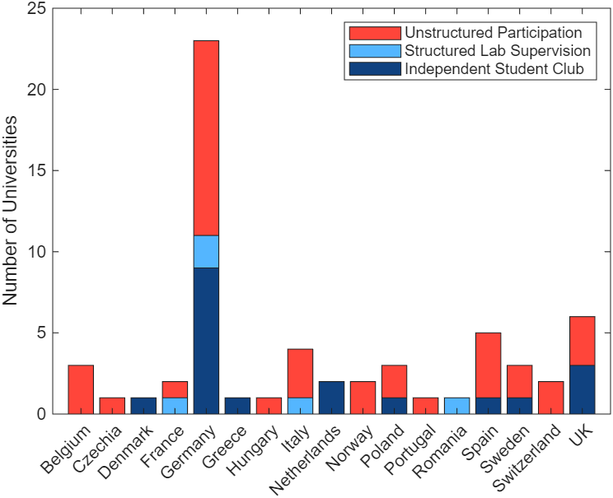
Figure 3. Universities or multi-university collaborations participating in REXUS/BEXUS with launch 2015-2025, sorted by team organizational structure

We clearly see that student clubs are popular in Germany, the Netherlands and the UK. Notably, 4 out of 5 universities that saw REXUS/BEXUS teams both with and without an independent student club are in Germany, largely explained by the creation of multiple such groups between 2019 and 2022.
Conversely, the francophone states–Belgium, France, Switzerland–do not have any such student clubs for REXUS/BEXUS projects, and most teams from Spain and Italy do not rely on such support either. If there is any long-lasting support structure, French and Italian teams tend to be found under the umbrella of a faculty-led organization like the “centre spatial” (“space center”) in France. The small sample size ($n≤2$) for some of the states allows no clear conclusion there.
  - Fly Your Satellite
For Fly Your Satellite, we observe that most projects depend on a faculty-provided support structure despite being student-led.
Nonetheless, out of 37 projects associated with the program, several (12 projects, 32%) can count on a student club for self-organization. We remark that these are a relatively recent phenomenon, as the first round in 2008 only had two such teams: the CubeSat Team PoliTo, from Turin, and SKA, from Warsaw. Both have become established players in this field, with the former even launching two satellites under ESA supervision. Faculty support remains critical, though. Beyond the high cost and complexity of nanosatellites, launching satellites entails critical regulatory authorization, which can be easier for a university. Still, CubeSat projects can be valuable sources of Bachelor’s and Master’s theses, making the universities’ investments worthwhile.
  - ERC
Turning to ERC, 75 distinct teams from 64 universities participated in the competition between 2018 and 2025.
Almost all ERC teams are student-led. As before, we see particularly well-established teams in Germany, though also in Czechia, Poland and Italy. Figure 4 shows the number of teams per state. Poland as the host of ERC leads the pack, but Germany and Italy are not far behind. It appears that the popularity of an event helps establish such structures. Another similarity is the relatively short lifetime of the few French teams, which tend to disband and reform after short periods.
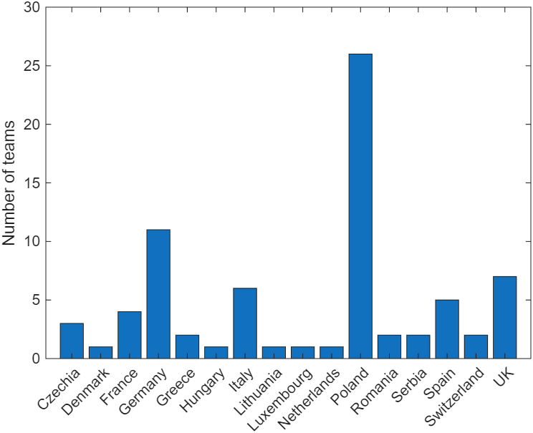
Figure 4. Number of ERC teams (2018-2025) by state

Figure 5 shows a box plot of the teams' “lifetime”, i.e. the timespan from the foundation of the club–not necessarily for robotics–to their latest participation in ERC. We clearly see some outliers, notably WARR from TU Munich. Compared to REXUS/BEXUS, ERC teams tend to create long-term structures persisting over multiple years, often re-joining the competition every year.
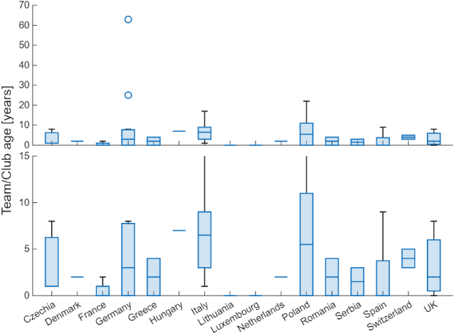
Figure 5. Box plot of lifetime of ERC teams (2018-2025) by state, zoomed in on up to 15 years

Since long-established teams tend to perform better in ERC, this may present a hurdle to the inclusion of French students in this kind of competition.
  - EUROC
Finally, EUROC has spawned a plethora of student rocketry clubs. Like robotics, virtually all competitors in EUROC are independent student-led teams. Once more, established teams tend to perform better, and also tend to participate consistently. Yet, in contrast, rocketry is more evenly spread across Europe. Interestingly, several EUROC teams (or their universities) have not participated in any of the other competitions examined here. Austria, absent from all other domains, fields two such teams. The unique technical challenges of rockets, as well as potential access to test infrastructure, may play a larger role than synergies with general (space) engineering. Further, a difference between the UK and France becomes visible. While both have national rocketry programs, UK teams are more active internationally, sharing experiences between the two opportunities.
- Discussion
Overall, student-led space projects are thriving across European universities. However, differences between countries have been shown.
An explanation can be the structure of the respective tertiary education programs. Several states like Germany, Czechia or Italy have continuous Bachelor-Master systems, where students spend 5 or more years at one institution. This allows them to gain first hands-on experience early in their programs, which they can later apply to more complex projects or use to take leadership responsibility.
In contrast, the French engineering cycle is split into the Classes Préparatoires and the Ecole d'Ingenieur, where especially the former is purely theoretical. This leaves only a short period of 3 years for teams to form, to find a project, gather sponsors and complete it. This is where more formal structure like C'Space and the Centre Spatiale of French universities provide critical support.
Further work could look at the other factors enabling the creation of such student teams. Factors of interest are the importance of theory and practice in the curriculum, the availability of test infrastructure from the university itself or nearby research institutes, the presence of local industry for sponsor- and partnerships, as well as the existence of a national coordinating body between student associations, like SEDS in the UK.
- Conclusions
A study of student team participation across European space-related competitions in multiple domains revealed stark differences in the number and form of teams depending on the country the university is located in.
Team participation is typically stronger in the programs' home countries, though ESA-organized or -supported programs tend to produce equitable participation across ESA member states. Germany, the Netherlands and the UK have a strong culture of independent student clubs working on space projects, leading to persistent participation and improved knowledge transfer. Italy, France and Spain, in contrast, tend to organize such projects around faculty-led structures or labs. In other cases, ad-hoc formation of student teams dominates, limiting the long-term impact of these educational programs.
Independent student teams are more popular for robotic projects owing to their lower entry hurdles and rapid development cycles. On the other end of the spectrum, student satellite projects are often under close supervision by the university, justified by their high costs and multi-year runtime. Universities and professors should encourage and enable the creation of independent student clubs, as this not only maximizes the educational return from competitions but also provides important project management experience, allowing students to take on responsibility in a low-risk environment.
Acknowledgements
This work was supported by the Defense Innovation Agency (AID) of the French Ministry of Defense (research project CONCORDE N° 2019 65 0090004707501).
Appendix
The source code, data and interactive maps are accessible at https://github.com/isae-vonarnim/ssea_student_teams_repository.
References
[1] European Space Agency, Announcement of opportunity for ESA Academy’s new PETRI programme: https://www.esa.int/Education/ESA_Academy_Experiments_programme/Announcement_of_opportunity_for_ESA_Academy_s_new_PETRI_programme, last visited: 2026-02-26.
[2] European Space Agency, About the ESA Academy Experiments programme: https://www.esa.int/Education/ESA_Academy_Experiments_programme/About_the_ESA_Academy_Experiments_programme, last visited: 2026-02-26.
[3] European Space Agency, Fly Your Satellite Programme History: https://www.esa.int/Education/Educational_Satellites/Fly_Your_Satellite_Programme_History, last visited: 2026-02-26.
[4] Rexus/Bexus, The REXUS/BEXUS Programme: https://rexusbexus.net/, last visited: 2026-02-26.
[5] European Space Agency, About REXUS/BEXUS: https://www.esa.int/Education/Rexus_Bexus/About_REXUS_BEXUS, last visited: 2026-02-26.
[6] European Rocketry Challenge, EUROC | EUROPEAN ROCKETRY CHALLENGE: https://euroc.pt/, last visited: 2026-02-26.
[7] European Rover Challenge, European Rover Challenge (ERC) – Space Robotics Competition: https://roverchallenge.eu/, last visited: 2026-02-26.
[8] Centre National d'Études Spatiales (CNES), C’Space: https://cnes.fr/education/cspace, last visited: 2026-02-26.
[9] Centre National d'Études Spatiales (CNES), Parabole: https://cnes.fr/education/parabole, last visited: 2026-02-26.
[10] German Aerospace Center (DLR), Student competition 'Überflieger 2': https://www.dlr.de/en/ar/topics-missions/space-research/international-space-station/ueberflieger-2, last visited: 2026-02-26.
[11] DreamUp, Winners for DLR Student Competition “Überflieger“ Selected: https://www.dreamup.org/winners-for-dlr-student-competition-uberflieger-selected/, last visited: 2026-02-26.
[12] A. Stamminger, H. Ciezki, W. Kitsche, M. Kobald, A. Schmidt, STERN – A Rocket programme for German Students. 21st ESA Symposium on European Rocket & Balloon Programmes and Related Research. Thun, Switzerland, 2013.
[13] J. Grande, R. Birkeland, T. Lindem, R. Schlanbusch, K. Dahle, Educational Benefits and Challenges for the Norwegian Student Satellite Program. 64th International Astronautical Congress (IAC). Beijing, China, 2013.
[14] Portuguese Space Agency, New competition challenges Portuguese higher education students to build their satellite - Portuguese Space Agency: https://ptspace.pt/new-competition-challenges-portuguese-higher-education-students-to-build-their-own-satellite/, last visited: 2026-02-26.
[15] Portuguese Space Agency, The Portuguese Space Ecosystem, 2025: https://ptspace.pt/wp-content/uploads/2025/08/The-Portuguese-Space-Ecosystem-S1-2025-Report.pdf, last visited: 2026-02-26.
[16] UKSEDS, Competitions Hub: https://hub.ukseds.org/p/competitions-hub, last visited: 2026-02-26.

Corresponding author: ISAE-SUPAERO, Toulouse, France, maximilian.von-arnim@isae-supaero.fr

