Belvis4 Branch auschecken 3
Start & Monitor the services 6
Start order of bundles 8
Using the ListModel in the GUI 8
Notes for server & agent structure 10
Create the new Service and start it by Server start 10
Exceptions and Logging 11
Find the services wihich implements the same interface: 12
Set Maven options if compile cancelled with “out of resources” message 13
Get the time series for BelVis instances (workflow) 13
Use the text table entries in DAO for translatable columns 15
Workflow for new command in the popup menu of view (explorer) 15
Add atomic permissions 16
Update the extern module version (e.g. iosys) locally 16
Configuration of OSGI modules (kiiosys, ami etc.) 17
Logging configuration 18
KisRpc asynchronous methods specialitites 18
Get & Set Bundle configuration option (e.g. export directory) 19
Refresh BelvisProcessExplorer directly after import/delete: 19
KiDSM Implementation 20
TRANSFER Tools JAR Integration (maven): 26
Bundle Import Export Configuration. 28
Maven-Dependencies vs Maven Bundle Plugin 30
Maven Bundle Plugin 33
Maven Otions for m2eclipse 33
BelVis update mit external modulen 34
Simple Dialog example 34
Debugging the DAO update / get methods: 34
SUREFIRE Test plugin 35
TSM-Importserver deaktivieren 35
TSM Dispatcher DB / Belvis4Domain DB 36
Start TSM with another Java SDK 37
Catch and handle not defined properties (mail, kidsm etc.) 37
Implementation of I/O Service Interfaces 37
Mapping the column names from DAO to General Properties (DAO Hash map) 38
Validation Workflow 39
Test JUnit NGTest 40
Zugriff auf TsmCncTaskAttendant für DAO methoden 41
Workflow to create valuesets (XML) 41
Get medium by model object. 41
Check DB schema version in the table 42
Intergration test and database creating 42
Check list after Maven compile with ExternalModules 43
Syslog, Log with TaskInfo 43
Start just the java class with main() from bundle 44
Jump to the special preference page directly from code 45
Tracing for SQL statements from Belvis 46
Validation rules configuration 46
Reassign the time series from one instance to another 47
Bundle dependencies (impl and interfaces) 47
Bundle plugins name convention 48
System Data in den Cluster kopieren 48
KITSXML Zeitreihe in Winterzeit t, ohne Sommerzeitumstellung. 48
Listener for ObjectUIAdapters swt.Text Feld 49
Get Service by Interface and ModelObject Class 49
Saving of Objektes from Wizard with Save Support (ModelobjectSaveSupport) 51
Input Validation XML for BelVis Objects 51
TexEditor compile OpenIssuesDev without Eclipse 51
Wizard Input Validation 52
Eine Änderung in de.kisters.belvis.model 52
Importfehler beim Import der Tenant Systemdaten 53
Generating the IDL files for Proxy 53
IModelObject setProtected() description 54
Getting the icon image for button declaration 54
List of last used Workspaces setting 55
Get list of columns from the database using specified data types (SQL) 55
Authentifizierung Terminologie: 55
Errors and reasons: 56
Dropping the tenant db 56
Resume the DB migration / update 56
Error with protocol header 57
Find the unsatisfied services: 57

Belvis4 Branch auschecken

Create the D:\WORK\scm\4-1-x Directory
Context menu→ CVS Auschecken…
Select Modul:
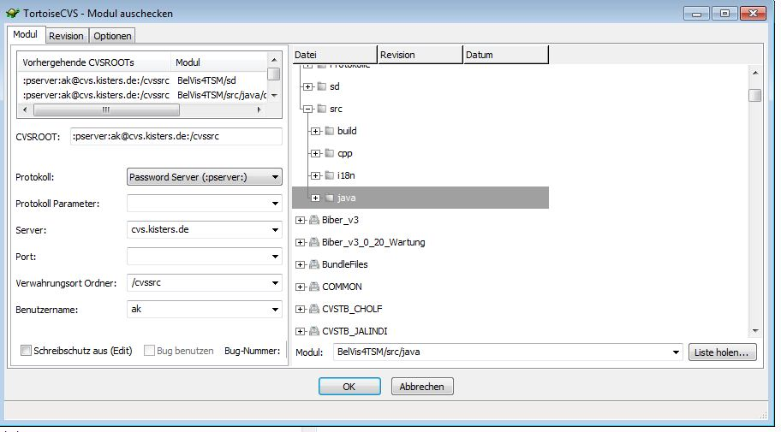

Select Revision for Modul: (don’t forget the option “search subfilters”
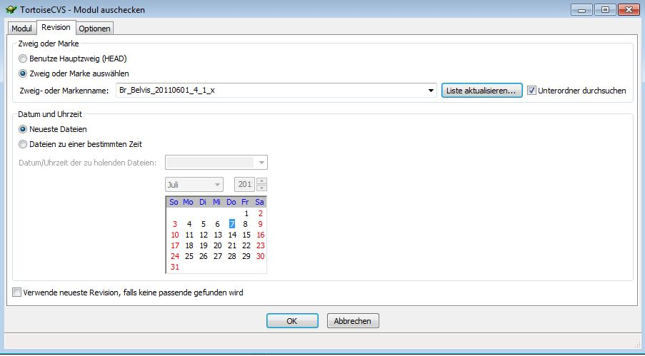

Press OK

Configure Workspace for Branch:

Create new workspace directory
Copy the .metadata Directory from HEAD-Workspace

Import “from existing project” (checkout – folder in scm)
Add the swt 64 bit plugin to target platform (configure run…)

Start & Monitor the services
start cmd as admin

D:\WORK\scm\git\4-5-x\belvisrepo\cluster\dcserver\server_tsmserver1
perl dcserver.pl console telnetd --port=6666 start

start cmd as admin

>telnet

>open localhost 6666
“lb” to show all server bundles
“Bundle <id>” to show bundle info

Service check:
“list” to show all services
“list | grep unsatis” to show all unsatisfied services

“list | grep ankafix” to show all services containing “ankfix” in name
“info <service id> “ to show the service info

OLD commands:lb bundle
OSGI console for DCServer (Felix)
cmd.exe
telnet localhost 6666 →
ps (lb)
to see the list of current services:
scr list (list)
To see details for selecteed Service:
scr info 80

OSGI console for Belvis Client (Equinox)
to see the list of current services (the proxies should run on the client side!):
services <filter>
e.g. services (objectClass="*virtage*") will print only services having “virtage” in their class name.

>>The comp command reports the reason is an unsatisfied reference to org.osgi.service.http
Osgi> ls
Osgi> ls –c
Osgi> comp <service id>

list all bundles with “*belvis.proxy*” pattern
osgi>ss belvis.proxy
show the current bundle info
osgi> bundle 74

ss
Look if the IPreferenceService is unsatisfied:

console "scr:list | grep unsatis", wenn er da nicht bei ist dann läuft er oder fehtl ganz
=> console "scr:list | grep IPref"

Example:

Equinox:
start belvis client with:
>BelvisClient.exe -console -consoleLog

list all bundels with "ankafix" in their name
>ss ankafix

show the bundle information
>bundle <ID>

list the services which have the "ankafix" in their package path (de.kisters.bundle.common.ankafix etc.) using the LDAP filter

>services (objectClass=*ankafix*)

Start order of bundles

The starting order of bundles is set in \cluster\dcserver\server_tsmserver1\configuration
via prefix numbers (the start order) → 99901-dcsmgr-kiiosys_common-default.properties

The config.xml contains the starting order.
E.g. the IOSYS should start before the belvis bundles (like bdi, common etc.)

Using the ListModel in the GUI
s. de.kisters.plugin.common.ui.widgets.MoverListsComposite

Task: fill the ListModel with instance data and forward it as parameter to MoverListsComposite.setInput() method:

1. create the model with data which will be managed by our ListViewer
Model<TasklistEntry> model = new Model<TasklistEntry>(TasklistEntry.class);

With database connection: fill by according service
ITasklistService service = (TasklistService)mServiceTracker.getService();
model = service.getTasksByParent(sessionAccess, null, parentId, 0,
mMaxrows + 1);

Without database connections – create a dummy model:
TasklistEntry entry1 = new TasklistEntry();
entry1.setProperty(TasklistEntry.PROP_ID, 1, true); // mandatory field
entry1.setLabel("hallo" + i);
entry1.setEditor("Ich" + i);
model.add(entry1);

2. Create the ListModel instance (with according UIAdaptor as param) and fill it with model data:
ListModel list = new ListModel(new TasklistAdapter());
list.modelReceived(model);
myMoverListsComposite.setInput(listModel, indx);

3. Display the data in he GUI as content of ListView (or TableView)

private final ListModel mListModel;
private ListViewer mViewer;
…
mListModel = listModel;
mViewer = mListModel.createViewer(myComposite, false);
mViewer.setInput(listModel);

4. Get the reordered ListModel back and check the according model:
Code to place on teh test View/Edit:
…
// get the ListModel Nr 2, idx=1
IListModel listModel = myComposite.getListModel(1);
int rowCount = listModel.getRowCount();
// print the reordered elements
for (int i = 0; i < rowCount; i++) {
TasklistAdapter taskListAdapter =
(TasklistAdapter)listModel.getRow(i);
// TasklistAdapter object:
System.out.println(taskListAdapter.getDefaultDisplay());
// TasklistEntry object
System.out.println(((TasklistEntry)taskListAdapter.getObject()).getEditor());

}

Notes for server & agent structure

TCA → AppSession → BelvisServer → TSM Session → TSM

Session Object is always the first parameter in API Call.

Cluster Controller distributes the session to TCA’s and Servers (e.g. I/O Server)

Cluster Controlle (Dispatcher) runs mostly alone on the machine (own Java VM).

BelVis OSGI wraps the KisRCP calls, but has nothing in common with remote calls.
OSGI knows nothing about remote calls in network.

Create the new Service and start it by Server start

de.kisters.bundle.belvis.common:
- XML datentypen erzeugen: processDefinition.xsd
- enthält XML parser
- *services.IProcessService (interface)

de.kisters.bundle.belvis.server.base:
- anmeldung process service: OSGI-INF/BelvisBaseService.xml → immediate="true"
- *services.impl.ProcessService (implementation)

Maven install starten um Bundle zu aktualisieren (copy nach belvisserver)

For both bundles exexute: run as → maven install
de.kisters.bundle.belvis.common
de.kisters.bundle.belvis.server.base

//To call the service reistered as „reference“ for calling service : i.e. TasklistService calls ProcessService:
IProcessService ps = (IProcessService)mContext.locateService(
IProcessService.class.getName()+ ".ref");

if (ps == null) {
throw new ServiceException(
"Starting of IProcessService failed ");
}

//To call the service from GUI
ServiceUtil.getService(IBasicdataService.class, "medium=power")
ProcessService to parse the XML

Interface
Implementation calling the parser and returning the instantiated Dataforward Object

AdminService is getting and calling the ProcessService (else the ProcessService is started only by server start)

To find the Time series for instances the “TSM Path” should be get.
i.e. Meteringpoint\AlternateKey (shortname)

Exceptions and Logging

ServiceExcpetion could be viewed as Belvis Exception

To throw exception:

if (basicdata == null) {
throw new ServiceException("No instances found");
}

To show the message in Belvis4TSM console :
System.out.println(“Message text”);

Logging : Server (Log.sysLog), Client (LogUtil)

For example use it by asyncron jobs instead of throw:
try {
dwg.start();
} catch (ServiceException e) {
Log.sysLog(LogLevel.ERROR,
"Failed to execute dataforward process: "
+ Log.getLongExceptionMessage(e));
}

Find the services wihich implements the same interface:

IBasicDataService is existing for 4 medium services
All Services are registered with according property “medium=power/water/etc”

In BelvisBaseService.xml only the IBasicDataService.ref is refereneced for ProcessService
…
<reference
name="de.kisters.bundle.belvis.common.services.IBasicdataService.ref"
interface="de.kisters.bundle.belvis.common.services.IBasicdataService"
bind="addBasicDataServiceReference" unbind="removeBasicDataServiceReference"
cardinality="1..n" policy="dynamic" />
…

addBasicDataService (final ServiceReference ref)
is called for each registered IBasicDataService and put to the HashMap mBasicDataReferenceMap.

The method mServiceProvider.getService() gets the according method from
this HashMap.

The methods bind/unbind are to find in the ProcessService
The mServiceProvider is implemented as anonymous class and forwarded
to DataforwardProcess , which uses the implemented getService(class, filter) method
to get the needed service depending on current medium.

Set Maven options if compile cancelled with “out of resources” message
cmd.exe →
Set MAVEN_OPTS=-Xms128m -Xmx768m -XX:PermSize=128m -XX:MaxPermSize=512m

Get the time series for BelVis instances (workflow)
We have the model list “result”
Model<IInstance> result = IBaseicDataService.getInstances()
// Now build the tsm path to get the according time series
// the bridge from BelVis to TSM

LinkedList<String> tsmparents = new LinkedList<String>();

// get the type of parent instances:
//returns : de.kisters.belvis.model.gen.power.MeteringpointPower
String parentType = result.get(0).getClass().getName();
//returns : “meteringpoint”
String tsmType =
getBasicDataService(filter.getMedium()).getBasicDataType(
mSessionAccess, parentType, null);
// first filter element: e.g. "meteringpoint"
tsmparents.add(tsmType);

// build the linked list with basic data tree path
RequestFilterTerm pathfilter = new RequestFilterTerm();
pathfilter.setPathFilter(tsmparents);

// get the alternate keys for "meteringpoint" instances
String[] tsmInstances = new String[result.size()];
int idx = 0;
for (IInstance instance : result) {
tsmInstances[idx++] = instance.getAlternateKey();
}

// build filter to get the list of tsm basic data objects
pathfilter.addColumnReference("shortName");
pathfilter.addOperator("in");
pathfilter.addValue(tsmInstances);

// now get the tsm basic data objects by instance type and
// alternate keys e.g. meteringpoint\asd893asdasd etc.
LinkedList<BasicData> basicdata = null;
try {
basicdata =
getTsmServiceWrapper().getBasicDataList(mSessionAccess,
pathfilter, null, null);
}

parents.add(basicdata);

// get the time series for tsm basic data

// build filter for time series (e.g. build the IN-Clausel for BasicDataID from basicdata list)
ProcfwkUtil.parseFilter(propFilter, parents, timerange);
try {
Model<Timeseries> timeseries =
getTimeseriesService().getTimeSeries(mSessionAccess,
propFilter, null);
//just display the names to chek the resulting timeseries
for (Timeseries foundTimeseries : timeseries) {
System.out.println(foundTimeseries.getFullName());
}
} catch (ServiceException e) {
throw new ServiceException(
"Failed to get timeseries for given filter", e);
}

Use the text table entries in DAO for translatable columns

Example : ProcfwkDAO, IProcess

IProcess and all (!) implemented classes (in the modeldefinition_yyy.xml )should contain the “textId” property

In ProcfwkDAO the column with text id should be mapped to this property:
…
put(E_PROCESSDEFTable.ELT_ID_L.getName(), IProcess.PROP_TEXTID);
…

The create() method should contain this code snippet:
…
if (modelobject.getTextId() == null) {
modelobject.setTextId(createLocTextEntry(connection, locale
.getLanguage(), modelobject.getName()));
… }

The 3rd argument getName() –>

Workflow for new command in the popup menu of view (explorer)

E.g. DeleteProcess

“Delete” Handler (DeleteProcessHandler) which calls the service function (deleteProcess) with selected model object as parameter.

Create the according function “deleteProcess(sessinAccess, modelobject)
IProcessService Interface → add method
Implement this method for Proxy, Adapter, ProcessService
(calling the dao.delete() method)

Plugin.xml
Org.eclipse.ui.commands → create command for DeleteProcessHandler
Org.eclipse.ui.menus → popup menu → new command.

Add atomic permissions

Method: checkPermission()

/de.kisters.belvis.db/data/dbdata/tsm/dispatcher_data/dispatcherxml/common/080_permission/
080_atomicPermissionsBelVis.xml
081_atomicPermissionsBelVis_en.xml
Functional Groups
/de.kisters.belvis.db/data/dbdata/tsm/dispatcher_data/dispatcherxml/common/100_functiongrp/
100_uafuncgrp_belvis.xml
100_uafuncgrp_belvis_en.xml

Update the extern module version (e.g. iosys) locally

To update the KIOSYS snapshot version locally
change the "version" property for IOSYS

/belvisgroup/build-config-belvis/pom.xml
...
<iosys.version>1.1.1-SNAPSHOT</iosys.version>
...

And stard full build with mvn clean install (belvisgroup)

mvn clean install -PwithExternalModules,withExternalSources
letzteres aber nur fürs debuggen, die I/O sourcen werden dann mit abgerufen und kopiert unter cluster/kiosyssrc

Configuration of OSGI modules (kiiosys, ami etc.)

D:\WORK\JAVA\Belvis4TSM\cluster\dcserver\server_tsmserver1\configuration

The config files (*.properties) refer to the according bundles for this area:

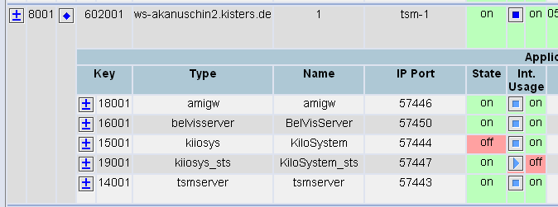

Logging configuration
1.
In the files (*.properties) → D:\WORK\JAVA\Belvis4TSM\cluster\dcserver\server_tsmserver1\configuration

e.g. 99510-dcsmgr-bundle_iosys_server_base-default.properties
the existing log4j property file should be referenced:

…
log4j.configuration=../configuration/io-server-log4j.properties
…
2.

This file (io-server-log4j.properties) includes location where the log information will be written:
e.g.
…
log4j.appender.appFileLog.File=${log4jDir}/iosystem-syslog.log
log4j.appender.KisLogger.File=${log4jDir}/iosystem-applog.log

log4jDir variable should be set

KisRpc asynchronous methods specialitites

- All asynchronous methods will have an extra argument of the type IFunctionCall with respect to the declared return type (see the core concepts section).
- All asynchronous methods return void as the return value is accessed via the IFunctionCall callback object.

Get & Set Bundle configuration option (e.g. export directory)

1. New entry (iosys.exportdir= ./export) in bundle property file
de.kisters.bundle.belvis.server.base/data/dcserver/→ 99400-dcsmgr-bundle_belvis_server_base-default.properties (check in!)
This file is copied to /cluster/dcserver/server_tsmserver1/configuration directory via “maven install”
The “./export” is relative to directory “runtime” and means the export is a subdirectory of “runtime”

2. add function getExportPath() to
de.kisters.bundle.belvis.server.base --> Site.java

3. To get the “exportdir” value in BelvisServer side:
String path = Activator.getDefault().getSite().getExportPath();

Refresh BelvisProcessExplorer directly after import/delete:

DeleteProcessHandler
//Call after delete action
service.deleteProcess(sessionAccess, df);
// the refresh event, which force the refresh() method for all active IRefreshable parts
// (e.g. BelvisProcessExplorer)
GlobalEventHandler.getInstance().fireRefresh(df);

KiDSM Implementation

KiDSM-Server current release:
http://maven-srv.kisters.de:8080/nexus/index.html#view-repositories;releases
search for: kidsm-distribution
I.e. kidsm-distribution-5.4.2.zip → download , exract and update according to hand book

Install KiDSM (WiKi – Anleitung)
System→Dienste→
ActiveMQ should be started
KiDSM should be started

Client Run Configuration (Eclipse)→Plug-ins → Target platform:
check the de.kisters.kidsm.plugin.admingui

1. New service DataforwardKiDSMService has to implement IKiDSMService
2. New Job : DataforwardJob (implements IBelvisBackgroundJob) and called from DataforwardKiDSMService
to start the dataforward process (ProcessService.startProcessWithId) as background job
New eintries in /de.kisters.bundle.belvis.server.base/OSGI-INF/BelvisBaseJob.xml for new services
for DataforwardKiDSMService
and DataforwardJob
→both reference the IProcessService

3. Configuration:
DataforwardKiDSMService registriert sich beim Start über das KIDSM connector bundle beim KiDSM, dann ist dort der Service bekannt, das kann man natürlich nur sehen, wenn man einen KIDSM hat und in den Bundle properties des BelVis servers der KIDSM Server eingetragen ist.
/de.kisters.bundle.belvis.server.base/data/dcserver/
99400-dcsmgr-bundle_belvis_server_base-default.properties
Should include the section like:
…
#kidsm
kidsm.host=localhost
kidsm.port=8888
kidsm.user=KiDSM
kidsm.password=KiDSM2009PassWord
kidsm.domain=

Check with “scr list” if the services are running.

Now all the implemented the IKiDSMServices should be visible in KiDSM Explorer

Troublehooting:
KiDSM versions Schema ist 5.X.Y
das X muss bei KiDSM Gui und KiDSM Server identisch sein, sonst klappt das nicht
d.h. mit einer 5.4.x gui kannst du nur 5.4.x server ansprechen. 5.2.x server klappen da nicht
Server-Version: C:\Programme\kisters\KIDSM\resources\version.txt
Client-Version: Eclipse→Run-Configuration (Client)→Plugin Liste→Target
de.kisters.kidsm.plugin.admingui (5.4.2)

KiDSM-Server current release:
http://maven-srv.kisters.de:8080/nexus/index.html#view-repositories;releases
search for: kidsm-distribution
I.e. kidsm-distribution-5.4.2.zip → download , exract and update according to hand book

GUI definition: Stammdaten
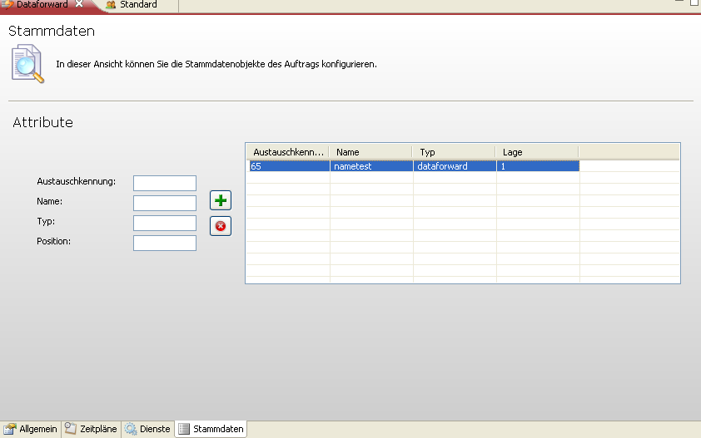

bdExchangeId = set manually in KiDSM explorer as “Austauschkennung” auf der “Stammdaten”-Tabpage
and avail. as paameter by DataforwardKiDSMService.start() - method
should be the process id (E_PROCESSDEF.EPRO_ID_L)
Type is set to define the various types of processes (Dataforward, Export, Mail etc.)
i.e. to know where (in which table) to search for bdExchangeId .
Name, Position is currently not important

GUI definition: Dienste

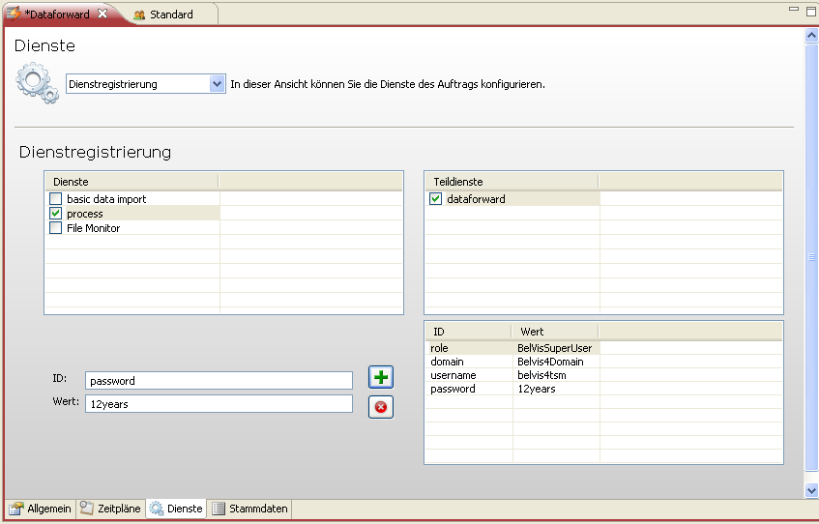
Role, domain, username, password
Should be set as parameter for service → DataforwardKiDSMService.start() → map evaluation
To create the JobSession

Sub services ids are listed in IBelvisBackgroundJob

1. Was soll man genau tun um die neue Service im KiDSM Explorer zu sehen?
Meine Schritte waren:

1. New service DataforwardKiDSMService has to implement IKiDSMService
Dieser registriert sich beim Start über das KIDSM connector bundle beim KiDSM, dann ist dort der Service bekannt, das kannst du natürlich nur sehen, wenn du einen KIDSM hast und in den Bundle properties des BelVis servers der KIDSM Server eingetragen ist.
2. New Job : DataforwardJob (implements IBelvisBackgroundJob) and called from DataforwardKiDSMService
to start the dataforward process (ProcessService.startProcessWithId) as background job (not yet implemented)
Der Background Job sollte noch im JobService bekannt gemacht werden, damit dieser eine Instanz bereitstellt (ist nur als einfache Verwaltung der möglichen Background jobs gedacht)
3. New eintries in /de.kisters.bundle.belvis.server.base/OSGI-INF/BelvisBaseJob.xml for new services
for DataforwardKiDSMService
and DataforwardJob
both reference the IProcessService
(the serices are active and running on the server)

2. Wenn ich richtig verstehe sollte der Aufruf vom DataforwardJob die ProcessService.startProcessWithId() Methode starten
Dafür sollte die bdExchangeId (manuell als BasicData Object ID im KiDSM GUI eingegeben) als Parameter übergeben werden
als ProcessID Parameter.
Die startProcessWithId()- Methode die JobId als Rückgabewert liefern?

Dazu bräuchte ich mal wieder deine Hilfe

Der DataforwardKiDSMService wird vom KiDSM gestartet (mit den dort eingegebenen Service parametern, d.h. login daten usw. wie im Basic data service). Der DataforwardKiDSMService startet den DataforwardJob als Hintergrund Job. Das ist aber eigentlich nicht nötig, weil der Prozessservice ja sowieso einen Hintergrundjob startet.
Ein kleiner Designfehler. Insofern hast du recht, du lieferst am besten die Job Id als Rückgabe. Das ist die schnelle Lösung. Ob und wie wir das nochmal umbauen müssen wir dann in Zukunft sehen.

Debug the Process Execution:
KiDSMConnectorService.startUnit() → ExecuteProcessKiDSMService.start()

TRANSFER Tools JAR Integration (maven):

alle 'nicht-bundle-jar's' in einen ordner (javalibs) kopieren und dieser ordner wird dann in das bundle mit aufgenommen.
Als Richtline kann man folgendes sagen:
Alles was im Manifest unter Runtime -> Classpath eingetragen wird, musst auch als copy-dependency in der pom.xml stehen.
das musst man per hand machen

JAR-Integration (JAR ist bereits in maven repository)

1. über maven dependency die abhängigkeit setzen
/de.kisters.bundle.belvis.server.base → pom.xml
…
…
<dependency>
<groupId>de.kisters.bpgroup.kidsm</groupId>
<artifactId>transfertools</artifactId>
<version>5.4.0-RC1.1</version>
</dependency

2. über maven-dependency-plugin an die richtige stelle kopieren
/de.kisters.bundle.belvis.server.base → pom.xml

pom.xml
Wenn die Liste mit GroupIDs oder ArtifactIDs by "copy-dependencies" ein leerzeichen nach der komma enthält, dann wird die Dependency einfach ignoriert (nicht kopiert).
Egal was man einstellt - es erfolgt keine Fehlermeldung vom maven. Nichts!
D.h. auch wenn die GroupId falsch ist – meldet maven den Fehler nicht und kopiert es auch nicht

Achtung: leerzeichen nach der Komma beachten!
<execution>
<id>copy-belvis-dependencies</id>
<phase>generate-resources</phase>
<goals>
<goal>copy-dependencies</goal>
</goals>
<configuration>
<includeGroupIds>de.kisters.belvisgroup,de.kisters.belvisgroup.belvis,de.kisters.bpgroup.kidsm</includeGroupIds>
<includeArtifactIds>dbcore,db,slf4j-log,transfertools,log</includeArtifactIds>
<stripVersion>true</stripVersion>
<outputDirectory>javalibs/kisters/belvis</outputDirectory>
</configuration>
</execution>

ODER als eigenständige „execution“ mit eigenem Verzeichnis

<execution>
<id>copy-kidsm-dependencies</id>
<phase>generate-resources</phase>
<goals>
<goal>copy-dependencies</goal>
</goals>
<configuration>
<includeGroupIds>de.kisters.bpgroup.kidsm</includeGroupIds>
<includeArtifactIds>transfertools</includeArtifactIds>
<stripVersion>true</stripVersion>
<outputDirectory>javalibs/kisters/kidsm</outputDirectory>
</configuration>
</execution>

3. und dann im manifest referenzieren
am besten: MANIFEST.MF → tabpage „Runtime“→ Classpath → „Add..“

Dann wir automatisch dolgender eintrag gemacht:
/de.kisters.bundle.belvis.server.base/META-INF
/MANIFEST.MF
Bundle-ClassPath: .,
…
javalibs/kisters/kidsm/transfertools.jar

Und auch im .classpath (!)

Notizen:
alle 'nicht-bundle-jar's' in einen ordner (javalibs) kopieren und dieser ordner wird dann in das bundle mit aufgenommen.
Als Richtline kann man folgendes sagen:
Alles was im Manifest unter Runtime -> Classpath eingetragen wird, musst auch als copy-dependency in der pom.xml stehen.
das musst man per hand machen

Falls ein JAR irgendwelche dependencies hat (direkt und indirekt)
Reicht es nur die direkte in den pom.xml eintragen, die indirekten werden dann automatisch geholt
Aber: wenn es JARs sind und nicht bundle, dann müssen die (direkten UND indirekten)
Mit <copy-dependencies> zu javalibs-Verzeichnis kopiert werden.
D.h im pom.xml können nur die direkten aufgelistet werden.
Bei <copy-dependencies> sollten aber beide! Angegeben werden! (by GroupID und ArtifactID)

Bundle Import Export Configuration.

Unresolved sun.io and bootdelagation:
http://www.mail-archive.com/users@felix.apache.org/msg02166.html

osgiFelix-custom.properties:

framework.zero.bundleList=felixscr,felixcfgadm,dcsmgr,shell,rshell

org.osgi.framework.bootdelegation=sun.*, \
com.sun.*, \
javax.*, \ → javax.xml (um nicht javax.* pauschal zu importieren)
org.omg.*, \
org.w3c.*, \
org.xml.*

#felix.log.level=4
#ds.loglevel=debug

Bootdelegation ist eigentlich nicht gur für modulare entwicklung,
und dient als Notlösung.
Sie sagt dass System für ALLE Bundle pauschal die packages importiren soll.
Nachteile:
wenn die Bundles in einer anderer Umgebung eingesetzt werden, dann können die nicht starten/aufgelöst sein weil die diese Packages nicht
selbst mitbringen.

Wenn z..b. transfertools.jar den javax.activation package selbst mitbringt und benutzt, aber in Bootdelegation javax.* pauschal zu Verfügung gestellt wird, dann wird zwangsläufig der javax.activation von Bootdelegation (und nicht vom transfertool mitgebrachtem javax.activation benutzt, ohne auf Versionen etc. zu achten.
Was natürlich zur versch. Problemen führen kann. (Exception etc.)

Vorteil: die allg. packages wie sun.io könen mit dieser Anweisung für alle Bundles
Zugänglich gemacht werden,ohne von jedem Bundle importiert zu sein!

Bootdelegation stellt die packages für alle Bundles zur Verfügung.
D.h. die müssen nicht importiert werden !

osgiFelix-default.properties (osgiFelix-custom.properties)
Stellt als System Bundle auch die packages zu Verfügung. Aber indem die nur exportiert werden.
D.h. als Unterschied zu Bootdelagation müssen diese packages von den Bundles importiert werden!

Maven-Dependencies vs Maven Bundle Plugin

Problem: Server startet nicht weil die Bundles bestimmte packages nicht finden können, di e
Sie angebilch brauchen.
Also Diskrepanz zw. Bundle-Path und Dependencies.

Erklärung:
Maven Bundle Plugin erstellt automatisch den
Bundle-Classpath vom MANIFEST.MF indem die *.classes analysiert werden.
D.h. es werden die Packages eingetragen sobald entdeckt wird dass es im Code die
Klassen aus diesen Packages referenziert sind. D.h. noch lange nicht
Dass zu Laufzeit wirklich gebrauch werden.

Maven Dependency Plugin trägt nur die Dependencies ein die er anhand der entspr. Pom.xml findet und nicht anhand Code-Analyse.
Also der pom.xml „ersteller“ kann evt. nicht alle JARs eintragen weil einige einfach „per hand“ im Classpath
kopiert worden sind. Folglich erscheinen die auch gar nicht in dependencies.

Beim starten sieht dann der Bundle , dass z.B. in Bundle-Class so was wie „org.springworkframe.“ steht
Findet aber nirgendwo diesen package (nicht importiert und nicht vom bootdelegation zur Verfügung gestellt).

Um dieses Problem zu vermeiden muss man in bundle plugin explizit sagen dass bestimmte packages
nicht importiert werden und nicht in den Bundle Classpath eingetragen werden.
<Import-Package>
!com.thoughtworks.*,
!org.apache.derby.*,
</Import-Package>

Um Blevis4 komplett zu “bereinigen” sollte man also maven bundle plugin laufen lassen und den Bundle-Classpath
Section automatisch zu erzeugen (d.h. imported packages wird automatisch erzeugt)

Dann im felix console nachschauen welche Bundles evt. nicht resolved werden konnten und genau diese
Packages aus dem Bundle-Classpath rauszuschmeissen indem man die mit „!“ in <Import-Package> Abschnitt
versieht.

Wenn es die Applikation mit ClassNotFound – Exception knallt:

Aber um jetzt Mail versenden zu können musste ich
javax.net,
javax.net.ssl,
javax.swing,

Alexander Kanuschin: in Import-Package-Sektion (belvis.server.base) nach und nach hinzufügen.
Alexander Kanuschin: sonst knallte es beim Versand mit ClassNotFound Exception.
Alexander Kanuschin: Jetzt einfach so den MANIFEST einchecken? Die Sektion wird doch vom Maven Bundle-Plugin nicht komplett überschrieben?

Markus Tippmann @ Kisters: wenn so etwas grundsätzlich im manifest fehlt, dann ist die vorgehensweise anders:
Markus Tippmann @ Kisters: du nimmst aus dem eclipse manifest den gesamten import-package block raus und speicherst das so. dann auf das project ein maven->run package ausführen
dann das manifest aus target/classes/META-INF öffnen, import-package block herauskopieren und in das eclispe manifest pasten
dann im eclipse manifest ctrl+shift+f zum formatieren drücken.
dann testen.
wenns klappt, einchecken, wenn nicht, fehlende imports manuell hinzufügen

Das Problem: Fehler in Eclipse
de.kisters.bundle.kidsm.connector.services;version="1.3", → unsatisfied constraint
D.h. imported package wurde von Eclipse nich erkannt (falsche Version, nicht exportiert)
Package wurde von de.kisters.bundle.kidsm.connector –Bundle exportiert, aber ohhe Version-Angabe.

Grund:
Inkonsistenz zw. MANIFEST-Dateien (target/classes/META-INF vs ./META-INF)

MaBuPlugin generiert den Export und Import section anhand von Bundle-Dependencies. Dabei generiert er die entsprechende
Sektionen in der MANIFEST-MF mit Angabe der Version . Die Version wird vom entspr. Bundle-Manifest geholt (hier 1.3.0-SNAPSHOT)
. Da nur die Import-Package Sektion übernommen wurde, Bleibt die Export-Version auf der Strecke, da es beim Hinzufügen
Des Export-Eintrag keine Version angegeben wurde.

Lösungen:
- Alle Export-Einträge sollten (manuell) mit der Version vershen werden.
Verworfen, da zu Aufwendig, die Versionen werden nicht automatisch aktualisiert!
- Die generierte target/classes/META-INF Version erstzt dann komplett die Eclipse MANIFEST.MF
die Eclipse MANIFEST.MF wird dann zu .cvsignore hinzugefügt.

Nachteile: alle MANIFEST-Infos (vor allem Export-Package-Einträge sollten dann manuell in der pom.xml eingetragen werden)
Evt. mit <_include> Option könnte für die „statischen“ Bundle-Infos ein ressource-File benutzt werden.
D.h. die Tippfehler werden erst dann erkannt wenn das MANIFEST von MaBuPlugin generiert wurde.

Vorteile: Es ist dann nur ein MANIFEST.MF (vollständig generiert). Dann stimmen auch die Export-Import Versionen.
Wichtig: es müss für alle existierenden Bundels eingesetzt werden.

es könnte sein das du im repository eine jar xyz-1.2.0.jar liegen hast
du kompilierst dagegen mit einem import xyz (ohne version) und du merkst es nicht. besser wäre du hast einen import xyz;version=1.3, dann merkst du nämlich das in deinem repository die xyz-1.3.0.jar nicht zu finden ist oder du gegen eine falsche kompilierst
das ganze wird dadurch viel sauberer
das ist auch einer der gründe warum das bundle plugin verwendet werden soll

UPDATE:
MANIFEST.MF wird inzwischen komplett automatisch generiert . die generierte Version ist nicht mehr in CVS und liegt in
target/classes/META-INF –Verzeichnis (oder D:\WORK\JAVA\Belvis4TSM\cluster\belvisserver\osgiBundles → direkt ins JAR schauen).
Selbst wenn ein Fehler in Eclipse gemeldet wird (z.b. „no avail. Bundle export package XYZ“) ist das kann Problem, da es
daran liegt, dass das package sich in JAR bedindet und Eclipse kann die packages in nested JARs nicht sehen.
Aber OSGi schon, also zu Laufzeit sollte es kein Problem sein.

Maven Bundle Plugin

<artifactId>maven-bundle-plugin</artifactId> pom.xml
Wen ein package in javalib liegt , und der akt. Bundle eine Klasse aus diesem bundle verwendet, dann sollte der
Package manuell im <Import-Package> Sektion eingetragen warden weil der plugin das nicht automatisch macht.

{case 131738}
org.osgi.framework.system.packages.extra - Specifies a comma-delimited list of packages that should be exported via the System Bundle from the framework class loader in addition to the packages in

Maven Otions for m2eclipse

in eclipse für m2eclipse muss man für die installierte JVM unter windows>preferences>java>installed jre evenfalls diese werte setzen als default commandline arguments, aber das kannste erstmal ignorieren solange du auf cmdline compiliert

Markus Tippmann: genau, die musste anpassen, falls es zu wenig speicher ist, musste mal ausprobieren, bei mir klappt es mit:

MAVEN_OPTS=-Xms128m -Xmx1024m -XX:PermSize=128m -XX:MaxPermSize=256m

BelVis update mit external modulen

Wenn das IO, KiDSM etc. die Version geändert hat, dann

JProc console beenden (sonst könen einige log Dateien nicht gelöscht werden)

mvn clean install -PwithExternalModules

Simple Dialog example

DateTimePickerDialog

Debugging the DAO update / get methods:

Update.getStatement() Update-Statement
values (ArrayList) values for update

AbstractDatabaseDAO → KiDbalExecBaseIf → KiDbalExec

AbstractDatabaseDAO.class →
protected int updateRecord(Object dbConnection, IModelObject model,
ITable table, SQLFilter filter) throws DAOException {

Get → retrieve() → to see the SQL query build by FilterProperty settings

column.getType() = 2005 → CLOB

KiDbalExec.class → does not supports CLOB

* Sql Insert or Update by Cursor. (UNDER CONSTRUCTION)
* CBLOB's are not supported
public int sqlInsertByCursor(String stm,
Object[] data,
Calendar cal) throws KiDbalException, SQLException {
return sqlInsertByCursor(stm, data, cal, null);

The JAVA types are checked by KiDBAl and converted into right column types
Except the International encoded strings (String, NCBLOB)
CLOB should not be used by Data model

SUREFIRE Test plugin

To skip the tests: pom.xml→
…
<artifactId>maven-surefire-plugin</artifactId>
<configuration>
<skipTests>true</skipTests>
…
Or by maven: -DskipTests

TSM-Importserver deaktivieren

D:\WORK\JAVA\Belvis4TSM\cluster\jproccontroller\configuration
49-jproc-importserver1-custom.properties
…
startmode=0 →
startmode=-1

TSM Dispatcher DB / Belvis4Domain DB

For creation of dispatcher db:

D:\WORK\JAVA\Belvis4TSM\cluster\tsm\bin\runtime →
tsm-dispatcher.properties

this configuration file is used only to create the belvis domain database:

\cluster\tsm\bin\runtime\dispatcher_data\dispatcherxml\common →
500_tsmDomain_Belvis4DomainAK.xml→
…
<ProcessTsmDispatcherData>
<UpdateOrCreate>
<TsmDomain doNotUpdate="true" domainName="Belvis4DomainAK"
jdbcurl="jdbc:oracle:thin:@oracle-10g-srv-2:1521:belvis10" dbuser="akbelvis4tsm"
passwordencrypted="FVoiVIR/Afo=" tsmsessiondt="3600" dbId="43" useDispatcherDb="false" />
</UpdateOrCreate>
</ProcessTsmDispatcherData>

Start TSM with another Java SDK

Download the Java SDK version (j2sdk-1_6_0_16-windows.tgz) from TSM Homepage
http://tsm.sf.kisters.de/dms/website/release/tsm_releaseframe.html

Rename the TSM_JAVA_HOME to e.g. TSM_JAVA_HOME_SAVED
And unpack it to \\belviscluster\java - directory → TSM will use this Version of JAVA

Catch and handle not defined properties (mail, kidsm etc.)

Property file:
99400-dcsmgr-bundle_belvis_server_base-custem.properties
…
#transfertools
#kidsm.mail.host=<mail host>

If mail host properties are not set (null) →
…
de.kisters.bundle.belvis.server.base → Site.java

all getters throw the IllegalStateException with message
ProcTransferUtil catch this exceptions, cancel the attepmpt of mail transfer and displays it as error in application log

Implementation of I/O Service Interfaces

The Interfaces are defined by IO and get the Information from BelVis Implementaion (as Service)

IO Interface: IIoSysCallerEnvironmentInformationService

BelVis Implementation : IoSysCallerEnvironmentInformationService
Just fills the HashMap with prepared information (no parameter, no return values)
e.g. the kidsm.mail.host, mail.server are retrieved and just stored in the HashMap

IO Interface: IIoSysBasicDataRequestService

BelVis Implementation : IoBasicDataRequestService
Have one and only method getBasicData() with param Key , HashMap<String, Object>)
Key – is the function id (the function name) , Parameters are stored in HashMap (key → parameter)
Returns the Map with mapped results (key → result)
Depending on Key the according BelVis function/service is called with extracted parameters (from HashMap)
The result is stored into the result HashMap (key → result)

Mapping the column names from DAO to General Properties (DAO Hash map)

We are in the DAO object

1.
We have the general property from IMarketRoleInstance (“alternateKey2” as (alternateKeyProperty )
And just want to get the according column name (as String!) from E_R_GRID_OPERATORTable:
To build the filter.

// To map the "alternateKey2" to ERGOP_ID2_S column
ITable gopTable = new E_R_GRID_OPERATORTable();
columnProvider =
new ExternalColumnProvider(gopTable, IGridOperatorDAO.class, null);
akColumn = columnProvider.getColumnName(alternateKeyProperty);

- The same situation , but we need not the column name, but the object IColumn!

IColumn tableColumn = gopTable.getColumnTemplate(getPropertyColumnMap().get(alternateKeyProperty)
Oder
IColumn tableColumn = gopTable.getColumnTemplate(getPropertyColumnMap().get(IMarketRoleInstance.PROP_ALTERNATEKEY3)

Validation Workflow

Karl:
Also ich habe den Validator geschrieben und im ValidationSupportProviderService registriert (also in die Map geschmissen) - mehr finde ich nicht
alles auf Clientseite

1 implement ProcessValidator
2. and put it (along with the Class to validate ) with the into hashmap of ValidationSupportProviderService
to validate the object in editor.
…
validators.put(Export.class.getName(), ProcessValidator.class);

Intern workflow: IModelObjectEditor tries to get init() method the according mValidator via ValidationSupportService
→ ValidationSupportService.getValidationSupport() → provider.hasValidator(modelObjectClassName, sessionProvider)
modelObjectClassName : check if for this class the Validator put in validation hash map in ValidationSupportProviderService

Result:
The editing of Process emplate will call the ProcessValidator.doValidate() method

At the end of this method the ValidaationUtil methods could be called (i.e. validateAlternateKeys)

Test JUnit NGTest

Ich habe gerade /belvisgroup/build-config-shared/pom.xml eingechecked und mit einem "withCobertura" profile versehen. Damit kann man nun projekte lokal kompilieren und sich die Testabdeckung anschauen.

Z.B.:

cd de.kisters.model
mvn clean install -PwithCobertura
cd target/site/cobertura
index.html im browser öffnen

1. Test NG instead of JUNIT → pom.xml
<dependency>
<groupId>org.testng</groupId>
<artifactId>testng</artifactId>
<version>5.11</version>
<type>jar</type>
<classifier>jdk15</classifier>
<scope>test</scope>
</dependency>

2. to make the AbstractTestBase available : → pom.xml
…
<dependency>
<groupId>de.kisters.belvisgroup</groupId>
<artifactId>common</artifactId>
<version>${shared.version}</version>
<type>jar</type>
<classifier>tests</classifier>
<scope>test</scope>
</dependency>
…

Zugriff auf TsmCncTaskAttendant für DAO methoden

TsmCncTaskAttendant ist für alle AbstractBelvisService vorhanden → createTask()

The returned „tat“ is saved automatically in the thread context of this service.
So to get the TsmCncTaskAttendant later (to execute the db transaction ) :
Example s . ProcfwkUtil
…
TsmCncTaskAttendant tat = (TsmCncTaskAttendant) ThreadContext.getTaskObject();
…

Workflow to create valuesets (XML)

http://bugzilla.kisters.de/show_bug.cgi?id=83026

Get medium by model object.

BelvisConstants.getMediumByModelObject(modelobject)

Check DB schema version in the table

ich brauche auch mal die info, wo man die version in der db sehen kann
systemparam_belvisdomain
bzw. systemparam_ankafix usw.
Feld DbSchemaVersion

Intergration test and database creating

Source code: Preparation.java

You find the module at:

belvisgroup/belvis/integrationtest

It still needs some polish before it can be used, but you can have a first look.

If you fully built a BelVis development environment, you can now

- adapt test resources within belvisgroup/belvis/integrationtest/src/main/resources
- copy defaultTestConnection.xml to localTestConnection.xml
- adapt localTestConnection.xml to your database server
- adapt testcontext.xml to use localTestConnection.xml (do not forget to set the portOffset to 40000/50000 etc. hardcoded.

- adapt JDBC URL within 500_tsmDomain_BelvisITDomain.xml
- on console enter directory belvisgroup/belvis/integrationtest
- check if the tsm-dispatcher.properties (tsm/runtime) and 500_tsmDomain_BelvisDomainAK.xml (tsm/runtime) exist and include the correct tenants!

- execute “mvn clean” to delete the old localTestConnection.xml from \classes directory!
(else the tsm-dispatcher.properties is replaced by integration database settings)

- execute "mvn verify -PwithIntegrationTest"
- Creates a new database for dispatcher and domain (as configured within localTestConnection.xml )
- Runs the server
- Runs the demo test
- Shutdown the server

If this works for you, you are prepared to create first integration tests. Currently it is always necessary to create all from scratch, but I will add options to run integration tests against a preconfigured database with already running server (else development of tests take too long).

NOTES: run

Check list after Maven compile with ExternalModules

The custom files remains now not overwritten

1.
Check if “kidsm-custom.properties” exist in
D:\WORK\scm\git\4-2-x\belvisrepo\cluster\KIDSM\conf

2.
“Copy all files from belviscluster\KIDSM\resources\jproc-configuration-files\TSM-3.2* to
*belviscluster\jproccontroller\configuration.”

- copy the 500_tsmDomain_Belvis4DomainAK.xml to according directory

Syslog, Log with TaskInfo

=> ITaskInfo ist das objekt welches die Daten für das Log hält. D.h.
Log.syslog(bla) schreibt dann die Message + die TaskInfo daten in das Log.
Die Loginfo wird aber "gestacked", deswegen muss es nach dem verlassen der Methode wieder released werden, damit die TaskInfo der vorhergehenden Methode wieder verfügbar ist.

try {
ITaskInfo taskInfo = ThreadContext.newTaskInfo();
} finally {
ThreadContext.releaseInfo;
}

Beispiel s. auch DevHandbook

Start just the java class with main() from bundle

Run configurations → Classpath → add “project” with the needed java application :
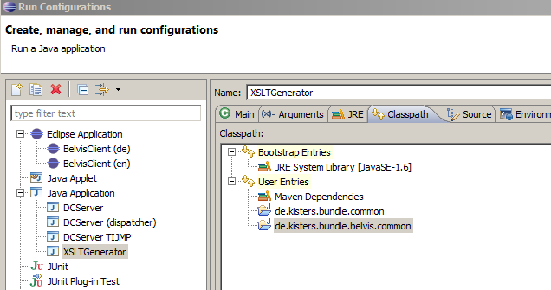

Jump to the special preference page directly from code

Open single preference page:

IPreferencePage page = new MyPreferencePage();
PreferenceManager mgr = new PreferenceManager();
IPreferenceNode node = new PreferenceNode("1", page);
mgr.addToRoot(node);
PreferenceDialog dialog =
new PreferenceDialog(Display.getDefault().getActiveShell(), mgr);
dialog.create();
dialog.setMessage(page.getTitle());
dialog.open();

Display to the preference dialog and jump to the special page (i.e. Perspective preferences):

PreferenceDialog rdialog =
PreferencesUtil.createPreferenceDialogOn(null,
"org.eclipse.ui.preferencePages.Perspectives", null, null);

rdialog.open();

Preference page id for explorer: “de.kisters.belvis.explorer.pref”

Tracing for SQL statements from Belvis

1. Grant the rights: (TOAD) :
Log in as system/manager
Execute in editor: grant alter session to AKBELVIS4TSM44X;
2. In code or in Unit tests
Before statement: dbexec.sqlExecNoResult("ALTER SESSION SET EVENTS '10046 TRACE NAME CONTEXT FOREVER, LEVEL 12'");
SQL statement
After statement: dbexec.sqlExecNoResult("ALTER SESSION SET EVENTS '10046 TRACE NAME CONTEXT OFF'");

Validation rules configuration

E_VS_VALIDATIONCONFIG as table (for instance to delete default.email)

Search for 210_vs_validationconfig.xml in cluster/tsm…

AppLog and SysLog configuration for BelVis

To get the number of instances after applying the property filter in dataforwarding
(ProcFWKUtil.ProcessFilter())

if (Log.isEnabledFor(LogLevel.DEBUG, Log.SYSTEMLOG)) {
Log.sysLog(LogLevel.DEBUG,
Messages.getInstance("ProcfwkUtil.0_InstancesForFilter_1", //$NON-NLS-1$
new Object[]{
result.size(), filter.getName()
}));
}

The log level configuration is to find in
\belviscluster\belvisserver\conf
belvis-server-log4j.properties
# sys log target configuration
log4j.logger.SysLog=INFO → DEBUG, sysLog

Reassign the time series from one instance to another

Change the instance id in TS_TIMESERIES.BD_ID
To needed instance found in BD_BASICDATA.BD_ID (check the bd type in BDT_ID)

Bundle dependencies (impl and interfaces)

Es geht nur darum das wir keine Abhängikeiten unter bundles erzeugen, bei denen es keinen Sinn macht bzw.
typischerweise sollen sich bundles über interfaces unterhalten,
d.h. alles an abhängikeiten in den pom's sollte über die .*common bundles (interface bundles) laufen.
beispiel: keine direkte abhängkeit zwischen pfm.core und server.base

bundle A implementiert Service A1impl, der Service B1impl verwendet
interface bundle I stellt Interfaces IA1 und IB1 zur verfügung
bundle B implementiert service B1impl

A ist abhängig von I aber nicht von B

Bundle plugins name convention

*.server.common => interfaces/datenklassen für server
*.common => interfaces/datenklassen für server und client
*plugin.*common => interfaces/datenklassen nur für client

wobei in Zukunft da eine Kisters weite umbenennung stattfinden soll:
aus plugin wird auch bundle, dafür bekommen die plugins im namen ein "ui", damit es klarer ist das es user interface bundles sind, der begriff plugin ist zu schwammig

System Data in den Cluster kopieren

das kopieren der System daten XML in den cluster kannste besser von hand machen, weil der gesamte deploy process für die entwicklung zu wild ist:

belvis-distribution erstellt die conf.tgz, belvis-cluster kopiert den cluster zusammen, cluster/belvisserver/install.pl kopiert die daten für einen cluster knoten (letzteres ist ein schritt beim kunden für neue knoten), für die entwicklung zu aufwendig.
also einfach:
*.db/data/dbdata/belvis nach /cluster/tsm/dispatcher-plugins-application-db kopieren

in git bash: cp belvis/base/server/de.kisters.belvis.db/data/dbdata/belvis cluster/tsm/dispatcher-plugins-application-db/ -r

KITSXML Zeitreihe in Winterzeit t, ohne Sommerzeitumstellung.

Wie gebe ich denn in einer KITSXML-Datei an, dass meine Zeitreihe in Winterzeit ist, ohne Sommerzeitumstellung? Also eigentlich UTC+1?

Da ist ein layout block in der xml:
<kitsxml version = "1.0" creator = "alex" date = "2009-09-25T16:00:00">
<timeseries>
</basic_data>
<layout>
<column name = "timestamp" timezone = "GMT+1"/>
<column name = "value"/>
<column name = "status"/>
</layout>

Listener for ObjectUIAdapters swt.Text Feld

http://belvis4-compile.kisters.de:8080/#/c/1089/
wird es eine Klasse geben die man als Listener eines ObjectUIAdapters registrieren kann und die swt.Text Felder asynchron aktualisiert.
Dazu braucht man nur das propertie de Model Object und die referenze auf das Textfeld im constructor uebergeben.
Wers mal braucht. ich brauchte es in diversen Wizards

Get Service by Interface and ModelObject Class

Wie komme ich an den entsprechenden Service heran?
über das Interface ist klar...
ServiceUtil.getService(Activator.getDefault().getBundle().getBundleContext(),
IMarketpartnerService.class, null);
aber wie bekomme ich den gleichen Service mit der model object class z.B. Marketpartner
es scheint hiermit zu gehen?
ServiceUtil.getModelObjectServiceFilter

habe nur noch keine Stelle gefunden wo es verwendet wird... mal testen
- Ja das sollte so gehen, der MarketpartnerService definiert ja das ModelObject dass er kann als Property: @Property(name = "de.kisters.belvis.model.gen.common.Marketpartner", vvalue = "true")

Und das ServiceUtil.getModelObjectServiceFilter baut Dir den dazu passenden Filter :)
also dann IModelObjectService + filter(class) => service der class

-check (nod) aber wenn du eh weisst dass du den Marketpartnerservice haben möchtest, kannst Du auch direkt dessen Interface nehmen und brauchst keinen Filter bauen, aber hängt
davon ab wo du gerade bist
-natürlich habe ich den nicht, aber getModelObjectClass()...
-so sollte es gehen...
IModelObjectService myService =
ServiceUtil.getService(Activator.getDefault().getBundle().getBundleContext(),
IModelObjectService.class,
ServiceUtil.getModelObjectServiceFilter(getModelObjectClass()));

Stefan Bröhl: wenn der Service nicht gefunden wird hat wohl Jemand die Property Annotation vergessen...
-und wo kann man das dann nutzen? ist vielleicht auch am AbstractModelObject eine methode getService() interessant?
- möglich wäre es... ist die Frage ob man es öfters braucht...

Als Beispiel – Das holen der Model Object Service anhand vom Objekt Class (generisch)

protected boolean doPerformFinish() {
ISessionProvider sessionProvider =
getSessionProvider(getClass().getSimpleName(),
MessageFormat.format("Finish {0} wizard", getModelObjectClass().getSimpleName())); //$NON-NLS-1$
try {
IModelObjectService<T> modelObjectService =
ServiceUtil.getModelObjectService(Activator.getDefault().getBundle().getBundleContext(),
getModelObjectClass());
modelObjectService.createOrUpdate(sessionProvider, getWorkingCopy(), null);
return true;
} catch (APIException | ServiceNotAvailableException e) {
LogUtil.log(LogLevel.ERROR, MessageFormat.format(Messages.getString(//
Messages.getString("AbstractModelObjectWizard.ModelObjectCreationFailed_0")), //$NON-NLS-1$
getModelObjectClass().getSimpleName()), Activator.getDefault(), e, true);
}
return false;

Saving of Objektes from Wizard with Save Support (ModelobjectSaveSupport)

z: Wie läuft denn jetzt das Speichern eines Objektes aus einem Wizard ohne SaveSupport ?
s: mit save support .Es gibt jetzt einen allgemeinen ModelObjectSaveSupport bzw. Loader
z: Muss ich da noch irgendwas tun, damit das funktioniert?
s: ausser benutzen eigentlich nicht
s: also direkt im wizard, nicht mehr über eclipse registery,
ModelobjectSaveSupport öffenen, CTRL+SHIFT+G und beispiel anschauen

Input Validation XML for BelVis Objects
Unter data/dbdata/belvis/Ankafix/20-basis auch eine 210_vs_validationconfig.xml anlegen um dort die input validation fuer ankafix objects einzutragen?
Bisher kenne ich die nur aus All/20-basis
Antowrt : es gibt doch schon eine 212_vs_validationconfig_ankafix.xml

TexEditor compile OpenIssuesDev without Eclipse

Ich hab im CVS eine Datei <path>/OpenIssuesDev/pdftest.tex eingechecked.
Damit lässt sich aus dem TeXeditor direkt das Document kompilieren, ohne Umweg über Eclipse.
Man muss allerdings am Ende der Datei einmal manuell den eigenen Documentpfad angeben, aber das ist ja nur einmal für die Zeit,
in der man das Doc schreibt. Sollte die Arbeit vereinfachen

Wizard Input Validation

A: wie war das noch, ich habe ein problem im wizard. wenn ich ein textfeld aendere,
dann ist finish ersmal aktiviert unabhaengig davon ob die page anschliessend valid ist oder nicht. nach der validierung
ist der finish button dann korrekt gesetzt. wo kommt das her?

K (grob skizziert ;)): wenn du checkproperty nutzt, wird automatisch setPageComplete(true) gesetzt, wenn keine fehler bekannt sind. das heißt, dass in deiner isPageValid mindestens ein Fehler (im validator) passieren muss, damit die page nach dem durchlauf von isPageValid nicht abgeschlossen werden kann.

T: setPageComplete(false) im Konstruktor? sonst ist der default erstmal complete

zu den Wizards: wir haben was gefunden... es liegt am Aufruf der checkProperty(...)
Methode an der falschen Stelle; Alex ist da weiter dran.

Eine Änderung in de.kisters.belvis.model

wenn ich eine änderung in de.kisters.belvis.model gemacht habe: was muss ich machen, damit die änderung in belvis greift? belvis mit maven komplett durchbauen hilft.. aber das geht vielleicht auch kürzer

Osterwald: thoeretische das model, dann das belvis.common.bundle um das neue model bekannt zu machen und dann noch das bundle, welches es verwendet. sollte ausrreichen, rein theoretisch

Bröhl: andere Antwort: schau mal nach in welchen anderen bundles das de.kisters.model-*jar eingepackt ist. diese musst du dann auch bauen und bei einem shared bundle es manuell in den cluster kopieren

Importfehler beim Import der Tenant Systemdaten

Weiß irgendjemand, ob Importfehler beim Import der Tenant Systemdaten wieder geloggt werden und falls ja, wohin?
Also sowas wie z.B.:
60 Anka-fix/20-basis/212_vs_validationconfig_ankafix.xml
61 ...failed
KISTERS: also fehler während einer migration werden hier geloggt: server_tsmdispatcher_tsm-dispatcher.log
vlt. landet da auch systemdaten-import-fehler

Christian: ok, da steht bei mir leider nichts. Gibt es eine Möglichkeit, den Fehler im Debugger zu erkennen - also könnte ich den Import z.B. noch mit dem AdminUtil machen?

KISTERS: versuch mal den dispatcher im debugger zu starten. und dann mache einen breakpoint in de.kisters.bundle.belvis.dispatcher.ext.services.impl.TenantApplicationDbAdminImpl.importSystemData(KiTATenantApplicationDbSystemDataStatus, HashMap<String, String>, String)
oder besser hier: de.kisters.bundle.belvis.dispatcher.ext.services.impl.TenantApplicationDbAdminImpl.importXML(InputStream,

Generating the IDL files for Proxy
If some new Classes/Interfaces are referenced – they must appear in the
Classes.idlf/Interfaces.idlf

Error:
de.kisters.kisrpc.codegen.parser.gen.parser.ParserException: [760,68] expecting: ')'

Search in generated file (all IDL files are merged to one file idl.idl → line 760, solumn 68
/belvis/base/common/de.kisters.belvis.proxy/src/main/resources/idl.idl

IModelObject setProtected() description
JT:Es geht um die modelobjekte, die sich automatisch ableichen, sofern sie denselben PK haben. Also du hast im memory ein ModelObject mit PK id=4711 und hast da eine eigenschaft drauf geändert. Jetzt lädst du das Objekt neu von der DB, dann entpricht dein Objekt was du eigentlich geändert hast, wieder dem aus der DB, es sei denn, du hast es vor dem Laden der anderen Objekte mit setProtected(true) vor dem automatischen Abgleich geschützt

AK: Also PK ist hier ausschlaggebend? Weil die getEffectivTimeslices nur den Clone liefert.
Und wenn - dann muss ich jede einzelne Zeitscheibe aus er Liste mit "setProtected" schützen?

JT: ja, der PK ist ausschlaggebend. getEffectiveTimeslices liefert zwar Clones, der PK ist aber trotzdem gesetzt, es werden ja bei bedarf neue "valid from" zeitstempel gesetzt. Außerdem wird falls notwendig ein "valid to" gesetzt. Diese Eigenschaft ist nicht Teil des PKs, könnte damit u.U. beim Neuladen der Zeitscheiben wieder mit einem offenen Ende überschrieben werden. Ich würde also auf jeden Fall alle Elemente der Rückgabe von "getEffectiveTimeslices" mit "setProtected" schützen

Getting the icon image for button declaration

/** trayImage to be shown in the button. */

private final Image mTrayImage = PluginImageProvider.getImage(PluginImageProvider.REFRESH_CMD_16X16_IMAGE);

List of last used Workspaces setting

For developing:

C:\eclipse\indigo-3.7.2\eclipse\configuration\.settings
org.eclipse.ui.ide.prefs

for client exe:
regedit
*ide.prefs* or *fragment of workspace name*

Get list of columns from the database using specified data types (SQL)

select * from user_tab_columns where table_name not like 'MIG%' and (data_type='NUMBER' and
DATA_LENGTH=22 or DATA_TYPE='NCLOB') order by table_name, column_name

Authentifizierung Terminologie:

Terminologie:
AuthSession = Authentifizierungssession, das Objekt mit dem man angemeldet ist. Ist diese Session abgelaufen muss man sich neu einloggen, man kann dann keine ApplicationSession mehr verwenden, die auf dieser Anmeldung basiert
AppSession = Applicationsession, das Objekt welches die Verbindungsdaten zu einer konkreten Applikation vermittelt. Eine Applikation ist kein DCServer, sondern eine Clusterapplikation, z.B. IOServer oder BelVisServer. Diese laufen beide bei uns in dem gleichen DCServer.
Bei erzeugung der ApplicationSession anhand einer AuthSession wird das LoadBalancing vorgenommen und ein Server ausgewählt. Ist die Application Session abgelaufen ist die Verbindung zu dieser Application weg und man muss sich anhand der Auth Session eine neue holen => neues Balancing
CallAccess = Entspricht in etwa dem Cookie im HTTP Header, reines Datenobject, welches den SessionKey, TaskID usw. enthält um dem Server mitzuteilen, wer grad mit ihm spricht. Das Objekt sollte pro Request neu erzeugt werden, weil die TaskID bzw. TaskSerial ja dann anders sein sollte (das wird bei uns nicht richtig durchgehalten, hat aber bisher auch keine Nachteile)

Frage:
sieht man irgendwo im tenant admin, wieviel verbindungen gerade z.b. zum tsm server auf sind?
TSM web gui -> TSM Cluster -> Cluster Nodes. Da gibts auch eine Spalte "Sessions" (das sind die call-access-dinger)
Application Sessaion schliessen
um eine Appl Session zu schliessen, kann man auf den DispatchService requestCloseAllApplSession aufrufen. Dann werden alle ApplSession einer Auth Session geschlossen, wenn es geht, vermute ich mal. Anschliessend kann man auch closeAuthSession aufrufen und sie kehrt mit true zurueck

Errors and reasons:

Wenn der Proxy-Teil fehlt, dann gibts z.B. solch eine Fehlermeldung...
"No service and no load support available for de.kisters.belvis.model.gen.power.Voltagelevel"

Dropping the tenant db

[09:40:24] Thomas Schwarz: Moin! Ich hab versucht, meine Belvis- DB zu löschen. Nun steht sie auf dem Status "Dropping". Hat jemend eine Idee, wie ich den Status ändern kann?
[09:46:24] Thomas Schwarz: die BelVis- Tabellen sind noch vollstädig...
[09:47:25] Jens Tippmann @ KISTERS: im dispatcher-schema gibts ne tabelle TDIS_TENANTAPPLICATIONDB
[09:48:13] Jens Tippmann @ KISTERS: da mal das feld dcta_state_i anschauen und einfach mal auf 60 setzen
so mache ich es immer, wenn das DB-Update fehlschlägt, dann steht da ne -20 drin und man muss dann aber noch im tenant diverse einträge aus SYSTEMPARAM_BELVIS löschen
T: ich hab da 2 Einträge... einer steht auf 50 und der andere auf 70
J: kannst du versuchen, aber da du schon versucht hast die zu löschen bin ich nicht sicher, ob mit dem tenant wirklich noch alles ok ist. versuche es mit 70 und dann nochmal droppen, vlt. gehts ja

Resume the DB migration / update
gibts auf der confluence-seite den teil "How to reset error state of an application-db in TSM". Der Status muss nicht zwingend -10 sein, -20 ist auch möglich.
in der tenant-DB gibts dann noch die tabelle SYSTEMPARAM_BELVIS. Da löscht du alle Einträge raus bis auf DbSchemaVersion, storageType und schemaSubType. anschließend geht das mit dem update wieder

Error with protocol header

Error:
de.kisters.kisrpc.client.KisRpcProxyException: Error with protocol header! Encoding factory TradeProductAPIEncoding not registered. Service=TradeProductAPI Method=getServiceVersion remote host=192.168.141.165 port=55358
was könnte ihm hier fehlen?

Reason:
RPCAdapter-Service auf Server-Seite nicht gestartet

Find the unsatisfied services:
D:\WORK\scm\git\4-6-x\belvisrepo\cluster\dcserver\server_tsmserver1
With git bash (because of grep)
dcserver.pl console list | grep unsatisfied
gucken ob der input validation service tatsächlich nicht hochkommt

wenn trotzdem “active” → cat in debugger service exception

Authentifizierung Terminologie:

Terminologie:
AuthSession = Authentifizierungssession, das Objekt mit dem man angemeldet ist. Ist diese Session abgelaufen muss man sich neu einloggen, man kann dann keine ApplicationSession mehr verwenden, die auf dieser Anmeldung basiert
AppSession = Applicationsession, das Objekt welches die Verbindungsdaten zu einer konkreten Applikation vermittelt. Eine Applikation ist kein DCServer, sondern eine Clusterapplikation, z.B. IOServer oder BelVisServer. Diese laufen beide bei uns in dem gleichen DCServer.
Bei erzeugung der ApplicationSession anhand einer AuthSession wird das LoadBalancing vorgenommen und ein Server ausgewählt. Ist die Application Session abgelaufen ist die Verbindung zu dieser Application weg und man muss sich anhand der Auth Session eine neue holen => neues Balancing
CallAccess = Entspricht in etwa dem Cookie im HTTP Header, reines Datenobject, welches den SessionKey, TaskID usw. enthält um dem Server mitzuteilen, wer grad mit ihm spricht. Das Objekt sollte pro Request neu erzeugt werden, weil die TaskID bzw. TaskSerial ja dann anders sein sollte (das wird bei uns nicht richtig durchgehalten, hat aber bisher auch keine Nachteile)

